
Bureau of Climate and Environmental Health
Massachusetts Department of Public Health
July 2023
Loker Elementary School, Wayland:
Indoor Air Quality assessment
& response to Environmental Health concerns
TABLE OF CONTENTS

INDOOR AIR QUALITY ASSESSMENT REPORT 2
ENVIRONMENTAL HEALTH CONCERNS 29
Cancer Concerns among Current and Former Staff 29
Concerns of Per- and Polyfluoroalkyl Substances (PFAS) in Drinking Water 30
Concerns about the Nearby Former Dow Chemical Facility 31
Appendix A Cancer Risk Factors, Exposure, Latency, and Incidence 32
Appendix B Breast Cancer Risk Factor Information 37
Appendix C Per- and Polyfluoroalkyl Substances (PFAS) in Drinking Water 48
Appendix D Former Dow Chemical Site at 412 Commonwealth Road, Wayland 51

INDOOR AIR QUALITY ASSESSMENT

Loker Elementary School
47 Loker Street
Wayland, MA

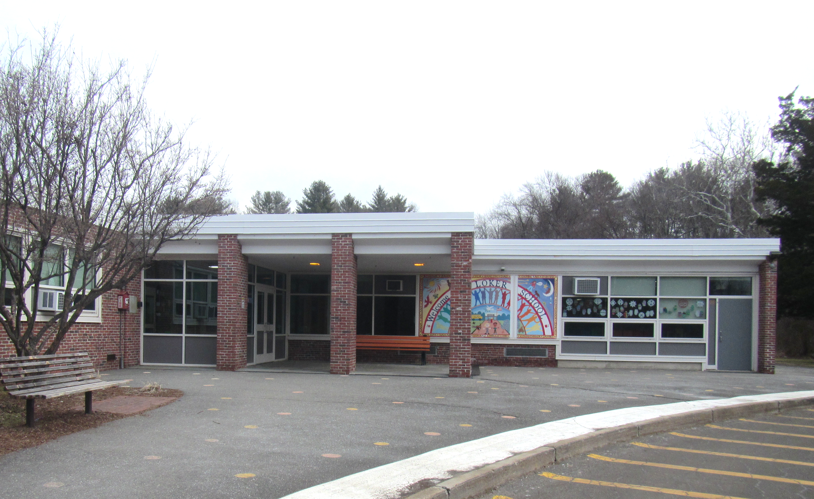

Prepared by:
Massachusetts Department of Public Health
Bureau of Climate and Environmental Health
Indoor Air Quality Program
July 2023

BACKGROUND
Building: | Loker Elementary School (LES)
Address: | 47 Loker Street, Wayland, MA
Assessment Requested Through: | Tom LeFleur, Director of Finance & Operations, Wayland Public Schools
Reason for Request: | General indoor air quality (IAQ) and chronic illness
Date of Assessment: | February 13, 2023
Massachusetts Department of Public Health/Bureau of Climate and Environmental Health (MDPH/BCEH) Staff Conducting Assessment: | Ruth Alfasso Environmental  Engineer/Inspector, IAQ Program
Building Description: | The LES is a single-story building with a brick façade and a flat roof. The original building was constructed in the 1950s, with an addition in the late 1990s.
Windows: | Windows in most areas are openable.

METHODS
Please refer to the Indoor Air Quality (IAQ) Manual for methods, sampling procedures, and interpretation of results (MDPH, 2015). Available at https://www.mass.gov/lists/indoor-air-quality-manual-and-appendices#indoor-air-quality-manual-.

RESULTS and DISCUSSION
The following is a summary of indoor air testing results (Table 1):
- Carbon Dioxide was below the MDPH recommended guideline of 800 parts per million (ppm) in most rooms assessed with approximately one quarter of the rooms having levels above 800 ppm. This is discussed further under “Ventilation” below.
- Temperature was within or slightly below the MDPH recommended range of 70°F to 78°F in most areas. The gym and a few adjacent classrooms were cooler, and occupants expressed discomfort.
- Relative Humidity was mostly below the MDPH recommended range of 40 to 60% in the areas tested. This is typical during the heating season.
- Carbon Monoxide was not detected (ND) in any indoor area assessed.
- Particulate matter (PM2.5) concentrations measured were below the National Ambient Air Quality (NAAQS) level of 35 μg/m³ in all areas tested.
- Total Volatile Organic Compounds (TVOC) ranged from ND to 0.5 ppm. Slight TVOC measurements (< 1.0 ppm) may be due to fluctuations in the instrument or to various products used indoors as discussed further below.

Ventilation
A heating, ventilating, and air conditioning (HVAC) system has several functions. First it provides heating and, if equipped, cooling. Second, it is a source of fresh air. Finally, an HVAC system will dilute and remove normally occurring indoor environmental pollutants by not only introducing fresh air, but by filtering the airstream and ejecting stale air to the outdoors via exhaust ventilation. Even if an HVAC system is operating as designed, point sources of respiratory irritation may exist and cause symptoms in sensitive individuals.
Fresh air in the majority of rooms is provided by unit ventilators (univents, Picture 1). Univents draw air from the outdoors through a fresh air intake located on the exterior wall of the building (Picture 2) and return air through an air intake located at the base of the unit. Fresh and return air are mixed, filtered, heated, and provided to rooms through an air diffuser located in the top of the unit (Figure 1). Thus, for proper operation, the top and front of the equipment should not be blocked. Some univents were blocked with furniture and items at the time of the assessment (Picture 1).
Mechanical exhaust ventilation in most classrooms is provided by exhaust vents located along or near the hallway wall connected to fans on the roof. Some of these vents were partly or fully blocked by furniture (Picture 3). A few exhaust vents were found covered with plastic (Picture 4). For proper operation of mechanical ventilation, including removal of stale air from rooms, exhaust vents should not be blocked. If the sealed exhaust vents were malfunctioning, they should be repaired and unsealed. Exhaust vents should be checked for airflow periodically to ensure they are on, the fans are operable, and repaired as needed. Some classrooms also had attached restrooms with exhaust vents. All restroom exhaust vents should be on and operating during occupied hours to remove odors and moisture.
Rooftop air handling units (AHU) supply fresh air to a few areas, including the gym, cafeteria, and some classrooms. Fresh air in these areas is supplied through ceiling-mounted vents (Picture 5). Adjustments to the operation of the AHUs was occurring at the time of the assessment to improve temperature control. This may account for the higher carbon dioxide readings seen in rooms nearer to the gym.
A few offices had no source of mechanical ventilation (Table 1). These were likely repurposed from rooms not intended to have regular occupancy. Occupied rooms should have a source of fresh air and exhaust.
The MDPH IAQ Program recommends that supply and exhaust ventilation operate continuously during occupied periods to provide air exchange and filtration. Without sufficient supply and exhaust ventilation, normally occurring environmental pollutants can build up and lead to indoor air quality/comfort complaints.
It is important to note that the univents examined appear to be past the end of their service life. According to the American Society of Heating, Refrigeration, and Air-Conditioning Engineering (ASHRAE), the service life of this type of unit is 15-20 years, assuming routine maintenance of the equipment (ASHRAE, 1991). Maintaining equipment older than that becomes increasingly difficult as parts wear out and replacement parts become harder to find.
To have proper ventilation with a mechanical ventilation system, the systems must be balanced after installation to provide an adequate amount of fresh air to the interior of a room while removing stale air from the room. It is recommended that HVAC systems be re-balanced every five years to ensure adequate air systems function (SMACNA, 1994).
Most classrooms and offices also have openable windows. Open windows are a source of fresh air during temperate weather. Windows should be tightly closed during severe weather and at the end of the school day.
Window air conditioners were noted in some classrooms and offices (Picture 6; Table 1). When these are operated, they can supply some fresh air. The cafeteria also has air conditioning supplied via the AHU. Windows should not be opened when air conditioning is in use, as this may lead to condensation on chilled surfaces, as well as using excess energy.
Univents have filters, which are reportedly changed 2-3 times a year. A classroom univent was opened and the filter examined. They appear to be good quality pleated filters with an unknown Minimum Efficiency Rating Value (MERV). The filter examined also appeared to need changing, and dust and debris were found inside the cabinet. During filter changes, univent cabinets should be cleaned/vacuumed out to remove debris that may be a source of particulates and odors to the indoor air. Filters should have a MERV rating of 8 or higher, if the equipment can handle the pressure reductions caused by more restrictive filters.

Moisture/Microbial Issues
MDPH IAQ staff examined the building for water damage and sources of moisture that can impact IAQ. Water-damaged ceiling tiles were noted in a few classrooms (Picture 7; Table 1). These reportedly stem from roof leaks that occurred prior to the roof being replaced this past summer. Water-damaged ceiling tiles should be replaced once the leaks have been repaired.
Significant water leaks occurred the week prior to the assessment due to very cold weather leading to frozen pipes. Major water damage occurred in the boiler room and the kitchen area, with minor leaks in the hallway adjacent to the kitchen. A professional restoration company and other contractors were on site promptly to remove accumulated water and repair damaged plumbing and electrical equipment. Additional work is needed to replace water-damaged ceilings and other material, however most of the damage is in areas that are not accessible to students or teachers.
In a few classrooms, the suspended ceiling tiles were bowed/sagging (Picture 8; Table 1). This is a sign that they have been exposed to high humidity for an extended period of time. This likely occurred during summers when the building was unoccupied, no air was circulating, and the weather outside was hot and humid. Bowed ceiling tiles are not a sign of microbial growth, but they suggest areas where caution should be used regarding storage of items over the summer to prevent water damage.
Some classrooms in the LES have sinks, with cabinets underneath, many of which had stored items, including porous items like paper towels (Picture 9). The area under sinks is a moist environment, so porous items or large amounts of items should not be stored there. Large amounts of items underneath sinks can also make detecting leaks more difficult.
Plants were found in several classrooms and offices (Table 1, Picture 10). Plants should be well maintained and not overwatered to prevent water damage and pests. Plants and other sources of odors should be kept away from the airstream of univents and other ventilation equipment.
The exterior of the building was examined for potential sources of odors, pollutants, and water infiltration. A water spigot was found to be running in one corner of the building (Picture 11). This is leaking against the foundation and may lead to damage to the building and water leaks inside. It is possible the spigot was damaged during the cold weather that led to other frozen pipes.
The building has a crawlspace, which is vented through small openings along the exterior walls (Picture 12). A few of the vent wells contained growing plants, which can block airflow through the vents, damage the vent screens (as shown in Picture 12), and be a source of odors and pest harborage. These vent wells should be maintained periodically to remove debris and ensure the vents are clear of obstructions.
There is a ramp underneath the newer wing to what is likely a storage area for maintenance equipment such as snowblowers, which could not be accessed at the time of the assessment (Picture 13). No fuel-powered equipment should be started inside this area or underneath the intake vents to prevent products of combustion from infiltrating into the occupied areas of the school.
Some of the doors to the exterior had light visible beneath them indicating that the weather-stripping was missing or worn out. Weather-stripping should be added or replaced to reduce infiltration of unconditioned air and pests.

Other IAQ Issues
Exposure to low levels of total volatile organic compounds (TVOCs) may produce eye, nose, throat, and/or respiratory irritation in some sensitive individuals. As noted above, low levels of TVOCs were detected in a few areas. This can either be due to the instrument readings fluctuating or indicat small amounts of VOCs, which are likely from various products used in the building. BCEH IAQ staff noted hand sanitizers, cleaning products, and dry erase materials in some areas (Table 1). All of these products have the potential to be irritants to the eyes, nose, throat, and respiratory system of sensitive individuals. Scented products such as air fresheners should not be used in schools, as many people are sensitive to the chemical compounds used in them. Consult the document “Clean Air Is Odor Free” for more information on use of scented products. While hand sanitizers may be necessary, these should be used in areas with good ventilation, with the containers kept closed when not in use.
Photocopiers were noted in hallways, as there is no space in the school for a dedicated copy room (Picture 14). Photocopiers can be a source of odors, particulates, and VOCs, particularly if older or heavily used. A laminator was found in the staff lunchroom (Table 1). Laminators melt plastic and can create odors and waste heat. They should be used away from occupants and with good ventilation, preferably a direct exhaust vent.
The art room has an electric-fired kiln. While most school kilns are located in their own dedicated closet, this kiln is in the corner of the art room (Picture 15). While this kiln has an exhaust vent to remove heat and odors/fumes from inside the equipment during operation, there is no general exhaust vent in the kiln area. The art teacher expressed concerns about the effectiveness of the existing exhaust vent. Occupants should be kept away from the kiln when it is in use, the existing kiln exhaust vent should be used during all kiln operation, and the adjacent window should also be opened.
Air purifying units were noted a few areas. Air purifiers with ionizing settings that produce ozone should not be used in occupied areas (US EPA, 2003). Air purifiers using high-efficiency particulate arrestance (HEPA) filters are a good choice to remove suspended particles in the air. They should be used and maintained, including filter changes, in accordance with manufacturer's instructions.
Ceiling fans are present in a few areas of the school (Table 1). Many of these were dusty, which can distribute particulates during operation. Ceiling fans, pedestal fans, and personal fans should be kept clean of accumulated dust and debris.
In one classroom tennis balls were found sliced open and placed on chair legs to reduce noise (Table 1). Tennis balls are made of a number of materials that are a source of respiratory irritants. Constant wearing of tennis balls can produce fibers and off-gas VOCs. Tennis balls are made with a natural rubber latex bladder, which becomes abraded when used as a chair leg pad. Use of tennis balls in this manner may introduce latex dust into the school environment. Some individuals are highly allergic to latex (e.g., spina bifida patients) (SBAA, 2001). It is recommended that the use of materials containing latex be limited to reduce the potential for symptoms in sensitive individuals (NIOSH, 1997). Latex-free glides should be used for this purpose.
Items were noted on surfaces in classrooms, including floors and univents. Items stored in classrooms, offices and storerooms provide a source for dusts to accumulate and make it difficult for custodial staff to clean. Items should be stored neatly and sorted frequently to remove items that are no longer needed.
Some areas of the school are carpeted. The carpeting in the 1990s wing appears to be in poor condition (Picture 16). Carpeting in schools has a service life of approximately 10-11 years (IICRC, 2002). Carpeting that is beyond its service life becomes increasingly difficult to clean and may release fibers which can be irritating if airborne. School staff reported that some carpeting in the school has already been removed and there is a plan to remove and replace other carpeting with non-porous flooring as budget allows.
Many classrooms had area rugs. Carpets and area rugs should be vacuumed regularly with a high efficiency particulate arrestance (HEPA)-filter-equipped vacuum cleaner and cleaned annually (or semi-annually in soiled/high traffic areas) in accordance with Institute of Inspection, Cleaning and Restoration Certification (IICRC) recommendations (IICRC, 2012). Second-hand area rugs should not be used in classrooms, as they may bring allergens such as pet hair into the school.
Food and food preparation equipment such as microwaves and small refrigerators, were found in some classrooms and staff areas. Food can be attractive to pests. Debris inside food preparation equipment can give off smoke and odors when the equipment is used. Refrigerators and food preparation equipment should be kept clean to prevent odors and potential microbial growth.
The BCEH/IAQ Program recommends that every school be tested for radon, and that this testing be conducted during the heating season while school is in session in a manner consistent with US EPA radon testing guidelines. According to facility staff, a few rooms in the school have recently been tested for radon with results below 2 pCi/l. Radon measurement specialists and other information can be found at www.nrsb.org and http://aarst-nrpp.com/wp, with additional information at: https://www.mass.gov/radon.

IAQ RECOMMENDATIONS
Management of a building without air conditioning can be challenging. The following documents can provide guidance that can be used to reduce the impact of hot, humid weather in buildings:
- Preventing mold growth in Massachusetts schools during hot, humid weather: https://www.mass.gov/service-details/preventing-mold-growth-in-massachusetts-schools-during-hot-humid-weather
- Remediation and prevention of mold growth and water damage in public schools and buildings to maintain air quality: https://www.mass.gov/service-details/remediation-and-prevention-of-mold-growth-and-water-damage-in-public-schools-and-buildings-to-maintain-air-quality
- Methods for increasing comfort in non-air-conditioned schools: https://www.mass.gov/doc/methods-for-increasing-comfort-in-non-air-conditioned-schools/download
In view of the findings at the time of the visit, the following recommendations are separated into short-term and long-term recommendations, that may require planning and capital funds to achieve.

Short-term recommendations
Ventilation Recommendations

- Operate supply and exhaust ventilation continuously when the building is occupied. Check univents and exhaust vents during occupied periods to ensure they are on and operating.
- Educate teachers and staff on the operation of univents and exhaust vents so they can avoid blocking units and can report off or inoperable units to facility staff. If not already in use, consider using a tracking program to collect and administer work orders for mechanical systems such as classroom univents.
- Investigate the reason for the taped off exhaust vents in rooms 15 and 16, and unblock/repair if possible.
- Perform regular filter changes for HVAC equipment using the best quality/highest MERV rated filters that can be used with current equipment. During filter changes, vacuum debris from univent and AHU cabinets. Clean debris from univent intakes periodically.
- Use openable windows to supplement fresh air ventilation during periods of mild weather. Ensure all windows are closed tightly at the end of each day to prevent pipe freezing during cold weather.
- Avoid opening windows when air conditioning is operating to prevent condensation and mold growth.
- Maintain portable air conditioners, window air conditioners and air purifiers in accordance with manufacturer's instructions including cleaning.
- Consider adopting a balancing schedule of every 5 years for all mechanical ventilation systems, as recommended by ventilation industrial standards (SMACNA, 1994).

Water Damage Recommendations

- Replace water-damaged ceiling tiles now that the roof is repaired.
- Continue with plans to repair damage caused by frozen pipes.
- Areas where ceiling tiles are bowed have likely been exposed to long periods of high humidity, most likely during hot summer weather. Take care when storing porous items in unconditioned areas, particularly on floors, during the summer months to prevent water damage.
- Ensure plants are well-maintained and not overwatered. Avoid placing plants on or in the airstream of univents.
- Avoid storage of porous materials or large amounts of items under sinks.
- Remove plants from crawlspace vent wells and periodically remove accumulated debris. Repair screens to prevent pest access to the crawl space.
- Repair the leaking spigot shown in Picture 11 and examine other outdoor spigots for damage due to freezing.
- Repair or replace weather-stripping on exterior doors where needed.

Other recommendations

- Avoid bringing in scented products (e.g., air fresheners, candles). Use only school-provided cleaning materials to avoid potential product interactions.
- Consider moving heavily used photocopiers away from occupants and to areas with exhaust ventilation.
- Use laminators away from occupants.
- Have the kiln exhaust vent assessed for proper function. Use the exhaust vent and open the window every time the kiln is used until it has cooled down. Keep occupants away from the kiln during operation.
- Avoid using any air purifiers that may produce ozone.
- Replace tennis balls with latex-free glides.
- Store items neatly and off the floor to assist with cleaning.
- Clean ceiling and personal fans of accumulated dust periodically.
- Keep food stored in tightly closed pest-proof containers.
- Keep food preparation equipment clean.
- Clean area rugs and carpets in accordance with IICRC recommendations. Store area rugs rolled up and off the floor in a dry area during summer break.
- Ensure no fuel-powered equipment is used inside or adjacent to the building.
- Consider including an IAQ component in the school’s Wellness Advisory Committee. An IAQ plan should have an IAQ liaison/teacher representative, a member of maintenance/facilities and administration that conduct regular walk-throughs to identify on-going and/or potential environmental issues.
- Consider adopting the US EPA (2000) document, “Tools for Schools,” as an instrument for maintaining a good IAQ environment in the building available at: Creating Healthy Indoor Air Quality in Schools | US EPA
- For guidance on maintaining an asthma-friendly healthy school environment, please consult the MDPH Asthma Prevention and Control Program’s Clearing the Air: An Asthma Toolkit for Healthy Schools.
- Consider testing the rest of the school for radon by a certified radon measurement specialist during the heating season when school is in session. Radon measurement specialists and other information can be found at: www.nrsb.org, and http://aarst-nrpp.com/wp.
- To learn more about radon, review the MDPH’s Radon in Schools and Child Care Programs factsheet, with additional information at: http://www.mass.gov/eohhs/gov/departments/dph/programs/environmental-health/exposure-topics/iaq/radon.
- Refer to the resource manual and other related indoor air quality documents located on the MDPH’s website for further building-wide evaluations and advice on maintaining public buildings. These documents are available at http://mass.gov/dph/iaq.

Long-term recommendations
- Continue with replacement wall-to-wall carpeting that is worn or beyond its service life.
- Consider adding ventilation to offices without it if they will continue to be regularly occupied.
- Consider moving the kiln to an area away from occupants or equip the corner of the room with a direct exhaust vent.
- Contact an HVAC engineering firm for an assessment of the condition and function of univents to see if they need replacement.

REFERENCES
ASHRAE. 1991. ASHRAE Applications Handbook, Chapter 33 “Owning and Operating Costs”. American Society of Heating, Refrigeration and Air Conditioning Engineers, Atlanta, GA.
IICRC. 2002. Institute of Inspection, Cleaning and Restoration Certification. A Life-Cycle Cost Analysis for Floor Coverings in School Facilities.
IICRC. 2012. Institute of Inspection, Cleaning and Restoration Certification. Carpet Cleaning: FAQ.
MDPH. 2015. Massachusetts Department of Public Health. Indoor Air Quality Manual: Chapters I-III. Available at: https://www.mass.gov/lists/indoor-air-quality-manual-and-appendices#indoor-air-quality-manual-
NIOSH. 1997. NIOSH Alert Preventing Allergic Reactions to Natural Rubber latex in the Workplace. National Institute for Occupational Safety and Health, Atlanta, GA.
SBAA. 2001. Latex In the Home And Community Updated Spring 2001. Spina Bifida Association of America, Washington, DC.
SMACNA. 1994. HVAC Systems Commissioning Manual. 1st ed. Sheet Metal and Air Conditioning Contractors’ National Association, Inc., Chantilly, VA.
US EPA. 1993. Radon Measurement in Schools, Revised Edition. Office of Air and Radiation, Office of Radiation and Indoor Air, Indoor Environments Division (6609J). EPA 402-R-92-014
US EPA. 2000. Tools for Schools. Office of Air and Radiation, Office of Radiation and Indoor Air, Indoor Environments Division (6609J). EPA 402-K-95-001, Second Edition. https://www.epa.gov/iaq-schools.
US EPA. 2003. “Ozone Generators that are Sold as Air Cleaners: An Assessment of Effectiveness and Health Consequences”. United States Environmental Protection Agency, Office of Air and Radiation, Indoor Environments Division, Washington, DC. Last updated September, 2018. https://www.epa.gov/indoor-air-quality-iaq/ozone-generators-are-sold-air-cleaners

Figure 1

Unit Ventilator (Univent)

Mixed Air

Air Diffuser

Outdoors Indoors

Fan

Heating/Cooling Coil

Air Mixing Plenum

Filter

Outdoor Return
Air Air

Air
Flow
Control
Louvers
Air Flow

= Fresh Air/Return Air

= Mixed Air

Picture 1

Unit ventilator (univent), note items on top and in front
Picture 2
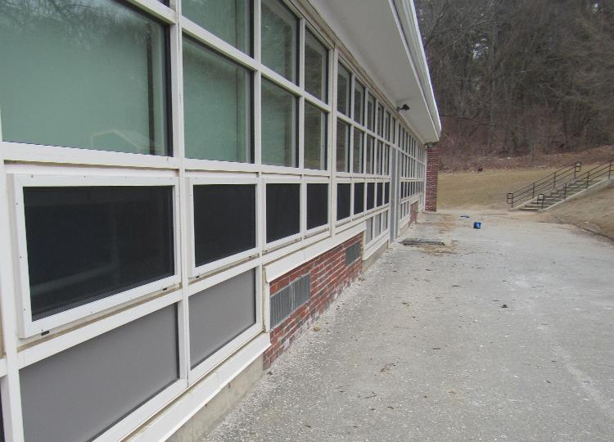
Univent air intakes on exterior of building (arrows)
Picture 3
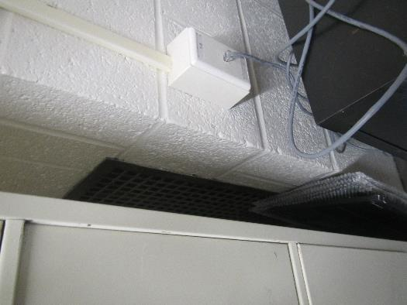
Exhaust vent blocked by cabinet
Picture 4
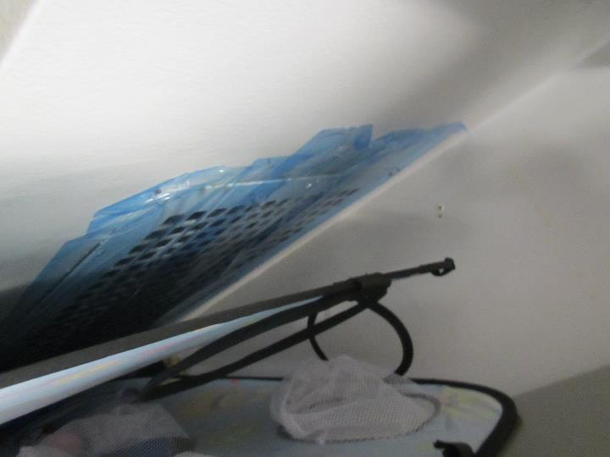
Exhaust vent with taped-on plastic
Picture 5
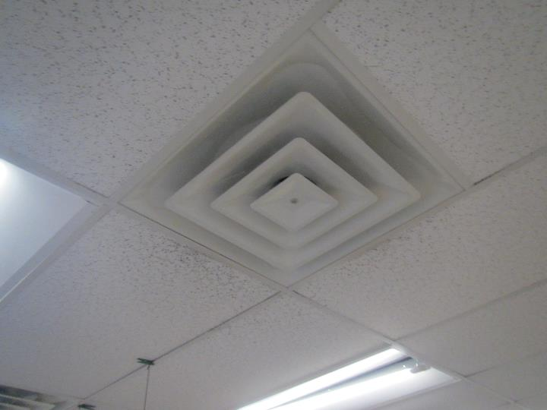
Ceiling-mounted supply vent
Picture 6
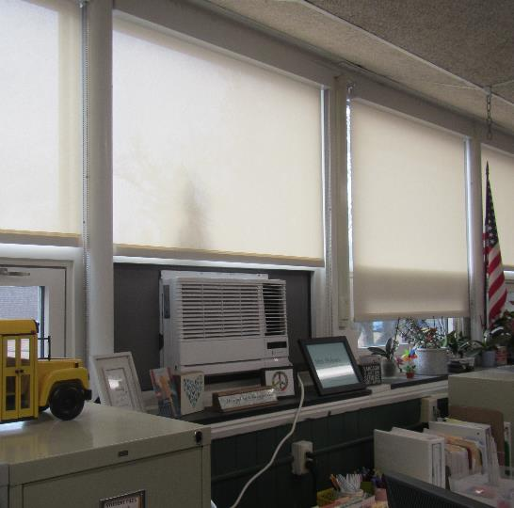
Window air conditioner
Picture 7
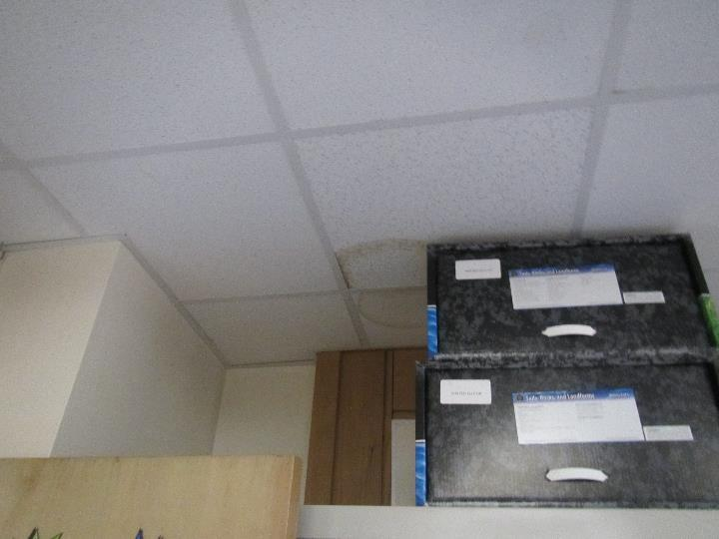
Water-damaged ceiling tiles
Picture 8
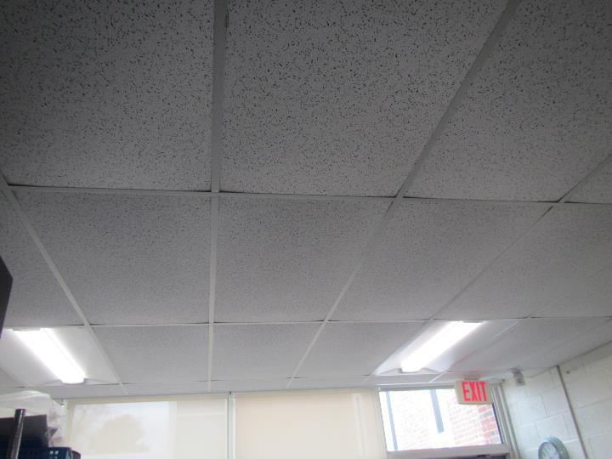
Bowed/sagging ceiling tiles
Picture 9
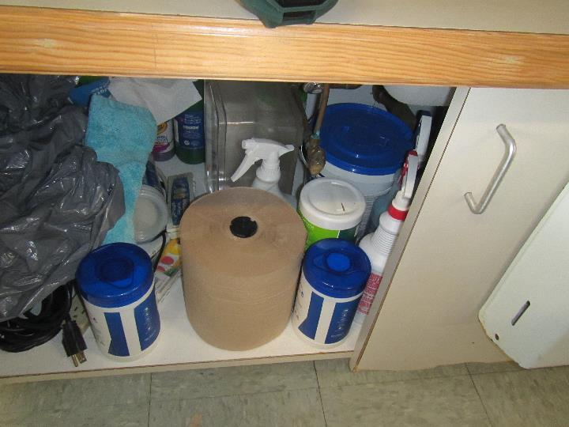
Large amounts of paper and other items under a classroom sink
Picture 10
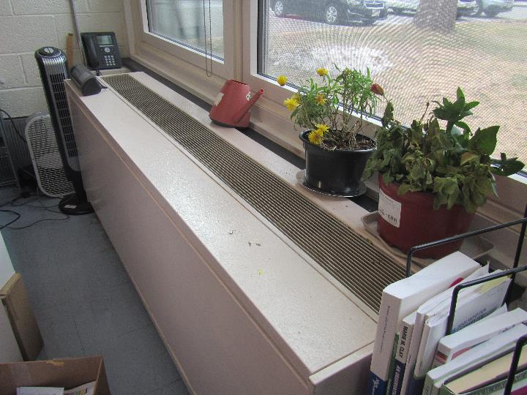
Plants on a univent
Picture 11
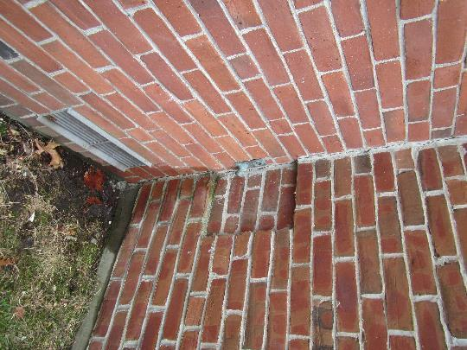
Leaking exterior water spigot
Picture 12
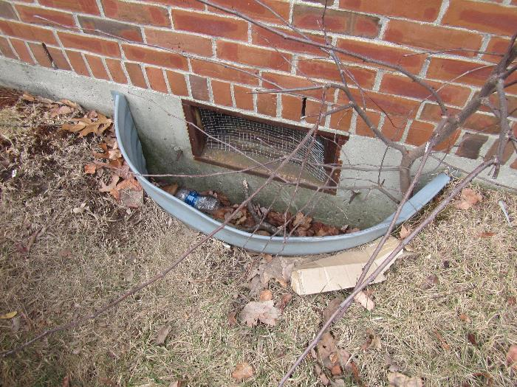
Crawlspace vent well with damaged screen and plant growing out of it
Picture 13
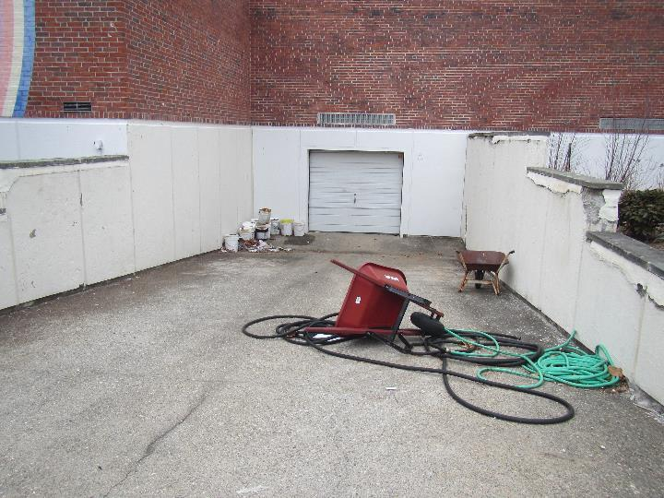
Ramp to storage area
Picture 14
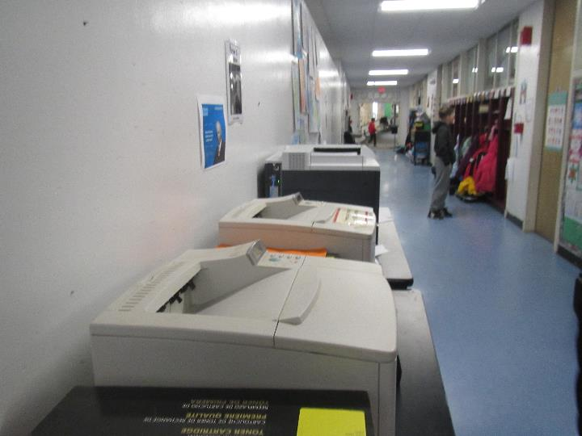
Copy machines in hallway
Picture 15
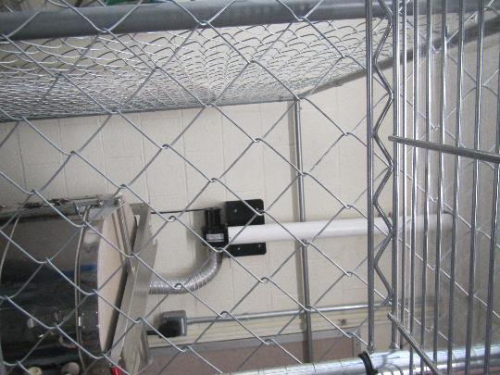
Kiln in a fenced area in the art classroom
Picture 16

Worn/stained carpeting
Location/Room | Carbon  Dioxide  (ppm) | Carbon Monoxide  (ppm) | Temp  (°F) | Relative  Humidity  (%) | PM2.5  (µg/m³) | TVOCs  (ppm) | Occupants  in Room | Windows  Openable | Ventilation |  | Remarks
 |  |  |  |  |  |  |  |  | Supply | Exhaust | Remarks
Background (outside) | 381 | ND | 49 | 52 | 3 | ND |  |  |  |  | Cloudy
Main office | 584 | ND | 70 | 32 | ND | ND | 3-5 | Y | Y | Y | WAC, plant, PC, NC
Assistant principal | 590 | ND | 70 | 32 | 2 | ND | 0 | N | Y | Y | Carpet, DEM, plush chairs
Principal | 606 | ND | 71 | 31 | 1 | ND | 0 | N | Y | Y | WAC, carpet, plush chairs
Ms. Major | 807 | ND | 69 | 33 | ND | ND | 3 | N | N | N | Partly carpeted, DEM, AP
METCO office | 722 | ND | 68 | 34 | 1 | ND | 2 | N | N | Y | Transfer vent in door, AP
Music | 502 | ND | 69 | 31 | ND | 0.1 | 1 | N | Y | Y | CF (dusty), area rug and carpet
CAF | 428 | ND | 68 | 32 | ND | ND | 5 | N | Y (has AC) | Y | Hanging items
Staff lunch | 479 | ND | 69 | 33 | ND | ND | 3 | Y 1 open | Y | Y | Laminator, food
Time out room | 426 | ND | 68 | 32 | ND | 0.2 | 0 | Y 1 open | Y | N | Plants
Nurse | 487 | ND | 68 | 33 | ND | ND | 2 | Y | Y | Y | WAC
Conference/ guidance | 521 | ND | 70 | 33 | ND | 0.2 | 0 | Y | Y | Y | Area rug, plush items
Guidance | 576 | ND | 68 | 33 | 1 | ND | 0 | Y | N | N | Area rug, plush items
ART | 662 | ND | 71 | 33 | 1 | ND | 1 | Y | Y | Y blocked | Kiln (electric) with vent, art supplies
Gym | 812 | ND | 67 | 32 | 1 | ND | 35 | N doors to outside | Y | Y | Music class
Gym office | 651 | ND | 63 | 36 | 2 | 0.2 | 0 | Y | N | N | Rubber balls
Library | 712 | ND | 69 | 34 | 1 | 0.2 | 18 | N | Y | Y off | CF, carpet and area rugs
Tech room | 519 | ND | 69 | 33 | ND | ND | 1 | N | N | N | AHU above in room and door to roof
1 | 647 | ND | 71 | 31 | 1 | ND | 23 | Y | Y | Y | Area rug, tennis balls on chair legs, hanging items
2 | 675 | ND | 69 | 32 | 1 | ND | 19 | Y | Y | Y on and restroom vent off | Area rugs, DEM, sinks
3 | 726 | ND | 69 | 35 | ND | 0.3 | 21 | Y | Y | Y on and restroom vent on | Area rugs
4 | 790 | ND | 69 | 35 | 1 | ND | 19 | Y | Y part blocked | Y on | Sink, DEM, HS
5 | 639 | ND | 69 | 33 | ND | ND | 7 | Y | Y | Y, Off or weak and blocked | Area rug, mats, door to outside
6 | 805 | ND | 70 | 33 | ND | ND | 21 | Y | Y part blocked | Y | Plants, area rug
7 | 660 | ND | 70 | 32 | ND | ND | 1 | Y | Y | Y blocked | Plants, sink, area rugs, DEM
8 | 711 | ND | 71 | 35 | ND | 0.2 | 18 | Y | Y | Y blocked | Bowed CT, area rug, sink, ajar ceiling tile
9 | 892 | ND | 69 | 36 | ND | ND | 22 | Y | Y | Y part blocked | DEM, DO
10 | 602 | ND | 71 | 32 | ND | ND | 1 | Y | Y | Y | Area rug, bowed CT, HS
12 | 489 | ND | 71 | 32 | ND | ND | 1 | Y | Y | Y | Plants, area rugs, AP, bowed ceiling tiles, sink
13 A and B | 613 | ND | 70 | 32 | 1 | ND | 1 | Y | Y | Y | DEM, area rugs
14 A | 664 | ND | 69 | 33 | ND | ND | 2 | Y | Y | Y | Area rug, WAC, door, sink
14 | 509 | ND | 69 | 31 | ND | ND | 1 | Y | Y | Y | Carpet, CP
15 | 824 | ND | 69 | 35 | ND | ND | 20 | Y | Y | Taped shut | WAC, paper items under sink, area rugs
16 | 983 | ND | 69 | 37 | ND | ND | 19 | Y | Y | Taped shut | WAC, plant, area rug, WD CT
17 | 1011 | ND | 72 | 38 | 1 | ND | 23 | Y | Y | unsure | WAC, area rugs
18 | 1080 | ND | 66 | 39 | ND | ND | 21 | Y | Y noisy | Y half blocked | Sink, perfume odor, WAC
19 | 930 | ND | 69 | 35 | ND | 0.1 | 22 | Y | Y | Y blocked | Area rug, WAC, door
20 | 1522 | ND | 69 | 38 | 1 | 0.4 (in hallway) | 25 | Y | Y | Y | Carpeted, DEM
21 | 1477 | ND | 63 | 44 | ND | 0.5 | 21 | Y | Y | Y | Old carpet, WD CT
22 | 656 | ND | 69 | 33 | 1 | ND | 18 | Y and door | N | Y | WAC, univent under items, closet with items, area rugs

ENVIRONMENTAL HEALTH CONCERNS

Loker Elementary School
47 Loker Street
Wayland, MA

During the IAQ assessment at Loker Elementary School in February 2023, staff raised environmental health concerns. The following information is provided in response to concerns of cancer among current and former staff as well as concern about Per- and Polyfluoroalkyl Substances (PFAS) in drinking water and the nearby former Dow Chemical facility, located approximately ½ mile southeast of the school.

Concerns of Cancer among Current and Former Staff
Administrators of the Wayland Public Schools requested assistance from the MDPH Bureau of Climate and Environmental Health (BCEH) in response to concerns about diagnoses of cancer among current and former staff at the Loker Elementary School over approximately the last 8 years. School administration staff were not aware of any acute health-related concerns, such as headaches or respiratory conditions.
MDPH/BCEH Community Health Assessment staff reviewed information on cancer diagnoses that were self-reported to the administration. A qualitative screening-level review of dates of diagnosis, cancer types, sex, age at diagnosis, and known risk factors for each reported cancer type was conducted to look for unusual patterns in cancer types and diagnoses over time. Limitations included some missing ages at diagnosis. To protect patient privacy, no specific details are provided about any of the particular diagnoses.
Based on the limited information received, it is our understanding that the diagnoses among current and former staff at the Loker Elementary School consist of several different cancer types with no established environmental risk factors in common. As such, it is unlikely that a common environmental factor played a contributing role in their development. No unusual patterns in cancer types or diagnoses over time were observed.
Breast cancer was the most reported cancer type among staff comprising more than 1/3rd of all diagnoses. Because a school’s workforce is often primarily composed of women, it is not unusual for breast cancer to be the most frequently diagnosed cancer type in the school population. Researchers suspect that established risk factors for breast cancer such as later maternal age at first birth and lower parity (the number of times a woman has given birth) may be more prevalent in women working in a professional setting. Women with more education are also more likely to undergo regular mammograms, increasing the likelihood of earlier detection for breast cancer (NIOSH 2010).
Appendix A provides information that offers a greater context in which to understand the incidence of and risk factors for cancer, with additional information specific to breast cancer.
Appendix B provides a more detailed discussion of risk factors for breast cancer, also available on the Massachusetts Environmental Public Health Tracking website at https://matracking.ehs.state.ma.us/Health-Data/Cancer/Risk_Factor_Summaries.html.

Claypit Hill Elementary School
It was noted that several staff at Loker Elementary School diagnosed with cancer had previously spent at least some time teaching at Claypit Hill Elementary School in Wayland. In March 2019, MDPH/IAQ conducted an indoor air quality assessment of Claypit Hill Elementary School. Levels of carbon dioxide were above the MDPH recommended level in more than half of the areas surveyed at the time of the assessment indicating a lack of air exchange. Accordingly, most recommendations focused on improving air ventilation. MDPH also recommended that the school be tested for radon by a certified radon measurement specialist during the heating season when school is in session (MDPH 2019). A report summarizing the findings of the building assessment and the recommendations made by MDPH is available at https://www.mass.gov/info-details/indoor-air-quality-reports-cities-and-towns-w#wayland-.

Concerns of Per- and Polyfluoroalkyl Substances (PFAS) in Drinking Water
Concerns were raised by some staff at Loker Elementary School about exposure to PFAS in Wayland’s municipal drinking water. PFAS are a group of fluorinated organic chemicals that have been used since the 1950s to make consumer products and materials resistant to water, grease, and stains (e.g., non-stick cookware, textiles, and paper food packaging). PFAS are also used in some firefighting foams and industrial processes.
Initial testing by the Wayland Water Division in January 2021 detected elevated levels exceeding the public drinking water standard (Wayland Water Division 2022). To bring PFAS levels into compliance, the town implemented a new treatment system at the Happy Hollow well site, which became fully operational in October 2022 (Wayland Water Division 2022; EEA 2023). The town of Wayland is currently considering connecting to the Massachusetts Water Resources Authority (MWRA) as part of a long-term plan to keep PFAS levels below the standard (McNamara 2023).
Appendix C provides a more detailed discussion about PFAS, possible health effects from exposure, public drinking water standards, and resources for additional information.

Concerns about the Nearby Former Dow Chemical Facility
Some staff raised concerns about possible exposures to chemicals originating from the nearby site of the former Dow Chemical facility located at 412 Commonwealth Road. The 16-acre site is currently owned by the town of Wayland and designated for conservation and recreational use. It was previously a farm that was used by the Dow Chemical Company to operate a small-scale chemical research facility from 1964 to 1988.
Appendix D provides an overview of remediation activities conducted at the site, a previous assessment conducted by MDPH, more recent plans to redevelop a portion of the site to construct a multi-purpose athletic field, and resources for additional information.

REFERENCES

Massachusetts Executive Office of Energy and Environmental Affairs (EEA). 2023. Data Portal, Drinking Water. Accessed March 7. Available at https://eeaonline.eea.state.ma.us/portal#!/search/drinking-water.
McNamara, N. 2023. Wayland mulls MWRA connection for town water supply. Patch. January 25. Available at www.patch.com/massachusetts/wayland/wayland-mulls-mwra-connection-town-water-supply.
MDPH. 2019. Indoor Air Quality Assessment, Claypit Hill Elementary School, 40 Adams Lane, Wayland, MA. Available at https://www.mass.gov/doc/claypit-hill-elementary-school-march-2019/download.
NIOSH. 2010. Letter to Dawn McCarthy from Elena Page concerning cancer incidence in a Transportation Security Administration facility. Cincinnati, OH. May 17, 2010.
Wayland Water Division. 2022. Annual Water Quality Report, Reporting Year 2021, PWS ID#3315000.

Appendix A
Cancer Risk Factors, Exposure, Latency, and Incidence

Cancer Risk Factors, Exposure, and Latency

While all cancers have the characteristic of abnormal and invasive cell growth, “cancer” is a general term that describes a group of different diseases with different causes, risk factors, characteristics, and age patterns. A risk factor is anything that increases a person's chance of developing cancer and can include hereditary conditions, medical conditions or treatments, infections, lifestyle factors, or environmental exposures. An individual's risk of developing cancer may change over time and may depend on a complex interaction between their genetic makeup and exposure to a cancer-causing agent (i.e., carcinogen). It is likely that multiple risk factors influence the development of most cancers.
- Risk factor summaries for several cancer types are available on the Massachusetts Environmental Public Health Tracking website at www.mass.gov/dph/matracking.
- Additional risk factor information by cancer type is available from the American Cancer Society at www.cancer.org.
Many cancers occur because of changes to cells that happen by random chance. Referred to as sporadic or spontaneous mutations, they are not due to any particular exposure to a cancer-causing agent. Other times, exposure may be an initiating or contributing factor to the development of cancer in an individual. If a person is exposed to something, it does not necessarily mean that their health will be affected. Any potential health risk depends on:
- whether you contact the chemical (e.g., drink contaminated water or touch contaminated soil),
- the amount of the chemical that gets into your body, and
- how toxic that chemical is.
The latency period is the time interval between an initiating event (such as a random mutation or exposure to a carcinogen) and the appearance of symptoms of the disease or its diagnosis. Cancer, in general, has a long latency period but it may vary depending on the type, magnitude, and timing of when the exposure or mutation occurred. Cancers that are solid tumors are believed to have a long latency period, estimated to be no shorter than 10 years and possibly as long as 50 years or more. For hematopoietic or blood-related cancers, such as lymphoma, experts think that the general latency period may be shorter, most commonly on the order of 5 to 10 years (Hall 2006; NRC 2005; UNSCEAR 2000; Bang 1996; Frumkin 1995). Due to the long latency period for most types of cancer, it is difficult to identify exactly what may have contributed to an individual’s cancer development.

Cancer Incidence

According to the American Cancer Society, one out of three women and one out of two men develop cancer in their lifetime (ACS 2020). For this reason, cancers often appear to occur in “clusters,” and it is understandable that someone may perceive that there is an unusually high number of cancer diagnoses in their neighborhood, workplace, or town. Upon close examination, many of these “clusters” are not unusual increases, as first thought, but are related to such factors as local population density or a concentration of individuals who possess related behaviors or risk factors for cancer. Some, however, are unusual; that is, they represent a true excess of cancer in a workplace, a community, or among a subgroup of people. A suspected cluster is more likely to be a true cancer cluster if it involves a high number of diagnoses of one type of cancer in a relatively short time period rather than several different types diagnosed over a long period of time (i.e., 20 years), a rare type of cancer rather than common types, and/or a large number of diagnoses among individuals in age groups not usually affected by that cancer. These types of clusters may warrant further public health investigation.
The Massachusetts Cancer Registry (MCR), a division in the MDPH Office of Data Management and Outcomes Assessment, is a population-based surveillance system that has been monitoring cancer incidence in the Commonwealth since 1982. Although the MCR can be used to evaluate cancer incidence in some cases, calculating an expected rate of cancer for a place of employment is difficult at best because data reported to the MCR is based on the individual’s place of residence at diagnosis, not their workplace. Therefore, the most practical first step in evaluating cancer in a workplace is to determine the types of cancer reported and whether they appear to represent an unusual pattern. An information sheet on cancer in Massachusetts is available online at https://www.mass.gov/info-details/cancer-in-massachusetts.

Breast Cancer

Nationally and statewide, breast cancer is the most common cancer diagnosed among women, except for skin cancers, accounting for about 30% of all newly diagnosed cancers among females (ACS 2022b; MCR 2021). For more than a decade, breast cancer has been the most common type of cancer diagnosed among female residents in Massachusetts and the second most common type of cancer diagnosed among females in the United States (MCR 2006, 2011, 2016; ACS 2007-2021, 2022a). The chance of developing invasive breast cancer at some time in a woman’s life is about 1 in 8 (12%). A woman’s risk of developing breast cancer increases with age, with most women diagnosed at age 55 and older (ACS 2022b).
The risk of developing breast cancer is influenced by several factors. The most well-established risk factors for breast cancer are related to genetics and specific reproductive events in a woman’s life that impact exposure of the breast tissue to estrogen and progesterone, such as age at first pregnancy, number of births, and age at menopause. Other factors such as drinking alcohol, being overweight, some medical conditions, and demographic characteristics (e.g., socioeconomic status) are known to also influence breast cancer risk (ACS 2022b; ASCO 2021).
It should be noted that because a school’s workforce is often primarily composed of women, it is not unusual for breast cancer to be the most frequently diagnosed cancer type in the school population. Several studies have found that women who work in professional jobs tend to have an increased risk of developing breast cancer (Ruben et al. 1993; Threlfall et al. 1985; MacArthur et al. 2007; King et al. 1994; Pollan and Gustavsson 1999) while other studies have not (Calle et al. 1998; Petralia et al. 1999). No occupational exposures have been identified in these studies. Rather, researchers suspect that established risk factors for breast cancer such as later maternal age at first birth and lower parity (the number of times a woman has given birth) may be more prevalent in women working in a professional setting. Women with more education are also more likely to undergo regular mammograms, increasing the likelihood of earlier detection for breast cancer (NIOSH 2010).

REFERENCES
American Cancer Society (ACS). 2007-2021. Cancer Facts & Figures, Annual Reports 2007 through 2021. Available at https://www.cancer.org/research/cancer-facts-statistics/all-cancer-facts-figures/cancer-facts-figures-2021.html.
ACS. 2020. Lifetime Risk of Developing or Dying from Cancer. Available at www.cancer.org/cancer/cancer-causes/general-info/lifetime-probability-of-developing-or-dying-from-cancer.html.
ACS. 2022a. Cancer Facts & Figures 2022. Available at www.cancer.org/content/dam/cancer-org/research/cancer-facts-and-statistics/annual-cancer-facts-and-figures/2022/2022-cancer-facts-and-figures.pdf.
ACS. 2022b. Breast Cancer. Available at www.cancer.org/cancer/breast-cancer.html.
American Society of Clinical Oncology (ASCO). 2021. Breast Cancer. Available at www.cancer.net/cancer-types/breast-cancer.
Bang KM. 1996. Epidemiology of Occupational Cancer. Occupational Medicine. 11(3) :467-485.
Calle, E.E. et al. 1998. Occupation and breast cancer mortality in a prospective cohort of US women. American Journal of Epidemiology 148(2):191-197.
Frumkin H. 1995. Carcinogens. In: Levy BS and Wegman DH, editors. Occupational Health- Recognizing and Preventing Work-Related Disease. 3rd ed. Boston: Little, Brown and Company. p.293
Hall EJ. 2006. Radiobiology for the radiologist. 6th ed. Philadelphia: Lippincott Williams & Wilkins; p. 138
King, A.S. et al. 1994. Mortality among female registered nurses and school teachers in British Columbia. American Journal of Industrial Medicine 26(1):125-132.
MacArthur, A.C. et al. 2007. Occupational female breast cancer and reproductive cancer mortality in British Columbia, Canada, 1950-94. Occupational Medicine 57:246-253.
Massachusetts Cancer Registry (MCR). 2006. Cancer Incidence and Mortality in Massachusetts 1999-2003: Statewide Report.
MCR. 2011. Cancer Incidence and Mortality in Massachusetts 2004-2008: Statewide Report.
MCR. 2016. Cancer Incidence and Mortality in Massachusetts 2009-2013: Statewide Report. Available at www.mass.gov/lists/cancer-incidence-statewide-reports.
MCR. 2021. Cancer Incidence and Mortality in Massachusetts 2013-2017: Statewide Report. Available at www.mass.gov/lists/cancer-incidence-statewide-reports.
National Research Council (NRC). 2005. Health risks from exposure to low levels of ionizing radiation. BEIR VII Phase 2. Washington, DC: National Academies Press.
National Institute for Occupational Safety and Health (NIOSH). Letter to Dawn McCarthy from Elena Page concerning cancer incidence in a Transportation Security Administration facility. Cincinnati, OH. May 17, 2010.
Petralia, S.A. et al. 1999. Risk of premenopausal breast cancer and patterns of established breast cancer risk factors among teachers and nurses. American Journal of Industrial Medicine 35(2):137-141.
Pollan, M. and Gustavsson, P. 1999. High-risk occupations for breast cancer in the Swedish female working population. American Journal of Public Health 89(6):875-881.
Ruben, C.H. et al. 1993. Occupation as a risk identifier for breast cancer. American Journal of Public Health 83(9):1311-1315.
Threlfall, W.J. et al. 1985. Reproductive variables as possible confounders in occupational studies of breast and ovarian cancer in females. Journal of Occupational Medicine 27(6):448-450.
United Nations Scientific Committee on the Effects of Atomic Radiation (UNSCEAR). 2000. Sources and Effects of Ionizing Radiation. Volume I. New York: United Nations Scientific Committee on the Effects of Atomic Radiation.

Appendix B
Breast Cancer Risk Factor Information

Massachusetts Department of Public Health | Bureau of Environmental Health

Breast Cancer
Risk Factor Information
MASSACHUSETTS DEPARTMENT OF PUBLIC HEALTH | BUREAU OF ENVIRONMENTAL HEALTH

This document gives a general overview of risk factors. The document covers:
- About Cancer and Risk Factors
- About Breast Cancer
- Types of Breast Cancer
- Known Risk Factors
- Possible Risk Factors
- Other Risk Factors That Have Been Investigated
- References / More Information

About Cancer and Risk Factors

Cancer is not just one disease.
Cancer is a group of over 100 different diseases. Cancer occurs when abnormal cells grow out of control and crowd out the normal cells. It can start anywhere in the body and can spread (metastasize) to other parts of the body. Cancer types are named for the original location in the body and the type of cell or tissue. Different types of cancer have different causes and risk factors.
Cancer can take a long time to develop.
The cause of cancer is sometimes related to events that happened many years ago. Most cancer types are thought to take anywhere from 10 to over 50 years to develop. A few types, such as leukemia or lymphoma, are thought to take less than 10 years.

A risk factor is anything that increases your chance of getting cancer.
Some risk factors can be controlled while others cannot. Risk factors can include:
- Hereditary conditions (e.g., genes passed down from parents)
- Medical conditions or treatments (e.g., a previous cancer diagnosis)
- Infections (e.g., human papilloma virus)
- Lifestyle factors (e.g., smoking cigarettes)
- Environmental exposures (e.g., certain air pollutants)

Most risk factors do not directly cause cancer.
A risk factor influences the development of cancer but usually does not directly cause cancer. Instead, a combination of risk factors likely drives cancer development. For example, genetic factors can make individuals more likely to get cancer when they are exposed to a cancer-causing chemical.

Environmental risk factors depend on how, how much, and how long you are exposed.
Your risk from exposure to certain chemicals or radiation depends on the type, extent, and duration of exposure. For example, inhaling a certain chemical may increase your risk of getting cancer. However, touching the same chemical may not. In addition, some substances may increase your risk only if you are exposed to high amounts over a long time.

It is difficult to identify the exact causes of cancer.
- Many cancers can develop due to random chance.
- Multiple risk factors can act in combination.
- Risk factors can change over time.
- Cancer might not develop or get diagnosed for a long time after an initiating event (such as exposure or random cell mutation).

Knowing your risk factors can help you make more informed choices.
Discuss your risk factors with your health care provider to make more informed decisions on lifestyle and health care.

About Breast Cancer

Breast cancer is the most common cancer in women in the United States.
Breast cancer accounts for about 1 in 3 cancer diagnoses in women in the United States. A woman has about a 1 in 8 chance of developing breast cancer in her life.^{2, 9} The American Cancer Society estimates that 287,850 women in the U.S. and 6,710 women in Massachusetts will be diagnosed with invasive breast cancer in 2022.¹ Since the mid-2000s, incidence rates of invasive breast cancer have increased by 0.5% each year.^{1,} ^{2, 6}

Breast cancer is rare for men.
Men can develop breast cancer, but it accounts for less than 1% of male cancer diagnoses.^{1, 7} White men are about 100 times less likely than white women to develop this cancer, and black men are about 70 times less likely than black women to develop it.⁵ For more information on breast cancer in men, visit the American Cancer Society website at www.cancer.org.⁵

Most breast cancers occur in women age 55 or older.
The risk of developing breast cancer increases with age. About 70% of women diagnosed with breast cancer are age 55 and older.^{2, 6, 10, 11} A very small number of women diagnosed with breast cancer are younger than 45.²

Although white women are more likely to develop breast cancer, black women are more likely to die from it.
Before age 40, non-Hispanic Black women have a higher chance of developing breast cancer than non-Hispanic white women.^{2, 3, 6} Between the ages of 65 to 84, non-Hispanic white women are most likely to be diagnosed with breast cancer followed closely by non-Hispanic black women.³ Hispanic, Asian/Pacific Islander, and American Indian/Alaskan Native women are less likely to develop breast cancer.^{2, 3, 6}

At any age, non-Hispanic black women are more likely to die from breast cancer than any other race or ethnic group.^{2, 3}

Types of Breast Cancer

Breast cancers are either in situ or invasive.
- An in situ breast cancer is considered the earliest stage of cancer. It has not invaded the breast’s deeper tissues or spread to other organs. In situ breast cancers are also referred to as non-invasive breast cancers.²
- An invasive breast cancer has spread beyond the layer of cells where it started into surrounding tissues and can spread (metastasize) to other parts of the body.²

The remainder of this risk factor summary will focus on invasive breast cancers. For more information on in situ breast cancers and other benign (non-cancerous) breast conditions, visit the American Cancer Society website at www.cancer.org.^{2, 4}

Most breast cancers are invasive (or infiltrating).
The two most common types of breast cancer are invasive ductal carcinoma and invasive lobular carcinoma.^{2, 6}
- Invasive ductal carcinoma begins in cells that line the milk duct of the breast. It makes up about 70-80% of all invasive breast cancers.
- Invasive lobular carcinoma begins in the milk-producing glands (lobules) of the breast. It accounts for 10% of invasive breast cancers. Invasive lobular carcinoma may be harder to detect by a mammogram.
Less common types of breast cancer include inflammatory breast cancer, Paget’s disease of the breast, angiosarcoma, and Phyllodes tumor.²

Certain properties of breast cancer cells inform treatment decisions.
Breast cancer cells are tested for two hormone receptors and a certain protein. Breast cancer tumors can be:
- Hormone receptor-positive: These breast cancer cells have either an estrogen receptor (ER), progesterone receptor (PR), or both. About 66% of breast cancers are ER and/or PR positive and are more common after menopause. They can be treated with hormone therapy.
- Human epidermal growth factor receptor 2 (HER2)-positive: These breast cancer cells have high levels of the HER2 protein, making them grow quickly. About 10-20% of breast cancers are HER2-positive and can be treated with drugs that target the HER2 protein. They can also be hormone receptor-positive.
- Triple-negative: These breast cancer cells do not have an estrogen receptor, progesterone receptor, or excess HER2 protein. They grow and spread faster than most other types of breast cancers. These breast cancers tend to be more common in women younger than 40 and can be difficult to treat.^{2, 6, 10}

Known Risk Factors

Medical Conditions

Non-cancer breast conditions:
Certain benign (non-cancerous) breast conditions may increase breast cancer risk, including:
- Lobular neoplasia (a change in the cells of the milk-producing glands)^{2, 6}
- Proliferative lesions with atypia (abnormal cells in the ducts or milk-producing glands that grow excessively)²
- Dense breast tissue (as seen on a mammogram)^{2, 6}

Previous breast cancer diagnosis:

A woman with cancer in one breast has a higher risk of developing a new cancer in the other breast or in another part of the same breast. This is different from a recurrence or return of the first cancer^{2, 6}

High lifetime exposure to estrogen and progesterone:
A longer lifetime exposure of the breast tissue to estrogen and progesterone can increase breast cancer risk. Several factors can increase risk, including:
- Starting menstruation before age 11 or 12
- Going through menopause after age 55
- Having a first pregnancy after age 30, or never having a full-term pregnancy^{2, 6}

Menopausal hormone therapy:
Use of menopausal hormone therapy (also called post-menopausal hormone therapy or hormone replacement therapy) may affect breast cancer risk.
- Combined hormone therapy with both estrogen and progesterone increases the risk of breast cancer. The risk seems to decrease within 5 years of stopping treatment but does not disappear completely.
- Estrogen-only therapy does not appear to increase the risk of breast cancer.^{2, 6, 11}
If you are considering menopausal hormone therapy, discuss the possible risks and benefits with your health care provider. In general, if a woman decides to use hormone therapy, it is usually best to use it at the lowest dose for as short a time as possible.²

Previous radiation therapy to chest:
Women who have had radiation therapy to the chest as treatment for another cancer (e.g., Hodgkin or non-Hodgkin lymphoma) have a higher risk for breast cancer.^{2, 11} The risk is highest if the radiation occurs as a teen or young adult, when the breasts are still developing. Radiation treatment after age 40 to 45 does not seem to increase breast cancer risk.²

Prior use of diethylstilbestrol (DES) drug:
From the 1940s to the early 1970s, some pregnant women were given DES because it was thought to lower their chances of miscarriage. Use of DES slightly increases breast cancer risk. A woman whose mother took DES while pregnant may also have a slightly higher risk of breast cancer.²

Hereditary Conditions

Family history of breast cancer:
Having a family history of breast cancer increases a woman’s risk of developing the disease. A woman has a higher risk if she has:
- Several close blood relatives (e.g., grandparents, aunts, cousins) diagnosed with breast and/or ovarian cancer.⁶
- A first-degree relative (i.e., mother, sister, or daughter) diagnosed with breast cancer. This almost doubles the risk. Having two first-degree relatives with breast cancer increases the risk by about 3 times.²
- A father or brother with breast cancer.^{2, 6}
It is important to note that most women with breast cancer do not have a family history of the disease.²

Inherited gene mutations:
About 5-10% of breast cancers likely result from a genetic mutation passed down from a parent.² Most of these mutations occur in the BRCA1 and BRCA2 genes. On average, women with BRCA1 mutations have a 65% chance of developing breast cancer by age 70 and women with BRCA2 mutations have about a 45% chance. In the United States, BRCA mutations are more common in Jewish people of Ashkenazi (Eastern Europe) origin. Other less common gene mutations can increase the risk of breast cancer, including ATM, CHEK2, NF1, TP53, PTEN, CDH1, STK11, and PALB2.^{2, 11}

Lifestyle Factors

Drinking alcohol:
Drinking alcohol is clearly linked to increased risk of breast cancer. The risk goes up with higher amounts of alcohol consumed.^{2, 6}
- Women who drink one alcoholic drink per day have a small increase in risk.²
- Women who have 2 to 3 alcoholic drinks per day have about a 20% higher risk compared to non-drinkers.²

Being overweight or obese:
After menopause (when the ovaries stop making estrogen), most estrogen comes from fat tissue. Being overweight or obese after menopause increases a woman’s risk of breast cancer.^{2, 6, 11} Similarly, women who are less physically active may have an increased risk of breast cancer, especially in women past menopause.^{2, 6}

Higher socioeconomic status:
The risk of breast cancer is higher in women of higher socioeconomic status (e.g., higher income, education), but is not due to socioeconomic status itself. Instead, this may be due to multiple reproductive and lifestyle risk factors (e.g., later age at first pregnancy, fewer children, greater use of menopausal hormone therapy, easier access to screening, etc.).^{6, 11}

Possible Risk Factors

Medical Conditions

Birth control use:
Use of birth control may affect breast cancer risk.
- Women using birth control pills (oral contraceptives) have a slightly greater risk of breast cancer. However, the risk seems to return to normal within 10 years after stopping.
- Some studies suggest women using long-acting progesterone birth control shots (such as Depo-Provera) every 3 months may have an increase in breast cancer risk, but not all studies have found this.
- Some studies suggest women using a hormone-releasing intrauterine device (IUD) may have an increased risk.
Few studies have looked at breast cancer risk from birth control implants, skin patches, and vaginal rings. If you are considering hormonal birth control, discuss your breast cancer risk factors with your health care provider.²

Height

Many studies have found that taller women have a higher risk of breast cancer than shorter women. The reasons for this aren’t exactly clear, but it may have something to do with factors that affect early growth, such as nutrition early in life, as well as hormonal or genetic factors.²

Lifestyle Factors

Smoking:
Recent research suggests that long-term heavy smokers may have a slightly higher risk of breast cancer, with risk increasing for certain groups, such as women who started smoking before having their first child.² Information about quitting smoking and related services is available from the Massachusetts DPH Tobacco Cessation and Prevention Program at 1-800-Quit-Now or 1-800-784-8669.

Secondhand smoke:
Some studies suggest a possible connection between secondhand smoke and an increased risk for breast cancer, particularly in premenopausal women. However, this is still being studied.^{2, 11}

No history of breastfeeding:
Women who have breastfed (especially for 1 year or more) might have a lower risk for breast cancer. Experts think this might be because breastfeeding reduces the number of menstrual cycles in a woman’s lifetime, lowering exposure to estrogen and progesterone.^{2, 11}

Working the night shift:
Some recent studies have suggested that working the night shift may increase the risk for breast cancer. The light-sensitive hormone melatonin may play a role in this link. Further research is looking into this possibility.^{2, 8}

Environmental Exposures

Exposure to chemicals with estrogen-like properties:
A great deal of research has been done trying to understand possible environmental risk factors for breast cancer. Some environmental chemicals, such as endocrine disruptors, elicit hormonal responses or have estrogen-like properties. ^{2, 11} In theory, estrogen-like chemicals could affect breast cancer risk. These chemicals can be found in certain:
- Plastics
- Cosmetics and personal care products
- Pesticides
- PCBs (polychlorinated biphenyls) ²
One research program found that exposure to endocrine disrupting chemicals during prenatal development, puberty, pregnancy, and menopausal transition was associated with an increased risk for breast cancer.¹² However, there is no clear link between exposure to these substances and breast cancer risk.²

Other Risk Factors That Have Been Investigated

Medical Conditions

Miscarriages and pregnancy terminations?
Several studies have found that miscarriages and pregnancy terminations (either induced or spontaneous abortions) do not affect breast cancer risk.^{2, 111}

Lifestyle Factors
Antiperspirants?
Use of antiperspirants has been investigated as a possible risk factor for breast cancer. Based on the available evidence, no associations or scientific basis have been found linking breast cancer risk with use of antiperspirants.^{2, 111}

Bras?
No scientific or clinical evidence indicates that bras can cause breast cancer.^{2, 11}

Breast implants?
Breast implants have not been linked to an increased risk for the most common types of breast cancer. However, breast implants with a textured surface have been linked to a rare cancer, breast implant-associated anaplastic large cell lymphoma (BIA-ALCL), which can form in the scar tissue around the implant.²

Dietary fat intake?
Studies of women in the United States have not found a consistent link between high-fat diets and breast cancer risk. One large study found a high-fat diet during adolescence was associated with a moderate increase in premenopausal breast cancer risk. Studies have found breast cancer is less common in other countries where the typical diet is lower in total, polysaturated, and saturated fats, but this association is complicated by other factors (such as activity level, intake of other nutrients, and genetic factors).^{2, 11}

References / More Information

This information sheet should not be considered exhaustive. For more information on other possible risk factors and health effects being researched, please see the resources below. Much of the information contained in this summary has been taken directly from these sources. This material is provided for informational purposes only and should not be considered as medical advice. Consult your physician if you have questions regarding a specific medical problem or condition.

American Cancer Society (ACS). http://www.cancer.org
- ACS. 2022. Cancer Facts & Figures 2022.
- ACS. 2022. Breast Cancer.
- ACS. 2019. Breast Cancer Facts & Figures 2019-2020.
- ACS. 2022. Non-Cancerous Breast Conditions.
- ACS. 2022. Breast Cancer in Men.

American Society of Clinical Oncology (ASCO). http://www.cancer.net
- ASCO. 2020. Breast Cancer.
- ASCO. 2020. Breast Cancer in Men.

International Agency for Research on Cancer (IARC). http://www.iarc.fr/
- IARC. 2010. IARC Monographs on the Evaluation of Carcinogenic Risks to Humans, Volume 98: Painting, Firefighting and Shiftwork. Available at: http://monographs.iarc.fr/ENG/Monographs/vol98/index.php

Massachusetts Cancer Registry (MCR), Massachusetts Department of Public Health.
- MCR. 2021. Cancer Incidence and Mortality in Massachusetts 2013-2017: Statewide Report. Available at: https://www.mass.gov/doc/cancer-incidence-and-mortality-in-massachusetts-2013-2017-statewide-report/download

National Cancer Institute (NCI). http://www.cancer.gov
- NCI. 2021. Breast Cancer.

Schottenfeld D and JF Fraumeni.
- Brinton LA, Gaudet MM, and Gierach GL. 2018. Breast Cancer. In: Cancer Epidemiology and Prevention. 4th Ed, edited by Thun MJ, Linet MS, Cerhan JR, Haiman CA, and Schottenfeld D, New York: Oxford University Press.

National Institute of Environmental Health Sciences (NIEHS). https://www.niehs.nih.gov/
- NIEHS. 2022. Breast Cancer.

Massachusetts Department of Public Health
Bureau of Environmental Health
250 Washington Street
Boston, MA 02108
Phone: 617-624-5757 | Fax: 617-624-5777 | TTY: 617-624-5286
www.mass.gov/dph/environmental_health

September 2022

Appendix C
Per- and Polyfluoroalkyl Substances (PFAS) in Drinking Water

Per- and Polyfluoroalkyl Substances (PFAS) are a group of fluorinated organic chemicals that have been used since the 1950s to make consumer products and materials resistant to water, grease, and stains (e.g., non-stick cookware, textiles, and paper food packaging). PFAS are also used in some firefighting foams and industrial processes. Perfluorooctanoic acid (PFOA) and perfluorooctane sulfonate (PFOS) have been the most extensively produced and studied of these chemicals. Although many PFAS are no longer produced in this country, nearly all people are exposed to PFAS. Most are exposed through food consumption and use of consumer products. In communities with PFAS-contaminated water supplies, drinking water can be a significant source of exposure. Because PFAS are odorless and tasteless, testing is the only way to know if PFAS are present in water. (MDPH 2022).
Researchers have evaluated the potential for PFAS to cause adverse health effects in both humans and laboratory animals. Although there are some gaps in the current scientific knowledge, environmental health scientists believe that exposure to PFAS may affect human health. In animal studies, which mostly involved exposure to high levels, PFAS have been associated with effects on the liver, kidneys, immune system, thyroid gland, and developing fetus. The most consistent finding in studies of humans exposed to elevated levels of PFAS is increased cholesterol levels. There is suggestive evidence that PFOS can increase the risk of cancer in humans based on evidence showing a link between PFOA exposure and both kidney and testicular cancer. Effects depend on how much a person is exposed to and how often and for how long they are exposed. Possible harm from exposure also depends on personal factors such as age, sex, diet, lifestyle, and current health status (MDPH 2022).
In October 2020, MassDEP published its PFAS public drinking water standard or Massachusetts Maximum Contaminant Level (MMCL) of 20 nanograms per liter (ng/L), or parts per trillion (ppt) for the sum of the concentrations of six specific PFAS. The standard is set to be protective against adverse health effects for all people consuming the water (MassDEP 2023). Initial testing by the Wayland Water Division in January 2021 detected PFAS6 at elevated levels exceeding the public drinking water standard (Wayland Water Division 2022). To bring PFAS levels into compliance, the town implemented a new treatment system at the Happy Hollow well site, which became fully operational in October 2022 (Wayland Water Division 2022; EEA 2023). The town of Wayland is currently considering connecting to the Massachusetts Water Resources Authority (MWRA) as part of a long-term plan to keep PFAS levels below the standard (McNamara 2023).
More information about PFAS is available at https://www.mass.gov/service-details/per-and-polyfluoroalkyl-substances-pfas-in-drinking-water. For additional questions on PFAS in drinking water, contact the MassDEP Drinking Water Program at 617-292-5770. For more information about the quality of the public drinking water in Wayland, refer to the annual drinking water quality reports available at https://www.wayland.ma.us/water-division/pages/annual-water-quality-reports or contact the Water Division of the Wayland Department of Public Works at 508-358-3672.

REFERENCES

Massachusetts Department of Environmental Protection (MassDEP). 2023. Per- and Polyfluoroalkyl Substances (PFAS). Accessed March 7. Available at https://www.mass.gov/info-details/per-and-polyfluoroalkyl-substances-pfas.
MassDEP. 2021. Per- and Polyfluoroalkyl substance (PFAS) Notice of Noncompliance with Violation Response/Compliance Schedule Approval (CSA) Form. Available at https://www.wayland.ma.us/system/files/uploads/pfas-enf-noncsa-wayland-3315000-2021-04-09.pdf.
Massachusetts Department of Public Health (MDPH). 2022. Per- and Polyfluoroalkyl Substances (PFAS) in Drinking Water. Available at https://www.mass.gov/service-details/per-and-polyfluoroalkyl-substances-pfas-in-drinking-water.
Massachusetts Executive Office of Energy and Environmental Affairs (EEA). 2023. Data Portal, Drinking Water. Accessed March 7. Available at https://eeaonline.eea.state.ma.us/portal#!/search/drinking-water.
McNamara, N. 2023. Wayland mulls MWRA connection for town water supply. Patch. January 25. Available at www.patch.com/massachusetts/wayland/wayland-mulls-mwra-connection-town-water-supply.
Wayland Water Division. 2022. Annual Water Quality Report, Reporting Year 2021, PWS ID#3315000.

Appendix D
Former Dow Chemical Site at 412 Commonwealth Road, Wayland

The 16-acre site at 412 Commonwealth Road was used by Dow Chemical Company from 1964 to 1988 to operate a small-scale chemical research facility known as the Wayland Eastern Research Laboratory for the synthesis of agricultural and pharmaceutical compounds. Prior to its use as a chemical research facility, the property was part of a farm (Ransom 2000; MDPH 2001). Currently, the site is owned by the town of Wayland and designated for conservation and recreational use (Weston and Sampson 2023).
Former activities at the site in the 1960s and 1970s resulted in contamination of soil, groundwater, surface water, and sediment with metals such as arsenic and mercury, chlorinated solvents, and polycyclic aromatic hydrocarbons (PAHs). Exposure to contaminants in surface soil was identified as the only possible pathway for local residents (MDPH 2001). Remediation activities were conducted under the Massachusetts Contingency Plan (MCP), the statewide cleanup program for releases of oil and hazardous materials per Massachusetts General Laws. These activities included soil excavation, removal of a concrete pad in a former fire training area, removal of underground storage tanks, demolition of all on-site buildings, and installation of monitoring wells. All remedial work was completed and a level of “no significant risk” was achieved with the site cleanup closed out in 2000 (Ransom 2000).
In 2001, MDPH released a Health Consultation titled “Assessment of Cancer Incidence and Exposure Opportunities from the Former Dow Chemical Site in Wayland, MA 1982-1994, 1995” available online at https://www.mass.gov/info-details/reports-by-citytown-w#wayland-. Based on the data reviewed, the assessment concluded it is unlikely that an environmental exposure (specifically, contamination associated with the former Dow Chemical site) was responsible for increased cancer rates in Wayland based on no discernable pattern of elevated cancer rates and no evidence of geographic clustering near the former Dow Chemical site (MDPH 2001).
More recently, the Town of Wayland is redeveloping a 5-acre section of the site to construct a multi-purpose athletic field with lights and a parking lot. As part of the pre-design and soil management planning process, soil samples were collected and detections of PFAS, total petroleum hydrocarbons (TPH), and PAHs were found at levels requiring notification to MassDEP and a formal evaluation of the site. By regulation, this evaluation includes hiring a Licensed Site Professional (LSP) to assess the site, determine appropriate remedial options, and solicit public involvement. A public meeting was held by the LSP on February 21, 2023 to provide information on site conditions, present the draft Release Abatement Measure which provides a framework for the management of soil generated during construction activities, and solicit public comment (Weston and Sampson 2023). The meeting was recorded and is available at www.waycam.tv/government-on-demand.
For more information about the former Dow Chemical site, visit the Massachusetts Department of Environmental Protection (MassDEP) website for waste sites and reportable releases at https://eeaonline.eea.state.ma.us/portal#!/wastesite/3-0003866 and https://eeaonline.eea.state.ma.us/portal#!/wastesite/3-0037690 or contact the MassDEP’s Northeast Regional Office at 978-694-3200.

REFERENCES

MDPH. 2001. Assessment of Cancer Incidence and Exposure Opportunities from the Former Dow Chemical Site in Wayland, Massachusetts 1982-1994, 1995. Available at https://eeaonline.eea.state.ma.us/portal#!/search/drinking-water/results?Town=WAYLAND&ContaminantGroup=PFAS&ChemicalName=PFAS6.

Ransom Environmental Consultants (Ransom). 2000. Response Action Outcome (RAO) Statement, Former Dow Chemical Facility, 412 Commonwealth Road, Wayland, Massachusetts, MA DEP Release Tracking No. 3-2866. Available at https://eeaonline.eea.state.ma.us/EEA/fileviewer/Scanned.aspx?id=229643.

Weston and Sampson. 2023. Draft Release Abatement Measure Plan, Loker Conservation and Recreation Area, 410 Commonwealth Road, Wayland, Massachusetts, RTN 3-37690. Available at https://eeaonline.eea.state.ma.us/EEA/fileviewer/Default.aspx?formdataid=0&documentid=735111.

The Environmental Protection Agency (EPA) conducted a National School Radon Survey in which it discovered nearly one in five schools had “…at least one frequently occupied ground contact room with short-term radon levels above 4 [picocuries per liter] pCi/L” (US EPA, 1993).

