INDOOR AIR QUALITY ASSESSMENT

Wayland Middle School
201 Main Street
Wayland, MA

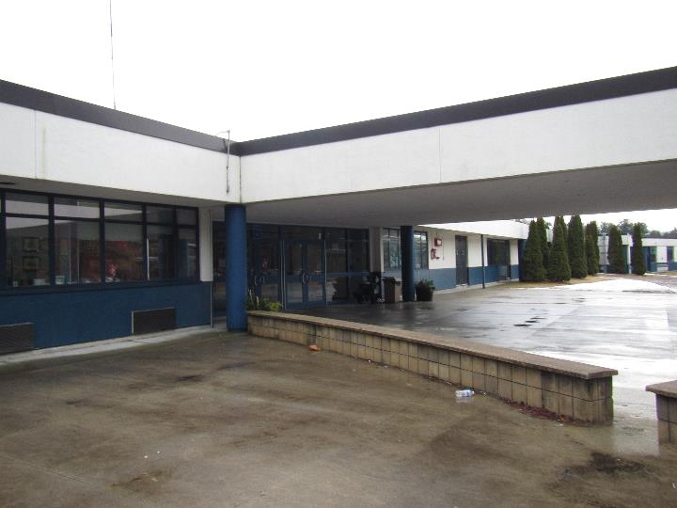

Prepared by:
Massachusetts Department of Public Health
Bureau of Environmental Health
Indoor Air Quality Program
February 2019

BACKGROUND
Building: | Wayland Middle School (WMS)
Address: | 201 Main Street, Wayland, MA
Assessment Requested by: | Susan Bottan, Director of Finance & Operations, Wayland Public Schools
Reason for Request: | Health concerns relating to indoor air quality (IAQ)
Date of Assessment: | February 8, 2019
Massachusetts Department of Public Health/Bureau of Environmental Health (MDPH/BEH) Staff Conducting Assessment: | Ruth Alfasso, Environmental Engineer/Inspector, and Jason Dustin, Environmental Analyst/Inspector, IAQ Program
Building Description: | The WMS is a single-story building originally built in 1972. The building was renovated in 1994 and a new wing on the northeast side of the building was added around 2000.
Windows: | Openable

METHODS
Please refer to the IAQ Manual and appendices for methods, sampling procedures, and interpretation of results (MDPH, 2015).

RESULTS and DISCUSSION
The following is a summary of indoor air testing results (Table 1).
- Carbon dioxide levels were above the MDPH recommended level of 800 parts per million (ppm) in over half of the areas surveyed, which indicates a lack of air exchange in many classrooms at the time of assessment.
- Temperature was within or close to the lower end of the MDPH recommended range of 70°F to 78°F in occupied areas.
- Relative humidity was below the MDPH recommended range of 40 to 60% in all but one area tested the day of assessment, which is typical of conditions during the heating season.
- Carbon monoxide levels were non-detectable (ND) in all areas tested.
- Particulate matter (PM2.5) concentrations measured were below the National Ambient Air Quality (NAAQS) level of 35 μg/m³ in all areas tested.

Ventilation
A heating, ventilating and air conditioning (HVAC) system has several functions. First it provides heating and, if equipped, cooling. Second, it is a source of fresh air. Finally, an HVAC system will dilute and remove normally-occurring indoor environmental pollutants by not only introducing fresh air, but by filtering the airstream and ejecting stale air to the outdoors via exhaust ventilation. Even if an HVAC system is operating as designed, point sources of respiratory irritation may exist and cause symptoms in sensitive individuals.
Fresh air in most classrooms is supplied by unit ventilators (univents, Picture 1). Univents draw air from the outdoors through a fresh air intake located on the exterior wall of the building (Picture 2) and return air through an air intake located at the base of the unit. Fresh and return air are mixed, filtered, heated or cooled and provided to rooms through an air diffuser located in the top of the unit (Figure 1). Most of the univents present in the WMS have a non-standard design where a portion of the unit also functions as exhaust for the room.
In some rooms the top and/or front of some univents were blocked by classroom items (Picture 3). In order for univents to provide fresh air as designed, intakes/returns must remain free of obstructions. Importantly, these units must remain on and be allowed to operate while rooms are occupied. It is also important to note that outside air is typically limited (by adjusting intake louvers) during cold/winter months to provide comfort and prevent the freezing of pipes.
Rooftop air handling units (AHU) supply fresh air and exhaust for some classrooms and common areas. In some areas, exhaust vents did not appear to be drawing air. This may be due to settings on the HVAC system or due to broken motors or belts. Lack of exhaust ventilation, particularly in areas where pollutants may be generated such as bathrooms, can allow odors, moisture and pollutants to build up.
To maximize air exchange, the IAQ program recommends that both supply and exhaust ventilation operate continuously during periods of occupancy. In order to have proper ventilation with a mechanical ventilation system, the systems must be balanced after installation to provide an adequate amount of fresh air to the interior of a room while removing stale air from the room. It is recommended that HVAC systems be re-balanced every five years to ensure adequate air systems function (SMACNA, 1994).
It is important to note that univents in the older areas of the building are over 40 years old. Efficient function of equipment of this age is difficult to maintain, since compatible replacement parts are often unavailable. According to the American Society of Heating, Refrigeration and Air-Conditioning Engineering (ASHRAE), the service life for the various components of the HVAC system is between 20 to 30 years, assuming routine maintenance of the equipment (ASHRAE, 1991).

Microbial/Moisture Concerns
Water-damaged ceilings/tiles were observed in many areas (Pictures 4 and 5). Some of these were attributed to roof leaks. Portions of the roof were repaired recently, so some of these water-damaged tiles are historic. There were, however, a few active leaks, including an area in the hallway next to the art room where a ceiling tile was removed and water was being collected in a small bucket (Picture 6). Other water-damaged ceiling tiles were due to leaks from ceiling-mounted unit ventilators. These leaks typically occur due to improperly insulated cooling lines or clogs/over flows in the drain pans or lines. Water-damaged ceiling tiles can provide a source of mold and should be replaced after a water leak is discovered and repaired. Any receptacles used to collect water from leaks should be monitored, emptied, and cleaned regularly to prevent overflow and stagnant water. Replacement ceiling tiles that act as funnels to direct water into a receptacle can be used to collect water and prevent spills from damaging floors or creating slippery conditions.
Plants were present in some classrooms and other areas, including some on top of univents (Pictures 7 and 8). Plants should be well maintained, not overwatered, and not placed on porous materials or in the airstream of ventilation equipment. There is a small greenhouse area built into a window to the courtyard (Picture 9). This area needs to be consistently maintained to prevent odors and pests. An aquarium was found in one room (Table 1). Aquariums should also be kept in good condition to prevent odors.
Sinks are present in some classrooms and storage areas. Some sinks have gaps in the backsplash which can lead to water damage and microbial growth in the material of the cabinet (Table 1). Backsplash gaps should be sealed or replaced with a one-piece unit. Some had large amounts of material stored underneath, including porous materials (Picture 10). The area under sinks is a damp environment and should be kept clear of porous items which may become mold-colonized. A few sinks were blocked off in some science prep/storage rooms. Sinks that are not used regularly can have the drain traps dry out, which can allow sewer odors into the building. This may also occur in other seldom used sinks and other drains such as the locker rooms. Drains should either be moistened periodically to maintain the trap seal, or be capped to prevent the infiltration of sewer odor/gases into occupied areas.
Refrigerators and water dispensers were located in carpeted areas (Picture 11; Table 1). These appliances can be a source of leaks or spills which can moisten carpeting and lead to microbial growth. Refrigerators should be kept clean and free from spills and spoiled food that can lead to odors.
The exterior of the building was examined for conditions that may lead to water infiltration or other IAQ concerns. A few of the doors to the exterior had light visible around them (Picture 12) which indicates that weather-stripping needs to be added or replaced to prevent moisture and pests from entering the building. It was raining on the morning of the assessment and there was water dripping down the side of the building in a few areas (Pictures 13 and 14), indicating that gutters or drains are not functioning completely. One downspout ended at the foundation of the building (Picture 15); this should be extended to drain water away from the building.
The exterior of the building is clad in a lightweight material that looks like stucco, which is likely part of an Exterior Insulation and Finish System (EIFS). Reportedly, there is a layer of insulation underneath this material, but it is not known if there’s a drainage layer as well. Portions of this material are damaged (Picture 14 and 16) due to weather and student activity. Damaged cladding can allow moisture to penetrate the building envelope.
In a few areas, including the courtyard, plants are near or against the exterior of the building (Picture 17). Plants can prevent the building from drying which may lead to damage, and plant roots may damage building foundations. Plants should be trimmed or removed to five feet away from the building.

Other Conditions
Exposure to low levels of total volatile organic compounds (TVOCs) may produce eye, nose, throat, and/or respiratory irritation in some sensitive individuals. BEH/IAQ staff examined rooms for products containing VOCs. BEH/IAQ staff noted hand sanitizers, scented products, cleaners, and dry erase materials in use within the building (Picture 18; Table 1). These products have the potential to be irritants to the eyes, nose, throat, and respiratory system of sensitive individuals.
There are copy machines, laminators and 3-D printers in the building which can produce waste heat and irritating odors. VOCs and ozone can be produced by photocopiers, particularly if the equipment is older and in frequent use. Ozone is a respiratory irritant (Schmidt Etkin, D., 1992).
There is a wood shop in the school. Some of the wood-cutting equipment has dedicated exhaust ventilation that goes to a wood-chip/sawdust collection system located outside the building (Pictures 19 and 20). This system needs to be used consistently and maintained/emptied regularly. In addition, the build-up of wood chips inside the wood shop needs to be regularly removed using a dedicated vacuum, preferably one equipped with a high efficiency particulate arrestance (HEPA) filter to prevent aerosolization of wood dust. Wet wiping of surfaces to remove dust should also be conducted. Wood shop doors should also be kept closed to prevent shavings/dust from being carried into other occupied areas.
There is a kiln located in a section of the art room. This unit is electrically-fired and has a dedicated exhaust vent. However, it is not enclosed in a separate room. During use, waste heat and odors/fumes will migrate into the art room. This kiln should be fired only after hours, when the room will be empty for the duration of the firing cycle.
A univent in the 6th grade wing was opened and examined. The filter appeared to be a good quality pleated filter (Picture 21), however it could not be determined what Minimum Efficiency Reporting Value (MERV) rating it had. The MDPH recommends pleated filters with a Minimum Efficiency Reporting Value (MERV) of 8, which are adequate in filtering out pollen and mold spores (ASHRAE, 2012). Filters should also be changed two to four times a year, or per the manufacturer’s recommendations; the WMS staff reported that these are changed 3 or 4 times a year. The filter cabinet examined was also mostly clean and free of dust and debris. Univent cabinets should be vacuumed out periodically during filter changes to remove dust and debris that may cause odors when heated or aerosolized. Also note that the univent fresh air vents on the outside of the building need to be cleaned periodically to prevent the build-up of debris that can reduce effectiveness and cause odors to be drawn into classrooms. Some of these vents also were missing screens, which are required to exclude pests (Picture 22).
Since these univents also provide cooling, they have condensation collection pans and drainage piping as well. The pans and drains need to be kept free of debris that may allow microbial growth when moistened and clogs that may lead to leaks.
In many areas, supply vents, exhaust vents and personal fans were dusty (Picture 23; Table 1). This dust can be reaerosolized under certain conditions, and can also be a medium for mold growth.
Many areas of the school, including hallways and classrooms, are carpeted. Carpeting is not recommended for high traffic or instructional areas of schools because it can be hard to keep clean, and may become a source of odors and mold if it gets wet. Carpeting is not recommended in areas subject to chronic moisture/condensation. In addition, carpeting in schools has a service life of approximately 10-11 years (IICRC, 2002).). Carpeting that is beyond its service life becomes increasingly difficult to clean and may release fibers which can be irritating if airborne. School staff reported that some carpeting in the school has already been removed and there is a program plan to remove and replace all the carpeting in classrooms and hallways over the next several years.
Carpets should be cleaned annually (or semi-annually in soiled/high traffic areas) in accordance with Institute of Inspection, Cleaning and Restoration Certification (IICRC) recommendations, (IICRC, 2012). Regular cleaning with a high efficiency particulate air (HEPA) filtered vacuum in combination with an annual cleaning will help to reduce accumulation and potential aerosolization of materials from carpeting. Area rugs were also observed in a few classrooms (Table 1). Area carpets too worn to be effectively cleaned should be replaced. Area rugs should be rolled up and stored in a clean, dry place when rooms are not occupied during the summer months to prevent moistening due to condensation.
In many classrooms and particularly in storage areas, large numbers of items were on floors, windowsills, tabletops, counters, bookcases and desks, which provide a source for dusts to accumulate (Pictures 3 and 24). These items (e.g., papers, folders, boxes) make it difficult for custodial staff to clean. Items should be relocated and/or be cleaned periodically to avoid excessive dust build up and associated irritation.
Note that the Environmental Protection Agency (EPA) conducted a National School Radon Survey in which it discovered nearly one in five schools had “…at least one frequently occupied ground contact room with short-term radon levels above 4 [picocuries per liter] pCi/L” (US EPA 1993). The BEH/IAQ Program therefore recommends that every school be tested for radon, and that this testing be conducted during the heating season while school is in session in a manner consistent with USEPA radon testing guidelines. Radon measurement specialists and other information can be found at www.nrsb.org and http://aarst-nrpp.com/wp, with additional information at: http://www.mass.gov/eohhs/gov/departments/dph/programs/environmental-health/exposure-topics/iaq/radon.

RECOMMENDATIONS
In view of the findings at the time of the visit, the following recommendations are made:
- Operate the HVAC system to provide for continuous fresh air ventilation during occupied hours.
- Remove furniture and items blocking the front and top of univents.
- Periodically assess whether exhaust vents (classrooms and restrooms) are drawing air and repair as needed.
- Use openable windows to supplement fresh air during temperate weather. Ensure all windows are closed tightly at the end of each day. Do not open windows when the air conditioning is in use to reduce the potential for condensation on chilled surfaces.
- Work with staff to troubleshoot temperature control problems.
- Utilize a system to report and track maintenance issues so that concerns can be reported by staff and maintenance staff can report when issues have been resolved.
- Consider adopting a balancing schedule of every 5 years for all mechanical ventilation systems, as recommended by ventilation industrial standards (SMACNA, 1994).
- For buildings in New England, periods of low relative humidity during the winter are often unavoidable. Therefore, scrupulous cleaning practices should be adopted to minimize common indoor air contaminants whose irritant effects can be enhanced when the relative humidity is low. To control for dusts, a high efficiency particulate arrestance (HEPA) filter equipped vacuum cleaner in conjunction with wet wiping of all surfaces is recommended. Avoid the use of feather dusters. Drinking water during the day can help ease some symptoms associated with a dry environment (throat and sinus irritations).
- Work with a roofing contractor/building engineer to investigate/repair building envelope leaks. Until this has been completed, avoid storing porous materials in areas of known leaks.
- Regularly empty and clean receptacles used for collecting water from leaks.
- Replace water-damaged ceiling tiles and inspect above them to clean/disinfect any additional moistened material.
- Keep plants in good condition, avoid overwatering, and keep them away from the airstream of ventilation equipment. Ensure that the greenhouse shown in Picture 9 is regularly maintained.
- Ensure aquariums are clean and odor free.
- Sinks and other fixtures that are not used regularly should have the drains moistened to ensure the traps function to prevent sewer gas from entering occupied areas. If fixtures are not needed long term, they should be properly sealed or removed and cut/capped.
- Repair sink backsplashes with appropriate sealant or replace. Avoid storing porous items or large amounts of items under sinks.
- Refrigerators and water dispensers should be moved from carpeted areas or placed on a waterproof mat.
- Repair or replace weather-stripping on exterior doors for a tight fit that excludes unconditioned air and pests.
- Repair the gutter system and ensure downspouts direct water away from the building.
- Inspect and repair stucco-like covering on the building to reduce water infiltration and damage.
- Trim back plants from the foundation approximately 5 feet, including in the courtyard.
- Reduce or eliminate the use of air fresheners, scented cleaners, hand sanitizers and dry erase materials to reduce irritation. Consult the MDPH guidance “Clean Air is Odor-Free,” attached as Appendix A, for more information.
- Ensure copy machines, laminators and other appliances are used in areas with adequate ventilation and away from occupants.
- Ensure the wood-chip/sawdust collection system in the wood shop is properly maintained and used consistently. Clean up remaining wood shavings using methods less likely to aerosolize dust, including use of a HEPA-equipped vacuum and wet wiping. Keep wood shop doors to the hallway closed.
- Operate the kiln when the art room is unoccupied and ensure exhaust ventilation is used during the entire kiln cycle to remove waste heat and odors. Avoid storing materials on or near the kiln.
- Continue to change filters in HVAC units at least twice a year with MERV 8 or higher (e.g., MERV 10 in use now) filters. Clean HVAC and univent cabinets of debris and dust when filters are changed.
- Ensure HVAC/uninvent condensation collection pans are regularly cleaned of any scale and debris to prevent overflows or clogged drain lines. Also ensure that cooling lines are properly insulated to prevent water damage due to condensation.
- Clean supply and exhaust vents and fans regularly to remove accumulated dust/debris.
- Ensure that screens are installed on univent fresh air intake vents to prevent pest entry or debris accumulation. Lawn mowers should discharge clippings away from these vents. Consider a crushed stone apron around the perimeter to serve as a buffer zone and aid in drainage.
- Continue with plans to replace carpeting with non-porous flooring. Prioritize areas with heavy foot traffic or moisture concerns (e.g. science storage and food preparation areas) for carpet removal.
- Clean carpeting and rugs at least once per year according to IICRC recommendations (IICRC 2012). Area carpets too worn to be effectively cleaned should be replaced. Roll up and store are rugs in a clean, dry place during the summer.
- Relocate or consider reducing the amount of materials stored in classrooms to allow for more thorough cleaning of classrooms. Plan regular clean-outs to remove and organize items in storerooms, particularly science storage areas. Clean items regularly with a wet cloth or sponge to prevent excessive dust build-up.
- Continue to utilize the US EPA’s (2000), “Tools for Schools”, as an instrument for maintaining a good IAQ environment in the building available at: http://www.epa.gov/iaq/schools/index.html.
- The school should be tested for radon by a certified radon measurement specialist during the heating season when school is in session. Radon measurement specialists and other information can be found at: www.nrsb.org, and http://aarst-nrpp.com/wp.
- Refer to resource manuals and other related IAQ documents for further building-wide evaluations and advice on maintaining public buildings. Copies of these materials are located on the MDPH’s website: http://mass.gov/dph/iaq.

REFERENCES
ASHRAE. 1991. ASHRAE Applications Handbook, Chapter 33 “Owning and Operating Costs”. American Society of Heating, Refrigeration and Air Conditioning Engineers, Atlanta, GA.
ASHRAE. 2012. American Society of Heating, Refrigeration and Air Conditioning Engineers (ASHRAE) Standard 52.2-2012 -- Method of Testing General Ventilation Air-Cleaning Devices for Removal Efficiency by Particle Size (ANSI Approved). 2012.
IICRC. 2002. Institute of Inspection, Cleaning and Restoration Certification. A Life-Cycle Cost Analysis for Floor Coverings in School Facilities.
IICRC. 2012. Institute of Inspection Cleaning and Restoration Certification. Institute of Inspection, Cleaning and Restoration Certification. Carpet Cleaning: FAQ.
MDPH. 2015. Massachusetts Department of Public Health. Indoor Air Quality Manual: Chapters I-III. Available at: http://www.mass.gov/eohhs/gov/departments/dph/programs/environmental-health/exposure-topics/iaq/iaq-manual/.
Schmidt Etkin, D. 1992. Office Furnishings/Equipment & IAQ Health Impacts, Prevention & Mitigation. Cutter Information Corporation, Indoor Air Quality Update, Arlington, MA.
SMACNA. 1994. HVAC Systems Commissioning Manual. 1st ed. Sheet Metal and Air Conditioning Contractors’ National Association, Inc., Chantilly, VA.
US EPA. 1993. Radon Measurement in Schools, Revised Edition. Office of Air and Radiation, Office of Radiation and Indoor Air, Indoor Environments Division (6609J). EPA 402-R-92-014. https://www.epa.gov/sites/production/files/2014-08/documents/radon_measurement_in_schools.pdf
US EPA. 2000. Tools for Schools. Office of Air and Radiation, Office of Radiation and Indoor Air, Indoor Environments Division (6609J). EPA 402-K-95-001, Second Edition. http://www.epa.gov/iaq/schools/index.html.
Picture 1
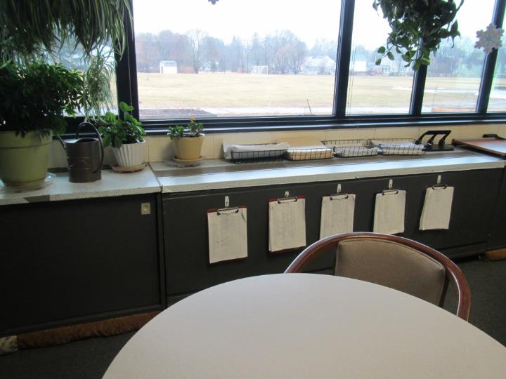
Unit ventilator
Picture 2
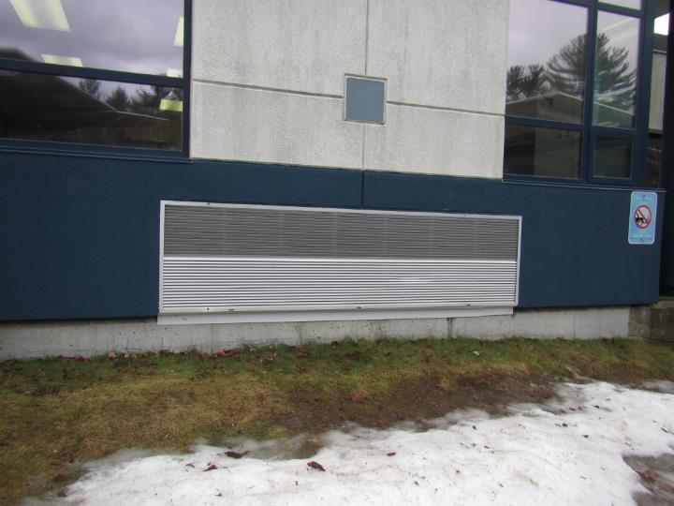
Univent fresh air supply
Picture 3
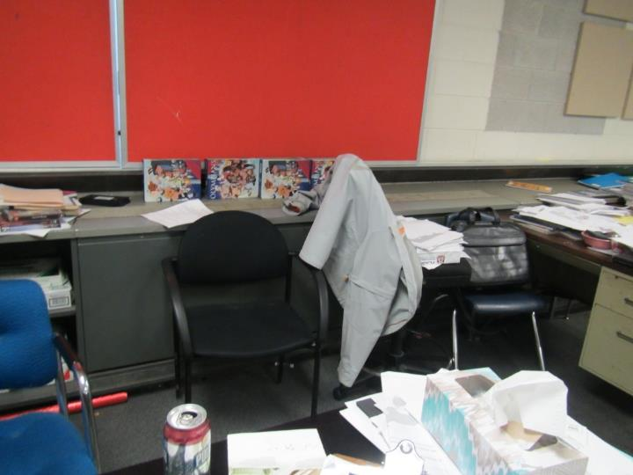
Items and furniture blocking univent
Picture 4
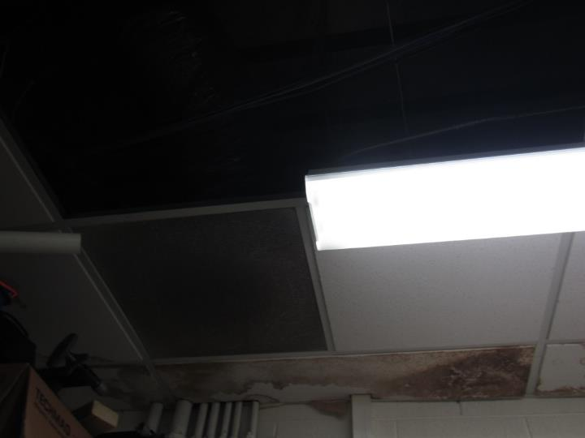
Water-damaged and missing ceiling tiles
Picture 5
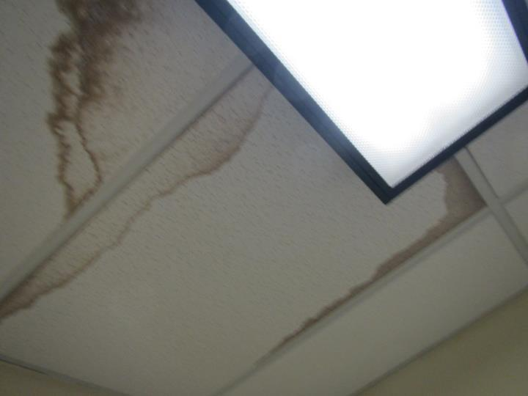
Water-damaged ceiling tiles
Picture 6
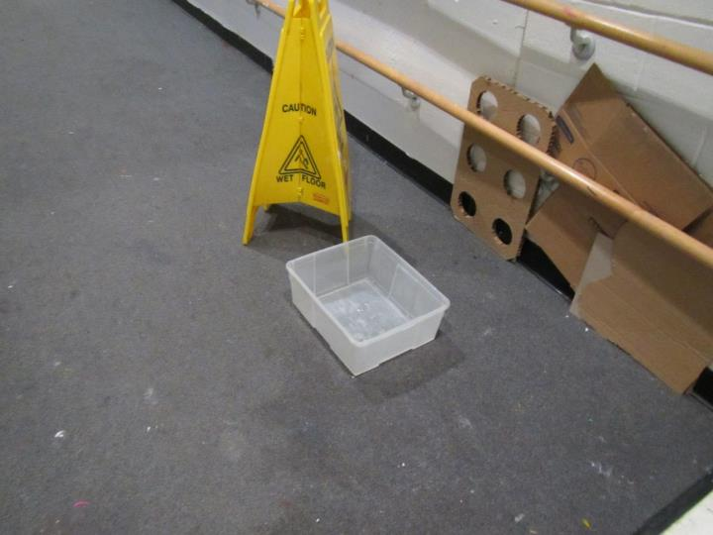
Water collection bucket in hallway near the art room
Picture 7
Classroom plants, including on and over univent
Picture 8
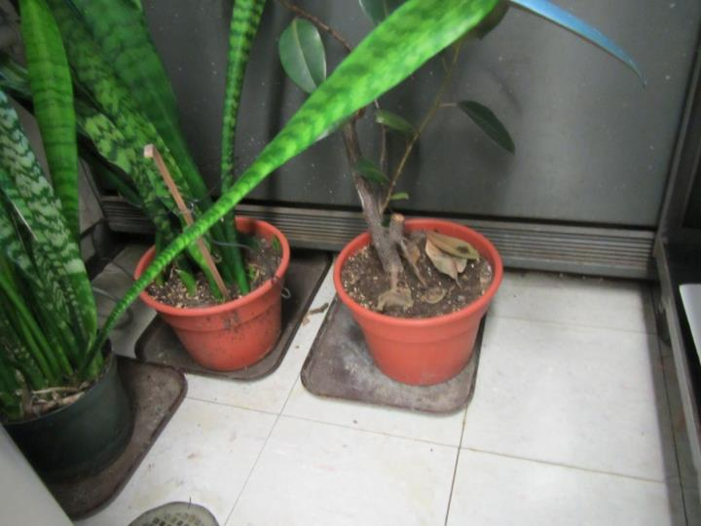
Classroom plants in front of univent, note water stains on trays and dead leaves
Picture 9
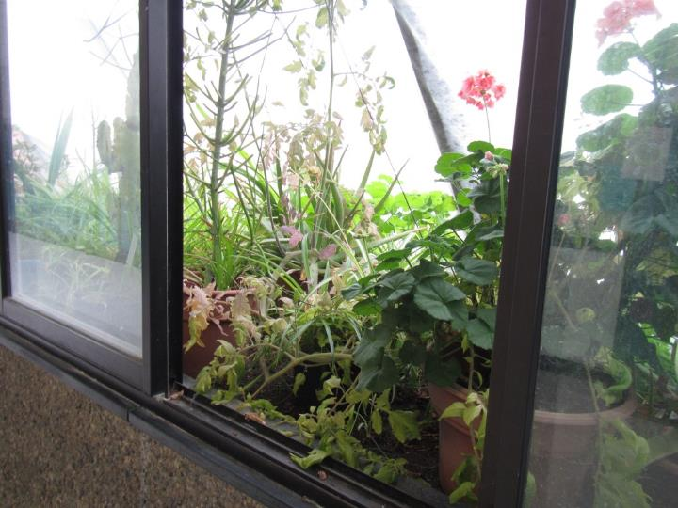
Hallway/courtyard greenhouse
Picture 10
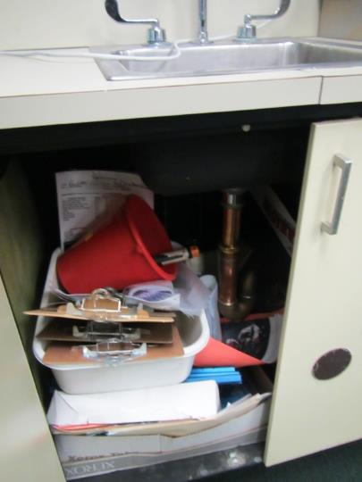
Large amounts of material, including porous items, underneath classroom sink
Picture 11
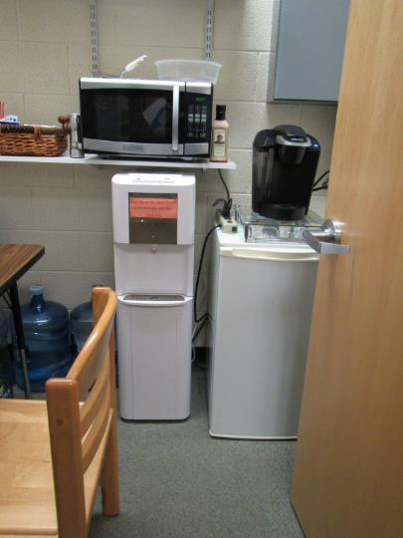
Refrigerator and water dispenser on carpet
Picture 12
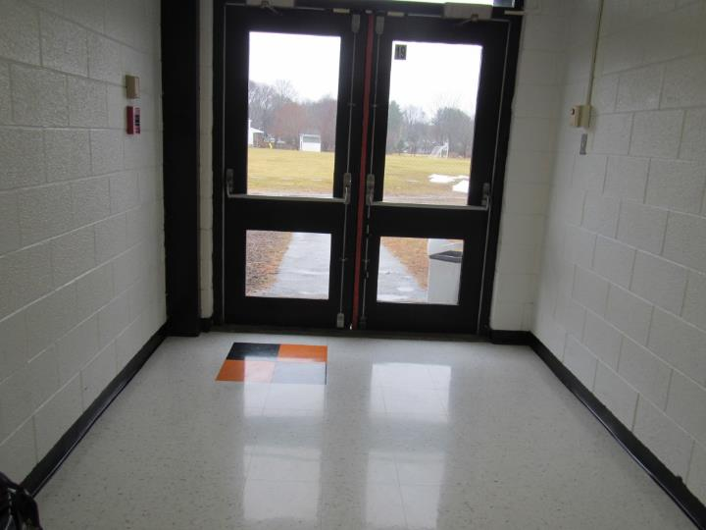
Light visible at bottom of door to the exterior
Picture 13
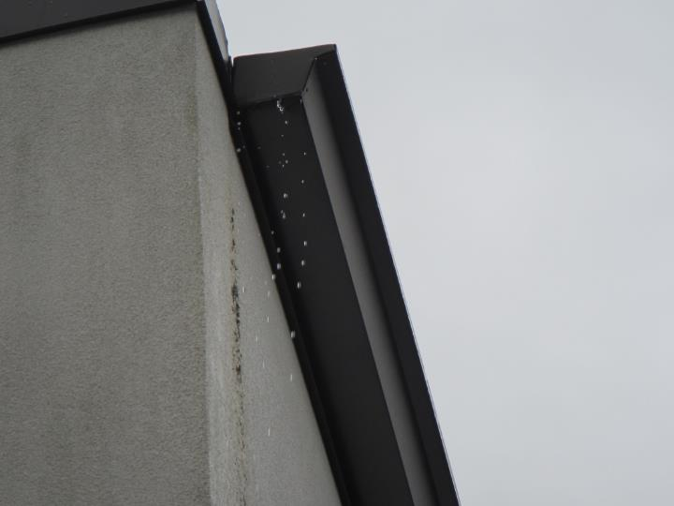
Rainwater dripping from damaged gutter
Picture 14
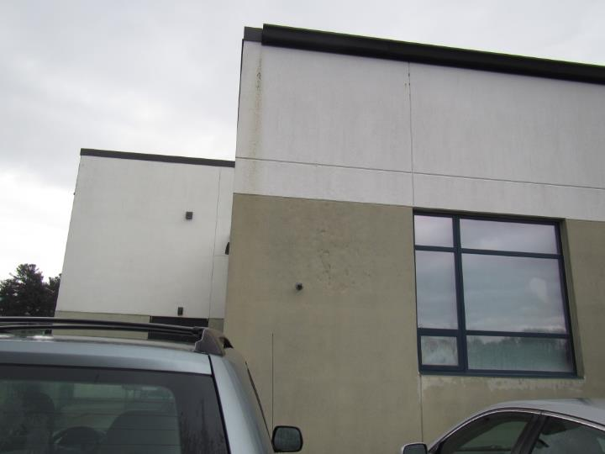
Evidence of water dripping from gutter and damage to exterior cladding
Picture 15
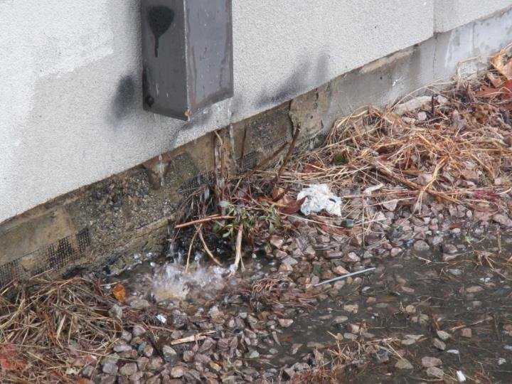
Downspout draining to edge of building/foundation
Picture 16
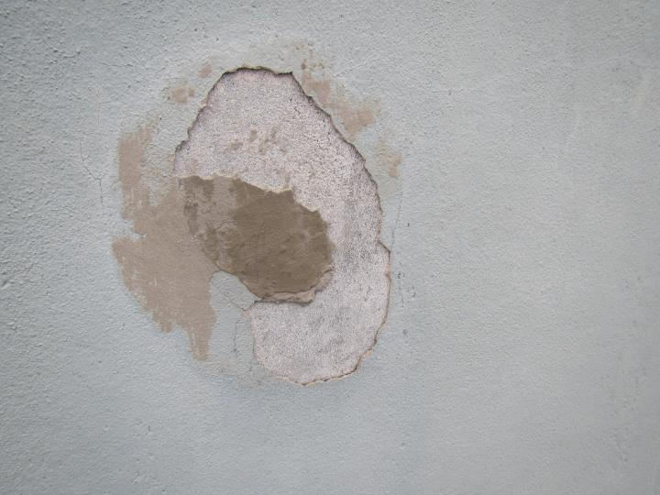
Damage to exterior cladding
Picture 17
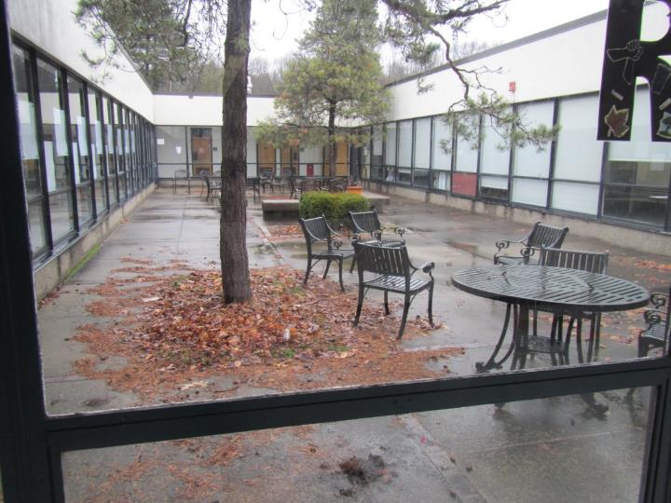
Trees in the courtyard against the building
Picture 18
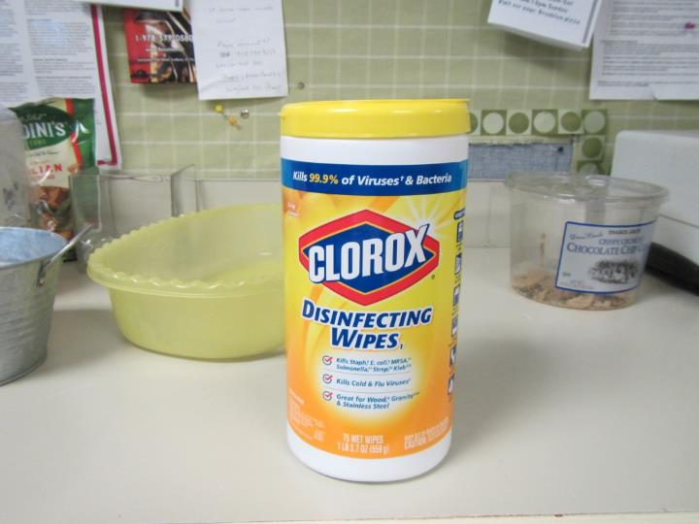
Sanitizing wipes
Picture 19
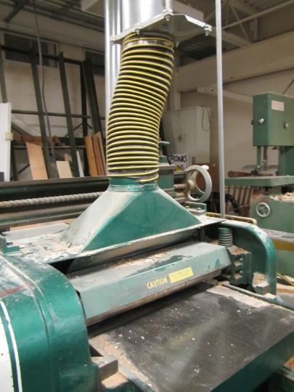
Dedicated equipment exhaust/sawdust collection
Picture 20
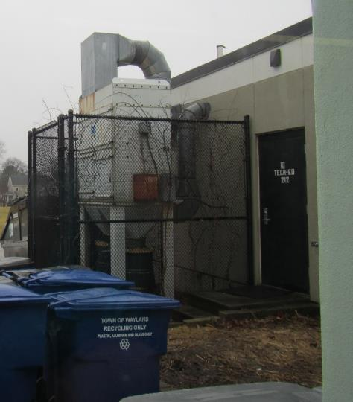
Sawdust collection system outside the building
Picture 21
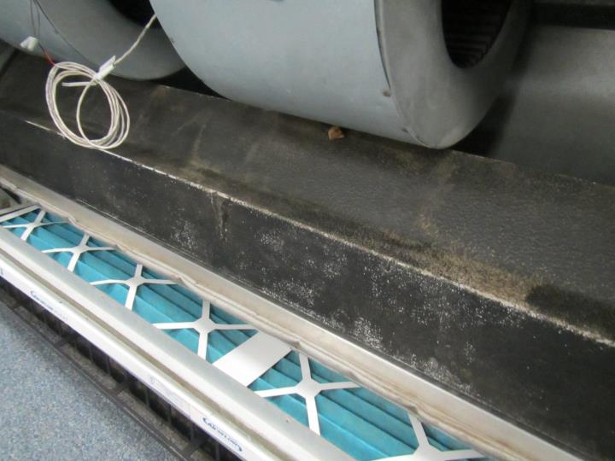
Pleated filter in uninvent
Picture 22
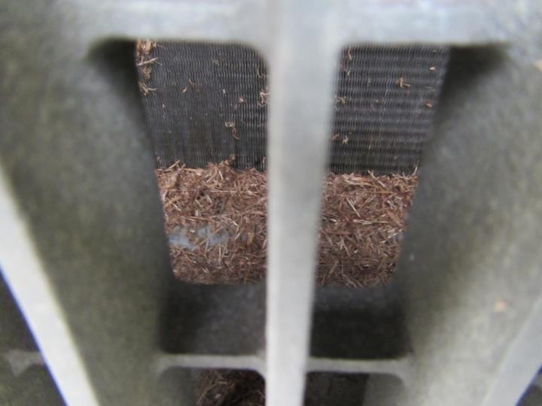
Fresh air intake missing screen (note debris accumulation)
Picture 23
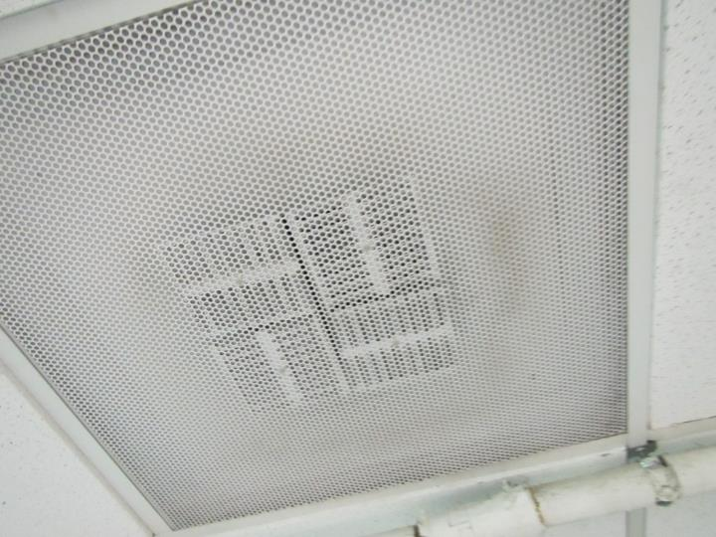
Dusty supply vent
Picture 24
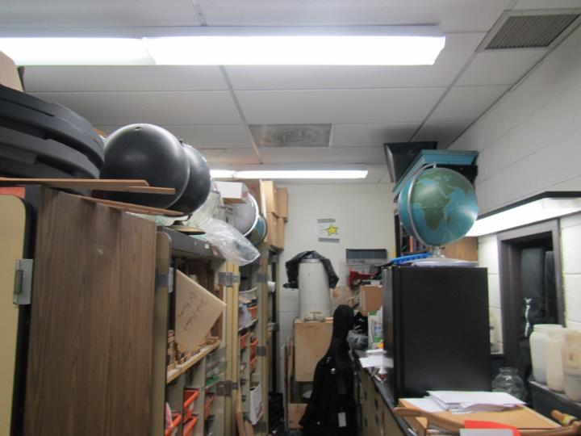
Cluttered storeroom
Location | Carbon  Dioxide  (ppm) | Carbon Monoxide  (ppm) | Temp  (°F) | Relative  Humidity  (%) | PM2.5  (µg/m³) | Occupants  in Room | Windows  Openable | Ventilation |  | Remarks
 |  |  |  |  |  |  |  | Supply | Exhaust
Background (outside) | 472 | ND | 55 | 44 | 20 |  |  |  |  | Rain
Copy room | 627 | ND | 72 | 30 | 4 | 0 | Y | Y | Y | Replacement univent, close to floor
ESL | 828 | ND | 74 | 28 | 2 | 1 | N | Y | Y | DEM, report of odor and previous fridge leak
Auditorium | 811 | ND | 70 | 32 | ND | 0 ( class on stage) | N | Y | Y | Carpet, WD CT
ART | 833 | ND | 71 | 34 | 1 | 12 | N | Y | Y | CF on, kiln (electric),NC, art supplies
CAF stage | 696 | ND | 70 | 32 | 1 | 3 | N | N | N | Instruments, wood floor
Wood shop | 656 | ND | 68 | 33 | 1 | 5 | N |  |  | DEM
Science storage | 824 | ND | 70 | 32 | 2 | 1 | N | Y | Y | Boxes, not on floor, sink, carpet, MT, vent dusty
Office main room | 734 | ND | 71 | 34 | 3 | 3 | N | Y | Y | Plants, WC on carpet
Vice Principal | 802 | ND | 71 | 33 | 2 | 2 | N | Y | Y
Mrs. Greenaway | 841 | ND | 71 | 33 | 3 | 2 | N | Y | Y | Carpet DEM
Library | 731 | ND | 70 | 35 | 7 | 18 | N | Y | Y | Carpet
Library rear | 701 | ND | 71 | 33 | 6 | 5 | N | Y | Y | Carpet
Cafeteria | 739 | ND | 70 | 37 | 8 | 100+ | N | Y | Y
Copy | 571 | ND | 72 | 34 | 7 | 0 | Y | Y | Y | Carpet
Gym 1 | 704 | ND | 71 | 34 | 7 | 20 | N | Y | Y | HVAC off
Gym 2 | 928 | ND | 71 | 36 | 7 | 21 | N | Y | Y | HVAC off
Atrium near area 16 | 1028 | ND | 73 | 34 | 2 | 1 | N | Y | Y | CF, carpet, plants
room 16 | 959 | ND | 75 | 31 | 2 | 16 | Y | Y | Y | Plants, carpet, DEM
101 | 1222 | ND | 72 | 33 | 5 | 16 | Y | Y |  | Plants, DEM, carpet, HS
102 | 1286 | ND | 72 | 33 | 6 | 17 | Y | Y |  | Plants, carpet, DEM, HS
103 | 1138 | ND | 72 | 32 | 9 | 15 | Y | Y |  | Obstructed univent, books, HS, DEM
104 | 1276 | ND | 72 | 32 | 6 | 20 | Y | Y |  | Carpet, DEM, plants, HS, fridge
105 | 1118 | ND | 72 | 33 | 8 | 7 | door | Y | Y | WD CT, books, plush furniture
106 | 1675 | ND | 73 | 38 | 7 | 18 | Y | Y | N | Items on UV, plant, DEM
107 | 1220 | ND | 71 | 33 | 8 | 21 | Y | Y |  | Plants, DEM, carpet, HS
108 | 1071 | ND | 72 | 33 | 6 | 24 | Y | Y |  | DEM, plants, HS, books, fridge
109 | 1055 | ND | 72 | 32 | 4 | 4 | Y door | Y | Y | Carpet, WD CT (1), fridge on carpet, microwave, area rug, dusty vent
110 | 1200 | ND | 73 | 33 | 5 | 22 | Y | Y | Y | UV, carpet, DEM
111 | 1112 | ND | 72 | 32 | 5 | 10 | Y | Y | Y | DEM, Carpet, HS
112 | 1107 | ND | 72 | 32 | 6 | 3 | N | Y | Y | DEM, carpet, door open
113 | 1455 | ND | 72 | 38 | 10 | 14 | N | Y | Y | NC, DEM
114 | 924 | ND | 73 | 37 | 7 | 20+ | Y | Y | Y | HS, CPs, DEM, tile
115 | 947 | ND | 71 | 34 | 3 | 14 | Y | Y | Y | Science sinks, aquarium, safety shower, WD CT
116 | 810 | ND | 70 | 33 | 3 | 20 | Y | Y | Y | Obstructed UV, science sinks, safety shower
117 | 767 | ND | 73 | 35 | 8 | 19 | Y | Y | Y | Tile, DEM, Plants near UV
118 | 774 | ND | 70 | 32 | 2 | 18 | Y | Y | Y | Science sinks, NC, HS, DEM
119 | 522 | ND | 70 | 34 | 15 | 3 | Y | Y | Y | DEM, Plants near UV, carpet
120 | 899 | ND | 71 | 31 | 2 | 19 | Y | Y | Y | Open to atrium, carpet
121 | 1163 | ND | 72 | 38 | 14 | 20 | Y | Y | Y | Carpet, WD CT
123 | 1212 | ND | 75 | 31 | 5 | 6 | Y | Y | Y | plant, DEM, carpet
Atrium near 124 | 779 | ND | 71 | 31 | 2 | 2 | N | Y | Y | CF
124 | 733 | ND | 70 | 34 | 13 | 3 | N | Y | Y | Carpet, WD CTs x 2
126 | 946 | ND | 72 | 32 | 1 | 10 | N | Y | Y | DEM, plant, carpet, dusty vents
128 | 1380 | ND | 72 | 39 | 12 | 19 | N | Y | Y off | Carpet, HS, CPs, historic leaks behind corridor windows
129 | 649 | ND | 71 | 31 | 4 | 4 | Y | Y | Y | Plant
129 inner room 1 | 904 | ND | 73 | 32 | 3 | 0 | N | Y | Y | Carpet, HS, DEM
130 | 813 | ND | 72 | 31 | 3 | 1 | N | Y | Y | DEM, PS, plant, carpet
129 inner room 2 | 622 | ND | 71 | 31 | 3 | 0 | N | Y | Y | Carpet, fridge, microwave
131 | 1097 | ND | 76 | 31 | 1 | 17 | N | Y | Y | CF - on, carpet (worn), HS, dusty vents
129 inner room 3 | 618 | ND | 72 | 31 | 4 | 0 | N | Y | Y | Carpet, fridge, HS
132 | 1231 | ND | 75 | 31 | 11 | 24 | Y | Y | Y | DEM, carpet
133 | 700 | ND | 71 | 37 | 8 | 2 | N | Y | Y | Carpet, DEM, WD CT
134 | 781 | ND | 71 | 34 | 9 | 6 | N | Y | Y | Carpet, WD CTs, pathway
135 | 771 | ND | 71 | 34 | 9 | 11 | N | Y | Y | CPs, HS, MT, WD CTs, carpet
136 | 819 | ND | 71 | 35 | 8 | 1 | N | Y | Y | CPs, carpeting, HS
137 | 945 | ND | 73 | 31 | 5 | 21 | N | Y | Y | Carpet, DEM
138 | 712 | ND | 68 | 38 | 9 | 17 | N | Y | Y | Carpet, DEM, WD CT
140 | 689 | ND | 71 | 33 | 8 | 0 | N | Y | Y | Carpet, DEM
142 | 1150 | ND | 73 | 33 | 3 | 21 | N | Y | Y | Carpet
143 | 848 | ND | 71 | 33 | 4 | 0 | Y |  |  | NC, DEM, sinks (Science room)
144 | 729 | ND | 70 | 35 | 9 | 14 | N | Y | Y | Tile, WD ceiling, CPs
145 | 711 | ND | 71 | 33 | 2 | 3 | Y | Y | Y | NC with area rug, sink (Evidence of previous leak under), DEM
145 interior | 651 | ND | 72 | 32 | 2 | 0 | N | N | Y | 2 WD CT, NC with area rug, DEM
146 | 888 | ND | 69 | 37 | 13 | 0 | N | Y | Y | WD CTs
147 | 749 | ND | 71 | 42 | 2 | 15 | Y | Y | Y | Many plants, fridge on carpet, open to hallway
148 | 1034 | ND | 70 | 37 | 11 | Class just left | Y | Y | Y | Carpet, plants, AI on UV
149 | 699 | ND | 70 | 34 | 2 | 1 | Y | Y | Y | Carpet, DEM, books
150 | 649 | ND | 73 | 29 | 4 | 1, class left half hour | Y | Y | Y | DEM, carpet
213 | 677 | ND | 69 | 36 | ND | 0 | N | Y | Y | Carpet, and area rug, DEM
214 | 882 | ND | 70 | 32 | 5 | 14 | N | Y | Y | Carpet
301 | 1136 | ND | 72 | 32 | 5 | 4 | Y | Y |  | PS, carpet
302 |  |  |  |  |  |  |  |  |  | Science prep room, carpeted, WD CT, items
303 | 887 | ND | 74 | 32 | 6 | 2 | N | Y | Y | Carpet
304 | 933 | ND | 71 | 34 | 2 | 5 | N | Y | Y | Dusty vent, carpet, sink, salt lamp
305 | 750 | ND | 71 | 33 | 3 | 3 | N | Y | Y | WD CT, carpet
307 | 712 | ND | 71 | 32 | 6 | 1 | N | Y | Y | WD CT, old carpet, DEM, plants
308 | 724 | ND | 70 | 33 | 6 | 1 | N | Y | Y | Temperature complaints, carpet, fridge on carpet
311 Main office | 710 | ND | 73 | 34 | 7 | 1 | Y | Y | Y | Carpet, DEM
316 nurse | 897 | ND | 72 | 31 | 3 | 3 | N | Y | Y | Plant
316 hearing/eye test |  |  |  |  |  |  | N | Y | Y | WD CT and dusty vent
319 | 846 | ND | 73 | 31 | 2 | 2 | N | Y | Y
324 science storage | 726 | ND | 71 | 31 | 3 | 0 | N | Y | Y | Carpet, plant
325 | 813 | ND | 69 | 37 | 13 | 0 | N | Y | N | WD CTs, old worn carpet, DEM
326 | 710 | ND | 70 | 35 | 14 | 1 | N | Y | Y | WD CT, pathways, PF, ceiling UV, personal heater
330 | 791 | ND | 71 | 36 | 12 | 5 | N | Y | Y | Carpet, WD CTs, temperature complaints
331 | 842 | ND | 73 | 28 | 2 | 0 | N | N | N | storage items, paper odor, carpet, open to hallway at the top
333 | 794 | ND | 71 | 34 | 10 | 0 | N | Y | Y | WD CT, AI, carpet
337 |  |  |  |  |  |  |  |  |  | WD CT
339 | 586 | ND | 70 | 34 | 1 | 4 | N | Y | Y | Carpet, sinks, backsplash open, items under sink

The service life is the median time during which a particular system or component of …[an HVAC]… system remains in its original service application and then is replaced. Replacement may occur for any reason, including, but not limited to, failure, general obsolescence, reduced reliability, excessive maintenance cost, and changed system requirements due to such influences as building characteristics or energy prices (ASHRAE, 1991).

