INDOOR AIR QUALITY ASSESSMENT

Wayland Middle School
201 Main Street
Wayland, Massachusetts

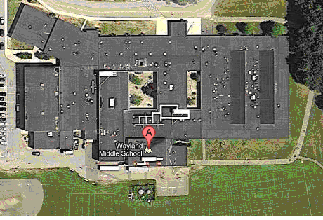

Prepared by:
Massachusetts Department of Public Health
Bureau of Environmental Health
Indoor Air Quality Program
June 2012

Background/Introduction
At the request of the Wayland Board of Health and the Wayland Public Schools (WPS), the Massachusetts Department of Public Health’s (MDPH) Bureau of Environmental Health (BEH) conducted an indoor air quality (IAQ) assessment at the Wayland Middle School (WMS), 201 Main Street, Wayland, Massachusetts. The visit was prompted by concerns relating to IAQ and health in the school. On April 13, 2012, a visit was made to the WMS by Michael Feeney, Director, and Ruth Alfasso, Inspector in BEH’s IAQ program. A previous visit to the WMS was made by the IAQ program in the fall of 1998. A report was issued detailing conditions observed at the time with recommendations to improve IAQ; this report is available by request.
The WMS is a single-story building originally built 1972. The building was renovated in 1994 and a new wing on the northeast side of the building was added around 2000.
The building contains general classrooms, science classrooms, a library, gymnasium and cafeteria. Most classrooms in the building are carpeted and windows in most areas of the school are openable. It was reported that a new roof is planned over the summer of 2012.
WPS hired an environmental testing company (Envirotest) to conduct an IAQ assessment of the WMS on February 29, 2012. Based on their findings, the following recommendations were made:
- close classroom doors;
- keep classroom exhaust vents clear of obstructions;
- clean exhaust grills regularly;
- switch brand of dry erase markers;
- keep classroom unit ventilators free of obstructions;
- standard cleaning product used in the building;
- close door to copier room and increase ventilation;
- open windows;
- prevent bus idling; and
- close classroom windows prior to bus arrival. (Envirotest, 2012).

Methods
Air tests for carbon dioxide, carbon monoxide, temperature and relative humidity were conducted with the TSI, Q-Trak, IAQ Monitor, Model 7565. Air tests for airborne particle matter with a diameter less than 2.5 micrometers were taken with the TSI, DUSTTRAK™ Aerosol Monitor Model 8520. Air monitoring for total volatile organic compounds (TVOCs) was conducted with a MiniRAE 2000 photoionization detector.

Results
The school houses approximately 630 students in grades 6-8 and has approximately 80 staff members. Tests were taken during normal operations, and results appear in Table 1.

Discussion

Ventilation
It can be seen from Table 1 that carbon dioxide levels were above 800 parts per million (ppm) in 19 of 75 areas tested, indicating acceptable air exchange in most of the building at the time of the assessment. In some areas, ventilation equipment was found deactivated, therefore no means of mechanical ventilation was being provided to these areas at the time of testing. It is also important to note that several areas had open windows or were empty/sparsely populated, which can greatly reduce carbon dioxide levels. Carbon dioxide levels would be expected to increase with higher occupancy and windows closed.
Fresh air to classrooms and other areas is supplied by a combination of unit ventilator (univent) systems (Picture 1), ceiling-mounted air-handling units (AHUs) and rooftop AHUs. A univent draws air from the outdoors through a fresh air intake located on the exterior wall of the building (Picture 2). Return air from the classroom is drawn through an air intake located at the base of the unit (Figure 1). Fresh and return air are mixed, filtered, heated or cooled and provided to classrooms through an air diffuser located in the top of the unit. The univents in WMS are atypical in that they are equipped with cooling coils for air conditioning as well as heating coils for heat. As mentioned, univents were found deactivated in some rooms at the time of assessment (Table 1) and several others were found obstructed by furniture and other items on top of air diffusers and/or in front of return vents along the bottom of the units (Picture 3). In order for univents to provide fresh air as designed, they must remain “on” and operating while rooms are occupied. Furthermore, units must remain free of obstructions.
The ceiling-mounted AHUs (Picture 4) supply conditioned air to classrooms from vents on the roof. For rooms supplied by rooftop AHUs, fresh air is brought in through ceiling-mounted diffusers (Picture 5).
Exhaust ventilation for classrooms is provided by wall or ceiling-mounted exhaust vents ducted to rooftop motors (Picture 6). At the time of the assessment, some exhaust ventilation was not operating. As with supply ventilation, in order to function properly, exhaust vents must be activated and allowed to operate while rooms are occupied. Without adequate supply and exhaust ventilation, excess heat and environmental pollutants can accumulate, leading to indoor air/comfort complaints.
Of note is the configuration of the medical office suite, which consists of an office/rest area (Room 316), an exam room and a storage closet (Room 318). Room 318 was converted into a separate rest area, with the supplies formerly stored in this area moved into the examination room. In the current configuration, the examination room contains a fresh air supply, but no exhaust vent. Odors and other pollutants that may be emitted from stored material are then directed into the office/rest area return vent over the nurse’s desk. Room 318 is a converted storage closet which contains a separate exhaust vent which would remove odors from stored materials. If room 318 will continue to be used as a rest area, consider adding additional exhaust ventilation or moving the existing exhaust vent to better serve this area.
To maximize air exchange, the MDPH recommends that both supply and exhaust ventilation operate continuously during periods of occupancy. In order to have proper ventilation with a mechanical supply and exhaust system, the systems must be balanced to provide an adequate amount of fresh air to the interior of a room while removing stale air from the room. It is recommended that heating, ventilation and air conditioning (HVAC) systems be re-balanced every five years to ensure adequate air systems function (SMACNA, 1994). The date of the last balancing of these systems was not available at the time of the assessment.
The Massachusetts Building Code requires a minimum ventilation rate of 15 cubic feet per minute (cfm) per occupant of fresh outside air or have openable windows in each room (SBBRS, 1997; BOCA, 1993). The ventilation must be on at all times that the room is occupied. Providing adequate fresh air ventilation with open windows and maintaining the temperature in the comfort range during the cold weather season is impractical. Mechanical ventilation is usually required to provide adequate fresh air ventilation.
Carbon dioxide is not a problem in and of itself. It is used as an indicator of the adequacy of the fresh air ventilation. As carbon dioxide levels rise, it indicates that the ventilating system is malfunctioning or the design occupancy of the room is being exceeded. When this happens, a buildup of common indoor air pollutants can occur, leading to discomfort or health complaints. The Occupational Safety and Health Administration (OSHA) standard for carbon dioxide is 5,000 parts per million parts of air (ppm). Workers may be exposed to this level for 40 hours/week, based on a time-weighted average (OSHA, 1997).
The MDPH uses a guideline of 800 ppm for publicly occupied buildings. A guideline of 600 ppm or less is preferred in schools due to the fact that the majority of occupants are young and considered to be a more sensitive population in the evaluation of environmental health status. Inadequate ventilation and/or elevated temperatures are major causes of complaints such as respiratory, eye, nose and throat irritation, lethargy and headaches. For more information concerning carbon dioxide, consult Appendix A.
Temperatures ranged from 69 °F to 76 °F, which were within or very close to the MDPH recommended range in all areas surveyed (Table 1). The MDPH recommends that indoor air temperatures be maintained in a range of 70 °F to 78 °F in order to provide for the comfort of building occupants. In many cases concerning indoor air quality, fluctuations of temperature in occupied spaces are typically experienced, even in a building with an adequate fresh air supply. Some classrooms experience solar heat gain and occupants commented that their rooms were too warm. Shades should be used to reduce heat and glare from the sun during warmer months.
Relative humidity measurements in the building ranged from 18 to 33 percent at the time of the assessment, which were below the MDPH recommended comfort range (Table 1). The MDPH recommends a comfort range of 40 to 60 percent for indoor air relative humidity. Relative humidity levels in the building would be expected to drop during the winter months due to heating. The sensation of dryness and irritation is common in a low relative humidity environment. Low relative humidity is a very common problem during the heating season in the northeast part of the United States.

Microbial/Moisture Concerns
A number of areas in the building have water-stained ceiling tiles and plaster (Pictures 4 and 7, Table 1), which stem from roof leaks, plumbing leaks and/or leaks and condensation from air conditioning components. It was noted that some of the ceiling-mounted AHUs have drain pans that are connected to drain pipes with too little pitch (Picture 8). As a result condensation does not drain and may overflow, resulting in moistening of ceiling tiles and other materials below the ceiling mounted units. Water-damaged building materials can provide a source of mold and should be replaced after a water leak is discovered and repaired. It was reported that a new roof for this building is planned for the summer of 2012 which will reduce the opportunity for leaks into the building.
Carpeting in a hallway between Rooms 104-106-112-113 had a significant musty odor (Figure 2; Picture 9). An exterior door with a significant space at its threshold exists in this location, which would allow for unconditioned hot, humid air to enter this hallway and moisten the carpet during summer months. The building is built on a slab foundation, which likely has a temperature that is below the dew point of air in the building during hot, humid weather. During summer months, moist air can penetrate through the door and condense water on the cooler floor, moistening the carpet. If the carpet is repeatedly moistened and not promptly dried, it can become mold-colonized and give off unpleasant odors. Carpeting near doors, especially those that are regularly opened or not tightly sealed, can be moistened by wind-driven rain or through tracking in of water on shoes and clothing. Removal of this carpeting and substitution of tile flooring is recommended.
Refrigerators and other food preparation equipment were also found located on carpet (Picture 10), which can become moistened due to spills or leaks; these items should be moved to uncarpeted areas when possible, or placed on waterproof mats. In general, use of carpeting in school hallways and classrooms is not recommended; additional discussion of this can be found in the “Other Conditions” section below.
The US Environmental Protection Agency (US EPA) and the American Conference of Governmental Industrial Hygienists (ACGIH) recommend that porous materials be dried with fans and heating within 24 to 48 hours of becoming wet (US EPA, 2001; ACGIH, 1989). If not dried within this time frame, mold growth may occur. Once mold has colonized porous materials, they are difficult to clean and should be removed/discarded.
Several classrooms had a number of plants (Picture 11; Table 1). Moistened plant soil and drip pans can serve as a source of mold growth. Plants should also be located away from univents to prevent aerosolization of dirt, pollen or mold.
Sinks were observed in some classrooms. In some cases open or weakly-sealed seams were observed between backsplashes and countertops (Picture 12). If these areas are not made watertight, water can penetrate through the seam, causing water damage to the material under or behind the sink. Water penetration and chronic exposure of porous and wood-based materials can cause these materials to swell and show signs of water damage. A few sinks had porous materials (e.g., paper towels, cloth) stored beneath them (Picture 13). Repeated moistening of these porous materials through condensation or plumbing leaks can result in mold growth. Storage of large amounts of material under the sinks can also prevent rapid detection of leaks.
An aquarium containing a turtle was noted in one of the science classrooms (Picture 14). Aquariums should be properly maintained to prevent microbial/algal growth as they can emit unpleasant odors into the classroom.
The outer envelope of the building was also examined for breaches which may allow entry of water, dusts and pests. Many classrooms have exit doors to the outside, and in some cases the weather-stripping had become worn or the door did not seal tightly allowing light to be seen through the gaps. These gaps can allow water, drafts, particulates and pests into classrooms. Doors should be checked for light penetration, and repaired, including new weather-stripping as needed.

Other IAQ Evaluations
Indoor air quality can be negatively influenced by the presence of respiratory irritants, such as products of combustion. The process of combustion produces a number of pollutants. Common combustion emissions include carbon monoxide, carbon dioxide, water vapor and smoke (fine airborne particle material). Of these materials, exposure to carbon monoxide and particulate matter with a diameter of 2.5 micrometers (μm) or less (PM2.5) can produce immediate, acute health effects upon exposure. To determine whether combustion products were present in the indoor environment, BEH staff obtained measurements for carbon monoxide and PM2.5.

Carbon Monoxide
Carbon monoxide is a by-product of incomplete combustion of organic matter (e.g., gasoline, wood and tobacco). Exposure to carbon monoxide can produce immediate and acute health affects. Several air quality standards have been established to address carbon monoxide and prevent symptoms from exposure to these substances. The MDPH established a corrective action level concerning carbon monoxide in ice skating rinks that use fossil-fueled ice resurfacing equipment. If an operator of an indoor ice rink measures a carbon monoxide level over 30 ppm, taken 20 minutes after resurfacing within a rink, that operator must take actions to reduce carbon monoxide levels (MDPH, 1997).
The American Society of Heating Refrigeration and Air-Conditioning Engineers (ASHRAE) has adopted the National Ambient Air Quality Standards (NAAQS) as one set of criteria for assessing indoor air quality and monitoring of fresh air introduced by HVAC systems (ASHRAE, 1989). The NAAQS are standards established by the US EPA to protect the public health from six criteria pollutants, including carbon monoxide and particulate matter (US EPA, 2006). As recommended by ASHRAE, pollutant levels of fresh air introduced to a building should not exceed the NAAQS levels (ASHRAE, 1989). The NAAQS were adopted by reference in the Building Officials & Code Administrators (BOCA) National Mechanical Code of 1993 (BOCA, 1993), which is now an HVAC standard included in the Massachusetts State Building Code (SBBRS, 1997). According to the NAAQS, carbon monoxide levels in outdoor air should not exceed 9 ppm in an eight-hour average (US EPA, 2006).
Carbon monoxide should not be present in a typical, indoor environment. If it is present, indoor carbon monoxide levels should be less than or equal to outdoor levels. Outdoor carbon monoxide concentrations were non-detect (ND) at the time of the assessment (Table 1). No measureable levels of carbon monoxide were detected in the building during the assessment (Table 1).
There were concerns expressed regarding idling of buses outside the windows and potential impact on IAQ. Since measurements were not taken when buses were present, impacts from idling could not be determined. A Massachusetts state law exists that restricts idling of vehicles to no more than five minutes unless absolutely necessary (MGL, 1986).
It was also noted that the Wayland Department of Public Works (DPW) parking/work lots are located due west of the WMS, with equipment parked approximately 100 feet from the closest area of the school (at the end of the new wing, Figure 2, Picture 15). The DPW parking/work lots appears to be roughly 8-10 feet lower than the level of the fresh air intakes for univents of rooms 101, 102, 107, and 108. Typically, muffler pipes for DPW type of equipment vent exhaust 6-8 feet above ground level. Winds tend to be westerly in New England (Trewartha, G.T., 1943). Exhaust from the DPW parking/work lots may impact on rooms 101, 102, 107, and 108 under westerly, low velocity wind conditions. Consider working with the town to reduce vehicle idling in the location nearest the school, and keeping windows in the classrooms closed when necessary.

Particulate Matter
The US EPA has established NAAQS limits for exposure to particulate matter. Particulate matter is airborne solids that can be irritating to the eyes, nose and throat. The NAAQS originally established exposure limits to particulate matter with a diameter of 10 μm or less (PM10). According to the NAAQS, PM10 levels should not exceed 150 micrograms per cubic meter (μg/m³) in a 24-hour average (US EPA, 2006). These standards were adopted by both ASHRAE and BOCA. Since the issuance of the ASHRAE standard and BOCA Code, US EPA established a more protective standard for fine airborne particles. This more stringent PM2.5 standard requires outdoor air particle levels be maintained below 35 μg/m³ over a 24-hour average (US EPA, 2006). Although both the ASHRAE standard and BOCA Code adopted the PM10 standard for evaluating air quality, MDPH uses the more protective PM2.5 standard for evaluating airborne particulate matter concentrations in the indoor environment.
Outdoor PM2.5 concentrations the day of the assessment were measured at 4 μg/m³. PM2.5 levels measured inside the building ranged from 1 to 9 μg/m³ (Table 1). Both indoor and outdoor PM 2.5 levels were below the NAAQS PM2.5 level of 35 μg/m³. Frequently, indoor air levels of particulates (including PM2.5) can be at higher levels than those measured outdoors. A number of activities that occur indoors and/or mechanical devices can generate particulate during normal operations. Sources of indoor airborne particulates may include but are not limited to particles generated during the operation of fan belts in the HVAC system, use of stoves and/or microwave ovens in kitchen areas; use of photocopiers, fax machines and computer printing devices; operation of an ordinary vacuum cleaner and heavy foot traffic indoors.

Volatile Organic Compounds
Indoor air concentrations can be greatly impacted by the use of products containing volatile organic compounds (VOCs). VOCs are carbon-containing substances that have the ability to evaporate at room temperature. Frequently, exposure to low levels of total VOCs (TVOCs) may produce eye, nose, throat and/or respiratory irritation in some sensitive individuals. For example, chemicals evaporating from a paint can stored at room temperature would most likely contain VOCs.
In an effort to determine whether VOCs were present in the building, air monitoring for TVOCs was conducted. Outdoor air samples were taken for comparison. Outdoor TVOC concentrations the day of the assessment were ND (Table 1). No measurable levels of TVOCs were detected in the building during the assessment.
Cleaning and sanitization products were observed in some rooms (Table 1). These products contain chemicals that can be irritating to the eyes, nose and throat of sensitive individuals. Cleaning products should be properly labeled and stored in an area inaccessible to children. In addition, a Material Safety Data Sheets (MSDS) should be available at a central location for each product in the event of an emergency. Consideration should be given to providing teaching staff with school issued cleaning products and supplies to prevent any potential for adverse chemical interactions between residues left from cleaners used by the facilities staff and those left by cleaners brought in by others.
Located in the work room/copier room are a number of photocopying machines. Of note were two printers (Risograph®), which use a liquid toner. BEH staff obtained the Material Safety Data Sheet (MSDS) for this product (Appendix B). This product contains petroleum distillates, which are VOCs that can be irritants to the eyes, nose and respiratory system. In accordance with the MSDS for this product, exposure to vapors or mist either from heating the Risograph ink or from exposure to it in poorly ventilated areas may cause irritation of the nose and throat, headache and nausea. In addition, the Risographs® are located next to a univent, which will draw in ands heat VOCs produced by this equipment, producing significant odors. Photocopiers can also produce VOCs and ozone, particularly if the equipment is older and in frequent use. VOCs and ozone are respiratory irritants (Schmidt Etkin, 1992). It is recommended that local separate exhaust systems that do not recirculate into the general ventilation system be used.
The majority of classrooms contained dry erase boards and related materials. Materials such as dry erase markers and dry erase board cleaners may contain VOCs, such as methyl isobutyl ketone, n-butyl acetate and butyl-cellusolve (Sanford, 1999), which can be irritating to the eyes, nose and throat. It was reported that the school was in the process of replacing existing dry erase materials with those that emit less VOCs.
In one classroom, chairs were outfitted with tennis balls that had been sliced open and placed on the base of legs. Tennis balls are made of a number of materials that are a source of respiratory irritants. Constant wearing of tennis balls can produce fibers and cause VOCs to off-gas. Tennis balls made with a natural rubber latex bladder become abraded when used as a chair leg pad. Use of tennis balls in this manner may introduce latex dust into the school environment. Some individuals are highly allergic to latex (e.g., spina bifida patients) (SBAA, 2001). It is recommended that the use of materials containing latex be limited in buildings to reduce the likelihood of symptoms in sensitive individuals (NIOSH, 1997).

Other Conditions
As reported by Wayland Board of Health officials, concerns have been raised regarding the WMS being affected by possible pollutants from the former Wayland incinerator site. As reported by Wayland officials, the general location of the former town incinerator was at or near the current Town of Wayland Department of Public Works building near Main Street. The existence of such an impact is highly unlikely due to the following:
- The DPW building is located downgradient from the school. Groundwater around the school would tend to flow downhill, away from the school building. Groundwater flow away from the school will tend to limit flooding in this building, in turn limiting any impact of contaminated groundwater on this building.
- The DPW site is entirely covered by either grass or tarmac which covers any possible ground particle source. It is common, accepted practice to cover possible ground contamination with tarmac and/or grass.
- The WMS is built on a slab with no below-grade sections which could be affected by groundwater.
- BEH staff conducted TVOC testing within the WMS in order to identify if a source chemical vapor existed at the time of the assessment. No measurable levels of TVOCs were detected in the building during the assessment.
Based on these observations and measurements, BEH staff do not believe that pollutants from the former incinerator site have the potential to impact the indoor air quality at the WMS.
Other conditions that can affect indoor air quality were observed during the assessment. The majority of floor surfaces in the school are covered by wall-to-wall carpeting, some of which appears to be original to the building. As noted in the moisture section, some of the carpeting was giving off musty odors due to repeated moistening. The Institute of Inspection, Cleaning and Restoration Certification (IICRC), recommends that carpeting be cleaned annually (or semi-annually in soiled high traffic areas) (IICRC, 2005). Since the average service time of carpeting in a school environment is approximately eleven years (Bishop, 2002), consideration should be given to planning for the replacement of carpeting with new flooring.
The chemistry storage areas were also briefly assessed. Of particular note is that the floor of the storage room was carpeted, making detection and cleanup of spills difficult. General storage of chemicals and items in the chemistry storage area should be reviewed and revised. Appendix C contains guidance on chemical storage and use in schools.
BEH staff observed accumulation of pencil shavings in trays and on tables/floors (Picture 16), and in some cases adjacent to univents. This material can be aerosolized by mechanical ventilation components, air movement from doors opening and closing, and/or foot traffic and may present a respiratory irritant.
A number of fans/blades had accumulated dust/debris. Fans should be cleaned periodically in order to prevent them from serving as a source of aerosolized particulates.
In some classrooms, items were observed on the floors, windowsills, tabletops, counters, bookcases and desks (Picture 17). Items stored in classrooms provide a source for dusts to accumulate. These items (e.g., papers, folders, boxes) make it difficult for custodial staff to clean. Items should be relocated and/or be cleaned periodically to avoid excessive dust build up. In addition, these materials can accumulate on flat surfaces (e.g., desktops, shelving and carpets) in occupied areas and subsequently be re-aerosolized causing further irritation. Similarly, dust/debris from items placed on top of univents can become airborne through movement of the heated air.
Upholstered furniture, plush toys and area carpets were observed in some classrooms (Picture 18; Table 1). Upholstered furniture is covered with fabrics that are exposed to human skin. This type of contact can leave oils, perspiration, hair and skin cells. Dust mites feed upon human skin cells and excrete waste products that contain allergens. In addition, if relative humidity levels increase above 60 percent, dust mites tend to proliferate (US EPA, 1992). In order to remove dust mites and other pollutants, frequent vacuuming of upholstered furniture is recommended (Berry, 1994). It is also recommended that upholstered furniture (if present in schools), be professionally cleaned on an annual basis. Where an excessively dusty environment exists due to outdoor conditions or indoor activities (e.g., renovations), cleaning frequency should be increased (every six months) (IICRC, 2000).

Conclusions/Recommendations
In view of the findings at the time of the visit, the following recommendations are made:
- Implement recommendations made by Envirotest.
- To maximize air exchange, operate existing ventilation equipment continuously throughout the building during periods of school occupancy. Ensure all blockages to supply and exhaust vents are removed. Ensure that exhaust ventilation fans and motors are operational.
- Keep univents free of dust and debris and change filters according to the manufacturer’s specifications.
- Consider modifying either the storage of materials or the supply and exhaust ventilation in the medical office suite (rooms 316 and 318).
- Consider adopting a balancing schedule of every 5 years for all mechanical ventilation systems, as recommended by ventilation industrial standards (SMACNA, 1994).
- Care should be taken to ensure windows are properly closed at night and weekends to avoid the freezing of pipes and potential flooding.
- Use room shades to adjust the amount of sunlight in rooms on sunny days to prevent glare and feelings of excessive heat.
- For buildings in New England, periods of low relative humidity during the winter are often unavoidable. Therefore, scrupulous cleaning practices should be adopted to minimize common indoor air contaminants whose irritant effects can be enhanced when the relative humidity is low. To control for dusts, a high efficiency particulate arrestance (HEPA) filter equipped vacuum cleaner in conjunction with wet wiping of all surfaces is recommended. Avoid the use of feather dusters. Drinking water during the day can help ease some symptoms associated with a dry environment (throat and sinus irritations).
- Replace the roof as planned and replace any missing/water-damaged ceiling tiles and make repairs to water-damaged plaster and other building materials once the roof work is completed.
- Assess carpeting in areas subject to moistening, such as in hallways near doors and prioritize water-damaged carpeting for replacement. Consider installing tile flooring in hallways and classrooms when possible, particularly in areas such right inside of exterior doors, science storage and where food is stored, prepared and eaten.
- Consider relocating refrigerators to areas with tile floors, or use impermeable mats to contain potential spills or leaks.
- Seal breaches between sink countertops and backsplashes to prevent water damage. Avoid storage of porous/excess materials under sinks.
- Seal around doors with weather-stripping or duct tape. Check for air-tightness by monitoring for light and/or drafts around door.
- Continue to work with bus operators and visitors to the facility to reduce idling of vehicles outside the school. Consider working with the Wayland DPW to reduce vehicle idling from their lots adjacent to the school. Close windows when idling vehicles can’t be avoided. The Massachusetts Department of Environmental Protection promulgated regulations based on this law and offer additional information on their website at http://www.mass.gov/dep/air/community/schbusir.htm to help schools comply.
- Routinely clean pencil shaving accumulations.
- Store cleaning products properly and out of reach of students. All cleaning products used at the facility should be approved by the school department with MSDS’ available at a central location. Consider providing staff with school-issued cleaning products.
- It is highly recommended that a thorough inventory of chemicals in the science department be done on a regular basis to assess chemical storage and disposal in an appropriate manner consistent with Massachusetts hazardous waste laws.
- Consider replacing tennis balls with latex-free tennis balls or glides.
- Routinely clean accumulated dust and debris periodically from the surface of supply and exhaust vents and blades of personal fans.
- Since the average service time of carpeting in a school environment is approximately eleven years (Bishop, 2002), consideration should be given to planning for the replacement of carpeting with new flooring.
- When possible, remove carpeting from high traffic areas such as hallways and classrooms. Special focus should be on water-damaged carpeting near exit doors and carpeting in science storage areas. Replace with tile flooring.
- Clean carpeting annually or semi-annually in soiled high traffic areas as per the recommendations of the Institute of Inspection, Cleaning and Restoration Certification (IICRC). Copies of the IICRC fact sheet can be downloaded at: http://www.certifiedcleaners.org/faq.shtml
- Clean plush toys, upholstered furniture and area rugs frequently to remove dust and dust mites. Consider purchasing new area rugs to replace those brought in from outside.
- Relocate or consider reducing the amount of materials stored in classrooms to allow for more thorough cleaning of classrooms. Clean items regularly with a wet cloth or sponge to prevent excessive dust build-up. Use of plastic totes for storage of items not in use will allow for more thorough cleaning.
- Consider adopting the US EPA (2000) document, “Tools for Schools”, to maintain a good indoor air quality environment in the building. This document can be downloaded from the Internet at http://www.epa.gov/iaq/schools/index.html.
- Refer to resource manuals and other related indoor air quality documents for further building-wide evaluations and advice on maintaining public buildings. Copies of these materials are located on the MDPH’s website: http://mass.gov/dph/iaq.

References
ACGIH. 1989. Guidelines for the Assessment of Bioaerosols in the Indoor Environment. American Conference of Governmental Industrial Hygienists, Cincinnati, OH.
ASHRAE. 1989. Ventilation for Acceptable Indoor Air Quality. American Society of Heating, Refrigeration and Air Conditioning Engineers. ANSI/ASHRAE 62-1989.
Berry, M.A. 1994. Protecting the Built Environment: Cleaning for Health. Michael A. Berry, Chapel Hill, NC.
Bishop, J. & Institute of Inspection, Cleaning and Restoration Certification. 2002. A Life Cycle Cost Analysis for Floor Coverings in School Facilities.
BOCA. 1993. The BOCA National Mechanical Code/1993. 8th ed. Building Officials and Code Administrators International, Inc., Country Club Hill, IL.
Envirotest Laboratory. 2012. Air Quality Measurements Wayland Middle School Various Classrooms Wayland MA, 2/29/2012. Envirotest Laboratory, Westwood, MA.
IICRC. 2000. IICRC S001 Reference Guideline for Professional On-Location Cleaning of Textile Floor Covering Materials Institute of Inspection, Cleaning and Restoration Certification. Institute of Inspection Cleaning and Restoration, Vancouver, WA.
IICRC. 2005. Carpet Cleaning FAQ 4 Institute of Inspection, Cleaning and Restoration Certification. Institute of Inspection Cleaning and Restoration, Vancouver, WA.
MGL. 1986. Stopped motor vehicles; Operation of Engine; Time Limit; Penalty. Massachusetts General Laws. M.G.L. c. 90:16A.
MDPH. 1997. Requirements to Maintain Air Quality in Indoor Skating Rinks (State Sanitary Code, Chapter XI). 105 CMR 675.000. Massachusetts Department of Public Health, Boston, MA.
NIOSH. 1997. NIOSH Alert Preventing Allergic Reactions to Natural Rubber latex in the Workplace. National Institute for Occupational Safety and Health, Atlanta, GA.
OSHA. 1997. Limits for Air Contaminants. Occupational Safety and Health Administration. Code of Federal Regulations. 29 C.F.R 1910.1000 Table Z-1-A.
Schmidt Etkin, D. 1992. Office Furnishings/Equipment & IAQ Health Impacts, Prevention & Mitigation. Cutter Information Corporation, Indoor Air Quality Update, Arlington, MA.
Sanford. 1999. Material Safety Data Sheet (MSDS No: 198-17). Expo® Dry Erase Markers Bullet, Chisel, and Ultra Fine Tip. Sanford Corporation. Bellwood, IL.
SBAA. 2001. Latex In the Home And Community Updated Spring 2001. Spina Bifida Association of America, Washington, DC.
SBBRS. 1997. Mechanical Ventilation. State Board of Building Regulations and Standards. Code of Massachusetts Regulations. 780 CMR 1209.0
SMACNA. 1994. HVAC Systems Commissioning Manual. 1st ed. Sheet Metal and Air Conditioning Contractors’ National Association, Inc., Chantilly, VA.
Trewartha, G.T. 1943. An Introduction to Weather and Climate. McGraw-Hill Book Company, New York, NY.
US EPA. 1992. Indoor Biological Pollutants. US Environmental Protection Agency, Environmental Criteria and Assessment Office, Office of Health and Environmental Assessment, research Triangle Park, NC. EPA 600/8-91/202 January 1992.
US EPA. 2000. Tools for Schools. Office of Air and Radiation, Office of Radiation and Indoor Air, Indoor Environments Division (6609J). EPA 402-K-95-001, Second Edition. http://www.epa.gov/iaq/schools/tools4s2.html
US EPA. 2001. “Mold Remediation in Schools and Commercial Buildings”. Office of Air and Radiation, Indoor Environments Division, Washington, DC. EPA 402-K-01-001. March 2001. Available at: http://www.epa.gov/iaq/molds/mold_remediation.html
US EPA. 2006. National Ambient Air Quality Standards (NAAQS). US Environmental Protection Agency, Office of Air Quality Planning and Standards, Washington, DC. http://www.epa.gov/air/criteria.html.

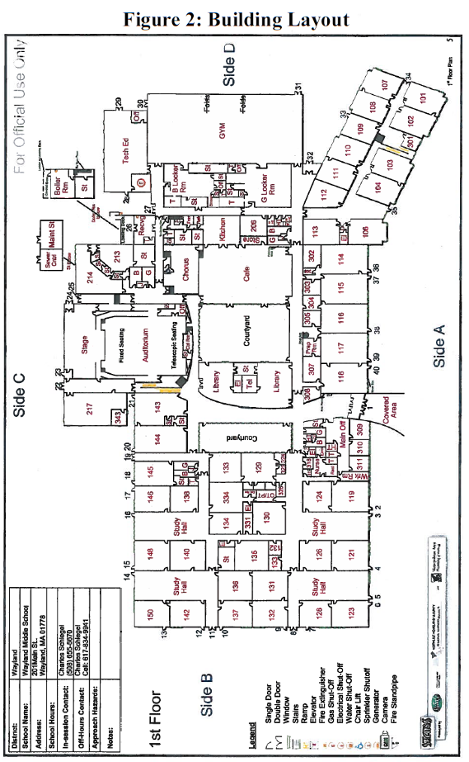
Picture 1

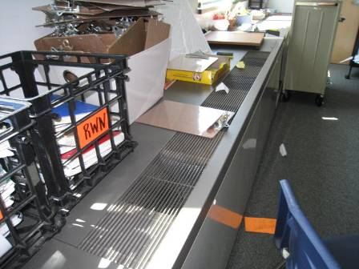

Classroom univent

Picture 2

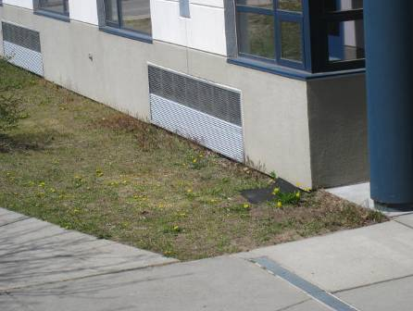

Univent fresh air intake

Picture 3

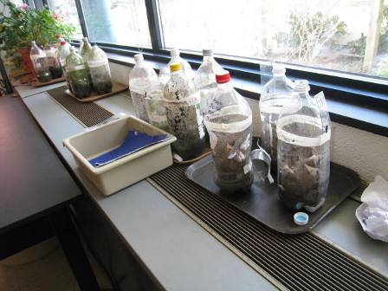

Items on top and in front of univent

Picture 4

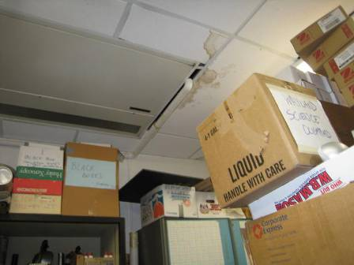

Ceiling-mounted AHU, note water-damaged tiles and stored items

Picture 5

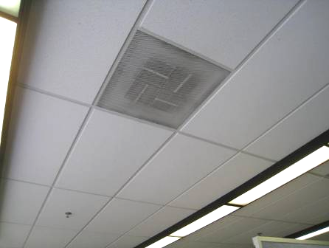

Typical supply vent for areas served by rooftop AHUs

Picture 6

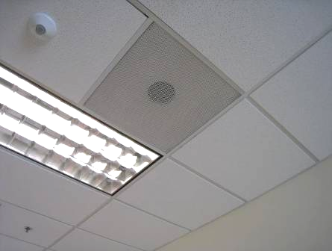

Ceiling-mounted exhaust vent

Picture 7

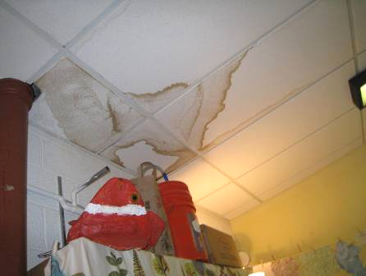

Water-damaged ceiling tiles

Picture 8

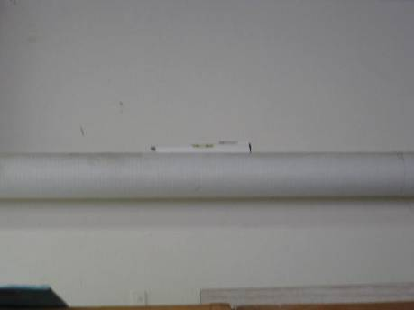

Condensation Drain Pipe with Level, Indicates No Pitch to Pipe

Picture 9

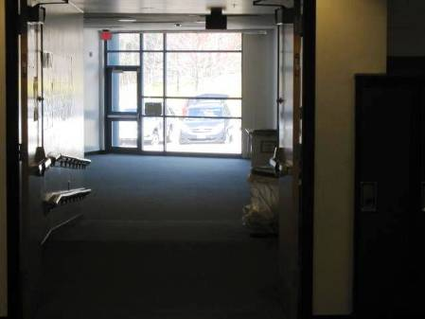

Location of Carpet with Musty Odor in Hallway between Rooms 104, 106, 112 and 113

Picture 10

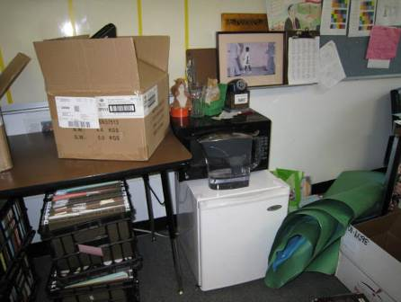

Refrigerator and other food-preparation items on carpet
Picture 11

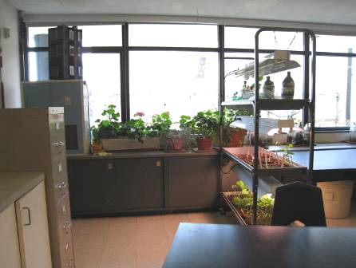

Plants on univent next to air diffuser

Picture 12

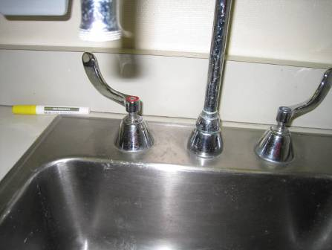

Sink with weakly-sealed backsplash

Picture 13

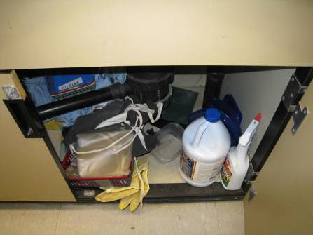
Porous items and cleaning products under sink

Picture 14

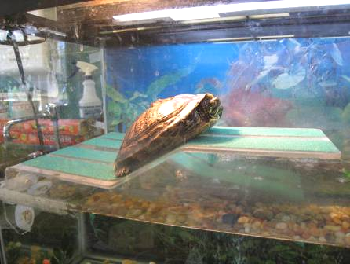

Aquarium with turtle

Picture 15

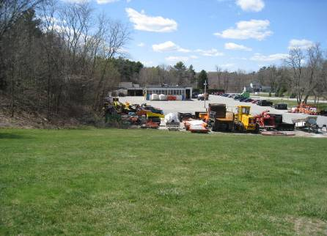

View from schoolyard near new wing of vehicles and diesel-powered equipment
in DPW yard

Picture 16

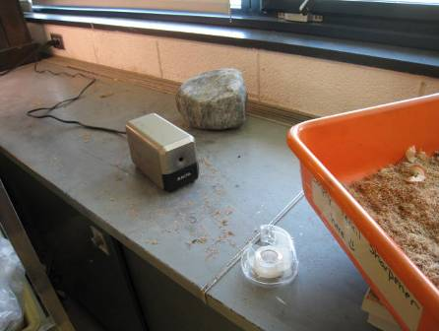

Pencil shavings on counter and bin of pencil shavings (arrow)

Picture 17

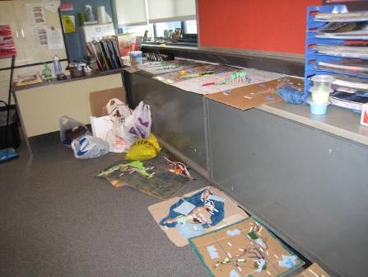

Items stored/displayed in classroom, including on top of univent

Picture 18

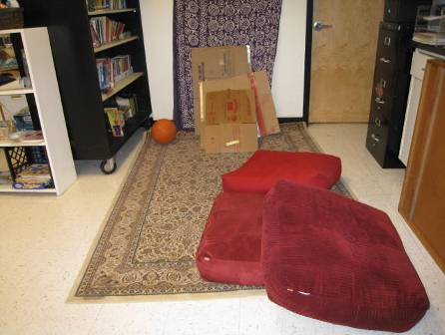

Upholstered pillows and area carpet in classroom
Location | Carbon  Dioxide  (ppm) | Carbon Monoxide  (ppm) | Temp  (°F) | Relative  Humidity  (%) | PM2.5  (µg/m³) | TVOC  (ppm) | Occupants  in Room | Windows  Openable | Ventilation |  | Remarks
 |  |  |  |  |  |  |  |  | Supply | Exhaust | Remarks
Background | 350 | ND | 55 | 50 | 4 | ND |  |  |  |  | Sunny
Applied Science (wood shop) | 512 | ND | 71 | 24 | 3 | ND | 8 | Y | Y | Y | Spray booth
Art | 665 | ND | 74 | 27 | 4 | ND | 13-15 | Y | Y | Y | Art supplies, ceiling fans, DEM, CF, Kiln is not operational
Auditorium (audience area) | 390 | ND | 72 | 21 | 4 | ND | 0 | N | Y | Y
Cafeteria | 570 | ND | 75 | 23 | 5 | ND | 200+ | Y | Y | Y | Door to outside
Gym | 461 | ND | 69 | 27 | 6 | ND | 0 | N | N | Y | DO
Hall end classroom | 737 | ND | 76 | 23 | 4 | ND | 20 | Y | Y | N | Door to outside, fridge, microwave, PS, items on UV, carpet, DEM
Library | 500 | ND | 73 | 22 | 4 | ND | 1 | Y | Y | Y | computers, 1 WD CT, items, fridge, laminator (marked do not use)
Main office | 676 | ND | 72 | 30 | 1 | ND | 5 | N | Y | Y
Science storage/prep |  |  |  |  |  | ND |  |  |  |  | Sci prep area has carpeting, exhaust off, MT
Server room |  |  |  |  |  |  |  |  |  |  | 6 WD CT. Special AC with pumped condensate drains
Staff toilet | 805 | ND | 73 | 26 | 5 | ND | 0 | N | N | Y doesn’t turn on | 1 MT, 4 WD CT, no carpet
Teachers workroom | 937 | ND | 76 | 23 | 3 | ND | 0 | N | Y |  | 3 WD CT, ceiling AHU from roof no AC. Backsplash open
114/115 | 440 | ND | 74 | 18 | 6 | ND | 1 | Y | Y | Y | CP under sink, paper under sink, tile floor, plants, DEM
101 | 1106 | ND | 74 | 28 | 4 | ND | 19 | Y | Y | Y | DEM, boxes in front of UV
102 | 1118 | ND | 75 | 31 | 5 | ND | 17 | Y | Y | Y | UV obstructed by milk crate, DEM
103 | 773 | ND | 76 | 22 | 5 | ND | 24 | Y | Y | Y | DEM, UV blocked
104 | 1108 | ND | 75 | 29 | 7 | ND | 23 | Y | Y | Y | DEM
106 | 1154 | ND | 75 | 27 | 4 | ND | 16 | Y | Y | Y | UV on cool, DEM, carpet, food
107 | 788 | ND | 75 | 27 | 6 | ND | 18 | Y | Y | Y | 1 WD CT, DO
108 | 1400 | ND | 75 | 30 | 5 | ND | 21 | Y | Y | Y | carpet, UV on (loud), PS, DEM, plaints
109 | 874 | ND | 75 | 25 | 3 | ND | gone 10 min | Y | Y | Y | Door to outside, DEM, carpet,
110 | 1389 | ND | 75 | 30 | 9 | ND | 7 | Y | Y | Y | 3 WD CT, UV off, solar gain, carpet, PF, DEM, plants,
111 | 850 | ND | 75 | 22 | 4 | ND | 5 | Y | Y | Y | WD CT, fridge, DO, reportedly warm in room, solar gain, carpeting
112 | 760 | ND | 75 | 23 | 4 | ND | 4 | N | Y | Y | DEM, carpet
113 | 644 | ND | 75 | 21 | 3 | ND | 0 | N | Y | Y | 25 computers, DEM
115 | 505 | ND | 72 | 19 |  | ND | 1 | Y | Y | Y | Aqua, DEM, items, plants, items under sink
116 | 1107 | ND | 76 | 28 | 8 | ND | 20 | Y | Y | Y | Plants near UV, DO
117 | 681 | ND | 76 | 20 | 5 | ND | 21 | Y | Y | Y | Tile floor, Door to outside, items, plants, DEM
118 | 752 | ND | 76 | 22 | 5 | ND | 15 | Y | Y | Y | Plants
119 |  | ND | 70 | 25 | 1 | ND | 5 | Y | Y | Y | DEM
119 Faculty lounge | 351 | ND | 72 | 21 | 3 | ND | 5 | N | Y | Y | plants near UV, fridge, microwave, DEM, sink (backsplash ok), toaster
120 | 491 | ND | 75 | 20 | 3 | ND | 4 | Y | Y | Y | modified hallway classroom, door to outside, UV on low, DEM, plants
121 | 610 | ND | 74 | 20 | 4 | ND | 20 | Y | Y | Y | UV on cool, DEM, door to outside, carpet
124 | 527 | ND | 73 | 23 | 5 | ND | 18 | N | Y | Y | DEM, 2 WD CT, carpet
126 | 653 | ND | 74 | 23 | 3 | ND | 12 | N | Y | Y | 2 WD CT, carpet, DEM, PS, some items, fridge, microwave
128 | 850 | ND |  | 24 |  | ND | 22 | N door to outside | Y | Y | 4 WD CT, carpet, plants, DEM, 2 MT, items, table in front of UV
129 | 680 | ND | 75 | 23 | 2 | ND | 7 | Y | Y | Y | 11 WD CT, dirty CT, DEM, items, carpet, AHU drain pan level, DO
129 left office | 687 | ND | 76 | 22 | 4 | ND | 0 | N | Y | Y | DO, >10 WD CT, carpet, small room
129 right office | 680 | ND | 76 | 23 | 4 | ND | 0 | N | Y |  | carpet, hot water pot, clutter, DO, small room
129 Side room | 713 | ND | 76 |  |  | ND | 2 | N |  |  | 3 WD CT
129 Side room | 865 | ND | 76 |  | 3 | ND | 1 | N | Y | Y | Carpet
130 | 690 | ND | 76 | 22 | 6 | ND | 17 | N | Y | Y | Supply/exhaust near each other, (not near people), items, DEM, carpet, DO
130 | 668 | ND | 76 | 22 | 3 | ND | Left 30 min | Y | Y | Y | UV on loud, DEM, door to outside, PS, carpet is worn
131 | 805 | ND | 75 | 25 | 4 | ND | 21 | N | Y | Y | Carpet, DO, clutter, high ceilings, PS
132 | 850 | ND | 76 | 23 | 5 | ND | 22 | Y open | Y | Y | carpet, items on walls, DEM, UV on door to outside
133 | 678 | ND | 75 | 23 | 3 | ND | 3 | Y | Y | Y | 5 WD CT
134 | 737 | ND | 76 | 24 | 4 | ND | 14 | N | Y | Y | 4 WD CT
135 | 580 | ND | 75 | 22 | 3 | ND | 0 | N | Y | Y | many computers, transom on hallway side is very dusty
136 | 680 | ND | 75 | 24 | 3 | ND | 19 | N | Y | Y | Plants, worn carpet, DEM
137 | 444 | ND | 74 | 21 | 4 | ND | 2 | Y | Y | Y | UV on cool, PF, DEM, hand sanitizers
138 |  |  |  |  |  | ND | 17 | N | Y | Y | >5 WD CT, DEM, hand sanitizer, art with food
140 | 480 | ND | 75 | 21 | 4 | ND | 0 | N | Y | Y | 6 WD CT, DEM, stuffed toys
142 | 422 | ND | 73 | 22 | 4 | ND | 2 | Y | Y | Y | UV on cool, 5 WD CT, DEM
143 | 385 | ND | 74 | 21 | 4 | ND | 0 | Y | Y | Y | sinks, fridge, many plants, items on UV, stained carpeting, tile floor, door to outside
144 | 578 | ND | 75 | 24 | 6 | ND | 15 | Y | Y | Y | paper under sink, plants, door to outside, PS, tile floor
145 | 600 | ND | 73 | 21 | 4 | ND | 1 | Y | Y | Y | carpet and pillows, plants, sink, items under sink, UV on
146 | 438 | ND | 74 | 21 | 4 | ND | gone 1 hour | Y | Y | Y | items, DO
147 | 386 | ND | 73 | 20 | 3 | ND | 0 | Y | Y | Y | Plants on UV, DEM, DO
148 | 401 | ND | 73 | 22 | 4 | ND | 1 | Y | Y | Y | 2 WD CT, door to outside, coffee pot
149 | 413 | ND | 74 | 22 | 4 | ND | 0 | Y | Y | Y | UV on heat (loud), DEM, carpet
150 | 386 | ND | 73 | 22 | 5 | ND | 2 | Y | Y | Y | solar gain, DEM, carpet, door to outside, PS, UV on
206 | 996 | ND | 74 | 27 | 5 | ND | 3 | N |  |  | Carpet, TB, DEM, plush items, fridge, microwave
214 (music) | 506 | ND | 72 | 22 | 5 | ND | 8 | Y open | Y | Y
214B | 476 | ND | 72 | 23 | 4 | ND | 0 | N | Y | Y
301 | 940 | ND | 75 | 28 | 5 | ND | 0 | Y | Y | Y | 1 WD CT, DO
304 | 754 | ND | 76 | 22 | 5 | ND | 2 | N | Y | Y | 3 WD CT, PF
305 | 848 | ND | 76 | 28 | 5 | ND | 3 | Y | Y | Y | 4 WD CT, 4 MT
307 | 562 | ND | 76 | 20 | 5 | ND | 0 | N | Y | Y | food, WD CT, carpet worn/soiled, plants, skylights
Office of 307 | 580 | ND | 75 | 20 | 5 | ND | 1 | N | Y | Y off | WD CT, fridge on carpet, items, DO, area rug
309 | 718 | ND | 70 | 33 | 1 | ND | 0 | Y | N | N | FC
311 conference | 2000 | ND | 73 | 30 | 7 | ND | 6 | Y | Y | Y | DEM, old UV w/AC
312 Copy room | 615 | ND | 72 | 22 | 3 | ND | 0 | Y open | Y | Y | DO to hall, 4 PC (2 risographs)
316 | 526 | ND | 70 | 27 | 2 | ND | 5 | N | Y | Y | HEPA air purifier filter on
316 storage | 615 | ND | 73 | 24 | 3 | ND | 0 | N | Y | Y | WD carpet, 2 MT
318 | 518 | ND | 72 | 24 | 2 | ND | 0 | N | Y | Y | WD carpet, 2 WD CT
326 | 580 | ND | 75 | 21 | 4 | ND | 0 | N | Y |  | Musty odor, UV on cool, carpet, 2 WD CT
331 | 719 | ND | 76 | 24 | 4 | ND | 0 | N | N | N
332 | 631 | ND | 74 | 21 | 3 | ND | 0 | N | Y | Y | 2 WD CT, items
334 | 763 | ND | 76 | 24 | 4 | ND | 9 | N | Y | Y | 6 WD CT

The dew point is used as a way to reference humidity – the dew point is the temperature at which the water in the air will start to condense. If there are surfaces with temperatures below the dew point, water condensation may occur.

