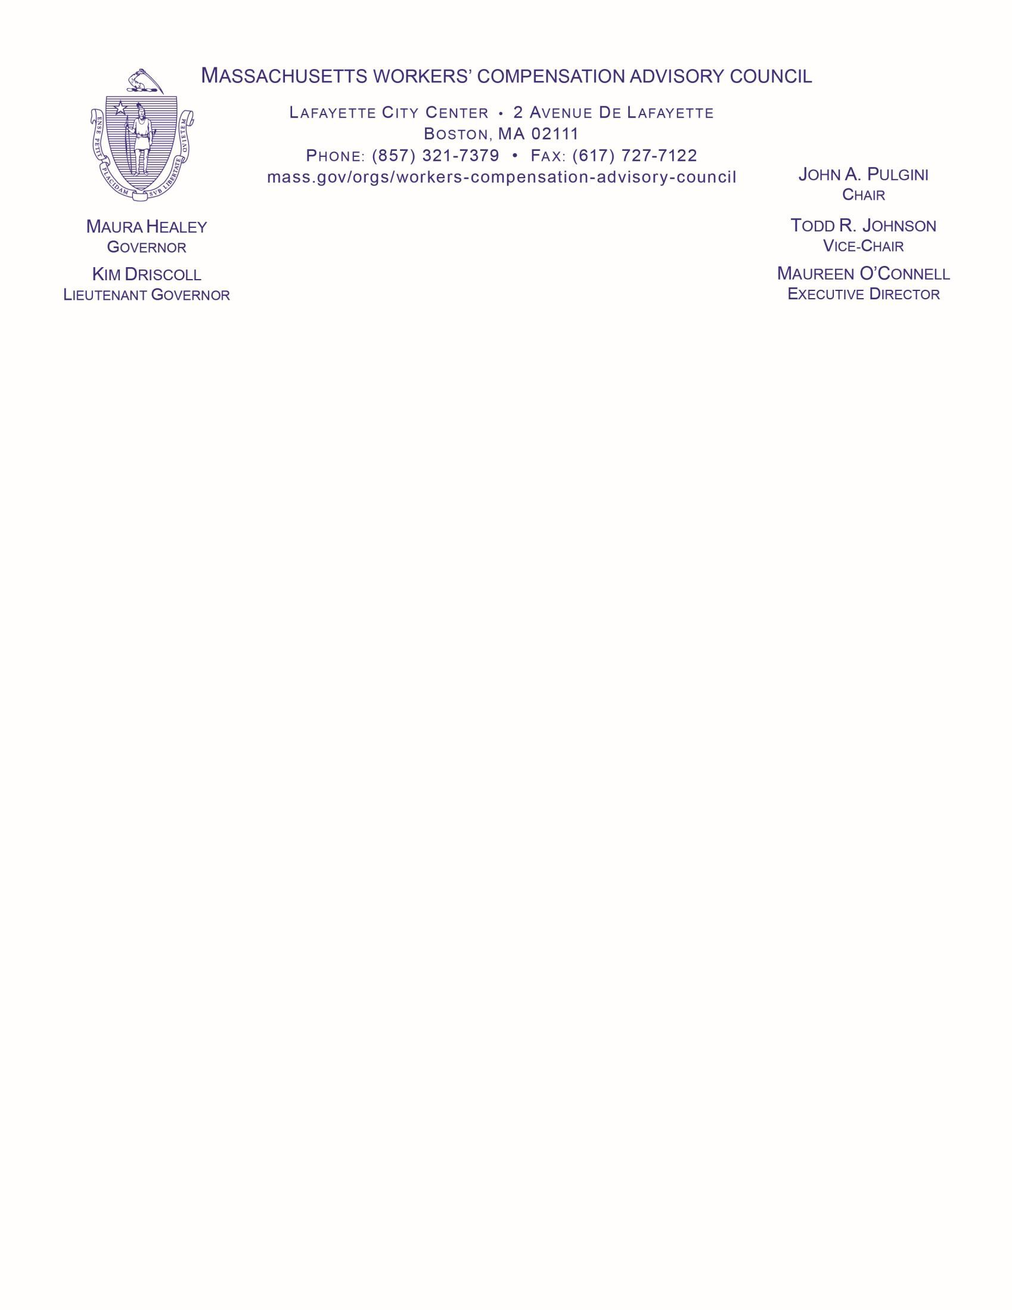

Present: John Pulgini, Todd Johnson, Michael Hess, Emily Spieler, James Steenbruggen, Stephen Falvey, Michael Kelly, Bernard Mulholland, Dr. Michael Ackland; DIA Director Sheri Bowles, Director of Administration Bill Taupier, Senior Judge Omar Hernández, General Counsel Philip Imbrescia, WCTF Director Holly Anderson, Director of Investigations Jon Solomon, Director of Operations Jeanne Natale, DIA - Maryann Brunton, Shamia Monroe, Vinnie Lopes; Cara Toomey
- WCRIBMA; Julie Bowler - Atlantic Charter; Isabel Hernandez - Healthe Systems; Cory Wedding
- MyMatrix; Caleb Huntington – Division of Insurance; Mary-Beth McGrath – Human Resources Division; Terence Cawley – WCRI; Attorney Kerry Nero; Christopher Stark – Mass Insurance Federation; and Maureen O’Connell.

AGENDA

Date: May 13, 2026
Location: Department of Industrial Accidents - via WebEx
Lafayette City Center | 2 Avenue de Lafayette, Boston, MA 02111

Time: 9:00 A.M.

  - CHAIR WELCOME
Roll Call

ACTION ITEMS
▫ Minutes – April 8, 2026

DIA UPDATE
Director’s Update – Sheri Bowles, Director
Judicial Update - Senior Judge Omar Hernández, Senior Judge
▫ Conference | Hearing | Reviewing Board Queue
▫ Impartial Medical Exams | Physicians
Vital Statistics - Bill Taupier, Director of Administration
▫ Cases Filed with DIA | Enforcement and Compliance
▫ Workers’ Compensation Trust Fund | Personnel Update

EXECUTIVE DIRECTOR’S UPDATE
Legislation

Chair John Pulgini called the meeting to order at 9:02 a.m. and conducted a roll call. With only six voting members present, a quorum was not achieved, and the minutes from April 8, 2026 were not voted on.
With no questions raised, the floor was then turned over to Director Sheri Bowles.
Director Sheri Bowles reported that the DIA Springfield office relocated on May 4, 2026. Deloitte is currently conducting an analysis in preparation for the FY27 assessment, with a preliminary report to be presented to DIA at a meeting on May 13, 2026, where the findings will be discussed. The analysis will be reviewed before any further comments are made.
Regarding the workers’ compensation medical reimbursement rate, there are no updates at this time, though EOHHS is targeting a public comment period in fall 2026. Director Bowles has also reached out to EOLWD to request a listening session in summer 2026 concerning impartial rates; however, there are no updates yet, as approval is required before proceeding.
Additionally, the Massachusetts State Auditor’s Office began an audit last fall to assess DIA’s compliance with EOTSS policies. The review is ongoing and now involves coordination with EOLWD IT and EOTSS, as certain aspects fall outside DIA’s jurisdiction.
Without questions for Director Bowles, the floor was directed to Senior Judge Omar Hernández.
Senior Judge Omar Hernández reported that conciliation metrics are well above 50% and expressed strong satisfaction with Dele Edibiri and the conciliation team. The conference queue has been significantly reduced with the addition of Judge Maureen Counihan, along with support from the judges in the DIA Fall River office, who assisted in easing the backlog in the Worcester DIA office. As a result, the Worcester queue has been reduced from four months to approximately 2.5 months, and Fall River is now also at 2.5 months.
Mediations are proving helpful, and Senior Judge Hernández is requesting that parties arrive prepared and with full authority to proceed. As mediation is a voluntary process, participants are expected to make a good faith effort when they appear. The number of pending hearing decisions has increased by one, which is not due to the judges, but rather because the parties are still working toward resolution.
With respect to the reviewing board, the numbers look to surpass last year – pleased with the staff and MA Bar Association. The department is planning to hire. The Human Resources Division is currently conducting an analysis of the salary and job description, and once that process is complete, the positions will be posted on MassCareers.
Without questions for Senior Judge Omar Hernández, the floor was directed to Bill Taupier, Director of Administration.

The Monthly Statistical Report Card can be found under Publications on the Workers’ Compensation Advisory Council’s website.
Mr. Taupier presented the Monthly Statistical Report Card slide deck for the Department of Industrial Accident (DIA) units.

With respect to Conciliations, in March 571 cases were resolved (53.8%) and 490 were referred to conference. The average waiting period for a conference is 8-16 weeks (down from last month). With respect to the May 2026 Conference queue: 625 and Hearing queue: 1,702.
Pending hearing decisions: 13 for the month of April 2026. Review Board inventory: 15, First Report of Injury (FROI) tracking close to last fiscal year filings for April 2,563 with First Reports and 825 cases – 8,326 for FY’26. Compliance and enforcement for April 12,001 compliance letters, 130 Stop Work Orders and 4,630 more people are covered by workers’ compensation insurance for FY’26. Workers’ Compensation Trust Fund: 90 uninsured injuries, $5,461,250 in payments against open claims and $870,540 recovered by the Civil Litigation. Assessments:
$71,002,174; Personnel: 188 employees.
Without questions for Mr. Taupier, the floor was directed to Maureen O’Connell, Executive
Director.
Executive Director Maureen O’Connell provided an update to the Council, noting that since the last meeting, revised legislation from the Joint Committee on Labor and Workforce Development—S1355, S1357, and S1367—has received an extension order filed through July 30, 2026.
Without questions for Executive Director O’Connell, and without a quorum, Chair Pulgini ended the meeting at 9:17am
Next Meeting: Tentatively scheduled for June 10, 2026

