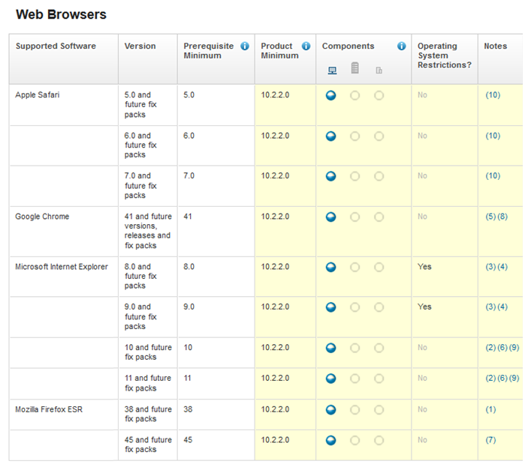

## Notes Referenced in Above Chart

|  |  |
| --- | --- |
| **(1)** | The only version of Firefox that IBM actively supports is the Extend Support Version of Firefox ESR 38 (see http://www.mozilla.org/en-US/firefox/organizations/). If customers use the non-ESR version of Firefox (version 25, 26, ...) it is our best estimation that changes in the current and future versions of the Firefox browser will not cause issues with our product used as long as Mozilla does not remove, explicitly or inadvertently disable functionality that the browser based tools rely on. However we recommend that you contact IBM support if you do encounter any such issues. For browser levels higher than the levels that have been certified with Cognos BI, Customer Support will accept usage-related and defect-related service requests. As with operating system and virtualization environments, if IBM support cannot recreate the issue in our lab, we may ask the Cognos BI customer to recreate the problem on a certified browser. |
|  |
| **(2)** | IBM Cognos Business Intelligence now contains document mode tags which will allows Internet Explorer to be used without manually setting any compatibility modes. Content from IBM Cognos Business Intelligence will be rendered in the appropriate document mode as designated by the product.   Not Supported on Windows Mobile. |
| **(3)** | Adobe Flash plug-in Version 9 or 10 required. |
| **(4)** | No longer supported based on Microsoft announcing end of support.  https://www.microsoft.com/en-us/WindowsForBusiness/End-of-IE-support   Not supported with Touch Enable devices (i.e. Microsoft Surface and Touch Enabled Laptops) |
| **(5)** | The current version of Google Chrome is supported based on testing with earlier versions of Chrome during development. We will work to maintain compatibility with Google Chrome, please be aware that issues may be introduced if and when Google makes significant changes to Chrome between rapid-releases.   Active Reports as MHT files are not supported |
| **(6)** | Adobe Flash plug-in Version 9 or 10 required.   Supported in Compatibility Mode only. |
| **(7)** | The only version of Firefox that IBM actively supports is the Extend Support Version of Firefox ESR 45 (see http://www.mozilla.org/en-US/firefox/organizations/). If customers use the non-ESR version of Firefox (version 46, 47, ...) it is our best estimation that changes in the current and future versions of the Firefox browser will not cause issues with our product used as long as Mozilla does not remove, explicitly or inadvertently disable functionality that the browser based tools rely on. However we recommend that you contact IBM support if you do encounter any such issues. For browser levels higher than the levels that have been certified with Cognos BI, Customer Support will accept usage-related and defect-related service requests. As with operating system and virtualization environments, if IBM support cannot recreate the issue in our lab, we may ask the Cognos BI customer to recreate the problem on a certified browser. |
| **(8)** | The current version of Google Chrome is supported based on testing with earlier versions of Chrome during development. We will work to maintain compatibility with Google Chrome, please be aware that issues may be introduced if and when Google makes significant changes to Chrome between rapid-releases.   Active Reports as MHT files are not supported. |
| **(9)** | IBM Cognos Business Intelligence now contains document mode tags which will allows Internet Explorer to be used without manually setting any compatibility modes. Content from IBM Cognos Business Intelligence will be rendered in the appropriate document mode as designated by the product.   Not Supported on Windows Mobile. Not supported with Touch Enable devices (i.e. Microsoft Surface and Touch Enabled Laptops) |
| **(10)** | Not Supported on iPad.   Active Reports as MHT files are not supported. |

Excerpted from IBM’s website:

https://www.ibm.com/software/reports/compatibility/clarity-reports/report/html/prereqsForProduct?deliverableId=1391013543612