Quick Guide for Webex Meetings

Using WebEx
- It is strongly recommended that you use the videoconference option for this meeting. Being able to see the commission members will make it easier to identify the speakers.
- If you plan on using the WebEx phone line vs the WebEx online connection, please let us know in advance. We need to identify your number in the call list so you can speak during the meeting.
- We recommend that you use a pair of headphones to prevent echoing.

Meeting Guidelines
- You will be muted automatically when you join the meeting to prevent unnecessary background noise.
- When you want to speak and are using a video conference, please wave your hand so the moderator can unmute you. If you are calling into the meeting, we will leave you unmuted for the duration of the meeting.
- When you want to speak, please start with “Hi, this is [your name].” We want to make sure that people calling in know who is speaking.

Public Participation
- Please do not share the meeting link with the public. DOR will provide a conference number for the public and it will be posted in advance, in accordance with the Open Meeting Law.
- The public will be in “listen only” mode during the meeting.

Other
- This meeting will be recorded for the purposes of note taking purposes only. Once the minutes are drafted, the recording will be deleted.
- If you want to show any files or materials, please share your files with DOR 24 hours prior to the meeting. We will share your content during the meeting.
- Contact Jonathan Oh (ohji@dor.state.ma.us) if you have any questions or concerns around using WebEx.

Joining the meeting
You can join the meeting by the following:
- https://massdor.webex.com/massdor/j.php?MTID=mbdba00616b8a6cf12abc2a47ddd376f3
- Call +1-408-418-9388 with access code 711 771 331. Please let us know if you are planning to call in.
We strongly recommend that you use the videoconference option.

Installing Webex application
If it’s your first time using Webex, once you join the meeting, an automatic download will start. However, in case it doesn’t happen, please use the following link to download the Webex meeting exe file manually:
- https://dorfilespublic.s3.us-east-2.amazonaws.com/webex.zip

Functions in the meeting
Several icons pop up when you hover over your meeting screen.
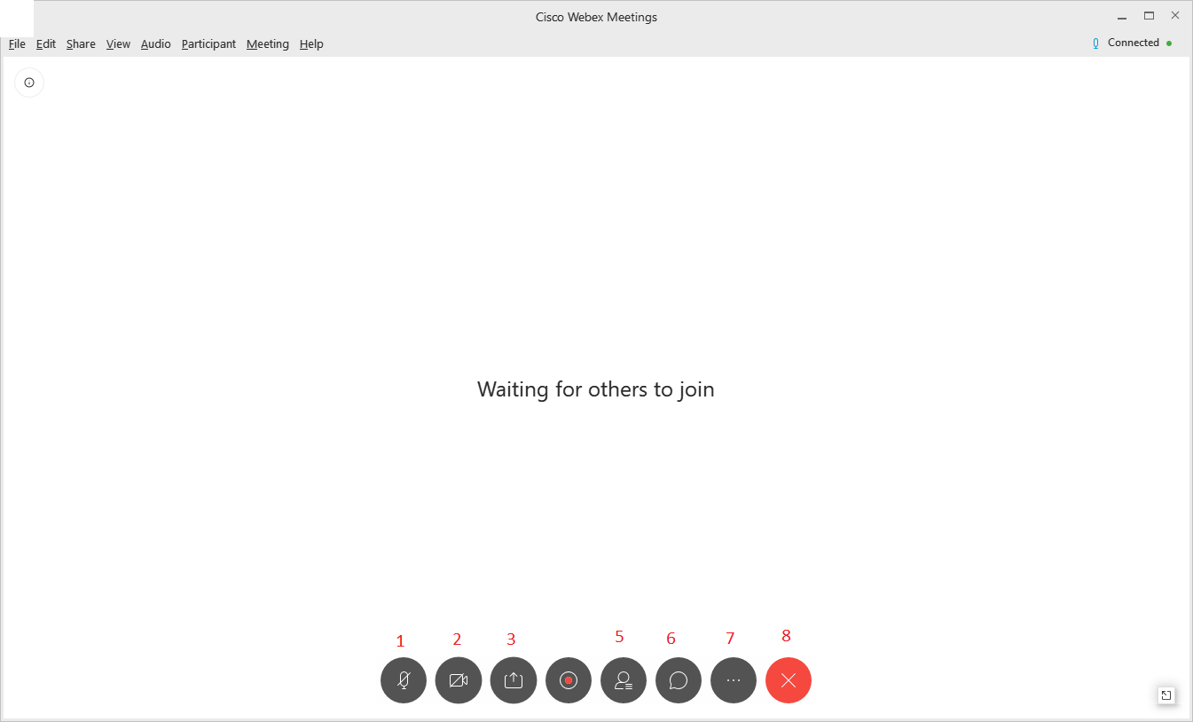
- Mute button. You can mute or unmute your microphone/audio input device.
- Stop my video button. You can stop your camera/video input device.
- Share content button. However, you will not be able to use this function during the TERC meeting. Please forward your files to Rachel Scannell (scannellr@dor.state.ma.us) before the meeting.
- Participants button. You can click to see the list of all the participants.
- Chat button. You can chat with the host if you have any issues.
- More options button. You can take notes, run polling, invite, share meeting link, and test connection.
- End meeting button. Click this button to exit the meeting. If you are the host of the meeting, you can end the meeting for others.

