Greater Boston Urology, LLC DON Application # GBU-25090411-RE

Exhibit B(10) – Applicant Webinar Presentation

29466025_1



Learn about the Benefits of Mobile
PET/CT Services
Our priority is always accessible and affordable patient care.
That’s why we’re looking to bring mobile PET/CT services to our
Dedham, Framingham, and Plymouth locations.
Learn more about these plans during our upcoming virtual chat!

What are PET/CT scans used for?
- More accurate diagnosis and staging, particularly for urological cancers.
- Early detection of recurrence or disease progression.
- Tracking treatment response over time.
- Integrated data to help doctors make better decisions, faster.

What does this mean for our patients?
- You’ll no longer need to travel to an outside imaging center.
- Appointments can be scheduled with other planned GBU visits.
- Services are covered by insurance and may even be more affordable.
- All imaging is handled by the same GBU team members managing your treatment.

Sign up for our virtual discussion to learn more!

Hosted by:
Dr. Michael Geffin
Stacy Giles, COO
Wednesday, Oct. 15
5:15 p.m. EST

Visit https://bit.ly/430qLdX or scan the QR code below:


Prostate Cancer, Screening Tests and Their Pitfall/Mobile Pet Scan and Its Benefits

Michael A. Geffin, MD
Director of Advanced Prostate Cancer Care
Co-Director of Research
Greater Boston Urology, LLC
Understanding challenges in early cancer detection methods


Prostate Cancer

Prostate Cancer Statistics for 2025 for the United States

Incidence - Approximately 313,780 new cases of prostate cancer are expected in the U.S., accounting for 15.4% of all new cancer diagnosis.
Diagnosis Trends- about 1:8 men with be diagnosed with prostate cancer in their lifetime
Mortality- It is estimated that there will be 35,770 deaths from prostate cancer in 2025
Survival- The 5 year survival rate for men who present with metastatic disease is 38% compared to nearly 100% for localized disease. This reflects improvements in early detection and treatment.

Rationale for
Screening



Why Screen for
Prostate Cancer?
Early Detection Importance
Screening detects prostate cancer early, increasing
treatment success and survival rates significantly.
High-Risk Groups
Screening is especially crucial for African American men
and those with a family history of prostate cancer.
Informed Decision-Making
Patients should discuss screening benefits and risks with healthcare providers to make informed choices
Common Screening
Methods

Prostate Specific
Antigen -PSA

PSA Blood Test
Purpose of PSA Test

The PSA test screens for prostate cancer by measuring PSA protein levels from normal and cancerous prostate cells.
Interpreting PSA Levels
Elevated PSA may indicate cancer or other conditions; levels above 4 ng/mL generally require further testing.
Limitations and Influences
PSA test sensitivity is limited; factors like age, prostate size, and medications can affect results.
Clinical Usefulness
Despite limitations, PSA remains valuable when combined with other diagnostics and clinical judgment.

Limitations of PSA
Testing

Pitfalls of PSA Testing

Limitations of PSA Accuracy
PSA test lacks a clear diagnostic cutoff and can yield false positives and negatives, reducing its reliability.
Non-Cancerous PSA Elevations
PSA levels can rise due to benign conditions like BPH, prostatitis, or physical activities, complicating diagnosis.
Age and Medication Effects
PSA levels naturally increase with age and can be influenced by medications or supplements, affecting results.
Need for Complementary Diagnostics
PSA testing should be combined with other tools and clinical assessments for accurate prostate cancer screening.

Digital Rectal Exam

Digital Rectal Exam (DRE)

DRE Procedure Overview
A healthcare provider inserts a gloved, lubricated finger into the rectum to check the prostate gland for abnormalities.
Detection Capabilities
DRE can detect prostate cancers missed by PSA tests, particularly those in the back part of the prostate.
Limitations and Benefits
While less sensitive than PSA tests, DRE provides valuable information and is used alongside PSA for screening.
Patient Experience and Use
The exam is quick and usually not painful but can be uncomfortable; it is part of routine physical exams for men.

Confirmatory Testing
Using Advanced
Screening Options

Newer Tests: PHI, 4Kscore and ExoDx
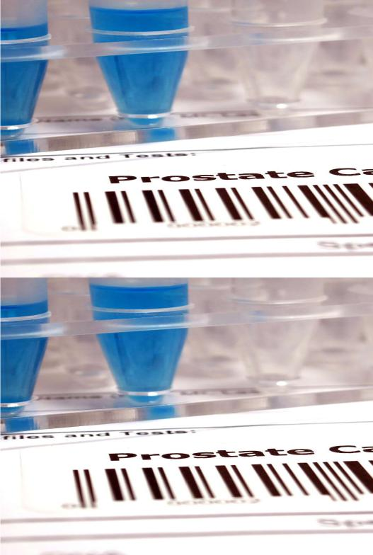
Prostate Health Index (PHI)
PHI combines total PSA, free PSA, and proPSA to improve accuracy in assessing prostate cancer risk.
4Kscore Test Components
4Kscore includes total PSA, free PSA, intact PSA, and hK2 plus clinical factors to assess aggressive cancer likelihood.
ExoDx Test
ExoDx looks at Exosomes eluted in the urine and is used to better rule out the risk of prostate cancer.

Newer Tests: PHI, 4Kscore and ExoDx
Advantages of New Tests
These tests improve specificity and sensitivity, reducing unnecessary biopsies and patient anxiety.
Clinical Decision Guidance
Testing helps refine risk in borderline cases and supports informed clinical decisions with healthcare providers.

Prostate Imaging for Screening
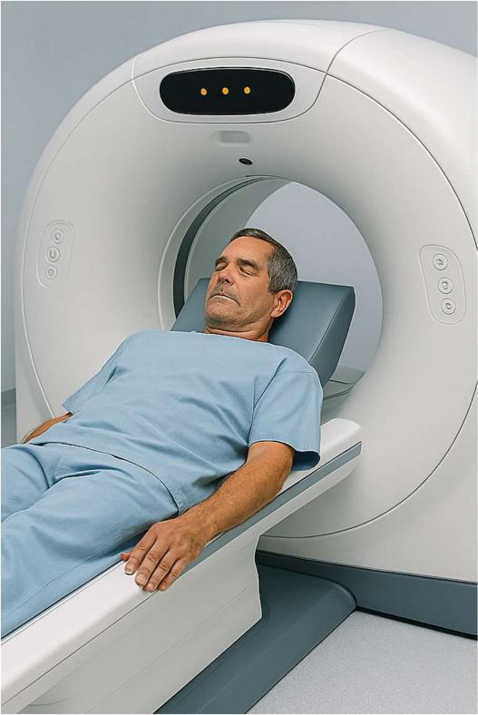
Prostate mpMRI
Prostate MRI’s have a high sensitivity for prostate cancer lesions. Better at finding the anterior lesion that were missed on sampling biopsies.
-Sensitivity 84%
-Specificity 76%
-NPV 91%
Prostate Ultrasounds
Standard greyscale ultrasound has a 40-60% sensitivity of prostate cancer. Micro-ultrasound (higher frequency lower wavelength) are now available and are comparable to MRI in lesion detection. Shear Wave Elastography measures tissue stiffness with 84% sensitivity for prostate cancer detection.

Biopsy
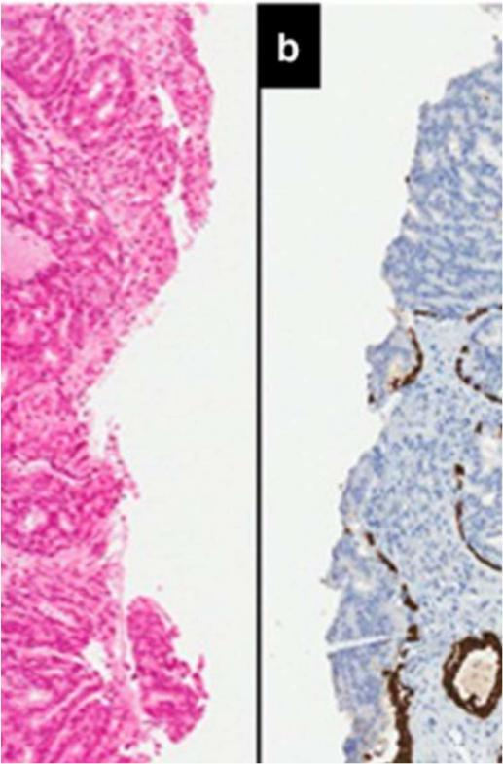
When Are Biopsies Recommended
Biopsies are advised when there is a high suspicion for clinically significant prostate cancer in the individual based on the data.
Purpose of Prostate Biopsy
A biopsy confirms prostate cancer by examining small tissue samples under a microscope for cancer cells.
-The cellular and molecular finding can help with stratifying risk of disease aggressiveness, metastasis and prognosis.
-Genetics can direct treatment options

Biopsy
Risks and Complications
Biopsies may cause discomfort, bleeding, infection, urinary issues, and erectile dysfunction as potential complications.
Advances in Imaging Guidance
Multiparametric MRI enhances biopsy accuracy by guiding tissue sampling precisely.

Prostate Cancer
Work Up

Metastatic Work Up- When to Test
Please Note that use of this NCCN Content is governed by the End-User License Agreement and you May Not distribute this Content or use it with any artificial intelligence model or tool.
Printed by Michael Geffin on 9/10/2025 6:46:22 PM. Copyright 2025 National Comprehensive Cancer Network, Inc. All Rights Reserved
NCCN Guidelines Version 1.2026 Prostate Cancer NCNN Guidelines Index
Table of Contents
Discussion

Initial Risk Stratification and Staging Workup for Clinically Localized Disease ^{i}
Risk Group | Clinical/Pathologic Features  (Staging, ST-1) | Clinical/Pathologic Features  (Staging, ST-1) | Clinical/Pathologic Features  (Staging, ST-1) | Additional Eyaluation⁰ | Initial Therapy
Low | Has all of the following:  - cT1—cT2a  - Grade Group 1  - PSA <10 ng/mL | N/A | N/A | - Confirmatory testing can be used to assess the appropriateness of active surveillance (PROS-F 2 of 5) | PROS-3
Intermediate | Has all of the following:  - No high-risk group features  - No very-high-risk group features  - Has one or more intermediate risk factors (IRFs):  - cT2b—cT2c  - Grade Group 2 or 3  - PSA 10-20 ng/mL | Favorable intermediate | Has all of the following:  - 1 IRF  - Grade Group 1 or 2  - <50% biopsy cores positive (eg, <6 of 12 cores) | - Confirmatory testing can be used to assess the appropriateness of active surveillance (PROS-F 2 of 5) | PROS-4
Intermediate | Has all of the following:  - No high-risk group features  - No very-high-risk group features  - Has one or more intermediate risk factors (IRFs):  - cT2b—cT2c  - Grade Group 2 or 3  PSA 10-20 ng/mL | Unfavorable intermediate | Has one or more of the following:  - 2 or 3 IRFs  - Grade Group 3  - ≥50% biopsy cores positive (eg, ≥6 of 12 cores) | - Soft tissue imaging and consider bone imaging  - If regional metastases are found, see PROS-7  - If distant metastases are found, see PROS-14 for Low-Volume M1(Metachronous or Synchronous) or Synchronous Oligometastatic CSPC or PROS-15 for High-Volume M1 CSPC | PROS-5
High | Has one or more high-risk features, but does not meet criteria for very high risk:  - cT3—cT4  - Grade Group 4 or Grade Group 5  - PSA >20 ng/mL | N/A | N/A | - Bone and soft tissue imaging  - If regional metastases are found, see PROS-7  - If distant metastases are found, see PROS-14 for Low-Volume M1(Metachronous or Synchronous) or Synchronous Oligometastatic CSPC or PROS-15 for High-Volume M1 CSPC | PROS-6
Very high | Has at least two of the following:  - cT3—cT4  - Grade Group 4 or 5  - PSA >40 ng/mL | N/A | N/A | - Bone and soft tissue imaging  - If regional metastases are found, see PROS-7  If distant metastases are found, see PROS-14 for Low-Volume M1(Metachronous or Synchronous) or Synchronous Oligometastatic CSPC or PROS-15 for High-Volume M1 CSPC | PROS-6

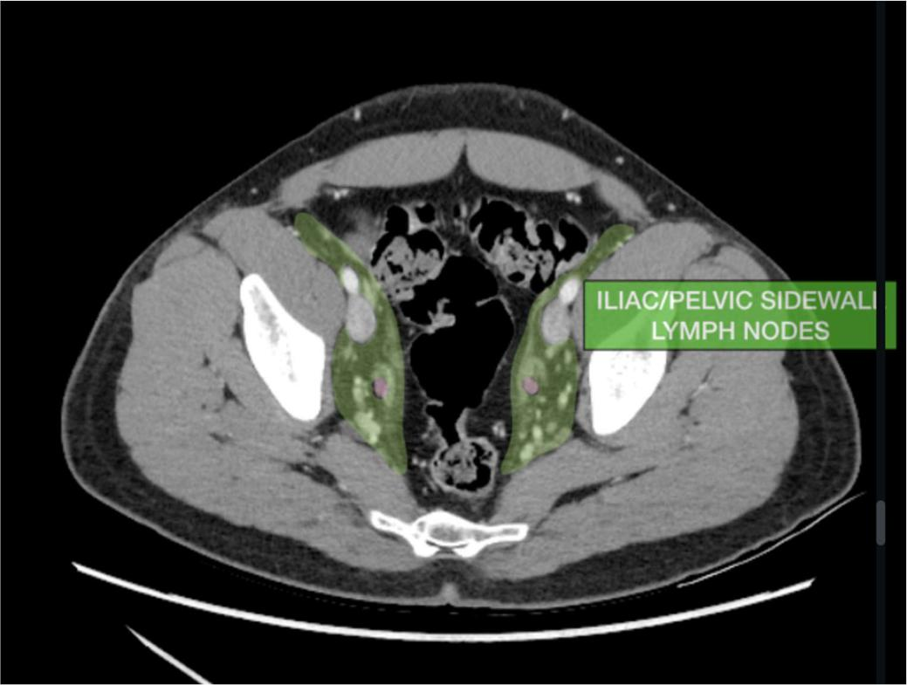

Metastatic Work Up -Testing
CT Scan
-Looking for bone lesions and enlarged lymph nodes in the pelvis
Limitations
- It’s not specific for Prostate Cancer
- Positive lymph node by CT is defined by enlargement in size
- Unable to detect small volume disease
- Artifacts often limit visualizations (hip replacements, clips, etc)

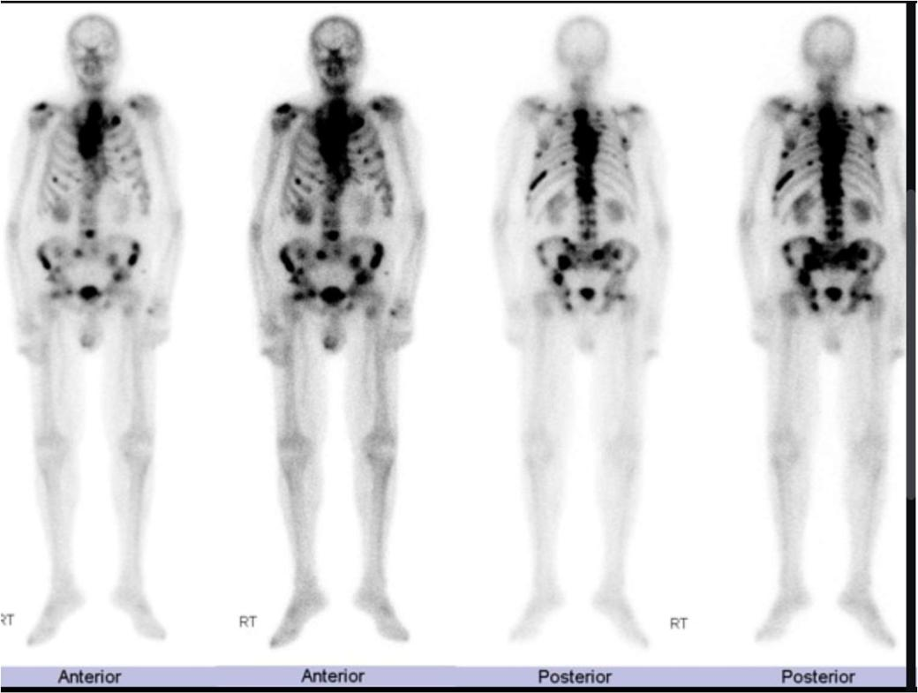

Metastatic Work Up - Testing
Bone Scan
Prostate Cancer tends to spread to
the bone and develops blastic lesions
Limitations
- Not prostate cell specific.
- Poor sensitivity
- Difficult for the patient due to movement and time issues
Metastatic Work Up – Testing –PSMA PET How Does It Work?
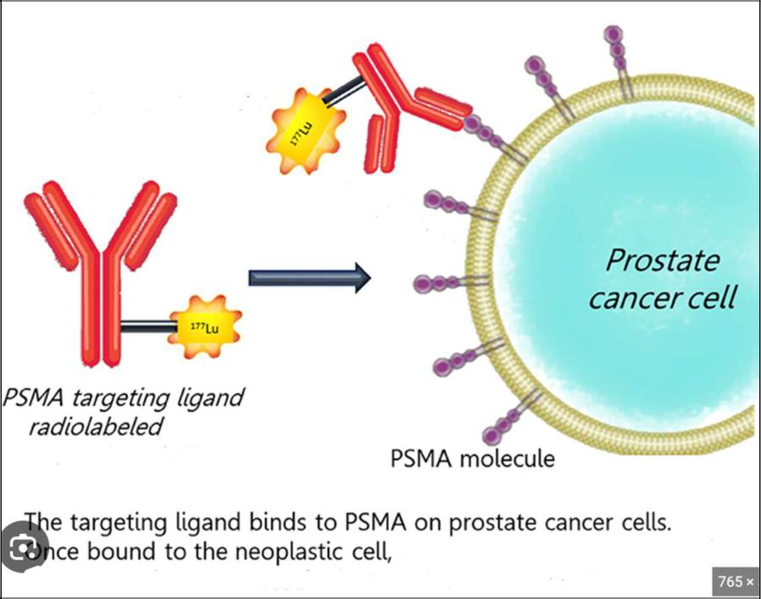
Positron Emission Tomography Scan (PET Scan)– a scanner that uses radioactive decay to form an image.
- PSMA PET scan uses an antibody to target any Prostate Specific Membrane Antigen (PSMA) on a cell.
- The antibody is attached to a radioactive tracer that the scanner can detect
Benefits
- Prostate Cancer cell specific
- High sensitivity

PSMA PET Scan for
Staging

 Seminars in Nuclear Medicine
Volume 54, Issue 1, January 2024, Pages 39-45

PSMA PET/CT for Primary Staging of Prostate Cancer An Updated Overview
Mads Ryo Jochumsen MD, PhD * , Kirsten Bouchelouche MD, DMSc *

Download: Download high-res image (568KB)
Download: Download full-size image
Figure 3. 71-yrs old man with newly diagnosed high-risk PCa (PSA 205, cT3, Gleason 4+4) underwent conventional bone SPECT/CT and CT scan for primary staging. No bone-or lymph node metastases were found. Two weeks later, a 18F-PSMA PET/CT scan demonstrated high PSMA uptake in the whole prostate gland (A, B) with involvement of the seminal vesicles (C). Multiple very small pelvic, para-aortal, retrocrural and mediastinal lymph node metastases with high PSMA uptake were found. This case

PSMA PET Scan vs
Conventional Imaging
For PSA Recurrances
After Surgery and
Radiation

Metastatic Work After Surgery –PSA Recurrence After RP
Positron Emission Scan (PSMA PET Scan)
69 year old male after radical prostatectomy with T3b, Gleasone 3+4 prostate cancer.
- -PSA rising to 0.6 ng/ml
- -PSMA PET Scan found solitary lymph node.
- -Had surgery and removal of the positive lymph node.

Metastatic Work Up After Radiation –PSA Recurrence After RT


Post Radiation PSA Recurrence

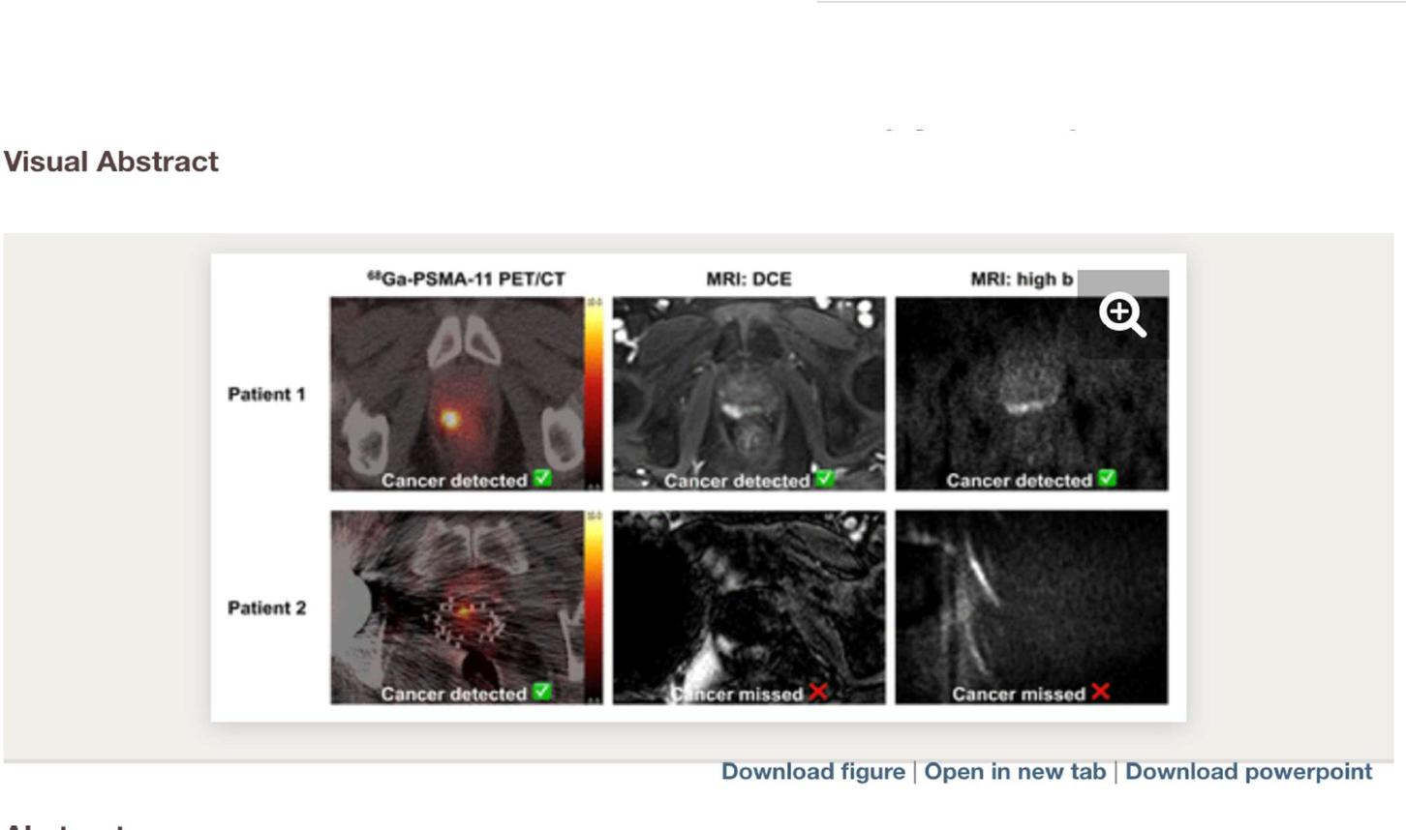

POST RADIATION PSA
RECURRENCE- SUMMARY

- ⁶⁸Ga-PSMA-11 PET/CT has high sensitivity and modest specificity for detecting intraprostatic radiorecurrent cancer measured against biopsy.
- mpMRI also has good sensitivity with comparatively lower specificity
- The use of both modalities together, however, conferred a significantly greater sensitivity and NPV than with MRI alone across all cancer definitions. Notably, 89%–92% of cancers missed by MRI were detected by PET/CT imaging.

Mobile PET Scan
Technology Benefits



Mobile PET Scan
Best Practice -
Benefit
Collaboration
Our Advance Prostate Cancer group would collaborate with the radiologists to put together the radiographic findings with the clinical scenario for best treatment options.

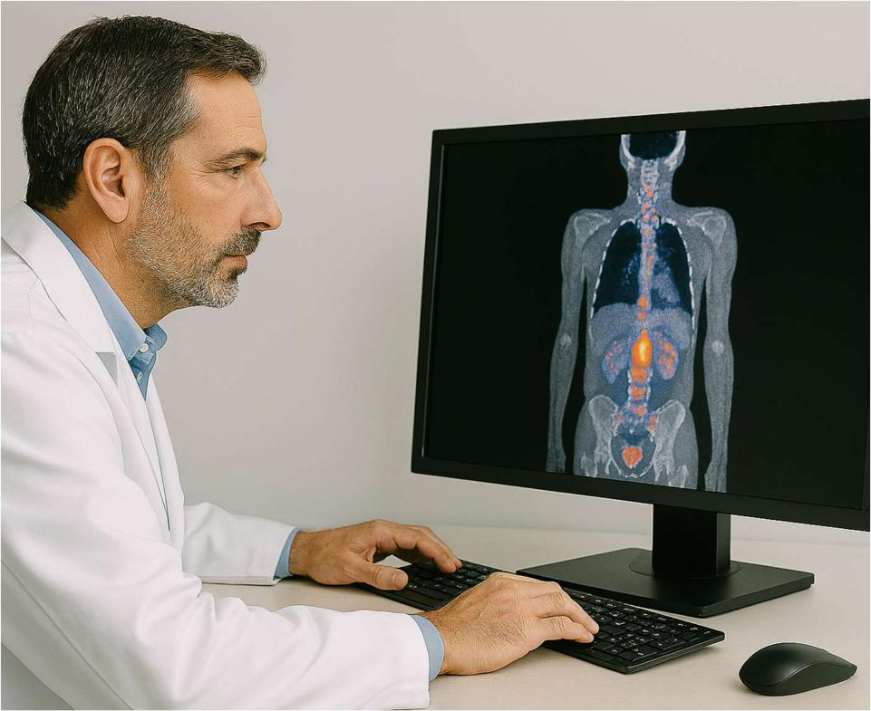
Mobile PET Scan
Best Practice -
Benefit

Consolidation of expertise

The current model is 9 radiology departments, each with 6 -10 radiologists, where individual radiologists reading 1-2 PSMA PET scan images a month. By centralizing imaging within a urology group, 2-3 dedicated radiologists could interpret 60 PSMA PET scans monthly, significantly enhancing diagnostic consistency, accuracy, and expertise in prostate cancer imaging.
Mobile PET Scan Best Practice - Benefit
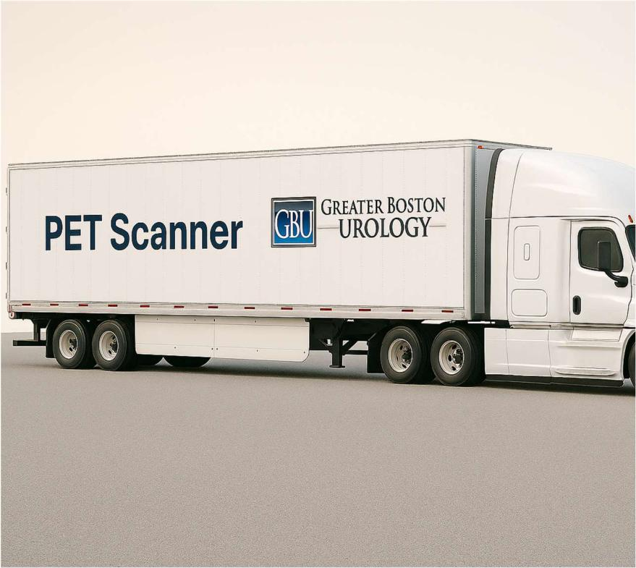
Expanded Access to Advanced Imaging
- Brings state-of-the-art molecular imaging (such as PSMA PET) directly to community settings.
- Increases access for rural and underserved populations.
- Reduces disparities in cancer detection and management outcomes.
- Reduces the need for patients to travel long distances to academic centers.

Mobile PET Scan
Best Practice -
Benefit
Faster Diagnosis and Treatment Planning
- Streamlines the process from suspicion to staging to treatment, allowing earlier intervention.
- Decreases waiting times for PET scans and results, helping patients begin therapy sooner.

MOBILE PET SCAN BEST PRACTICE - BENEFIT

Improved Patient Experience
Patients can receive care in a familiar, convenient setting rather than navigating hospital systems.
-Reduce anxiety.

Mobile PET Scan Best Practice - Benefit

Cost Efficiency for the Healthcare System
Mobile PET services operate with lower overhead than hospital-based scanners.



Mobile PET Scan
Best Practice -
Benefit

Support for Community-Based Research
Expands opportunities for clinical trials and data collection in real-world, community settings.

Summary – Advanced Prostate Cancer Clinic
Model of: Disease Care Specialty – Prostate Cancer
Greater Boston Urology Advanced Prostate Cancer Clinics – Access to Experts in Prostate Cancer Care
  - Specialized Screening tests
  - Specialized Diagnostic tests
  - Specialized State of the Art Imaging testing
  - Specialized Treatment Options (not discussed today)
  - Advancing care with research trials
Thank you
- Dedham : Michael Curran M.D., Marie Alpert, RN Prostate Cancer Nurse Navigator, Donna Robin, PA
- Plymouth : Michael Geffin M.D., Victoria Webber, PA


Summary
PSMA PET Scan
-Significant Advance for Prostate Cancer Care
-Having Mobile PET Scan will help patient access to most advanced care
Thank you for taking time out to
learn about PSMA PET Scans
Michael A. Geffin, MD
Director, Advanced Prostate Cancer Care
Co-Director of Research
Question?

Research Opportunities For Patients At Greater Boston Urology


Prostate Cancer
EvoPar02 - A Randomised, Double-blind, Placebo-controlled, Phase 3 Study of a Novel PARP inhibitor in Patients with BRCAm Localised High-Risk Prostate Cancer Receiving Radiotherapy with Androgen Deprivation Therapy

Bladder Cancer
Moonrise -2 Phase 3 Study of TAR-210 (Erdafitinib Intravesical Delivery System) Verin Participants With Intermediate-Risk Non-

Muscle Invasive Bladder Cancer
Moonrise -3 Phase 3 Study of TAR-210 (Erdafitinib Intravesical Delivery System) Versus Intravesical Chemotherapy in Patients With BCG-Treated High-Risk NMIBC With Susceptible FGFR Alterations

