INDOOR AIR QUALITY ASSESSMENT

Webster Town Hall
350 Main Street
Webster, MA

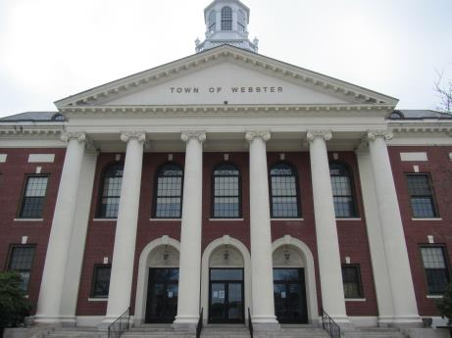

Prepared by:
Massachusetts Department of Public Health
Bureau of Environmental Health
Indoor Air Quality Program
June 2016

Background
Building: | Webster Town Hall (WTH)
Address: | 350 Main Street, Webster, MA
Assessment Requested by: | Webster Board of Health
Reason for Request: | Health concerns and general indoor air quality (IAQ)
Date of Assessment: | May 6, 2016
Massachusetts Department of Public Health/Bureau of Environmental Health (MDPH/BEH) Staff Conducting Assessment: | Mike Feeney, Director, IAQ Program  Ruth Alfasso, Environmental Engineer/Inspector, IAQ Program
Building Description: | Town Hall is a former school built in the 1800s. Exterior is brick and stone, with a mostly-flat roof and skylight/cupola. Three floors are occupied including a basement level. Building is attached to the Webster senior center and residences along one wall, the interior of which contains a two-story auditorium space.
Year Built: | 1928
Building Population: | Approximately 25 staff with members of the public visiting daily
Windows: | openable

METHODS
Please refer to the IAQ Manual for methods, sampling procedures, and interpretation of results (MDPH, 2015).

IAQ Testing Results
The following is a summary of indoor air testing results (Table 1).
- Carbon dioxide levels were below 800 parts per million (ppm) in all but two of the 40 areas tested, indicating adequate fresh air supply for the space.
- Temperature was within the recommended range of 70°F to 78°F in almost all areas tested with several readings below.
- Relative humidity was within or slightly below the recommended range of 40 to 60% in all areas tested.
- Carbon monoxide levels were non-detectable in all indoor areas tested.
- Fine particulate matter (PM2.5) concentrations measured were below the National Ambient Air Quality Standard (NAAQS) level of 35 μg/m³ in nearly all areas tested. Several readings in the second floor area were above the standard. This is addressed further below.

This sampling indicates that there is adequate fresh air in most areas of the building. However, note that many areas were empty or sparsely occupied, which reduces the creation of carbon dioxide in the space.

Ventilation
A heating, ventilating and air conditioning (HVAC) system has several functions. First it provides heating and, if equipped, cooling. Second, it is a source of fresh air. Finally, an HVAC system will dilute and remove normally occurring indoor environmental pollutants by not only introducing fresh air, but by filtering the airstream and ejecting stale air to the outdoors via exhaust ventilation. Even if an HVAC system is operating as designed, point sources of respiratory irritants may exist and cause symptoms in sensitive individuals. The following analysis examines and identifies components of the HVAC system and likely sources of respiratory irritant/allergen exposure due to water damage, aerosolized dust and/or chemicals found in the indoor environment.
Some areas in the basement of the WTH (e.g., the Health offices) have supply vents (Picture 1) which receive air ducted from air handling units (AHUs) located in the attic (Picture 2). Note that these vents require long ductwork to traverse the intervening floors of the building and so may not be able to deliver air efficiently.
Most other areas have no source of fresh air apart from openable windows, which are present along exterior walls. No source of exhaust ventilation was observed in any areas of the building, including restrooms. Without exhaust ventilation, any pollutants that are generated in the building, including carbon dioxide, water vapor and odors, have no means of escape and can build up.
Heating/cooling in some areas of the office is accomplished through the use of fan coil units (FCU) that are located in offices (Picture 3). Fan coil units heat/cool and filter the air but do not supply a source of fresh air. Many were blocked or obstructed by items in front or on top.
The auditorium is a large two-floor open area which is between the main part of the WTH and the attached building, which contains the Webster senior center and residential units (Picture 4). It appears that the two buildings had previously shared a ventilation system. The vents for this system have been blocked off with plastic and tape from the auditorium side (Picture 5). Although the auditorium is not currently used very often, building staff report that the town library will be moving temporarily to the space while construction on the new library is ongoing. Supply of fresh air to this space would need to be provided with increased occupancy.
Although temperatures were mostly within the MDPH recommended range during the visit, some occupants expressed concerns regarding temperature control. Without functioning mechanical ventilation, temperature control is difficult.

Microbial/Moisture Concerns
Several sources of microbial concerns were identified in this building. In one area of concern, the Retirement Office, musty odors and numerous signs of water damage were observed in an adjacent room used for storage (Pictures 6 and 7). Observations of the location of damaged plaster suggest several sources of moisture in this area, primarily roof leaks from ice dams that occurred during the winter of 2015. Given the location of the water-damaged wall plaster, carpeting beneath filing cabinets was also likely moistened for an extended period of time. It is recommended that carpet should be dried with 24 hours of becoming moist to prevent mold growth (US EPA, 2008). If not dried with 24 hours, the carpeting should be removed. Another possible source of chronic moisture to carpet is due to this room sharing a wall with the unheated auditorium. The Retirement Office is along an outside wall and abuts the auditorium which is a seldom-used space that is often kept unheated. The shared wall between the auditorium and the Retirement Office may be chilled below the dew point during humid weather and lead to condensation on the wall. While plaster itself does not readily grow mold, paint and dust/debris on the wall, ceiling tiles, the carpeted floor and porous items near the wall may become mold-colonized.
The auditorium has numerous areas of water-damaged and cracked ceiling and wall plaster (Picture 8). Similar conditions were observed in other offices and hallways (Pictures 9 through 11). These likely originate with leaks from the building envelope (roof and walls) that should be repaired. Although the plaster itself does not appear to be mold-colonized, any porous items stored in contact with or beneath the areas of leaks may be subject to moistening and microbial growth. In addition, flaking paint and paint dust may present a lead hazard, depending on the age of the paint. Water-damaged ceiling tiles can be a source of mold and odors and should be replaced once a leak has been repaired.
Occupants of the IT and Community Development offices reported that flooding used to occur in these lower-level offices during wet weather. They reported that grading and drainage work had been performed on the grounds and that flooding had not reoccurred. If any damaged furniture or stored items remain from these past episodes, they should be discarded.
Several offices on the lower level had small sinks, some of which reportedly did not function, but had not been properly abandoned/capped (Picture 12). One occupant reported that he poured water down the drain of a sink regularly to prevent the drain from becoming dry and allowing sewer odors into the occupied space. Keeping these traps wet will prevent the infiltration of sewer gases; however unused/unusable fixtures should be properly removed with all associated piping capped.
The restrooms were examined and, as mentioned above, no exhaust ventilation was present, which would allow restroom-generated moisture and odors to build up. In the women’s restroom on the lower level, there was an open pipe, gaps around pipes, and other holes in the walls next to the toilet (Picture 13). This can allow air from the sewer system or unconditioned areas to penetrate into the bathroom and provide pathways and harborage for pests.
Some unused offices, conference rooms and storerooms had musty odors (Table 1). These likely originate with water-damaged building materials or stored materials in the space coupled with the lack of supply and exhaust ventilation. The service closet on the second floor had stored mops and other janitorial items which may also emit odors if not kept clean.
Water coolers and small refrigerators were observed on carpeting (Picture 14). Spills and leaks from these appliances can moisten carpeting and lead to microbial growth and odors.
Plants were observed in a few areas (Table 1) including on porous surfaces (e.g. carpet). Plants can be a source of pollen and mold, which can be respiratory irritants to some individuals. Plants should be properly maintained and equipped with drip pans to prevent water damage to porous materials. Plants should also be located away from air diffusers to prevent the aerosolization of dirt, pollen and mold.
The exterior of the building was also examined for sources of water damage and odors. Several downspouts were broken (Picture 15) which allows water to splash against the walls and foundation and may lead to damage to the building envelope and infiltration. Window wells beneath some of the basement windows had water and debris accumulated in them (Picture 16) which can lead to pests and odors which can enter occupied spaces when the windows are open.

Other IAQ Evaluations

VOCs
Exposure to low levels of total volatile organic compounds (TVOCs) may produce eye, nose, throat, and/or respiratory irritation in some sensitive individuals. To determine if VOCs were present, BEH/IAQ staff examined rooms for products containing VOCs. BEH/IAQ staff noted air fresheners, hand sanitizers, cleaners, and dry erase materials in use within the building (Table 1). All of these products have the potential to be irritants to the eyes, nose, throat, and respiratory system of sensitive individuals. This is particularly true in a building with no functioning exhaust ventilation.

Particulate Matter
While most locations sampled including outside background had very low or non-detectable levels of particulate matter (PM2.5), levels were above the NAAQS standards of 35 μg/m³ (Table 1) in the Community Development area. The occupant reported that she had recently finished cleaning using several spray cleaners. The combination of aerosol spray and mobilized dust likely contributed to the high levels observed. A revisit to the area a short time later showed that levels, while still higher than most areas of the building, had been reduced below the NAAQS standards.

Other conditions
Accumulated items were found stored on floors and other flat surfaces. In addition, there were several storerooms, including the attic, containing boxes, rolls of old plans, old books, other paper items, decorative items, and furniture (Pictures 17-23). As discussed above, some of these items had musty odors, which indicates that they had been water-damaged in the past. Boxes and other items were often found stored directly in contact with floors, which may be subject to condensation and lead to additional water damage. In addition, large quantities of paper can provide harborage for pests and may represent a fire hazard. A systematic review of stored paperwork and other items should be conducted with a goal of reducing the overall amount of items and reorganizing the remaining items to be stored in a manner (contained and away from floors) that will prevent further damage, deterioration and odors.
Air purifiers were found in offices in the WTH (Pictures 24 and 25). Some of these were a brand called RabbitAir ™. The product literature for these units suggests it has both filtration and “negative ion generation” with a separate switch (Rabbit Air, 2016). This means it produces ozone, which is a respiratory irritant and should not be used in occupied spaces (US EPA, 2003). The units should be operated with the “negative ion” generator off. In addition, all air purifiers should be maintained, with filter changes and cleaning, per manufacturer’s instructions.
Some offices are carpeted. Carpets should be cleaned regularly in accordance with Institute of Inspection, Cleaning and Restoration Certification (IICRC) recommendations (IICRC, 2012). Many of the carpets in the WTH were worn and taped up and should be replaced (Picture 26).
Fluorescent light bulbs were found stored in a manner where they could become broken (Picture 27). These bulbs contain mercury that can be released if the bulbs are broken, and they will also create broken glass. Fresh and spent bulbs should be stored in sturdy packaging to prevent breakage, and spent bulbs need to be discarded as universal waste.

Conclusions/Recommendations
Based on observations at the time of assessment, the BEH/IAQ recommends a two-phase approach. The first consists of short-term measures to improve air quality and the second consists of long-term measures that will require planning and resources to adequately address overall concerns.

Short-term Recommendations:
- Remove carpeting from the Retirement office storeroom.
- Replace stained ceiling tiles, including those in the Retirement Office. Inspect and clean the area above the stained tiles to remove dust/debris that may also be colonized with mold.
- Remove items from the floor and on/against the wall in the Retirement Office that abuts the auditorium to prevent trapped air and condensation. While the auditorium is used as a library, temperature control in this adjoining space should reduce the potential for thermal bridging.
- Use and maintain the HVAC system that serves the basement area, including changing the filters every 6 months or more frequently if needed.
- Use openable windows in other areas of the building to provide fresh air during temperate periods. Ensure that all windows are closed tightly at the end of the day. Do not open windows while air conditioning/cooling is occurring to prevent condensation.
- Investigate a way to provide fresh air and temperature control for the auditorium area during the periods when it is used as a temporary library. This may include portable ventilation equipment or window-mounted heating/cooling units. Ensure that systems installed will not promote condensation on library materials.
- Repair roof leaks.
- Repair/repaint areas of peeling plaster on walls and the ceiling. If lead paint may be an issue, ensure that lead-safe procedures are used in accordance with the Department of Labor Standards Regulations, 454 CMR 22.
- Monitor the lower level for any signs of recurrent flooding. Do not store any porous items on floors in the lower level; use shelving, pallets or non-porous containers to protect items.
- Continue to add water to broken or seldom-used sinks to ensure water trap/seal until they can be properly removed and capped.
- Consider installing fans or windows to the outside in restrooms to provide exhaust ventilation.
- Ensure that the open pipe in Picture 13 does not connect to the sewer system and cap/repair. Seal gaps around pipes in the restrooms with an appropriate sealant.
- Inspect materials in offices with musty odors for water damage/odors and discard those that can be discarded. For items with significant historical value or that are required to be kept for legal reasons, high-quality duplication or professional restoration may be required.
- In general, the large quantity and variety of stored items, including papers, books, furniture and decorative items may be a source of moldy odors and dust, may provide harborage for pests, and may represent a fire hazard. A comprehensive program to sort and catalog these items should be conducted, discarding those items that are no longer needed, making electronic copies of items for accessibility when possible, and storing the rest in an organized, water-resistant manner (e.g. in cabinets, on shelves, or in plastic containers). Non-porous stored items should be cleaned periodically using a HEPA-filter-equipped vacuum cleaner followed by wet wiping to prevent the buildup of dusts that can become reaerosolized or dampened and mold-colonized.
- Consider placing refrigerators and water dispensers in areas without carpeting, or use a waterproof mat beneath them.
- Keep plants in good condition, avoid overwatering, and avoid placing them on porous items such as carpets or paper.
- Repair the gutter/downspout system to direct water away from the building.
- Clean the basement window wells of debris and check drainage to prevent the accumulation of water.
- Reduce the use of VOC-containing cleaners/sanitizers and air fresheners, especially given the lack of ventilation in this building. Consider using HEPA-equipped vacuuming, wet wiping, and soap and water for regular cleaning tasks to prevent the introduction of VOCs and other potentially irritating chemicals into the indoor air.
- Use the RabbitAir™ air purifiers with the “negative ion generation” turned off. Maintain all air purifiers in accordance with manufacturer’s instructions.
- Clean supply and exhaust vents and personal fans regularly to prevent aerosolization of debris.
- Clean carpeting and upholstered items regularly in accordance with IICRC recommendations (IICRC, 2012).
- Store fluorescent light bulbs in a secure manner to prevent breakage.
- Refer to resource manual and other related IAQ documents located on the MDPH’s website for further building-wide evaluations and advice on maintaining public buildings. These documents are available at: http://mass.gov/dph/iaq.

Long-term recommendations:
- Consult with a building and HVAC expert to determine the feasibility of installing supply and exhaust ventilation in the WTH.
- Repair or replace the roof including appropriate insulation to prevent ice dams.
- Replace all carpeting in the WTH. Do not install carpeting in any below-grade areas; use floor tiles or other non-porous flooring. Consider the activities in each room, so that non-porous flooring can also be used in kitchens, file/storage areas and in areas where refrigerators and water dispensing equipment may be used. Carpet squares are recommended for ease of replacement when small areas are moistened or damaged.

References
IICRC. 2012. Institute of Inspection, Cleaning and Restoration Certification. Carpet Cleaning: FAQ. Retrieved from http://www.iicrc.org/consumers/care/carpet-cleaning/#faq.
MDPH. 2015. Massachusetts Department of Public Health. Indoor Air Quality Manual: Chapters I-III. Available at: http://www.mass.gov/eohhs/gov/departments/dph/programs/environmental-health/exposure-topics/iaq/iaq-manual/.
Rabbit Air. 2016. Ultra Quiet Air Purifier, Owner’s Manual, Models: SPA-700A, SPA-780A. Accessed from: https://cdn.shopify.com/s/files/1/0260/5699/files/minusa2_manual_1603.pdf
US EPA. 2003. “Ozone Generators that are Sold as Air Cleaners: An Assessment of Effectiveness and Health Consequences”. US Environmental Protection Agency, Office of Air and Radiation, Indoor Environments Division, Washington, D.C. https://www.epa.gov/indoor-air-quality-iaq/ozone-generators-are-sold-air-cleaners last updated on March 17, 2016.
US EPA. 2008. “Mold Remediation in Schools and Commercial Buildings”. Office of Air and Radiation, Indoor Environments Division, Washington, DC. EPA 402-K-01-001. September 2008. Available at: http://www.epa.gov/mold/mold-remediation-schools-and-commercial-buildings-guide.

Picture 1
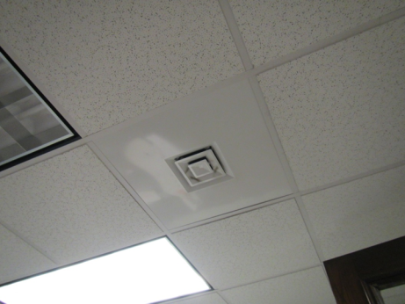
Supply vent in the basement
Picture 2
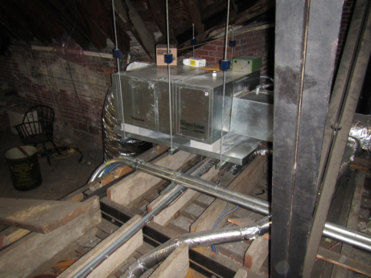
Air handling unit in attic
Picture 3
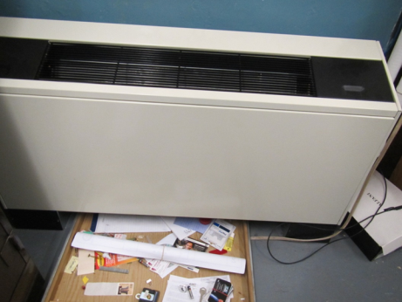
Fan coil unit, note items blocking airflow
Picture 4
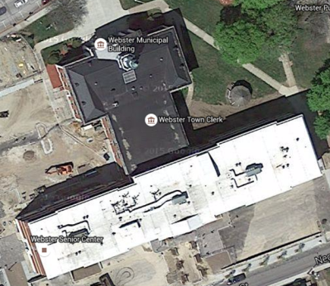
Auditorium
Senior center and apartments
Aerial view of Webster Town Hall and attached residential/senior center building
Picture 5
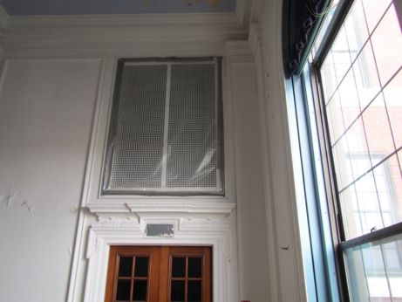
Taped off vents into the auditorium from the attached senior center/residential building
Picture 6
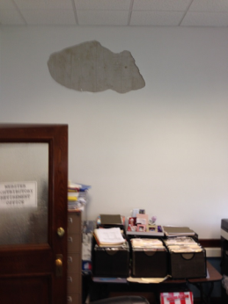
Cracked plaster in the retirement office
Picture 7
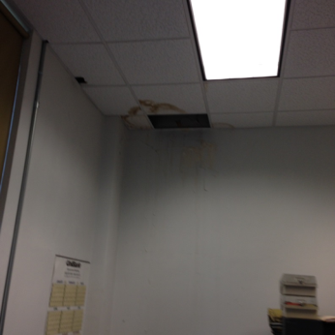
Water-damaged ceiling tile/wall in the room adjacent to the retirement office
Picture 8
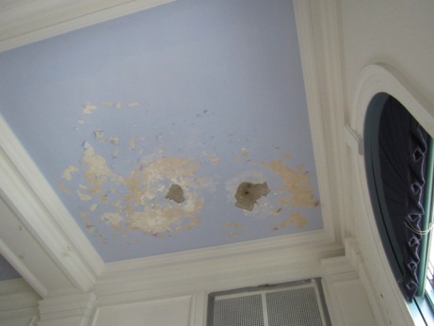
Water-damaged plaster in the auditorium
Picture 9
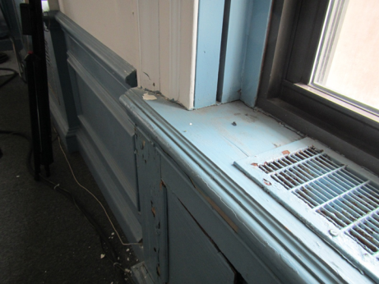
Water-damaged plaster, windowsill, and wall in a meeting room
Picture 10
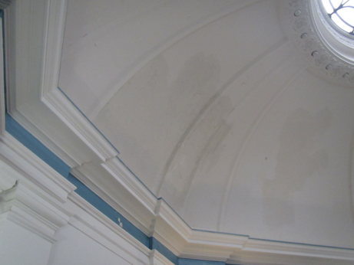
Water-damaged plaster in the central dome
Picture 11
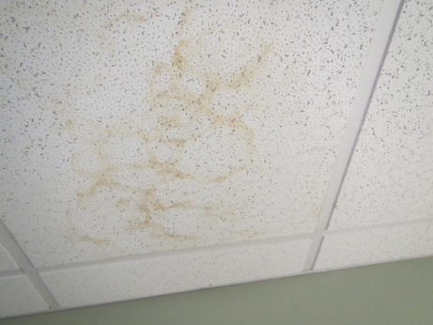
Water-damaged ceiling tile
Picture 12
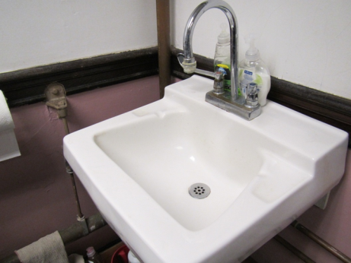
Small sink in basement
Picture 13
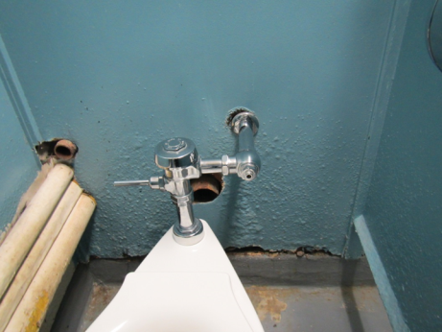
Broken pipe and gaps around pipes in women’s restroom
Picture 14
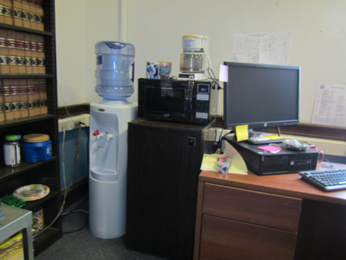
Water cooler and refrigerator on carpet
Picture 15
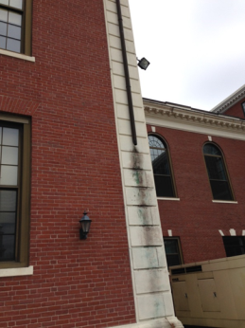
Broken downspout
Picture 16
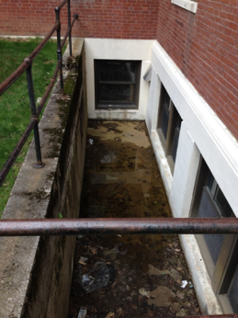
Water and debris in window well
Picture 17
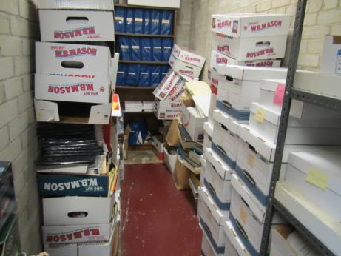
Stored items, including boxes on the floor of a below-grade area
Picture 18
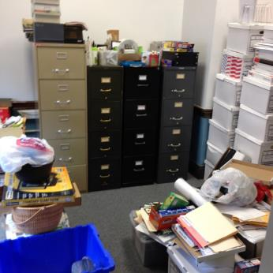
Stored items in an office
Picture 19
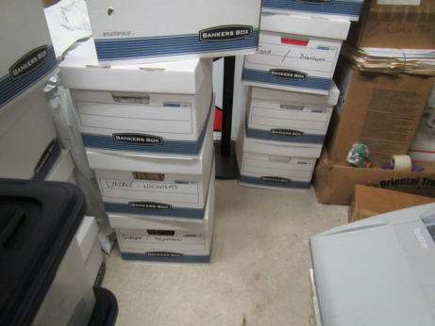
Stored boxes
Picture 20
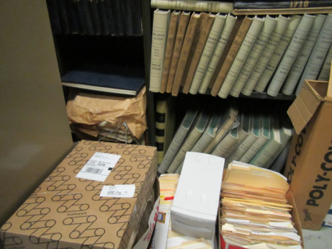
Old books and other stored items, some on the floor
Picture 21
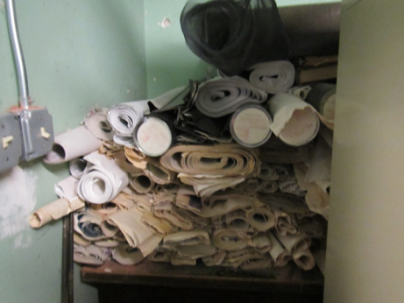
Old stored plans
Picture 22
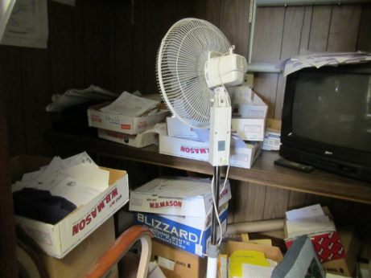
Items in one of the vault areas
Picture 23
\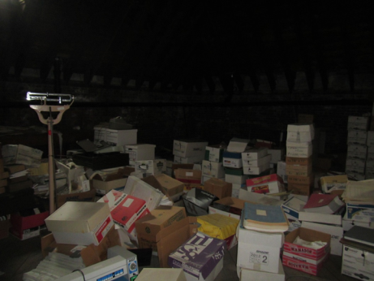
Items stored in the attic
Picture 24
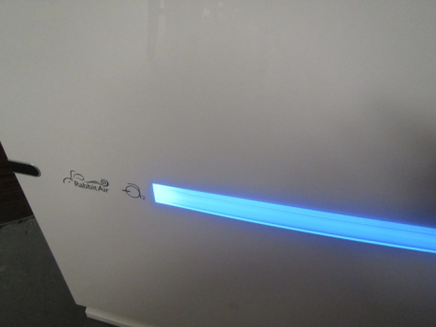
RabbitAir™ air purifier
Picture 25
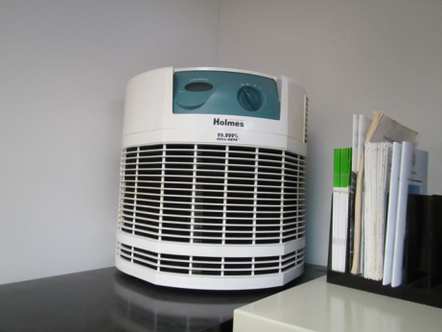
HEPA air purifier
Picture 26
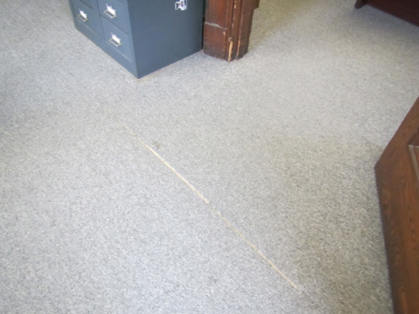
Worn, stained carpeting
Picture 27
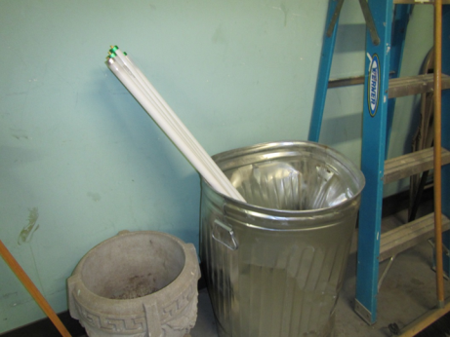
Improperly stored fluorescent bulbs

Location | Carbon  Dioxide  (ppm) | Carbon Monoxide  (ppm) | Temp  (°F) | Relative  Humidity  (%) | PM2.5  (µg/m³) | Occupants  in Room | Windows  Openable | Ventilation |  | Remarks
 |  |  |  |  |  |  |  | Supply | Exhaust
Background | 347 | 0.5 | 60 | 45 | 0 |  |  |  |  | Overcast and breezy
Basement
Board of Health Office | 646 | ND | 74 | 40 | 0 | 3 | Y | Y | N | APs, NC, HS
BOH Director’s Office | 681 | ND | 74 | 38 | 0 | 1 | N | Y | N | Fridge and microwave, NC, AP, papers, plant
BOH Vault |  |  |  |  |  |  |  |  |  | Paper/boxes on floor
BOH storage | 471 | ND | 74 | 33 | 0 | 0 | N | N | N
Engineering | 511 | ND | 72 | 36 | 1 | 1 | Y | N | N
Engineering storage |  |  |  |  |  |  |  |  |  | AI, boxes (note, there are several storage rooms in the engineering area)
Engineer’s Office | 397 | ND | 73 | 33 | 1 | 0 | Y | N | N | AP
Engineer’s conference room | 371 | ND | 72 | 34 | 0 | 0 | N | N | N | Carpet
Basement kitchen | 471 | ND | 71 | 38 | 0 | 0 | Y | N | N | Phone/data equipment, kitchen equipment, food.
First Floor
Town collector | 582 | ND | 70 | 39-40 | 1 | 1 | Y | N | N | DEM, HS, carpet – worn, WC on carpet
Town collector inner office | 609 | ND | 71 | 39 | 1 | 1 | Y | N | N | Reports of drafts, boxes on floor, DEM, shredder
Collection Desk | 584 | ND | 72 | 37 | 1 | 0 | Y | N | N | HS
Refrigerator area | 576 | ND | 72 | 37 | 1 | 0 | Y | N | N | Mini fridge
Bottom of auditorium
Board of selectman, entry | 630 | ND | 69 | 43 | 1 | 1 | N | N | N | Mail and copy equipment, carpet
Office | 787 | ND | 70 | 42 | 2 | 2 | Y | N | N | Carpeted, food preparation equipment
Side Office | 709 | ND | 71 | 41 | 1 | 1 | Y | N | N
Inside office | 706 | ND | 71 | 39 | 1 | 0 | N | N | N
IT | 605 | ND | 72 | 38 | 11 | 1 | Y | N | N | Sink (dry, nonfunctional), DEM, NC
IT storage | 587 | ND | 73 | 38 | 17 | 0 | Y | N | N | WD CT, items on floor, area used to floor
Community Development | 559 | ND | 73 | 37 | 39+ | 1 | Y | N | N | Food
Vault |  |  |  |  |  |  |  |  |  | Cleaner odor, use of Clorox and Lysol
Office Conference | 552 | ND | 74 | 36 | 48 | 0 |  | N | N | Sink, PC, AP, food
Women’s restroom |  |  |  |  |  |  |  |  |  | No exhaust vent, holes in walls, cleaners, plants
Assessor’s office entry | 697 | ND | 72 | 38 | 0 | 1 | Y | Y | N | Food, carpet
Assessor’s main | 644 | ND | 73 | 37 | 0 | 2 | Y | Y | N | Food, WC on carpet
Vault | 632 | ND | 73 | 34 | 0 | 0 | N | N | N | AI, old books
Left office | 623 | ND | 73 | 35 | 0 | 1 | Y | Y | N | Carpet
Right office | 658 | ND | 73 | 35 | 0 | 0 | Y | N | N | Low ceiling, old carpet
Front | 638 | ND | 73 | 35 | 0 | 0 | Y | N | N
Conference room | 369 | ND | 71 | 36 | 0 | 0 | Y | N | N | Musty/leather smell, old books
Second Floor
Town Clerk | 661 | ND | 72 | 34 | 1 | 1 | Y | N | N | WD CT, plants, carpeted, food
Town clerk inner office | 526 | ND | 72 | 34 | 0 | 0 | Y | N | N | Fridge and microwave, WC on carpet
Town clerk vault | 541 | ND | 72 | 32 | 0 | 0 | N | N | N | NC, old books and records, DO
Town clerk reception area | 586 | ND | 73 | 35 | 0 | 1 | Y | N | N
Accountant | 537 | ND | 72 | 35 | 0 | 3 | Y | N | N | Carpet, PFs, plants, WC on carpet, AP
Accountant inner office | 590 | ND | 72 | 34 | 0 | 0 | Y | N | N | Boxes on floor
Accountant Vault | 594 | ND | 72 | 32 | 0 | 0 | N | N | N | Food prep, NC, AI, boxes/AI on floor
Selectmen’s meeting room | 450 | ND | 71 | 34 | 0 | 0 | Y | Y | N | WD CT, WC on carpet, WD plaster near window
Top of Auditorium | 397 | ND | 68 | 35 | 0 | 0 | Y | Y | N | NC, significant WD plaster on ceiling, vents taped up
Treasurer | 670 | ND | 67 | 43 | 1 | 2 | Y | N | N | Carpet, plants
Treasurer inside office | 878 | ND | 69 | 44 | 0 | 0 | Y | N | N | Plant, carpet
Treasurer vault | 918 | ND | 69 | 39 | 0 | 0 | N | N | N | Mini fridge, CP/HS, boxes on floor, DO
Treasurer break room | 573 | ND | 72 | 36 | 0 | 0 | Y | N | N
Vault |  |  |  |  |  |  |  |  |  | WD ceiling, slight musty smell, old papers and books
Retirement | 644 | ND | 70 | 38 | 1 | 1 | Y | N | N | WC, WD plaster

