BULLETIN
What Massachusetts COVID-19 Vaccine Providers Need to Know
Week of 10/22/21

Latest Numbers

- As of 10/22, 4,705,194 people in Massachusetts have been fully vaccinated.

Who to Vaccinate this Week

- Anyone age 12 and older who lives, works, or studies in Massachusetts is eligible for a vaccine. Health care providers can also vaccinate their patient panels regardless of place of residency.
- Reminder Effective 9/24/2021, CDC recommends a Pfizer-BioNTech booster for certain people who received the two-dose Pfizer-BioNTech COVID-19 vaccine at least 6 months ago. See below for more information.
- Effective 8/13/21, CDC recommends that people who are moderately to severely immunocompromised receive an additional dose of an mRNA COVID-19 Vaccine (Pfizer-BioNTech or Moderna) at least 28 days after the completion of the initial mRNA COVID-19 vaccine series.

What to Know this Week

New FDA/CDC meetings
FDA’s advisory committee (VRBPAC) will meet October 26 to discuss 5-11 year old vaccination
CDC’s advisory committee (ACIP) has meetings currently scheduled for:
- October 20 & 21, current agenda includes COVID-19 vaccines discussion on Thursday October 21
- November 2 & 3, agenda has not yet been posted

New Listen to a COCA call on October 26, 2-3pm, What Clinicians Need to Know about the Recent Updates to CDC’s Recommendations for COVID-19 Boosters

New Preliminary information about Pfizer COVID-19 vaccines for children <12 years old
- There are approximately 28M children between the ages of 5-11 years old in the United States. The US government has procured enough vaccine to support vaccination of this population.
- The Pfizer-BioNTech COVID-19 Vaccine for 5–11-year-olds will be a new product with new packaging and a new national drug code (NDC). Current product for adults and adolescents should not be used in children.
- The new product configuration will be 10-dose vials, in packages of 10 vials (100 dose total) pending FDA authorization. The product can be stored for 10 weeks at 2-8°C. There will also be changes to the product shipper.
- COVID-19 pediatric vaccines will require diluent, and this will be provided with ancillary supplies which are configured specific to new vaccine packaging and appropriate for use in children.
- The new NDC will require additional coding and information technology accommodations, which are underway.

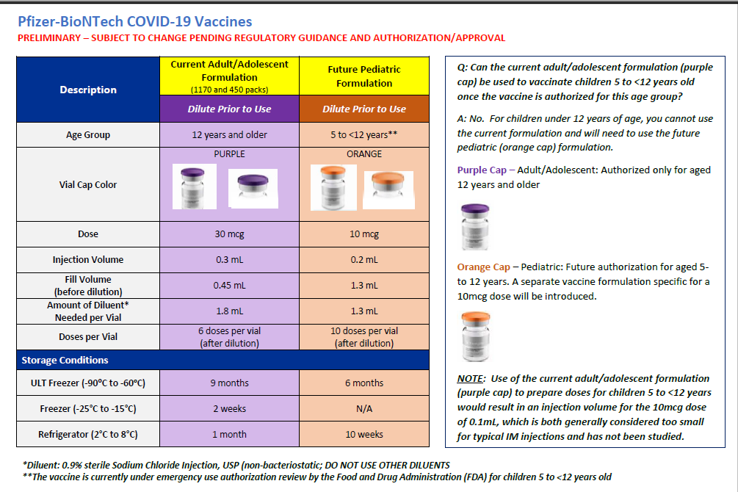

New Updated Guidance on Use and Allowable Wastage of COVID-19 Vaccine
Health care providers authorized to order, store, and administer the COVID-19 vaccine in Massachusetts, per the Massachusetts COVID-19 Vaccine Program agreement, should try to maintain no more than a 30 day supply of COVID-19 vaccine (up to 45 day supply allowable for primary care provider offices). Providers should track and rotate vaccine in stock by expiration date (administering oldest doses first) and should request assistance from DPH to transfer significant numbers of doses that are likely to expire before they can be administered.
Given the increase in vaccine availability, the Department is asking providers to maximize doses administered, understanding that this will increase waste. In the Commonwealth’s effort to effectively administer vaccines to as many individuals as possible, and to utilize as many doses as possible that are due to expire, the following guidance is provided:
Overall vaccine wastage should be maintained at or below 5% of a site’s overall COVID-19 vaccine inventory. For pediatric primary care practices this threshold should be at or below 10%.
For vials due to expire in 16-31 days 25% per vial wastage is permitted (for Pfizer 6-dose vials this means up to 2 doses; for Moderna 10-dose vials up to 3 doses; for Moderna 14-dose vials up to 4 doses; for Janssen/J&J 5-dose vials up 2 doses)
For vials due to expire in 8-15 days 50% per vial wastage is permitted (for Pfizer 6-dose vials this means up to 3 doses; for Moderna 10-dose vials up to 5 doses; for Moderna 14-dose vials up to 7 doses; for Janssen/J&J 5-dose vials up 3 doses)
For vials due to expire in 7 days or fewer, there is no limit on the number of doses in the vial that can be wasted if even a single dose can be administered before expiration.
Health care providers should use their best judgment when making decisions about puncturing a new vial and use the above standards as guiding principles. This guidance is intended to enable providers to meet the needs of individuals who remain unvaccinated when doses would otherwise be wasted. Please continue to contact the DPH Vaccine Unit at DPH-Vaccine-Management@massmail.state.ma.us for assistance managing your inventory or to arrange for transfers of excess doses of COVID-19 vaccine.

New The Importance of Keeping Consumer Demographic Information in MIIS Up to Date During COVID-19: Due to increased demand for access to vaccination records and proof of vaccination, it is critical that vaccination records remain as up-to-date as possible in the Massachusetts Immunization Information System (MIIS). As Massachusetts explores potential vaccine credential systems, the Department of Public Health is strongly encouraging providers to ensure they have an email address and/or phone number for every patient in their MIIS immunization records. For example, providers can do this via automated emails or text messages to their patients or by reconciling their internal records so each patient can be reached by phone or email.

The MIIS allows providers to access their patient records through this web-based application to enable demographic and immunization updates. You can view Patient Lookup in the MIIS for more information. Technical solutions will be available soon to allow demographic only updates to be sent directly from your electronic health record systems. Please contact the MIIS Helpdesk miishelpdesk@mass.gov for more information.

New The Institute for Safe Medication Practices has published a report titled Mix-Ups Between the Influenza (Flu) Vaccine and COVID-19 Vaccines in the October 7 issue of Medication Safety Alert.

Causative factors include increased demand and coadministration of the vaccines, syringes near each other, unlabeled syringes, distractions, and staffing shortages.

To avoid errors, ISMP recommends implementing these safety strategies: provide staffing support; separate vaccination areas; label the syringes; separate the vaccines; identify the patient and requested vaccine; involve the patient/parent in the checking process; document lot number/expiration date; scan the barcode; provide the intended vaccine; and report vaccine errors.

Reminder Pfizer-BioNTech boosters
These recommendations are ONLY for those who originally received the two-dose series of Pfizer’s COVID vaccine. Booster doses might be recommended as soon as this week for those who received COVID vaccines manufactured by Moderna or Janssen (Johnson & Johnson). The CDC Advisory Committee (ACIP) will be meeting on October 20 and 21. The agenda includes discussion of Moderna, J&J, and mixed boosters.

CDC recommends that the following groups should receive a booster dose of Pfizer-BioNTech’s COVID-19 vaccine at least 6 months after completing their Pfizer-BioNTech primary vaccine series:

- People aged 65 years and older
- Residents aged 18 years and older in long-term care settings
- People aged 50–64 years with underlying medical conditions

CDC recommends that a booster dose of Pfizer-BioNTech’s COVID-19 vaccine should be made available so that the following groups may receive a booster dose of Pfizer-BioNTech’s COVID-19 vaccine at least 6 months after completing their Pfizer-BioNTech primary vaccine series, based on their individual benefits and risks:

- People aged 18–49 years with underlying medical conditions
- People aged 18–64 years at increased risk for SARS-CoV-2 exposure and transmission because of occupational or institutional setting

Reminder Booster checkbox online
On Vaxfinder, Massachusetts’ COVID-19 vaccine finder, you’ll now find a box to check if you are looking specifically for a Pfizer booster dose.

Reminder Pfizer resources
- COVID-19 Vaccine Booster Shot
- Clinical Considerations
- Pfizer standing orders
- CDC Pfizer webpage
- Pfizer EUA/Fact Sheet for Providers https://www.fda.gov/media/144413/download
- Pfizer EUA/Fact Sheet for Recipients https://www.fda.gov/media/144414/download

Reminder Massachusetts resources
- COVID-19 booster frequently asked questions
- Eligibility questions and an Eligibility Checker tool
- Search for Vaccine locations: https://vaxfinder.mass.gov/
- COVID-19 Vaccine Resource Line/2-1-1 is available for individuals who are unable to use Vaxfinder, or have difficulty accessing the internet. Available in English and Spanish and has translators available in approximately 100 additional languages.
- COVID-19 Vaccine Information

Reminder CDC guidance supports coadministration of COVID-19 vaccines with other vaccines, including influenza vaccines, without regard to timing.
- ACIP 2021/2022 flu recommendations:
- Full report: Prevention and Control of Seasonal Influenza with Vaccines: Recommendations of the Advisory Committee on Immunization Practices, United States, 2021–22 Influenza Season.
- Full report pdf: https://www.cdc.gov/mmwr/volumes/70/rr/pdfs/rr7005a1-H.pdf
- Summary https://www.cdc.gov/flu/professionals/acip/summary/summary-recommendations.htm
- Summary pdf: https://www.cdc.gov/flu/pdf/professionals/acip/acip-2020-21-summary-of-recommendations.pdf

New All shipments of Pfizer 1170 tray orders are being suspended for shipment during the first week of November for the rollout of the Pfizer Pediatric vaccines so please plan accordingly in the coming weeks.

Reminder COVID Vaccine Ordering All vaccine orders placed in the MIIS are reviewed and approved within 3 business days after being submitted. Once approved, the Vaccine Management Unit submits orders daily to the CDC for processing and shipping. CDC ships vaccines within 3-4 business days. Orders from sites showing large, expiring, or expired doses of COVID vaccine inventory could be delayed, reduced, or canceled by the Vaccine Management Unit. To prevent orders from being delayed, reduced, or canceled providers must:
- ensure that the MIIS inventory matches the site’s physical inventory
- confirm that all doses administered have been reported and processed in MIIS
- confirm that all storage and handling issues have been reported in MIIS

Please Note: Repackaging of COVID vaccines doses for smaller ordering sizes is only available for primary care provider (PCP) offices – (pediatric, family medicine, internal medicine practices in addition to small specialty practices). Smaller dose orders can still be placed as usual in MIIS. Individual exceptions to these ordering limitations may be made on a case by case basis by contacting the Vaccine Unit.

The minimum dose amounts orderable by PCPs:
- 60 doses (6 dose vial) of Pfizer
- 70 doses (14 dose vial) of Moderna
- 25 doses (5 dose vial) of Johnson & Johnson

The Vaccine Unit will be fulfilling orders from the State Lab, and courier services will deliver vaccines and ancillary kits. Vaccines are transported in a cooler and in a refrigerated temperature range with a digital data logger. Upon receiving Pfizer and Moderna vaccines, ensure vaccines are placed in the refrigerator and write the beyond used date on the vials.

For all other provider sites, the following packaging presentation of COVID-19 vaccines are available for ordering:
- Pfizer 1170 doses
- Moderna 100 doses
- Moderna 140 doses
- Johnson and Johnson 100 doses
Pfizer 450 dose is no longer available for ordering.

Reminder Sites must provide a justification to order above the ceiling limits and meet the conditions below:
- Please plan your ordering and inventory to ensure you do not maintain more than a 30-day supply of vaccine (or up to a 45-day supply for primary care provider offices). Given the ample supply of vaccine, there is no need to order quantities beyond your anticipated 30-day/45-day throughput to ensure adequate supply.
- Report to the MIIS all doses within 24 hours of administration
- Agree to allowable vaccine wastage guidelines (updated October 13, 2021)

Reminder CDC COVID-19 Vaccination Record Cards As a reminder, COVID-19 Vaccination Record Cards remain property of the U.S. Government until provided to the vaccine recipient following vaccination. Unauthorized use and reproduction of the cards constitute fraud. Healthcare providers are encouraged to keep ample supply of vaccination record cards on site for those patients requesting replacements. Healthcare providers can order extra print copies from the MA Health Promotion Clearinghouse.

New CDC MMWRs
October 19, early release, Effectiveness of Pfizer-BioNTech mRNA Vaccination Against COVID-19 Hospitalization Among Persons Aged 12–18 Years — United States, June–September 2021

Resources & Learning Opportunities

New IAC’s Vaccines: COVID-19 main page has been updated to include the latest CDC materials on Pfizer-BioNTech COVID-19 Vaccine booster doses, additional doses for immunocompromised people, patient education, and vaccine confidence. This page provides links to key COVID-19 vaccine resource pages from IAC, CDC, and other partners.

New Influenza During the COVID-19 Pandemic - a new course from the American Academy of Pediatric - This four-part course series provides key information about the 2021-2022 flu season. The purpose of this PediaLink module is to educate pediatric health care professionals on the current American Academy of Pediatrics policy recommendations for routine use of seasonal influenza vaccine and antiviral medications for the prevention and treatment of influenza in infants, children, and adolescents. The recommendations for the prevention and treatment of influenza are updated annually.

Updated MDPH Immunization Division’s free accredited COVID-19 Vaccine Training was updated on October 13, 2021. A list of the updates is available from a link on the training site home page. These training sessions are designed for health care providers, vaccine coordinators, and all health care personnel who handle and/or administer COVID-19 vaccines.

Reminder Vaccine Providers: Check Out CDC’s New Learning Module on Vaccine Coadministration
CDC has a new resource for vaccine providers on coadministration of COVID-19 vaccines with other vaccines, including flu vaccines. This module covers clinical considerations, best practices, and resources on coadministration. Providers are encouraged to offer patients COVID-19 vaccine and flu vaccine at the same visit if the timing coincides. Continuing education is available for this course.

Reminder The AAP has launched a COVID-19 Vaccine Campaign Toolkit containing customizable messages, videos, and graphics to help reassure parents and caregivers about the COVID-19 vaccine for children, teens, and young adults. The contents of this toolkit are designed to reach parents who have not yet vaccinated their eligible children and encourage them to talk to a trusted provider.

Reminder Morbidity and Mortality Weekly Report, better known as MMWR, is CDC’s primary publication for disseminating the science it produces. The staff at MMWR have launched a landing page to help people find the latest information on COVID-19 vaccine effectiveness and safety.

MDPH Resources

Immunization Division Main Number
For questions about immunization recommendations, disease reporting, etc.
Phone: 617-983-6800 (24/7 MDPH Epi line)
Fax: 617-983-6840
Website: https://www.mass.gov/topics/immunization

MIIS Help Desk
Phone: 617-983-4335
Fax: 857-323-8321
Email questions to: miishelpdesk@mass.gov
Website: https://www.mass.gov/service-details/massachusetts-immunization-information-system-miis

MDPH Vaccine Unit
Phone: 617-983-6828
Email questions to: dph-vaccine-management@mass.gov
Website: https://www.mass.gov/service-details/vaccine-management

COVID email box:
Email questions to: COVID-19-Vaccine-Plan-MA@mass.gov

