BULLETIN
What Massachusetts COVID-19 Vaccine Providers Need to Know
Week of 10/27/21

Latest Numbers

- As of 10/27, 4,718,067 people in Massachusetts have been fully vaccinated.

Who to Vaccinate this Week

- Anyone age 12 and older who lives, works, or studies in Massachusetts is eligible for a vaccine. Health care providers can also vaccinate their patient panels regardless of place of residency.
- New Effective 10/21/2021, CDC recommends a booster shot of COVID-19 vaccines in certain populations. There are now booster recommendations for all three available COVID-19 vaccines in the United States. See below for more information.
- Certain individuals who received a Pfizer-BioNTech or Moderna COVID-19 vaccine are eligible for a booster shot 6 months or more after their initial series.
- All people who received the Johnson & Johnson COVID-19 vaccine are recommended to get a booster shot if it has been at least 2 months since their primary dose.
- Effective 8/13/21, CDC recommends that people who are moderately to severely immunocompromised receive an additional dose of an mRNA COVID-19 Vaccine (Pfizer-BioNTech or Moderna) at least 28 days after the completion of the initial mRNA COVID-19 vaccine series.

What to Know this Week

New FDA/CDC meetings
FDA’s advisory committee (VRBPAC) met October 26 to discuss 5-11 year old vaccination. They did end the day with a vote recommending authorization of the Pfizer BioNTech 10ug COVID-19 for children 5-11 years under Emergency Use Authorization. Next steps are for the FDA to consider its advisory committee’s recommendation. Once FDA approves/authorizes the vaccine, it can go to ACIP for consideration. After ACIP it goes to the CDC director. The 5-11 year old pediatric Pfizer COVID-19 vaccine should not be administered until the CDC director gives approval/authorization.

CDC’s advisory committee (ACIP) will meet November 2 & 3, the agenda has not yet been posted

A CDC COCA call is currently planned for November 4 at 2pm: Pediatric COVID-19 Vaccines: CDC’s Recommendations for COVID-19 Primary Series in Children 5–11 years old

New On October 21, ACIP recommended a booster shot of the Moderna and Johnson & Johnson/Janssen COVID-19 vaccine in certain populations. CDC Director, Dr. Rochelle Walensky accepted those recommendations and released a statement.
New Updated EUAs:
Once a new EUA Fact Sheet is issued, it must be used. Previous ones no longer contain accurate information.
- Pfizer Fact Sheet for Healthcare Providers: https://www.fda.gov/media/144413/download
- Pfizer Fact Sheet for Recipients and Caregivers: https://www.fda.gov/media/144414/download
- Moderna Fact Sheet for Healthcare Providers: https://www.fda.gov/media/144637/download
- Moderna Fact Sheet for Recipients and Caregivers: https://www.fda.gov/media/144638/download
- Janssen Fact Sheet for Healthcare Providers: https://www.fda.gov/media/146304/download
- Janssen Fact Sheet for Recipients and Caregivers: https://www.fda.gov/media/146305/download

New Watch for new/updated CDC resources and upcoming CDC informational activities related to the recommendation, including:
- Updated booster shot webpage for the public
- Updated Clinical Considerations
- Updated U.S. COVID-19 Vaccine Product Information (screening form, standing orders, product info)

New COVID-19 vaccine booster, after a mRNA primary series (Pfizer or Moderna)
People in the following groups are eligible to receive a booster shot at least 6 months after completion of their mRNA primary series:
- 65 years and older
- Age 18+ who live in long-term care settings
- Age 18+ who have underlying medical conditions
- Age 18+ who work in high-risk settings
- Age 18+ who live in high-risk settings

New COVID-19 vaccine booster, after a J&J/Janssen primary series
People in the following groups are recommended to receive a booster shot at least 2 months after their J&J/Janssen vaccine:
- Everyone age 18+

New COVID-19 vaccine dosages
 | Primary Series | 3rd dose in a primary series  (moderate to severely immunocompromised persons) | Booster Dose
Pfizer, age 12+ | 0.3mL  21 days apart | 0.3mL  At least 28 days after dose #2 | 0.3mL  At least 6 months after completing a primary series
Moderna, age 18+ | 0.5mL  28 days apart | 0.5mL  At least 28 days after dose #2 | 0.25mL  At least 6 months after completing a primary series
J&J/Janssen, age 18+ | 0.5mL  1 dose only | N/A | 0.5mL  At least 2 months after dose #1

Important notes:
- The Moderna booster dose is half the dose used in the primary series
- Pfizer-BioNTech and Janssen booster doses are the same dose as primary vaccine
- If an individual who is moderately to severely immunocompromised received a primary dose of Janssen vaccine and receives a booster dose using Moderna, the 0.25mL booster dose should be used
- Booster dose interval should follow the interval recommended by the primary series. People who received a single dose Janssen primary series can receive a mRNA COVID-19 booster dose at least 2 months after their single dose Janssen primary series
- 3rd doses of mRNA vaccine for immunocompromised persons were authorized in August, and therefore they are not yet eligible for booster doses. Guidance on booster doses for these people should be provided soon.

New Moderna Multidose Vials (MDVs)
The Moderna COVID-19 Vaccine is supplied in two MDV presentations: A MDV containing 5.5 mL and a MDV containing 7.5 mL
Primary series doses of 0.5 mL and booster doses of 0.25 mL may be extracted from either vial presentation.

- When extracting only primary series doses, a maximum of 11 doses (range: 10-11 doses) may be extracted from the vial containing 5.5 mL or a maximum of 15 doses (range: 13-15 doses) may be extracted from the vial containing 7.5 mL.

- When extracting only booster doses or a combination of primary series and booster doses, the maximum number of doses that may be extracted from either vial presentation should not exceed 20 doses. Do not puncture the vial stopper more than 20 times.

- The link below is provided to assist with determining the amount of waste that may be reported in vials of Moderna 14 or Moderna 10 when administering a combination of primary (0.5mL) and booster (0.25mL) doses. Guidance for Vaccine Providers and Organizations

  - Process a storage and handling issue in the MIIS to report the wasted doses remaining in the vial.

If the amount of vaccine remaining in the vial cannot provide a full dose of 0.5 mL or 0.25 mL, discard the vial and contents. Do not pool excess vaccine from multiple vials.

New Mixing and Matching COVID-19 Vaccines (heterologous boosters)
Eligible individuals may choose which vaccine they receive as a booster dose. Some people may have a preference for the vaccine type that they originally received, and others may prefer to get a different booster. CDC’s recommendations now allow for this type of mix and match dosing for booster shots. People who have questions about whether one vaccine is better for them than the others should discuss their individual situation with their healthcare provider. CDC has indicated that individual risk-benefit assessment informing which booster product to use may include the availability of booster product and the risk profile of vaccine boosters, including rare events.
**Important Note: this mix and match is for booster doses only! All doses of the primary series and additional dose (if indicated for moderately to severely immunocompromised people who received 2 doses of mRNA vaccine) should utilize the same vaccine product.

Reminder Definition of “fully vaccinated” has not changed. At this time, people are still considered fully vaccinated two weeks after their second dose in a 2-dose series, such as the Pfizer or Moderna vaccines, or two weeks after a single-dose vaccine, such as the J&J/Janssen vaccine.

Reminder Coadministration
If a patient is eligible, both flu and COVID-19 vaccines can be administered at the same visit, as recommended by CDC and ACIP. In addition to flu vaccine, COVID-19 vaccine can be given with other vaccines as well.

New Pfizer Vaccines US Medical Affairs will be hosting Immunization Site Training Sessions for All Providers on the Storage, Handling, & Administration for Current & Potential New Formulations of our COVID-19 vaccine.

These sessions will be updated to reflect new information and changes that evolve. Such updates will be identified at the start of each session and further explained during each presentation.
Use the links below to join the sessions at the designated times.

Date & Time | Password
Attendee link – October 28 – 12 PM ET | 9ywEun8Mjs7
Attendee link – October 29 – 12 PM ET | cnRBrmGr324
Attendee link – November 1 – 5 PM ET | g9ZmgHaip32
Attendee link – November 2 – 5 PM ET | sJDZQERp325
Attendee link – November 3 – 12 PM ET | 82qdN3PppPp
Attendee link – November 4 – 12 PM ET | Y4ZkXdh2bz7
Attendee link – November 5 – 12 PM ET | rJSpNPts332

New Moderna is offering a webinar for vaccination providers to learn more about the Moderna COVID-19 Vaccine booster dose, which has been authorized for emergency use in the United States. There will be no continuing education offered for this webinar. Please register at the link below for one of our available sessions.

Webinar: Important updates on the mRNA-1273 50 µg Booster Dose
- Thursday, October 28th at 12pm ET – Register here for Oct 28
- Thursday, November 4th at 3pm ET – Register here for Nov 4
- Thursday, November 11th at 12pm ET – Register here for Nov 11

Reminder Preliminary information about Pfizer COVID-19 vaccines for children <12 years old
- There are approximately 28M children between the ages of 5-11 years old in the United States. The US government has procured enough vaccine to support vaccination of this population.
- The Pfizer-BioNTech COVID-19 Vaccine for 5–11-year-olds will be a new product with new packaging and a new national drug code (NDC). Current product for adults and adolescents should not be used in children.
- The new product configuration will be 10-dose vials, in packages of 10 vials (100 dose total) pending FDA authorization. The product can be stored for 10 weeks at 2-8°C. There will also be changes to the product shipper.
- COVID-19 pediatric vaccines will require diluent, and this will be provided with ancillary supplies which are configured specific to new vaccine packaging and appropriate for use in children.
- The new NDC will require additional coding and information technology accommodations, which are underway.

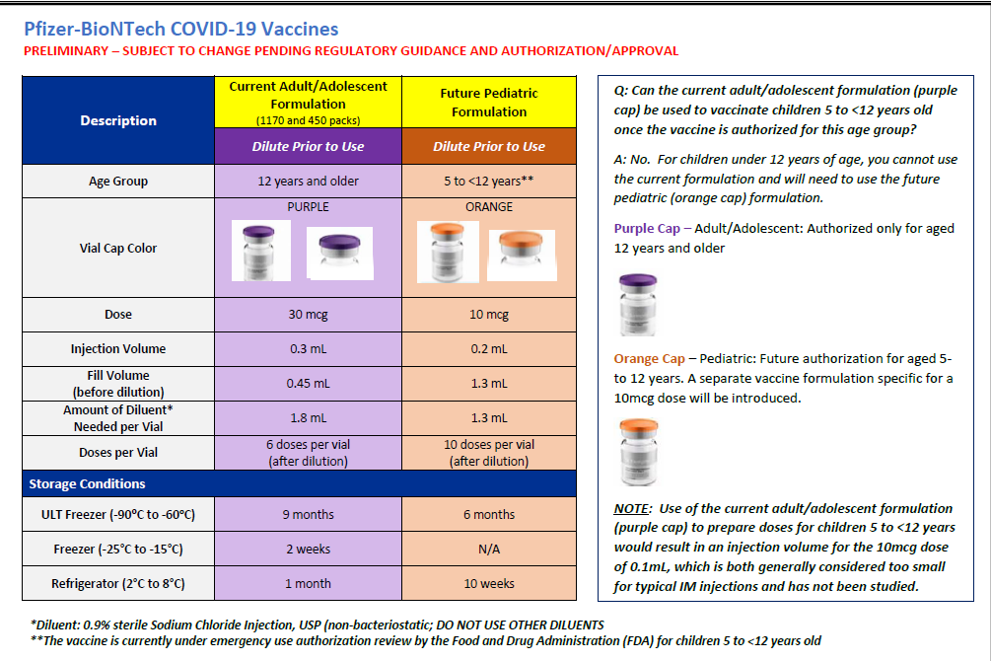

Reminder The Importance of Keeping Consumer Demographic Information in MIIS Up to Date During COVID-19: Due to increased demand for access to vaccination records and proof of vaccination, it is critical that vaccination records remain as up-to-date as possible in the Massachusetts Immunization Information System (MIIS). As Massachusetts explores potential vaccine credential systems, the Department of Public Health is strongly encouraging providers to ensure they have an email address and/or phone number for every patient in their MIIS immunization records. For example, providers can do this via automated emails or text messages to their patients or by reconciling their internal records so each patient can be reached by phone or email.

The MIIS allows providers to access their patient records through this web-based application to enable demographic and immunization updates. You can view Patient Lookup in the MIIS for more information. Technical solutions will be available soon to allow demographic only updates to be sent directly from your electronic health record systems. Please contact the MIIS Helpdesk miishelpdesk@mass.gov for more information.

Reminder Massachusetts resources
- COVID-19 booster frequently asked questions
- Eligibility questions and an Eligibility Checker tool
- Search for Vaccine locations: https://vaxfinder.mass.gov/
- COVID-19 Vaccine Resource Line/2-1-1 is available for individuals who are unable to use Vaxfinder, or have difficulty accessing the internet. Available in English and Spanish and has translators available in approximately 100 additional languages.
- COVID-19 Vaccine Information

Reminder Pfizer 1170 shipment suspended To maximize delivery of Pfizer pediatric doses, shipment of the Pfizer 1170 trays will be suspended on Friday, October 29th. Shipments will restart on Thursday, November 4 (or 6 days after the FDA meeting is set for).

Reminder COVID Vaccine Ordering All vaccine orders placed in the MIIS are reviewed and approved within 3 business days after being submitted. Once approved, the Vaccine Management Unit submits orders daily to the CDC for processing and shipping. CDC ships vaccines within 3-4 business days. Orders from sites showing large, expiring, or expired doses of COVID vaccine inventory could be delayed, reduced, or canceled by the Vaccine Management Unit. To prevent orders from being delayed, reduced, or canceled providers must:
- ensure that the MIIS inventory matches the site’s physical inventory
- confirm that all doses administered have been reported and processed in MIIS
- confirm that all storage and handling issues have been reported in MIIS

Please Note: Repackaging of COVID vaccines doses for smaller ordering sizes is only available for primary care provider (PCP) offices – (community health centers, pediatric, family medicine, internal medicine practices in addition to small specialty practices). Smaller dose orders can still be placed as usual in MIIS. Individual exceptions to these ordering limitations may be made on a case by case basis by contacting the Vaccine Unit.

The minimum dose amounts orderable by PCPs:
- 60 doses (6 dose vial) of Pfizer
- 70 doses (14 dose vial) of Moderna
- 25 doses (5 dose vial) of Johnson & Johnson

The Vaccine Unit will be fulfilling orders from the State Lab, and courier services will deliver vaccines and ancillary kits. Vaccines are transported in a cooler and in a refrigerated temperature range with a digital data logger. Upon receiving Pfizer and Moderna vaccines, ensure vaccines are placed in the refrigerator and write the beyond used date on the vials.

For all other provider sites, the following packaging presentation of COVID-19 vaccines are available for ordering:
- Pfizer 1170 doses
- Moderna 100 doses
- Moderna 140 doses
- Johnson and Johnson 100 doses
Pfizer 450 dose is no longer available for ordering.

Reminder Sites must provide a justification to order above the ceiling limits and meet the conditions below:
- Please plan your ordering and inventory to ensure you do not maintain more than a 30-day supply of vaccine (or up to a 45-day supply for primary care provider offices). Given the ample supply of vaccine, there is no need to order quantities beyond your anticipated 30-day/45-day throughput to ensure adequate supply.
- Report to the MIIS all doses within 24 hours of administration
- Agree to allowable vaccine wastage guidelines (updated October 13, 2021)

New Moderna Expiry Extension Moderna continues to update data regarding extension of expired dates. A total of 78 lots have been approved for extension to date. Expiration dates are in the process of being updated in the MIIS inventory page.

The product must be maintained in the frozen state for the extension to be applicable (extension does not apply to thawed vials). Moderna’s look up tool remains the official indicator of product expiry.

https://www.modernatx.com/covid19vaccine-eua/providers/vial-lookup#vialLookUpTool

Resources & Learning Opportunities

Reminder Morbidity and Mortality Weekly Report, better known as MMWR, is CDC’s primary publication for disseminating the science it produces. The staff at MMWR have launched a landing page to help people find the latest information on COVID-19 vaccine effectiveness and safety.
New CDC MMWRs
October 22, 2021 (Early Release)
- Severity of Disease Among Adults Hospitalized with Laboratory-Confirmed COVID-19 Before and During the Period of SARS-CoV-2 B.1.617.2 (Delta) Predominance — COVID-NET, 14 States, January–August 2021
- COVID-19 Vaccination and Non–COVID-19 Mortality Risk — Seven Integrated Health Care Organizations, United States, December 14, 2020–July 31, 2021
October 22, 2021
- Effectiveness of Pfizer-BioNTech mRNA Vaccination Against COVID-19 Hospitalization Among Persons Aged 12–18 Years — United States, June–September 2021

Reminder IAC’s Vaccines: COVID-19 main page has been updated to include the latest CDC materials on Pfizer-BioNTech COVID-19 Vaccine booster doses, additional doses for immunocompromised people, patient education, and vaccine confidence. This page provides links to key COVID-19 vaccine resource pages from IAC, CDC, and other partners.

Reminder Influenza During the COVID-19 Pandemic - a new course from the American Academy of Pediatric - This four-part course series provides key information about the 2021-2022 flu season. The purpose of this PediaLink module is to educate pediatric health care professionals on the current American Academy of Pediatrics policy recommendations for routine use of seasonal influenza vaccine and antiviral medications for the prevention and treatment of influenza in infants, children, and adolescents. The recommendations for the prevention and treatment of influenza are updated annually.

Updated MDPH Immunization Division’s free accredited COVID-19 Vaccine Training was updated on October 13, 2021. A list of the updates is available from a link on the training site home page. These training sessions are designed for health care providers, vaccine coordinators, and all health care personnel who handle and/or administer COVID-19 vaccines.

Reminder Vaccine Providers: Check Out CDC’s New Learning Module on Vaccine Coadministration
CDC has a new resource for vaccine providers on coadministration of COVID-19 vaccines with other vaccines, including flu vaccines. This module covers clinical considerations, best practices, and resources on coadministration. Providers are encouraged to offer patients COVID-19 vaccine and flu vaccine at the same visit if the timing coincides. Continuing education is available for this course.

Reminder The AAP has launched a COVID-19 Vaccine Campaign Toolkit containing customizable messages, videos, and graphics to help reassure parents and caregivers about the COVID-19 vaccine for children, teens, and young adults. The contents of this toolkit are designed to reach parents who have not yet vaccinated their eligible children and encourage them to talk to a trusted provider.

MDPH Resources

Immunization Division Main Number
For questions about immunization recommendations, disease reporting, etc.
Phone: 617-983-6800 (24/7 MDPH Epi line)
Fax: 617-983-6840
Website: https://www.mass.gov/topics/immunization

MIIS Help Desk
Phone: 617-983-4335
Fax: 857-323-8321
Email questions to: miishelpdesk@mass.gov
Website: https://www.mass.gov/service-details/massachusetts-immunization-information-system-miis

MDPH Vaccine Unit
Phone: 617-983-6828
Email questions to: dph-vaccine-management@mass.gov
Website: https://www.mass.gov/service-details/vaccine-management

COVID email box:
Email questions to: COVID-19-Vaccine-Plan-MA@mass.gov

