BULLETIN
What Massachusetts COVID-19 Vaccine Providers Need to Know
Week of 1/11/2022
LATEST NUMBERS
- As of 1/11/2022 5,132,780 people in Massachusetts have been fully vaccinated.
Massachusetts has now fully vaccinated over 5 million people!

WHO TO VACCINATE THIS WEEK
COVID-19 vaccination is recommended for everyone aged 5 years and older for the prevention of coronavirus disease 2019 (COVID-19). People ages 5-17 can get the Pfizer vaccine. People age 18+ can get any vaccine.

- A primary series for anyone ages 5 and older who lives, works, or studies in Massachusetts is eligible for a vaccine. Health care providers can also vaccinate their patient panels regardless of place of residency.
- An additional (third) mRNA primary series dose for people ages 5 and older who are moderately to severely immunocompromised, at least 28 days after the completion of the second mRNA COVID-19 vaccine dose.
- A booster dose for everyone ages 12 years and older
- At least 5 months after completion of an mRNA vaccine primary series.
(includes those who received two doses of different mRNA vaccine products, and those immunocompromised persons who received an additional primary series dose)
- At least 2 months after completion of a Janssen/J&J primary dose.

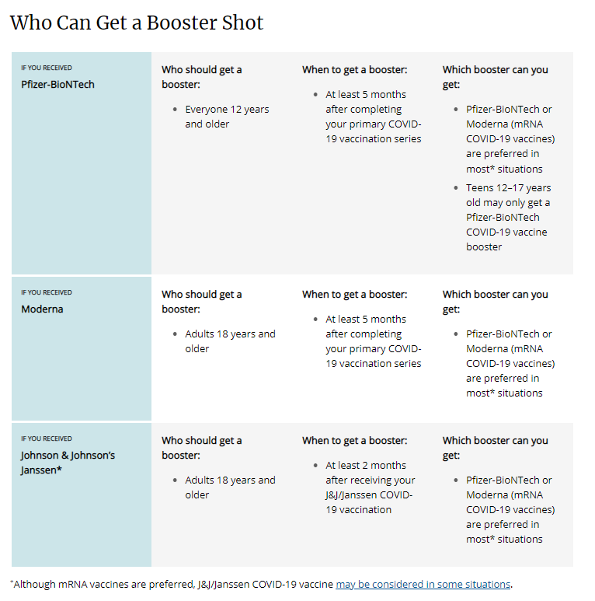

WHAT TO KNOW THIS WEEK

New Updated FDA/CDC Recommendations
- (1/4/22) CDC recommends Pfizer booster at 5 months, and additional primary dose for immunocompromised children ages 5-11. Read more: CDC press release.
- (1/5/21) ACIP Recommends Adolescents 12-17 “Should” Get a Booster - ACIP voted 13 -1 to recommend “A single Pfizer-BioNTech COVID-19 vaccine booster dose is recommended for persons aged 12-17 years at least 5 months under FDA’s EUA”.
- (1/7/21) CDC shortens interval for booster dose of Moderna COVID-19 vaccine to 5 months. Read more here.

Reminder mRNA COVID-19 Vaccines Preferred Over the Janssen/J&J COVID-19 Vaccine
On December 16th CDC endorsed recommendations made by ACIP earlier in the day, expressing a clinical preference for individuals to receive an mRNA COVID-19 vaccine over Janssen/J&J COVID-19 vaccine.

See the Clinical Considerations for more information, some of which is detailed here:

- In most situations, Pfizer-BioNTech or Moderna COVID-19 vaccines are preferred over the Janssen/J&J COVID-19 vaccine for primary and booster vaccination, including boosters for those who received Janssen/J&J COVID-19 vaccine for their single dose primary series
- Janssen/J&J COVID-19 vaccines may be offered to the following populations:
  - Persons with a contraindication to mRNA COVID-19 vaccines (e.g. severe allergic reaction after a previous dose or to a component of an mRNA COVID-19 vaccine)
  - Persons who would otherwise remain unvaccinated for COVID-19 due to limited access to mRNA COVID-19 vaccines
  - Persons who would prefer the Janssen/J&J COVID-19 vaccine despite safety concerns identified

Reminder Stay Up to Date with Your Vaccines
To align with standard language CDC uses about other vaccinations, CDC will now use the phrase “up to date” when talking about COVID-19 vaccination. CDC recommends that individuals stay “up to date” by receiving any additional doses they are eligible for, according to CDC’s recommendations, to ensure they have optimal protection against COVID-19. The technical definition of “fully vaccinated” – two doses of an mRNA vaccine or one dose of the Janssen/J&J vaccine – has not changed. Individuals are considered fully vaccinated once they have received their primary series. For more information, please visit Stay Up to Date with Your Vaccines.

Reminder State-sponsored COVID-19 vaccination locations opening in Boston, Roxbury, Lynn, and Taunton Beginning in early January, eligible residents aged 5 and older will be able to receive their primary series of COVID-19 vaccinations and residents aged 16 and older will be able to receive their booster shots at these locations. These sites add to the nearly 1,000 locations statewide where residents can receive their COVID-19 vaccine and booster.
Fenway Park: 4 Jersey Street, Boston, MA
- Opened January 6th
- Capacity to administer 1,300 doses daily.
- Administering primary series for individuals 5+, as well as boosters.
- Appointments are available by visiting vaxfinder.mass.gov . Walk-ins also accepted.
Melnea Cass Recreation Complex, 120 MLK Jr Blvd, Roxbury, MA
- Opened January 5th
- Capacity to administer 400 doses daily.
- Administering Pfizer primary series for individuals 5+, as well as Pfizer boosters.
- Appointments are available by visiting vaxfinder.mass.gov . Walk-ins also accepted.
Whittier Street Health Center, 1290 Tremont Street, Roxbury, MA
- Opened in December
- Capacity to administer 500 doses daily.
- Administering primary series for individuals 5+, as well as boosters.
- Appointments are available now by visiting vaxfinder.mass.gov . Walk-ins also accepted.
North Shore Community College, Modular Building at 300 Broad Street, Lynn, MA
- Opened January 5th
- Capacity to administer 400 doses daily.
- Administering primary series for individuals 5+, as well as boosters.
- Appointments are available now by visiting vaxfinder.mass.gov . Walk-ins also accepted.
Taunton COVID-19 Vaccine Clinic, 2005 Bay Street, Taunton, MA
- Opening January 6th
- Capacity to administer 400 doses daily.
- Administering primary series for individuals 5+, as well as boosters.
- Appointments are available now by visiting vaxfinder.mass.gov

Reminder Pfizer ‘gray top/Do Not Dilute/12+’ Now Available
This formulation has a gray vial cap, smaller pack ordering, and easier use. The minimum order size is 300 doses, and the product does not require reconstitution with a diluent. The 6-dose vial has the same dose volume as the purple cap (0.3mL) and is stable at 2ºC to 8ºC for up to 10 weeks. The product can also be stored at ultra-low freezer temp (-90ºC to -60ºC) for up to 9 months. Do not store this formulation in a freezer (-25ºC to -15ºC).

To place an order for the Pfizer 12+ gray cap vaccines, create a COVID order. You will find ‘COVID-19 Pfizer 12+’ under the Vaccine column. If you do not see this under the ‘Vaccine’ column, click on ‘add vaccine’. Select Pfizer, NDC 59267-1025-04. Vaccines are orderable in 300-dose increments. There will be no repackaging of vaccines for smaller order amounts.

Providers should use up the Pfizer purple cap product in their inventory prior to transitioning to the new gray cap product to help ensure vaccine is not wasted and to reduce administration or storage errors.

Reminder Expiration Extension for Pfizer orange cap/Dilute/5-11year old and gray cap/Do Not Dilute/12+year old
On December 16th the FDA approved a shelf-life extension for the Pfizer Pediatric vaccine (orange cap, 5-11 year old, diluent required) and Adolescent/Adult Tris vaccine (gray cap, age 12+, no diluent). This approval may be found at Healthcare Providers for 5-11 years of age, orange cap (must dilute) (fda.gov) ; Healthcare Providers for 12 years of age and older, gray cap (no dilution) (fda.gov) and takes effect immediately. This extension applies to frozen (ULT) inventories only.

As you are aware, the date printed on the Pfizer Pediatric (orange cap) and Adolescent/Adult (gray cap, 12+, no diluent) vaccine vials indicate the manufacture date and NOT the expiration date. Originally, the expiration date was 6 months from the manufacture date. The expiration date for Pfizer orange and gray cap vaccine has now been extended to 9 months (while held at ULT frozen). The Fact Sheets for both orange and gray cap vials provided by the FDA now reads, “regardless of storage conditions, vaccines should not be used after 9 months from the date of manufacture printed on the vial and cartons”. The updated expiry dates for both the orange and gray cap vials based on 9 months from the date of manufacture are provided below.

Printed Manufacturing Date | 9-Month Expiry Date*
06/2021 | Feb. 28, 2022
07/2021 | Mar. 31, 2022
08/2021 | Apr. 30, 2022
09/2021 | May 31, 2022
10/2021 | Jun. 30, 2022
11/2021 | July. 31, 2022
12/2021 | Aug. 31, 2022
01/2022 | Sept. 30, 2022
02/2022 | Oct. 31, 2022
*Date of expiration always falls on the last day of the month

The QR code provided on the Pfizer Pediatric Vaccine carton provides a link to the EUA but does not provide information on expiration dates.

Reminder Storage of Pfizer Orange Cap/Dilute/5-11yo and Gray Cap/Do Not Dilute/12+yo
Please follow EUA recommendations for storage:

Pfizer 5 through 11 years of age formulation (Orange Cap)
- If not previously thawed at 2ºC to 8ºC (35ºF to 46ºF), allow vials to thaw at room temperature [up to 25ºC (77ºF)] for 30 minutes.
- Pfizer-BioNTech COVID-19 Vaccine multiple dose vials with orange caps and labels with orange borders may be stored at room temperature [8°C to 25°C (46°F to 77°F)] for a total of 12 hours prior to dilution.
- After dilution, the vial should be held between 2ºC to 25°C (35°F to 77°F). Vials should be discarded 12 hours after dilution.

Pfizer Gray Cap/Do Not Dilute/12 years and older formulation.
- Frozen vials may be stored in an ultra-low temperature freezer at -90ºC to -60ºC (-130ºF to -76ºF). Do not store vials at -25°C to -15°C (-13°F to 5°F). Once vials are thawed, they should not be refrozen.
- Vials may be transferred to the refrigerator [2ºC to 8ºC (35ºF to 46ºF)], thawed and stored for up to 10 weeks. The 10-week refrigerated expiry date should be recorded on the carton at the time of transfer. A carton of 10 vials may take up to 6 hours to thaw at this temperature.

Regardless of storage condition, vaccines should not be used after 9 months from the date of manufacture printed on the vial and cartons.

There is a nice comparison guide from the Pfizer website Pfizer Formulation/Presentation Guide – Dec 2021 (please note, as of 1/5/2022 the extended expiration dates at ultra low freezer temps are not yet reflected in this document)

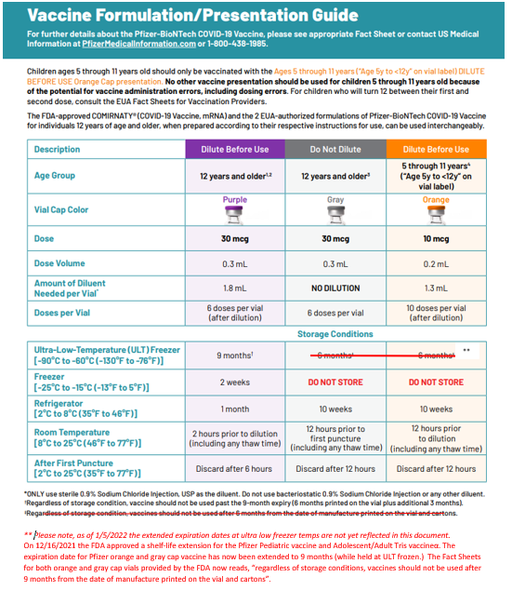

Reminder Monoclonal Antibody Treatment for COVID-19
Massachusetts has several public sites administering monoclonal antibody treatment, therapies that have shown to be effective in reducing severity of disease and keeping COVID-19-positive individuals from being hospitalized. Referral from a health care provider is required for treatment, which is provided at no cost to the patient and offered regardless of immigration status or health insurance. Patients should discuss with their health care providers whether monoclonal antibody treatment is right for them. For more info see the press release here: https://www.mass.gov/news/baker-polito-administration-announces-state-supported-monoclonal-antibody-treatment-sites-in-massachusetts

Provider information, including an overview, guidance, and a Monoclonal Antibody Therapy Locator can be found here.

New Public Portal Launch – Please Ensure Patient Information in the MIIS is Up to Date.
On January 10, 2022 the Baker-Polito administration announced a new option for residents to access their COVID-19 vaccination record from the state’s immunization registry and obtain a ‘SMART Health Card’ QR code to indicate proof of vaccination. Massachusetts residents can visit www.myvaxrecords.mass.gov, a web portal that follows national standards for security and privacy and provides residents a way to electronically view and save their COVID-19 vaccine record. By providing a cell phone number or email address, users can obtain a digital record of their vaccinations recorded in the Massachusetts Immunization Information System. Their COVID-19 vaccination record includes a unique QR code that can be saved to the user’s phone files, camera roll or the Apple Wallet. It can also be printed out for a paper record.
Patients now have increased accessibility to obtain their immunizations through My Vax Records. As a reminder it is important to keep patient demographic information in MIIS up to date during COVID-19. Massachusetts providers who vaccinate individuals are required to enter certain data into the Massachusetts Immunization Information System (MIIS). This allows users to access their vaccination records for any reason they may need them. Patients with missing or out-of-date demographic information (such as phone, email) may not be able to return a match. These patients will be directed to their healthcare provider who is responsible for updating their immunization record in the MIIS. Therefore, the Department of Public Health strongly encourages providers to ensure they have an email address and/or phone number for patients in their MIIS immunization records.

The MIIS allows providers to make updates to patient demographics in the following ways:

1. Access their patient records through this web-based application to enable demographic and immunization updates. You can view Patient Lookup in the MIIS for more information.
2. Technical solutions are available to allow demographic only updates to be sent directly from your electronic health record systems.
3. A one-time bulk file will be accepted and uploaded into the MIIS.

Please contact the MIIS Helpdesk miishelpdesk@mass.gov for more information.

COVID-19 VACCINE DOSAGES AND OTHER INFORMATION

Reminder COVID-19 Quick Reference Guide
CDC’s quick reference guide is a 2-page document that provides basic information on the proper storage, preparation, and administration of the currently authorized COVID-19 vaccine products in the United States.

Reminder CDC’s Product Info by US Vaccine webpage now has Pfizer info in three separate subpages:
- Orange Cap Age 5 through 11
- Purple Cap Age 12 and Older
- Gray Cap Age 12 and Older

Reminder Updated EUAs
Once a new EUA Fact Sheet is issued, it must be used. Previous ones no longer contain accurate information.
- Pfizer, HCP, 12 years of age and older, purple cap (must dilute): https://www.fda.gov/media/153713/download
- Pfizer, HCP, 12 years of age and older, gray cap (no dilution): https://www.fda.gov/media/153715/download
- Pfizer, HCP, 5 - 11 years of age, orange cap (must dilute): https://www.fda.gov/media/153714/download
- Pfizer, Recipient, 12 years of age and older: https://www.fda.gov/media/144414/download
- Pfizer, Recipient, 5-11 years: https://www.fda.gov/media/153717/download
- Moderna, HCP: https://www.fda.gov/media/144637/download
- Moderna, Recipient: https://www.fda.gov/media/144638/download
- Janssen, HCP: https://www.fda.gov/media/146304/download
- Janssen, Recipient: https://www.fda.gov/media/146305/download

Primary Series

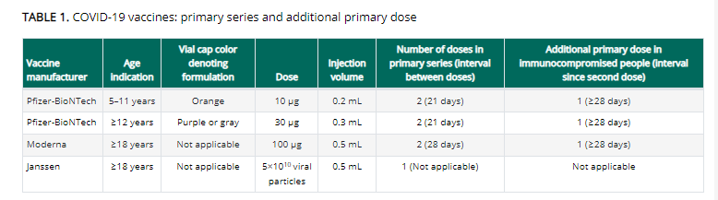

Boosters

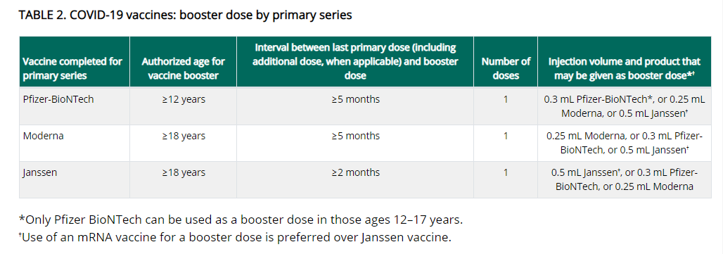

Vaccinate Your Family has put together this chart:

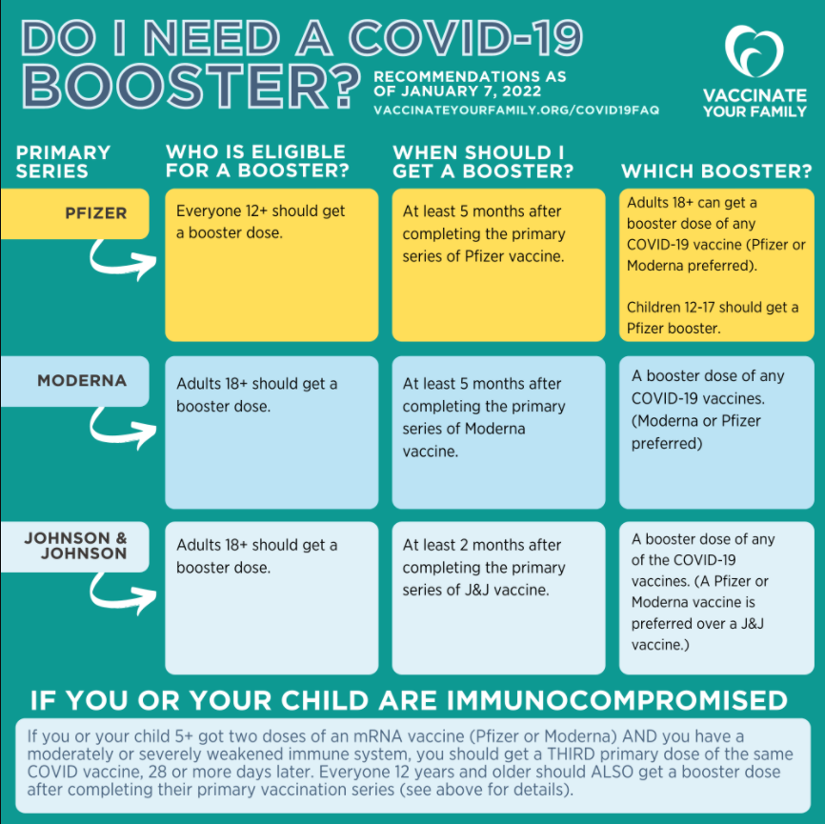

Reminder Booster doses for People who received COVID-19 vaccine outside the United States
The Interim Clinical Considerations contain guidance for these situations. Please refer to the guidance here.

People who completed all of the recommended doses of an WHO-EUL COVID-19 vaccine not approved or authorized by FDA, or people who completed a heterologous (mix-and-match) series composed of any combination of FDA-approved, FDA-authorized, or WHO-EUL COVID-19 vaccines:
- Are considered fully vaccinated.
- People aged ≥ 12 years (including moderately or severely immunocompromised people who received an additional primary dose) should receive a single booster dose of Pfizer-BioNTech COVID-19 Vaccine at least 5 months after completing their primary series.

Footnote 4, in the Clinical Considerations, has a list of WHO-EUL COVID-19 vaccines. The list will be updated as additional COVID-19 vaccines receive an EUL from WHO. As of 1/5/2022 the list is:

- Pfizer-BioNTech COVID-19 Vaccine (e.g., BNT162b2, COMIRNATY, Tozinameran)
- AstraZeneca-Oxford COVID-19 Vaccine (e.g., [ChAdOx1-S (recombinant)], AZD1222, Covishield, Vaxzevria)
- Janssen (Johnson & Johnson) COVID-19 Vaccine (e.g., Ad26.COV2.S)
- Moderna COVID-19 Vaccine (e.g., mRNA 1273, Takeda, Spikevax)
- Sinopharm-BIBP COVID-19 Vaccine
- Sinovac-CoronaVac COVID-19 Vaccine
- Bharat Biotech International COVID-19 Vaccine (e.g., BBV152, COVAXIN)
- Novavax COVID-19 Vaccine (e.g., NVX-CoV2373, Covovax)

Reminder Pfizer 1170 (effective 12/23) and 450 trays are discontinued and no longer available for ordering in the MIIS.

Reminder Moderna 14 is discontinued and no longer available for ordering in the MIIS. Orders for Moderna 10 will be identified by the same NDC as previous Moderna 10 orders (NDC= 80777-273-99).

All Moderna 10 orders will include 2 ancillary kits to support administration of booster doses.

- Process a storage and handling is for wasted/expired doses in the MIIS. The link here is the Vaccine Storage and Handling Problem - mini guide.

Reminder Moderna Expiry Extension
Moderna continues to update data regarding extension of expired dates. Expiration dates are in the process of being updated in the MIIS inventory page.
The product must be maintained in the frozen state for the extension to be applicable (extension does not apply to thawed vials). Moderna’s look up tool remains the official indicator of product expiry.
Look up the expiration date by scanning the QR code located on the carton or use the company’s expiration date lookup feature on its website.

RESOURCES & LEARNING OPPORTUNITIES

New From MAPC - Creative COVID-19 Communications
Free-to-use graphics, videos, and more! MAPC’s Arts & Culture and Public Health teams partnered with local artists and designers to produce creative, culturally resonant communications about COVID-19 and vaccinations. The materials are available for public use. Municipalities, health agencies, community groups, and members of the public can freely use them to encourage vaccinations in their communities.

Reminder Communication Skills for Clinicians Discussing COVID-19 Vaccination
PNQIN (Perinatal Neonatal Quality Improvement Network) and UMass Chan Medical School are offering free trainings on: Communication Skills for Clinicians Discussing COVID-19 Vaccination. This training is a 90-minute webinar designed to improve the counseling skills of Massachusetts clinicians and other providers for discussing COVID-19 vaccination with pregnant and postpartum people, parents and caregivers of young children, and families. The training will also focus on addressing vaccine hesitancy and reducing racial disparities in rates of COVID-19 vaccination. Continuing Education credits available.

Registration links and info:
January 14th: 12:00pm – 1:30pm
January 21st: 12:00pm – 1:30pm
February 11th: 12:00pm – 1:30pm

Reminder CDC launches “Interactive COVID-19 Vaccine Conversations Module for Healthcare Professionals”
CDC has launched a new resource to equip healthcare professionals with the tools they need to have effective COVID-19 vaccine conversations with patients. The Interactive COVID-19 Vaccine Conversations Module for Healthcare Professionals includes:
- Tips for Having Effective Vaccine Conversations with Patients
- Vaccine Conversations in Practice: Case Scenarios

Reminder Vaccine Education Center at Children’s Hospital of Philadelphia has a new video series, “Vaccine Conversations”, which features topics that today’s parents are commonly asking. The first videos for this series feature Dr. Offit and some pediatricians active on social media discussing vaccine topics related to their specialties. More videos will be coming soon.
- Vaccines, the Immune System, and Autoimmunity
- Vaccines and Breastfeeding
- Why Do We Give Vaccines for Diseases We Do Not See?
- Why Do Unvaccinated People Pose a Risk to vaccinated People?

Reminder COVID-19 Vaccine Webinar Series
CDC is offering a series of brief (15-20 minute) webinars addressing topics around COVID-19 vaccination. These interactive, web-based training modules offer a real-world perspective on different issues around COVID-19 vaccines. Topics range from routine clinical and vaccine safety information to guidance for on-site clinic vaccination activities and having conversations with vaccine recipients. Each webinar includes self-test practice questions and lists additional resources related to the topic discussed. The landing page for all mini webinars is here: https://www.cdc.gov/vaccines/covid-19/training-education/webinars.html

Reminder Access hundreds of free and accurate educational materials to support COVID-19 and flu vaccination in your community at the Vaccine Resource Hub. The Vaccine Resource Hub has been developed as a part of the CDC Foundation’s Partnering for Vaccine Equity program to support individuals and organizations working to increase immunization across all communities, especially those experiencing racial and ethnic disparities. Resources include infographics, toolkits, videos, unbranded digital assets, messaging, and much more - all free and available for download and sharing.

Please note, the Hub is being launched in two phases. During Phase One (now) the site already has many features, links, and content that you can search and download. In Phase Two (early 2022), the site will have even more content, pages, stories, webinars, and links.

Reminder Pfizer COVID-19 Vaccine Medical Updates on Current & Immunization Site Training
Pfizer Vaccines US Medical Affairs continues to host frequent (almost daily) Medical Updates & Immunization Site Training for All Providers. Session topics include:
- Use of vaccine for Children 5 through 11 Years of Age, and Individuals 12 Years of Age and Older
- Storage, Handling, Preparation, & Administration for the multiple presentations of the vaccine
- Recent medical updates regarding the vaccine
- An overview of healthcare provider resources
- Question and answer session

To access current and future training sessions, please visit: https://www.pfizermedicalinformation.com/en-us/medical-updates

Reminder Morbidity and Mortality Weekly Report, better known as MMWR, is CDC’s primary publication for disseminating the science it produces. The staff at MMWR have launched a landing page to help people find the latest information on COVID-19 vaccine effectiveness and safety.

CDC MMWRs
January 7, 2022 (EARLY RELEASE)
- Effectiveness of BNT162b2 (Pfizer-BioNTech) mRNA Vaccination Against Multisystem Inflammatory Syndrome in Children Among Persons Aged 12–18 Years — United States, July–December 2021
- Risk for Newly Diagnosed Diabetes >30 Days After SARS-CoV-2 Infection Among Persons Aged <18 years — United States, March 1, 2020–June 28, 2021
January 7, 2022
- Risk Factors for Severe COVID-19 Outcomes Among Persons Aged ≥18 Years Who Completed a Primary COVID-19 Vaccination Series — 465 Health Care Facilities, United States, December 2020–October 2021
- Receipt of COVID-19 Vaccine During Pregnancy and Preterm or Small-for-Gestational-Age at Birth — Eight Integrated Health Care Organizations, United States, December 15, 2020–July 22, 2021

MDPH RESOURCES

Reminder Massachusetts Resources
- COVID-19 Vaccine Information
- COVID-19 booster information and booster frequently asked questions
- Search for Vaccine locations: https://vaxfinder.mass.gov/
- COVID-19 Vaccine Resource Line/2-1-1 is available for individuals who are unable to use Vaxfinder, or have difficulty accessing the internet. Available in English and Spanish and has translators available in approximately 100 additional languages.

Immunization Division Main Number
For questions about immunization recommendations, disease reporting, etc.
Phone: 617-983-6800 (24/7 MDPH Epi line)
Fax: 617-983-6840
Website: https://www.mass.gov/topics/immunization

MIIS Help Desk
Phone: 617-983-4335
Fax: 857-323-8321
Email questions to: miishelpdesk@mass.gov
Website: https://www.mass.gov/service-details/massachusetts-immunization-information-system-miis

MDPH Vaccine Unit
Phone: 617-983-6828
Email questions to: dph-vaccine-management@mass.gov
Website: https://www.mass.gov/service-details/vaccine-management

COVID-19 Email Box
Email questions to: COVID-19-Vaccine-Plan-MA@mass.gov

