BULLETIN
What Massachusetts COVID-19 Vaccine Providers Need to Know
Week of 12/14/21
Latest Numbers
- As of 12/14/2021 5,008,626 people in Massachusetts have been fully vaccinated.
Massachusetts has now fully vaccinated over 5 million people!

Who to Vaccinate this Week
COVID-19 vaccination is recommended for everyone aged 5 years and older for the prevention of coronavirus disease 2019 (COVID-19).

- A primary series for anyone ages 5 and older who lives, works, or studies in Massachusetts is eligible for a vaccine. Health care providers can also vaccinate their patient panels regardless of place of residency.
- An additional (third) mRNA primary series dose for people ages 12 and older who are moderately to severely immunocompromised, at least 28 days after the completion of the second mRNA COVID-19 vaccine dose.
- New A booster dose for ages 16 and older. You’re eligible for a booster if:
    - Pfizer & Moderna: It’s been at least 6 months since the primary series
    - Johnson & Johnson: It’s been at least 2 months since the primary series

What to Know this Week
December 14, 2021 will mark the one-year anniversary of the first COVID-19 vaccine administered in the U.S (December 15th for the state of Massachusetts)!

Reminder Holiday Ordering and Delivery Cadence
All COVID-19 vaccines orders must be submitted no later than Thursday December 16th at noon (12PM) to ensure delivery before the holidays. Plan and order vaccines accordingly. Orders placed on the week of December 20th may not be delivered until after January 4, 2022.
No vaccine orders will be delivered Thursday, December 23rd through Monday, December 27th or Thursday, December 30th through Tuesday, January 4th.

BOOSTER DOSES
New COVID-19 Booster Recommendations expanded to include 16-and-17-year-olds
16–17-year olds can get a Pfizer booster. People 18+ can get any booster.

On 12/9/2021 CDC expanded COVID-19 booster recommendations to 16- and 17-year-olds. Information is available on the booster shots webpage and the Clinical Considerations webpage. At this time, only the Pfizer-BioNTech COVID-19 vaccine is authorized and recommended for adolescents aged 16 and 17.

In Massachusetts, following the updated recommendations and guidance from the CDC, MDPH announced that all adolescents ages 16 and 17 are able get their Pfizer COVID booster if they are at least 6 months post their initial Pfizer vaccination series. Adolescents ages 16 and 17 are able to receive the Pfizer COVID-19 booster from more than 500 locations including at retail pharmacies, primary care practices, regional collaboratives, local boards of health, community health centers, hospital systems, state-supported vaccination sites and mobile clinics. Visit www.mass.gov/covid19booster for more information.
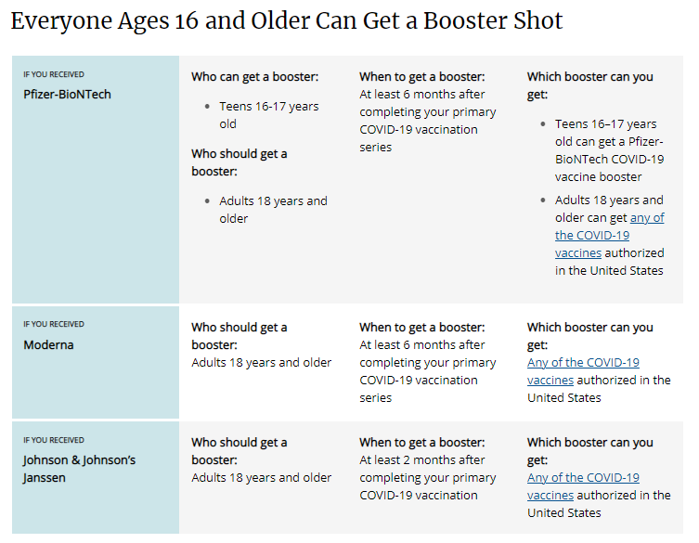

Providers should:
- Proactively outreach to patients who:
  - Are age 65 and older; or
  - Have underlying medical conditions; or
  - Received the J&J vaccine (single dose)

- Allow patients to self-determine their risk of exposure. Providers should not turn away any patient who requests a booster if the patient is:
  - 16 years of age or over and completed their primary series at least 6 months ago for the Moderna or Pfizer vaccine or received their J&J vaccine at least 2 months ago.
In addition to providing boosters, providers should take every opportunity to vaccinate anyone who has not yet received the COVID-19 vaccine by offering vaccine during routine or non-routine visits to medical offices, clinics, pharmacies, and hospitals.

Reminder The Importance of Keeping Consumer Demographic Information in MIIS Up to Date During COVID-19
As you know, Massachusetts providers who vaccinate individuals are required to enter certain data into the Massachusetts Immunization Information System (MIIS). This allows users to access their vaccination records for any reason they may need them.

The Massachusetts Department of Public Health is developing an online patient portal that will allow constituents to more easily access their own immunization record found in MIIS. This portal will eventually support a voluntary tool that will allow patients to easily and electronically access their vaccination status. To ensure that patients are able to utilize this system, it is critical that the MIIS database is up-to-date with their information.
Patients with missing or out-of-date demographic information (such as phone, email) may not be able to return a match. These patients will be directed to their healthcare provider who is responsible for updating their immunization record in the MIIS.
Therefore, the Department of Public Health strongly encourages providers to ensure they have an email address and/or phone number for patients in their MIIS immunization records.

The MIIS allows providers to make updates to patient demographics in the following ways:

1. Access their patient records through this web-based application to enable demographic and immunization updates. You can view Patient Lookup in the MIIS for more information.
2. Technical solutions are available to allow demographic only updates to be sent directly from your electronic health record systems.
3. A one-time bulk file will be accepted and uploaded into the MIIS.

Please contact the MIIS Helpdesk miishelpdesk@mass.gov for more information.

Reminder Pfizer ‘Gray Top/Do Not Dilute/12+’ Available to Order December 23rd
The transition to the Pfizer fully licensed vaccine formulation (Comirnaty) for ages 12+ will occur on December 23rd. This formulation will have a gray vial cap and allow for smaller pack ordering and easier use. The minimum order size will be 300 doses and the product does not require reconstitution with a diluent. The 6-dose vial will have the same dose volume as the current purple cap (0.3mL) and be stable at 2ºC to 8ºC for up to 10 weeks. The product can also be stored at ultra-low freezer temp (-90ºC to -60ºC) for up to 6 months. Do not store this formulation in a freezer (-25ºC to -15ºC).

Providers should use up the Pfizer purple cap product in their inventory prior to transitioning to the new gray cap product to help ensure vaccine is not wasted and to reduce administration or storage errors.

There is a nice comparison guide from the Pfizer website Pfizer Formulation/Presentation Guide – Nov 2021
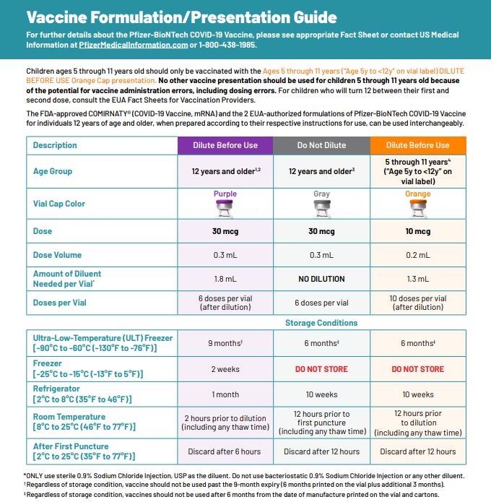

DOSES FOR THE 5-11 YEAR OLD POPULATION
CDC recommends Pfizer COVID-19 vaccine for children ages 5-11 years. The Pfizer pediatric (5-11 years of age) vaccine formulation:
- Must be placed in an ultracold freezer (until expiration date) or a refrigerator (for up to 10 weeks) upon receiving the vaccine. Do not place the vaccine in a regular freezer or use the shipper as temporary storage.
- Comes as a multiple dose vial with an orange cap and a label with an orange border
- The vials and cartons state ‘for age 5 years to <12 years’
- Must be diluted
- Primary series of 2 doses (0.2 mL each) 3 weeks apart in individuals 5 through 11 years of age
- Is NOT interchangeable with the 12 and older formulations
- CDC webpage on COVID-19 Vaccination for Children 5-11 Years Old

Reminder Pfizer-BioNTech COVID-19 Vaccine: Clinical Materials for Ages 5 through 11 years from CDC

Reminder Online MA Resources
Trust the Facts Get the Vax Materials, including:
- Updated! - Videos for Parents (on vaccine safety and efficacy; in multiple languages)
- Flyer: "Protect Yourself. Protect Your Family" (printable, also in Spanish)
- Flyer: "COVID-19 Vaccine Facts for Parents" (printable)

DPH Website: COVID-19 vaccinations for children 5-11 (info on vaccine safety, finding a vaccine, printable consent forms, and more)

Trusted Sources Video: Dr. Frinny Polanco Walters at Boston Children's Hospital (in English and Spanish)

Ideas for Promoting Pediatric Clinics and Vaccine Availability (list of ideas and resources for community organizations, providers, and more)

Frequently asked questions on COVID-19 vaccine with a focus on children & youth with complex medical needs webpage

COVID-19 VACCINE DOSAGES AND OTHER INFORMATION
Reminder Updated EUAs
Once a new EUA Fact Sheet is issued, it must be used. Previous ones no longer contain accurate information.
- Pfizer, HCP, 12 years of age and older, purple cap (must dilute): https://www.fda.gov/media/153713/download
- Pfizer, HCP, 12 years of age and older, gray cap (no dilution) This formulation is not yet available in the United States: https://www.fda.gov/media/153715/download
- Pfizer, HCP, 5 - 11 years of age, orange cap (must dilute): https://www.fda.gov/media/153714/download
- Pfizer, Recipient, 12 years of age and older: https://www.fda.gov/media/144414/download
- Pfizer, Recipient, 5-11 years: https://www.fda.gov/media/153717/download
- Moderna, HCP: https://www.fda.gov/media/144637/download
- Moderna, Recipient: https://www.fda.gov/media/144638/download
- Janssen, HCP: https://www.fda.gov/media/146304/download
- Janssen, Recipient: https://www.fda.gov/media/146305/download

Primary Series
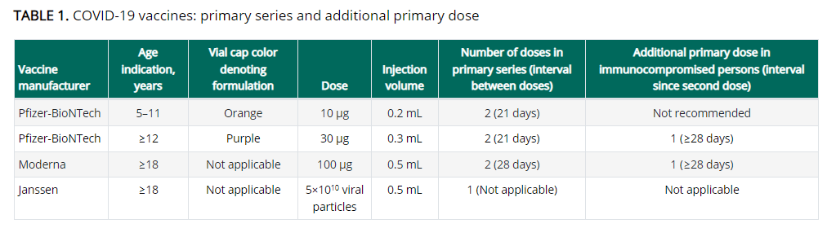

Boosters
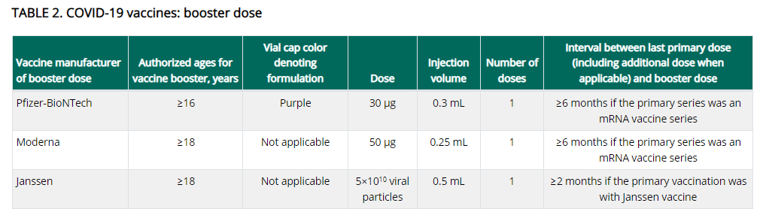

https://www.cdc.gov/vaccines/covid-19/clinical-considerations/covid-19-vaccines-us.html

Important notes:
- The primary series should be completed with the same product.
- Booster doses can be any product.
- The Moderna booster dose is half the dose used in the primary series.
- If eligible for a booster dose, someone who received a Pfizer primary series can get any FDA-approved or authorized COVID-19 vaccine (Pfizer-BioNTech, Moderna, or Janssen) as the booster dose, at an interval of ≥6 months since primary vaccination.
- If eligible for a booster dose, someone who received a Moderna primary series can get any FDA-approved or authorized COVID-19 vaccine (Pfizer-BioNTech, Moderna, or Janssen) as the booster dose, at an interval of ≥6 months since primary vaccination.
- Persons aged ≥18 years who received primary vaccination with Janssen COVID-19 vaccine should receive a single COVID-19 vaccine booster dose ≥2 months after their primary dose. Any FDA-approved or authorized COVID-19 vaccine (Pfizer-BioNTech, Moderna, or Janssen) can be used as the booster dose, at an interval of ≥2 months after the primary Janssen vaccine dose.

Reminder Booster doses for People who received COVID-19 vaccine outside the United States
The Interim Clinical Considerations contain guidance for these situations. Please refer to the guidance here.

People who completed all of the recommended doses of an WHO-EUL COVID-19 vaccine not approved or authorized by FDA, or people who completed a heterologous (mix and match) series composed of any combination of FDA-approved, FDA-authorized, or WHO-EUL COVID-19 vaccines:
- Are considered fully vaccinated.
- People aged ≥ 16 years (including moderately or severely immunocompromised people who received an additional primary dose) should receive a single booster dose of Pfizer-BioNTech COVID-19 Vaccine (30 µg formulation [purple cap]) at least 6 months after completing their primary series.

Footnote 4, in the Clinical Considerations, has a list of WHO-EUL COVID-19 vaccines. The list will be updated as additional COVID-19 vaccines receive an EUL from WHO. As of 12/6/2021 the list is:

- Pfizer-BioNTech COVID-19 Vaccine (e.g., BNT162b2, COMIRNATY, Tozinameran)
- AstraZeneca-Oxford COVID-19 Vaccine (e.g., [ChAdOx1-S (recombinant)], AZD1222, Covishield, Vaxzevria)
- Janssen (Johnson & Johnson) COVID-19 Vaccine (e.g., Ad26.COV2.S)
- Moderna COVID-19 Vaccine (e.g., mRNA 1273, Takeda, Spikevax)
- Sinopharm-BIBP COVID-19 Vaccine
- Sinovac-CoronaVac COVID-19 Vaccine
- Bharat Biotech International COVID-19 Vaccine (e.g., BBV152, COVAXIN)

Reminder Expiry Date vs Beyond Use Date (BUD)
The expiration date is set by the manufacturer and is the date by which the vaccine should be used. The expiration date assumes that the vaccine has been stored and handled according to the manufacturer’s guidance. Expiration dates cannot change based on how vaccine is being stored or when a vial is punctured. However on occasion, the expiration date may be updated by the manufacturer as additional stability data become available.

Beyond Use Date (BUD) is the date of when the vaccine can no longer be used due to a change in storage temperature, reconstitution, puncturing the vial, etc. It is recommended to place a label with the BUD and the initials of the person making the calculation whenever a vaccine vial or box is moved to a different temperature storage unit, reconstituted or had a vial punctured resulting in a chance in the BUD.

You can find BUD guidance and labels for Moderna , Janssen , Pfizer 12+ , and Pfizer 5-11 from the CDC’s U.S. COVID-19 Vaccine Product Information webpage.

Reminder Using syringes with 0.2 mL tick marks to draw up 0.25 mL and 1.3 mL doses
CDC has received several questions regarding use of syringes with 0.2 mL tick marks to draw up doses of Moderna booster vaccine (0.25mL) and Pfizer pediatric diluent (1.3mL).

ACIP and CDC do not yet have any official guidance on this issue. Providers are advised that when using syringes that have tick marks at 0.2 mL intervals, they should use their best judgment to draw up half-way between the tick marks to extract the proper volume. For example, Moderna booster vaccine should be draw to between 0.24mL and 0.26mL. Pfizer pediatric diluent should be drawn between 1.2mL and 1.4mL. Alternately, if a provider has a syringe in their inventory they are more comfortable using, they may use this syringe to administer the vaccine and replace syringes from their private supply with those from the ancillary supplies kit.

Pfizer recommends the use of a syringe with appropriate graduations to dilute with the directed 1.3 mL of saline. The impact to the final dose with a 1.2 or 1.4 mL dilution volume would be within 4% of the target dose. This suggests that using a syringe with 0.2 mL graduations and estimating the 1.3 mL volume will not significantly impact the intended dose.

Reminder Moderna Multidose Vials (MDVs)
The Moderna COVID-19 Vaccine is supplied in two MDV presentations: A MDV containing 5.5 mL and a MDV containing 7.5 mL. Primary series doses of 0.5 mL and booster doses of 0.25 mL may be extracted from either vial presentation. If the amount of vaccine remaining in the vial cannot provide a full dose of 0.5 mL or 0.25 mL, discard the vial and contents. Do not pool excess vaccine from multiple vials, and do not puncture a vial more than 20 times.

- When extracting only primary series doses, a maximum of 11 doses (range: 10-11 doses) may be extracted from the vial containing 5.5 mL or a maximum of 15 doses (range: 13-15 doses) may be extracted from the vial containing 7.5 mL.

- When extracting only booster doses or a combination of primary series and booster doses, the maximum number of doses that may be extracted from either vial presentation should not exceed 20 doses. Do not puncture the vial stopper more than 20 times.

- The link below is provided to assist with determining the amount of waste that may be reported in vials of Moderna 14 or Moderna 10 when administering a combination of primary (0.5mL) and booster (0.25mL) doses. Guidance for Vaccine Providers and Organizations

  - Process a storage and handling issue in the MIIS to report the wasted doses remaining in the vial.

Reminder Pfizer 450 trays is discontinued and no longer available for ordering in the MIIS.

Reminder Moderna 14 is discontinued and no longer available for ordering in the MIIS. Orders for Moderna 10 will be identified by the same NDC as previous Moderna 10 orders (NDC= 80777-273-99).

All Moderna 10 orders will include 2 ancillary kits to support administration of booster doses.

- Process a storage and handling is for wasted/expired doses in the MIIS. The link here is the Vaccine Storage and Handling Problem - mini guide.

Reminder Moderna Expiry Extension
Moderna continues to update data regarding extension of expired dates. Expiration dates are in the process of being updated in the MIIS inventory page.
The product must be maintained in the frozen state for the extension to be applicable (extension does not apply to thawed vials). Moderna’s look up tool remains the official indicator of product expiry.
Look up the expiration date by scanning the QR code located on the carton or use the company’s expiration date lookup feature on its website.

RESOURCES & LEARNING OPPORTUNITIES

New Pfizer COVID-19 Vaccine Medical Updates on Current & Immunization Site Training
Pfizer Vaccines US Medical Affairs continues to host frequent (almost daily) Medical Updates & Immunization Site Training for All Providers. Session topics include:
- Use of vaccine for Children 5 through 11 Years of Age, and Individuals 12 Years of Age and Older
- Storage, Handling, Preparation, & Administration for the multiple presentations of the vaccine
- Recent medical updates regarding the vaccine
- An overview of healthcare provider resources
- Question and answer session

To access current and future training sessions, please visit: https://www.pfizermedicalinformation.com/en-us/medical-updates

Reminder Morbidity and Mortality Weekly Report, better known as MMWR, is CDC’s primary publication for disseminating the science it produces. The staff at MMWR have launched a landing page to help people find the latest information on COVID-19 vaccine effectiveness and safety.

CDC MMWRs
December 10, 2021 (Early Release)
- SARS-CoV-2 B.1.1.529 (Omicron) Variant — United States, December 1–8, 2021
- Booster and Additional Primary Dose COVID-19 Vaccinations Among Adults Aged ≥65 Years — United States, August 13, 2021–November 19, 2021
December 10, 2021
- Comparative Effectiveness and Antibody Responses to Moderna and Pfizer-BioNTech COVID-19 Vaccines among Hospitalized Veterans — Five Veterans Affairs Medical Centers, United States, February 1–September 30, 2021
- Community-Based Testing Sites for SARS-CoV-2 — United States, March 2020–November 2021

MDPH RESOURCES

Reminder Massachusetts Resources
- COVID-19 booster information and booster frequently asked questions
- Eligibility questions and an Eligibility Checker tool
- Search for Vaccine locations: https://vaxfinder.mass.gov/
- COVID-19 Vaccine Resource Line/2-1-1 is available for individuals who are unable to use Vaxfinder, or have difficulty accessing the internet. Available in English and Spanish and has translators available in approximately 100 additional languages.
- COVID-19 Vaccine Information
- MDPH Immunization Division’s free accredited COVID-19 Vaccine Training was updated on October 13, 2021. A list of the updates is available from a link on the training site home page. These training sessions are designed for health care providers, vaccine coordinators, and all health care personnel who handle and/or administer COVID-19 vaccines.

Immunization Division Main Number
For questions about immunization recommendations, disease reporting, etc.
Phone: 617-983-6800 (24/7 MDPH Epi line)
Fax: 617-983-6840
Website: https://www.mass.gov/topics/immunization

MIIS Help Desk
Phone: 617-983-4335
Fax: 857-323-8321
Email questions to: miishelpdesk@mass.gov
Website: https://www.mass.gov/service-details/massachusetts-immunization-information-system-miis

MDPH Vaccine Unit
Phone: 617-983-6828
Email questions to: dph-vaccine-management@mass.gov
Website: https://www.mass.gov/service-details/vaccine-management

COVID-19 Email Box
Email questions to: COVID-19-Vaccine-Plan-MA@mass.gov

