BULLETIN
What Massachusetts COVID-19 Vaccine Providers Need to Know
Week of 12/21/21

Latest Numbers
- As of 12/21/2021 5,047,850 people in Massachusetts have been fully vaccinated.
Massachusetts has now fully vaccinated over 5 million people!

Who to Vaccinate this Week
COVID-19 vaccination is recommended for everyone aged 5 years and older for the prevention of coronavirus disease 2019 (COVID-19).

- A primary series for anyone ages 5 and older who lives, works, or studies in Massachusetts is eligible for a vaccine. Health care providers can also vaccinate their patient panels regardless of place of residency.
- An additional (third) mRNA primary series dose for people ages 12 and older who are moderately to severely immunocompromised, at least 28 days after the completion of the second mRNA COVID-19 vaccine dose.
- A booster dose for ages 16 and older. You’re eligible for a booster if:
    - Pfizer & Moderna: It’s been at least 6 months since the primary series
    - Johnson & Johnson: It’s been at least 2 months since the primary series

What to Know this Week
We just passed the one-year anniversary of the first COVID-19 vaccines administered - December 14th (USA), and December 15th (MA)!

Please Note Due to the holiday there will be no Bulletin the week of 12/29/2021.

Reminder Holiday Ordering and Delivery Cadence
As a reminder all orders placed this week may not be delivered until after January 4, 2022.
There are no vaccine orders being delivered Thursday, December 23rd through Monday, December 27th or Thursday, December 30th through Tuesday, January 4th.

New mRNA COVID-19 Vaccines Preferred Over the Janssen COVID-19 Vaccine
On December 16th CDC endorsed recommendations made by ACIP earlier in the day, expressing a clinical preference for individuals to receive an mRNA COVID-19 vaccine over Johnson & Johnson’s COVID-19 vaccine.

ACIP’s unanimous recommendation followed a robust discussion of the latest evidence on vaccine effectiveness, vaccine safety and rare adverse events, and consideration of the U.S. vaccine supply. The U.S. supply of mRNA vaccines is abundant––with nearly 100 million doses in the field for immediate use. This updated CDC recommendation follows similar recommendations from other countries, including Canada and the United Kingdom. Given the current state of the pandemic both here and around the world, the ACIP reaffirmed that receiving any vaccine is better than being unvaccinated. Individuals who are unable or unwilling to receive an mRNA vaccine will continue to have access to Johnson & Johnson’s COVID-19 vaccine.

See the Clinical Considerations for more information, some of which is detailed here:

- In most situations, Pfizer-BioNTech or Moderna COVID-19 vaccines are preferred over the Janssen COVID-19 vaccine for primary and booster vaccination, including boosters for those who received Janssen COVID-19 vaccine for their single dose primary series
- Janssen COVID-19 vaccines may be offered to the following populations:
  - Persons with a contraindication to mRNA COVID-19 vaccines (e.g. severe allergic reaction after a previous dose or to a component of an mRNA COVID-19 vaccine)
  - Persons who would otherwise remain unvaccinated for COVID-19 due to limited access to mRNA COVID-19 vaccines
  - Persons who would prefer the Janssen COVID-19 vaccine despite safety concerns identified

New Janssen COVID-19 Vaccine Update
On December 14th the FDA announced revisions to the Janssen COVID-19 Vaccine Fact Sheet for Heath Care Providers Administering Vaccine (Vaccination Providers) and the Fact Sheet for Recipients and Caregivers. The fact sheets now include a contraindication to the administration of the Janssen COVID-19 Vaccine to individuals with a history of thrombosis with thrombocytopenia following the Janssen COVID-19 Vaccine or any other adenovirus-vectored COVID-19 vaccine, and updated information about the risk of TTS following vaccination. Cases of TTS following administration of the Janssen COVID-19 Vaccine have been reported in males and females 18 years of age and older, with the highest reporting rate of approximately 1 case per 100,000 doses administered in females 30-49 years of age; overall, approximately 1 out of 7 cases has been fatal. The FDA and CDC continue to investigate the level of potential excess risk. The FDA continues to find that the known and potential benefits of the Janssen COVID-19 Vaccine outweigh its known and potential risks in individuals 18 years of age and older. Individuals should speak to their health care provider to determine which COVID-19 vaccine is most appropriate for their own situation.

Reminder Pfizer ‘gray top/Do Not Dilute/12+’ Available to Order December 23rd
This formulation will have a gray vial cap and allow for smaller pack ordering and easier use. The minimum order size will be 300 doses and the product does not require reconstitution with a diluent. The 6-dose vial will have the same dose volume as the current purple cap (0.3mL) and be stable at 2ºC to 8ºC for up to 10 weeks. The product can also be stored at ultra-low freezer temp (-90ºC to -60ºC) for up to 9 months. Do not store this formulation in a freezer (-25ºC to -15ºC).

To place an order for the Pfizer 12+ gray cap vaccines, create a COVID order and click on ‘add vaccine’. Select Pfizer, NDC 59267-1025-04. Vaccines are orderable in 300 doses increments. There will be no repackaging of vaccines for smaller order amounts.

Providers should use up the Pfizer purple cap product in their inventory prior to transitioning to the new gray cap product to help ensure vaccine is not wasted and to reduce administration or storage errors.

There is a nice comparison guide from the Pfizer website Pfizer Formulation/Presentation Guide – Nov 2021 (please note, as of 12/20/2021 the extended expiration dates at ultra low freezer temps are not yet reflected in this document)

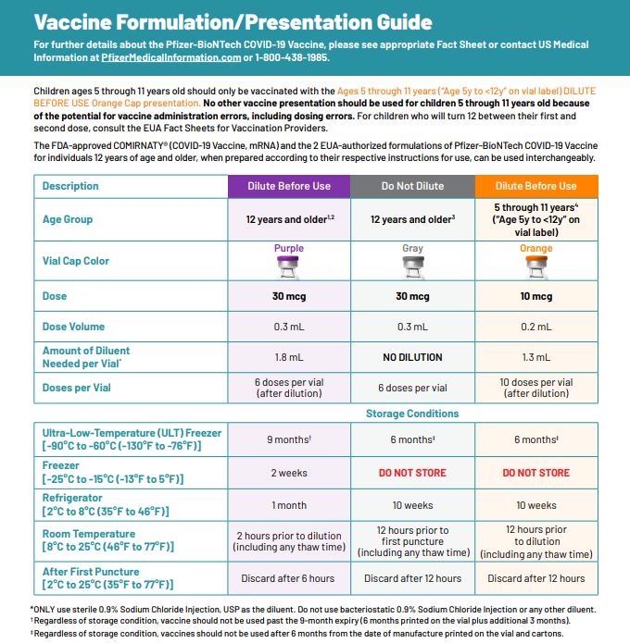

New Expiration Extension for Pfizer orange cap/Dilute/5-11yo and gray cap/Do Not Dilute/12+yo
On December 16th the FDA approved a shelf-life extension for the Pfizer Pediatric vaccine (orange cap, 5-11yo, diluent required) and the soon to be available Adol/Adult Tris (gray cap, age 12+, no diluent). This approval may be found at Healthcare Providers for 5-11 years of age, orange cap (must dilute) (fda.gov) ; Healthcare Providers for 12 years of age and older, gray cap (no dilution) (fda.gov) and takes effect immediately. This extension applies to frozen (ULT) inventories only.

As you are aware, the date printed on the Pfizer Pediatric (orange cap) and Adult/Adolescent (gray cap, 12+, no diluent) vaccine vials indicate the manufacture date and NOT the expiration date. Originally, the expiration date was 6 months from the manufacture date. The expiration date for Pfizer orange and gray cap vaccine has now been extended to 9 months (while held at ULT frozen.) The Fact Sheets for both orange and gray cap vials provided by the FDA now reads, “regardless of storage conditions, vaccines should not be used after 9 months from the date of manufacture printed on the vial and cartons”. The updated expiry dates for both the orange and gray cap vials based on 9 months from the date of manufacture are provided below.

Printed Manufacturing Date | 9-Month Expiry Date*
06/2021 | Feb. 28, 2022
07/2021 | Mar. 31, 2022
08/2021 | Apr. 30, 2022
09/2021 | May 31, 2022
10/2021 | Jun. 30, 2022
11/2021 | July. 31, 2022
12/2021 | Aug. 31, 2022
01/2022 | Sept. 30, 2022
02/2022 | Oct. 31, 2022
*Date of expiration always falls on the last day of the month

The QR code provided on the Pfizer Pediatric Vaccine carton provides a link to the EUA but does not provide information on expiration dates.

Please follow EUA recommendations for storage:

Pfizer 5 through 11 years of age formulation
- If not previously thawed at 2ºC to 8ºC (35ºF to 46ºF), allow vials to thaw at room temperature [up to 25ºC (77ºF)] for 30 minutes.
- Pfizer-BioNTech COVID-19 Vaccine multiple dose vials with orange caps and labels with orange borders may be stored at room temperature [8°C to 25°C (46°F to 77°F)] for a total of 12 hours prior to dilution.
- After dilution, the vial should be held between 2ºC to 25°C (35°F to 77°F). Vials should be discarded 12 hours after dilution.

Pfizer 12 years and older formulation.
- Frozen vials may be stored in an ultra-low temperature freezer at -90ºC to -60ºC (-130ºF to -76ºF). Do not store vials at -25°C to -15°C (-13°F to 5°F). Once vials are thawed they should not be refrozen.
- Vials may be transferred to the refrigerator [2ºC to 8ºC (35ºF to 46ºF)], thawed and stored for up to 10 weeks. The 10-week refrigerated expiry date should be recorded on the carton at the time of transfer. A carton of 10 vials may take up to 6 hours to thaw at this temperature.

Regardless of storage condition, vaccines should not be used after 9 months from the date of manufacture printed on the vial and cartons.

New Monoclonal Antibody Treatment for COVID-19
Massachusetts has several public sites administering monoclonal antibody treatment, therapies that have shown to be effective in reducing severity of disease and keeping COVID-19-positive individuals from being hospitalized. Referral from a health care provider is required for treatment, which is provided at no cost to the patient and offered regardless of immigration status or health insurance. Patients should discuss with their health care providers whether monoclonal antibody treatment is right for them. For more info see the press release here: https://www.mass.gov/news/baker-polito-administration-announces-state-supported-monoclonal-antibody-treatment-sites-in-massachusetts

BOOSTER DOSES
Reminder COVID-19 Booster Recommendations expanded to include 16-and-17-year-olds
16–17-year olds can get a Pfizer booster. People 18+ can get any booster.

On 12/9/2021 CDC expanded COVID-19 booster recommendations to 16- and 17-year-olds. Information is available on the booster shots webpage and the Clinical Considerations webpage. At this time, only the Pfizer-BioNTech COVID-19 vaccine is authorized and recommended for adolescents aged 16 and 17.

In Massachusetts, following the updated recommendations and guidance from the CDC, MDPH announced that all adolescents ages 16 and 17 are able get their Pfizer COVID booster if they are at least 6 months post their initial Pfizer vaccination series. Adolescents ages 16 and 17 are able to receive the Pfizer COVID-19 booster from more than 500 locations including at retail pharmacies, primary care practices, regional collaboratives, local boards of health, community health centers, hospital systems, state-supported vaccination sites and mobile clinics. Visit www.mass.gov/covid19booster for more information.

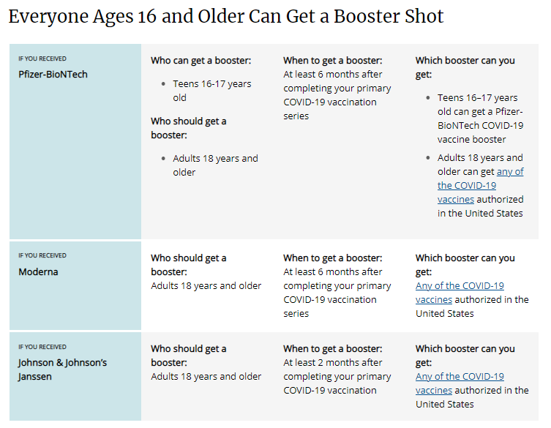

Reminder The Importance of Keeping Consumer Demographic Information in MIIS Up to Date During COVID-19
As you know, Massachusetts providers who vaccinate individuals are required to enter certain data into the Massachusetts Immunization Information System (MIIS). This allows users to access their vaccination records for any reason they may need them.

The Massachusetts Department of Public Health is developing an online patient portal that will allow constituents to more easily access their own immunization record found in MIIS. This portal will eventually support a voluntary tool that will allow patients to easily and electronically access their vaccination status. To ensure that patients are able to utilize this system, it is critical that the MIIS database is up-to-date with their information.

Patients with missing or out-of-date demographic information (such as phone, email) may not be able to return a match. These patients will be directed to their healthcare provider who is responsible for updating their immunization record in the MIIS.
Therefore, the Department of Public Health strongly encourages providers to ensure they have an email address and/or phone number for patients in their MIIS immunization records.

The MIIS allows providers to make updates to patient demographics in the following ways:

1. Access their patient records through this web-based application to enable demographic and immunization updates. You can view Patient Lookup in the MIIS for more information.
2. Technical solutions are available to allow demographic only updates to be sent directly from your electronic health record systems.
3. A one-time bulk file will be accepted and uploaded into the MIIS.

Please contact the MIIS Helpdesk miishelpdesk@mass.gov for more information.

DOSES FOR THE 5-11 YEAR OLD POPULATION
CDC recommends Pfizer COVID-19 vaccine for children ages 5-11 years. The Pfizer pediatric (5-11 years of age) vaccine formulation:
- Must be placed in an ultracold freezer (until expiration date) or a refrigerator (for up to 10 weeks) upon receiving the vaccine. Do not place the vaccine in a regular freezer or use the shipper as temporary storage.
- Comes as a multiple dose vial with an orange cap and a label with an orange border
- The vials and cartons state ‘for age 5 years to <12 years’
- Must be diluted
- Primary series of 2 doses (0.2 mL each) 3 weeks apart in individuals 5 through 11 years of age
- Is NOT interchangeable with the 12 and older formulations
- CDC webpage on COVID-19 Vaccination for Children 5-11 Years Old

Reminder Pfizer-BioNTech COVID-19 Vaccine: Clinical Materials for Ages 5 through 11 years from CDC

Reminder COVID-19 Quick Reference Guide
CDC’s quick reference guide is a 2-page document that provides basic information on the proper storage, preparation, and administration of the currently authorized COVID-19 vaccine products in the United States. It is now updated with Pfizer Peds.

COVID-19 VACCINE DOSAGES AND OTHER INFORMATION
Reminder Updated EUAs
Once a new EUA Fact Sheet is issued, it must be used. Previous ones no longer contain accurate information.
- Pfizer, HCP, 12 years of age and older, purple cap (must dilute): https://www.fda.gov/media/153713/download
- Pfizer, HCP, 12 years of age and older, gray cap (no dilution) This formulation is not yet available in the United States: https://www.fda.gov/media/153715/download
- Pfizer, HCP, 5 - 11 years of age, orange cap (must dilute): https://www.fda.gov/media/153714/download
- Pfizer, Recipient, 12 years of age and older: https://www.fda.gov/media/144414/download
- Pfizer, Recipient, 5-11 years: https://www.fda.gov/media/153717/download
- Moderna, HCP: https://www.fda.gov/media/144637/download
- Moderna, Recipient: https://www.fda.gov/media/144638/download
- Janssen, HCP: https://www.fda.gov/media/146304/download
- Janssen, Recipient: https://www.fda.gov/media/146305/download

Primary Series
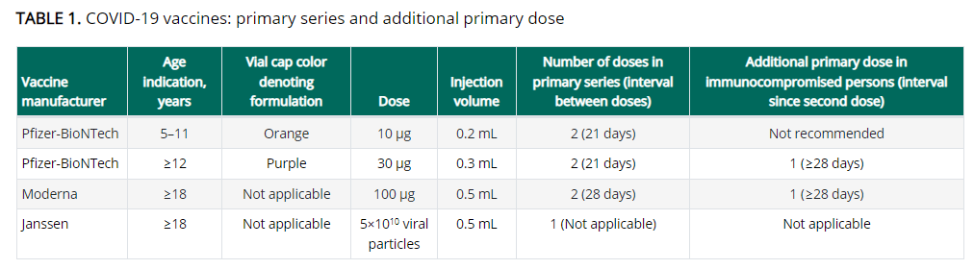

Boosters
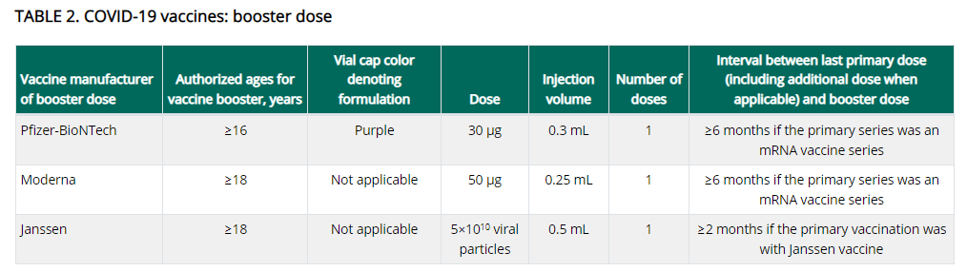

https://www.cdc.gov/vaccines/covid-19/clinical-considerations/covid-19-vaccines-us.html

Reminder Booster doses for People who received COVID-19 vaccine outside the United States
The Interim Clinical Considerations contain guidance for these situations. Please refer to the guidance here.

People who completed all of the recommended doses of an WHO-EUL COVID-19 vaccine not approved or authorized by FDA, or people who completed a heterologous (mix and match) series composed of any combination of FDA-approved, FDA-authorized, or WHO-EUL COVID-19 vaccines:
- Are considered fully vaccinated.
- People aged ≥ 16 years (including moderately or severely immunocompromised people who received an additional primary dose) should receive a single booster dose of Pfizer-BioNTech COVID-19 Vaccine (30 µg formulation [purple cap]) at least 6 months after completing their primary series.

Footnote 4, in the Clinical Considerations, has a list of WHO-EUL COVID-19 vaccines. The list will be updated as additional COVID-19 vaccines receive an EUL from WHO. As of 12/20/2021 the list is:

- Pfizer-BioNTech COVID-19 Vaccine (e.g., BNT162b2, COMIRNATY, Tozinameran)
- AstraZeneca-Oxford COVID-19 Vaccine (e.g., [ChAdOx1-S (recombinant)], AZD1222, Covishield, Vaxzevria)
- Janssen (Johnson & Johnson) COVID-19 Vaccine (e.g., Ad26.COV2.S)
- Moderna COVID-19 Vaccine (e.g., mRNA 1273, Takeda, Spikevax)
- Sinopharm-BIBP COVID-19 Vaccine
- Sinovac-CoronaVac COVID-19 Vaccine
- Bharat Biotech International COVID-19 Vaccine (e.g., BBV152, COVAXIN)
- Novavax COVID-19 Vaccine (e.g., NVX-CoV2373, Covovax)

Reminder Expiry Date vs Beyond Use Date (BUD)
The expiration date is set by the manufacturer and is the date by which the vaccine should be used. The expiration date assumes that the vaccine has been stored and handled according to the manufacturer’s guidance. Expiration dates cannot change based on how vaccine is being stored or when a vial is punctured. However on occasion, the expiration date may be updated by the manufacturer as additional stability data become available.

Beyond Use Date (BUD) is the date of when the vaccine can no longer be used due to a change in storage temperature, reconstitution, puncturing the vial, etc. It is recommended to place a label with the BUD and the initials of the person making the calculation whenever a vaccine vial or box is moved to a different temperature storage unit, reconstituted or had a vial punctured resulting in a chance in the BUD.

You can find BUD guidance and labels for Moderna , Janssen , Pfizer 12+ , and Pfizer 5-11 from the CDC’s U.S. COVID-19 Vaccine Product Information webpage.

New Mini Webinar: Expiration Dates & Beyond-Use Dates
A CDC mini webinar discusses how to determine the expiration date, beyond-use date, and beyond-use time; when to use the expiration date and when to use the beyond-use date; and where to find comprehensive vaccine storage and preparation resources for clinical staff. The direct link to the webinar is here: https://www2.cdc.gov/vaccines/ed/covid19/videos/bud/bud.asp

Reminder Moderna Multidose Vials (MDVs)
The Moderna COVID-19 Vaccine is supplied in two MDV presentations: A MDV containing 5.5 mL and a MDV containing 7.5 mL. Primary series doses of 0.5 mL and booster doses of 0.25 mL may be extracted from either vial presentation. If the amount of vaccine remaining in the vial cannot provide a full dose of 0.5 mL or 0.25 mL, discard the vial and contents. Do not pool excess vaccine from multiple vials, and do not puncture a vial more than 20 times.

- When extracting only primary series doses, a maximum of 11 doses (range: 10-11 doses) may be extracted from the vial containing 5.5 mL or a maximum of 15 doses (range: 13-15 doses) may be extracted from the vial containing 7.5 mL.

- When extracting only booster doses or a combination of primary series and booster doses, the maximum number of doses that may be extracted from either vial presentation should not exceed 20 doses. Do not puncture the vial stopper more than 20 times.

- The link below is provided to assist with determining the amount of waste that may be reported in vials of Moderna 14 or Moderna 10 when administering a combination of primary (0.5mL) and booster (0.25mL) doses. Guidance for Vaccine Providers and Organizations

  - Process a storage and handling issue in the MIIS to report the wasted doses remaining in the vial.

Reminder Pfizer 1170 (effective 12/23) and 450 trays are discontinued and no longer available for ordering in the MIIS.

Reminder Moderna 14 is discontinued and no longer available for ordering in the MIIS. Orders for Moderna 10 will be identified by the same NDC as previous Moderna 10 orders (NDC= 80777-273-99).

All Moderna 10 orders will include 2 ancillary kits to support administration of booster doses.

- Process a storage and handling is for wasted/expired doses in the MIIS. The link here is the Vaccine Storage and Handling Problem - mini guide.

Reminder Moderna Expiry Extension
Moderna continues to update data regarding extension of expired dates. Expiration dates are in the process of being updated in the MIIS inventory page.
The product must be maintained in the frozen state for the extension to be applicable (extension does not apply to thawed vials). Moderna’s look up tool remains the official indicator of product expiry.
Look up the expiration date by scanning the QR code located on the carton or use the company’s expiration date lookup feature on its website.

RESOURCES & LEARNING OPPORTUNITIES

New CDC launches “Interactive COVID-19 Vaccine Conversations Module for Healthcare Professionals”
CDC has launched a new resource to equip healthcare professionals with the tools they need to have effective COVID-19 vaccine conversations with patients. The Interactive COVID-19 Vaccine Conversations Module for Healthcare Professionals includes:
- Tips for Having Effective Vaccine Conversations with Patients
- Vaccine Conversations in Practice: Case Scenarios

New Vaccine Education Center at Children’s Hospital of Philadelphia has a new video series, “Vaccine Conversations”, which features topics that today’s parents are commonly asking. The first videos for this series feature Dr. Offit and some pediatricians active on social media discussing vaccine topics related to their specialties. More videos will be coming soon.
- Vaccines, the Immune System, and Autoimmunity
- Vaccines and Breastfeeding
- Why Do We Give Vaccines for Diseases We Do Not See?
- Why Do Unvaccinated People Pose a Risk to vaccinated People?

New COVID-19 Vaccine Webinar Series
CDC is offering a series of brief (15-20 minute) webinars addressing topics around COVID-19 vaccination. These interactive, web-based training modules offer a real-world perspective on different issues around COVID-19 vaccines. Topics range from routine clinical and vaccine safety information to guidance for on-site clinic vaccination activities and having conversations with vaccine recipients. Each webinar includes self-test practice questions and lists additional resources related to the topic discussed. The landing page for all mini webinars is here: https://www.cdc.gov/vaccines/covid-19/training-education/webinars.html

New Access hundreds of free and accurate educational materials to support COVID-19 and flu vaccination in your community at the Vaccine Resource Hub. The Vaccine Resource Hub has been developed as a part of the CDC Foundation’s Partnering for Vaccine Equity program to support individuals and organizations working to increase immunization across all communities, especially those experiencing racial and ethnic disparities. Resources include infographics, toolkits, videos, unbranded digital assets, messaging, and much more - all free and available for download and sharing.

Please note, the Hub is being launched in two phases. During Phase One (now) the site already has many features, links, and content that you can search and download. In Phase Two (early 2022), the site will have even more content, pages, stories, webinars, and links.

Reminder Pfizer COVID-19 Vaccine Medical Updates on Current & Immunization Site Training
Pfizer Vaccines US Medical Affairs continues to host frequent (almost daily) Medical Updates & Immunization Site Training for All Providers. Session topics include:
- Use of vaccine for Children 5 through 11 Years of Age, and Individuals 12 Years of Age and Older
- Storage, Handling, Preparation, & Administration for the multiple presentations of the vaccine
- Recent medical updates regarding the vaccine
- An overview of healthcare provider resources
- Question and answer session

To access current and future training sessions, please visit: https://www.pfizermedicalinformation.com/en-us/medical-updates

Reminder Morbidity and Mortality Weekly Report, better known as MMWR, is CDC’s primary publication for disseminating the science it produces. The staff at MMWR have launched a landing page to help people find the latest information on COVID-19 vaccine effectiveness and safety.

CDC MMWRs
December 17, 2021 (Early Releases)
- Evaluation of a Test to Stay Strategy in Transitional Kindergarten Through Grade 12 Schools — Los Angeles County, California, August 16–October 31, 2021
- Evaluation of Test to Stay Strategy on Secondary and Tertiary Transmission of SARS-CoV-2 in K–12 Schools — Lake County, Illinois, August 9–October 29, 2021

December 17, 2021
- Report of Health Care Provider Recommendation for COVID-19 Vaccination Among Adults, by Recipient COVID-19 Vaccination Status and Attitudes — United States, April–September 2021
- SARS-CoV-2 B.1.1.529 (Omicron) Variant — United States, December 1–8, 2021
- Booster and Additional Primary Dose COVID-19 Vaccinations Among Adults Aged ≥65 Years — United States, August 13, 2021–November 19, 2021
December 10, 2021
- Comparative Effectiveness and Antibody Responses to Moderna and Pfizer-BioNTech COVID-19 Vaccines among Hospitalized Veterans — Five Veterans Affairs Medical Centers, United States, February 1–September 30, 2021
- Community-Based Testing Sites for SARS-CoV-2 — United States, March 2020–November 2021

MDPH RESOURCES

Reminder Massachusetts Resources
- COVID-19 Vaccine Information
- COVID-19 booster information and booster frequently asked questions
- Eligibility questions and an Eligibility Checker tool
- Search for Vaccine locations: https://vaxfinder.mass.gov/
- COVID-19 Vaccine Resource Line/2-1-1 is available for individuals who are unable to use Vaxfinder, or have difficulty accessing the internet. Available in English and Spanish and has translators available in approximately 100 additional languages.

Immunization Division Main Number
For questions about immunization recommendations, disease reporting, etc.
Phone: 617-983-6800 (24/7 MDPH Epi line)
Fax: 617-983-6840
Website: https://www.mass.gov/topics/immunization

MIIS Help Desk
Phone: 617-983-4335
Fax: 857-323-8321
Email questions to: miishelpdesk@mass.gov
Website: https://www.mass.gov/service-details/massachusetts-immunization-information-system-miis

MDPH Vaccine Unit
Phone: 617-983-6828
Email questions to: dph-vaccine-management@mass.gov
Website: https://www.mass.gov/service-details/vaccine-management

COVID-19 Email Box
Email questions to: COVID-19-Vaccine-Plan-MA@mass.gov

