BULLETIN
What Massachusetts COVID-19 Vaccine Providers Need to Know
Week of 12/2/21

Latest Numbers

- As of 12/2/2021 4,883,161 people in Massachusetts have been fully vaccinated.

Who to Vaccinate this Week
COVID-19 vaccination is recommended for everyone aged 5 years and older for the prevention of coronavirus disease 2019 (COVID-19).

- A primary series for anyone ages 5 and older who lives, works, or studies in Massachusetts is eligible for a vaccine. Health care providers can also vaccinate their patient panels regardless of place of residency.
- An additional (third) mRNA primary series dose for people ages 12 and older who are moderately to severely immunocompromised, at least 28 days after the completion of the second mRNA COVID-19 vaccine dose.
- A booster dose for ages 18 and older. You’re eligible for a booster if:
    - Pfizer & Moderna: It’s been at least 6 months since the primary series
    - Johnson & Johnson: It’s been at least 2 months since the primary series

What to Know this Week

BOOSTER DOSES
All individuals 18+ are eligible for a COVID-19 Booster Providers should:
- Proactively outreach to patients who:
  - Are age 65 and older; or
  - Have underlying medical conditions; or
  - Received the J&J vaccine (single dose)

- Allow patients to self-determine their risk of exposure. Providers should not turn away any patient who requests a booster if the patient is:
  - 18 years of age or over and completed their primary series at least 6 months ago for the Moderna or Pfizer vaccine or received their J&J vaccine at least 2 months ago.
MA booster info can be found here
CDC booster info can be found here and here
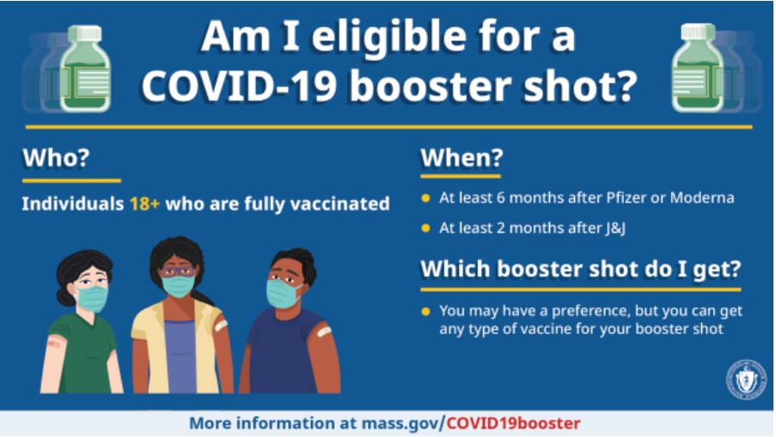
In addition to providing boosters, providers should take every opportunity to vaccinate anyone who has not yet received the COVID-19 vaccine by offering vaccine during routine or non-routine visits to medical offices, clinics, pharmacies, and hospitals.

DOSES FOR THE 5-11 YEAR OLD POPULATION
CDC recommends Pfizer COVID-19 vaccine for children ages 5-11 years. The Pfizer pediatric (5-11 years of age) vaccine formulation:
- Must be placed in an ultracold freezer (until expiration date) or a refrigerator (for up to 10 weeks) upon receiving the vaccine. Do not place the vaccine in a regular freezer or use the shipper as temporary storage. Do not refill the shipper with dry ice.
- Comes as a multiple dose vial with an orange cap and a label with an orange border
- The vials and cartons state ‘for age 5 years to <12 years’
- Must be diluted
- Primary series of 2 doses (0.2 mL each) 3 weeks apart in individuals 5 through 11 years of age
- Is NOT interchangeable with the 12 and older formulations
- CDC webpage on COVID-19 Vaccination for Children 5-11 Years Old

New Vaccine Education Center at Children’s Hospital of Philadelphia
- November Parents PACK issue is dedicated to COVID-19 vaccination of young children, and includes 3 Considerations for COVID-19 Vaccination of 5- to 11-year-old Children. Also available as a PDF for easy photocopying and sharing.
- VEC at CHOP also released an infographic to visually demonstrate the low frequency of severe adverse events following COVID-19 vaccination. The infographic also describes who is at greatest risk of experiencing each effect.

Reminder AAP COVID-19 Vaccine Campaign Toolkit
The American Academy of Pediatrics (AAP) has created a COVID-19 Vaccine Campaign Toolkit to assist pediatric healthcare professionals in addressing parent and caregiver COVID-19 vaccines questions and concerns. The Toolkit includes articles, graphics, social media messages, and videos. It is designed to reach parents and caregivers, who have not yet vaccinated their eligible children, to encourage them to talk to a trusted provider.

New The Massachusetts Department of Public Health has updated its Children & Youth with Special Health Needs (CYSHN) and the COVID-19 Vaccine webpage to include FAQs for vaccinating this population.

Reminder Pfizer-BioNTech COVID-19 Vaccine: Clinical Materials for Ages 5 through 11 years from CDC
- Pfizer Standing Orders (persons 5 through 11 years of age)
- Pfizer Vaccine Prep and Administration Summary (persons 5 through 11 years of age)
- Pfizer Storage and Handling Summary (persons 5 through 11 years of age)
- Pfizer Storage and Handling Labels (persons 5 through 11 years of age)
- Pfizer Beyond Use Date guidance and labels (persons 5 through 11 years of age)
- Pfizer Vaccine Transporting Vaccine for Clinics held at Satellite, Temporary or Off-Site Locations (persons 5 through 11 years of age)
- Pfizer Vaccine Dosage Chart
- Prevaccination Screening Form
COVID-19 vaccine dosages
Reminder Updated EUAs:
Once a new EUA Fact Sheet is issued, it must be used. Previous ones no longer contain accurate information.
- Pfizer Fact Sheet for Healthcare Providers: https://www.fda.gov/media/144413/download
- Pfizer Fact Sheet for Recipients and Caregivers: https://www.fda.gov/media/144414/download
- Pfizer, HCP, 5-11 years: https://www.fda.gov/media/153714/download
- Pfizer, Recipient, 5-11 years: https://www.fda.gov/media/153717/download
- Moderna Fact Sheet for Healthcare Providers: https://www.fda.gov/media/144637/download
- Moderna Fact Sheet for Recipients and Caregivers: https://www.fda.gov/media/144638/download
- Janssen Fact Sheet for Healthcare Providers: https://www.fda.gov/media/146304/download
- Janssen Fact Sheet for Recipients and Caregivers: https://www.fda.gov/media/146305/download

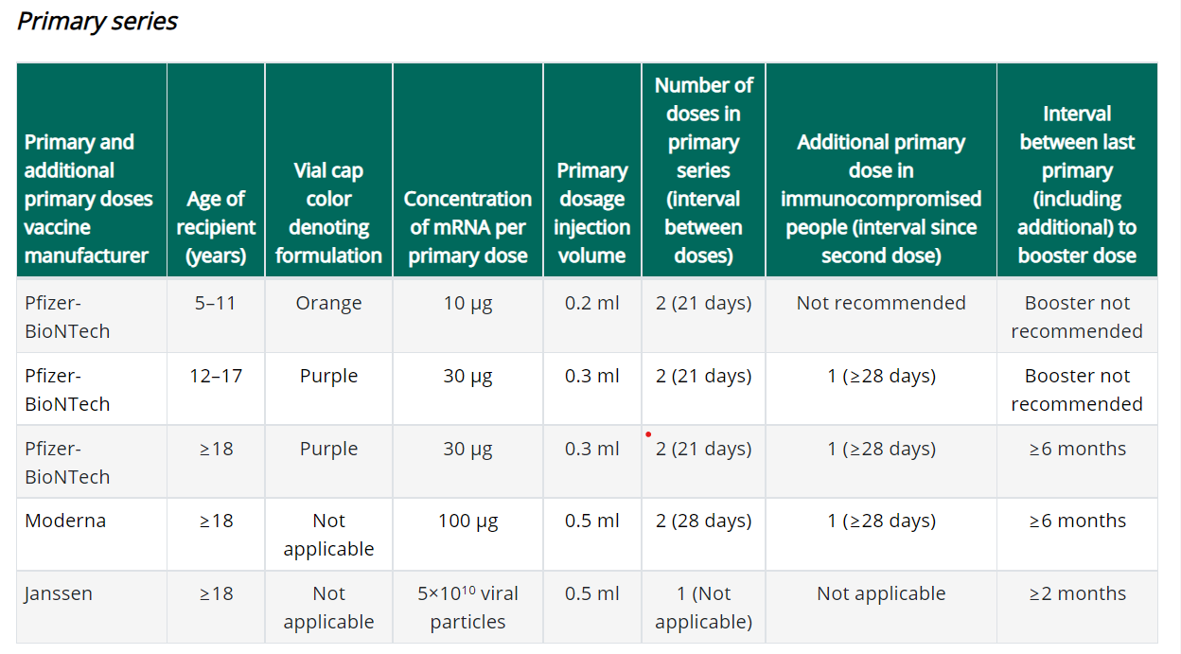

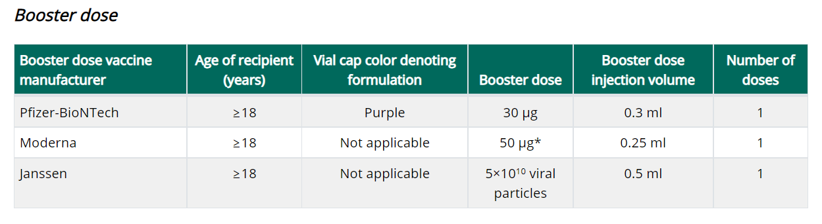
https://www.cdc.gov/vaccines/covid-19/clinical-considerations/covid-19-vaccines-us.html

Important notes:
- The primary series should be completed with the same product.
- Booster doses can be any product. The Moderna booster dose is half the dose used in the primary series.
- If eligible for a booster dose, someone who received a Pfizer primary series can get any FDA-approved or authorized COVID-19 vaccine (Pfizer-BioNTech, Moderna, or Janssen) as the booster dose, at an interval of ≥6 months since primary vaccination.
- If eligible for a booster dose, someone who received a Moderna primary series can get any FDA-approved or authorized COVID-19 vaccine (Pfizer-BioNTech, Moderna, or Janssen) as the booster dose, at an interval of ≥6 months since primary vaccination.
- Persons aged ≥18 years who received primary vaccination with Janssen COVID-19 vaccine should receive a single COVID-19 vaccine booster dose ≥2 months after their primary dose. Any FDA-approved or authorized COVID-19 vaccine (Pfizer-BioNTech, Moderna, or Janssen) can be used as the booster dose, at an interval of ≥2 months after the primary Janssen vaccine dose.

New Using syringes with 0.2 mL tickmarks to draw up 0.25 mL and 1.3 mL doses
CDC has received a number of questions regarding use of syringes with 0.2 mL tick marks to draw up doses of Moderna booster vaccine (0.25mL) and Pfizer pediatric diluent (1.3mL).

ACIP and CDC do not yet have any official guidance on this issue. Providers are advised that when using syringes that have tick marks at 0.2 mL intervals, they should use their best judgment to draw up half-way between the tick marks to extract the proper volume. For example, Moderna booster vaccine should be draw to between 0.24mL and 0.26mL. Pfizer pediatric diluent should be drawn between 1.2mL and 1.4mL. Alternately, if a provider has a syringe in their inventory they are more comfortable using, they may use this syringe to administer the vaccine and replace syringes from their private supply with those from the ancillary supplies kit.

Pfizer recommends the use of a syringe with appropriate graduations to dilute with the directed 1.3 mL of saline. The impact to the final dose with a 1.2 or 1.4 mL dilution volume would be within 4% of the target dose. This suggests that using a syringe with 0.2 mL graduations and estimating the 1.3 mL volume will not significantly impact the intended dose.

Reminder Moderna Multidose Vials (MDVs)
The Moderna COVID-19 Vaccine is supplied in two MDV presentations: A MDV containing 5.5 mL and a MDV containing 7.5 mL. Primary series doses of 0.5 mL and booster doses of 0.25 mL may be extracted from either vial presentation. If the amount of vaccine remaining in the vial cannot provide a full dose of 0.5 mL or 0.25 mL, discard the vial and contents. Do not pool excess vaccine from multiple vials.

- When extracting only primary series doses, a maximum of 11 doses (range: 10-11 doses) may be extracted from the vial containing 5.5 mL or a maximum of 15 doses (range: 13-15 doses) may be extracted from the vial containing 7.5 mL.

- When extracting only booster doses or a combination of primary series and booster doses, the maximum number of doses that may be extracted from either vial presentation should not exceed 20 doses. Do not puncture the vial stopper more than 20 times.

- The link below is provided to assist with determining the amount of waste that may be reported in vials of Moderna 14 or Moderna 10 when administering a combination of primary (0.5mL) and booster (0.25mL) doses. Guidance for Vaccine Providers and Organizations

  - Process a storage and handling issue in the MIIS to report the wasted doses remaining in the vial.

Reminder Number of doses that can be extracted from each multi-dose vial (MDV)
MDPH Immunization Division guidance is to extract no more than the number of doses that are officially stated in the EUA as being in the multi-dose vial. (ie., Pfizer 5-11 yo/orange top 10 doses; Pfizer purple top 6 doses).

Reminder Definition of “fully vaccinated” has not changed. At this time, people are still considered fully vaccinated two weeks after their second dose in a 2-dose series, such as the Pfizer or Moderna vaccines, or two weeks after a single-dose vaccine, such as the J&J/Janssen vaccine.

Reminder Coadministration
If a patient is eligible, both flu and COVID-19 vaccines can be administered at the same visit, as recommended by CDC and ACIP. In addition to flu vaccine, COVID-19 vaccine can be given with other vaccines as well.

Reminder The Importance of Keeping Consumer Demographic Information in MIIS Up to Date During COVID-19: Due to increased demand for access to vaccination records and proof of vaccination, it is critical that vaccination records remain as up-to-date as possible in the Massachusetts Immunization Information System (MIIS). As Massachusetts explores potential vaccine credential systems, the Department of Public Health is strongly encouraging providers to ensure they have an email address and/or phone number for every patient in their MIIS immunization records. For example, providers can do this via automated emails or text messages to their patients or by reconciling their internal records so each patient can be reached by phone or email.

The MIIS allows providers to access their patient records through this web-based application to enable demographic and immunization updates. You can view Patient Lookup in the MIIS for more information. Technical solutions will be available soon to allow demographic only updates to be sent directly from your electronic health record systems. Please contact the MIIS Helpdesk miishelpdesk@mass.gov for more information.

Reminder COVID-19 Vaccine Product Guides The link below is the updated version of the Product Guide, which includes information on both the Pfizer pediatric 100 and 300 and Moderna booster ancillary supplies. This guide provides specifications for COVID-19 vaccine and associated products. This is NOT a catalog from which you can order products. It provides key product information including product package dimensions and weight, minimum order quantities, product presentation, distribution method, storage information, and additional information. This guide is updated as more products become available. https://www.mass.gov/media/2365116/download

New There will be limited shipments of COVID vaccines for the upcoming holidays season. Please plan ahead and order the doses you need for the month of December as shipments will be limited.

Reminder COVID-19 Vaccine Ordering All vaccine orders placed in the MIIS are reviewed and approved within 3 business days after being submitted. Once approved, the Vaccine Management Unit submits orders daily to the CDC for processing and shipping. CDC ships vaccines within 3-4 business days. Orders from sites showing large, expiring, or expired doses of COVID-19 vaccine inventory could be delayed, reduced, or canceled by the Vaccine Management Unit. To prevent orders from being delayed, reduced, or canceled providers must:
- ensure that the MIIS inventory matches the site’s physical inventory
- confirm that all doses administered have been reported and processed in MIIS
- confirm that all storage and handling issues have been reported in MIIS

Please Note: Repackaging of COVID-19 vaccines doses for smaller ordering sizes is only available for primary care provider (PCP) offices – (community health centers, pediatric, family medicine, internal medicine practices in addition to small specialty practices). Smaller dose orders can still be placed as usual in MIIS. Individual exceptions to these ordering limitations may be made on a case by case basis by contacting the Vaccine Unit.

The minimum dose amounts orderable by PCPs:
- 60 doses (6 dose vial) of Pfizer (12+ formulation)
- 70 doses (14 dose vial) of Moderna
- 25 doses (5 dose vial) of Johnson & Johnson

The Vaccine Unit will be fulfilling orders from the State Lab, and courier services will deliver vaccines and ancillary kits. Vaccines are transported in a cooler and in refrigerated temperature range with a digital data logger. Upon receiving Pfizer and Moderna vaccines, ensure vaccines are placed in the refrigerator and write the beyond used date on the vials.

For all other provider sites, the following packaging presentation of COVID-19 vaccines are available for ordering:
- Pfizer (12+) 1170 doses
- Pfizer (12+) 450 doses
- Pfizer pediatric (5-11) 100 doses
- Moderna 100 doses
- Johnson and Johnson 100 doses

Sites must provide a justification to order above the ceiling limits and meet the conditions below:
- Site are maintaining no more than a 30-day supply of vaccine (or up to a 45-day supply for primary care provider offices). Given the ample supply of vaccine, there is no need to order quantities beyond your anticipated 30-day/45-day throughput to ensure adequate supply.
- Report to the MIIS all doses within 24 hours of administration
- Agree to allowable vaccine wastage guidelines (updated October 13, 2021)

Reminder Moderna 14 discontinued and no longer available for ordering in the MIIS. Orders for Moderna 10 will be identified by the same NDC as previous Moderna 10 orders (NDC= 80777-273-99).

All Moderna 10 orders will include 2 ancillary kits to support administration of booster doses.

- Process a storage and handling is for wasted/expired doses in the MIIS. The link here is the Vaccine Storage and Handling Problem - mini guide.

Reminder Moderna Expiry Extension Moderna continues to update data regarding extension of expired dates. Expiration dates are in the process of being updated in the MIIS inventory page.
The product must be maintained in the frozen state for the extension to be applicable (extension does not apply to thawed vials). Moderna’s look up tool remains the official indicator of product expiry.
Look up the expiration date by scanning the QR code located on the carton or use the company’s expiration date lookup feature on its website.

Resources & Learning Opportunities

New Register for the Dec. 8, 12-1 pm, “Current Issues in Vaccines” webinar. Dr Paul Offit will discuss “Do We Need a COVID-19 Vaccine Booster Dose?”

New Register for the Dec 9, 1-2 pm, IAC webinar “Fight the flu and COVID-19 too: influenza vaccination in December and beyond and practical approaches to coadministration of vaccines in adults”

New Pfizer COVID-19 Vaccine Medical Updates on Current & Immunization Site Training
Pfizer Vaccines US Medical Affairs continues to host frequent Medical Updates & Immunization Site Training for All Providers. Session topics include:
- Use of vaccine for Children 5 through 11 Years of Age, and Individuals 12 Years of Age and Older
- Storage, Handling, Preparation, & Administration for the multiple presentations of the vaccine
- Recent medical updates regarding the vaccine
- An overview of healthcare provider resources
- Question and answer session
To access current and future training sessions, please visit: https://www.pfizermedicalinformation.com/en-us/medical-updates

Attendee link – Thurs December 2 – 12 PM ET | fgZsgRpf379
Attendee link – Fri December 3 – 12 PM ET | rkMHiiMB223
Attendee link – Mon December 6 – 5 PM ET | 7TPd4QgG6kM
Attendee link – Tues December 7 – 5 PM ET | 5Q4fggcppc2
Attendee link – Wed December 8 – 12 PM ET | kpRpN6Kk5P5
Attendee link – Thurs December 9 – 12 PM ET | xmBqyuSr252
Attendee link – Fri December 10 – 12 PM ET | ZnuC32Puqy5
Attendee link – Mon December 13 – 5 PM ET | D9ufVHMSM99
Attendee link – Tues December 14 – 5 PM ET | H3WuiDZtd22
Attendee link – Wed December 15 – 12 PM ET | gpPQjEdZ494
Attendee link – Thurs December 16 – 12 PM ET | cVST3X9Rff2
Attendee link – Fri December 17 – 12 PM ET | ybW7Pnf6nN2
Attendee link – Mon December 20 – 3 PM ET | TupjKrQv427
Attendee link – Tues December 21 – 12 PM ET | BTt8MrXwR58
Attendee link – Mon December 27 – 3 PM ET | dbEMTcK4c26
Attendee link – Tues December 28 – 12 PM ET | 47DiG6JXsgA

Reminder Morbidity and Mortality Weekly Report, better known as MMWR, is CDC’s primary publication for disseminating the science it produces. The staff at MMWR have launched a landing page to help people find the latest information on COVID-19 vaccine effectiveness and safety.

CDC MMWRs
November 26, 2021
- Risk for Stillbirth Among Women With and Without COVID-19 at Delivery Hospitalization — United States, March 2020–September 2021
November 19, 2021
- Incidence of SARS-CoV-2 Infection, Emergency Department Visits, and Hospitalizations Because of COVID-19 Among Persons Aged ≥12 Years, by COVID-19 Vaccination Status — Oregon and Washington, July 4–September 25, 2021
November 12, 2021
- The Advisory Committee on Immunization Practices’ Interim Recommendation for Use of Pfizer-BioNTech COVID-19 Vaccine in Children Aged 5–11 Years — United States, November 2021

MDPH Resources

Reminder Massachusetts resources
- COVID-19 booster frequently asked questions
- Eligibility questions and an Eligibility Checker tool
- Search for Vaccine locations: https://vaxfinder.mass.gov/
- COVID-19 Vaccine Resource Line/2-1-1 is available for individuals who are unable to use Vaxfinder, or have difficulty accessing the internet. Available in English and Spanish and has translators available in approximately 100 additional languages.
- COVID-19 Vaccine Information
- MDPH Immunization Division’s free accredited COVID-19 Vaccine Training was updated on October 13, 2021. A list of the updates is available from a link on the training site home page. These training sessions are designed for health care providers, vaccine coordinators, and all health care personnel who handle and/or administer COVID-19 vaccines.

Immunization Division Main Number
For questions about immunization recommendations, disease reporting, etc.
Phone: 617-983-6800 (24/7 MDPH Epi line)
Fax: 617-983-6840
Website: https://www.mass.gov/topics/immunization

MIIS Help Desk
Phone: 617-983-4335
Fax: 857-323-8321
Email questions to: miishelpdesk@mass.gov
Website: https://www.mass.gov/service-details/massachusetts-immunization-information-system-miis

MDPH Vaccine Unit
Phone: 617-983-6828
Email questions to: dph-vaccine-management@mass.gov
Website: https://www.mass.gov/service-details/vaccine-management

COVID-19 email box:
Email questions to: COVID-19-Vaccine-Plan-MA@mass.gov

