BULLETIN
What Massachusetts COVID-19 Vaccine Providers Need to Know
Week of 1/26/2022
LATEST NUMBERS
- As of 1/26/2022 5,188,134 people in Massachusetts have been fully vaccinated.
Massachusetts has now fully vaccinated over 5 million people!

WHO TO VACCINATE THIS WEEK
COVID-19 vaccination is recommended for everyone aged 5 years and older for the prevention of coronavirus disease 2019 (COVID-19). People ages 5-17 can get the Pfizer vaccine. People age 18+ can get any vaccine.

- A primary series for anyone ages 5 and older who lives, works, or studies in Massachusetts is eligible for a vaccine. Health care providers can also vaccinate their patient panels regardless of place of residency.
- An additional (third) mRNA primary series dose for people ages 5 and older who are moderately to severely immunocompromised, at least 28 days after the completion of the second mRNA COVID-19 vaccine dose.
- A booster dose for everyone ages 12 years and older
- At least 5 months after completion of an mRNA vaccine primary series.
(includes those who received two doses of different mRNA vaccine products, and those immunocompromised persons who received an additional primary series dose)
- At least 2 months after completion of a Janssen/J&J primary dose.

WHAT TO KNOW THIS WEEK
New Changes on the label of the Moderna COVID-19 vaccine
Distribution of Moderna vials with the updated labels (see new label below) began during the week of January 13, 2021.

What has changed on the label of the Moderna COVID-19 vaccine:
- The label has been updated to indicate a volume of 5.5mL.
- Doses for primary series and booster shots are now listed on the label.
- Important reminder not to exceed a maximum of 20 punctures per vial

What remains the same for the Moderna COVID-19 vaccine:
- Formulation
- NDC [80777-273-99]
- Physical vial size
- Number of reportable doses
- Dose volumes
- Reporting requirements
  - Wastage should continue to be reported based on 10 doses per vial.
- Proper dosage of Moderna COVID-19 Vaccine
  - Primary series doses 1 and 2 dosage = 0.5 mL
  - Additional primary dose (3rd) dosage for immunocompromised persons = 0.5 mL
  - Booster dosage = 0.25 mL
- Each vial can ONLY be punctured up to 20 times.
  - Once the vial has reached the 20-puncture limit, the vial should be discarded even if there is vaccine remaining in the vial.
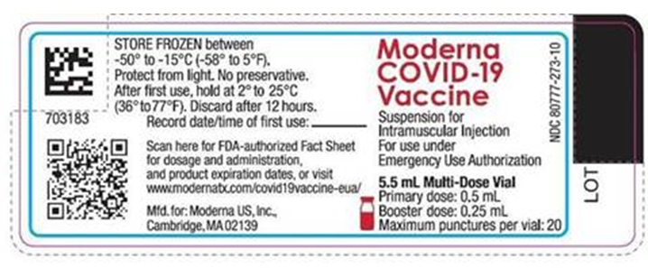

New Watch for Expired Vaccine
Providers should make it a practice to regularly check inventory for expired vaccine and immediately remove expired inventory to prevent it from being administered.
Vaccine Expiration Date Lookup & Reference Information:
- Expiry Information for Pfizer COVID-19 Vaccines
- Moderna Vial Expiration Date Look-up Tool
- J&J Expiration Date Lookup Tool

Reminder Pfizer Expiration Extension for orange cap/Dilute/5-11year old and gray cap/Do Not Dilute/12+year old
On December 16th the FDA approved a shelf-life extension for the Pfizer Pediatric vaccine (orange cap, 5-11 year old, diluent required) and Adolescent/Adult Tris vaccine (gray cap, age 12+, no diluent). This approval may be found at Healthcare Providers for 5-11 years of age, orange cap (must dilute) (fda.gov) ; Healthcare Providers for 12 years of age and older, gray cap (no dilution) (fda.gov) and takes effect immediately. This extension applies to frozen (ULT) inventories only.

As you are aware, the date printed on the Pfizer Pediatric (orange cap) and Adolescent/Adult (gray cap, 12+, no diluent) vaccine vials indicate the manufacture date and NOT the expiration date. Originally, the expiration date was 6 months from the manufacture date. The expiration date for Pfizer orange and gray cap vaccine has now been extended to 9 months (while held at ULT frozen). The Fact Sheets for both orange and gray cap vials provided by the FDA now reads, “regardless of storage conditions, vaccines should not be used after 9 months from the date of manufacture printed on the vial and cartons”. The updated expiry dates for both the orange and gray cap vials based on 9 months from the date of manufacture are provided below.

Printed Manufacturing Date | 9-Month Expiry Date*
06/2021 | Feb. 28, 2022
07/2021 | Mar. 31, 2022
08/2021 | Apr. 30, 2022
09/2021 | May 31, 2022
10/2021 | Jun. 30, 2022
11/2021 | July. 31, 2022
12/2021 | Aug. 31, 2022
01/2022 | Sept. 30, 2022
02/2022 | Oct. 31, 2022
*Date of expiration always falls on the last day of the month

The QR code provided on the Pfizer Pediatric Vaccine carton provides a link to the EUA but does not provide information on expiration dates.

New Ancillary Kit Reminders and Information
Providers are encouraged to report any issues with equipment in the ancillary kits. Please be prepared to provide photos, lot number, order number, date ordered, and dates received when filing a report for a deficient ancillary kit.

- Report deficiencies to McKesson directly. Their customer service desk is charged with responding to problems and identifying trends.
- Let the MDPH Vaccine Management know about the issue. Copy dph-vaccine-management@mass.gov when sending information to McKesson.
- If an error or injury occurs during vaccine administration, enter the information into Vaccine Adverse Event Reporting System (VAERS) at https://vaers.hhs.gov/reportevent.html
- Because syringes are a medical device, issues should be reported by filling out a FDA form 3500 at https://www.accessdata.fda.gov/scripts/medwatch/

For assistance or questions regarding ancillary kits, contact:
For Pfizer ancillary kits:
McKesson MedSurg to report
SNSSupport@McKesson.com

For Moderna or J&J/Janssen ancillary kits:
McKesson Specialty
Phone #: (833) 343-2703
Email: COVIDVaccineSupport@McKesson.com

New CDC’s Pregnancy and the COVID-19 Vaccine: Frequently Asked Questions has been updated and is now available in 12 languages.

Reminder The Role of OB/GYNs in Building Vaccine Confidence: As providers of health care throughout a patient’s life, obstetrician-gynecologists are uniquely positioned to educate patients on the benefits and safety of the COVID-19 vaccine. The American College of Obstetricians and Gynecologists (ACOG) outlines three steps OB/GYNs can take to build vaccine confidence with patients, including:
- Review ACOG’s Practice Advisory on vaccinating pregnant and lactating patients against COVID-19.
- Use ACOG’s COVID-19 vaccines and pregnancy Conversation Guide for clinicians.
- Tell your patients about the COVID-19 resources on ACOG’s new patient website.

Reminder Stay Up to Date with Your Vaccines
To align with standard language CDC uses about other vaccinations, CDC will now use the phrase “up to date” when talking about COVID-19 vaccination. CDC recommends that individuals stay “up to date” by receiving any additional doses they are eligible for, according to CDC’s recommendations, to ensure they have optimal protection against COVID-19. The technical definition of “fully vaccinated” – two doses of an mRNA vaccine or one dose of the Janssen/J&J vaccine – has not changed. Individuals are considered fully vaccinated 14 days after completion of their primary series. For more information, and to see a detailed table, please visit Stay Up to Date with Your Vaccines.

Reminder COVID-19 Quick Reference Guide
CDC’s quick reference guide is a 2-page document that provides basic information on the proper storage, preparation, and administration of the currently authorized COVID-19 vaccine products in the United States.

Reminder CDC’s Product Info by US Vaccine webpage now has Pfizer info in three separate subpages:
- Orange Cap Age 5 through 11
- Purple Cap Age 12 and Older
- Gray Cap Age 12 and Older

Reminder Pfizer COVID-19 Vaccines
There is a nice comparison guide from the Pfizer website Pfizer Vaccine Formulation/Presentation Guide - Jan 2022

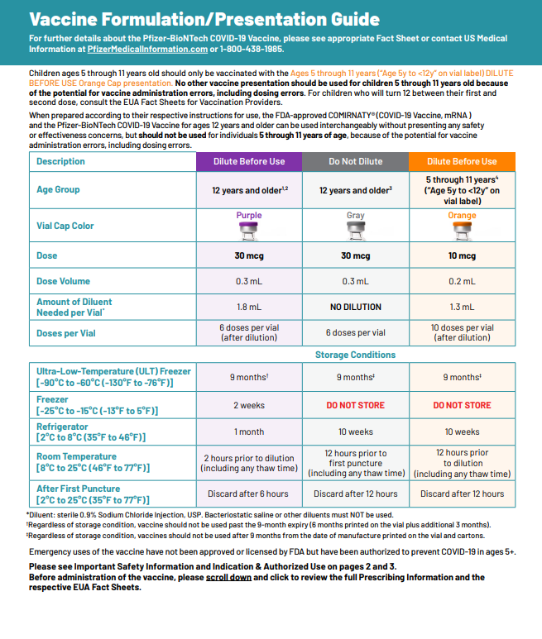
Reminder EUA Fact Sheets
Once a new EUA Fact Sheet is issued, it must be used. Previous ones no longer contain accurate information.
- Pfizer, HCP, 12 years of age and older, purple cap (must dilute): https://www.fda.gov/media/153713/download
- Pfizer, HCP, 12 years of age and older, gray cap (no dilution): https://www.fda.gov/media/153715/download
- Pfizer, HCP, 5 - 11 years of age, orange cap (must dilute): https://www.fda.gov/media/153714/download
- Pfizer, Recipient, 12 years of age and older: https://www.fda.gov/media/144414/download
- Pfizer, Recipient, 5-11 years: https://www.fda.gov/media/153717/download
- Moderna, HCP: https://www.fda.gov/media/144637/download
- Moderna, Recipient: https://www.fda.gov/media/144638/download
- Janssen, HCP: https://www.fda.gov/media/146304/download
- Janssen, Recipient: https://www.fda.gov/media/146305/download

Primary Series

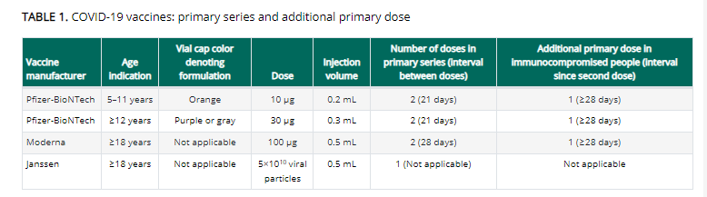

Boosters

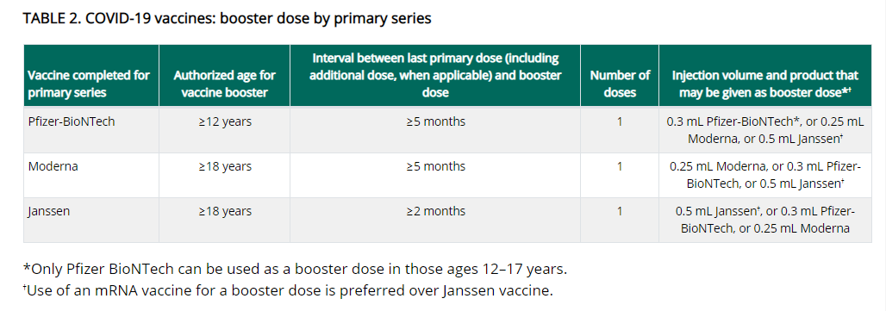

Reminder Booster doses for People who received COVID-19 vaccine outside the United States
The Interim Clinical Considerations contain guidance for these situations. Please refer to the guidance here.

People who completed all of the recommended doses of an WHO-EUL COVID-19 vaccine not approved or authorized by FDA, or people who completed a heterologous (mix-and-match) series composed of any combination of FDA-approved, FDA-authorized, or WHO-EUL COVID-19 vaccines:
- Are considered fully vaccinated.
- People aged ≥ 12 years (including moderately or severely immunocompromised people who received an additional primary dose) should receive a single booster dose of Pfizer-BioNTech COVID-19 Vaccine at least 5 months after completing their primary series.

Footnote 4, in the Clinical Considerations, has a list of WHO-EUL COVID-19 vaccines. The list will be updated as additional COVID-19 vaccines receive an EUL from WHO. As of 1/17/2022 the list is:

- Pfizer-BioNTech COVID-19 Vaccine (e.g., BNT162b2, COMIRNATY, Tozinameran)
- AstraZeneca-Oxford COVID-19 Vaccine (e.g., [ChAdOx1-S (recombinant)], AZD1222, Covishield, Vaxzevria)
- Janssen (Johnson & Johnson) COVID-19 Vaccine (e.g., Ad26.COV2.S)
- Moderna COVID-19 Vaccine (e.g., mRNA 1273, Takeda, Spikevax)
- Sinopharm-BIBP COVID-19 Vaccine
- Sinovac-CoronaVac COVID-19 Vaccine
- Bharat Biotech International COVID-19 Vaccine (e.g., BBV152, COVAXIN)
- Novavax COVID-19 Vaccine (e.g., NVX-CoV2373, Covovax)

Reminder Monoclonal Antibody Treatment for COVID-19
Updated guidance was issued January 12,2022, replacing the guidance issued December 23, 2021.
Massachusetts has several public sites administering monoclonal antibody treatment, therapies that have shown to be effective in reducing severity of disease and keeping COVID-19-positive individuals from being hospitalized. Referral from a health care provider is required for treatment, which is provided at no cost to the patient and offered regardless of immigration status or health insurance. Patients should discuss with their health care providers whether monoclonal antibody treatment is right for them.
Provider information, including an overview, guidance, and a Monoclonal Antibody Therapy Locator can be found here.

Reminder Public Portal Launch – Please Ensure Patient Information in the MIIS is Up to Date.
On January 10, 2022 the Baker-Polito administration announced a new option for residents to access their COVID-19 vaccination record from the state’s immunization registry and obtain a ‘SMART Health Card’ QR code to indicate proof of vaccination. Massachusetts residents can visit www.myvaxrecords.mass.gov, a web portal that follows national standards for security and privacy and provides residents a way to electronically view and save their COVID-19 vaccine record. By providing a mobile phone number or email address, users can obtain a digital record of their vaccinations recorded in the Massachusetts Immunization Information System. Their COVID-19 vaccination record includes a unique QR code that can be saved to the user’s phone files, camera roll, the Apple Wallet or Google Pay through a 3rd party application, Common Health. (https://www.commonhealth.org/smart-health-cards). It can also be printed out for a paper record.
Patients now have increased accessibility to obtain their immunizations through My Vax Records. As a reminder it is important to keep patient demographic information in MIIS up to date during COVID-19. Massachusetts providers who vaccinate individuals are required to enter certain data into the Massachusetts Immunization Information System (MIIS). This allows users to access their vaccination records for any reason they may need them. Patients with missing or out-of-date demographic information (such as phone, email) may not be able to return a match. These patients will be directed to their vaccine provider who is responsible for updating their immunization record in the MIIS. Therefore, the Department of Public Health strongly encourages providers to ensure they have an email address and/or mobile phone number for patients in their MIIS immunization records.

The MIIS allows providers to make updates to patient demographics in the following ways:

1. Access their patient records through this web-based application to enable demographic and immunization updates. You can view Patient Lookup in the MIIS for more information.
2. Technical solutions are available to allow demographic only updates to be sent directly from your electronic health record systems.
3. A one-time bulk file will be accepted and uploaded into the MIIS.

Please contact the MIIS Helpdesk miishelpdesk@mass.gov for more information.

RESOURCES & LEARNING OPPORTUNITIES

Reminder COVID-19 Vaccine Training Modules
CDC’s four training modules (General Overview, Pfizer, Moderna, Janssen/J&J) can be found here.

Reminder COVID-19 Vaccine Webinar Series
CDC is offering a series of brief (15-20 minute) webinars addressing topics around COVID-19 vaccination. These interactive, web-based training modules offer a real-world perspective on different issues around COVID-19 vaccines. Topics range from routine clinical and vaccine safety information to guidance for on-site clinic vaccination activities and having conversations with vaccine recipients. Each webinar includes self-test practice questions and lists additional resources related to the topic discussed. The landing page for all mini webinars is here: https://www.cdc.gov/vaccines/covid-19/training-education/webinars.html

Reminder From MAPC - Creative COVID-19 Communications
Free-to-use graphics, videos, and more! MAPC’s Arts & Culture and Public Health teams partnered with local artists and designers to produce creative, culturally resonant communications about COVID-19 and vaccinations. The materials are available for public use. Municipalities, health agencies, community groups, and members of the public can freely use them to encourage vaccinations in their communities.

Reminder Communication Skills for Clinicians Discussing COVID-19 Vaccination
PNQIN (Perinatal Neonatal Quality Improvement Network) and UMass Chan Medical School are offering free trainings on: Communication Skills for Clinicians Discussing COVID-19 Vaccination. This training is a 90-minute webinar designed to improve the counseling skills of Massachusetts clinicians and other providers for discussing COVID-19 vaccination with pregnant and postpartum people, parents and caregivers of young children, and families. The training will also focus on addressing vaccine hesitancy and reducing racial disparities in rates of COVID-19 vaccination. Continuing Education credits available.

Registration link and info:
February 11th: 12:00pm – 1:30pm

Reminder CDC launches “Interactive COVID-19 Vaccine Conversations Module for Healthcare Professionals”
CDC has launched a new resource to equip healthcare professionals with the tools they need to have effective COVID-19 vaccine conversations with patients. The Interactive COVID-19 Vaccine Conversations Module for Healthcare Professionals includes:
- Tips for Having Effective Vaccine Conversations with Patients
- Vaccine Conversations in Practice: Case Scenarios

Reminder Pfizer COVID-19 Vaccine Medical Updates on Current & Immunization Site Training
Pfizer Vaccines US Medical Affairs continues to host frequent (almost daily) Medical Updates & Immunization Site Training for All Providers. Session topics include:
- Use of vaccine for Children 5 through 11 Years of Age, and Individuals 12 Years of Age and Older
- Storage, Handling, Preparation, & Administration for the multiple presentations of the vaccine
- Recent medical updates regarding the vaccine
- An overview of healthcare provider resources
- Question and answer session

To access current and future training sessions, please visit: https://www.pfizermedicalinformation.com/en-us/medical-updates

Reminder Morbidity and Mortality Weekly Report, better known as MMWR, is CDC’s primary publication for disseminating the science it produces. The staff at MMWR have launched a landing page to help people find the latest information on COVID-19 vaccine effectiveness and safety.

CDC MMWRs
January 21, 2022 (EARLY RELEASE)
- COVID-19 Incidence and Death Rates Among Unvaccinated and Fully Vaccinated Adults with and Without Booster Doses During Periods of Delta and Omicron Variant Emergence — 25 U.S. Jurisdictions, April 4–December 25, 2021
- Effectiveness of a Third Dose of mRNA Vaccines Against COVID-19–Associated Emergency Department and Urgent Care Encounters and Hospitalizations Among Adults During Periods of Delta and Omicron Variant Predominance — VISION Network, 10 States, August 2021–January 2022
January 21, 2022
- Use of the Janssen (Johnson & Johnson) COVID-19 Vaccine: Updated Interim Recommendations from the Advisory Committee on Immunization Practices — United States, December 2021
- Racial and Ethnic Disparities in Receipt of Medications for Treatment of COVID-19 — United States, March 2020–August 2021
- Notes from the Field: Early Evidence of the SARS-CoV-2 B.1.1.529 (Omicron) Variant in Community Wastewater — United States, November–December 2021

January 19, 2022 (EARLY RELEASE)
- COVID-19 Cases and Hospitalizations by COVID-19 Vaccination Status and Previous COVID-19 Diagnosis — California and New York, May–November 2021

MDPH RESOURCES

Reminder Massachusetts Resources
- COVID-19 Vaccine Information
- COVID-19 booster information and booster frequently asked questions
- Search for Vaccine locations: https://vaxfinder.mass.gov/
- COVID-19 Vaccine Resource Line/2-1-1 is available for individuals who are unable to use Vaxfinder, or have difficulty accessing the internet. Available in English and Spanish and has translators available in approximately 100 additional languages.

Immunization Division Main Number
For questions about immunization recommendations, disease reporting, etc.
Phone: 617-983-6800 (24/7 MDPH Epi line)
Fax: 617-983-6840
Website: https://www.mass.gov/topics/immunization

MIIS Help Desk
Phone: 617-983-4335
Fax: 857-323-8321
Email questions to: miishelpdesk@mass.gov
Website: https://www.mass.gov/service-details/massachusetts-immunization-information-system-miis

MDPH Vaccine Unit
Phone: 617-983-6828
Email questions to: dph-vaccine-management@mass.gov
Website: https://www.mass.gov/service-details/vaccine-management

COVID-19 Email Box
Email questions to: COVID-19-Vaccine-Plan-MA@mass.gov

