BULLETIN
What Massachusetts COVID-19 Vaccine Providers Need to Know
Week of 12/9/21
Latest Numbers
- As of 12/9/2021 4,959,190 people in Massachusetts have been fully vaccinated.

Who to Vaccinate this Week
COVID-19 vaccination is recommended for everyone aged 5 years and older for the prevention of coronavirus disease 2019 (COVID-19).

- A primary series for anyone ages 5 and older who lives, works, or studies in Massachusetts is eligible for a vaccine. Health care providers can also vaccinate their patient panels regardless of place of residency.
- An additional (third) mRNA primary series dose for people ages 12 and older who are moderately to severely immunocompromised, at least 28 days after the completion of the second mRNA COVID-19 vaccine dose.
- A booster dose for ages 18 and older. You’re eligible for a booster if:
    - Pfizer & Moderna: It’s been at least 6 months since the primary series
    - Johnson & Johnson: It’s been at least 2 months since the primary series

What to Know this Week
December 14, 2021 will mark the one-year anniversary of the first COVID-19 vaccine administered in the U.S (December 15th for the state of Massachusetts)!

New Holiday Ordering and Delivery Cadence All COVID-19 vaccines orders must be submitted by the week of December 13th to ensure delivery before the holidays. Plan and order vaccines accordingly. Orders placed on the week of December 20th may not be delivered until after January 4, 2022.

NO VACCINE ORDERS WILL BE DELIVERED THURSDAY, December 23 through Monday, December 27 OR THURSDAY, DECEMBER 30 THROUGH TUESDAY, JANUARY 4.

New The Importance of Keeping Consumer Demographic Information in MIIS Up to Date During COVID-19
As you know, Massachusetts providers who vaccinate individuals are required to enter certain data into the Massachusetts Immunization Information System (MIIS). This allows users to access their vaccination records for any reason they may need them.
The Massachusetts Department of Public Health is developing an online patient portal that will allow constituents to more easily access their own immunization record found in MIIS. This portal will eventually support a voluntary tool that will allow patients to easily and electronically access their vaccination status. To ensure that patients are able to utilize this system, it is critical that the MIIS database is up-to-date with their information.
Patients with missing or out of date demographic information (such as phone, email) may not be able to return a match. These patients will be directed to their healthcare provider who is responsible for updating their immunization record in the MIIS.
Therefore, the Department of Public Health strongly encourages providers to ensure they have an email address and/or phone number for patients in their MIIS immunization records.

The MIIS allows providers to make updates to patient demographics in the following ways:

1. Access their patient records through this web-based application to enable demographic and immunization updates. You can view Patient Lookup in the MIIS for more information.
2. Technical solutions are available to allow demographic only updates to be sent directly from your electronic health record systems.
3. A one time bulk file will be accepted and uploaded into the MIIS.

Please contact the MIIS Helpdesk miishelpdesk@mass.gov for more information.

New Pfizer Gray Top Is Coming Soon The transition to the Pfizer fully licensed vaccine formulation (Comirnaty) for ages 12+ is planned to begin in mid to late December. This formulation will have a gray vial cap and allow for smaller pack ordering and easier use. The minimum order size is expected to be 300 doses and the product does not require reconstitution with a diluent. The 6-dose vial will have the same dose volume as the current purple cap (0.3mL) and be stable at 2ºC to 8ºC for up to 10 weeks. The product can also be stored at ultra-low freezer temp (-90ºC to -60ºC) for up to 6 months. Do not store this formulation in a freezer (-25ºC to -15ºC).

Providers should use up the Pfizer purple cap product in their inventory prior to transitioning to the new gray cap product to help ensure vaccine is not wasted and to reduce administration or storage errors.

There is a nice comparison guide from the Pfizer website Pfizer Formulation/Presentation Guide – Nov 2021
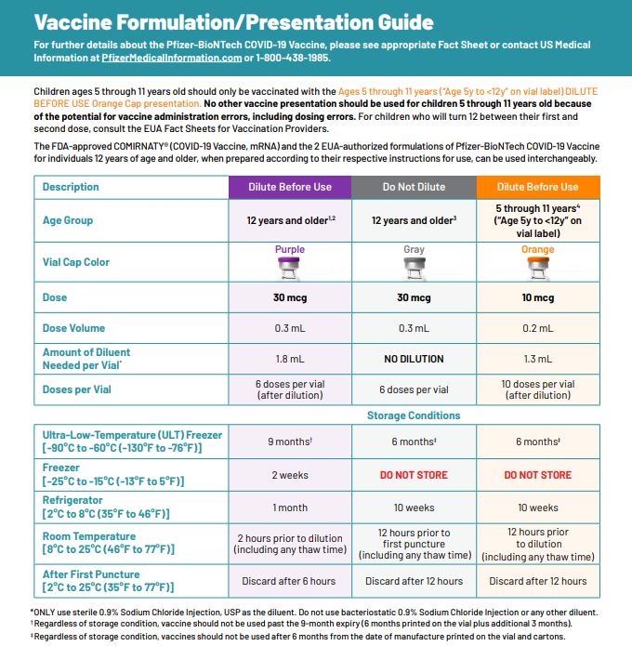

BOOSTER DOSES
All individuals 18+ are eligible for a COVID-19 Booster Providers should:
- Proactively outreach to patients who:
  - Are age 65 and older; or
  - Have underlying medical conditions; or
  - Received the J&J vaccine (single dose)

- Allow patients to self-determine their risk of exposure. Providers should not turn away any patient who requests a booster if the patient is:
  - 18 years of age or over and completed their primary series at least 6 months ago for the Moderna or Pfizer vaccine or received their J&J vaccine at least 2 months ago.
MA booster info can be found here
CDC booster info can be found here and here
In addition to providing boosters, providers should take every opportunity to vaccinate anyone who has not yet received the COVID-19 vaccine by offering vaccine during routine or non-routine visits to medical offices, clinics, pharmacies, and hospitals.

DOSES FOR THE 5-11 YEAR OLD POPULATION
CDC recommends Pfizer COVID-19 vaccine for children ages 5-11 years. The Pfizer pediatric (5-11 years of age) vaccine formulation:
- Must be placed in an ultracold freezer (until expiration date) or a refrigerator (for up to 10 weeks) upon receiving the vaccine. Do not place the vaccine in a regular freezer or use the shipper as temporary storage.
- Comes as a multiple dose vial with an orange cap and a label with an orange border
- The vials and cartons state ‘for age 5 years to <12 years’
- Must be diluted
- Primary series of 2 doses (0.2 mL each) 3 weeks apart in individuals 5 through 11 years of age
- Is NOT interchangeable with the 12 and older formulations
- CDC webpage on COVID-19 Vaccination for Children 5-11 Years Old

New Online MA Resources
Trust the Facts Get the Vax Materials, including:
- Updated! - Videos for Parents (on vaccine safety and efficacy; in multiple languages)
- Flyer: "Protect Yourself. Protect Your Family" (printable, also in Spanish)
- Flyer: "COVID-19 Vaccine Facts for Parents" (printable)

DPH Website: COVID-19 vaccinations for children 5-11 (info on vaccine safety, finding a vaccine, printable consent forms, and more)

Trusted Sources Video: Dr. Frinny Polanco Walters at Boston Children's Hospital (in English and Spanish)

Ideas for Promoting Pediatric Clinics and Vaccine Availability (list of ideas and resources for community organizations, providers, and more)

Frequently asked questions on COVID-19 vaccine with a focus on children & youth with complex medical needs webpage

Reminder Vaccine Education Center at Children’s Hospital of Philadelphia
- November Parents PACK issue is dedicated to COVID-19 vaccination of young children, and includes 3 Considerations for COVID-19 Vaccination of 5- to 11-year-old Children. Also available as a PDF for easy photocopying and sharing.
- VEC at CHOP also released an infographic to visually demonstrate the low frequency of severe adverse events following COVID-19 vaccination. The infographic also describes who is at greatest risk of experiencing each effect.

Reminder AAP COVID-19 Vaccine Campaign Toolkit
The American Academy of Pediatrics (AAP) has created a COVID-19 Vaccine Campaign Toolkit to assist pediatric healthcare professionals in addressing parent and caregiver COVID-19 vaccines questions and concerns. The Toolkit includes articles, graphics, social media messages, and videos. It is designed to reach parents and caregivers, who have not yet vaccinated their eligible children, to encourage them to talk to a trusted provider.

Reminder Pfizer-BioNTech COVID-19 Vaccine: Clinical Materials for Ages 5 through 11 years from CDC

COVID-19 VACCINE DOSAGES AND OTHER INFORMATION
Reminder Updated EUAs Once a new EUA Fact Sheet is issued, it must be used. Previous ones no longer contain accurate information.
- Pfizer, HCP, 12 years of age and older, purple cap (must dilute): https://www.fda.gov/media/153713/download
- Pfizer, HCP, 12 years of age and older, gray cap (no dilution) This formulation is not yet available in the United States: https://www.fda.gov/media/153715/download
- Pfizer, HCP, 5 - 11 years of age, orange cap (must dilute): https://www.fda.gov/media/153714/download
- Pfizer, Recipient, 12 years of age and older: https://www.fda.gov/media/144414/download
- Pfizer, Recipient, 5-11 years: https://www.fda.gov/media/153717/download
- Moderna, HCP: https://www.fda.gov/media/144637/download
- Moderna, Recipient: https://www.fda.gov/media/144638/download
- Janssen, HCP: https://www.fda.gov/media/146304/download
- Janssen, Recipient: https://www.fda.gov/media/146305/download

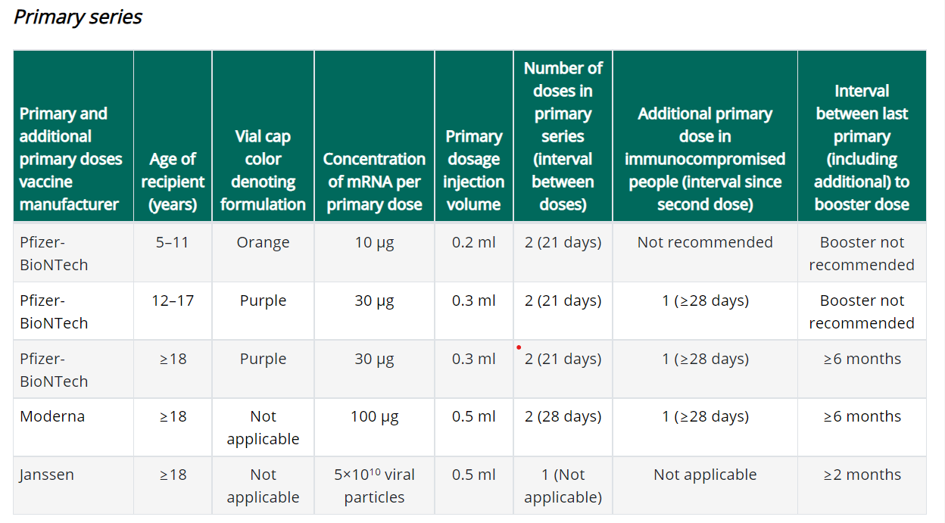

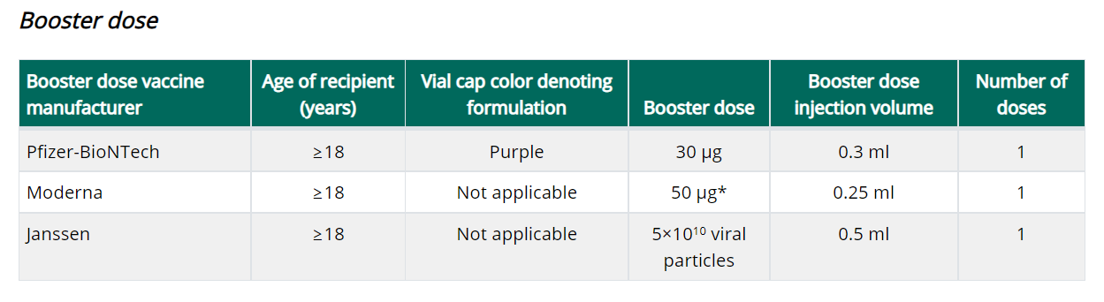
https://www.cdc.gov/vaccines/covid-19/clinical-considerations/covid-19-vaccines-us.html

Important notes:
- The primary series should be completed with the same product.
- Booster doses can be any product.
- The Moderna booster dose is half the dose used in the primary series.
- If eligible for a booster dose, someone who received a Pfizer primary series can get any FDA-approved or authorized COVID-19 vaccine (Pfizer-BioNTech, Moderna, or Janssen) as the booster dose, at an interval of ≥6 months since primary vaccination.
- If eligible for a booster dose, someone who received a Moderna primary series can get any FDA-approved or authorized COVID-19 vaccine (Pfizer-BioNTech, Moderna, or Janssen) as the booster dose, at an interval of ≥6 months since primary vaccination.
- Persons aged ≥18 years who received primary vaccination with Janssen COVID-19 vaccine should receive a single COVID-19 vaccine booster dose ≥2 months after their primary dose. Any FDA-approved or authorized COVID-19 vaccine (Pfizer-BioNTech, Moderna, or Janssen) can be used as the booster dose, at an interval of ≥2 months after the primary Janssen vaccine dose.

New Booster doses for People who received COVID-19 vaccine outside the United States
The Interim Clinical Considerations contain guidance for these situations. Please refer to the guidance here.

People who completed all of the recommended doses of an WHO-EUL COVID-19 vaccine not approved or authorized by FDA, or people who completed a heterologous (mix and match) series composed of any combination of FDA-approved, FDA-authorized, or WHO-EUL COVID-19 vaccines:
- Are considered fully vaccinated.
- People aged ≥18 years (including moderately or severely immunocompromised people who received an additional primary dose) should receive a single booster dose of Pfizer-BioNTech COVID-19 Vaccine (30 µg formulation [purple cap]) at least 6 months after completing their primary series.

Footnote 4, in the Clinical Considerations, has a list of WHO-EUL COVID-19 vaccines. The list will be updated as additional COVID-19 vaccines receive an EUL from WHO. As of 12/6/2021 the list is:

- Pfizer-BioNTech COVID-19 Vaccine (e.g., BNT162b2, COMIRNATY, Tozinameran)
- AstraZeneca-Oxford COVID-19 Vaccine (e.g., [ChAdOx1-S (recombinant)], AZD1222, Covishield, Vaxzevria)
- Janssen (Johnson & Johnson) COVID-19 Vaccine (e.g., Ad26.COV2.S)
- Moderna COVID-19 Vaccine (e.g., mRNA 1273, Takeda, Spikevax)
- Sinopharm-BIBP COVID-19 Vaccine
- Sinovac-CoronaVac COVID-19 Vaccine
- Bharat Biotech International COVID-19 Vaccine (e.g., BBV152, COVAXIN)

New Expiry Date vs Beyond Use Date (BUD)
The expiration date is set by the manufacturer and is the date by which the vaccine should be used. The expiration date assumes that the vaccine has been stored and handled according to the manufacturer’s guidance. Expiration dates cannot change based on how vaccine is being stored or when a vial is punctured. However on occasion, the expiration date may be updated by the manufacturer as additional stability data become available.

Beyond Use Date (BUD) is the date of when the vaccine can no longer be used due to a change in storage temperature, reconstitution, puncturing the vial, etc. It is recommended to place a label with the BUD and the initials of the person making the calculation whenever a vaccine vial or box is moved to a different temperature storage unit, reconstituted or had a vial punctured resulting in a chance in the BUD.

You can find BUD guidance and labels for Moderna , Janssen , Pfizer 12+ , and Pfizer 5-11 from the CDC’s U.S. COVID-19 Vaccine Product Information webpage.

Reminder Using syringes with 0.2 mL tick marks to draw up 0.25 mL and 1.3 mL doses
CDC has received several questions regarding use of syringes with 0.2 mL tick marks to draw up doses of Moderna booster vaccine (0.25mL) and Pfizer pediatric diluent (1.3mL).

ACIP and CDC do not yet have any official guidance on this issue. Providers are advised that when using syringes that have tick marks at 0.2 mL intervals, they should use their best judgment to draw up half-way between the tick marks to extract the proper volume. For example, Moderna booster vaccine should be draw to between 0.24mL and 0.26mL. Pfizer pediatric diluent should be drawn between 1.2mL and 1.4mL. Alternately, if a provider has a syringe in their inventory they are more comfortable using, they may use this syringe to administer the vaccine and replace syringes from their private supply with those from the ancillary supplies kit.

Pfizer recommends the use of a syringe with appropriate graduations to dilute with the directed 1.3 mL of saline. The impact to the final dose with a 1.2 or 1.4 mL dilution volume would be within 4% of the target dose. This suggests that using a syringe with 0.2 mL graduations and estimating the 1.3 mL volume will not significantly impact the intended dose.

Reminder Moderna Multidose Vials (MDVs)
The Moderna COVID-19 Vaccine is supplied in two MDV presentations: A MDV containing 5.5 mL and a MDV containing 7.5 mL. Primary series doses of 0.5 mL and booster doses of 0.25 mL may be extracted from either vial presentation. If the amount of vaccine remaining in the vial cannot provide a full dose of 0.5 mL or 0.25 mL, discard the vial and contents. Do not pool excess vaccine from multiple vials.

- When extracting only primary series doses, a maximum of 11 doses (range: 10-11 doses) may be extracted from the vial containing 5.5 mL or a maximum of 15 doses (range: 13-15 doses) may be extracted from the vial containing 7.5 mL.

- When extracting only booster doses or a combination of primary series and booster doses, the maximum number of doses that may be extracted from either vial presentation should not exceed 20 doses. Do not puncture the vial stopper more than 20 times.

- The link below is provided to assist with determining the amount of waste that may be reported in vials of Moderna 14 or Moderna 10 when administering a combination of primary (0.5mL) and booster (0.25mL) doses. Guidance for Vaccine Providers and Organizations

  - Process a storage and handling issue in the MIIS to report the wasted doses remaining in the vial.

Reminder Number of doses that can be extracted from each multi-dose vial (MDV)
MDPH Immunization Division guidance is to extract no more than the number of doses that are officially stated in the EUA as being in the multi-dose vial. (ie., Pfizer 5-11 yo/orange top 10 doses; Pfizer purple top 6 doses).

Reminder Definition of “fully vaccinated” has not changed. At this time, people are still considered fully vaccinated two weeks after their second dose in a 2-dose series, such as the Pfizer or Moderna vaccines, or two weeks after a single-dose vaccine, such as the J&J/Janssen vaccine.

Reminder Coadministration
If a patient is eligible, both flu and COVID-19 vaccines can be administered at the same visit, as recommended by CDC and ACIP. In addition to flu vaccine, COVID-19 vaccine can be given with other vaccines as well.
Reminder There will be limited shipments of COVID vaccines for the upcoming holidays season. Please plan ahead and order the doses you need for the month of December as shipments will be limited.

Reminder COVID-19 Vaccine Ordering All vaccine orders placed in the MIIS are reviewed and approved within 3 business days after being submitted. Once approved, the Vaccine Management Unit submits orders daily to the CDC for processing and shipping. CDC ships vaccines within 3-4 business days. Orders from sites showing large, expiring, or expired doses of COVID-19 vaccine inventory could be delayed, reduced, or canceled by the Vaccine Management Unit. To prevent orders from being delayed, reduced, or canceled providers must:
- ensure that the MIIS inventory matches the site’s physical inventory
- confirm that all doses administered have been reported and processed in MIIS
- confirm that all storage and handling issues have been reported in MIIS

Please Note Repackaging of COVID-19 vaccines doses for smaller ordering sizes is only available for primary care provider (PCP) offices – (community health centers, pediatric, family medicine, internal medicine practices in addition to small specialty practices). Smaller dose orders can still be placed as usual in MIIS. Individual exceptions to these ordering limitations may be made on a case by case basis by contacting the Vaccine Unit.

The minimum dose amounts orderable by PCPs:
- 60 doses (6 dose vial) of Pfizer (12+ formulation)
- 50 doses (10 dose vial) of Moderna
- 25 doses (5 dose vial) of Johnson & Johnson

The Vaccine Unit will be fulfilling orders from the State Lab, and courier services will deliver vaccines and ancillary kits. Vaccines are transported in a cooler and in refrigerated temperature range with a digital data logger. Upon receiving Pfizer and Moderna vaccines, ensure vaccines are placed in the refrigerator and write the beyond used date on the vials.

For all other provider sites, the following packaging presentation of COVID-19 vaccines are available for ordering:
- Pfizer (12+) 1170 doses
- Pfizer pediatric (5-11) 100 doses
- Moderna 100 doses
- Johnson and Johnson 100 doses

Sites must provide a justification to order above the ceiling limits and meet the conditions below:
- Site are maintaining no more than a 30-day supply of vaccine (or up to a 45-day supply for primary care provider offices). Given the ample supply of vaccine, there is no need to order quantities beyond your anticipated 30-day/45-day throughput to ensure adequate supply.
- Report to the MIIS all doses within 24 hours of administration
- Agree to allowable vaccine wastage guidelines (updated October 13, 2021)

New Pfizer 450 trays is discontinued and no longer available for ordering in the MIIS.

Reminder Moderna 14 discontinued and no longer available for ordering in the MIIS. Orders for Moderna 10 will be identified by the same NDC as previous Moderna 10 orders (NDC= 80777-273-99).

All Moderna 10 orders will include 2 ancillary kits to support administration of booster doses.

- Process a storage and handling is for wasted/expired doses in the MIIS. The link here is the Vaccine Storage and Handling Problem - mini guide.

Reminder Moderna Expiry Extension Moderna continues to update data regarding extension of expired dates. Expiration dates are in the process of being updated in the MIIS inventory page.
The product must be maintained in the frozen state for the extension to be applicable (extension does not apply to thawed vials). Moderna’s look up tool remains the official indicator of product expiry.
Look up the expiration date by scanning the QR code located on the carton or use the company’s expiration date lookup feature on its website.

RESOURCES & LEARNING OPPORTUNITIES

New Pfizer COVID-19 Vaccine Medical Updates on Current & Immunization Site Training
Pfizer Vaccines US Medical Affairs continues to host frequent Medical Updates & Immunization Site Training for All Providers. Session topics include:
- Use of vaccine for Children 5 through 11 Years of Age, and Individuals 12 Years of Age and Older
- Storage, Handling, Preparation, & Administration for the multiple presentations of the vaccine
- Recent medical updates regarding the vaccine
- An overview of healthcare provider resources
- Question and answer session

To access current and future training sessions, please visit: https://www.pfizermedicalinformation.com/en-us/medical-updates

Attendee link – Fri December 10 – 12 PM ET | ZnuC32Puqy5
Attendee link – Mon December 13 – 5 PM ET | D9ufVHMSM99
Attendee link – Tues December 14 – 5 PM ET | H3WuiDZtd22
Attendee link – Wed December 15 – 12 PM ET | gpPQjEdZ494
Attendee link – Thurs December 16 – 12 PM ET | cVST3X9Rff2
Attendee link – Fri December 17 – 12 PM ET | ybW7Pnf6nN2
Attendee link – Mon December 20 – 3 PM ET | TupjKrQv427
Attendee link – Tues December 21 – 12 PM ET | BTt8MrXwR58
Attendee link – Mon December 27 – 3 PM ET | dbEMTcK4c26
Attendee link – Tues December 28 – 12 PM ET | 47DiG6JXsgA

Reminder Morbidity and Mortality Weekly Report, better known as MMWR, is CDC’s primary publication for disseminating the science it produces. The staff at MMWR have launched a landing page to help people find the latest information on COVID-19 vaccine effectiveness and safety.

CDC MMWRs
November 26, 2021
- Risk for Stillbirth Among Women With and Without COVID-19 at Delivery Hospitalization — United States, March 2020–September 2021
November 19, 2021
- Incidence of SARS-CoV-2 Infection, Emergency Department Visits, and Hospitalizations Because of COVID-19 Among Persons Aged ≥12 Years, by COVID-19 Vaccination Status — Oregon and Washington, July 4–September 25, 2021
November 12, 2021
- The Advisory Committee on Immunization Practices’ Interim Recommendation for Use of Pfizer-BioNTech COVID-19 Vaccine in Children Aged 5–11 Years — United States, November 2021

MDPH RESOURCES

Reminder Massachusetts resources
- COVID-19 booster frequently asked questions
- Eligibility questions and an Eligibility Checker tool
- Search for Vaccine locations: https://vaxfinder.mass.gov/
- COVID-19 Vaccine Resource Line/2-1-1 is available for individuals who are unable to use Vaxfinder, or have difficulty accessing the internet. Available in English and Spanish and has translators available in approximately 100 additional languages.
- COVID-19 Vaccine Information
- MDPH Immunization Division’s free accredited COVID-19 Vaccine Training was updated on October 13, 2021. A list of the updates is available from a link on the training site home page. These training sessions are designed for health care providers, vaccine coordinators, and all health care personnel who handle and/or administer COVID-19 vaccines.

Immunization Division Main Number
For questions about immunization recommendations, disease reporting, etc.
Phone: 617-983-6800 (24/7 MDPH Epi line)
Fax: 617-983-6840
Website: https://www.mass.gov/topics/immunization

MIIS Help Desk
Phone: 617-983-4335
Fax: 857-323-8321
Email questions to: miishelpdesk@mass.gov
Website: https://www.mass.gov/service-details/massachusetts-immunization-information-system-miis

MDPH Vaccine Unit
Phone: 617-983-6828
Email questions to: dph-vaccine-management@mass.gov
Website: https://www.mass.gov/service-details/vaccine-management

COVID-19 email box:
Email questions to: COVID-19-Vaccine-Plan-MA@mass.gov

