BULLETIN
What Massachusetts COVID-19 Vaccine Providers Need to Know
Week of 2/23/2022
LATEST NUMBERS

- As of 2/23/2022 5,275,850 people in Massachusetts have been fully vaccinated.

WHO TO VACCINATE THIS WEEK

COVID-19 vaccination is recommended for everyone aged 5 years and older for the prevention of coronavirus disease 2019 (COVID-19). People ages 5-17 can get the Pfizer vaccine. People age 18+ can get any vaccine.

- A primary series for anyone ages 5 and older who lives, works, or studies in Massachusetts is eligible for a vaccine. Health care providers can also vaccinate their patient panels regardless of place of residency.
- A booster dose for immunocompetent persons ages 12 years and older
- At least 5 months after completion of an mRNA vaccine primary series.
- At least 2 months after completion of a Janssen/J&J primary dose.
- mRNA COVID19 vaccines are preferred
- Moderately to severely immunocompromised ages 5 and older – see below for new details

WHAT TO KNOW THIS WEEK

New The Interim Clinical Considerations were updated Tuesday February 22
On February 22, CDC updated its Clinical Considerations and added considerations for an 8-week interval between the first and second doses of a primary mRNA vaccine schedule.

Following a thorough evaluation of the latest safety and effectiveness data, CDC is providing new information to help healthcare providers recommend the optimal COVID-19 vaccination schedule based on the individual patient. This updated guidance is specific to the mRNA (Pfizer or Moderna) COVID-19 vaccine primary series and is only for some patients who are not yet vaccinated.
- Specifically, people ages 12 through 64 years who are not moderately or severely immunocompromised—and particularly males ages 12 through 39 years—may benefit from getting their second mRNA vaccine dose 8 weeks after their first dose, instead of after the 3-week (Pfizer) or 4-week (Moderna) interval. The potential benefits of this extended interval are two-fold:
- Stronger immune response—Data show that a longer interval between the first and second doses may give the body a chance to build a stronger immune response, increasing the effectiveness of these vaccines.
- Further minimization of the already rare risk of adverse events—New studies have shown the small risk of myocarditis and pericarditis associated with mRNA vaccination—mostly among males between the ages of 12 and 39 years—might be reduced with a longer interval.

- It’s important to note that patients who meet these criteria and have already received their primary mRNA series at the 3-week (Pfizer) or 4-week (Moderna) interval remain well-protected—especially if they have received a booster dose—and do not need to repeat any doses.
- The extended interval is not recommended for all people ages 12 through 64 years, and there are situations where providers should continue to recommend the 3-week (Pfizer) or 4-week (Moderna) intervals between primary doses. These include when there is concern about high levels of community transmission, and among people who are moderately or severely immunocompromised. In addition, the extended interval is not recommended for anyone ages 65 years or older.

Healthcare providers are a valued and trusted source of health information and can play a key role in a patient’s decision to get vaccinated. This new guidance is intended to help inform clinical decision-making by giving providers additional information to tailor vaccine recommendations based on the patient.

The interval between COVID-19 mRNA vaccine doses is best determined by considering the balance of risks and benefits, based on the individual’s age and health conditions. Regardless of the interval between the first and second dose, data show mRNA vaccines remain highly effective at reducing the risk of hospitalization or serious complications from COVID-19 infection.

CDC continues to update recommendations based on the latest science and data in order to best protect people in the United States.

NEW COVID-19 vaccination schedule for the primary series in the general population
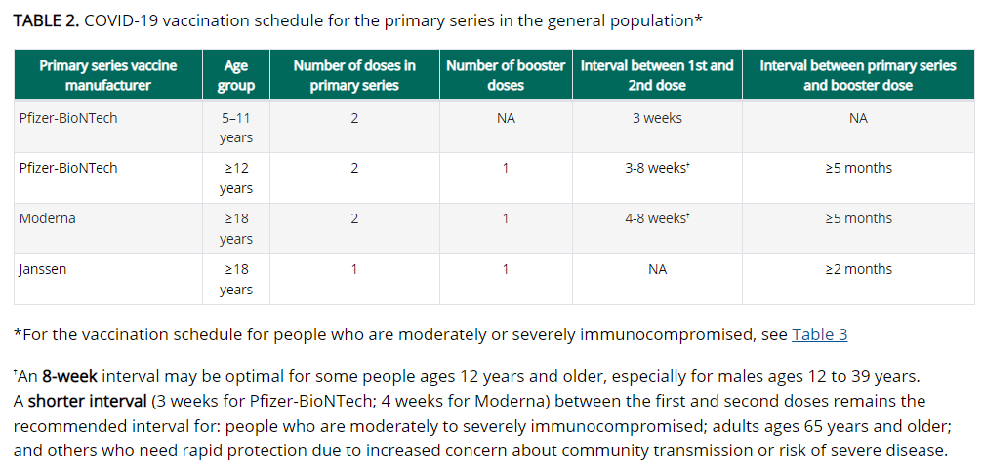

New CDC Clinician Outreach and Communication Activity (COCA) Call Thursday, February 24, 2PM – 3PM ET
Updated Guidance for Clinicians on COVID-19 Vaccines
During this COCA Call, CDC experts will present:
- Updated recommendations on COVID-19 vaccines for people who are moderately or severely immunocompromised
- Simplified recommendations for vaccination following receipt of passive antibody therapy
- Summarized recommendations for COVID-19 vaccination by age group

New American College of Obstetricians and Gynecologists (ACOG) Resources
Visit the ACOG website for COVID-19 resources for individuals, families, and health care professionals, including these two new items:
- ACOG’s first-ever video PSA encouraging all people who are pregnant, thinking about becoming pregnant, and lactating to get vaccinated against COVID-19. This PSA is designed to work on multiple platforms including TV, radio, social media, and websites. You can find the PSA here: www.acog.org/covidvaccine and on ACOG’s Twitter page: @ACOG
- COVID-19 Patient Education Video, which can be shared on clinician websites and via social media. ACOG hopes that this resource helps to support clinicians and partners in counseling their patients to get vaccinated against COVID-19. Get Your Recommended COVID-19 Vaccine During Pregnancy | ACOG

Reminder COVID-19 vaccine for the 6 months through 4-year-old population delayed.
On Friday February 11, Pfizer-BioNTech said it is postponing its rolling application to the FDA to expand the use of its two-dose Covid-19 vaccine for children ages 6 months to 4 years. The move means that vaccines for this age group will not be available in the coming weeks. Pfizer said that it will wait for its data on a three-dose series of the vaccine, because it believes three doses "may provide a higher level of protection in this age group." Data on the third dose is expected in early April, the company said.

Reminder The Interim Clinical Considerations were updated Friday February 11
Updates on February 11 include:
- Updated guidance for moderately or severely immunocompromised people
  - Clarification of existing recommendation to receive a 3-dose mRNA vaccine primary series followed by a booster dose for a total of 4 doses
  - New guidance to shorten the interval between completion of the mRNA vaccine primary series and the booster dose to at least 3 months (instead of 5 months)
  - New guidance for those who received the Janssen COVID-19 Vaccine primary series to receive an additional dose and a booster dose, for a total of 3 doses to be up to date
- Updated guidance that it is no longer necessary to delay COVID-19 vaccination following receipt of monoclonal antibodies or convalescent plasma
- Updated guidance on receiving a booster dose if vaccinated outside the United States

Reminder COVID-19 vaccine formulations currently approved or authorized in the United States

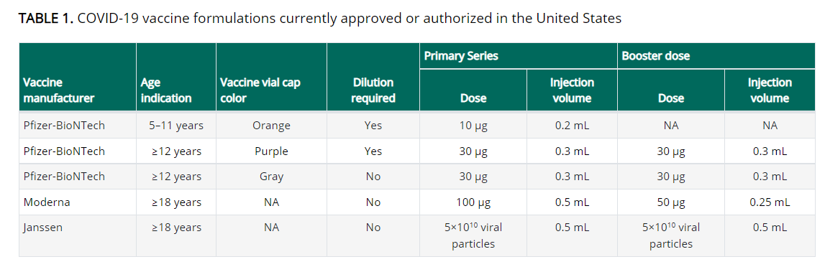

Reminder COVID-19 vaccination schedule for moderately or severely immunocompromised persons ages 5 years and older
People with immunocompromising conditions or people who take immunosuppressive medications or therapies are at increased risk for severe COVID-19. Because the immune response following COVID-19 vaccination may differ in moderately or severely immunocompromised people, specific guidance for this population is provided. Use of mRNA vaccines is preferred.

Primary series for people with moderate or severe immunocompromise
mRNA COVID-19 vaccines
A 3-dose primary series is recommended for people ages 5 years and older who are moderately or severely immunocompromised at the time of vaccination (see Clinical Considerations, Table 3, below). The same mRNA vaccine product should be used for all doses of the primary series.

Janssen/J&J COVID-19 Vaccine
A primary Janssen/J&J vaccine dose is recommended for people ages 18 years and older who are moderately or severely immunocompromised, followed by a second (additional) dose using an mRNA COVID-19 vaccine at least 4 weeks later (see Clinical Considerations, Appendix B for additional information). If Moderna COVID-19 vaccine is used for the second dose, administer a 100 mcg (0.5 ml) dose.

Booster doses for people with moderate or severe immunocompromise
Booster doses are recommended for people 12 years of age and older after completion of primary vaccination.

mRNA COVID-19 vaccine primary series
A single booster dose is recommended at least 3 months after the third dose in the primary series, for a total of four doses, preferably with an mRNA COVID-19 vaccine. If Moderna vaccine is used for the booster dose, a 50 mcg (0.25 mL) dose should be used.

Janssen/J&J COVID-19 primary vaccination
A single booster dose is recommended at least 2 months after the 2nd (additional) dose, for a total of 3 doses (1 Janssen/J&J vaccine dose followed by 1 additional mRNA vaccine dose, then 1 booster dose). mRNA vaccines are preferred for the booster dose. If the Moderna vaccine is used for the booster dose, a 50 mcg (0.25 ml) dose should be used.

Special situation: Many recipients of Janssen/J&J COVID-19 Vaccine may have already received a booster dose (Pfizer-BioNTech, Moderna [50 mcg, 0.25 ml], or Janssen vaccine), without having had the 2nd (additional) mRNA vaccine dose. In this situation, regardless of type and timing of vaccine received as the 2nd dose, administer a Pfizer-BioNTech vaccine or a Moderna vaccine (100 mcg [0.5 mL]) as the 3rd dose at least 2 months after dose 2. See Clinical Considerations Appendix B for additional dose information for Janssen/J&J COVID-19 Vaccine recipients.

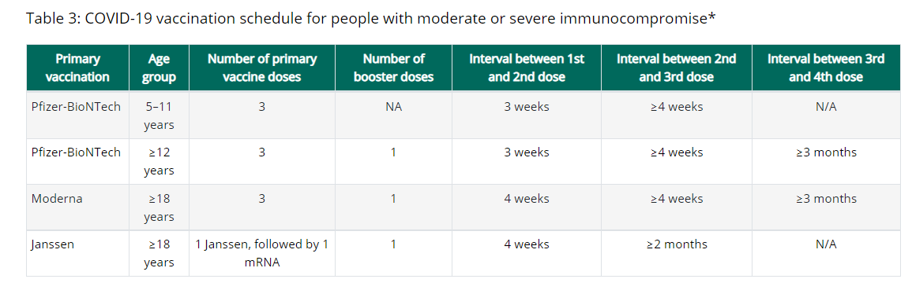
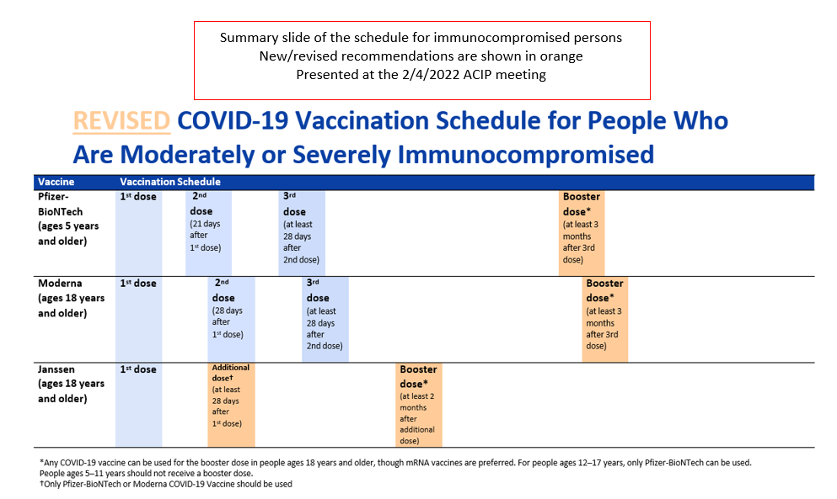

Reminder People who received COVID-19 vaccine outside the United States
- Emergency Use Instructions (EUI) and EUI Factsheets are now available for Pfizer and Moderna on the EUI tab
- Appendix E of the Clinical Considerations also has extensive details and tables describing different scenarios and how to proceed

Reminder People who received passive antibody products
People who previously received antibody products (anti-SARS-CoV-2 monoclonal antibodies or convalescent plasma) as part of COVID-19 treatment, post-exposure prophylaxis, or pre-exposure prophylaxis can be vaccinated at any time; COVID-19 vaccination does not need to be delayed following receipt of monoclonal antibodies or convalescent plasma.
Although some reduction in vaccine-induced antibody titers was observed in people who previously received antibody products, the clinical significance of this reduction is unknown, and the balance of benefits vs. risks favors proceeding with vaccination even considering the possibility of diminished vaccine effectiveness in this situation.
However, in people who previously received a COVID-19 vaccine, administration of tixagevimab/cilgavimab (EVUSHELD™) for pre-exposure prophylaxis should be deferred for at least two weeks after vaccination, per the product EUA .

Reminder Watch for Expired Vaccine
Providers should make it a practice to regularly check inventory for expired vaccine and immediately remove expired inventory to prevent it from being administered.
Vaccine Expiration Date Lookup & Reference Information:
- Expiry Information for Pfizer COVID-19 Vaccines
- Moderna Vial Expiration Date Look-up Tool
- J&J Expiration Date Lookup Tool

Reminder Stay Up to Date with Your Vaccines
To align with standard language CDC uses about other vaccinations, CDC will now use the phrase “up to date” when talking about COVID-19 vaccination. CDC recommends that individuals stay “up to date” by receiving any additional doses they are eligible for, according to CDC’s recommendations, to ensure they have optimal protection against COVID-19. The technical definition of “fully vaccinated” – two doses of an mRNA vaccine or one dose of the Janssen/J&J vaccine – has not changed. Individuals are considered fully vaccinated 14 days after completion of their primary series. For more information, and to see a detailed table, please visit Stay Up to Date with Your Vaccines.

Reminder COVID-19 Quick Reference Guide
CDC’s quick reference guide is a 2-page document that provides basic information on the proper storage, preparation, and administration of the currently authorized COVID-19 vaccine products in the United States.

Reminder CDC’s Product Info by US Vaccine webpage now has Pfizer info in three separate subpages:
- Orange Cap Age 5 through 11
- Purple Cap Age 12 and Older
- Gray Cap Age 12 and Older

Reminder EUA Fact Sheets
Once a new EUA Fact Sheet is issued, it must be used. Previous ones no longer contain accurate information.
- Pfizer, HCP, 12 years of age and older, purple cap (must dilute): https://www.fda.gov/media/153713/download
- Pfizer, HCP, 12 years of age and older, gray cap (no dilution): https://www.fda.gov/media/153715/download
- Pfizer, HCP, 5 - 11 years of age, orange cap (must dilute): https://www.fda.gov/media/153714/download
- Pfizer, Recipient, 12 years of age and older: https://www.fda.gov/media/144414/download
- Pfizer, Recipient, 5-11 years: https://www.fda.gov/media/153717/download
- Moderna, HCP: https://www.fda.gov/media/144637/download
- Moderna, Recipient: https://www.fda.gov/media/144638/download
- Janssen/J&J, HCP: https://www.fda.gov/media/146304/download
- Janssen/J&J, Recipient: https://www.fda.gov/media/146305/download

Reminder EUI Fact Sheets
CDC has issued EUI for use of the COVID-19 vaccines by Pfizer and Moderna for primary, additional, and/or booster doses in certain individuals. The EUI are necessary because these uses extend beyond their FDA-approved labeling. The EUI and CDC’s clinical guidance help to ensure these individuals can get primary, additional, and/or booster doses of the COVID-19 vaccine by Pfizer or Moderna so they can be better protected against COVID-19. The EUI are currently issued only for Pfizer-BioNTech and Moderna COVID-19 vaccines since EUI can only apply to FDA-approved medical products.
- Pfizer, HCP: https://www.cdc.gov/vaccines/covid-19/eui/downloads/pfizer-HCP.pdf
- Pfizer, Recipient: https://www.cdc.gov/vaccines/covid-19/eui/downloads/Pfizer-Caregiver.pdf
- Moderna, HCP: https://www.cdc.gov/vaccines/covid-19/eui/downloads/Moderna-HCP.pdf
- Moderna, Recipient: https://www.cdc.gov/vaccines/covid-19/eui/downloads/Moderna-Caregiver.pdf

Reminder v-safe After Vaccination Health Checker
Encourage everyone to enroll in v-safe!
v-safe provides personalized and confidential health check-ins via text messages and web surveys so you can quickly and easily share with CDC how you, or your dependent, feel after getting a COVID-19 vaccine. This information helps CDC monitor the safety of COVID-19 vaccines in near real time.
- You need a smartphone and your COVID19 vaccination record to enroll
- Available in multiple languages including English, Spanish, Chinese, Korean, and Vietnamese

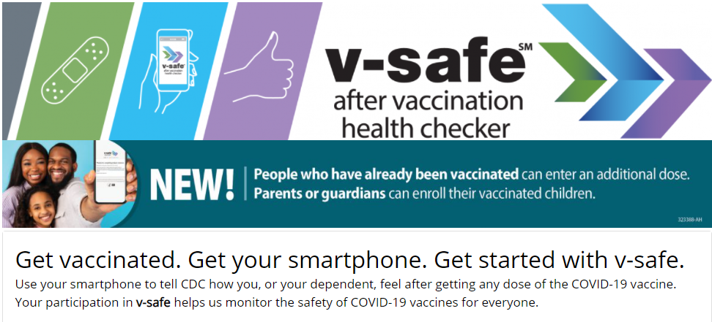

RESOURCES & LEARNING OPPORTUNITIES

Save the Date for the 27th Annual Massachusetts Adult Immunization Conference! This all-day event will be held virtually on Tuesday, April 5, 2022. Registration is now open: click here to register.

Reminder COVID-19 Vaccine Training Modules
CDC’s four training modules (General Overview, Pfizer, Moderna, Janssen/J&J) can be found here.

Reminder COVID-19 Vaccine Webinar Series
CDC is offering a series of brief (15-20 minute) webinars addressing topics around COVID-19 vaccination. These interactive, web-based training modules offer a real-world perspective on different issues around COVID-19 vaccines. Topics range from routine clinical and vaccine safety information to guidance for on-site clinic vaccination activities and having conversations with vaccine recipients. Each webinar includes self-test practice questions and lists additional resources related to the topic discussed. The landing page for all mini webinars is here: https://www.cdc.gov/vaccines/covid-19/training-education/webinars.html

Reminder CDC’s Pregnancy and the COVID-19 Vaccine: Frequently Asked Questions has been updated and is now available in 12 languages.

Reminder CDC launches “Interactive COVID-19 Vaccine Conversations Module for Healthcare Professionals”
CDC has launched a new resource to equip healthcare professionals with the tools they need to have effective COVID-19 vaccine conversations with patients. The Interactive COVID-19 Vaccine Conversations Module for Healthcare Professionals includes:
- Tips for Having Effective Vaccine Conversations with Patients
- Vaccine Conversations in Practice: Case Scenarios

Reminder Pfizer COVID-19 Vaccine Medical Updates on Current & Immunization Site Training
Pfizer Vaccines US Medical Affairs continues to host frequent (almost daily) Medical Updates & Immunization Site Training for All Providers. Session topics include:
- Use of vaccine for Children 5 through 11 Years of Age, and Individuals 12 Years of Age and Older
- Storage, Handling, Preparation, & Administration for the multiple presentations of the vaccine
- Recent medical updates regarding the vaccine
- An overview of healthcare provider resources
- Question and answer session

To access current and future training sessions, please visit: https://www.pfizermedicalinformation.com/en-us/medical-updates

Reminder Morbidity and Mortality Weekly Report, better known as MMWR, is CDC’s primary publication for disseminating the science it produces. The staff at MMWR have launched a landing page to help people find the latest information on COVID-19 vaccine effectiveness and safety.

Recent CDC MMWRs

February 18, 2022 (EARLY RELEASE)
- Pediatric Emergency Department Visits Before and During the COVID-19 Pandemic — United States, January 2019–January 2022

- Pediatric Emergency Department Visits Associated with Mental Health Conditions Before and During the COVID-19 Pandemic — United States, January 2019–January 2022
February 18, 2022
- Multistate Outbreak of SARS-CoV-2 B.1.1.529 (Omicron) Variant Infections Among Persons in a Social Network Attending a Convention — New York City, November 18–December 20, 2021

- Investigation of SARS-CoV-2 Transmission Associated With a Large Indoor Convention — New York City, November–December 2021

- Safety Monitoring of COVID-19 Vaccine Booster Doses Among Adults — United States, September 22, 2021–February 6, 2022

- Waning 2-Dose and 3-Dose Effectiveness of mRNA Vaccines Against COVID-19–Associated Emergency Department and Urgent Care Encounters and Hospitalizations Among Adults During Periods of Delta and Omicron Variant Predominance — VISION Network, 10 States, August 2021–January 2022

- Effectiveness of Maternal Vaccination with mRNA COVID-19 Vaccine During Pregnancy Against COVID-19–Associated Hospitalization in Infants Aged <6 Months — 17 States, July 2021–January 2022

- Hospitalizations of Children and Adolescents with Laboratory-Confirmed COVID-19 — COVID-NET, 14 States, July 2021–January 2022

February 18, 2022 (non-COVID-19 related)

- Advisory Committee on Immunization Practices Recommended Immunization Schedule for Adults Aged 19 Years or Older — United States, 2022

- Advisory Committee on Immunization Practices Recommended Immunization Schedule for Children and Adolescents Aged 18 Years or Younger — United States, 2022

MDPH RESOURCES

Reminder Massachusetts Resources
- COVID-19 Vaccine Information
- COVID-19 booster information and booster frequently asked questions
- Search for Vaccine locations: https://vaxfinder.mass.gov/
- COVID-19 Vaccine Resource Line/2-1-1 is available for individuals who are unable to use Vaxfinder, or have difficulty accessing the internet. Available in English and Spanish and has translators available in approximately 100 additional languages.
- COVID-19 Vaccine Training and Education Resources for Providers: https://www.mass.gov/info-details/covid-19-vaccine-training-and-education-resources-for-providers
- Reminder Multilingual COVID-19 Materials. Resources related to Coronavirus Disease 2019 (COVID-19) in multiple languages. Includes videos and printables on topics like vaccine safety, pregnancy and the vaccine, and FAQs.

Immunization Division Main Number
For questions about immunization recommendations, disease reporting, etc.
Phone: 617-983-6800 (24/7 MDPH Epi line)
Fax: 617-983-6840
Website: https://www.mass.gov/topics/immunization

MIIS Help Desk
Phone: 617-983-4335
Fax: 857-323-8321
Email questions to: miishelpdesk@mass.gov
Website: https://www.mass.gov/service-details/massachusetts-immunization-information-system-miis

MDPH Vaccine Unit
Phone: 617-983-6828
Email questions to: dph-vaccine-management@mass.gov
Website: https://www.mass.gov/service-details/vaccine-management

COVID-19 Email Box
Email questions to: COVID-19-Vaccine-Plan-MA@mass.gov

