BULLETIN
What Massachusetts COVID-19 Vaccine Providers Need to Know
Week of 2/9/2022
LATEST NUMBERS

- As of 2/9/2022 5,232,233 people in Massachusetts have been fully vaccinated.
Massachusetts has now fully vaccinated over 5 million people!

WHO TO VACCINATE THIS WEEK

COVID-19 vaccination is recommended for everyone aged 5 years and older for the prevention of coronavirus disease 2019 (COVID-19). People ages 5-17 can get the Pfizer vaccine. People age 18+ can get any vaccine.

- A primary series for anyone ages 5 and older who lives, works, or studies in Massachusetts is eligible for a vaccine. Health care providers can also vaccinate their patient panels regardless of place of residency.
- A booster dose for immunocompetent persons ages 12 years and older
- At least 5 months after completion of an mRNA vaccine primary series.
- At least 2 months after completion of a Janssen/J&J primary dose.
- mRNA COVID19 vaccines are preferred
- Moderately to severely immunocompromised ages 5 and older – see below for new details

WHAT TO KNOW THIS WEEK

Some of this information is preliminary. In an attempt to get information to you in as timely a manner as possible, we are including it. Please understand that the details could change.

New Vaccination for moderately or severely immunocompromised persons ages 5 years and older
(this info was presented at the 2/4/2022 ACIP meeting, along with the statement that the Clinical Considerations would be updated shortly to reflect this info. Please watch the Clinical Considerations for the official guidance release)

People with immunocompromising conditions are at increased risk for severe COVID-19, may not mount a protective immune response after initial vaccination, and have waning protection over time. CDC is adjusting the Clinical Considerations for this population to now recommend an additional dose after a Janssen COVID-19 Vaccine primary series, and shorter booster interval after an mRNA COVID-19 vaccine primary series.

- An additional primary series dose for people ages 5 and older who are moderately to severely immunocompromised
- At least 28 days after the completion of the second mRNA COVID-19 vaccine dose.
- At least 28 days after the completion of the single Janssen/J&J COVID-19 vaccine dose.
- These additional doses in a primary series should be a mRNA vaccine, even for those persons who received a Janssen/J&J first dose. People ages 5-17 should get the Pfizer vaccine.

- A booster dose for people ages 12 and older who are moderately to severely immunocompromised
- A Pfizer booster, for people ages 12 through 17 years, at least 3 months after the completion of the third mRNA COVID-19 vaccine dose.
- For people ages 18 and over who received an mRNA vaccine as their first primary series, administer a booster (mRNA COVID19 vaccines preferred), at least 3 months after the completion of the third mRNA COVID-19 vaccine dose.
- For people ages 18 and over who received Janssen/J&J as their first primary dose, administer a booster (mRNA COVID19 vaccines preferred), at least 2 months after the completion of the additional primary series dose.

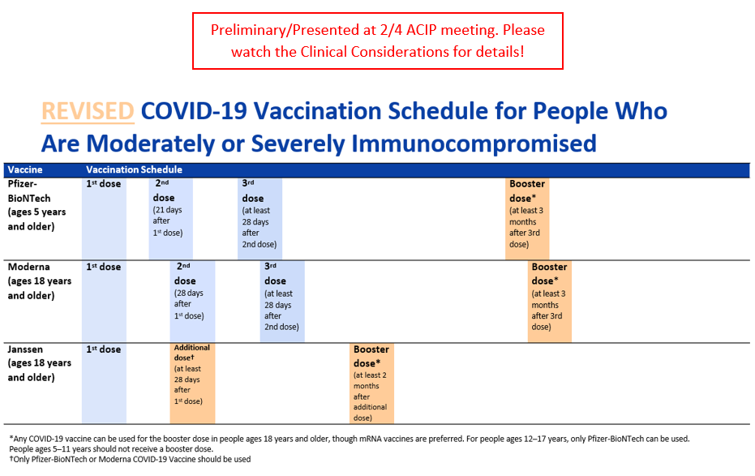

New Pfizer Maroon Cap/Under 5 years old
Pfizer-BioNTech has begun submitting data to FDA for an Emergency Use Authorization (EUA) application for a vaccine for children ages 6m–4 years. Data were submitted for two doses of what is anticipated to be a three-dose series. FDA’s Advisory Committee is scheduled to meet on February 15, 2022. ACIP is anticipated to meet within several days of any FDA decision.
The ACIP meeting will be posted here once scheduled: https://www.cdc.gov/vaccines/acip/index.html

Some things to be aware of:
- The current Pfizer products for adults, adolescents, and children ages 5–11 years should NOT be used in children ages 6m–4 years.
- Maroon cap/Under 5 years old vaccine will ship at -80°C, like all current Pfizer COVID-19 vaccines
- Different color cap (maroon), different dose (3 micrograms/0.2mL), different amount of diluent added (2.2mL), and a new national drug code (NDC).
- Maroon cap/Under 5 years old vaccine packaging configuration is expected to be 10-dose vials in cartons of 10 vials each (100 doses total) with a minimum order quantity of 100 doses. The diluent will be provided with ancillary supplies to support 100 doses per kit.

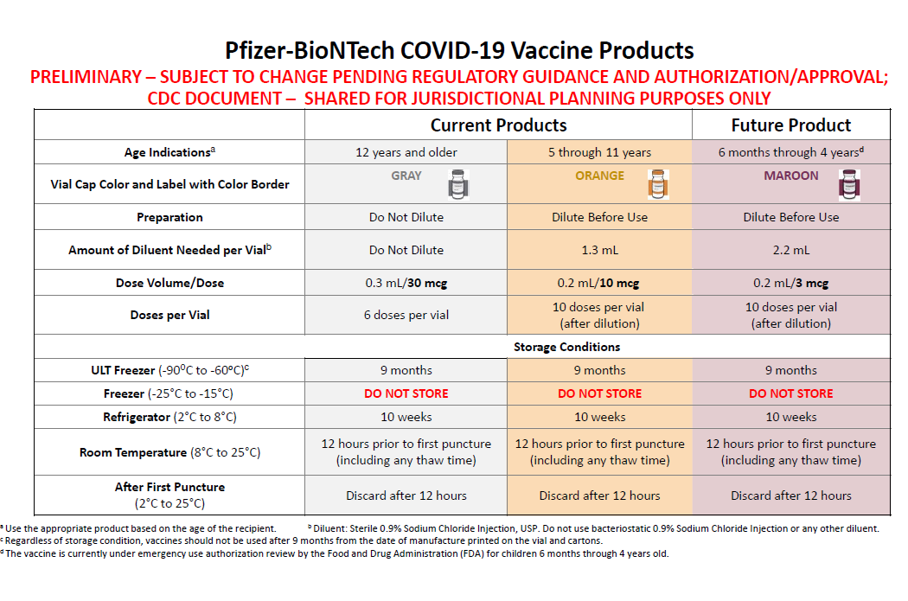

New Ordering Information for the Pfizer under 5: Effective immediately, Massachusetts COVID-19 Vaccine Program (MCVP)-enrolled provider sites are able to place pre-orders for the new under 5 formulation of vaccine through the Massachusetts Immunization Information System (MIIS). Assuming FDA and CDC approvals occur next week, orders for this formulation placed before 9AM Thursday February 10th will be delivered on Monday February 21st. Please note that February 21st is a holiday, therefore you must ensure your office is open on February 21st if you are placing vaccine orders in the MIIS on 2/7-2/10. Any orders placed on or after Friday February 11th will begin being delivered on Tuesday February 22nd and throughout the rest of that week.

New Moderna/Spikevax approved by FDA on January 31, and subsequently recommended by ACIP and endorsed by CDC on February 4. The vaccine has been known as the Moderna COVID-19 Vaccine; the approved vaccine will be marketed as Spikevax. Spikevax is approved for the prevention of COVID-19 in individuals 18 years of age and older.
Moderna EUA fact sheets have been updated to reflect this change.

Reminder Watch for Expired Vaccine
Providers should make it a practice to regularly check inventory for expired vaccine and immediately remove expired inventory to prevent it from being administered.
Vaccine Expiration Date Lookup & Reference Information:
- Expiry Information for Pfizer COVID-19 Vaccines
- Moderna Vial Expiration Date Look-up Tool
- J&J Expiration Date Lookup Tool

Reminder Stay Up to Date with Your Vaccines
To align with standard language CDC uses about other vaccinations, CDC will now use the phrase “up to date” when talking about COVID-19 vaccination. CDC recommends that individuals stay “up to date” by receiving any additional doses they are eligible for, according to CDC’s recommendations, to ensure they have optimal protection against COVID-19. The technical definition of “fully vaccinated” – two doses of an mRNA vaccine or one dose of the Janssen/J&J vaccine – has not changed. Individuals are considered fully vaccinated 14 days after completion of their primary series. For more information, and to see a detailed table, please visit Stay Up to Date with Your Vaccines.

Reminder COVID-19 Quick Reference Guide
CDC’s quick reference guide is a 2-page document that provides basic information on the proper storage, preparation, and administration of the currently authorized COVID-19 vaccine products in the United States.

Reminder CDC’s Product Info by US Vaccine webpage now has Pfizer info in three separate subpages:
- Orange Cap Age 5 through 11
- Purple Cap Age 12 and Older
- Gray Cap Age 12 and Older

Reminder EUA Fact Sheets
Once a new EUA Fact Sheet is issued, it must be used. Previous ones no longer contain accurate information.
- Pfizer, HCP, 12 years of age and older, purple cap (must dilute): https://www.fda.gov/media/153713/download
- Pfizer, HCP, 12 years of age and older, gray cap (no dilution): https://www.fda.gov/media/153715/download
- Pfizer, HCP, 5 - 11 years of age, orange cap (must dilute): https://www.fda.gov/media/153714/download
- Pfizer, Recipient, 12 years of age and older: https://www.fda.gov/media/144414/download
- Pfizer, Recipient, 5-11 years: https://www.fda.gov/media/153717/download
- Moderna, HCP: https://www.fda.gov/media/144637/download
- Moderna, Recipient: https://www.fda.gov/media/144638/download
- Janssen, HCP: https://www.fda.gov/media/146304/download
- Janssen, Recipient: https://www.fda.gov/media/146305/download

Reminder Public Portal Launch – Please Ensure Patient Information in the MIIS is Up to Date.
On January 10, 2022 the Baker-Polito administration announced a new option for residents to access their COVID-19 vaccination record from the state’s immunization registry and obtain a ‘SMART Health Card’ QR code to indicate proof of vaccination. Massachusetts residents can visit www.myvaxrecords.mass.gov, a web portal that follows national standards for security and privacy and provides residents a way to electronically view and save their COVID-19 vaccine record. By providing a mobile phone number or email address, users can obtain a digital record of their vaccinations recorded in the Massachusetts Immunization Information System. Their COVID-19 vaccination record includes a unique QR code that can be saved to the user’s phone files, camera roll, the Apple Wallet or Google Pay through a 3rd party application, Common Health. (https://www.commonhealth.org/smart-health-cards). It can also be printed out for a paper record.
Patients now have increased accessibility to obtain their immunizations through My Vax Records. As a reminder it is important to keep patient demographic information in MIIS up to date during COVID-19. Massachusetts providers who vaccinate individuals are required to enter certain data into the Massachusetts Immunization Information System (MIIS). This allows users to access their vaccination records for any reason they may need them. Patients with missing or out-of-date demographic information (such as phone, email) may not be able to return a match. These patients will be directed to their vaccine provider who is responsible for updating their immunization record in the MIIS. Therefore, the Department of Public Health strongly encourages providers to ensure they have an email address and/or mobile phone number for patients in their MIIS immunization records.

The MIIS allows providers to make updates to patient demographics in the following ways:

1. Access their patient records through this web-based application to enable demographic and immunization updates. You can view Patient Lookup in the MIIS for more information.
2. Technical solutions are available to allow demographic only updates to be sent directly from your electronic health record systems.
3. A one-time bulk file will be accepted and uploaded into the MIIS.

Please contact the MIIS Helpdesk miishelpdesk@mass.gov for more information.

RESOURCES & LEARNING OPPORTUNITIES

Reminder COVID-19 Vaccine Training Modules
CDC’s four training modules (General Overview, Pfizer, Moderna, Janssen/J&J) can be found here.

Reminder COVID-19 Vaccine Webinar Series
CDC is offering a series of brief (15-20 minute) webinars addressing topics around COVID-19 vaccination. These interactive, web-based training modules offer a real-world perspective on different issues around COVID-19 vaccines. Topics range from routine clinical and vaccine safety information to guidance for on-site clinic vaccination activities and having conversations with vaccine recipients. Each webinar includes self-test practice questions and lists additional resources related to the topic discussed. The landing page for all mini webinars is here: https://www.cdc.gov/vaccines/covid-19/training-education/webinars.html

Reminder Communication Skills for Clinicians Discussing COVID-19 Vaccination
A free training on Communication/Motivational Interviewing Skills for Clinicians Discussing COVID-19 Vaccination is being offered by UMass Chan Medical School and PNQIN (Perinatal Neonatal Quality Improvement Network). This training is a 90-minute webinar designed to improve the counseling skills of Massachusetts clinicians and other providers for discussing COVID-19 vaccination with pregnant and postpartum people, parents and caregivers of young children, and families. The training will also focus on addressing vaccine hesitancy and reducing racial disparities in rates of COVID-19 vaccination. Continuing Education credits available.

Registration link and info: February 11th: 12:00pm – 1:30pm

Reminder CDC’s Pregnancy and the COVID-19 Vaccine: Frequently Asked Questions has been updated and is now available in 12 languages.

Reminder The Role of OB/GYNs in Building Vaccine Confidence: As providers of health care throughout a patient’s life, obstetrician-gynecologists are uniquely positioned to educate patients on the benefits and safety of the COVID-19 vaccine. The American College of Obstetricians and Gynecologists (ACOG) outlines three steps OB/GYNs can take to build vaccine confidence with patients, including:
- Review ACOG’s Practice Advisory on vaccinating pregnant and lactating patients against COVID-19.
- Use ACOG’s COVID-19 vaccines and pregnancy Conversation Guide for clinicians.
- Tell your patients about the COVID-19 resources on ACOG’s new patient website.

Reminder CDC launches “Interactive COVID-19 Vaccine Conversations Module for Healthcare Professionals”
CDC has launched a new resource to equip healthcare professionals with the tools they need to have effective COVID-19 vaccine conversations with patients. The Interactive COVID-19 Vaccine Conversations Module for Healthcare Professionals includes:
- Tips for Having Effective Vaccine Conversations with Patients
- Vaccine Conversations in Practice: Case Scenarios

Reminder Pfizer COVID-19 Vaccine Medical Updates on Current & Immunization Site Training
Pfizer Vaccines US Medical Affairs continues to host frequent (almost daily) Medical Updates & Immunization Site Training for All Providers. Session topics include:
- Use of vaccine for Children 5 through 11 Years of Age, and Individuals 12 Years of Age and Older
- Storage, Handling, Preparation, & Administration for the multiple presentations of the vaccine
- Recent medical updates regarding the vaccine
- An overview of healthcare provider resources
- Question and answer session

To access current and future training sessions, please visit: https://www.pfizermedicalinformation.com/en-us/medical-updates

Reminder Morbidity and Mortality Weekly Report, better known as MMWR, is CDC’s primary publication for disseminating the science it produces. The staff at MMWR have launched a landing page to help people find the latest information on COVID-19 vaccine effectiveness and safety.

CDC MMWRs
February 4, 2022 (EARLY RELEASE)
- Effectiveness of Face Mask or Respirator Use in Indoor Public Settings for Prevention of SARS-CoV-2 Infection — California, February–December 2021

- Clinical Characteristics and Outcomes Among Adults Hospitalized with Laboratory-Confirmed SARS-CoV-2 Infection During Periods of B.1.617.2 (Delta) and B.1.1.529 (Omicron) Variant Predominance — One Hospital, California, July 15–September 23, 2021, and December 21, 2021–January 27, 2022
February 4, 2022
- COVID-19 Vaccination Coverage and Vaccine Confidence by Sexual Orientation and Gender Identity — United States, August 29–October 30, 2021

- SARS-CoV-2 Infection and Hospitalization Among Adults Aged ≥18 Years, by Vaccination Status, Before and During SARS-CoV-2 B.1.1.529 (Omicron) Variant Predominance — Los Angeles County, California, November 7, 2021–January 8, 2022

- Notes from the Field: COVID-19 Vaccination Among Persons Living with Diagnosed HIV Infection — New York, October 2021

MDPH RESOURCES

Reminder Massachusetts Resources
- COVID-19 Vaccine Information
- COVID-19 booster information and booster frequently asked questions
- Search for Vaccine locations: https://vaxfinder.mass.gov/
- COVID-19 Vaccine Resource Line/2-1-1 is available for individuals who are unable to use Vaxfinder, or have difficulty accessing the internet. Available in English and Spanish and has translators available in approximately 100 additional languages.
- New COVID-19 Vaccine Training and Education Resources for Providers: https://www.mass.gov/info-details/covid-19-vaccine-training-and-education-resources-for-providers

Immunization Division Main Number
For questions about immunization recommendations, disease reporting, etc.
Phone: 617-983-6800 (24/7 MDPH Epi line)
Fax: 617-983-6840
Website: https://www.mass.gov/topics/immunization

MIIS Help Desk
Phone: 617-983-4335
Fax: 857-323-8321
Email questions to: miishelpdesk@mass.gov
Website: https://www.mass.gov/service-details/massachusetts-immunization-information-system-miis

MDPH Vaccine Unit
Phone: 617-983-6828
Email questions to: dph-vaccine-management@mass.gov
Website: https://www.mass.gov/service-details/vaccine-management

COVID-19 Email Box
Email questions to: COVID-19-Vaccine-Plan-MA@mass.gov

