BULLETIN
What Massachusetts COVID-19 Vaccine Providers Need to Know
Week of 3/8/2022

LATEST NUMBERS

- As of 3/8/2022 5,298,708 people in Massachusetts have been fully vaccinated.

WHO TO VACCINATE THIS WEEK

COVID-19 vaccination is recommended for everyone aged 5 years and older for the prevention of coronavirus disease 2019 (COVID-19). People ages 5-17 can get the Pfizer vaccine. People age 18+ can get any vaccine.

- A primary series for anyone ages 5 and older who lives, works, or studies in Massachusetts is eligible for a vaccine. Health care providers can also vaccinate their patient panels regardless of place of residency.
- A booster dose for immunocompetent persons ages 12 years and older
- At least 5 months after completion of an mRNA vaccine primary series.
- At least 2 months after completion of a Janssen/J&J primary dose.
- mRNA COVID19 vaccines are preferred
- Moderately to severely immunocompromised ages 5 and older – see section below, vaccination schedule for moderately or severely immunocompromised persons ages 5 years and older, for details

KEY POINTS
- COVID-19 vaccines currently approved or authorized by FDA are effective in preventing serious outcomes of coronavirus disease 2019 (COVID-19), including severe disease, hospitalization, and death.
- COVID-19 primary series vaccination is recommended for everyone ages 5 years and older in the United States for the prevention of COVID-19.
- In most situations, Pfizer-BioNTech or Moderna COVID-19 Vaccines are preferred over the Janssen/J&J COVID-19 Vaccine for primary and booster vaccination.
- A 3-dose primary mRNA COVID-19 vaccine series is recommended for people ages 5 years and older who are moderately or severely immunocompromised, followed by a booster dose in those ages 12 years and older.
- A booster dose of COVID-19 vaccine is recommended for everyone ages 12 years and older. Timing of a booster dose varies based on COVID-19 vaccine product and immunocompetence.
- Efforts to increase the number of people in the United States who are up to date with their COVID-19 vaccines remain critical to preventing illness, hospitalizations, and deaths from COVID-19.

WHAT TO KNOW THIS WEEK

New J&J/Janssen Vaccine Expiration Extension
The FDA announced the approval of a shelf-life extension for the J&J/Janssen vaccine for an additional three months. The shelf life of this vaccine has been updated from 6 months to 9 months. This decision is based on data from ongoing stability assessment studies, which have demonstrated that the vaccine is stable at 9 months when refrigerated at temperatures of 36º – 46º Fahrenheit (2º – 8º Celsius).
This shelf-life extension applies to all inventory dated to expire on March 7, 2022 or later. Vaccine dated prior to March 7, 2022 should be disposed of.
- Vaccine providers should visit the Janssen COVID-19 Vaccine Expiry Checker webpage to confirm the expiration dates.
- J&J/Janssen COVID-19 vaccine expiration dates will be updated in the MIIS by 3/11.
- This shelf-life extension applies to refrigerated vials of J&J/Janssen COVID-19 vaccine that have been held in accordance with the manufacturer’s storage conditions.
COVID-19 vaccines that are authorized under an EUA do not have fixed expiration dates, and expiration dates may be extended as we get more stability data. Always check the manufacturer’s website to obtain the most up-to-date expiration dates for the COVID-19 vaccines you have on hand.
Reminder COVID-19 vaccine formulations currently approved or authorized in the United States
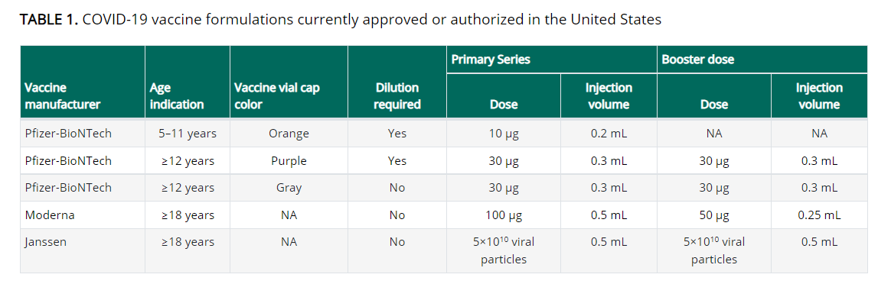

Reminder The Interim Clinical Considerations were updated Tuesday February 22
CDC updated its Clinical Considerations and added considerations for an 8-week interval between the first and second doses of a primary mRNA vaccine schedule.

This updated guidance is specific to the mRNA (Pfizer or Moderna) COVID-19 vaccine primary series and is only for some patients who are not yet vaccinated.
- Specifically, people ages 12 through 64 years who are not moderately or severely immunocompromised—and particularly males ages 12 through 39 years—may benefit from getting their second mRNA vaccine dose 8 weeks after their first dose, instead of after the 3-week (Pfizer) or 4-week (Moderna) interval. The potential benefits of this extended interval are two-fold:
- Stronger immune response—Data show that a longer interval between the first and second doses may give the body a chance to build a stronger immune response, increasing the effectiveness of these vaccines.
- Further minimization of the already rare risk of adverse events—New studies have shown the small risk of myocarditis and pericarditis associated with mRNA vaccination—mostly among males between the ages of 12 and 39 years—might be reduced with a longer interval.

- It’s important to note that patients who meet these criteria and have already received their primary mRNA series at the 3-week (Pfizer) or 4-week (Moderna) interval remain well-protected—especially if they have received a booster dose—and do not need to repeat any doses.
- The extended interval is not recommended for all people ages 12 through 64 years, and there are situations where providers should continue to recommend the 3-week (Pfizer) or 4-week (Moderna) intervals between primary doses. These include when there is concern about high levels of community transmission, and among people who are moderately or severely immunocompromised. In addition, the extended interval is not recommended for anyone ages 65 years or older.

Reminder COVID-19 vaccination schedule for the primary series in the general population
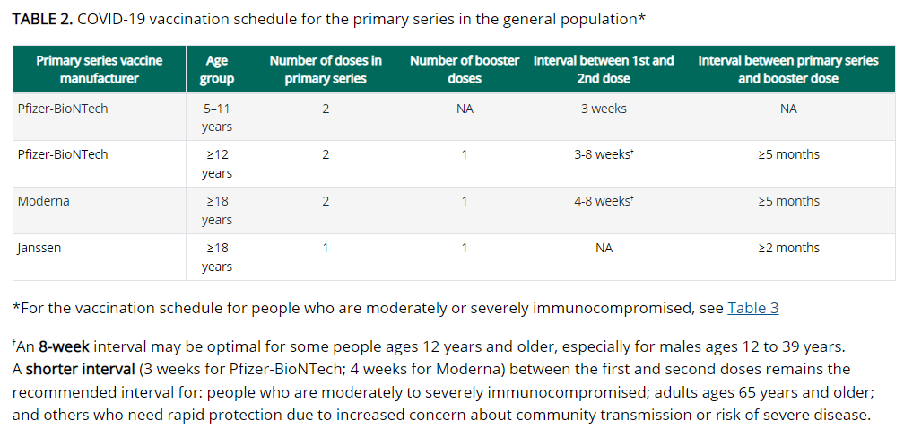

New Graphic Primary Series (for people who are NOT immunocompromised)

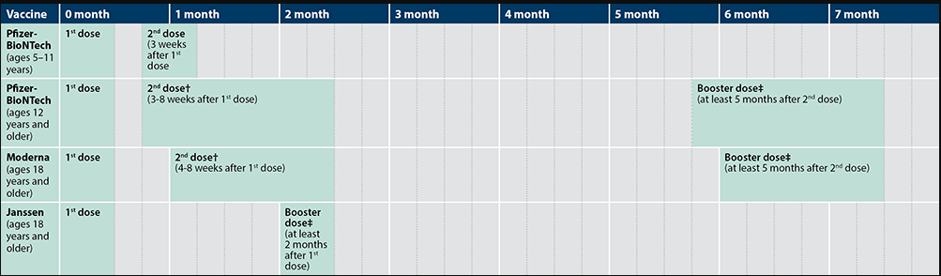

Reminder COVID-19 vaccination schedule for moderately or severely immunocompromised persons ages 5 years and older
People with immunocompromising conditions or people who take immunosuppressive medications or therapies are at increased risk for severe COVID-19. Because the immune response following COVID-19 vaccination may differ in moderately or severely immunocompromised people, specific guidance for this population is provided. Use of mRNA vaccines is preferred.

Primary series for people with moderate or severe immunocompromise
mRNA COVID-19 vaccines
A 3-dose primary series is recommended for people ages 5 years and older who are moderately or severely immunocompromised at the time of vaccination (see Clinical Considerations, Table 3, below). The same mRNA vaccine product should be used for all doses of the primary series.

Janssen/J&J COVID-19 Vaccine
A primary Janssen/J&J vaccine dose is recommended for people ages 18 years and older who are moderately or severely immunocompromised, followed by a second (additional) dose using an mRNA COVID-19 vaccine at least 4 weeks later (see Clinical Considerations, Appendix B for additional information). If Moderna COVID-19 vaccine is used for the second dose, administer a 100 mcg (0.5 ml) dose.

Booster doses for people with moderate or severe immunocompromise
Booster doses are recommended for people 12 years of age and older after completion of primary vaccination.

mRNA COVID-19 vaccine primary series
A single booster dose is recommended at least 3 months after the third dose in the primary series, for a total of four doses, preferably with an mRNA COVID-19 vaccine. If Moderna vaccine is used for the booster dose, a 50 mcg (0.25 mL) dose should be used.

Janssen/J&J COVID-19 primary vaccination
A single booster dose is recommended at least 2 months after the 2nd (additional) dose, for a total of 3 doses (1 Janssen/J&J vaccine dose followed by 1 additional mRNA vaccine dose, then 1 booster dose). mRNA vaccines are preferred for the booster dose. If the Moderna vaccine is used for the booster dose, a 50 mcg (0.25 ml) dose should be used.

Special situation: Many recipients of Janssen/J&J COVID-19 Vaccine may have already received a booster dose (Pfizer-BioNTech, Moderna [50 mcg, 0.25 ml], or Janssen vaccine), without having had the 2nd (additional) mRNA vaccine dose. In this situation, regardless of type and timing of vaccine received as the 2nd dose, administer a Pfizer-BioNTech vaccine or a Moderna vaccine (100 mcg [0.5 mL]) as the 3rd dose at least 2 months after dose 2. See Clinical Considerations Appendix B for additional dose information for Janssen/J&J COVID-19 Vaccine recipients.

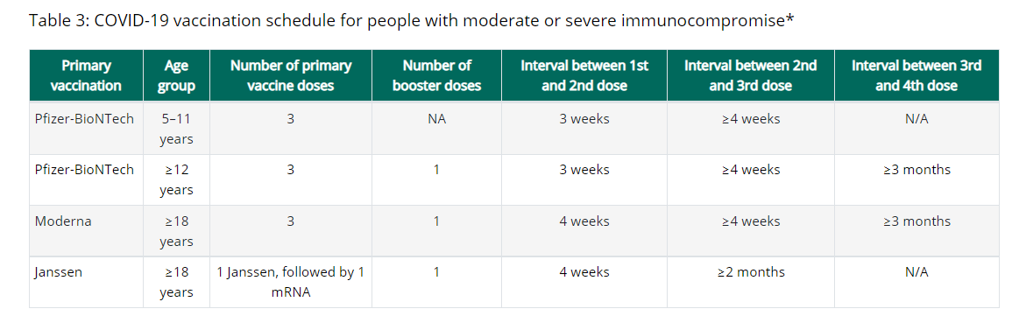

New Graphic COVID-19 Vaccination Schedule for People Who Are Moderately or Severely Immunocompromised

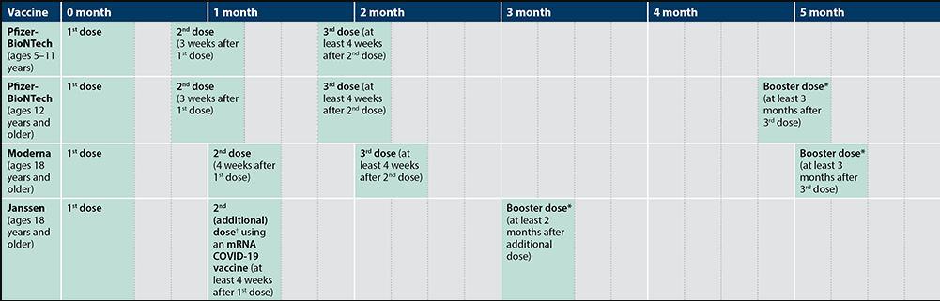

*An mRNA COVID-19 vaccine is preferred over the Janssen COVID-19 Vaccine for booster vaccination of people ages 18 years and older. For people ages 12–17 years, only Pfizer-BioNTech can be used. People ages 5–11 years should not receive a booster dose.
†Only Pfizer-BioNTech or Moderna COVID-19 Vaccine should be used. See Appendix B for more information on vaccinating people who are moderately or severely immunocompromised and who received Janssen COVID-19 Vaccine for the primary series.

Reminder Watch for Expired Vaccine
Providers should make it a practice to regularly check inventory for expired vaccine and immediately remove expired inventory to prevent it from being administered.
Vaccine Expiration Date Lookup & Reference Information:
- Expiry Information for Pfizer COVID-19 Vaccines
- Moderna Vial Expiration Date Look-up Tool
- J&J Expiration Date Lookup Tool

Reminder CDC’s Product Info by US Vaccine webpage now has Pfizer info in three separate subpages:
- Orange Cap Age 5 through 11
- Purple Cap Age 12 and Older
- Gray Cap Age 12 and Older

Reminder EUA Fact Sheets
Once a new EUA Fact Sheet is issued, it must be used. Previous ones no longer contain accurate information.
- Pfizer, HCP, 12 years of age and older, purple cap (must dilute): https://www.fda.gov/media/153713/download
- Pfizer, HCP, 12 years of age and older, gray cap (no dilution): https://www.fda.gov/media/153715/download
- Pfizer, HCP, 5 - 11 years of age, orange cap (must dilute): https://www.fda.gov/media/153714/download
- Pfizer, Recipient, 12 years of age and older: https://www.fda.gov/media/144414/download
- Pfizer, Recipient, 5-11 years: https://www.fda.gov/media/153717/download
- Moderna, HCP: https://www.fda.gov/media/144637/download
- Moderna, Recipient: https://www.fda.gov/media/144638/download
- Janssen/J&J, HCP: https://www.fda.gov/media/146304/download
- Janssen/J&J, Recipient: https://www.fda.gov/media/146305/download

Reminder EUI Fact Sheets
CDC has issued EUI for use of the COVID-19 vaccines by Pfizer and Moderna for primary, additional, and/or booster doses in certain individuals. The EUI are necessary because these uses extend beyond their FDA-approved labeling. The EUI and CDC’s clinical guidance help to ensure these individuals can get primary, additional, and/or booster doses of the COVID-19 vaccine by Pfizer or Moderna so they can be better protected against COVID-19. The EUI are currently issued only for Pfizer-BioNTech and Moderna COVID-19 vaccines since EUI can only apply to FDA-approved medical products.
- Pfizer, HCP: https://www.cdc.gov/vaccines/covid-19/eui/downloads/pfizer-HCP.pdf
- Pfizer, Recipient: https://www.cdc.gov/vaccines/covid-19/eui/downloads/Pfizer-Caregiver.pdf
- Moderna, HCP: https://www.cdc.gov/vaccines/covid-19/eui/downloads/Moderna-HCP.pdf
- Moderna, Recipient: https://www.cdc.gov/vaccines/covid-19/eui/downloads/Moderna-Caregiver.pdf
- EUI FAQs

RESOURCES & LEARNING OPPORTUNITIES

Save the Date for the 27th Annual Massachusetts Adult Immunization Conference! This all-day event will be held virtually on Tuesday, April 5, 2022. Registration is now open: click here to register.

Reminder COVID-19 Vaccine Training Modules
CDC’s four training modules (General Overview, Pfizer, Moderna, Janssen/J&J) can be found here.

Reminder COVID-19 Vaccine Webinar Series
CDC is offering a series of brief (15-20 minute) webinars addressing topics around COVID-19 vaccination. These interactive, web-based training modules offer a real-world perspective on different issues around COVID-19 vaccines. Topics range from routine clinical and vaccine safety information to guidance for on-site clinic vaccination activities and having conversations with vaccine recipients. Each webinar includes self-test practice questions and lists additional resources related to the topic discussed. The landing page for all mini webinars is here: https://www.cdc.gov/vaccines/covid-19/training-education/webinars.html

Reminder COVID-19 Quick Reference Guide
CDC’s quick reference guide is a 2-page document that provides basic information on the proper storage, preparation, and administration of the currently authorized COVID-19 vaccine products in the United States.

Reminder CDC’s Pregnancy and the COVID-19 Vaccine: Frequently Asked Questions has been updated and is now available in 12 languages.

Reminder American College of Obstetricians and Gynecologists (ACOG) Resources
Visit the ACOG website for COVID-19 resources for individuals, families, and health care professionals, including these two new items:
- ACOG’s first-ever video PSA encouraging all people who are pregnant, thinking about becoming pregnant, and lactating to get vaccinated against COVID-19. This PSA is designed to work on multiple platforms including TV, radio, social media, and websites. You can find the PSA here: www.acog.org/covidvaccine and on ACOG’s Twitter page: @ACOG
- COVID-19 Patient Education Video, which can be shared on clinician websites and via social media. ACOG hopes that this resource helps to support clinicians and partners in counseling their patients to get vaccinated against COVID-19. Get Your Recommended COVID-19 Vaccine During Pregnancy | ACOG

Reminder CDC launches “Interactive COVID-19 Vaccine Conversations Module for Healthcare Professionals”
CDC has launched a new resource to equip healthcare professionals with the tools they need to have effective COVID-19 vaccine conversations with patients. The Interactive COVID-19 Vaccine Conversations Module for Healthcare Professionals includes:
- Tips for Having Effective Vaccine Conversations with Patients
- Vaccine Conversations in Practice: Case Scenarios

Reminder Pfizer COVID-19 Vaccine Medical Updates on Current & Immunization Site Training
Pfizer Vaccines US Medical Affairs continues to host frequent (almost daily) Medical Updates & Immunization Site Training for All Providers. Session topics include:
- Use of vaccine for Children 5 through 11 Years of Age, and Individuals 12 Years of Age and Older
- Storage, Handling, Preparation, & Administration for the multiple presentations of the vaccine
- Recent medical updates regarding the vaccine
- An overview of healthcare provider resources
- Question and answer session

To access current and future training sessions, please visit: https://www.pfizermedicalinformation.com/en-us/medical-updates

Reminder Morbidity and Mortality Weekly Report, better known as MMWR, is CDC’s primary publication for disseminating the science it produces. The staff at MMWR have launched a landing page to help people find the latest information on COVID-19 vaccine effectiveness and safety.

Recent CDC MMWRs

March 4, 2022

- Disparities in COVID-19 Vaccination Coverage Between Urban and Rural Counties — United States, December 14, 2020–January 31, 2022

- SARS-CoV-2 B.1.1.529 (Omicron) Variant Transmission Within Households — Four U.S. Jurisdictions, November 2021–February 2022

- Safety Monitoring of COVID-19 Vaccine Booster Doses Among Persons Aged 12–17 Years — United States, December 9, 2021–February 20, 2022

- Effectiveness of COVID-19 Pfizer-BioNTech BNT162b2 mRNA Vaccination in Preventing COVID-19–Associated Emergency Department and Urgent Care Encounters and Hospitalizations Among Nonimmunocompromised Children and Adolescents Aged 5–17 Years — VISION Network, 10 States, April 2021–January 2022

MDPH RESOURCES

Reminder Massachusetts Resources
- COVID-19 Vaccine Information
- COVID-19 booster information and booster frequently asked questions
- Search for Vaccine locations: https://vaxfinder.mass.gov/
- COVID-19 Vaccine Resource Line/2-1-1 is available for individuals who are unable to use Vaxfinder, or have difficulty accessing the internet. Available in English and Spanish and has translators available in approximately 100 additional languages.
- COVID-19 Vaccine Training and Education Resources for Providers: https://www.mass.gov/info-details/covid-19-vaccine-training-and-education-resources-for-providers
- Multilingual COVID-19 Materials. Resources related to Coronavirus Disease 2019 (COVID-19) in multiple languages. Includes videos and printables on topics like vaccine safety, pregnancy and the vaccine, and FAQs.

Immunization Division Main Number
For questions about immunization recommendations, disease reporting, etc.
Phone: 617-983-6800 (24/7 MDPH Epi line)
Fax: 617-983-6840
Website: https://www.mass.gov/topics/immunization

MIIS Help Desk
Phone: 617-983-4335
Fax: 857-323-8321
Email questions to: miishelpdesk@mass.gov
Website: https://www.mass.gov/service-details/massachusetts-immunization-information-system-miis

MDPH Vaccine Unit
Phone: 617-983-6828
Email questions to: dph-vaccine-management@mass.gov
Website: https://www.mass.gov/service-details/vaccine-management

COVID-19 Email Box
Email questions to: COVID-19-Vaccine-Plan-MA@mass.gov

