BULLETIN
What Massachusetts COVID-19 Vaccine Providers Need to Know
Week of 4/26/2022

LATEST NUMBERS

- As of 4/26/2022 5,354,261 people in Massachusetts have been fully vaccinated.

WHO TO VACCINATE THIS WEEK

COVID-19 vaccination is recommended for everyone aged 5 years and older for the prevention of coronavirus disease 2019 (COVID-19). People ages 5-17 can get the Pfizer vaccine. People age 18+ can get any vaccine.

- A primary series for anyone ages 5 and older who lives, works, or studies in Massachusetts is eligible for a vaccine. Health care providers can also vaccinate their patient panels regardless of place of residency.
- A booster dose for persons ages 12 years and older
- At least 5 months after completion of an mRNA vaccine primary series.
- At least 2 months after completion of a Janssen/J&J primary dose.
- mRNA COVID19 vaccines are preferred
- These groups may receive a second booster dose, which must be an mRNA vaccine, at least 4 months after their first booster dose:
- All people aged 12 years and older who are moderately or severely immunocompromised
- Adults aged 50 years and older who are not moderately or severely immunocompromised
- Adults aged 18–49 years who are not moderately or severely immunocompromised and who received Janssen/J&J as both their primary series dose and booster dose

WHAT TO KNOW THIS WEEK

Reminder Pfizer Gray and Orange Cap Shelf-Life Extension to 12 Months
The FDA has approved an amendment to the EUA for Pfizer Tris COVID-19 vaccine extending the shelf-life of the following Pfizer product formulations from 9 to 12 months:
- Pfizer Tris Pediatric vaccine (Orange Cap for ages 5 through 11, with diluent)
- Pfizer Adult Tris (Gray Cap for ages 12+, no diluent)

This extension applies ONLY to vials stored consistently in an ultra-low temperature freezer at -90ºC to -60ºC (-130ºF to -76ºF).

Vials stored consistently in an ultra-low temperature freezer at -90ºC to -60ºC (-130ºF to -76ºF) may remain in use for up to 12 months beyond the date of manufacture printed on the vials and cartons. Vials stored in refrigerated vials (2ºC to 8ºC) are NOT eligible for extension, regardless of the expiration date. Additional information on Pfizer storage and handling may be found at Administration Overview for Pfizer-BioNTech COVID-19 Vaccine | CDC.

Pfizer Orange and Gray Cap Tris Vaccine expiry dates based on 12 months from the date of the manufacture are shown below and at Expiry Information for Pfizer COVID-19 Vaccines
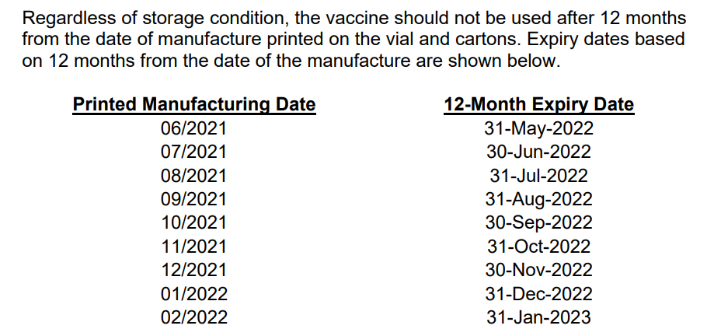

No changes have been made to the vaccine itself to enable extension of expiry dating. This change is based on stability data submitted by the manufacturer to the FDA.

Reminders:
- Do not use Pfizer Tris products beyond 12 months from manufacture date.
- This extension applies ONLY to vials stored consistently in an ultra-low temperature freezer at -90°C to -60°C (-130°F to -76°F).
- Do not store Pfizer vials at -25°C to -15°C (-13°F to 5°F). Once vials are thawed, they should not be refrozen.

For more information, please review the updated FDA Factsheets:
Fact Sheet for Healthcare Providers Administering Vaccine (Gray Cap/Adult)
Fact Sheet for Healthcare Providers Administering Vaccine (Orange Cap/PEDS)

COVID-19 vaccines authorized under an EUA do not have fixed expiration dates, and expiration dates may be extended as more stability data is collected. Always check Expiry Information for Pfizer COVID-19 Vaccines to obtain the most up-to-date expiration dates for the Pfizer COVID-19 vaccines you have in inventory.

Reminder 2nd boosters of Pfizer and Moderna authorized for certain individuals
Updated recommendations acknowledge the increased risk of severe disease in certain populations including those who are elderly or over the age of 50 with multiple underlying conditions, along with the currently available data on vaccine and booster effectiveness.

These groups may receive a second booster, which must be a mRNA vaccine:

- A 2nd booster dose of the Pfizer or Moderna may be administered to individuals 50 years of age and older at least 4 months after receipt of a first booster dose of any authorized or approved COVID-19 vaccine.
- A 2nd booster dose of the Pfizer may be administered to individuals 12 years of age and older with certain kinds of immunocompromise at least 4 months after receipt of a first booster dose of any authorized or approved COVID-19 vaccine. These are people who have undergone solid organ transplantation, or who are living with conditions that are considered to have an equivalent level of immunocompromise.
- A 2nd booster dose of the Moderna may be administered to individuals 18 years of age and older with the same certain kinds of immunocompromise at least 4 months after the first booster dose of any authorized or approved COVID-19 vaccine
- A 2nd booster dose of Pfizer or Moderna may be administered to individuals ages 18–49 years who are not moderately or severely immunocompromised and who received Janssen/J&J COVID-19 Vaccine as both their primary series dose and their booster dose, at least 4 months after the first Janssen/J&J booster dose

Reminder Prevent errors in vaccine administration from occurring!
Be sure you are using the correct vaccine for the age you are vaccinating.
- Pfizer vaccine is color coded. Orange is for ages 5-11. Purple and gray are for ages 12+.
- Moderna is for ages 18+
- Janssen/J&J is for ages 18+

Be sure you know whether the vaccine you are using requires a diluent or not.
- Pfizer Orange must be mixed before using, with 1.3 mL of 0.9% sodium chloride (preservative-free, normal saline)
- Pfizer Purple must be mixed before using, with 1.8 mL of 0.9% sodium chloride (preservative-free, normal saline)
- Pfizer Gray - do NOT mix with any diluent
- Moderna - do NOT mix with any diluent
- Janssen/J&J - do NOT mix with any diluent

Use reference materials
- COVID-19 Vaccine Quick Reference Guide for Healthcare Professionals
- Standing Orders
  - Pfizer
    - 5-11 Orange Cap (updated 3/31/22)
    - 12 + Gray Cap (updated 4/1/22)
    - 12 + Purple Cap (updated 4/1/22)
  - Moderna (updated 3/31/22)
  - Janssen (updated 4/1/22)

- Preparation & Administration Summaries
  - Pfizer
    - 5-11 Orange Cap (updated 3/3/22)
    - 12 + Gray Cap (updated 3/3/22)
    - 12 + Purple Cap (updated 3/3/22)
  - Moderna (updated 3/3/22)
  - Janssen (updated 2/28/22)

- From the main page at U.S. COVID-19 Vaccine Product Information you can also get to a Preparation Infographic for each formulation, a Pfizer Vaccine Dosage Chart, and other vaccine specific information.

Reminder Remember to report adverse events and vaccine administration errors to VAERS
VAERS is the nation’s early warning system that monitors the safety of vaccines after they are authorized or licensed for use by the FDA. VAERS is part of the larger vaccine safety system in the United States that helps make sure vaccines are safe. The system is co-managed by CDC and FDA.

VAERS accepts and analyzes reports of possible health problems—also called “adverse events”—after vaccination. As an early warning system, VAERS cannot prove that a vaccine caused a problem. Specifically, a report to VAERS does not mean that a vaccine caused an adverse event. But VAERS can give CDC and FDA important information. If it looks as though a vaccine might be causing a problem, FDA and CDC will investigate further and take action if needed.

Healthcare providers who administer COVID-19 vaccines are required by law to report vaccine administration errors, whether or not associated with an adverse event.
See VAERS home page and VAERS FAQs for more information.

Reminder COVID-19 vaccine formulations currently approved or authorized in the United States
Table 1 of the Clinical Considerations, shown here, has been updated. Please note that although a new formulation of Moderna (blue cap) is listed, we do not currently have any of that formulation in MA. For additional information on the formulations, storage and handling, preparation, and administration of COVID-19 vaccines, see U.S. COVID-19 Vaccine Product Information.

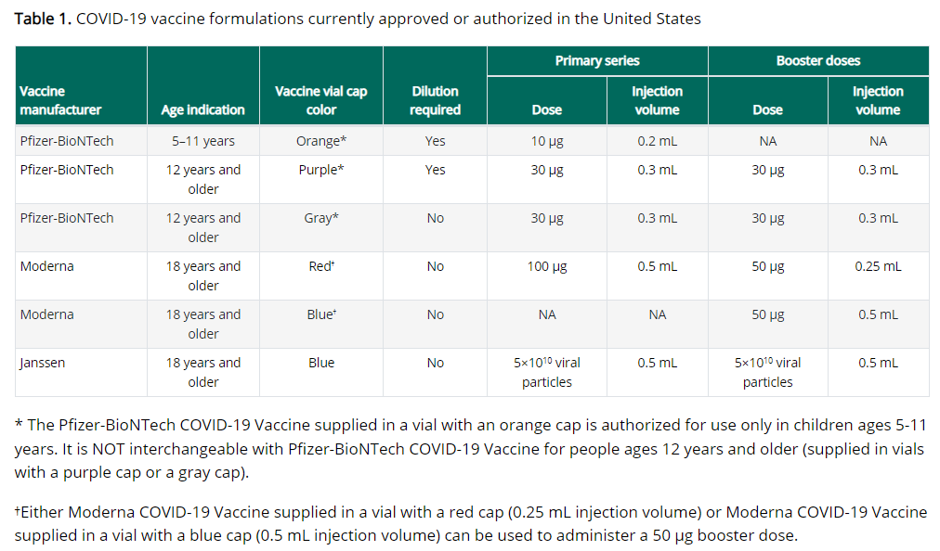

Reminder COVID-19 vaccination schedule for the primary series in the general population
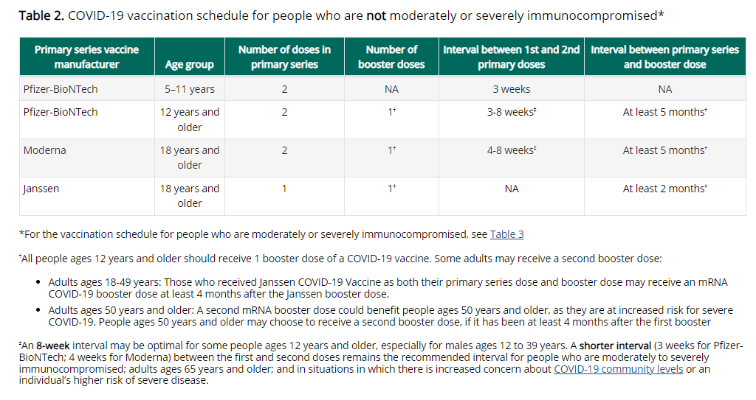

Reminder A second visual of the COVID-19 vaccination schedule in the general population
For full details and footnotes, go to the Clinical Considerations

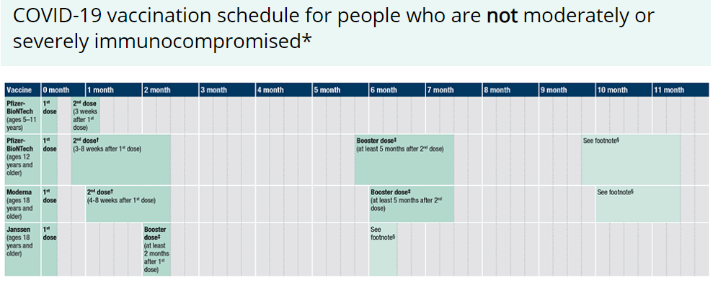

Reminder COVID-19 vaccination schedule for moderately or severely immunocompromised persons ages 5 years and older
People with immunocompromising conditions or people who take immunosuppressive medications or therapies are at increased risk for severe COVID-19. Because the immune response following COVID-19 vaccination may differ in moderately or severely immunocompromised people, specific guidance for this population is provided.

For more detailed information about schedules and booster doses for people who are moderately or severely immunocompromised, see Guidance for COVID-19 vaccination for people who are moderately or severely immunocompromised. Also see Appendix D - D1. People who are moderately or severely immunocompromised and initiate a Janssen/J&J COVID-19 Vaccine primary series, and D2. People who are moderately or severely immunocompromised and initiate an mRNA COVID-19 vaccine primary series

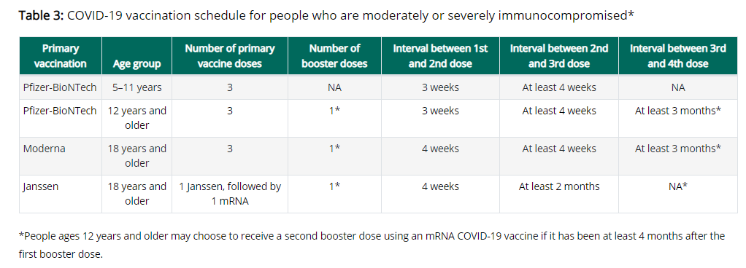

Reminder A second visual of the COVID-19 vaccination schedule for people with moderate or severe immunocompromise
For full details and footnotes, go to the Clinical Considerations

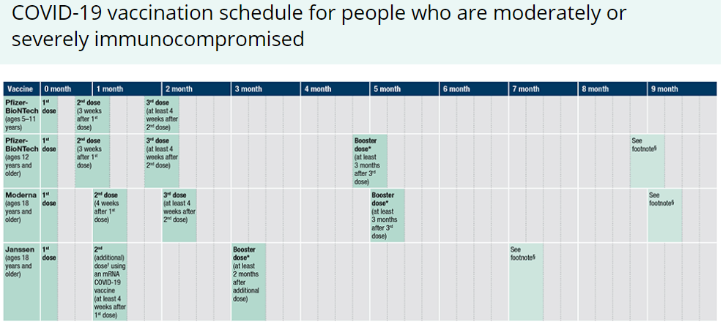

Reminder Watch for Expired Vaccine
Providers should make it a practice to regularly check inventory for expired vaccine and immediately remove expired inventory to prevent it from being administered.
Vaccine Expiration Date Lookup & Reference Information:
- Expiry Information for Pfizer COVID-19 Vaccines
- Moderna Vial Expiration Date Look-up Tool
- J&J Expiration Date Lookup Tool

Reminder CDC’s Product Info by US Vaccine webpage now has Pfizer info in three separate subpages:
- Orange Cap Age 5 through 11
- Purple Cap Age 12 and Older
- Gray Cap Age 12 and Older

Reminder EUA Fact Sheets
Once a new EUA Fact Sheet is issued, it must be used. Previous ones no longer contain accurate information.
- Pfizer, HCP, 12 years of age and older, purple cap (must dilute): https://www.fda.gov/media/153713/download
- Pfizer, HCP, 12 years of age and older, gray cap (no dilution): https://www.fda.gov/media/153715/download
- Pfizer, HCP, 5 - 11 years of age, orange cap (must dilute): https://www.fda.gov/media/153714/download
- Pfizer, Recipient, 12 years of age and older: https://www.fda.gov/media/153716/download
- Pfizer, Recipient, 5-11 years: https://www.fda.gov/media/153717/download
- Moderna, HCP, red cap and label with a light blue border which can be used for primary series doses and for a booster dose: https://www.fda.gov/media/157233/download
- Moderna, HCP, dark blue cap and label with a purple border which can be used only for a booster dose (not yet available in MA): https://www.fda.gov/media/157232/download
- Moderna, Recipient: https://www.fda.gov/media/144638/download
- Janssen/J&J, HCP: https://www.fda.gov/media/146304/download
- Janssen/J&J, Recipient: https://www.fda.gov/media/146305/download

Reminder EUI Fact Sheets
CDC has issued EUI for use of the COVID-19 vaccines by Pfizer and Moderna for primary, additional, and/or booster doses in certain individuals. The EUI are necessary because these uses extend beyond their FDA-approved labeling. The EUI and CDC’s clinical guidance help to ensure these individuals can get primary, additional, and/or booster doses of the COVID-19 vaccine by Pfizer or Moderna so they can be better protected against COVID-19. The EUI are currently issued only for Pfizer-BioNTech and Moderna COVID-19 vaccines since EUI can only apply to FDA-approved medical products.
- Pfizer, HCP: https://www.cdc.gov/vaccines/covid-19/eui/downloads/pfizer-HCP.pdf
- Pfizer, Recipient: https://www.cdc.gov/vaccines/covid-19/eui/downloads/Pfizer-Caregiver.pdf
- Moderna, HCP: https://www.cdc.gov/vaccines/covid-19/eui/downloads/Moderna-HCP.pdf
- Moderna, Recipient: https://www.cdc.gov/vaccines/covid-19/eui/downloads/Moderna-Caregiver.pdf
- EUI FAQs

RESOURCES & LEARNING OPPORTUNITIES

Reminder COVID-19 Vaccine Training Modules
CDC’s four training modules (General Overview, Pfizer, Moderna, Janssen/J&J) can be found here.

Reminder COVID-19 Vaccine Webinar Series
CDC is offering a series of brief (15-20 minute) webinars addressing topics around COVID-19 vaccination. These interactive, web-based training modules offer a real-world perspective on different issues around COVID-19 vaccines. Topics range from routine clinical and vaccine safety information to guidance for on-site clinic vaccination activities and having conversations with vaccine recipients. Each webinar includes self-test practice questions and lists additional resources related to the topic discussed. The landing page for all mini webinars is here: https://www.cdc.gov/vaccines/covid-19/training-education/webinars.html

Reminder COVID-19 Quick Reference Guide
CDC’s quick reference guide is a 2-page document that provides basic information on the proper storage, preparation, and administration of the currently authorized COVID-19 vaccine products in the United States.

Reminder CDC launches “Interactive COVID-19 Vaccine Conversations Module for Healthcare Professionals”
CDC has launched a new resource to equip healthcare professionals with the tools they need to have effective COVID-19 vaccine conversations with patients. The Interactive COVID-19 Vaccine Conversations Module for Healthcare Professionals includes:
- Tips for Having Effective Vaccine Conversations with Patients
- Vaccine Conversations in Practice: Case Scenarios

Reminder Pfizer COVID-19 Vaccine Medical Updates on Current & Immunization Site Training
Pfizer Vaccines US Medical Affairs continues to host frequent (almost daily) Medical Updates & Immunization Site Training for All Providers. Session topics include:
- Use of vaccine for Children 5 through 11 Years of Age, and Individuals 12 Years of Age and Older
- Storage, Handling, Preparation, & Administration for the multiple presentations of the vaccine
- Recent medical updates regarding the vaccine
- An overview of healthcare provider resources
- Question and answer session

To access current and future training sessions, please visit: https://www.pfizermedicalinformation.com/en-us/medical-updates

Reminder Morbidity and Mortality Weekly Report, better known as MMWR, is CDC’s primary publication for disseminating the science it produces. The staff at MMWR have launched a landing page to help people find the latest information on COVID-19 vaccine effectiveness and safety.

Recent CDC MMWRs

April 22, 2022 (Early Release)
- Provisional Mortality Data — United States, 2021

- Provisional COVID-19 Age-Adjusted Death Rates, by Race and Ethnicity — United States, 2020–2021

April 22, 2022
- Hospitalizations of Children Aged 5–11 Years with Laboratory-Confirmed COVID-19 — COVID-NET, 14 States, March 2020–February 2022

April 15, 2022
- COVID-19 Mortality and Vaccine Coverage — Hong Kong Special Administrative Region, China, January 6, 2022–March 21, 2022

- Effectiveness of COVID-19 mRNA Vaccination in Preventing COVID-19–Associated Hospitalization Among Adults with Previous SARS-CoV-2 Infection — United States, June 2021–February 2022

MDPH RESOURCES

Reminder Massachusetts Resources
- COVID-19 Vaccine Information
- COVID-19 booster information and booster frequently asked questions
- Search for Vaccine locations: https://vaxfinder.mass.gov/
- COVID-19 Vaccine Resource Line/2-1-1 is available for individuals who are unable to use Vaxfinder, or have difficulty accessing the internet. Available in English and Spanish and has translators available in approximately 100 additional languages.
- COVID-19 Vaccine Training and Education Resources for Providers: https://www.mass.gov/info-details/covid-19-vaccine-training-and-education-resources-for-providers
- Multilingual COVID-19 Materials. Resources related to Coronavirus Disease 2019 (COVID-19) in multiple languages. Includes videos and printables on topics like vaccine safety, pregnancy and the vaccine, and FAQs.

Immunization Division Main Number
For questions about immunization recommendations, disease reporting, etc.
Phone: 617-983-6800 (24/7 MDPH Epi line)
Fax: 617-983-6840
Website: https://www.mass.gov/topics/immunization

MIIS Help Desk
Phone: 617-983-4335
Fax: 857-323-8321
Email questions to: miishelpdesk@mass.gov
Website: https://www.mass.gov/service-details/massachusetts-immunization-information-system-miis

MDPH Vaccine Unit
Phone: 617-983-6828
Email questions to: dph-vaccine-management@mass.gov
Website: https://www.mass.gov/service-details/vaccine-management

COVID-19 Email Box Email questions to: COVID-19-Vaccine-Plan-MA@mass.gov

