BULLETIN
What Massachusetts COVID-19 Vaccine Providers Need to Know
Week of 6/17/2022

LATEST NUMBERS

- As of 6/17/2022 5,400,083 people in Massachusetts have been fully vaccinated.

WHO TO VACCINATE THIS WEEK

COVID-19 vaccination is recommended for everyone aged 5 years and older for the prevention of coronavirus disease 2019 (COVID-19). People ages 5-17 can get the Pfizer vaccine. People age 18+ can get any vaccine (mRNA vaccines are preferred in most situations).

- A primary series for anyone ages 5 and older who lives, works, or studies in Massachusetts is eligible for a vaccine. Health care providers can also vaccinate their patient panels regardless of place of residency.
- A booster dose for all person’s ages 5 years and older
- At least 5 months after completion of an mRNA vaccine primary series.
- At least 2 months after completion of a Janssen primary dose.
- mRNA COVID19 vaccines are preferred
- Janssen COVID-19 Vaccine should only be used in limited situations. See Contraindications and precautions and Safety considerations for Janssen COVID-19 Vaccine.
- These groups should receive a second booster dose, which must be an mRNA vaccine, at least 4 months after their first booster dose:
- All people aged 12 years and older who are moderately or severely immunocompromised
- Adults aged 50 years and older
  - This group may receive a second booster dose, which must be an mRNA vaccine, at least 4 months after their first booster dose.
- Adults aged 18–49 years who are not moderately or severely immunocompromised and who received Janssen as both their primary series dose and booster dose

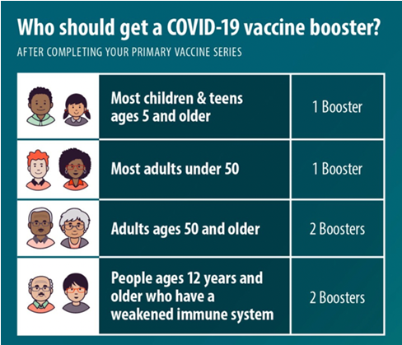

- See below for more information for persons who are immunocompromised
WHAT TO KNOW THIS WEEK

New FDA advisory committee met June 14 and June 15
On June 14, 2022, FDA VRBPAC voted unanimously to recommend authorization of the Moderna COVID-19 vaccine 2-dose primary series for both children 12-17 years (100 ug) and 6-11 years (50 ug) under Emergency Use Authorization (EUA). Two separate votes were taken at the meeting:
- Moderna 12-17 Yrs: “Based on the totality of scientific evidence available, the benefits of the Moderna COVID-19 Vaccine when administered as a 2-dose series (100 ug each dose) outweigh its risks for use in adolescents 12-17 years of age”
- Moderna 6-11 Yrs: “Based on the totality of scientific evidence available, the benefits of the Moderna COVID-19 Vaccine when administered as a 2-dose series (50 ug each dose) outweigh its risks for use in adolescents 6-11 years of age”

On June 15, 2022, FDA VRBPAC voted unanimously to recommend authorization of both the Moderna COVID-19 vaccine 2-dose primary series for children 6 months - 5 years (25 ug) and the Pfizer 3-dose series for children 6 months - 4 years (3 ug) under Emergency Use Authorization (EUA). Two separate votes were taken at the meeting:
- Moderna <6: “Based on the totality of scientific evidence available, the benefits of the Moderna COVID-19 Vaccine when administered as a 2-dose series (25 ug each dose) outweigh its risks for use in infants and children 6 months through 5 years of age.”
- Pfizer<5: “Based on the totality of scientific evidence available, the benefits of the Pfizer-BioNTech COVID-19 Vaccine when administered as a 3-dose series (3 ug each dose) outweigh its risks for use in infants and children 6 months through 4 years of age.”

See VRBPAC slides for more details.

New FDA Authorizes COVID-19 Vaccines for Children Down to 6 Months of Age
Today, June 17, 2022, the FDA authorized emergency use of the Moderna COVID-19 Vaccine and the Pfizer-BioNTech COVID-19 Vaccine for the prevention of COVID-19 to include use in children down to 6 months of age.
- For the Moderna COVID-19 Vaccine, the FDA amended the emergency use authorization (EUA) to include use of the vaccine in individuals 6 months through 17 years of age. The vaccine had been authorized for use in adults 18 years of age and older.
- For the Pfizer-BioNTech COVID-19 Vaccine, the FDA amended the EUA to include use of the vaccine in individuals 6 months through 4 years of age. The vaccine had been authorized for use in individuals 5 years of age and older.
See full press release.

New Next Steps
1) ACIP meets this Friday and Saturday to determine clinical recommendations for the newly authorized vaccines.
2) The CDC Director, Dr. Rochelle Walensky, will take ACIP’s recommendations under consideration and issue clinical guidance for vaccination.
Vaccinations cannot be administered to these new populations until the CDC Director makes a formal statement with the clinical indications.

Reminder ACIP Meetings Announced
ACIP has announced that they will hold two meetings
- June 17, 2022: 10:00am – 3:30pm ET
- June 18, 2022: 10:00am – 4:00pm ET
- Webcast Link

Reminder Pediatric ordering information for Pfizer (6 months to 4 years old) and
Moderna (6 months to 5 years old) COVID vaccine formulations

Massachusetts COVID-19 Vaccine Program (MCVP) enrolled provider sites were able to place pre-orders for the new formulations of the COVID vaccine through the Massachusetts Immunization Information System (MIIS). Pre-orders placed before 9 AM Tuesday, June 7th will begin being delivered on Monday, June 20th. Any orders placed after 9 AM Tuesday, June 7th up until the pre-ordering deadline of 9AM Tuesday, June 14th will begin being delivered on Thursday, June 23rd, and throughout the rest of that week and into the following week.

Please note these shipping dates are estimated and based ACIP and CDC approvals by this Saturday June 18th. If there are any delays in these approvals at the federal level the above estimated shipping dates will be delayed. Assuming CDC approval over the weekend, routine ordering for these new formulations will be turned on in the MIIS for all practices on Monday June 20th however ordered placed early next week may not arrive until the week of June 27th.

New EUA Fact Sheets
Once a new EUA Fact Sheet is issued, it must be used. Previous ones no longer contain accurate information.
Pfizer EUAs
- New Pfizer, HCP, 6 months through 4 years, maroon cap (must dilute):https://www.fda.gov/media/159312/download
- New Pfizer, HCP-Dear Healthcare Provider Letter, 6 months through 4 years, maroon cap (must dilute): https://www.fda.gov/media/159303/download
- New Pfizer, Recipient, 6 months through 4 years of age: https://www.fda.gov/media/159313/download
- Pfizer, HCP, 12 years of age and older, purple cap (must dilute): https://www.fda.gov/media/153713/download
- Pfizer, HCP, 12 years of age and older, gray cap (no dilution): https://www.fda.gov/media/153715/download
- Pfizer, HCP, 5 - 11 years of age, orange cap (must dilute): https://www.fda.gov/media/153714/download
- Pfizer, Recipient, 12 years of age and older: https://www.fda.gov/media/153716/download
- Pfizer, Recipient, 5-11 years: https://www.fda.gov/media/153717/download

Moderna EUAs
- New Moderna, HCP, Wall Chart Showing Different vials/presentations: https://www.fda.gov/media/159306/download

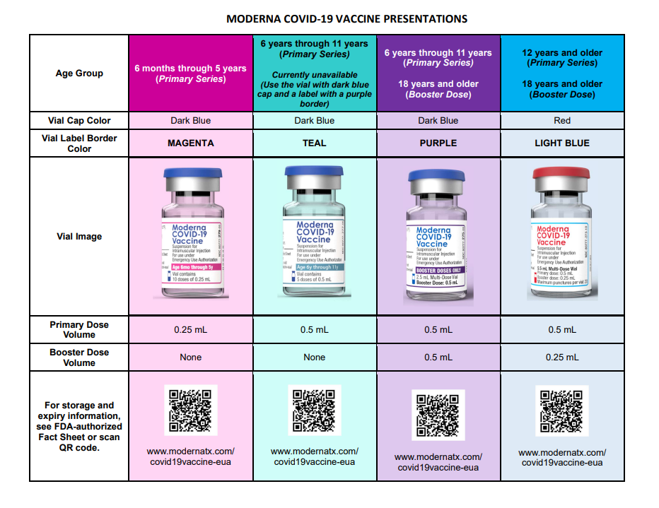

- New Moderna, HCP, 6 months through 5 years of age (magenta border): https://www.fda.gov/media/159307/download
- New Moderna, Recipient, 6 months through 5 years of age (magenta border): https://www.fda.gov/media/159309/download
- New Moderna, HCP, 6 years through 11 years of age (teal & purple border): https://www.fda.gov/media/159308/download
- New Moderna, HCP-Dear Healthcare Provider Letter, 6 years through 11 years of age (teal & purple border): https://www.fda.gov/media/159305/download
- New Moderna, Recipient, 6 years through 11 years of age (teal & purple border): https://www.fda.gov/media/159310/download
- New Moderna, HCP, 12 years and older and booster doses for 18 years and older (light blue border): https://www.fda.gov/media/157233/download
- New Moderna, Recipient, 12 years and older (black border): https://www.fda.gov/media/144638/download
- New Moderna, HCP, 18 years and older booster dose presentation only (purple border): https://www.fda.gov/media/157232/download

Janssen EUAs
- Janssen, HCP: https://www.fda.gov/media/146304/download
- Janssen, Recipient: https://www.fda.gov/media/146305/download

Reminder CDC Resource, At-A-Glance COVID-19 Vaccination Schedule
A helpful new 2-page pdf showing COVID-19 vaccine recommendations based on primary series product, age, and immune status.

Reminder CDC launches interactive tool for the public to assess need for first or second booster doses of COVID-19 vaccine
CDC added a new interactive tool to help users identify whether they (or someone else) need to receive a booster dose of COVID-19 vaccine. The “COVID-19 Vaccine Boosters” tool asks a series of simple questions about age, immunocompromise, number and type of previous doses of COVID-19 vaccines, and how long ago they received the most recent vaccination. From these answers, the tool reports whether a first or second booster dose may be beneficial and presents considerations for when to receive it.

Reminder COVID-19 vaccine formulations currently approved or authorized in the United States
Please note that although a new formulation of Moderna (blue cap) is listed, we do not currently have any of that formulation in MA. For additional information on the formulations, storage and handling, preparation, and administration of COVID-19 vaccines, see U.S. COVID-19 Vaccine Product Information.

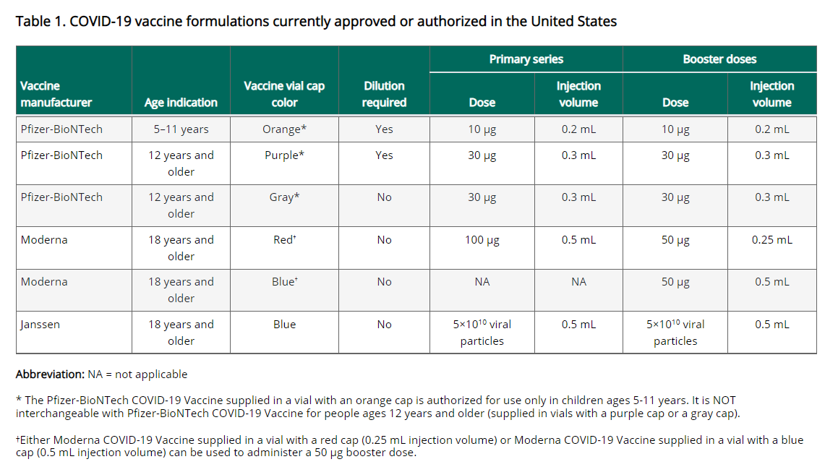

Reminder COVID-19 vaccination schedule for people who are NOT immunocompromised
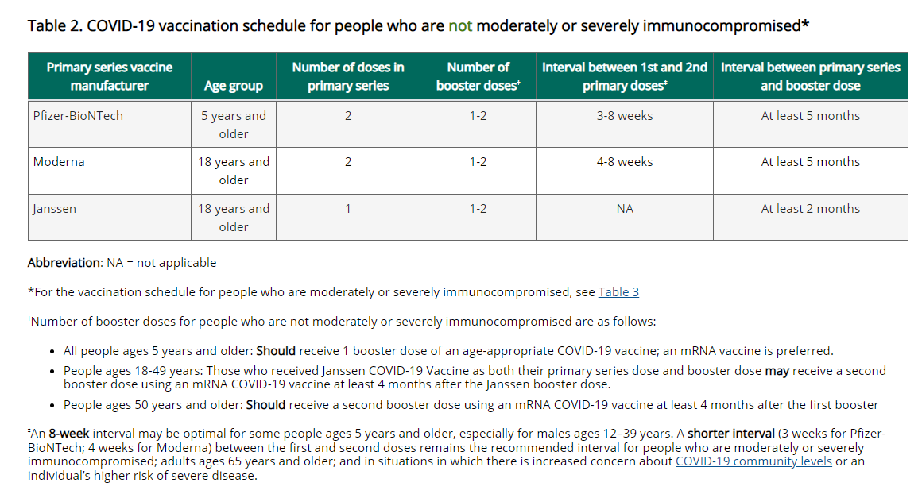

Reminder Booster doses for people who are NOT moderately or severely immunocompromised
All people ages 5 years and older should receive at least 1 booster dose. An mRNA vaccine is preferred for the first booster dose. Any age-appropriate mRNA vaccine can be used for the booster dose(s): it can be the same mRNA vaccine as the primary series (homologous booster) or a different mRNA vaccine (heterologous booster). Janssen vaccine should only be used in limited situations and cannot be used as a second booster dose.

mRNA COVID-19 vaccine primary series
- People ages 5–17 years: Should receive 1 booster dose at least 5 months after the second primary series dose, for a total of 3 doses.
- People ages 18–49 years: Should receive 1 booster dose at least 5 months after the second primary series dose, for a total of 3 doses.
- People ages 50 years and older: Should receive 2 booster doses. The first should be administered at least 5 months after completion of the primary series and the second at least 4 months after the first booster dose, for a total of 4 doses.

Janssen COVID-19 Vaccine primary series
- People ages 18–49 years: Should receive 1 booster dose at least 2 months after the single primary series dose, for a total of 2 doses. In addition, people who received Janssen COVID-19 Vaccine as both their primary series dose and first booster dose may receive a second booster dose at least 4 months after the first booster dose, for a total of 3 doses.
- People ages 50 years and older: Should receive 2 booster doses. The first should be administered at least 2 months after the single primary series dose and the second at least 4 months after the first booster dose, for a total of 3 doses.

Interval between primary series and booster doses
First booster dose: The recommended interval is based on the product received for the primary series. In most people, the interval is:
- At least 5 months after an mRNA 2-dose primary series or
- At least 2 months after a Janssen single-dose primary series
Second booster dose: The recommended interval between the first booster dose and the second booster is at least 4 months, regardless of primary series or first booster dose product.

Reminder A second visual of the COVID-19 vaccination schedule for people who are NOT immunocompromised
For full details and footnotes, go to the Clinical Considerations

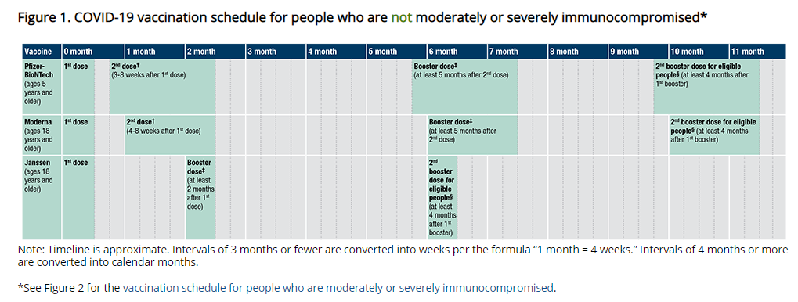

Reminder A third visual of the COVID-19 vaccination schedule for people who are NOT immunocompromised
For full details and footnotes, see At a Glance COVID-19 Vaccination Schedules

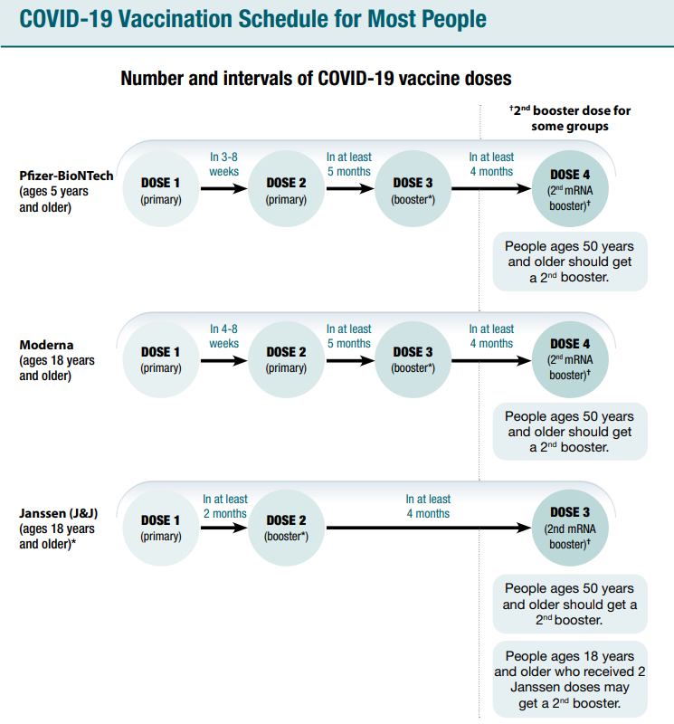

Reminder COVID-19 vaccination schedule for moderately or severely immunocompromised persons ages 5 years and older
People with immunocompromising conditions or people who take immunosuppressive medications or therapies are at increased risk for severe COVID-19. Because the immune response following COVID-19 vaccination may differ in moderately or severely immunocompromised people, specific guidance for this population is provided.

People who are or who become moderately or severely immunocompromised should follow the COVID-19 vaccination schedule according to their age and immune status at the time of eligibility for doses. For example, people who become moderately or severely immunocompromised after completing a 2-dose mRNA or single-dose Janssen COVID-19 Vaccine primary series do not need additional primary doses; however, they should follow the schedule for people who are moderately or severely immunocompromised for booster doses. For situations in which diminished vaccine efficacy is anticipated, see Additional considerations for vaccination outside of the FDA and CDC dosing intervals on a case-by-case basis. Use of mRNA vaccines is preferred.

For more detailed information about schedules and booster doses for people who are moderately or severely immunocompromised, see Guidance for COVID-19 vaccination for people who are moderately or severely immunocompromised. Also see Appendix D

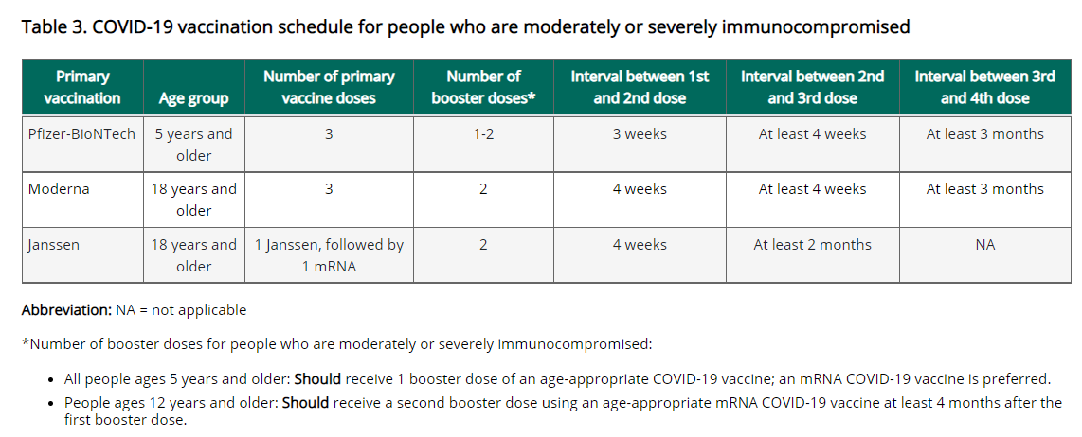

Reminder A second visual of the COVID-19 vaccination schedule for people with moderate or severe immunocompromise
For full details and footnotes, go to the Clinical Considerations
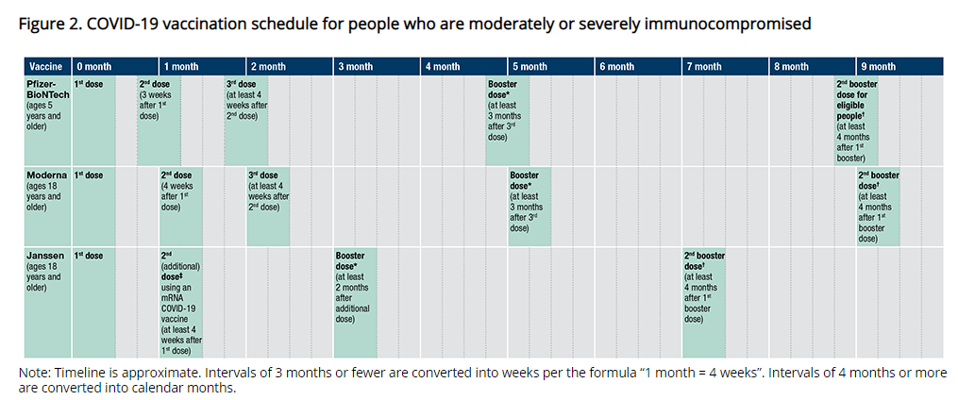
Reminder Primary series for people who ARE immunocompromised
mRNA COVID-19 vaccines
A 3-dose primary series is recommended for people ages 5 years and older who are moderately or severely immunocompromised at the time of vaccination (Table 3). The same mRNA vaccine product should be used for all doses of the primary series (see Interchangeability of COVID-19 vaccine products).

Pfizer-BioNTech COVID-19 Vaccine (5 years and older): The second dose is administered 3 weeks aft
er the first dose; the third dose is administered at least 4 weeks after the second dose.

Moderna COVID-19 Vaccine (18 years and older): The second dose is administered 4 weeks after the first dose; the third dose is administered at least 4 weeks after the second dose. The dose is 100 µg (0.5 ml [red cap vial]) for all doses in the primary series.

Janssen COVID-19 Vaccine
An mRNA vaccine is preferred; in limited situations a single primary Janssen vaccine dose can be used for people ages 18 years and older who are moderately or severely immunocompromised, followed by a second (additional) dose using an mRNA COVID-19 vaccine at least 4 weeks later (see Appendix D for additional information). If Moderna COVID-19 vaccine is used for the second dose, administer a 100 µg (0.5 ml [red cap vial]) dose.

Reminder Booster doses for people who are immunocompromised
All people ages 5 years and older and who are moderately or severely immunocompromised should receive at least 1 booster dose. An mRNA vaccine is preferred for the first booster dose. Any age-appropriate mRNA vaccine can be used for the booster dose(s): it can be the same mRNA vaccine as the primary series (homologous booster) or a different mRNA vaccine (heterologous booster). Janssen should only be used in limited situations and cannot be used as a second booster dose.

mRNA COVID-19 vaccine primary series
- People ages 5-11 years: Should receive 1 booster dose at least 3 months after the third primary dose, for a total of 4 doses.
- People ages 12 years and older: Should receive 2 booster doses. The first should be administered at least 3 months after completion of the primary series and the second at least 4 months after the first booster dose, for a total of 5 doses.

Special situation: For people who inadvertently received the booster dose before their third primary dose, regardless of type of vaccine received as the booster dose, administer a Pfizer-BioNTech vaccine or a Moderna vaccine (100 µg [0.5 mL, red cap vial]) as the fourth dose (third primary) at least 3 months after the third dose. See Appendix D for additional guidance.

Janssen COVID-19 Vaccine primary series
People ages 18 years and older should receive 2 booster doses. The first should be administered at least 2 months after the second (additional) dose and the second at least 4 months after the first booster dose, for a total of 4 doses.
Special situation: Many recipients of Janssen COVID-19 Vaccine may have received a booster dose (Pfizer-BioNTech, Moderna [50 µg], or Janssen vaccine), without having had the second (additional) mRNA vaccine dose. In this situation, regardless of type and timing of vaccine received as the second dose, administer a Pfizer-BioNTech vaccine or a Moderna vaccine (100 µg [0.5 mL, red cap vial]) as the third (additional) dose at least 2 months after dose 2. See Appendix D for additional dose information for Janssen COVID-19 Vaccine recipients.

Reminder A third visual of the COVID-19 vaccination schedule for people who are immunocompromised
For full details and footnotes, see At a Glance COVID-19 Vaccination Schedules

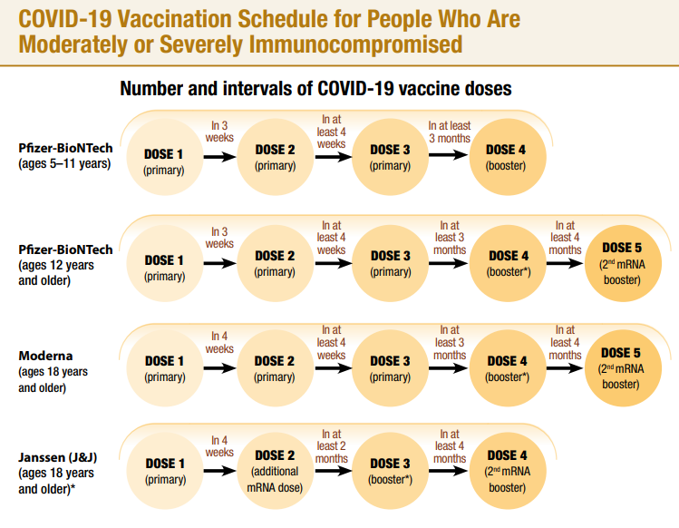

Reminder Prevent errors in vaccine administration from occurring!
Be sure you are using the correct vaccine for the age you are vaccinating.
- Pfizer vaccine is color coded. Orange is for ages 5-11. Purple and gray are for ages 12+.
- Moderna is for ages 18+
- Janssen is for ages 18+

Be sure you know whether the vaccine you are using requires a diluent or not.
- Pfizer Orange must be mixed before using, with 1.3 mL of 0.9% sodium chloride (preservative-free, normal saline)
- Pfizer Purple must be mixed before using, with 1.8 mL of 0.9% sodium chloride (preservative-free, normal saline)
- Pfizer Gray - do NOT mix with any diluent
- Moderna - do NOT mix with any diluent
- Janssen - do NOT mix with any diluent

Use reference materials
- COVID-19 Vaccine Quick Reference Guide for Healthcare Professionals (updated 5/26/2022)
- Standing Orders
  - Pfizer
    - 5-11 Orange Cap (updated 5/24/22)
    - 12 + Gray Cap (updated 5/24/22)
    - 12 + Purple Cap (updated 5/24/22)
  - Moderna (updated 5/24/22)
  - Janssen (updated 5/24/22)

- Preparation & Administration Summaries
  - Pfizer
    - 5-11 Orange Cap (updated 3/3/22)
    - 12 + Gray Cap (updated 4/6/22)
    - 12 + Purple Cap (updated 4/6/22)
  - Moderna (updated 4/6/22)
  - Janssen (updated 4/6/22)

- From the main page at U.S. COVID-19 Vaccine Product Information you can also get to a Preparation Infographic for each formulation, a Pfizer Vaccine Dosage Chart, and other vaccine specific information.

Reminder Watch for Expired Vaccine
Providers should make it a practice to regularly check inventory for expired vaccine and immediately remove expired inventory to prevent it from being administered.
Vaccine Expiration Date Lookup & Reference Information:
- Expiry Information for Pfizer COVID-19 Vaccines
- Moderna Vial Expiration Date Look-up Tool
- Janssen Expiration Date Lookup Tool

Reminder EUI Fact Sheets
CDC has issued EUI for use of the COVID-19 vaccines by Pfizer and Moderna for primary, additional, and/or booster doses in certain individuals. The EUI are necessary because these uses extend beyond their FDA-approved labeling. The EUI and CDC’s clinical guidance help to ensure these individuals can get primary, additional, and/or booster doses of the COVID-19 vaccine by Pfizer or Moderna so they can be better protected against COVID-19. The EUI are currently issued only for Pfizer-BioNTech and Moderna COVID-19 vaccines since EUI can only apply to FDA-approved medical products.
- Pfizer, HCP: https://www.cdc.gov/vaccines/covid-19/eui/downloads/pfizer-HCP.pdf
- Pfizer, Recipient: https://www.cdc.gov/vaccines/covid-19/eui/downloads/Pfizer-Caregiver.pdf
- Moderna, HCP: https://www.cdc.gov/vaccines/covid-19/eui/downloads/Moderna-HCP.pdf
- Moderna, Recipient: https://www.cdc.gov/vaccines/covid-19/eui/downloads/Moderna-Caregiver.pdf
- EUI FAQs

RESOURCES & LEARNING OPPORTUNITIES

Reminder COVID-19 Vaccine Training Modules
CDC’s four training modules (General Overview, Pfizer, Moderna, Janssen) can be found here.

Reminder COVID-19 Vaccine Webinar Series
CDC is offering a series of brief (15-20 minute) webinars addressing topics around COVID-19 vaccination. These interactive, web-based training modules offer a real-world perspective on different issues around COVID-19 vaccines. Topics range from routine clinical and vaccine safety information to guidance for on-site clinic vaccination activities and having conversations with vaccine recipients. Each webinar includes self-test practice questions and lists additional resources related to the topic discussed. The landing page for all mini webinars is here: https://www.cdc.gov/vaccines/covid-19/training-education/webinars.html

Reminder COVID-19 Quick Reference Guide
CDC’s quick reference guide is a 2-page document that provides basic information on the proper storage, preparation, and administration of the currently authorized COVID-19 vaccine products in the United States.

Reminder CDC launches “Interactive COVID-19 Vaccine Conversations Module for Healthcare Professionals”
CDC has launched a new resource to equip healthcare professionals with the tools they need to have effective COVID-19 vaccine conversations with patients. The Interactive COVID-19 Vaccine Conversations Module for Healthcare Professionals includes:
- Tips for Having Effective Vaccine Conversations with Patients
- Vaccine Conversations in Practice: Case Scenarios
Reminder Pfizer COVID-19 Vaccine Medical Updates on Current & Immunization Site Training
Pfizer Vaccines US Medical Affairs continues to host frequent (almost daily) Medical Updates & Immunization Site Training for All Providers. Session topics include:
- Use of vaccine for Children 5 through 11 Years of Age, and Individuals 12 Years of Age and Older
- Storage, Handling, Preparation, & Administration for the multiple presentations of the vaccine
- Recent medical updates regarding the vaccine
- An overview of healthcare provider resources
- Question and answer session

To access current and future training sessions, please visit: https://www.pfizermedicalinformation.com/en-us/medical-updates

Reminder Morbidity and Mortality Weekly Report, better known as MMWR, is CDC’s primary publication for disseminating the science it produces. The staff at MMWR have launched a landing page to help people find the latest information on COVID-19 vaccine effectiveness and safety.

Recent CDC MMWRs
June 10, 2022
- COVID-19 Vaccination Coverage, by Race and Ethnicity — National Immunization Survey Adult COVID Module, United States, December 2020–November 2021
- Ventilation Improvement Strategies Among K–12 Public Schools — The National School COVID-19 Prevention Study, United States, February 14–March 27, 2022

June 3, 2022
- COVID-19 Cases, Hospitalizations, and Deaths among American Indian or Alaska Native Persons — Alaska, 2020–2021

MDPH RESOURCES

Reminder Massachusetts Resources
- COVID-19 Vaccine Information
- COVID-19 booster information and booster frequently asked questions
- Search for Vaccine locations: https://vaxfinder.mass.gov/
- COVID-19 Vaccine Resource Line/2-1-1 is available for individuals who are unable to use Vaxfinder, or have difficulty accessing the internet. Available in English and Spanish and has translators available in approximately 100 additional languages.
- COVID-19 Vaccine Training and Education Resources for Providers: https://www.mass.gov/info-details/covid-19-vaccine-training-and-education-resources-for-providers
- Multilingual COVID-19 Materials. Resources related to Coronavirus Disease 2019 (COVID-19) in multiple languages. Includes videos and printables on topics like vaccine safety, pregnancy and the vaccine, and FAQs.

Immunization Division Main Number
For questions about immunization recommendations, disease reporting, etc.
Phone: 617-983-6800 (24/7 MDPH Epi line)
Fax: 617-983-6840
Website: https://www.mass.gov/topics/immunization

MIIS Help Desk
Phone: 617-983-4335
Fax: 857-323-8321
Email questions to: miishelpdesk@mass.gov
Website: https://www.mass.gov/service-details/massachusetts-immunization-information-system-miis

MDPH Vaccine Unit
Phone: 617-983-6828
Email questions to: dph-vaccine-management@mass.gov
Website: https://www.mass.gov/service-details/vaccine-management

COVID-19 Email Box
Email questions to: COVID-19-Vaccine-Plan-MA@mass.gov

