BULLETIN
What Massachusetts COVID-19 Vaccine Providers Need to Know
Week of 6/20/2022

LATEST NUMBERS

- As of 6/20/2022 5,400,083 people in Massachusetts have been fully vaccinated.

New WHO TO VACCINATE THIS WEEK

Everyone ages 6 months and older should receive a COVID-19 primary series vaccination for the prevention of COVID-19.

Everyone ages 5 years and older should receive at least 1 booster dose of COVID-19 vaccine if eligible (i.e., if a booster dose is FDA-approved or FDA-authorized for use in a specified population). Recommendations for booster dose(s) vary based on age, COVID-19 vaccine product, and immunocompetence.

The recommended schedule and use of each COVID-19 vaccine product vary by the age and immune status of the recipient. There are two vaccination schedules: one for people who are not moderately or severely immunocompromised and one for people who are moderately or severely immunocompromised.

New KEY POINTS

- COVID-19 vaccines currently approved or authorized by FDA are effective in preventing serious outcomes of COVID-19 disease, including severe disease, hospitalization, and death.
- Everyone ages 6 months and older in the United States should receive a COVID-19 primary series vaccination for the prevention of COVID-19.
- Everyone ages 5 years and older should receive at least 1 booster dose of COVID-19 vaccine if eligible (i.e., if a booster dose is FDA-approved or FDA-authorized for use in a specified population). Recommendations for booster dose(s) vary based on age, COVID-19 vaccine product, and immunocompetence.
- Janssen COVID-19 vaccine should only be used in limited situations; Pfizer-BioNTech or Moderna COVID-19 vaccines are preferred for primary and booster vaccination.
- Efforts to increase the number of people in the United States who are up to date with their COVID-19 vaccines remain critical to preventing illness, hospitalizations, and deaths from COVID-19.
- The clinical considerations provide additional information to healthcare professionals and public health officials on use of COVID-19 vaccines.

WHAT TO KNOW THIS WEEK

New CDC Recommends COVID-19 Vaccines for Young Children
On June 18, 2022, ACIP voted unanimously to recommend the Moderna and Pfizer COVID-19 vaccines for young children. A short time later, CDC Director Rochelle Walensky endorsed the recommendation.
- A two-dose Moderna COVID-19 vaccine series (25ug) is recommended for children ages 6 months – 5 years, under the EUA issued by FDA
Two doses of 25ug Moderna COVID-19 vaccine, 28 days apart
- A three-dose Pfizer-BioNTech COVID-19 vaccine series (3ug each) is recommended for children ages 6 month – 4 years, under the EUA issued by FDA
Three doses of 3ug Pfizer-BioNTech COVID-19 vaccine, 21 days between dose 1 and 2 and at least 8 weeks between dose 2 and 3

Updated June 19 CDC Resource, At-A-Glance COVID-19 Vaccination Schedule
A helpful 2-page pdf showing COVID-19 vaccine recommendations based on primary series product, age, and immune status.

New ACIP Meeting June 23
ACIP will be meeting to discuss recommendations for the recently authorized Moderna COVID-19 Vaccine for ages 6-17 years on June 23rd.
Agenda and link to webcast here.

New Information for parents and caregivers:
- COVID-19 Vaccines for Children and Teens | CDC
- Frequently Asked Questions about COVID-19 Vaccination in Children | CDC
- 6 Things to Know about COVID-19 Vaccination for Children | CDC
- V-safe After Vaccination Health Checker | CDC
- COVID-19 Vaccine: Frequently Asked Questions | American Academy of Pediatrics

NEW Pediatric ordering information for Pfizer (6 months through 4 years old) and Moderna (6 months through 5 years old) COVID vaccine formulations

Effective immediately Massachusetts COVID-19 Vaccine Program (MCVP) enrolled provider sites are able to place routine orders for these new formulations of the COVID vaccine through the Massachusetts Immunization Information System (MIIS).

COVID-19 Vaccine Pediatric Age Groups
- Moderna COVID-19 Vaccine
  - Ages 6 months through 5 years
  - Do not dilute
  - 2 dose primary series
  - Shipping temps, storage and handling will be similar to other Moderna formulations in use

Please Note: The new FDA authorized Moderna 6-11 year formulation is not available for ordering yet as it has not been approved by ACIP/CDC.
- Pfizer-BioNTech COVID-19 Vaccine
  - Ages 6 months through 4 years
  - Requires dilution/reconstitution
  - 3 dose primary series
  - Shipping temps, storage and handling will be similar to Pfizer orange cap formulation

- Initial shipments of the Pfizer-BioNTech vaccine for children aged 6m–4 years may state “2y to <5y” or “6m to <5y” on the vial or carton labels. Please note that vials or cartons with labels that state “2y to <5y” can be used for children aged 6m through 4 years.
- Pfizer-BioNTech vaccine vial labels and cartons may also state that a vial should be discarded 6 hours after the first dilution however as stated in the EUA Fact Sheet the timeframe for use post-dilution is actually 12 hours just like orange and gray cap Pfizer vaccine formulations..

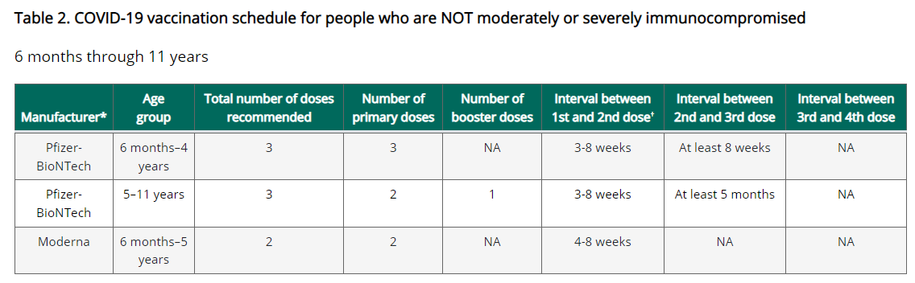

New EUA Fact Sheets
Once a new EUA Fact Sheet is issued, it must be used. Previous ones no longer contain accurate information.
Pfizer EUAs
- New Pfizer, HCP, Wall Chart Showing Different presentations: https://www.fda.gov/media/159304/download

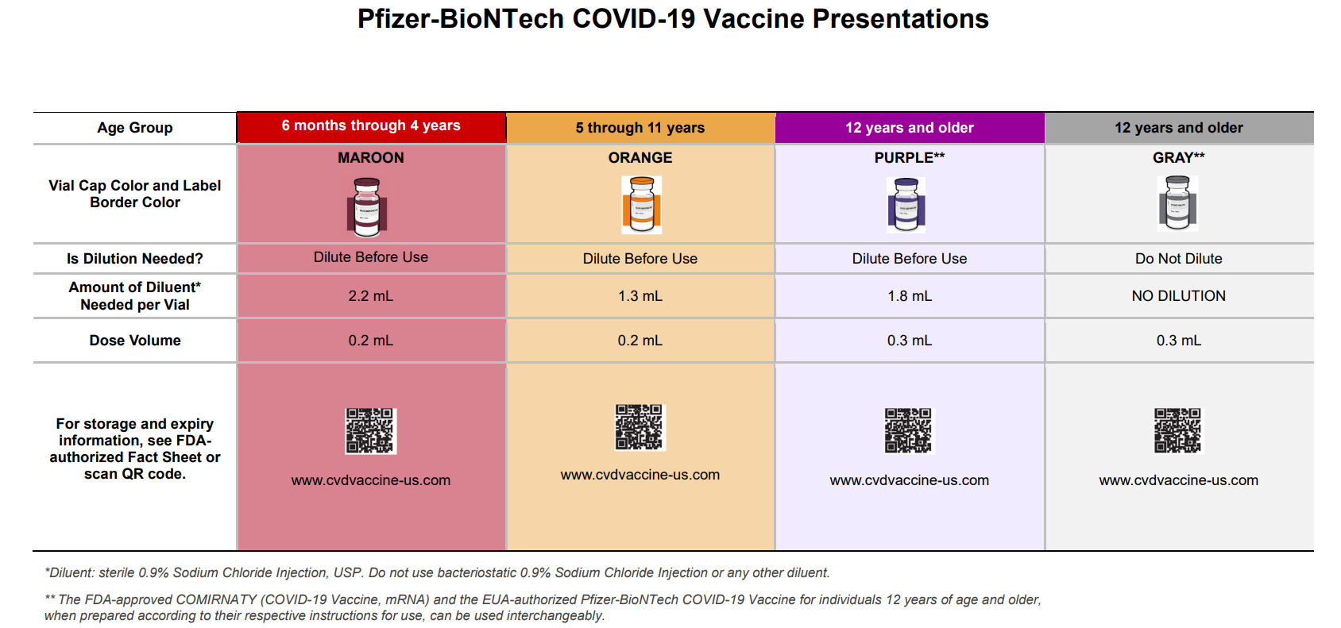

- New Pfizer, HCP, 6 months through 4 years, maroon cap (must dilute):https://www.fda.gov/media/159312/download
- New Pfizer, HCP-Dear Healthcare Provider Letter, 6 months through 4 years, maroon cap (must dilute): https://www.fda.gov/media/159303/download
- New Pfizer, Recipient, 6 months through 4 years of age: https://www.fda.gov/media/159313/download
- Pfizer, HCP, 12 years of age and older, purple cap (must dilute): https://www.fda.gov/media/153713/download
- Pfizer, HCP, 12 years of age and older, gray cap (no dilution): https://www.fda.gov/media/153715/download
- Pfizer, HCP, 5 - 11 years of age, orange cap (must dilute): https://www.fda.gov/media/153714/download
- Pfizer, Recipient, 12 years of age and older: https://www.fda.gov/media/153716/download
- Pfizer, Recipient, 5-11 years: https://www.fda.gov/media/153717/download

Moderna EUAs
- New Moderna, HCP, Wall Chart Showing Different vials/presentations: https://www.fda.gov/media/159306/download

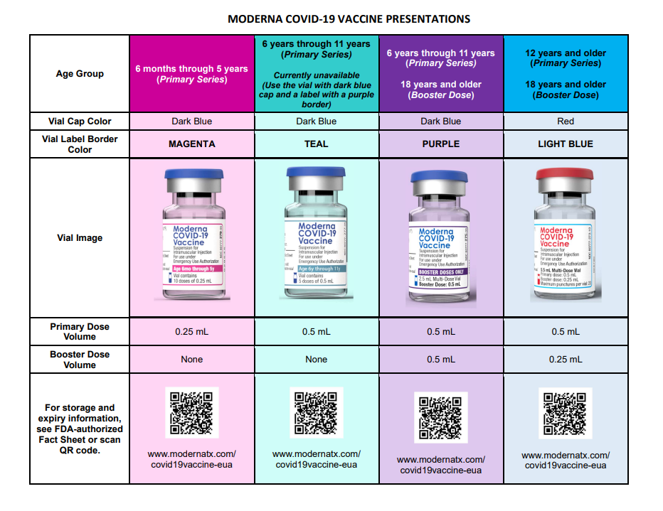

- New Moderna, HCP, 6 months through 5 years of age (magenta border): https://www.fda.gov/media/159307/download
- New Moderna, Recipient, 6 months through 5 years of age (magenta border): https://www.fda.gov/media/159309/download
- New Moderna, HCP, 6 years through 11 years of age (teal & purple border): https://www.fda.gov/media/159308/download
- New Moderna, HCP-Dear Healthcare Provider Letter, 6 years through 11 years of age (teal & purple border): https://www.fda.gov/media/159305/download
- New Moderna, Recipient, 6 years through 11 years of age (teal & purple border): https://www.fda.gov/media/159310/download
- New Moderna, HCP, 12 years and older and booster doses for 18 years and older (light blue border): https://www.fda.gov/media/157233/download
- New Moderna, Recipient, 12 years and older (black border): https://www.fda.gov/media/144638/download
- New Moderna, HCP, 18 years and older booster dose presentation only (purple border): https://www.fda.gov/media/157232/download

Janssen EUAs
- Janssen, HCP: https://www.fda.gov/media/146304/download
- Janssen, Recipient: https://www.fda.gov/media/146305/download

New COVID-19 vaccine formulations currently approved or authorized in the United States

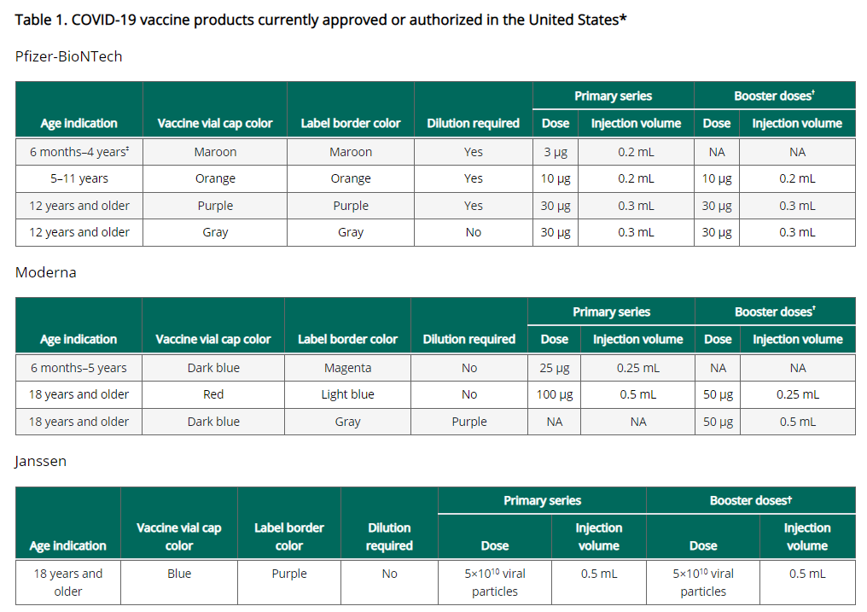

New COVID-19 vaccination schedule for people who are NOT moderately or severely immunocompromised

For primary series and booster dose(s), an age-appropriate mRNA vaccine is preferred over the Janssen vaccine. The same mRNA vaccine product should be used for all doses of the primary series (see Interchangeability of COVID-19 vaccine products). All people ages 5 years and older should receive at least 1 booster dose if eligible (i.e., if a booster dose is FDA-approved or FDA-authorized for use in a specified population); an mRNA vaccine must be used for the second booster dose.

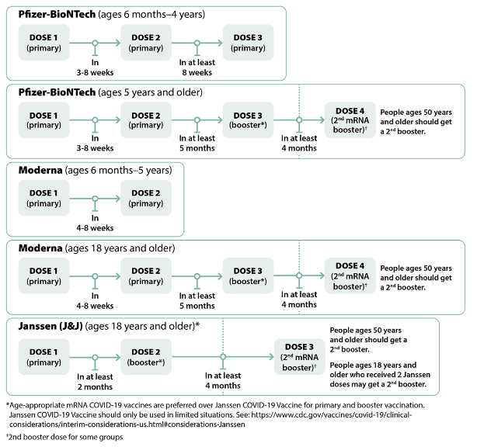

New A second visual of the vaccination schedule for people who are NOT moderately or severely immunocompromised
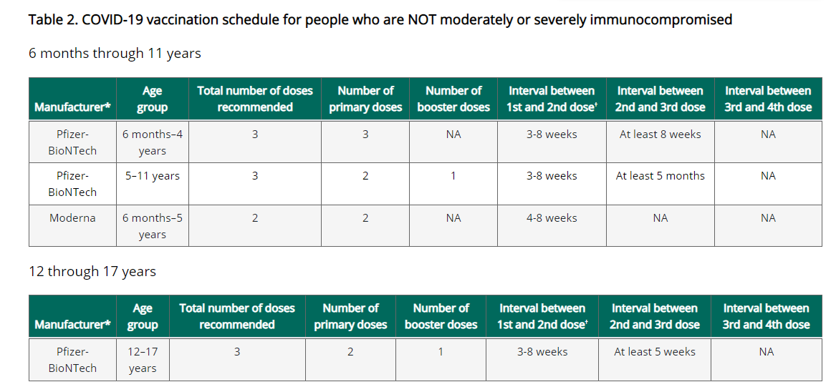
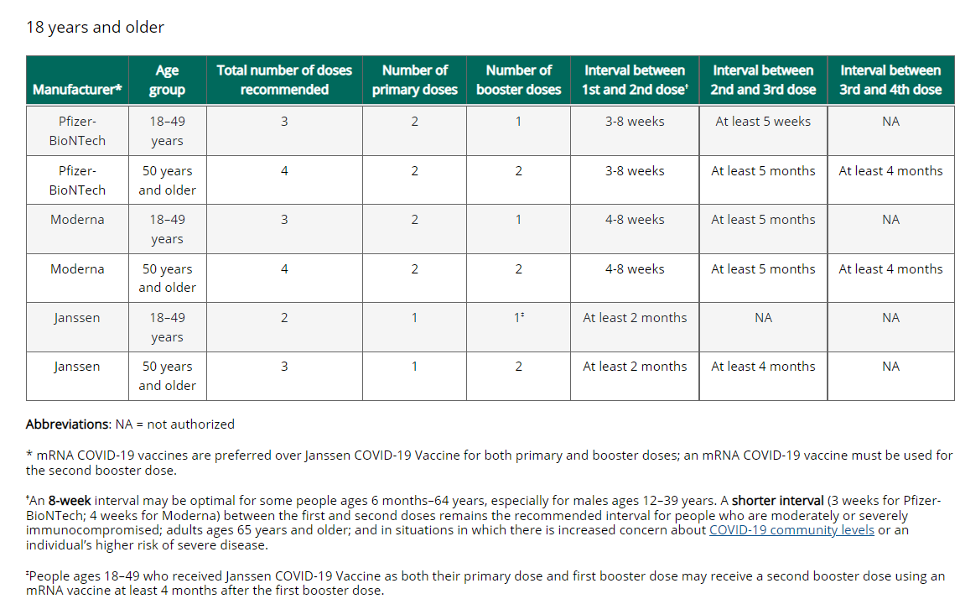

New Vaccination Schedule for people who are NOT moderately or severely immunocompromised
Ages 6 months through 11 years
Pfizer-BioNTech COVID-19 Vaccine
- Children ages 6 months–4 years: Should receive a 3-dose primary series. The first and second doses are separated by 3-8 weeks and the second and third doses are separated by at least 8 weeks. Currently, a booster is not authorized for this age group.
- Children ages 5–11 years: Should receive a 2-dose primary series separated by 3-8 weeks and 1 booster dose at least 5 months after completion of the primary series.
Moderna COVID-19 Vaccine
Children ages 6 months–5 years: Should receive a 2-dose primary series separated by 4-8 weeks. Currently, a booster dose is not authorized for children in this age group who receive a Moderna primary series.

Ages 12 through17 years
Pfizer-BioNTech COVID-19 Vaccine
- Adolescents ages 12–17 years: Should receive a 2-dose primary series separated by 3-8 weeks and 1 booster dose at least 5 months after completion of the primary series.
Moderna COVID-19 Vaccine
- ACIP will be meeting to discuss recommendations for ages 6-17 years on June 23rd.

Ages 18 years and older
Pfizer-BioNTech COVID-19 Vaccine
- Adults ages 18–49 years: Should receive a 2-dose primary series separated by 3-8 weeks and 1 booster dose at least 5 months after completion of the primary series.
- Adults ages 50 years and older: Should receive a 2-dose primary series separated by 3-8 weeks and 2 booster doses. The first booster dose should be administered at least 5 months after completion of the primary series and the second booster dose at least 4 months after the first booster dose.
Moderna COVID-19 Vaccine
- Adults ages 18 years and older: Should receive a 2-dose primary series separated by 4-8 weeks and 1 booster dose at least 5 months after completion of the primary series.
- Adults ages 50 years and older: Should receive a 2-dose primary series separated by 4-8 weeks and 2 booster doses. The first booster dose should be administered at least 5 months after completion of the primary series and the second booster dose at least 4 months after the first booster dose.
Janssen COVID-19 Vaccine
Janssen COVID-19 Vaccine should only be used in limited situations and cannot be used as a second booster; see Contraindications and precautions and Safety considerations for Janssen COVID-19 Vaccine.

New Considerations for intervals for mRNA COVID-19 vaccine primary series
An 8-week interval may be optimal for people who are not moderately or severely immunocompromised and ages 6 months-64 years, especially for males ages 12–39 years.

mRNA COVID-19 vaccines are FDA-approved or FDA-authorized for a 3-week (Pfizer-BioNTech vaccine) or 4-week (Moderna vaccine) interval between the first and second dose. A 3- or 4-week interval continues to be the recommended interval for people who are moderately or severely immunocompromised, adults ages 65 years and older, and in situations when the fullest possible protection needs to be achieved sooner (e.g., increased concern about COVID-19 community levels or an individual’s higher risk for severe disease).

mRNA COVID-19 vaccines are safe and effective at the FDA-approved or FDA-authorized intervals, but a longer interval may be considered for some populations. While absolute risk remains small, the risk for myocarditis is higher for males ages 12-39 years, and this risk might be reduced by extending the interval between the first and second dose. Some studies in adolescents (ages 12-17 years) and adults have shown the small risk of myocarditis associated with mRNA COVID-19 vaccines might be reduced and peak antibody responses and vaccine effectiveness may be increased with an interval longer than 4 weeks. Extending the interval beyond 8 weeks has not been shown to provide additional benefit. In summary, an 8-week interval may be optimal for people who are not moderately or severely immunocompromised and ages 6 months-64 years, especially for males ages 12–39 years.

New Transitioning from a younger to older age group
People should receive the recommended age-appropriate vaccine dosage based on their age on the day of vaccination. If a person moves from a younger age group to an older age group during the primary series or between the primary series and receipt of the booster dose(s), they should receive the vaccine product and dosage for the older age group for all subsequent doses.
FDA authorization allows for different dosing for certain age transitions as described below. Refer to Clinical Considerations Table 1 for information about age-specific vaccine products and dosages.

Pfizer-BioNTech COVID-19 Vaccine
Children who will turn from age 4 years to 5 years: FDA authorization of the Pfizer-BioNTech COVID-19 Vaccine allows children who will turn from age 4 years to 5 years between any dose in the primary series to receive:
- A 2-dose primary series using the Pfizer-BioNTech COVID-19 Vaccine product authorized for children ages 5–11 years
or
- A 3-dose primary series initiated with the Pfizer-BioNTech COVID-19 Vaccine product authorized for children ages 6 months–4 years. Each of doses 2 and 3 may be with the Pfizer-BioNTech COVID-19 Vaccine product authorized for children ages 6 months–4 years, or the Pfizer-BioNTech COVID-19 Vaccine product authorized for children ages 5–11 years.
Children who will turn from age 11 years to 12 years: FDA authorization of the Pfizer-BioNTech COVID-19 Vaccine allows children who will turn from age 11 years to 12 years between their first and second dose in the primary series to receive, for either dose: (1) the Pfizer-BioNTech COVID-19 Vaccine product authorized for children ages 5–11 years or (2) the Pfizer-BioNTech COVID-19 Vaccine product authorized for people ages 12 years and older.

New COVID-19 vaccination schedule for people who ARE moderately or severely immunocompromised
People with immunocompromising conditions or people who take immunosuppressive medications or therapies are at increased risk for severe COVID-19. Because the immune response following COVID-19 vaccination may differ in people who are moderately or severely immunocompromised at the time of vaccination, specific guidance for this population is provided.

People who are or who become moderately or severely immunocompromised should follow the COVID-19 vaccination schedule according to their age and immune status at the time of eligibility for doses. For example, people who become moderately or severely immunocompromised after completing a 2-dose mRNA or single-dose Janssen COVID-19 Vaccine primary series do not need additional primary doses; however, they should follow the schedule for people who are moderately or severely immunocompromised for booster doses.

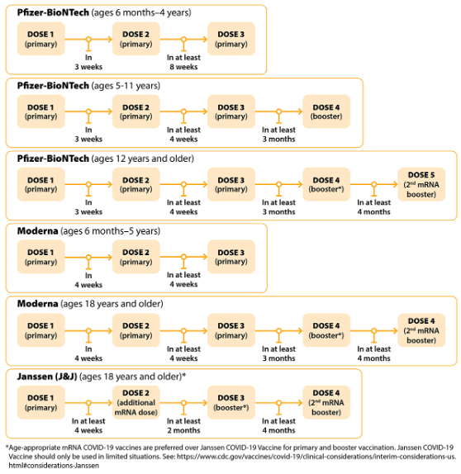

New Vaccination Schedule for people who ARE moderately or severely immunocompromised
Ages 6 months through 11 years
Pfizer-BioNTech COVID-19 Vaccine
- Children ages 6 months–4 years: Should receive a 3-dose primary series. The first and second doses are separated by 3 weeks and the second and third doses are separated by at least 8 weeks. Currently, a booster dose is not authorized for this age group.
- Children ages 5–11 years: Should receive a 3-dose primary series and 1 booster dose. For the primary series, the first and second doses are separated by 3 weeks and the second and third doses are separated by at least 4 weeks. The booster dose is administered at least 3 months after completion of the primary series.
Moderna COVID-19 Vaccine
- Children ages 6 months–5 years: Should receive a 3-dose primary series. The first and second doses are separated by 4 weeks and the second and third doses are separated by at least 4 weeks. Currently, a booster dose is not authorized for children in this age group who receive a Moderna primary series.

ages 12 through 17 years
Pfizer-BioNTech COVID-19 Vaccine
- Adolescents ages 12–17 years: Should receive a 3-dose primary series and 2 booster doses. For the primary series, the first and second doses are separated by 3 weeks and the second and third doses are separated by at least 4 weeks. The first booster dose is administered at least 3 months after completion of the primary series and the second booster dose at least 4 months after the first booster dose.
Moderna COVID-19 Vaccine
- ACIP will be meeting to discuss recommendations for ages 6-17 years on June 23rd.

ages 18 years and older
Pfizer-BioNTech COVID-19 Vaccine
- Adults ages 18 years and older: Should receive a 3-dose primary series and 2 booster doses. For the primary series, the first and second doses are separated by 3 weeks and the second and third doses are separated by at least 4 weeks. The first booster dose is administered at least 3 months after completion of the primary series and the second booster dose at least 4 months after the first booster dose.
Moderna COVID-19 Vaccine
- Adults ages 50 years and older: Should receive a 3-dose primary series and 2 booster doses. For the primary series, the first and second doses are separated by 4 weeks and the second and third doses are separated by at least 4 weeks. The first booster dose is administered at least 3 months after completion of the primary series and the second at least 4 months after the first booster dose.

Reminder CDC launches interactive tool for the public to assess need for first or second booster doses of COVID-19 vaccine
CDC added a new interactive tool to help users identify whether they (or someone else) need to receive a booster dose of COVID-19 vaccine. The “COVID-19 Vaccine Boosters” tool asks a series of simple questions about age, immunocompromise, number and type of previous doses of COVID-19 vaccines, and how long ago they received the most recent vaccination. From these answers, the tool reports whether a first or second booster dose may be beneficial and presents considerations for when to receive it.

Reminder Watch for Expired Vaccine
Providers should make it a practice to regularly check inventory for expired vaccine and immediately remove expired inventory to prevent it from being administered.
Vaccine Expiration Date Lookup & Reference Information:
- Expiry Information for Pfizer COVID-19 Vaccines
- Moderna Vial Expiration Date Look-up Tool
- Janssen Expiration Date Lookup Tool

RESOURCES & LEARNING OPPORTUNITIES

New Moderna COVID-19 Vaccine Office Hours: Pediatric and Adolescent Indications
Have questions about the Moderna COVID-19 vaccine or the recently approved pediatric and adolescent indications? Sign up for a Q&A session with one of their medical science liaisons.
These are informal, "drop-in" sessions. Join at any time during the session, get your questions answered, and get back to your day!

Reminder Pfizer COVID-19 Vaccine Medical Updates on Current & Immunization Site Training
Pfizer Vaccines US Medical Affairs continues to host frequent (almost daily) Medical Updates & Immunization Site Training for All Providers. Session topics include:
- Use of vaccine for Children 5 through 11 Years of Age, and Individuals 12 Years of Age and Older
- Storage, Handling, Preparation, & Administration for the multiple presentations of the vaccine
- Recent medical updates regarding the vaccine
- An overview of healthcare provider resources
- Question and answer session

To access current and future training sessions, please visit: https://www.pfizermedicalinformation.com/en-us/medical-updates

Reminder COVID-19 Vaccine Training Modules
CDC’s four training modules (General Overview, Pfizer, Moderna, Janssen) can be found here.

Reminder COVID-19 Vaccine Webinar Series
CDC is offering a series of brief (15-20 minute) webinars addressing topics around COVID-19 vaccination. These interactive, web-based training modules offer a real-world perspective on different issues around COVID-19 vaccines. Topics range from routine clinical and vaccine safety information to guidance for on-site clinic vaccination activities and having conversations with vaccine recipients. Each webinar includes self-test practice questions and lists additional resources related to the topic discussed. The landing page for all mini webinars is here: https://www.cdc.gov/vaccines/covid-19/training-education/webinars.html

Reminder COVID-19 Quick Reference Guide
CDC’s quick reference guide is a 2-page document that provides basic information on the proper storage, preparation, and administration of the currently authorized COVID-19 vaccine products in the United States.

Reminder CDC launches “Interactive COVID-19 Vaccine Conversations Module for Healthcare Professionals”
CDC has launched a new resource to equip healthcare professionals with the tools they need to have effective COVID-19 vaccine conversations with patients. The Interactive COVID-19 Vaccine Conversations Module for Healthcare Professionals includes:
- Tips for Having Effective Vaccine Conversations with Patients
- Vaccine Conversations in Practice: Case Scenarios

Reminder Morbidity and Mortality Weekly Report, better known as MMWR, is CDC’s primary publication for disseminating the science it produces. The staff at MMWR have launched a landing page to help people find the latest information on COVID-19 vaccine effectiveness and safety.

Recent CDC MMWRs
June 17, 2022
- COVID-19 Cases and Hospitalizations Among Medicare Beneficiaries With and Without Disabilities — United States, January 1, 2020–November 20, 2021
- Trends in Acute Hepatitis of Unspecified Etiology and Adenovirus Stool Testing Results in Children — United States, 2017–2022
- Notes from the Field: COVID-19–Associated Mortality Risk Among Long-Term Care Facility Residents and Community-Dwelling Adults Aged ≥65 Years — Illinois, December 2020 and January 2022
- Notes from the Field: Diagnosis and Investigation of Pneumonic Plague During a Respiratory Disease Pandemic — Wyoming, 2021

June 10, 2022
- COVID-19 Vaccination Coverage, by Race and Ethnicity — National Immunization Survey Adult COVID Module, United States, December 2020–November 2021
- Ventilation Improvement Strategies Among K–12 Public Schools — The National School COVID-19 Prevention Study, United States, February 14–March 27, 2022

MDPH RESOURCES

Reminder Massachusetts Resources
- New COVID-19 vaccinations for children ages 6 months to 4 years old
- New COVID-19 vaccinations for children ages 5-11
- New COVID-19 vaccinations for people ages 12-17
- COVID-19 Vaccine Information
- COVID-19 booster information and booster frequently asked questions
- Search for Vaccine locations: https://vaxfinder.mass.gov/
- COVID-19 Vaccine Resource Line/2-1-1 is available for individuals who are unable to use Vaxfinder, or have difficulty accessing the internet. Available in English and Spanish and has translators available in approximately 100 additional languages.
- COVID-19 Vaccine Training and Education Resources for Providers: https://www.mass.gov/info-details/covid-19-vaccine-training-and-education-resources-for-providers
- Multilingual COVID-19 Materials. Resources related to Coronavirus Disease 2019 (COVID-19) in multiple languages. Includes videos and printables on topics like vaccine safety, pregnancy and the vaccine, and FAQs.

Immunization Division Main Number
For questions about immunization recommendations, disease reporting, etc.
Phone: 617-983-6800 (24/7 MDPH Epi line)
Fax: 617-983-6840
Website: https://www.mass.gov/topics/immunization

MIIS Help Desk
Phone: 617-983-4335
Fax: 857-323-8321
Email questions to: miishelpdesk@mass.gov
Website: https://www.mass.gov/massachusetts-immunization-information-system-miis

MDPH Vaccine Unit
Phone: 617-983-6828
Email questions to: dph-vaccine-management@mass.gov
Website: https://www.mass.gov/service-details/vaccine-management

COVID-19 Email Box
Email questions to: COVID-19-Vaccine-Plan-MA@mass.gov

