BULLETIN
What Massachusetts COVID-19 Vaccine Providers Need to Know
Week of 7/27/2022

Please note: Future Bulletins may decrease in frequency and will be sent out on an as needed basis as new information becomes available.

LATEST NUMBERS

- As of 7/27/2022 5,420,516 people in Massachusetts have been fully vaccinated.
- Massachusetts has administered over 15 million doses of COVID vaccine!

WHO TO VACCINATE

Everyone ages 6 months and older should receive a COVID-19 primary series vaccination for the prevention of COVID-19.

Everyone ages 5 years and older should receive at least 1 booster dose of COVID-19 vaccine if eligible (i.e., if a booster dose is FDA-approved or FDA-authorized for use in a specified population). Recommendations for booster dose(s) vary based on age, COVID-19 vaccine product, and immunocompetence.

The recommended schedule and use of each COVID-19 vaccine product vary by the age and immune status of the recipient. There are two vaccination schedules: one for people who are not moderately or severely immunocompromised and one for people who are moderately or severely immunocompromised.

QUESTION OF THE WEEK

Q: Where can I find information on Novavax (standing orders, etc)?

A: CDC has posted information on Novavax. You can get to all the information from the U.S. COVID-19 Vaccine Product Information webpage. From this page you can get to the Novavax Storage and Handling Summary , Novavax Standing Orders , Novavax Preparation and Administration Summary , and more.

WHAT TO KNOW THIS WEEK

Novavax
On July 13, 2022, the FDA issued an EUA for the Novavax COVID-19 Vaccine, Adjuvanted for the prevention of COVID-19 caused by severe acute respiratory syndrome coronavirus 2 (SARS-CoV-2) in individuals 18 years of age and older.

On July 19, 2022, ACIP met and voted to recommend Novavax be used as another primary series option for adults ages 18 years and older. A short time later, CDC Director Rochelle Walensky endorsed ACIP’s recommendation.

Novavax is an adjuvanted protein subunit vaccine. The CDC news release states that protein subunit vaccines package harmless proteins of the COVID-19 virus alongside another ingredient called an adjuvant that helps the immune system respond to the virus in the future. Vaccines using protein subunits have been used for more than 30 years in the United States, beginning with the first licensed hepatitis B vaccine. Other protein subunit vaccines used in the United States today include those to protect against influenza and whooping cough (acellular pertussis).

The following is attributable to Dr. Walensky:
“Today, we have expanded the options available to adults in the U.S. by recommending another safe and effective COVID-19 vaccine. If you have been waiting for a COVID-19 vaccine built on a different technology than those previously available, now is the time to join the millions of Americans who have been vaccinated. With COVID-19 cases on the rise again across parts of the country, vaccination is critical to help protect against the complications of severe COVID-19 disease.”

Novavax EUA, HCP: https://www.fda.gov/media/159897/download
Novavax EUA, Recipient: https://www.fda.gov/media/159898/download

Novavax COVID-19 Vaccine Characteristics
- Age indication: 18 years and older, primary series only
- Interval: 2 dose primary series 21 days apart
- Dose: 5 mcg SARS-CoV-2rS 50 mcg Matrix-M™ adjuvant
- Injection volume: 0.5 mL
- Preparation: Do not dilute
- Doses per vial: 10 doses
- Injection route/site: Intramuscular/deltoid
- Storage: Refrigerator 2° to 8°C (36°to 46°F) DO NOT FREEZE
- Beyond use time: 6 hours after first puncture
- Expiration: No expiration date is printed on the vial or carton, it must be looked up on the Expiry Date Checker at https://us.novavaxcovidvaccine.com/hcp (also accessible from https://www.novavaxcovidvaccine.com/ and navigating to the HCP page)

New Novavax Vaccine Ordering
Novavax vaccine will only be available for ordering by health care provider sites/LBOHs that will be open to the public and have their clinics posted on the state’s VaxFinder Website: https://vaxfinder.mass.gov/. To be eligible to order vaccine you must first note your intent to list your Novavax clinics on the following Google Form. Once you do, your Novavax vaccine ordering will be activated in the MIIS within 24hrs. Here are additional ordering details to keep in mind:
  - NDC 80631-0100-10
  - Minimum order amount: 100 doses
  - Maximum order amount: 500 doses (please ensure your order includes 2nd dose needs)

Novavax Clinical Considerations
- Adults ages 18+ should receive a Novavax 2-dose primary series separated by 3–8 weeks. Currently, a booster dose using any COVID-19 vaccine is not authorized for adults in this age group who receive a Novavax primary series.
  - For people who are not moderately or severely immunocompromised, first and second doses of Novavax should be administered 3-8 weeks apart.
  - For people who are moderately or severely immunocompromised, first and second doses of Novavax should be administered 3 weeks apart.
- The following are NOT currently authorized for people receiving a Novavax COVID-19 Vaccine primary series:
  - 3rd primary dose for people who are moderately or severely immunocompromised
  - Booster dose using ANY COVID-19 vaccine after a Novavax primary series
  - CDC will provide clinical guidance for what FDA authorizes; once authorized, these doses can be added to the COVID-19 vaccination schedule

COCA Call July 28, 2pm
CDC COCA Call: Recommendations for the Novavax COVID-19 Primary Series in Adults Ages 18 and Older - July 28, 2022, 2:00 PM – 3:00 PM ET
- During this COCA Call, presenters will discuss CDC’s new guidance on the Novavax COVID-19 vaccine for adults ages 18 years and older, including adults who are moderately or severely immunocompromised

Helpful Reference Materials (please watch for all reference materials to be updated to include Novavax)
- New AAP’s Pediatric COVID-19 Vaccine Dosing Quick Reference Guide
- At-A-Glance COVID-19 Vaccination Schedule
A helpful pdf showing a graphic of the COVID-19 vaccine recommendations based on primary series product, age, and immune status.
- Interim COVID-19 Immunization Schedule for 6 Months of Age and Older
A helpful pdf summarizing products, schedules, doses, boosters
- Moderna COVID-19 Vaccine for Children who Transition from a Younger to Older Age Group
- Pfizer-BioNTech for Children who Transition from a Younger to Older Age Group
- Pfizer COVID-19 Vaccine Products At-A-Glance
- Moderna COVID-19 Vaccine At-A-Glance

Standing Orders
- New Novavax
https://www.cdc.gov/vaccines/covid-19/info-by-product/novavax/downloads/novavax-standing-orders.pdf

- CDC’s Moderna COVID-19 Vaccine info (including the standing orders below)
https://www.cdc.gov/vaccines/covid-19/info-by-product/moderna/index.html
- Moderna Blue cap with magenta bordered label – 6 months through 5 years of age
https://www.cdc.gov/vaccines/covid-19/info-by-product/moderna/downloads/infant_standing-orders.pdf
- Moderna Blue cap with purple-bordered label – 6 through 11 years of age
https://www.cdc.gov/vaccines/covid-19/info-by-product/moderna/downloads/6-11-standing-orders.pdf
- Moderna Red cap with blue-bordered label – 12 through 17 years of age
https://www.cdc.gov/vaccines/covid-19/info-by-product/moderna/downloads/12-17-standing-orders.pdf
- Moderna Red cap – 18 years of age and older (updated 5/24/2022)
https://www.cdc.gov/vaccines/covid-19/info-by-product/moderna/downloads/standing-orders.pdf
- CDC’s Pfizer COVID-19 Vaccine info (including the standing orders below)
https://www.cdc.gov/vaccines/covid-19/info-by-product/pfizer/index.html
- Pfizer Maroon Cap: 6 months through 4 years of age
https://www.cdc.gov/vaccines/covid-19/info-by-product/pfizer/downloads/infant-standing-orders.pdf
- Pfizer Orange Cap: 5 through 11 years of age (updated 5/24/2022)
https://www.cdc.gov/vaccines/covid-19/info-by-product/pfizer/downloads/Pfizer_PED_StandingOrders.pdf
- Pfizer Gray Cap: 12 years of age and older (updated 5/24/2022)
https://www.cdc.gov/vaccines/covid-19/info-by-product/pfizer/downloads/gray-cap-Pfizer-BioNTech-standing-orders.pdf

Preparations and Administration Summaries
- New Novavax https://www.cdc.gov/vaccines/covid-19/info-by-product/novavax/downloads/novavax-prep-admin-summary.pdf
- Pfizer https://www.cdc.gov/vaccines/covid-19/info-by-product/pfizer/administration.html
- Moderna https://www.cdc.gov/vaccines/covid-19/info-by-product/moderna/administration.html

Information for parents and caregivers:
- COVID-19 Vaccines for Children and Teens | CDC
- Frequently Asked Questions about COVID-19 Vaccination in Children | CDC
- 6 Things to Know about COVID-19 Vaccination for Children | CDC
- V-safe After Vaccination Health Checker | CDC
- COVID-19 Vaccine: Frequently Asked Questions | American Academy of Pediatrics

V-safe Reminder
Parents and guardians can easily enroll their children in the V-safe After Vaccination Health Checker. V-safe provides personalized and confidential health check-ins via text messages and web surveys so that enrolled COVID-19 vaccine recipients can quickly and easily share with CDC how they feel after getting a COVID-19 vaccine.

The information collected by the tracker is an important tool as it helps CDC monitor and communicate about the safety of COVID-19 vaccines in near real time. Click here to access instructions for adding a dependent in V-safe that can be shared with parents and guardians. Click here to access V-safe information sheets in multiple languages.

Vaccines Formulations Available for Ordering
All provider enrolled in the Massachusetts COVID-19 Vaccine Program (MCVP) are able to place routine orders for all of the following COVID-19 vaccine formulations through the Massachusetts Immunization Information System (MIIS).

Brand | NDC | NDC Description | Minimum ordering size
- | 59267-0078-04 | COVID-19 (Pfizer);(PED 6m-4y) MDV10;10-pk | 100
- | 59267-1055-04 | COVID-19 (Pfizer);(PED 5-11) MDV10;10-pk | 100
- | 59267-1025-04 | COVID-19 (Pfizer 12+); TRIS; MDV6; 10-pack | 300
COMIRNATY | 00069-2025-10 | COVID-19; (12+) MDV6; 10-pack | 300
- | 80777-0279-99 | COVID-19 (Moderna);(PED 6m-5y) MDV10;10-pack | 100
- | 80777-0275-99 | COVID-19 (Moderna);(PED 6-11 Primary | 18 + Booster); MDV5; 10-pack* | 100
- | 80777-0273-99 | COVID-19 (Moderna); MDV10; 10-pack (12+ Primary | 18+ Booster) | 100
- | 59676-0580-15 | COVID-19 (Janssen); MDV5; 10-pack | 100

- Initial shipments of the Pfizer-BioNTech vaccine for children aged 6m–4 years may state “2y to <5y” or “6m to <5y” on the vial or carton labels. Please note that vials or cartons with labels that state “2y to <5y” can be used for children aged 6m through 4 years.
- Pfizer-BioNTech vaccine vial labels and cartons may also state that a vial should be discarded 6 hours after the first dilution however as stated in the EUA Fact Sheet the timeframe for use post-dilution is actually 12 hours just like orange and gray cap Pfizer vaccine formulations.

*Please Note: For pediatric practices that are currently not supplying the Pfizer 5-11 year old formulation due to logistical challenges please consider supplying the new Moderna 6-11 year old formulation as it comes in only 5 dose vials, requires no reconstitution, and can be stored in a standard freezer until expiration.

COVID-19 vaccine formulations currently approved or authorized in the United States
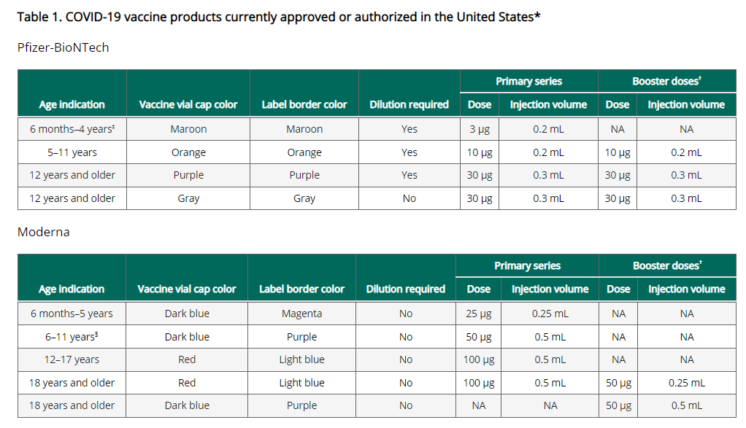
Please note this footnote: †For people ages 5–17 years, Pfizer is currently FDA-authorized for use as a booster dose in people who received Pfizer as their primary series; Moderna is not authorized for use as a booster dose in this age group. For people ages 18 years and older, Pfizer and Moderna can be used as a booster dose. Currently, Novavax is not authorized for booster vaccination.

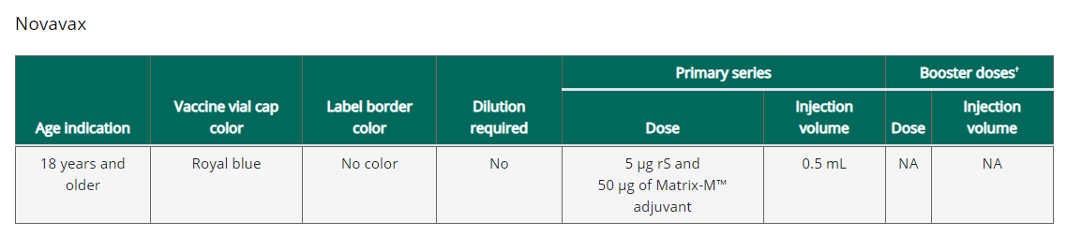

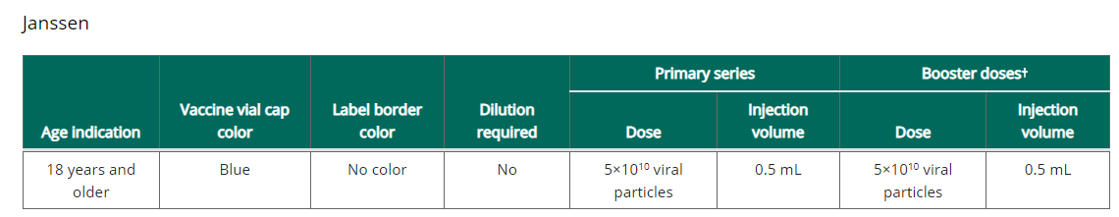
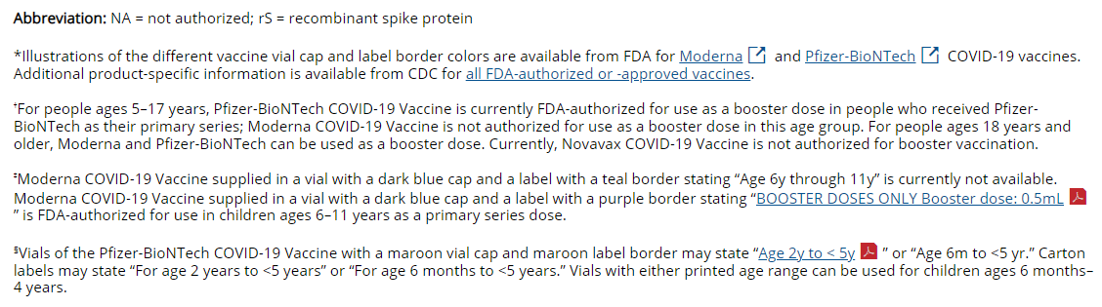

COVID-19 vaccination schedule for people who are NOT moderately or severely immunocompromised
For primary series and booster dose(s), an age-appropriate mRNA vaccine is preferred over the Janssen vaccine. The same mRNA vaccine product should be used for all doses of the primary series (see Interchangeability of COVID-19 vaccine products). All people ages 5 years and older should receive at least 1 booster dose if eligible (i.e., if a booster dose is FDA-approved or FDA-authorized for use in a specified population); an mRNA vaccine must be used for the second booster dose.

While this graphic is a helpful visual, it does not include clinical details necessary for administering COVID-19 vaccines. For clinical detail see the Clinical Considerations and guidance for people who are not immunocompromised

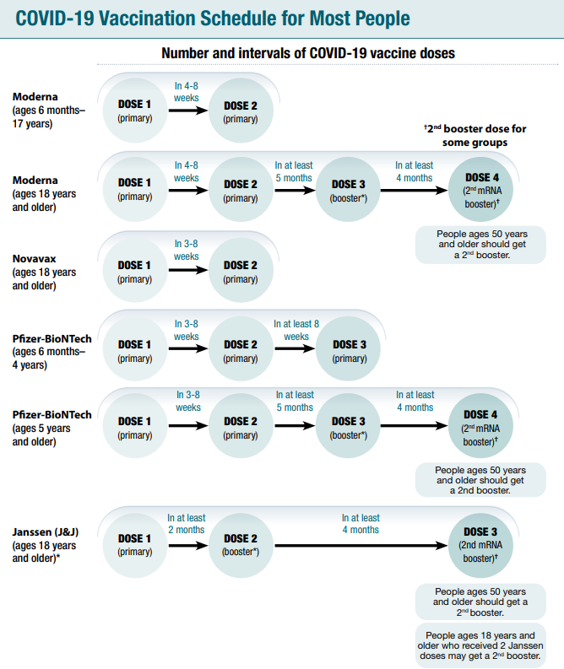

Considerations for intervals for mRNA COVID-19 vaccine primary series
An 8-week interval may be optimal for people who are not moderately or severely immunocompromised and ages 6 months-64 years, especially for males ages 12–39 years COVID-19 vaccines are FDA-approved or FDA-authorized for a 3-week (Pfizer-BioNTech vaccine) or 4-week (Moderna vaccine) interval between the first and second dose. A 3- or 4-week interval continues to be the recommended interval for people who are moderately or severely immunocompromised, adults ages 65 years and older, and in situations when the fullest possible protection needs to be achieved sooner (e.g., increased concern about COVID-19 community levels or an individual’s higher risk for severe disease).

mRNA COVID-19 vaccines are safe and effective at the FDA-approved or FDA-authorized intervals, but a longer interval may be considered for some populations. While absolute risk remains small, the risk for myocarditis is higher for males ages 12-39 years, and this risk might be reduced by extending the interval between the first and second dose. Some studies in adolescents (ages 12-17 years) and adults have shown the small risk of myocarditis associated with mRNA COVID-19 vaccines might be reduced and peak antibody responses and vaccine effectiveness may be increased with an interval longer than 4 weeks. Extending the interval beyond 8 weeks has not been shown to provide additional benefit. In summary, an 8-week interval may be optimal for people who are not moderately or severely immunocompromised and ages 6 months-64 years, especially for males ages 12–39 years.

Transitioning from a younger to older age group
People should receive the recommended age-appropriate vaccine dosage based on their age on the day of vaccination. If a person moves from a younger age group to an older age group during the primary series or between the primary series and receipt of the booster dose(s), they should receive the vaccine product and dosage for the older age group for all subsequent doses.
FDA authorization allows for dosing options for certain age transitions for Pfizer-BioNTech COVID-19 Vaccine and Moderna COVID-19 Vaccine as described below.
Refer to Clinical Considerations Table 1 for information about age-specific vaccine products and dosages.

Pfizer-BioNTech COVID-19 Vaccine
Children who will turn from age 4 years to 5 years: FDA authorization of the Pfizer-BioNTech COVID-19 Vaccine allows children who will turn from age 4 years to 5 years between any dose in the primary series to receive:
- A 2-dose primary series using the Pfizer-BioNTech COVID-19 Vaccine product authorized for children ages 5–11 years
or
- A 3-dose primary series initiated with the Pfizer-BioNTech COVID-19 Vaccine product authorized for children ages 6 months–4 years. Each of doses 2 and 3 may be with the Pfizer-BioNTech COVID-19 Vaccine product authorized for children ages 6 months–4 years, or the Pfizer-BioNTech COVID-19 Vaccine product authorized for children ages 5–11 years.

Children who will turn from age 11 years to 12 years: FDA authorization of the Pfizer-BioNTech COVID-19 Vaccine allows children who will turn from age 11 years to 12 years between their first and second dose in the primary series to receive, for either dose: (1) the Pfizer-BioNTech COVID-19 Vaccine product authorized for children ages 5–11 years or (2) the Pfizer-BioNTech COVID-19 Vaccine product authorized for people ages 12 years and older.

Moderna COVID-19 Vaccine
Children who will turn from age 5 years to 6 years: FDA authorization of the Moderna COVID-19 Vaccine allows children who will turn from age 5 years to 6 years between doses in the primary series to receive, for any primary dose: (1) the Moderna COVID-19 Vaccine product authorized for children ages 6 months–5 years or (2) the
Moderna COVID-19 Vaccine product authorized for children ages 6–11 years.

Children who will turn from age 11 years to 12 years: FDA authorization of the Moderna COVID-19 Vaccine allows children who will turn from age 11 years to 12 years between doses in the primary series to receive, for any primary dose: (1) the Moderna COVID-19 Vaccine product authorized for children ages 6–11 years or (2) the Moderna COVID-19 Vaccine product authorized for people ages 12 years and older.

COVID-19 vaccination schedule for people who ARE moderately or severely immunocompromised
People with immunocompromising conditions or people who take immunosuppressive medications or therapies are at increased risk for severe COVID-19. Because the immune response following COVID-19 vaccination may differ in people who are moderately or severely immunocompromised at the time of vaccination, specific guidance for this population is provided.

People who are or who become moderately or severely immunocompromised should follow the COVID-19 vaccination schedule according to their age and immune status at the time of eligibility for doses. For example, people who become moderately or severely immunocompromised after completing a 2-dose mRNA or single-dose Janssen COVID-19 Vaccine primary series do not need additional primary doses; however, they should follow the schedule for people who are moderately or severely immunocompromised for booster doses.
While this graphic is a helpful visual, it does not include clinical details necessary for administering COVID-19 vaccines. For clinical detail see the Clinical Considerations and guidance for people who are immunocompromised.

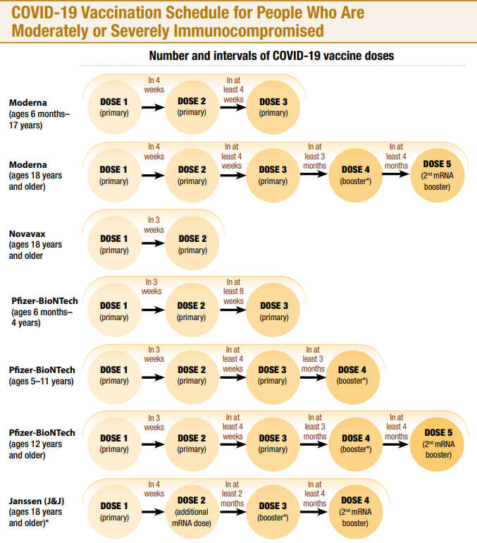
CDC interactive tool for the public to assess need for first or second booster doses of COVID-19 vaccine
CDC has an interactive tool to help users identify whether they (or someone else) need to receive a booster dose of COVID-19 vaccine. The “Find Out When You Can Get Your Booster” tool asks a series of simple questions about age, immunocompromise, number and type of previous doses of COVID-19 vaccines, and how long ago they received the most recent vaccination. From these answers, the tool reports whether a first or second booster dose may be beneficial and presents considerations for when to receive it. Find the tool here.

Watch for Expired Vaccine
Providers should make it a practice to regularly check inventory for expired vaccine and immediately remove expired inventory to prevent it from being administered.
Vaccine Expiration Date Lookup & Reference Information:
- New Novavax Expiry Date Checker
- Expiry Information for Pfizer COVID-19 Vaccines
- Moderna Vial Expiration Date Look-up Tool
- Janssen Expiration Date Lookup Tool

EUA Fact Sheets
Once a new EUA Fact Sheet is issued, it must be used. Previous ones no longer contain accurate information.

New Novavax EUAs
- Novavax, HCP: https://www.fda.gov/media/159897/download
- Novavax, Recipient: https://www.fda.gov/media/159898/download

Pfizer EUAs
- Pfizer, HCP, Wall Chart Showing Different presentations: https://www.fda.gov/media/159304/download

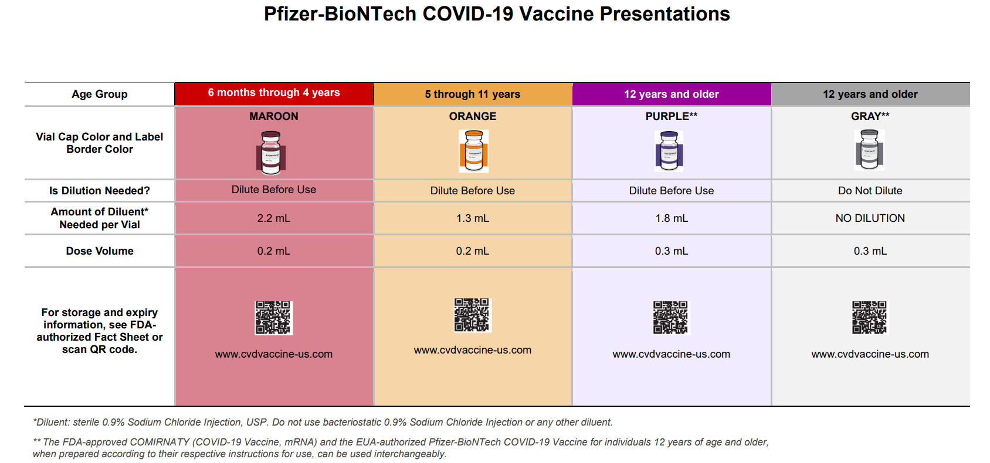

- Pfizer, HCP, 6 months through 4 years, maroon cap (must dilute):https://www.fda.gov/media/159312/download
- Pfizer, HCP-Dear Healthcare Provider Letter, 6 months through 4 years, maroon cap (must dilute): https://www.fda.gov/media/159303/download
- Pfizer, Recipient, 6 months through 4 years of age: https://www.fda.gov/media/159313/download
- Pfizer, HCP, 12 years of age and older, purple cap (must dilute): https://www.fda.gov/media/153713/download
- Pfizer, HCP, 12 years of age and older, gray cap (no dilution): https://www.fda.gov/media/153715/download
- Pfizer, HCP, 5 - 11 years of age, orange cap (must dilute): https://www.fda.gov/media/153714/download
- Pfizer, Recipient, 12 years of age and older: https://www.fda.gov/media/153716/download
Pfizer, Recipient, 5-11 years: https://www.fda.gov/media/153717/download

Moderna EUAs
- Moderna, HCP, Wall Chart Showing Different vials/presentations: https://www.fda.gov/media/159306/download

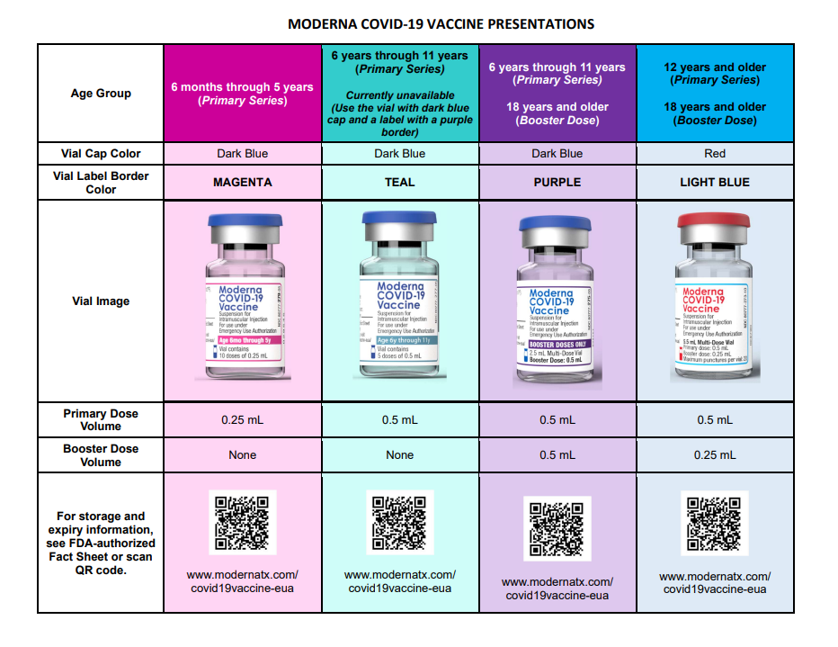

- Moderna, HCP, 6 months through 5 years of age (magenta border): https://www.fda.gov/media/159307/download
- Moderna, Recipient, 6 months through 5 years of age (magenta border): https://www.fda.gov/media/159309/download
- Moderna, HCP, 6 years through 11 years of age (teal & purple border): https://www.fda.gov/media/159308/download
- Moderna, HCP-Dear Healthcare Provider Letter, 6 years through 11 years of age (teal & purple border): https://www.fda.gov/media/159305/download
- Moderna, Recipient, 6 years through 11 years of age (teal & purple border): https://www.fda.gov/media/159310/download
- Moderna, HCP, 12 years and older and booster doses for 18 years and older (light blue border): https://www.fda.gov/media/157233/download
- Moderna, Recipient, 12 years and older (black border): https://www.fda.gov/media/144638/download
- Moderna, HCP, 18 years and older booster dose presentation only (purple border): https://www.fda.gov/media/157232/download

Janssen EUAs
- Janssen, HCP: https://www.fda.gov/media/146304/download
- Janssen, Recipient: https://www.fda.gov/media/146305/download

RESOURCES & LEARNING OPPORTUNITIES

Pediatric Vaccination Toolkit for Pediatricians and Physicians
The US HHS public education campaign, We Can Do This, recently launched the Pediatricians and Family Physicians Toolkit to help physicians increase confidence in and uptake of COVID-19 vaccines among their patients and in the communities they serve. Developed in partnership with the American Academy of Pediatrics, it includes information from CDC and new, culturally tailored materials, including a sample letter to parents, pediatrician talking points, posters and flyers that can be hung in offices and waiting rooms, as well as digital communications like social media posts and sample text messages.

In addition to the new toolkit, HHS has released a new PSA in English and Spanish, announcing the new vaccine authorization for children 6 months and older, and a one-pager that describes some of the most effective messages when communicating with parents about the importance of the COVID-19 vaccine.

Moderna COVID-19 Vaccine Office Hours: Pediatric and Adolescent Indications
Have questions about the Moderna COVID-19 vaccine or the recently approved pediatric and adolescent indications? Sign up for a Q&A session with one of their medical science liaisons, held on multiple days/times throughout July.
These are informal, "drop-in" sessions. Join at any time during the session, get your questions answered, and get back to your day!

Pfizer COVID-19 Vaccine Medical Updates on Current & Immunization Site Training
Pfizer Vaccines US Medical Affairs continues to host frequent Medical Updates & Immunization Site Training for All Providers. Session topics include:
- Use of vaccine for Children 6 months and older
- Storage, Handling, Preparation, & Administration for the multiple presentations of the vaccine
- Recent medical updates regarding the vaccine
- An overview of healthcare provider resources
- Question and answer session
To access the training sessions, please visit: https://www.pfizermedicalinformation.com/en-us/medical-updates

COVID-19 Vaccine Training Modules
CDC’s four training modules (General Overview, Pfizer, Moderna, Janssen) can be found here.

COVID-19 Vaccine Webinar Series
CDC is offering a series of brief (15-20 minute) webinars addressing topics around COVID-19 vaccination. These interactive, web-based training modules offer a real-world perspective on different issues around COVID-19 vaccines. Topics range from routine clinical and vaccine safety information to guidance for on-site clinic vaccination activities and having conversations with vaccine recipients. Each webinar includes self-test practice questions and lists additional resources related to the topic discussed. The landing page for all mini webinars is here: https://www.cdc.gov/vaccines/covid-19/training-education/webinars.html

CDC “Interactive COVID-19 Vaccine Conversations Module for Healthcare Professionals”
CDC has a resource to equip healthcare professionals with the tools they need to have effective COVID-19 vaccine conversations with patients. The Interactive COVID-19 Vaccine Conversations Module for Healthcare Professionals includes:
- Tips for Having Effective Vaccine Conversations with Patients
- Vaccine Conversations in Practice: Case Scenarios

Morbidity and Mortality Weekly Report, better known as MMWR, is CDC’s primary publication for disseminating the science it produces. The staff at MMWR have launched a landing page to help people find the latest information on COVID-19 vaccine effectiveness and safety.

Recent CDC MMWRs
July 22, 2022
- Effectiveness of 2, 3, and 4 COVID-19 mRNA Vaccine Doses Among Immunocompetent Adults During Periods when SARS-CoV-2 Omicron BA.1 and BA.2/BA.2.12.1 Sublineages Predominated — VISION Network, 10 States, December 2021–June 2022
July 15, 2022
- Safety Monitoring of COVID-19 mRNA Vaccine First Booster Doses Among Persons Aged ≥12 Years with Presumed Immunocompromise Status — United States, January 12, 2022–March 28, 2022
July 8, 2022
- Factors Associated with Severe Outcomes Among Immunocompromised Adults Hospitalized for COVID-19 — COVID-NET, 10 States, March 2020–February 2022

MDPH RESOURCES

Massachusetts Resources
- COVID-19 vaccinations for children ages 6 months to 4 years old
- COVID-19 vaccinations for children ages 5-11
- COVID-19 vaccinations for people ages 12-17
- COVID-19 Vaccine Information
- COVID-19 booster information and booster frequently asked questions
- Search for Vaccine locations: https://vaxfinder.mass.gov/
- COVID-19 Vaccine Resource Line/2-1-1 is available for individuals who are unable to use Vaxfinder, or have difficulty accessing the internet. Available in English and Spanish and has translators available in approximately 100 additional languages.
- COVID-19 Vaccine Training and Education Resources for Providers: https://www.mass.gov/info-details/covid-19-vaccine-training-and-education-resources-for-providers
- Multilingual COVID-19 Materials. Resources related to Coronavirus Disease 2019 (COVID-19) in multiple languages. Includes videos and printables on topics like vaccine safety, pregnancy and the vaccine, and FAQs.

Immunization Division Main Number
For questions about immunization recommendations, disease reporting, etc.
Phone: 617-983-6800 (24/7 MDPH Epi line)
Fax: 617-983-6840
Website: https://www.mass.gov/topics/immunization

MIIS Help Desk
Phone: 617-983-4335
Fax: 857-323-8321
Email questions to: miishelpdesk@mass.gov
Website: https://www.mass.gov/massachusetts-immunization-information-system-miis

MDPH Vaccine Unit
Phone: 617-983-6828
Email questions to: dph-vaccine-management@mass.gov
Website: https://www.mass.gov/service-details/vaccine-management

COVID-19 Email Box
Email questions to: COVID-19-Vaccine-Plan-MA@mass.gov

