BULLETIN
What Massachusetts COVID-19 Vaccine Providers Need to Know
Week of 8/18/2022

LATEST NUMBERS

- As of 8/18/2022 5,438,096 people in Massachusetts have been fully vaccinated.

WHO TO VACCINATE

Everyone ages 6 months and older should receive a COVID-19 primary series vaccination for the prevention of COVID-19.

Everyone ages 5 years and older should receive at least 1 booster dose of COVID-19 vaccine if eligible (i.e., if a booster dose is FDA-approved or FDA-authorized for use in a specified population). Recommendations for booster dose(s) vary based on age, COVID-19 vaccine product, and immunocompetence.

The recommended schedule and use of each COVID-19 vaccine product vary by the age and immune status of the recipient. There are two vaccination schedules: one for people who are not moderately or severely immunocompromised and one for people who are moderately or severely immunocompromised.

QUESTION OF THE WEEK

Q: Will there be a bivalent COVID-19 booster available this fall?

A: Yes. There are still authorizations that need to occur. See below for more details.

WHAT TO KNOW THIS WEEK

Four COVID-19 vaccines are currently approved under a BLA or authorized under an EUA by the FDA:
- Pfizer-BioNTech is an mRNA vaccine.
It is authorized (EUA) for people 6 months – 11 years and approved (BLA) for people ages 12 years and older.
- Moderna is an mRNA vaccine.
It is authorized (EUA) for people 6 months – 17 years and approved (BLA) for people ages 18 years and older.
- J&J/Janssen is a viral vector vaccine.
It is authorized (EUA) for people 18 years and older.
- Novavax is an adjuvanted protein subunit vaccine.
It is authorized (EUA) for people 18 years and older (primary series only).

New Bivalent COVID-19 Boosters
On June 30, 2022, the FDA advised manufacturers seeking to update their COVID-19 vaccines to add an Omicron BA.4/5 spike protein component to the current vaccine composition to create a bivalent booster vaccine.

Pending potential FDA Emergency Use Authorizations (EUAs) for new bivalent COVID-19 boosters developed by Pfizer-BioNTech and Moderna in or around September 2022, CDC’s ACIP will convene to discuss potential recommendations. Once scheduled, ACIP meeting information is announced on the ACIP website. Administration of any new bivalent COVID-19 boosters can begin only after CDC’s official recommendations.

The bivalent COVID-19 vaccine will be administered as a single booster dose. It is anticipated that bivalent COVID-19 vaccine booster doses may initially be authorized for people ages 12 years and older (Pfizer-BioNTech) and for people ages 18 years and older (Moderna), followed by younger pediatric age groups. It is also anticipated that the bivalent COVID-19 vaccines will only be authorized as a single booster dose in people who have completed a primary vaccination series but would not vary based on number or type of prior booster doses received.

The new vaccines will have the same storage and handling parameters as the original vaccine products.

Pfizer-BioNTech COVID-19 Vaccines
- Ultra-cold freezer storage (-90°C to -60°C) until expiry
- NO FREEZER STORAGE
- Refrigerate (2°C to 8°C) up to 10 weeks without puncturing

Moderna COVID-19 Vaccines
- NO ULTRA-COLD FREEZER STORAGE
- Freezer storage (-25°C to -15°C) until expiry
- Refrigerate (2°C to 8°C) up to 30 days without puncturing

Novavax
Novavax is the fourth COVID-19 vaccine to receive EUA status and a CDC recommendation. Novavax is an adjuvanted protein subunit vaccine. Protein subunit vaccines package harmless proteins of the virus alongside another ingredient called an adjuvant that helps the immune system respond to the virus in the future. Vaccines using protein subunits have been used for more than 30 years in the United States, beginning with the first licensed hepatitis B vaccine. Other protein subunit vaccines used in the United States today include those to protect against influenza and whooping cough (acellular pertussis).

Novavax COVID-19 Vaccine Characteristics
- Age indication: 18 years and older, primary series only
- Interval: 2 dose primary series 21 days apart
- Dose: 5 mcg SARS-CoV-2rS 50 mcg Matrix-M™ adjuvant
- Injection volume: 0.5 mL
- Preparation: Do not dilute
- Doses per vial: 10 doses
- Injection route/site: Intramuscular/deltoid
- Storage: Refrigerator 2° to 8°C (36°to 46°F) DO NOT FREEZE
- Beyond use time: 6 hours after first puncture
- Expiration: No expiration date is printed on the vial or carton, it must be looked up on the Expiry Date Checker at https://us.novavaxcovidvaccine.com/hcp (also accessible from https://www.novavaxcovidvaccine.com/ and navigating to the HCP page)

Novavax Clinical Considerations
- Adults ages 18+ should receive a Novavax 2-dose primary series separated by 3–8 weeks. Currently, a booster dose using any COVID-19 vaccine is not authorized for adults in this age group who receive a Novavax primary series.
  - For people who are not moderately or severely immunocompromised, first and second doses of Novavax should be administered 3-8 weeks apart.
  - For people who are moderately or severely immunocompromised, first and second doses of Novavax should be administered 3 weeks apart.
- The following are NOT currently authorized for people receiving a Novavax COVID-19 Vaccine primary series:
  - 3rd primary dose for people who are moderately or severely immunocompromised
  - Booster dose using ANY COVID-19 vaccine after a Novavax primary series
  - CDC will provide clinical guidance for what FDA authorizes; once authorized, these doses can be added to the COVID-19 vaccination schedule

Helpful Reference Materials
- Interim COVID-19 Immunization Schedule for 6 Months of Age and Older
A helpful pdf summarizing products, schedules, doses, boosters
- AAP’s Pediatric COVID-19 Vaccine Dosing Quick Reference Guide
- At-A-Glance COVID-19 Vaccination Schedule
A helpful pdf showing a graphic of the COVID-19 vaccine recommendations based on primary series product, age, and immune status.
- Moderna COVID-19 Vaccine for Children who Transition from a Younger to Older Age Group
- Pfizer-BioNTech for Children who Transition from a Younger to Older Age Group
- Pfizer COVID-19 Vaccine Products At-A-Glance
- Moderna COVID-19 Vaccine At-A-Glance

Standing Orders
- Novavax
https://www.cdc.gov/vaccines/covid-19/info-by-product/novavax/downloads/novavax-standing-orders.pdf

- CDC’s Moderna COVID-19 Vaccine info (including the standing orders below)
https://www.cdc.gov/vaccines/covid-19/info-by-product/moderna/index.html
- Moderna Blue cap with magenta bordered label – 6 months through 5 years of age
https://www.cdc.gov/vaccines/covid-19/info-by-product/moderna/downloads/infant_standing-orders.pdf
- Moderna Blue cap with purple-bordered label – 6 through 11 years of age
https://www.cdc.gov/vaccines/covid-19/info-by-product/moderna/downloads/6-11-standing-orders.pdf
- Moderna Red cap with blue-bordered label – 12 through 17 years of age
https://www.cdc.gov/vaccines/covid-19/info-by-product/moderna/downloads/12-17-standing-orders.pdf
- Moderna Red cap – 18 years of age and older (updated 5/24/2022)
https://www.cdc.gov/vaccines/covid-19/info-by-product/moderna/downloads/standing-orders.pdf
- CDC’s Pfizer COVID-19 Vaccine info (including the standing orders below)
https://www.cdc.gov/vaccines/covid-19/info-by-product/pfizer/index.html
- Pfizer Maroon Cap: 6 months through 4 years of age
https://www.cdc.gov/vaccines/covid-19/info-by-product/pfizer/downloads/infant-standing-orders.pdf
- Pfizer Orange Cap: 5 through 11 years of age (updated 5/24/2022)
https://www.cdc.gov/vaccines/covid-19/info-by-product/pfizer/downloads/Pfizer_PED_StandingOrders.pdf
- Pfizer Gray Cap: 12 years of age and older (updated 5/24/2022)
https://www.cdc.gov/vaccines/covid-19/info-by-product/pfizer/downloads/gray-cap-Pfizer-BioNTech-standing-orders.pdf

Preparations and Administration Summaries
- Novavax https://www.cdc.gov/vaccines/covid-19/info-by-product/novavax/downloads/novavax-prep-admin-summary.pdf
- Pfizer https://www.cdc.gov/vaccines/covid-19/info-by-product/pfizer/administration.html
- Moderna https://www.cdc.gov/vaccines/covid-19/info-by-product/moderna/administration.html

Information for parents and caregivers:
- COVID-19 Vaccines for Children and Teens | CDC
- Frequently Asked Questions about COVID-19 Vaccination in Children | CDC
- 6 Things to Know about COVID-19 Vaccination for Children | CDC
- V-safe After Vaccination Health Checker | CDC
- COVID-19 Vaccine: Frequently Asked Questions | American Academy of Pediatrics

Vaccines Formulations Available for Ordering

New Pre-ordering Bivalent COVID-19 Vaccine
As described above, pending approvals by FDA and ACIP, bivalent COVID-19 vaccine will be available sometime early fall. CDC will be allowing states to submit pre-orders for vaccine in two waves beginning next week. MCVP-enrolled providers can place pre-orders for bivalent COVID-19 vaccine in the MIIS by noon on Monday August 22nd to be considered for the first wave and by Monday August 29th to be considered for the second wave. Please note that pre-orders are not a guarantee you will receive the doses requested. Your final pre-order amount may be reduced based on overall supply and demand and provider type requesting vaccine (priority will be given to primary care providers, CHCs and hospitals). More information on the timing of anticipated deliver dates of Wave 1 and 2 pre-orders will be made available in the coming weeks.

New Novavax COVID-19 Vaccine
Effective immediately all Massachusetts COVID-19 Vaccine Program (MCVP) enrolled provider sites are able to place orders for Novavax COVID vaccine through the Massachusetts Immunization Information System (MIIS). For guidance on how to place COVID-19 vaccine orders in the MIIS please see mini-guide | Flu/COVID-19 order.
  - NDC 80631-0100-10
  - Minimum order amount: 100 doses
  - Maximum order amount: 400 doses (please ensure your order includes 2nd dose needs)

All providers enrolled Massachusetts COVID-19 Vaccine Program (MCVP) are able to place routine orders for all of the following COVID-19 vaccine formulations through the Massachusetts Immunization Information System (MIIS).

Brand | NDC | NDC Description | Minimum ordering size
- | 59267-0078-04 | COVID-19 (Pfizer);(PED 6m-4y) MDV10;10-pk | 100
- | 59267-1055-04 | COVID-19 (Pfizer);(PED 5-11) MDV10;10-pk | 100
- | 59267-1025-04 | COVID-19 (Pfizer 12+); TRIS; MDV6; 10-pack | 300
COMIRNATY | 00069-2025-10 | COVID-19; (12+) MDV6; 10-pack | 300
- | 80777-0279-99 | COVID-19 (Moderna);(PED 6m-5y) MDV10;10-pack | 100
- | 80777-0275-99 | COVID-19 (Moderna);(PED 6-11 Primary | 18 + Booster); MDV5; 10-pack* | 100
- | 80777-0273-99 | COVID-19 (Moderna); MDV10; 10-pack (12+ Primary | 18+ Booster) | 100
Spikevax | 80777-1000-99 | COVID-19 (Moderna); 18+; MDV10; 10-pack | 100
 | 80631-0100-10 | COVID-19 (Novavax);18+; MDV10; 10-pack | 100
- | 59676-0580-15 | COVID-19 (Janssen); MDV5; 10-pack | 100

- Initial shipments of the Pfizer-BioNTech vaccine for children aged 6m–4 years may state “2y to <5y” or “6m to <5y” on the vial or carton labels. Please note that vials or cartons with labels that state “2y to <5y” can be used for children aged 6m through 4 years.
- Pfizer-BioNTech vaccine vial labels and cartons may also state that a vial should be discarded 6 hours after the first dilution however as stated in the EUA Fact Sheet the timeframe for use post-dilution is actually 12 hours just like orange and gray cap Pfizer vaccine formulations.

*Please Note: For pediatric practices that are currently not supplying the Pfizer 5-11 year old formulation due to logistical challenges please consider supplying the new Moderna 6-11 year old formulation as it comes in only 5 dose vials, requires no reconstitution, and can be stored in a standard freezer until expiration.

COVID-19 vaccine formulations currently approved or authorized in the United States
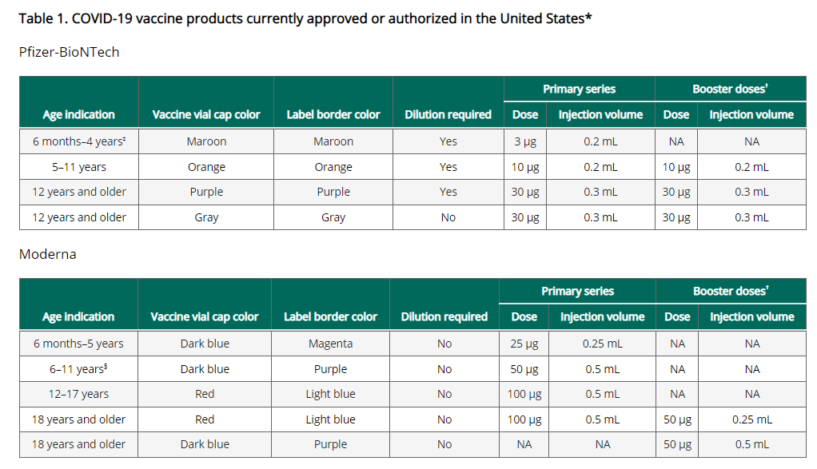
Please note this footnote: †For people ages 5–17 years, Pfizer is currently FDA-authorized for use as a booster dose in people who received Pfizer as their primary series; Moderna is not authorized for use as a booster dose in this age group. For people ages 18 years and older, Pfizer and Moderna can be used as a booster dose. Currently, Novavax is not authorized for booster vaccination.

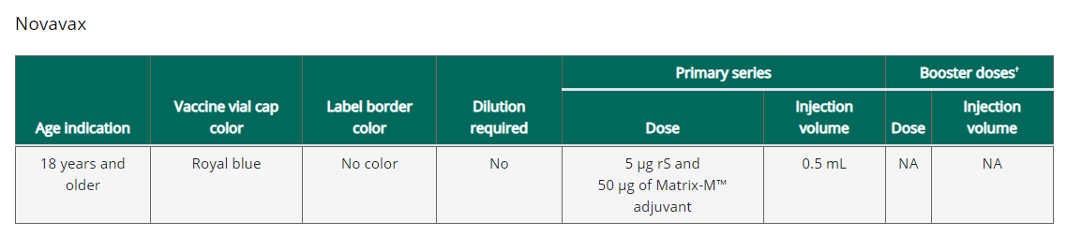

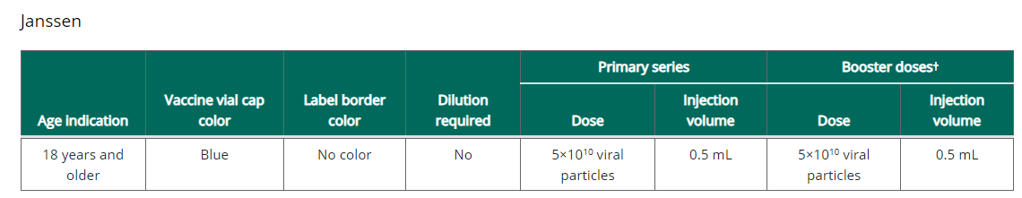
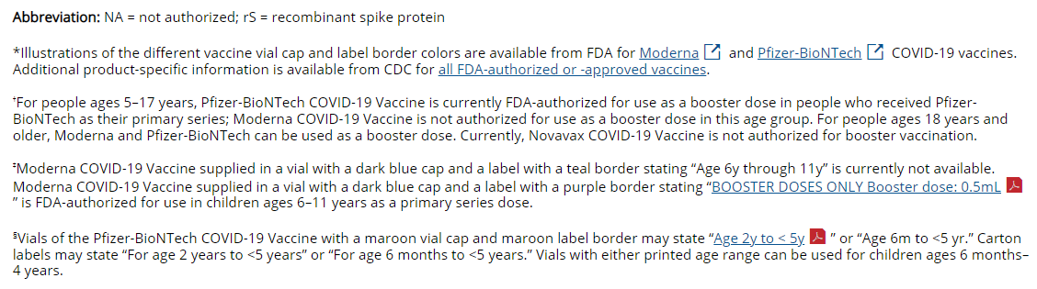

COVID-19 vaccination schedule for people who are NOT moderately or severely immunocompromised
For primary series and booster dose(s), an age-appropriate mRNA vaccine is preferred over the Janssen vaccine. The same mRNA vaccine product should be used for all doses of the primary series (see Interchangeability of COVID-19 vaccine products). All people ages 5 years and older should receive at least 1 booster dose if eligible (i.e., if a booster dose is FDA-approved or FDA-authorized for use in a specified population); an mRNA vaccine must be used for the second booster dose.

While this graphic is a helpful visual, it does not include clinical details necessary for administering COVID-19 vaccines. For clinical detail see the Clinical Considerations and guidance for people who are not immunocompromised

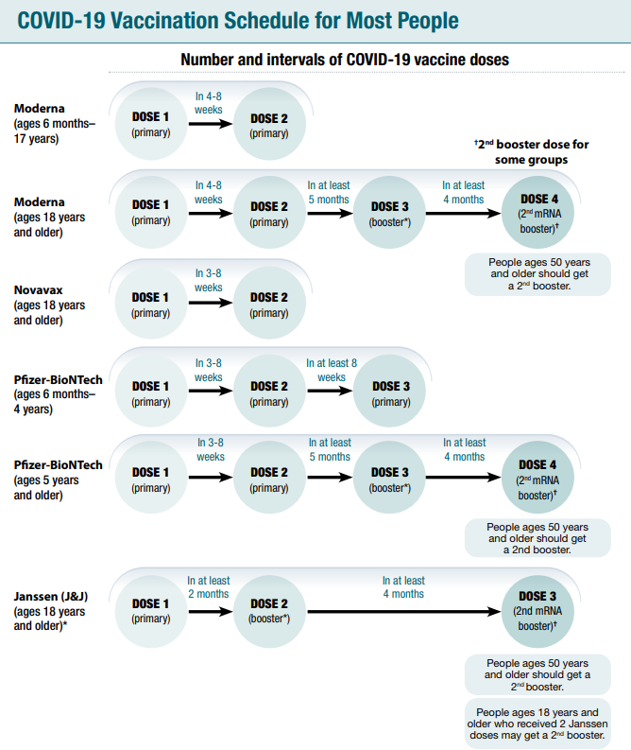

Considerations for intervals for mRNA COVID-19 vaccine primary series
An 8-week interval may be optimal for people who are not moderately or severely immunocompromised and ages 6 months-64 years, especially for males ages 12–39 years COVID-19 vaccines are FDA-approved or FDA-authorized for a 3-week (Pfizer-BioNTech vaccine) or 4-week (Moderna vaccine) interval between the first and second dose. A 3- or 4-week interval continues to be the recommended interval for people who are moderately or severely immunocompromised, adults ages 65 years and older, and in situations when the fullest possible protection needs to be achieved sooner (e.g., increased concern about COVID-19 community levels or an individual’s higher risk for severe disease).

mRNA COVID-19 vaccines are safe and effective at the FDA-approved or FDA-authorized intervals, but a longer interval may be considered for some populations. While absolute risk remains small, the risk for myocarditis is higher for males ages 12-39 years, and this risk might be reduced by extending the interval between the first and second dose. Some studies in adolescents (ages 12-17 years) and adults have shown the small risk of myocarditis associated with mRNA COVID-19 vaccines might be reduced and peak antibody responses and vaccine effectiveness may be increased with an interval longer than 4 weeks. Extending the interval beyond 8 weeks has not been shown to provide additional benefit. In summary, an 8-week interval may be optimal for people who are not moderately or severely immunocompromised and ages 6 months-64 years, especially for males ages 12–39 years.

Transitioning from a younger to older age group
CDC recommends vaccine recipients receive the recommended age-appropriate vaccine product and dosage based on their age on the day of vaccination. If a person moves from a younger age group to an older age group, once they qualify for the older age formulation they should receive the vaccine product and dosage for the older age group.

FDA authorization does allow for dosing options for certain age transitions. These options are considered acceptable, as opposed to recommended. Since these options are acceptable, they are not considered vaccine administration errors and do not need to be reported to VAERS. For more detail see the Pfizer-BioNTech COVID-19 Vaccine for Children who Transition from a Younger to Older Age Group and the Moderna COVID-19 Vaccine for Children who Transition from a Younger to Older Age Group, and the Clinical Considerations.

COVID-19 vaccination schedule for people who ARE moderately or severely immunocompromised
People with immunocompromising conditions or people who take immunosuppressive medications or therapies are at increased risk for severe COVID-19. Because the immune response following COVID-19 vaccination may differ in people who are moderately or severely immunocompromised at the time of vaccination, specific guidance for this population is provided.

People who are or who become moderately or severely immunocompromised should follow the COVID-19 vaccination schedule according to their age and immune status at the time of eligibility for doses. For example, people who become moderately or severely immunocompromised after completing a 2-dose mRNA or single-dose Janssen COVID-19 Vaccine primary series do not need additional primary doses; however, they should follow the schedule for people who are moderately or severely immunocompromised for booster doses.
While this graphic is a helpful visual, it does not include clinical details necessary for administering COVID-19 vaccines. For clinical detail see the Clinical Considerations and guidance for people who are immunocompromised.

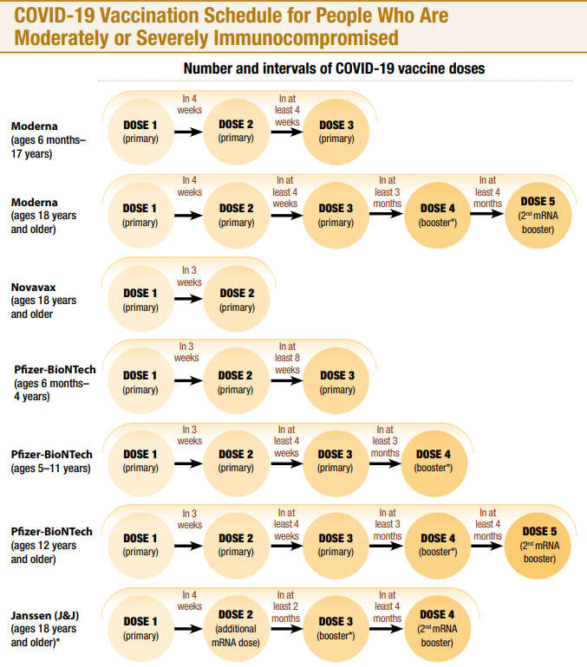

CDC interactive tool for the public to assess need for first or second booster doses of COVID-19 vaccine
CDC has an interactive tool to help users identify whether they (or someone else) need to receive a booster dose of COVID-19 vaccine. The “Find Out When You Can Get Your Booster” tool asks a series of simple questions about age, immunocompromise, number and type of previous doses of COVID-19 vaccines, and how long ago they received the most recent vaccination. From these answers, the tool reports whether a first or second booster dose may be beneficial and presents considerations for when to receive it. Find the tool here.

Watch for Expired Vaccine
Providers should make it a practice to regularly check inventory for expired vaccine and immediately remove expired inventory to prevent it from being administered.
Vaccine Expiration Date Lookup & Reference Information:
- Novavax Expiry Date Checker
- Expiry Information for Pfizer COVID-19 Vaccines
- Moderna Vial Expiration Date Look-up Tool
- Janssen Expiration Date Lookup Tool

EUA Fact Sheets
Once a new EUA Fact Sheet is issued, it must be used. Previous ones no longer contain accurate information.

Novavax EUAs
- Novavax, HCP: https://www.fda.gov/media/159897/download
- Novavax, Recipient: https://www.fda.gov/media/159898/download

Pfizer EUAs
- Pfizer, HCP, 6 months through 4 years, maroon cap (must dilute):https://www.fda.gov/media/159312/download
- Pfizer, HCP-Dear Healthcare Provider Letter, 6 months through 4 years, maroon cap (must dilute): https://www.fda.gov/media/159303/download
- Pfizer, Recipient, 6 months through 4 years of age: https://www.fda.gov/media/159313/download
- Pfizer, HCP, 12 years of age and older, purple cap (must dilute): https://www.fda.gov/media/153713/download
- Pfizer, HCP, 12 years of age and older, gray cap (no dilution): https://www.fda.gov/media/153715/download
- Pfizer, HCP, 5 - 11 years of age, orange cap (must dilute): https://www.fda.gov/media/153714/download
- Pfizer, Recipient, 12 years of age and older: https://www.fda.gov/media/153716/download
Pfizer, Recipient, 5-11 years: https://www.fda.gov/media/153717/download

Moderna EUAs
- Moderna, HCP, 6 months through 5 years of age (magenta border): https://www.fda.gov/media/159307/download
- Moderna, Recipient, 6 months through 5 years of age (magenta border): https://www.fda.gov/media/159309/download
- Moderna, HCP, 6 years through 11 years of age (teal & purple border): https://www.fda.gov/media/159308/download
- Moderna, HCP-Dear Healthcare Provider Letter, 6 years through 11 years of age (teal & purple border): https://www.fda.gov/media/159305/download
- Moderna, Recipient, 6 years through 11 years of age (teal & purple border): https://www.fda.gov/media/159310/download
- Moderna, HCP, 12 years and older and booster doses for 18 years and older (light blue border): https://www.fda.gov/media/157233/download
- Moderna, Recipient, 12 years and older (black border): https://www.fda.gov/media/144638/download
- Moderna, HCP, 18 years and older booster dose presentation only (purple border): https://www.fda.gov/media/157232/download

Janssen EUAs
- Janssen, HCP: https://www.fda.gov/media/146304/download
- Janssen, Recipient: https://www.fda.gov/media/146305/download
RESOURCES & LEARNING OPPORTUNITIES

Pfizer COVID-19 Vaccine Medical Updates on Current & Immunization Site Training
Pfizer Vaccines US Medical Affairs continues to host frequent Medical Updates & Immunization Site Training for All Providers. Session topics include:
- Use of vaccine for Children 6 months and older
- Storage, Handling, Preparation, & Administration for the multiple presentations of the vaccine
- Recent medical updates regarding the vaccine
- An overview of healthcare provider resources
- Question and answer session
To access the training sessions, please visit: https://www.pfizermedicalinformation.com/en-us/medical-updates

COVID-19 Vaccine Training Modules
CDC’s four training modules (General Overview, Pfizer, Moderna, Janssen) can be found here.

COVID-19 Vaccine Webinar Series
CDC is offering a series of brief (15-20 minute) webinars addressing topics around COVID-19 vaccination. These interactive, web-based training modules offer a real-world perspective on different issues around COVID-19 vaccines. Topics range from routine clinical and vaccine safety information to guidance for on-site clinic vaccination activities and having conversations with vaccine recipients. Each webinar includes self-test practice questions and lists additional resources related to the topic discussed. The landing page for all mini webinars is here: https://www.cdc.gov/vaccines/covid-19/training-education/webinars.html

Morbidity and Mortality Weekly Report, better known as MMWR, is CDC’s primary publication for disseminating the science it produces. The staff at MMWR have launched a landing page to help people find the latest information on COVID-19 vaccine effectiveness and safety.

Recent CDC MMWRs
August 11, 2022 (Early Release)
- Summary of Guidance for Minimizing the Impact of COVID-19 on Individual Persons, Communities, and Health Care Systems — United States, August 2022

August 12, 2022
- COVID-19 Self-Test Data: Challenges and Opportunities — United States, October 31, 2021–June 11, 2022

- Notes from the Field: School-Based and Laboratory-Based Reporting of Positive COVID-19 Test Results Among School-Aged Children — New York, September 11, 2021–April 29, 2022

August 5, 2022
- Interim Recommendation of the Advisory Committee on Immunization Practices for Use of the Novavax COVID-19 Vaccine in Persons Aged ≥18 years — United States, July 2022

- Post–COVID-19 Symptoms and Conditions Among Children and Adolescents — United States, March 1, 2020–January 31, 2022

- Notes from the Field: Increase in Pediatric Intracranial Infections During the COVID-19 Pandemic — Eight Pediatric Hospitals, United States, March 2020–March 2022

MDPH RESOURCES

Massachusetts Resources
- COVID-19 vaccinations for children ages 6 months to 4 years old
- COVID-19 vaccinations for children ages 5-11
- COVID-19 vaccinations for people ages 12-17
- COVID-19 Vaccine Information
- COVID-19 booster information and booster frequently asked questions
- Search for Vaccine locations: https://vaxfinder.mass.gov/
- COVID-19 Vaccine Resource Line/2-1-1 is available for individuals who are unable to use Vaxfinder, or have difficulty accessing the internet. Available in English and Spanish and has translators available in approximately 100 additional languages.
- COVID-19 Vaccine Training and Education Resources for Providers: https://www.mass.gov/info-details/covid-19-vaccine-training-and-education-resources-for-providers
- Multilingual COVID-19 Materials. Resources related to Coronavirus Disease 2019 (COVID-19) in multiple languages. Includes videos and printables on topics like vaccine safety, pregnancy and the vaccine, and FAQs.

Immunization Division Main Number
For questions about immunization recommendations, disease reporting, etc.
Phone: 617-983-6800 (24/7 MDPH Epi line)
Fax: 617-983-6840
Website: https://www.mass.gov/topics/immunization

MIIS Help Desk
Phone: 617-983-4335
Fax: 857-323-8321
Email questions to: miishelpdesk@mass.gov
Website: https://www.mass.gov/massachusetts-immunization-information-system-miis

MDPH Vaccine Unit
Phone: 617-983-6828
Email questions to: dph-vaccine-management@mass.gov
Website: https://www.mass.gov/service-details/vaccine-management

COVID-19 Email Box
Email questions to: COVID-19-Vaccine-Plan-MA@mass.gov

