

BULLETIN
What Massachusetts COVID-19 Vaccine Providers Need to Know
Week of 9/28/2022

LATEST NUMBERS

- As of 9/28/2022 5,469,085 people in Massachusetts have been fully vaccinated.

WHO TO VACCINATE

Everyone ages 6 months and older should receive a COVID-19 primary series vaccination for the prevention of COVID-19. Monovalent mRNA vaccines (i.e., Moderna and Pfizer) and Novavax Vaccine are recommended.

Children ages 5-11 years are recommended to receive 1 monovalent mRNA booster dose if eligible.

Everyone ages 12 years and older is recommended to receive 1 age-appropriate bivalent mRNA booster dose regardless of primary series product and number of monovalent booster doses previously received.

The recommended schedule and use of each COVID-19 vaccine product approved under BLA or authorized under EUA varies by the age and immune status of the recipient. There are two vaccination schedules: one for people who are not moderately or severely immunocompromised and one for people who are moderately or severely immunocompromised.

Vaccination providers should ensure the correct age-appropriate product is administered based on the recipient’s age on the day of vaccination (Table 1). Vaccine doses should be administered by the intramuscular route and in accordance with the recommended intervals for that age group. For guidance on timing of vaccination in specific situations, see Transitioning from a younger to older age group, Considerations for extended intervals for COVID-19 vaccine primary series doses, and COVID-19 vaccination and SARS-CoV-2-infection.

See Appendices B (People who received COVID-19 vaccine outside the United States) and C (People who received COVID-19 vaccine as part of a clinical trial) for recommendations for these populations.

QUESTION OF THE WEEK

Q: A person already received 2 previously recommended monovalent booster doses. Can the person get a bivalent booster dose?
A: Yes. Everyone ages 12 and older who completed a primary series is recommended to receive 1 bivalent booster dose regardless of previous booster dose history. For people who previously received 1 or more monovalent booster doses, the bivalent booster dose should be administered at least 2 months after the last monovalent booster dose.

BIVALENT VACCINE SUPPLY

NEW Bivalent Moderna COVID-19 Vaccine is Now Available for Ordering Again

The federal government has reopened bivalent Moderna COVID-19 vaccine ordering, which has been turned back on in the MIIS. Please note that supplies of Moderna vaccine may still be limited in the coming weeks so providers are instructed to only order a 1-2 week supply of vaccine at a time. Providers remain able to order vaccine on a weekly basis and supplies of the bivalent Pfizer vaccine are still sufficient to supplement your Moderna inventories. Providers should not schedule appointments beyond their vaccine on-hand in order to ensure all appointments are fulfilled.

For those who vaccinate pediatric populations, please also keep in mind that in the coming weeks the FDA may authorize the Moderna bivalent vaccine for use in individuals ages 6-17. If they do, the same formulation that is currently available for order will likely be authorized for use with those 6-11 years of age, at a half-dose volume. See below for additional information about Moderna COVID-19 vaccine storage and handling.

Moderna COVID-19 vaccines
- NO ULTRA-COLD FREEZER STORAGE
- Freezer storage (-50°C to -15°C) until expiry
- Refrigerate (2°C to 8°C) up to 30 days without puncturing
- Moderna bivalent COVID-19 vaccine is packaged in 5-dose vials in cartons of 10 vials each (50 doses total), with a minimum order quantity of 100 doses
- The same vial (dark blue cap, gray border) and presentation for Moderna bivalent is expected to be used for all authorized age groups (people ages 6 years and older), but volume and dosage expected to differ by age:
  - Adolescents ages 12-17 years: same volume and dosage as for adults ages 18 years and older
  - Children ages 6-11 years: half the volume and dosage as for adults ages 18 years and older (drawn from the same vial). i.e., one vial yields double the number of doses when used for 6–11-year-olds as when used for people ages 12 years and older
- Moderna bivalent COVID-19 vaccine does not require diluent
- Once punctured, each vial must be used within 12 hours.

NEW Pre-ordering Bivalent Pfizer-BioNTech COVID-19 Vaccine Booster Doses for Ages 5-11, began on Monday September 26, 2022

In anticipation of FDA authorization for bivalent boosters for the 5-11 age groups, CDC is opened pre-ordering of the new bivalent Pfizer-BioNTech vaccine for children ages 5-11 years began on Monday, September 26.

The following are the storage and handing requirements for the Pfizer-BioNTech bivalent COVID-19 vaccine for children ages 5-11 years:
- Ultra-cold freezer storage (-90°C to -60°C) until expiry
- NO FREEZER STORAGE
- Refrigerate (2°C to 8°C) up to 10 weeks without puncturing
- Packaged in 10-dose vials in cartons of 10 vials each (100 doses total)
- Requires diluent (note: awardees will not be able to opt out of receiving ancillary kits)
- Minimum order quantity of 100 doses
- Vial with an orange cap similar to the existing Pfizer-BioNTech product for this age group, but with a label that identifies it as a bivalent booster
- Once punctured, each vial must be used within 12 hours.

Pre-orders for the bivalent Pfizer-BioNTech vaccine for children ages 5-11 years must be placed no later than 9 AM on Monday, October 3rd. Please note that delivery of vaccine could begin as early as October 8th so if you place a pre-order for vaccine it is important that your site is open, and staff are available to accept vaccine shipment on the October 10th holiday.

Please note that pre-orders are not a guarantee you will receive the doses requested. Your final pre-order amount may be reduced based on overall supply and demand, and provider type requesting vaccine (priority will be given to primary care providers, CHCs and hospitals).

If you need assistance or have questions, please contact the Massachusetts Department of Public Health Vaccine Management Unit at 617-983-6828.

Ample Supplies of Pfizer COVID-19 Vaccine Availability
There continues to be ample supply of bivalent Pfizer COVID vaccines. We encourage all health care providers to begin vaccinating in your practices and hosting clinics. Sites with doses on hand that are not actively vaccinating may be prevented from ordering additional supply and may have vaccine on hand transferred to another site. You can order up to a two week supply of vaccine and order as often as needed.

To project your vaccine needs, consider the following:
- What is the patient population your clinic is serving, i.e., workforce or a public clinic
- What is your staff capacity for vaccination each day/week
- What is your storage capacity to store doses
- How many doses do you need for the next two weeks

As reminder, provider sites can order above the ceiling limit posted in the MIIS. A pop-up warning will appear; click okay to bypass the warning. It will move you to the next screen to review and confirm the shipping information; click okay. The order worklist will appear on the next screen. Please check the order status on the worklist. Ensure your order is in ‘Submitted to State’ status. Orders will be processed by Vaccine Unit staff within 24-48 hours. Once approved, orders are submitted to CDC the next morning before 9 AM. Once orders are submitted to CDC, orders cannot be canceled or modified.

To ensure there are no issues or delay with your vaccine order:
- Report administered doses to the MIIS
- Review your inventory and process a storage and handling issue in the MIIS for expired or wasted vaccines.

Providers are strongly encouraged to offer flu vaccine in conjunction with bivalent booster doses.

If you have any questions or need assistance with placing a bivalent Pfizer COVID vaccine booster, please call the Vaccine Management Unit at 617-983-6828 or email at dph-vaccine-managment@mass.gov.

WHAT TO KNOW THIS WEEK

Authorization and endorsement of updated, bivalent boosters
On August 31, 2022, the FDA authorized both Moderna and Pfizer bivalent boosters.
On September 1, 2022, ACIP met and made recommendations for use of the bivalent boosters. These recommendations were endorsed a short time later by CDC Director Rochelle Walensky.

- Individuals ages 12 years and older, including those who are moderately or severely immunocompromised, are recommended to receive 1 dose of the updated/bivalent vaccine at least two months after receipt of a primary series or prior monovalent booster dose.
- Either Pfizer bivalent vaccine (12 years and older) or Moderna bivalent vaccine (18 years and older) can be used based on the patient's age at time of administration.
- ACIP repealed its previous recommendations for administration of monovalent vaccine boosters for persons ages 12 years and older. The new bivalent booster recommendation replaces previous booster recommendations for this age group. With the FDA approval of the updated boosters, the original COVID-19 vaccines are no longer approved as boosters for people ages 12 years and older.
- For children five through 11 years, the previous ACIP recommendation remains unchanged, and a monovalent booster continues to be recommended.

Updated COVID-19 boosters add Omicron BA.4 and BA.5 spike protein components to the current vaccine composition, helping to restore protection that has waned since previous vaccination by targeting variants that are more transmissible and immune-evading.

In the coming weeks, CDC also expects to recommend updated COVID-19 boosters for other pediatric groups. When data are available and FDA authorizes these other types of COVID-19 boosters, CDC will quickly move to help make them available in the United States.

The new vaccines will have the same storage and handling parameters as the original vaccine products.

Pfizer-BioNTech COVID-19 Vaccines
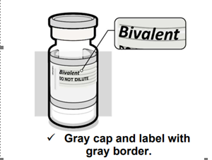 | - Ultra-cold freezer storage (-90°C to -60°C) until expiry  - NO FREEZER STORAGE  - Refrigerate (2°C to 8°C) up to 10 weeks without puncturing  - Note that it says “Bivalent” on the label

Moderna COVID-19 Vaccines
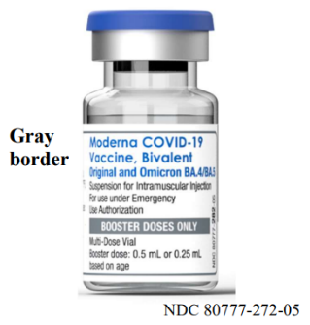 | - NO ULTRA-COLD FREEZER STORAGE  - Freezer storage (-25°C to -15°C) until expiry  - Refrigerate (2°C to 8°C) up to 30 days without puncturing  - Note that it says “Bivalent” on the label

CDC has streamlined what it means to be “up to date” with COVID-19 vaccines.
With the arrival of updated boosters, CDC is reframing what it means to be up to date with COVID-19 vaccination. You are up to date if you have completed a primary series and received the most recent booster dose recommended for you by CDC.

Four COVID-19 vaccines are currently approved under a BLA or authorized under an EUA by the FDA:
The following COVID-19 vaccines, categorized into three vaccine types, are currently approved under a BLA or authorized under an EUA by the U.S. FDA:
- mRNA vaccines
  - Moderna COVID-19 Vaccine/SPIKEVAX and Moderna COVID-19 Vaccine, Bivalent
  - Pfizer-BioNTech COVID-19 Vaccine/COMIRNATY and Pfizer-BioNTech COVID-19 Vaccine, Bivalent
- Protein subunit vaccine
  - Novavax COVID-19 Vaccine, Adjuvanted
- Adenovirus vector vaccine
  - Janssen (Johnson & Johnson) COVID-19 Vaccine

None of the currently FDA-approved or FDA-authorized COVID-19 vaccines are live-virus vaccines.
For primary series vaccination, three monovalent COVID-19 vaccines (listed in alphabetical order by manufacturer), are recommended: Moderna, Novavax, and Pfizer. Bivalent mRNA vaccines are not authorized or approved at this time for primary series doses.
For booster vaccination, Moderna and Pfizer are recommended. A person’s eligibility for booster vaccination and the appropriate mRNA booster dose product to use (i.e., monovalent or bivalent) depends on age and primary series product.
Janssen COVID-19 Vaccine is authorized for adults ages 18 years and older in certain limited situations due to safety considerations (see Appendix A).
COVID-19 vaccine formulations currently approved or authorized in the United States
This table is page 1 of the 5-page Summary Document for Interim Clinical Considerations
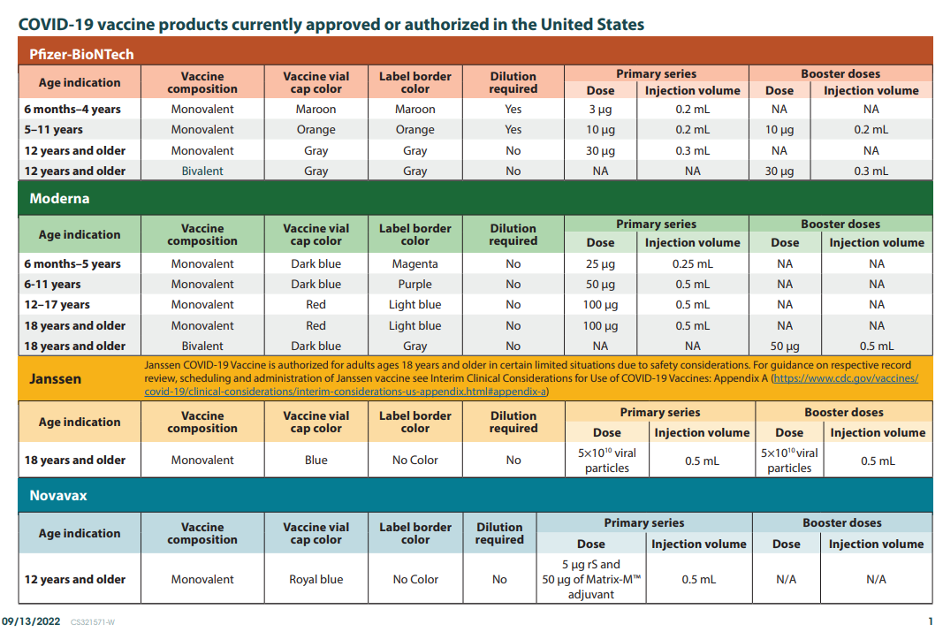

Vaccines Formulations Available for Ordering

COVID Vaccine Available for ordering in the MIIS
All providers enrolled Massachusetts COVID-19 Vaccine Program (MCVP) are able to place routine orders for all of the following COVID-19 vaccine formulations through the Massachusetts Immunization Information System (MIIS).
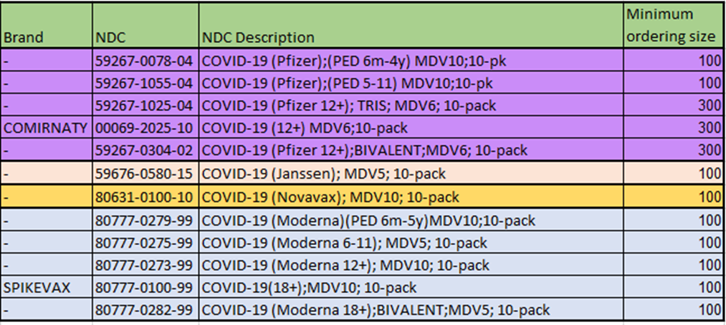

- Initial shipments of the Pfizer-BioNTech vaccine for children aged 6m–4 years may state “2y to <5y” or “6m to <5y” on the vial or carton labels. Please note that vials or cartons with labels that state “2y to <5y” can be used for children aged 6m through 4 years.
- Pfizer-BioNTech vaccine vial labels and cartons may also state that a vial should be discarded 6 hours after the first dilution however as stated in the EUA Fact Sheet the timeframe for use post-dilution is actually 12 hours just like orange and gray cap Pfizer vaccine formulations.

*Please Note: For pediatric practices that are currently not supplying the Pfizer 5-11 year old formulation due to logistical challenges please consider supplying the new Moderna 6-11 year old formulation as it comes in only 5 dose vials, requires no reconstitution, and can be stored in a standard freezer until expiration.

Reminder Expiry Date vs Beyond Use Date (BUD)
The expiration date is set by the manufacturer and is the date by which the vaccine should be used. The expiration date assumes that the vaccine has been stored and handled according to the manufacturer’s guidance. Expiration dates cannot change based on how vaccine is being stored or when a vial is punctured. However, on occasion, the expiration date may be updated by the manufacturer as additional stability data become available.

Beyond Use Date (BUD) is the date of when the vaccine can no longer be used due to a change in storage temperature, reconstitution, puncturing the vial, etc. It is recommended to place a label with the BUD and the initials of the person making the calculation whenever a vaccine vial or box is moved to a different temperature storage unit, reconstituted, or had a vial punctured resulting in a chance in the BUD.

You can find BUD guidance and labels for Moderna, Novavax, Janssen, and Pfizer from the CDC’s U.S. COVID-19 Vaccine Product Information webpage.

Process a storage and handling problem in the MIIS for any expired or wasted vaccines.

Watch for Expired Vaccine
Providers should make it a practice to regularly check inventory for expired vaccine and immediately remove expired inventory to prevent it from being administered.
Vaccine Expiration Date Lookup & Reference Information:
- Novavax Expiry Date Checker
- Pfizer COVID-19 Vaccine Expiry Website
- Moderna Vial Expiration Date Look-up Tool
- Janssen Expiration Date Lookup Tool

Helpful Reference Materials
- At-A-Glance COVID-19 Vaccination Schedule (updated 9/6/2022)
A helpful pdf showing a graphic of the COVID-19 vaccine recommendations based on
primary series product, age, and immune status.
- Summary Document for Interim Clinical Considerations (Updated 9/13/2022)
- Interim COVID-19 Immunization Schedule (Updated 9/7/2022)
- AAP’s Pediatric COVID-19 Vaccine Dosing Quick Reference Guide (updated Sept 2022)
- Moderna COVID-19 Vaccine for Children who Transition from a Younger to Older Age Group
- Pfizer-BioNTech for Children who Transition from a Younger to Older Age Group
- Vaccine administration errors and deviations (Appendix D)
- FAQs for the Interim Clinical Considerations
- COVID-19 vaccination and SARS-CoV-2 infection
- People who received COVID-19 vaccine outside the United States (Appendix B)
- People who received COVID-19 vaccine as part of a clinical trial (Appendix C)
- Triage of people with a history of allergies or allergic reactions (Appendix E)

Standing Orders
- Novavax (updated 9/7/2022)
https://www.cdc.gov/vaccines/covid-19/info-by-product/novavax/downloads/novavax-standing-orders.pdf

- CDC’s Moderna COVID-19 Vaccine info (including the standing orders below)
https://www.cdc.gov/vaccines/covid-19/info-by-product/moderna/index.html
- Moderna Blue cap with magenta bordered label – 6 months through 5 years of age
https://www.cdc.gov/vaccines/covid-19/info-by-product/moderna/downloads/infant_standing-orders.pdf
- Moderna Blue cap with purple-bordered label – 6 through 11 years of age
https://www.cdc.gov/vaccines/covid-19/info-by-product/moderna/downloads/6-11-standing-orders.pdf
- Moderna Red cap with blue-bordered label – 12 through 17 years of age
https://www.cdc.gov/vaccines/covid-19/info-by-product/moderna/downloads/12-17-standing-orders.pdf
- Moderna, Monovalent and Bivalent– 18 years of age and older (updated 9/22/2022)
https://www.cdc.gov/vaccines/covid-19/info-by-product/moderna/downloads/standing-orders.pdf

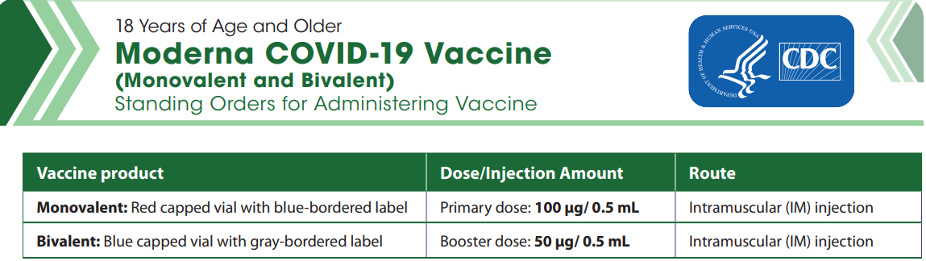

- CDC’s Pfizer COVID-19 Vaccine info (including the standing orders below)
https://www.cdc.gov/vaccines/covid-19/info-by-product/pfizer/index.html
- Pfizer Maroon Cap: 6 months through 4 years of age
https://www.cdc.gov/vaccines/covid-19/info-by-product/pfizer/downloads/infant-standing-orders.pdf
- Pfizer Orange Cap: 5 through 11 years of age (updated 5/24/2022)
https://www.cdc.gov/vaccines/covid-19/info-by-product/pfizer/downloads/Pfizer_PED_StandingOrders.pdf
- Pfizer Gray Cap, Monovalent and Bivalent: 12 years of age and older (updated 9/12/2022)
https://www.cdc.gov/vaccines/covid-19/info-by-product/pfizer/downloads/gray-cap-Pfizer-BioNTech-standing-orders.pdf

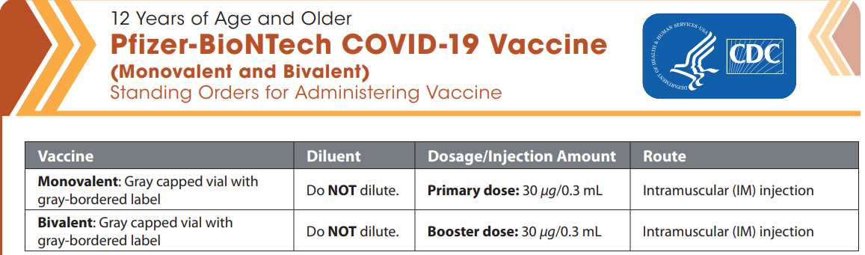

Preparations and Administration Summaries
- Novavax https://www.cdc.gov/vaccines/covid-19/info-by-product/novavax/downloads/novavax-prep-admin-summary.pdf
- Pfizer https://www.cdc.gov/vaccines/covid-19/info-by-product/pfizer/downloads/vaccine-at-a-glance.pdf
- Moderna https://www.cdc.gov/vaccines/covid-19/info-by-product/moderna/downloads/vaccine-at-a-glance.pdf

Information for parents and caregivers:
- Stay Up to Date with COVID-19 Vaccines Including Boosters| CDC
- Frequently Asked Questions about COVID-19 Vaccination in Children | CDC
- 6 Things to Know about COVID-19 Vaccination for Children | CDC
- V-safe After Vaccination Health Checker | CDC
- COVID-19 Vaccine: Frequently Asked Questions | American Academy of Pediatrics
- COVID-19 Vaccination for Children and Teens with Disabilities CDC

COVID-19 vaccination schedule for people who are NOT moderately or severely immunocompromised
For primary series vaccination, Moderna, Novavax, and Pfizer COVID-19 vaccines are recommended; only monovalent vaccines are approved or authorized for primary series doses. The same vaccine product should be used for all doses of the primary series (see Interchangeability of COVID-19 vaccine products).

For booster vaccination, Moderna and Pfizer are recommended. Recommendations vary based on age and primary series product. People ages 12 years and older are recommended to receive 1 age-appropriate bivalent mRNA booster dose after completion of any FDA-approved or FDA-authorized monovalent primary series or previously received monovalent booster dose(s). This new booster recommendation replaces all prior booster recommendations for this age group. Monovalent mRNA vaccines are no longer authorized as a booster dose for people ages 12 years and older.

Children ages 5–11 years are recommended to receive 1 monovalent mRNA booster dose if eligible (i.e., if a booster dose is FDA-authorized for use in a specified population).

While this graphic is a helpful visual, it does not include clinical details necessary for administering COVID-19 vaccines. For clinical detail see the Clinical Considerations and guidance for people who are not immunocompromised

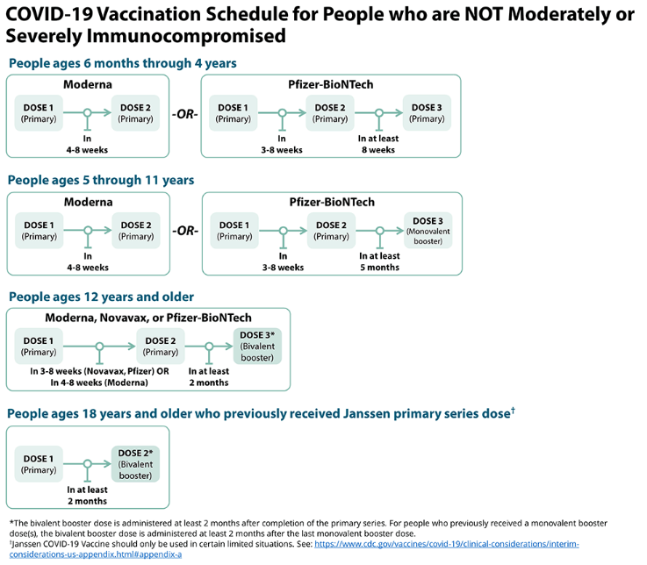

Considerations for intervals for mRNA COVID-19 vaccine primary series
An 8-week interval may be optimal for people who are not moderately or severely immunocompromised and ages 6 months-64 years, especially for males ages 12–39 years. COVID-19 vaccines are FDA-approved or FDA-authorized for a 3-week (Pfizer vaccine) or 4-week (Moderna vaccine) interval between the first and second dose. A 3- or 4-week interval continues to be the recommended interval for people who are moderately or severely immunocompromised, adults ages 65 years and older, and in situations when the fullest possible protection needs to be achieved sooner (e.g., increased concern about COVID-19 community levels or an individual’s higher risk for severe disease).

mRNA COVID-19 vaccines are safe and effective at the FDA-approved or FDA-authorized intervals, but a longer interval may be considered for some populations. While absolute risk remains small, the risk for myocarditis is higher for males ages 12-39 years, and this risk might be reduced by extending the interval between the first and second dose. Some studies in adolescents (ages 12-17 years) and adults have shown the small risk of myocarditis associated with mRNA COVID-19 vaccines might be reduced and peak antibody responses and vaccine effectiveness may be increased with an interval longer than 4 weeks. Extending the interval beyond 8 weeks has not been shown to provide additional benefit. In summary, an 8-week interval may be optimal for people who are not moderately or severely immunocompromised and ages 6 months-64 years, especially for males ages 12–39 years.

Transitioning from a younger to older age group
CDC recommends vaccine recipients receive the recommended age-appropriate vaccine product and dosage based on their age on the day of vaccination. If a person moves from a younger age group to an older age group, once they qualify for the older age formulation, they should receive the vaccine product and dosage for the older age group.

FDA authorization does allow for dosing options for certain age transitions. These options are considered acceptable, as opposed to recommended. Since these options are acceptable, they are not considered vaccine administration errors and do not need to be reported to VAERS. For more detail see the Pfizer-BioNTech COVID-19 Vaccine for Children who Transition from a Younger to Older Age Group and the Moderna COVID-19 Vaccine for Children who Transition from a Younger to Older Age Group, and the Clinical Considerations.

COVID-19 vaccination schedule for people who ARE moderately or severely immunocompromised
People with immunocompromising conditions or people who take immunosuppressive medications or therapies are at increased risk for severe COVID-19. Because the immune response following COVID-19 vaccination may differ in people who are moderately or severely immunocompromised at the time of vaccination, specific guidance for this population is provided.

For primary series vaccination, Moderna, Novavax, and Pfizer COVID-19 vaccines are recommended; only monovalent vaccines are approved or authorized for primary series doses. The same vaccine product should be used for all doses of the primary series (see Interchangeability of COVID-19 vaccine products).

For booster vaccination, Moderna and Pfizer are recommended. Recommendations vary based on age and primary series product. People ages 12 years and older are recommended to receive 1 age-appropriate bivalent mRNA booster dose after completion of any FDA-approved or FDA-authorized monovalent primary series or previously received monovalent booster dose(s). This new booster recommendation replaces all prior booster recommendations for this age group. Monovalent mRNA vaccines are no longer authorized as a booster dose for people ages 12 years and older.

Children ages 5–11 years are recommended to receive 1 monovalent mRNA booster dose if eligible (i.e., if a booster dose is FDA-authorized for use in a specified population).

People who are or who become moderately or severely immunocompromised should follow the COVID-19 vaccination schedule according to their age and immune status at the time of eligibility for that dose. For example, people who become moderately or severely immunocompromised after completing a 2-dose mRNA primary series do not need additional primary doses; however, they should follow the schedule for people who are moderately or severely immunocompromised for the booster dose. For situations in which diminished vaccine efficacy is anticipated, see Additional considerations for vaccination outside of the FDA and CDC dosing intervals on a case-by-case basis.
While this graphic is a helpful visual, it does not include clinical details necessary for administering COVID-19 vaccines. For clinical detail see the Clinical Considerations and guidance for people who are immunocompromised.

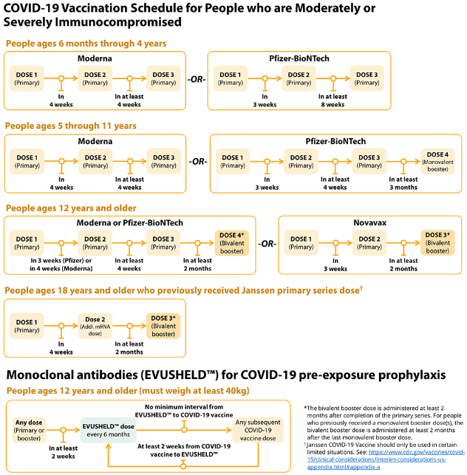

CDC interactive tool for the public to assess if they are eligible for a booster dose of COVID-19 vaccine
CDC has an interactive tool to help users identify whether they (or someone else) need to receive a booster dose of COVID-19 vaccine. The “Find Out When You Can Get Your Booster” tool asks a series of simple questions about age, immunocompromise, number and type of previous doses of COVID-19 vaccines, and how long ago they received the most recent vaccination. From these answers, the tool reports whether a first or second booster dose may be beneficial and presents considerations for when to receive it. Find the tool here.

EUA Fact Sheets
Once a new EUA Fact Sheet is issued, it must be used. Previous ones no longer contain accurate information.

- Novavax EUAs can be found on the FDA website here

- Pfizer EUAs can be found on the FDA website here

- Moderna EUAs can be found on the FDA website here

- Janssen EUAs can be found on the FDA website here

RESOURCES & LEARNING OPPORTUNITIES

Moderna Education Sessions
- 25-minute presentation followed by live Q&A, register here
- Regional Medical Affairs Office Hours, register here

Pfizer COVID-19 Vaccine Medical Updates on Current & Immunization Site Training
Pfizer Vaccines US Medical Affairs continues to host frequent Medical Updates & Immunization Site Training for All Providers. Session topics include:
- Emergency use authorization of the Pfizer-BioNTech COVID-19 Vaccine, Bivalent (Original and Omicron BA.4/BA.5) as a single booster dose for individuals 12 years of age and older
- Use of each currently authorized vaccine presentation, including storage, handling, preparation, and administration
- Question and answer session
To access the training sessions, please visit: https://www.pfizermedicalinformation.com/en-us/medical-updates

Novavax Office Hours
Starting August 31, 2022, Novavax will begin a new series of weekly training webinars. Use this link to see dates and times, and to register: https://novav.ax/officehours

COVID-19 Vaccine Training Modules
CDC’s four training modules (General Overview, Pfizer, Moderna, Janssen) can be found here.

COVID-19 Vaccine Webinar Series
CDC is offering a series of brief (15-20 minute) webinars addressing topics around COVID-19 vaccination. These interactive, web-based training modules offer a real-world perspective on different issues around COVID-19 vaccines. Topics range from routine clinical and vaccine safety information to guidance for on-site clinic vaccination activities and having conversations with vaccine recipients. Each webinar includes self-test practice questions and lists additional resources related to the topic discussed. The landing page for all mini webinars is here: https://www.cdc.gov/vaccines/covid-19/training-education/webinars.html

Morbidity and Mortality Weekly Report, better known as MMWR, is CDC’s primary publication for disseminating the science it produces. The staff at MMWR have launched a landing page to help people find the latest information on COVID-19 vaccine effectiveness and safety.

Recent CDC MMWRs
September 16, 2022
• Mortality Risk Among Patients Hospitalized Primarily for COVID-19 During the Omicron and Delta Variant Pandemic Periods — United States, April 2020–June 2022

MDPH RESOURCES

Massachusetts Resources
- COVID-19 vaccinations for children ages 6 months to 4 years old
- COVID-19 vaccinations for children ages 5-11
- COVID-19 vaccinations for people ages 12-17
- COVID-19 Vaccine Information
- COVID-19 booster information and booster frequently asked questions
- Search for Vaccine locations: https://vaxfinder.mass.gov/
- COVID-19 Vaccine Resource Line/2-1-1 is available for individuals who are unable to use Vaxfinder, or have difficulty accessing the internet. Available in English and Spanish and has translators available in approximately 100 additional languages.
- COVID-19 Vaccine Training and Education Resources for Providers: https://www.mass.gov/info-details/covid-19-vaccine-training-and-education-resources-for-providers
- Multilingual COVID-19 Materials. Resources related to Coronavirus Disease 2019 (COVID-19) in multiple languages. Includes videos and printables on topics like vaccine safety, pregnancy and the vaccine, and FAQs.

Immunization Division Main Number
For questions about immunization recommendations, disease reporting, etc.
Phone: 617-983-6800 (24/7 MDPH Epi line)
Fax: 617-983-6840
Website: https://www.mass.gov/topics/immunization

MIIS Help Desk
Phone: 617-983-4335
Fax: 857-323-8321
Email questions to: miishelpdesk@mass.gov
Website: https://www.mass.gov/massachusetts-immunization-information-system-miis

MDPH Vaccine Unit
Phone: 617-983-6828
Email questions to: dph-vaccine-management@mass.gov
Website: https://www.mass.gov/service-details/vaccine-management

COVID-19 Email Box
Email questions to: COVID-19-Vaccine-Plan-MA@mass.gov

