Highlights from this week’s report:
- Influenza severity for Massachusetts remains high this week.
- The percentage of influenza-like illness visits for Massachusetts has continued to increase and remains higher than the previous two years in the same week.
- Overall influenza-like illness activity for Massachusetts remains high this week. All regions are reporting high ILI activity.
- The percent of influenza-associated hospitalizations in Massachusetts has continued to increase in recent weeks and is consistent with what was seen in the previous year.
- In the 2019-2020 flu season, more influenza B than influenza A positive specimens have been reported by hospitals and outpatient facilities in Massachusetts.
- The number of influenza positive laboratory tests reported to MDPH increased this week by 19% compared to last week. The number of influenza A and influenza B positive laboratory tests reported to MDPH increased by 31% and 12%, respectively, compared to last week.
- All influenza strains that have been characterized in Massachusetts this season to date are covered by the current influenza vaccine.
- Nationally, influenza-like illness activity remains elevated, and approximately equal numbers of influenza A and influenza B have been reported so far this season.
- As of February 1, 2020, there have been eleven confirmed cases of the 2019 novel coronavirus (2019-nCoV) in the U.S. and one case identified in Massachusetts. For the most up to date information on 2019-nCoV please visit https://www.cdc.gov/coronavirus/2019-ncov/index.html.
- Additional statewide and national data including geographic spread, ILI activity, and pneumonia and influenza mortality are available at CDC’s FluView Weekly Report at www.cdc.gov/flu/weekly and FluView Interactive https://www.cdc.gov/flu/weekly/fluviewinteractive.htm.

Flu activity remains elevated. It’s not too late to get vaccinated.
Flu vaccination is always the best way to prevent flu and its potentially serious complications.

Influenza-like illness activity
Influenza-like illness (ILI) is defined as fever above 100F in addition to either cough and/or sore throat. Many more people are infected with influenza than are tested for influenza. ILI is used throughout the regular influenza season as a way to help track influenza activity in individuals who are not tested, as trends in ILI have been shown to mirror influenza trends. Seventy-eight healthcare facilities called ‘sentinel sites’ report the number of patients they see with ILI each week during regular flu season. Sentinel sites include provider offices, school health services, community health centers, urgent care centers, and emergency departments across Massachusetts.

Figure 1 shows that the percentage of ILI visits at sentinel outpatient facilities has continued to increase and remains higher than the previous two years in the same week. For more information, see CDC’s influenza surveillance website at www.cdc.gov/flu/weekly/fluactivitysurv.htm.

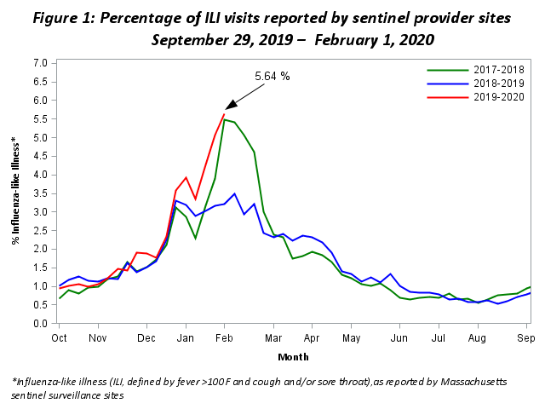
Influenza-associated hospitalizations
As part of the National Syndromic Surveillance Program, MDPH receives data from Emergency Departments (EDs) covering more than 90% of ED visits statewide. These data are used to track patient visits related to influenza by monitoring the reason patients are seeking care (chief complaint) and the diagnoses the patients receive (ICD-10 code). These data are available to MDPH in near real-time.

Figure 2 shows the percent of all ED visits which result in a patient hospitalized because of illness associated with influenza infection. The percentage of influenza-associated hospitalizations has continued to increase in recent weeks and is consistent with what was seen in the previous year.
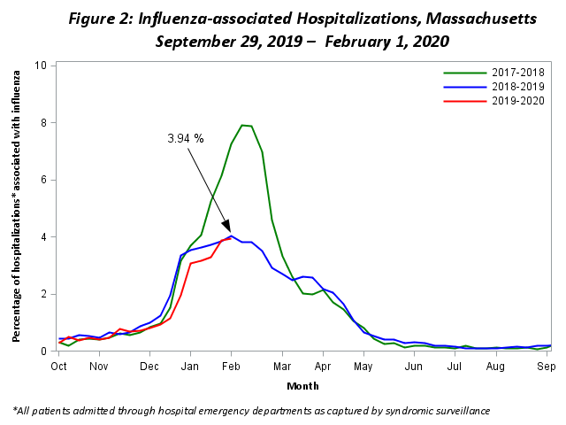

ILI Activity in Massachusetts
Figure 3 shows the current season’s weekly ILI activity compared to the last five flu seasons in Massachusetts. ILI activity for each week is categorized as minimal, low, moderate, or high, with a shade of blue corresponding to the category of ILI activity for that week. Darker shades of blue indicate more intense ILI activity. Figure 3 shows that ILI activity in Massachusetts remains high this week.

Figure 3: ILI Activity in Massachusetts Reported Weekly by Sentinel Sites

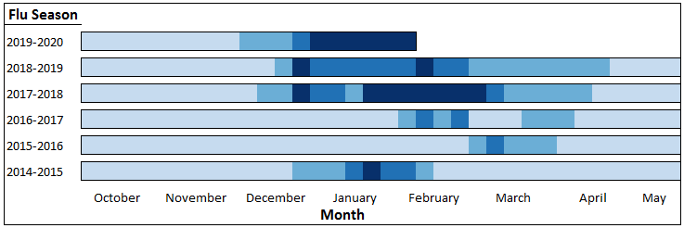
Minimal | Low | Moderate | High

ILI Activity in Massachusetts by Region
Figure 4 shows the relative intensity of reported ILI activity in Massachusetts by region. Although regions may not all experience the same intensity of ILI at similar times, infections due to influenza can be found throughout Massachusetts during flu season. Figure 4 shows that all regions are reporting high ILI activity.

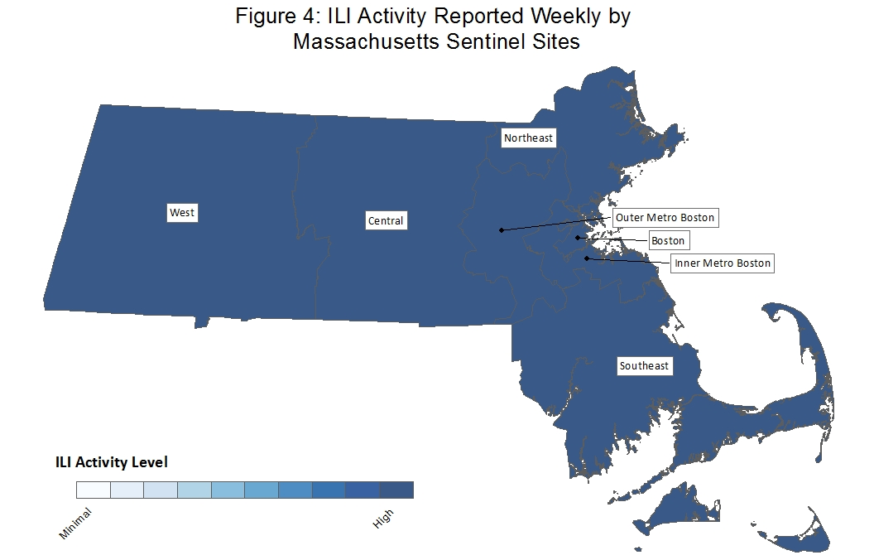

Laboratory testing for influenza
Laboratories in Massachusetts report all positive influenza test results to MDPH. The majority of individuals with influenza-like illness are not tested; therefore the number of positive test results does not reflect the total number of influenza cases in Massachusetts. However, laboratory data do provide information about the types of influenza virus circulating in Massachusetts and help indicate the presence and define the distribution of influenza in the state. Figure 5 illustrates the number of positive laboratory confirmed influenza cases reported by hospitals and outpatient facilities in Massachusetts by week; more influenza B than influenza A positive specimens have been reported and the number of positive specimens for both influenza strains has increased in recent weeks.

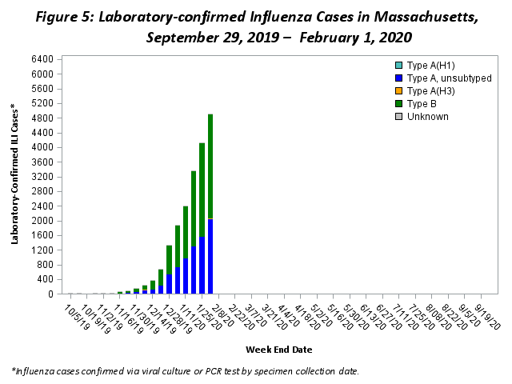

Testing at the State Public Health Laboratory
The Massachusetts State Public Health Laboratory (MA SPHL) performs influenza surveillance testing year round to confirm circulating influenza virus types. Samples are submitted by outpatient healthcare providers (ILINet) and hospital diagnostic laboratories in Massachusetts. For the 2019-2020 season, Table 1 summarizes the influenza surveillance testing conducted by MA SPHL beginning September 29, 2019. In the 2019-2020 flu season, 124 cases of A/H1N1 influenza, 17 cases of A/H3N2 influenza, one case of B/Yamagata influenza, and 252 cases of B/Victoria influenza have been confirmed in 510 samples tested.

Table 1: Weekly Summary of Massachusetts State Public Health Laboratory Influenza Surveillance Test Results
2019-2020 Season: Influenza Surveillance
MA Department of Public Health’s Bureau of Laboratory Sciences (MDPH-BLS)
MMWR Week:  (Specimen Collected) | 2009 H1N1 | seasonal A/H3N2 | H3N2v | B Yam | B Vic | No. Flu Pos (%) | Unsat | Total Tested | Total  Rec’d
02 (01/05 – 01/11/20) | 11 | 1 | 0 | 0 | 30 | 42(82%) | 1 | 51 | 52
03 (01/12 – 01/18/20) | 26 | 1 | 0 | 0 | 44 | 71(83%) | 0 | 86 | 86
04 (01/19 – 01/25/20) | 29 | 2 | 0 | 0 | 52 | 83(89%) | 0 | 93 | 93
05 (01/26 – 02/01/20) | 32 | 2 | 0 | 0 | 50 | 84(88%) | 0 | 96 | 96
Prior 4 wk Total | 98 | 6 | 0 | 0 | 176 | 280(86%) | 1 | 326 | 327
Cumulative Season total | 124 | 17 | 0 | 1 | 252 | 394(77%) | 9 | 510 | 519
All data are subject to change as test results become finalized. The 2019 -2020 influenza season began the week of 09/29- 10/05/2019.

All specimens which test negative for influenza at MA SPHL are also tested for non-influenza respiratory diseases. Table 2 shows that respiratory syncytial virus (RSV), rhinovirus (RHV)/enterovirus (ENT), parainfluenza virus (PIV), human metapneumovirus (HMPV), seasonal human coronavirus (HCV) and adenovirus (ADENO) have been identified this flu season. This contributes to ILI trends in Massachusetts. Massachusetts has one confirmed case of the 2019 novel coronavirus (2019-nCoV) to date.

Table 2: Weekly Summary of Massachusetts State Public Health Laboratory non-Influenza Respiratory Surveillance Test Results
2019-2020 Season: Influenza Like Illness Surveillance
MA Department of Public Health’s Bureau of Laboratory Sciences (MDPH-BLS)
MMWR Week:  (Specimen Collected) | RSV | RHV/ENT | PIV | HMPV | HCV | ADENO | Co-Infection | No. Pos (%) | Unsat | Total Tested | Total  Rec’d
02 (01/05 – 01/11/20) | 0 | 0 | 2 | 1 | 2 | 0 | 0 | 5(56%) | 0 | 9 | 9
03 (01/12 – 01/18/20) | 0 | 1 | 0 | 1 | 4 | 0 | 1 | 5(33%) | 0 | 15 | 15
04 (01/19 – 01/25/20) | 0 | 2 | 0 | 0 | 2 | 1 | 0 | 5(45%) | 0 | 11 | 11
05 (01/26 – 02/01/20) | 2 | 0 | 0 | 0 | 4 | 0 | 0 | 6(50%) | 0 | 12 | 12
Prior 4 wk Total | 2 | 3 | 2 | 2 | 12 | 1 | 1 | 21(45%) | 0 | 47 | 47
Cumulative Season total | 8 | 17 | 3 | 2 | 13 | 3 | 2 | 44(37%) | 0 | 118 | 118
All data are subject to change as test results become finalized. The 2019 -2020 influenza season began the week of 9/29- 10/05/2019.

MA SPHL submits a subset of influenza samples to CDC for further genetic analysis (antigenic characterization). All strains that have been analyzed from Massachusetts this season are covered by the current influenza vaccine.

Every two weeks MA SPHL screens influenza specimens to detect mutations within influenza A/H3N2, A/2009 H1N1, B/Victoria and B/Yamagata viruses to look for antiviral resistance. No mutations have been identified in the 2019-2020 season.

Additional information on national antiviral resistance testing including recommendations for antiviral treatment and chemoprophylaxis of influenza virus infection can be found at http://www.cdc.gov/flu/weekly/.

