Sentinel Provider Surveillance: Influenza-like illness activity
Week 3 Activity (representing geographic distribution): Widespread
Week 3 ILI Activity (representing intensity of ILI activity): 8 (High)
Provider offices across the US report the amount of influenza-like illness (ILI) they see in their patients each week during regular flu season. These outpatient providers’ offices, which include doctors' offices, school health services, community health centers, and emergency departments, are called 'sentinel sites.’ Here we present Massachusetts sentinel site data. Please note that the data represent not only confirmed influenza cases, but also those just with ILI, which may be caused by other viruses. ILI is defined as fever above 100F in addition to either cough or sore throat. ILI is a marker of influenza and is used throughout the regular influenza season to monitor influenza since most people are not tested for influenza. Figure 1 shows that influenza-like illness activity is increasing, consistent with rising activity in other parts of the United States. For more information, see CDC’s influenza surveillance website at www.cdc.gov/flu/weekly/fluactivitysurv.htm.

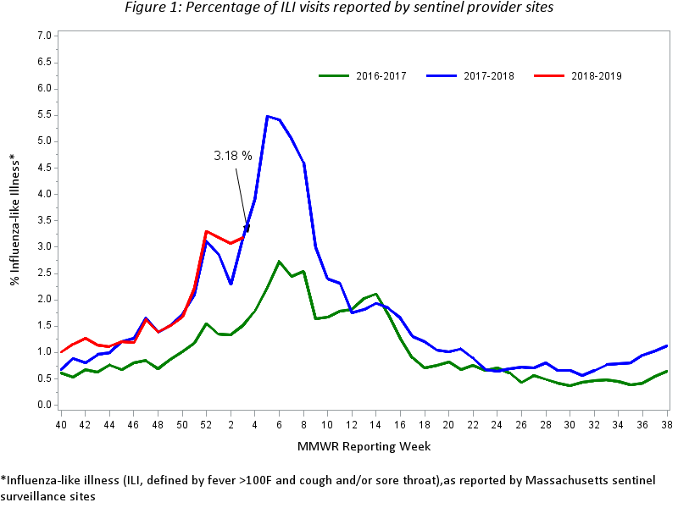
Figure 2 shows the intensity of reported ILI activity in Massachusetts by region. The activity level for each region (and associated color) is in relation to a baseline ILI activity level for that region. Differences in activity may reflect variation in the size and type of patient population served by reporters in that region. Figure 2 shows that all seven regions of the state are reporting increased ILI activity.

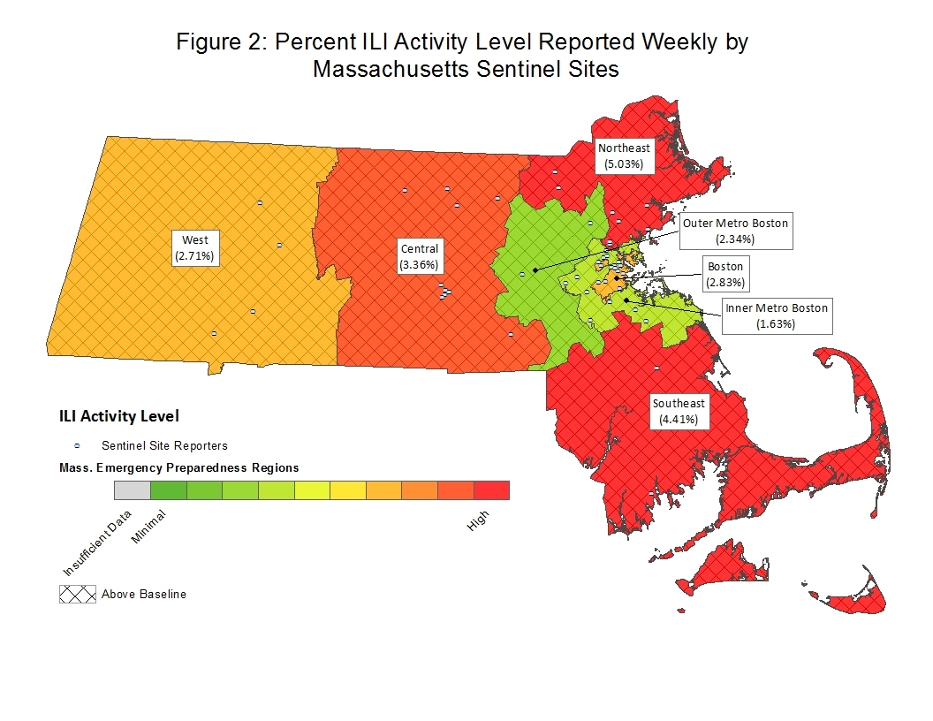
Laboratory testing for influenza
Laboratories in Massachusetts report all positive influenza laboratory tests to the Massachusetts Department of Public Health (MDPH), including viral culture and polymerase chain reaction (PCR). Because the majority of cases are not tested, the number of 'confirmed' cases does not reflect the overall incidence of influenza; however, this information is essential to track the types of influenza circulating in Massachusetts and can be a useful indicator of the presence and distribution of influenza in the state. Table 1 reflects the number of influenza cases confirmed via viral culture or PCR test by region and influenza type. Figure 3 illustrates the number of laboratory confirmed cases in Massachusetts by week, shown along with Massachusetts ILI.

Table 1: Laboratory-confirmed Influenza by Region – 2018-2019 and 2017-2018 Influenza Seasons
 | 2018-2019 |  |  |  | 2017-2018
 | A |  | B |  | A |  | B
Region | Week | YTD | Week | YTD | Week | YTD | Week | YTD
Boston | 147 | 614 | 1 | 14 | 125 | 422 | 24 | 90
Central | 80 | 359 | 1 | 29 | 63 | 169 | 17 | 58
Inner Metro Boston | 177 | 775 | 2 | 8 | 155 | 571 | 23 | 96
Northeast | 344 | 1,593 | 8 | 70 | 206 | 729 | 64 | 258
Outer Metro Boston | 98 | 515 | 4 | 32 | 55 | 177 | 17 | 66
Southeast | 61 | 309 | 0 | 4 | 62 | 239 | 6 | 38
Unknown | 113 | 318 | 0 | 10 | 4 | 18 | 0 | 4
West | 370 | 1,210 | 1 | 9 | 407 | 1,287 | 79 | 231
Total | 1,390 | 5,693 | 17 | 176 | 1,077 | 3,612 | 230 | 841
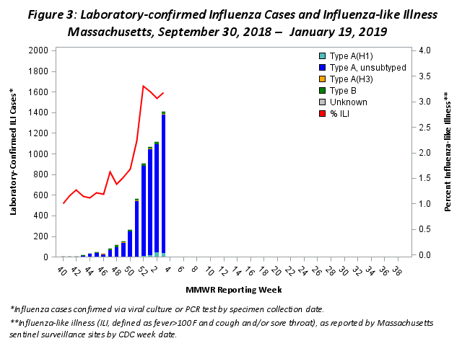
Influenza-Associated Hospitalizations
In 2015, MDPH began to collect emergency department (ED) visit data from hospitals in Massachusetts, as part of the National Syndromic Surveillance Program. MDPH receives data from 55 ED facilities or systems, constituting more than 90% of statewide ED visits captured in near real time. This hospital ED visit data is used to track seasonal influenza trends by monitoring chief complaint and diagnosis code-based syndromes. The graph below shows influenza-associated hospitalizations as a percent of all ED hospitalizations for the current season and previous two seasons.

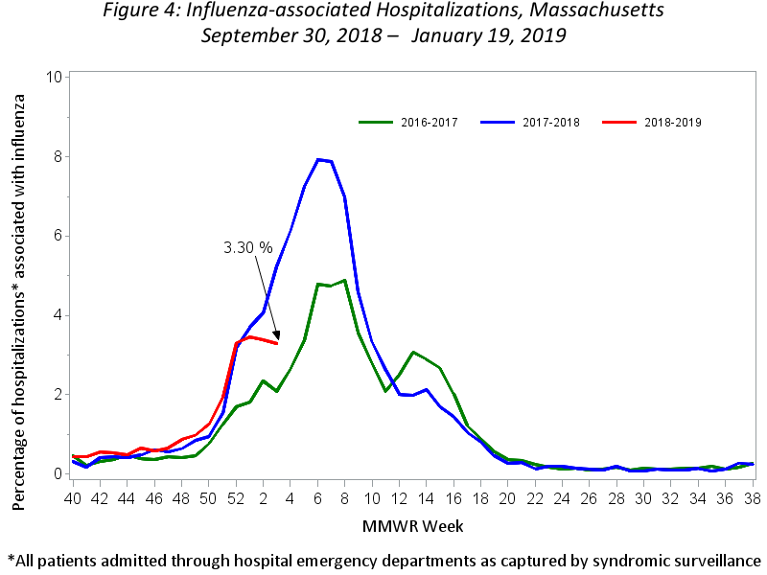
Testing at the State Public Health Laboratory
As part of a more comprehensive respiratory surveillance initiative, MDPH’s Bureau of Infectious Disease and Laboratory Sciences (MDPH-BIDLS) performs testing to confirm typing and subtyping of circulating influenza viruses followed by testing of influenza-negative samples for the evidence of adenovirus, respiratory syncytial virus (RSV) A/B, parainfluenza virus (PIV) types 1-4 , coronavirus (HCoV) HKU1, OC43, NL63, 229E, human metapneumovirus (HMPV), and rhinovirus/enterovirus (RHV/ENT) using a multiplex PCR respiratory viral panel. Samples are submitted by ~60 outpatient healthcare providers (ILINet) and include early influenza positives, as well as specimens and isolates from clinical hospital diagnostic laboratories across Massachusetts. For the 2018-2019 season, Figure 5 and Tables 2 and 3 summarize virologic surveillance testing conducted by MDPH-BIDLS beginning MMWR week 40 (week ending October 6, 2018). MDPH-BIDLS performs influenza surveillance testing year round. For the 2018-2019 season to date, six cases of A/H3N2 influenza, three cases of B Yamagata, and 111 cases of A/2009 H1N1 have been confirmed in 198 cases tested.

Figure 5: Influenza positive tests reported to CDC by MDPH-BIDLS, September 30, 2018 – January 19, 2019
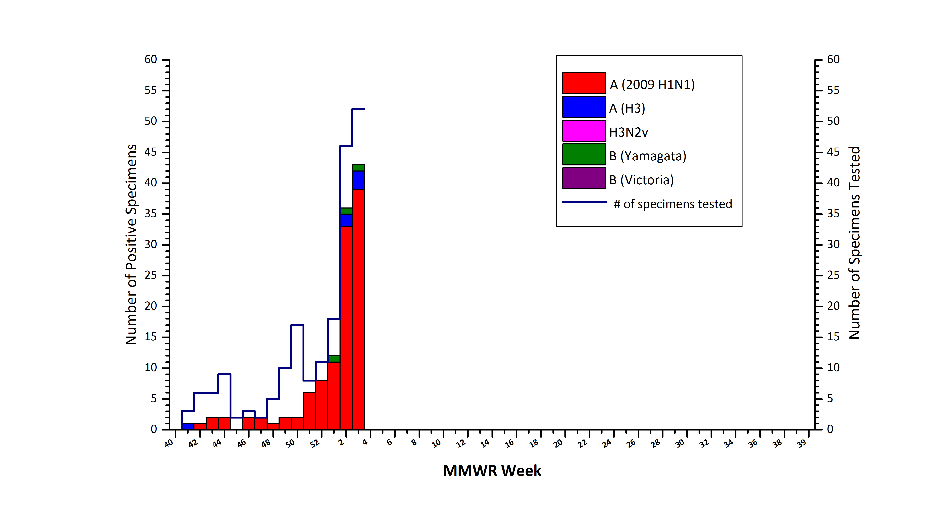

Table 2: Weekly Summary of MDPH-BIDLS Influenza Surveillance Test Results
2018-2019 Season: Influenza Surveillance
MA Department of Public Health’s Bureau of Infectious Disease and Laboratory Sciences (MDPH-BIDLS)
MMWR Week:  (Specimen Collected) | 2009 H1N1 | seasonal A/H3N2 | H3N2v | B Yam | B Vic | No. Flu Pos (%) | Un-sat | Total Tested | Total  Rec’d
52 (12/23 – 12/29/18) | 8 | 0 | 0 | 0 | 0 | 8(73%) | 1 | 11 | 12
01 (12/30 – 01/05/19) | 11 | 0 | 0 | 1 | 0 | 12(67%) | 1 | 18 | 19
02 (01/06 – 01/12/19) | 33 | 2 | 0 | 1 | 0 | 36(78%) | 1 | 46 | 47
03 (01/13 – 01/19/19) | 39 | 3 | 0 | 1 | 0 | 43(83%) | 1 | 52 | 53
Prior 4 wk Total | 91 | 5 | 0 | 3 | 0 | 99(78%) | 4 | 127 | 131
Cumulative Season total | 111 | 6 | 0 | 3 | 0 | 120(61%) | 9 | 198 | 207
All data are subject to change as test results become finalized. The 2018 -2019 influenza season began MMWR 40 (09/30- 10/06/2018).
Table 3: Weekly Summary of MDPH-BIDLS non-Influenza Respiratory Surveillance Test Results
2018-2019 Season: Influenza Like Illness Surveillance
MA Department of Public Health’s Bureau of Infectious Disease and Laboratory Sciences (MDPH-BIDLS)
MMWR Week:  (Specimen Collected) | RSV | RHV/ENT | PIV | HMPV | HCV | ADV | # Co-Infection | No. Pos (%) | Unsat | Total Tested | Total  Rec’d
52 (12/23 – 12/29/18) | 0 | 0 | 0 | 0 | 0 | 0 | 0 | 0(0%) | 0 | 3 | 3
01 (12/30 – 01/05/19) | 2 | 0 | 0 | 0 | 0 | 0 | 0 | 2(33%) | 0 | 6 | 6
02 (01/06 – 01/12/19) | 0 | 0 | 0 | 0 | 3 | 0 | 0 | 3(33%) | 0 | 9 | 9
03 (01/13 – 01/19/19) | 1 | 0 | 0 | 0 | 4 | 0 | 0 | 5(56%) | 0 | 9 | 9
Prior 4 wk Total | 3 | 0 | 0 | 0 | 7 | 0 | 0 | 10(37%) | 0 | 27 | 27
Cumulative Season total | 3 | 9 | 1 | 0 | 8 | 1 | 0 | 22(30%) | 0 | 74 | 74
All data are subject to change as test results become finalized. The 2018 -2019 influenza season began MMWR 40 (9/30- 10/06/2018).

For the 2018-2019 season, two original specimens positive for each influenza virus A(H3N2), influenza virus A(H1N1)pdm09, and influenza virus B (with one sample from each Victoria and Yamagata lineage, if possible) will be sent every two weeks by MDPH-BIDLS to a CDC contract laboratory performing National Influenza Virus Surveillance standardized test methods. Antigenic characterization of these submitted specimens include: hemagglutination inhibition (HI), genetic analysis (sequencing) and sensitivity to FDA-approved drugs for identification of resistance. Selection criteria for submitting influenza positive specimens will be based on a Ct value (<30) for Inf A and Inf B tests using the CDC Flu rRT-PCR Dx Panel. See Table 4 for a summary of specimens characterized in the 2018-2019 season to date.

Table 4: Summary of 2018-2019 CDC Contract Laboratory Specimen Characterization
Influenza Virus Type | Characterized Total
A/SINGAPORE/INFIMH-16-0019/2016-LIKE | 1
A/Michigan/45/2015-LIKE | 2

The CDC Flu rRT-PCT Dx Panel for Influenza A subtyping was updated prior to the start of the 2016-2017 season. The oligonucleotide primers and probe were improved to ensure detection of currently circulating influenza A(H1N1)pdm09 viruses. The “seasonal” H1 target from Influenza A(H1N1) viruses that caused seasonal epidemics in humans prior to 2009 no longer circulates in humans and this target within the assay was discontinued.

As samples are received, MDPH-BIDLS will screen additional samples every two weeks to detect point mutations within the neuraminidase gene of influenza A/H3N2 viruses (E119, R292, and N294) and influenza A/2009 H1N1 viruses (H275 and I223) to assess resistance trends using the current CDC pyrosequencing method. This information will be reported locally and captured nationally in FluView (http://www.cdc.gov/flu/weekly/). No mutations were detected in the 2016-2017 season. For the 2017-2018 season, one A/H3N2 isolate with a mutation (E119 variant) conferring oseltamivir-resistance was detected.

Table 5: DPH-BIDLS Influenza Antiviral Resistance Screening: 2018-2019 Season
Virus Collection Period: September 30, 2018- ongoing
 | Oseltamivir |  | Zanamivir
 | Samples Tested | Resistant Viruses, Number (%) | Samples Tested | Resistant Viruses,  Number (%)
Influenza A (H3N2) ^{i} | 0 | 0 (0) | 0 | 0 (0)
Influenza A (H1N1)pdm09 ^{ii} | 0 | 0 (0) | 0 | 0 (0)
^{i} Samples tested by pyrosequencing at position E119, R292, and N294 within the neuraminidase (NA) gene.
^{ii} Samples tested by pyrosequencing at position H275 and I223 within the NA gene.

Additional information on national antiviral resistance testing including recommendations for antiviral treatment and chemoprophylaxis of influenza virus infection can be found at http://www.cdc.gov/flu/weekly/.

CDC activity indicator – indicates how widespread influenza activity level is in the state.
CDC ILI activity indicator – more quantitative indicator of the level of ILI activity across the state.

