Highlights from this week’s report:
- Influenza severity for Massachusetts is low this week.
- The percent of influenza-like illness (ILI) visits in Massachusetts is 1.58%, which is higher than previous seasons and lower than the regional baseline of 2.0%.
- The percent of hospitalizations associated with influenza is 0.22%, which is higher than previous seasons.
- Overall ILI activity is minimal. The Outer Metro Boston and Southeast regions are reporting low ILI activity; the Boston, Central, Inner Metro Boston, and Northeast regions are reporting minimal ILI activity.
- Laboratory-confirmed influenza cases decreased by 48% this week. More influenza A than influenza B positive specimens have been reported by hospitals and outpatient facilities in Massachusetts. For influenza A, the predominant strain is currently H3N2.
- Nationally, seasonal influenza viruses continue to circulate, and activity is increasing in parts of the country.
- Additional statewide and national data including geographic spread, ILI activity, and pneumonia and influenza mortality are available at CDC’s FluView Weekly Report at www.cdc.gov/flu/weekly and FluView Interactive https://www.cdc.gov/flu/weekly/fluviewinteractive.htm.
- Statewide and national COVID data are available at
https://www.mass.gov/info-details/covid-19-response-reporting and
https://www.cdc.gov/coronavirus/2019-ncov/covid-data/covidview/index.html

Flu vaccination is always the best way to prevent flu and its potentially serious complications.

Note: This will be the last report of the extended influenza season as influenza activity has decreased.

Influenza-like illness activity
Influenza-like illness (ILI) is defined as fever (temperature of 100 deg F or greater) in addition to cough and/or sore throat. Many more people are infected with influenza than are tested for influenza. ILI is used throughout the regular influenza season to help track influenza activity in individuals who are not tested, as trends in ILI have been shown to mirror influenza trends. Eighty-eight healthcare facilities called ‘sentinel sites’ report the number of patients they see with ILI each week during regular flu season to the Massachusetts Department of Public Health (MDPH). Sentinel sites include provider offices, school health services, community health centers, urgent care centers, and emergency departments across Massachusetts. Data reported by emergency departments provide information about ED visits that include diagnostic codes (influenza diagnosis code) as well as terms indicative of ILI. The CDC uses trends from past years to determine a region-specific baseline rate of ILI visits, which for Massachusetts is 2.0%. A rate above this regional baseline indicates higher than normal levels of ILI in the state. For more information on how regional baselines are calculated see CDC’s influenza surveillance website at https://www.cdc.gov/flu/weekly/overview.htm.

Figure 1 shows that 1.58% of reported visits are due to ILI, which is lower than the regional baseline of 2.0%. ILI visits for the current week are higher than previous seasons.

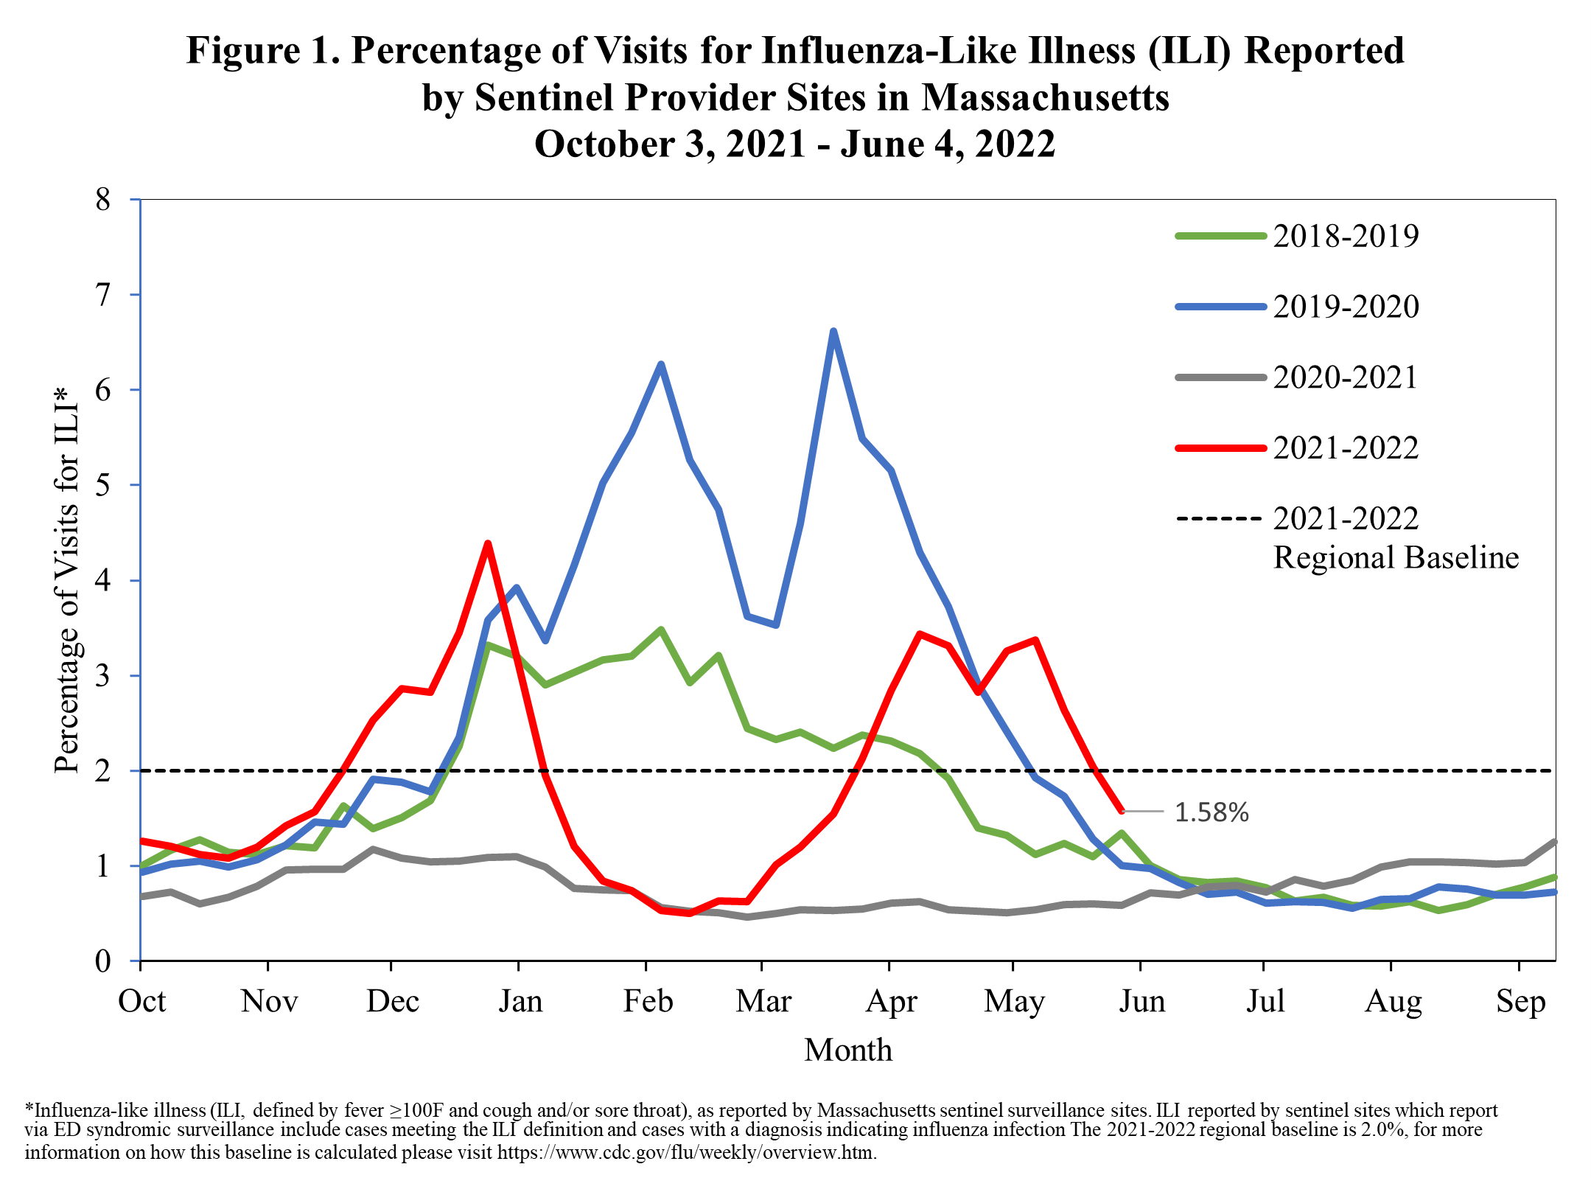

Influenza-associated hospitalizations
As part of the National Syndromic Surveillance Program, MDPH receives data from Emergency Departments (EDs) covering 100% of ED visits statewide. These data are used to track patient visits related to influenza by monitoring the diagnoses the patients receive (ICD-10 code). These data are available to MDPH in near real-time.

Figure 2 shows the percent of all ED visits which result in a patient hospitalized because of illness associated with influenza infection. The percentage of influenza-associated hospitalizations is higher than previous seasons.

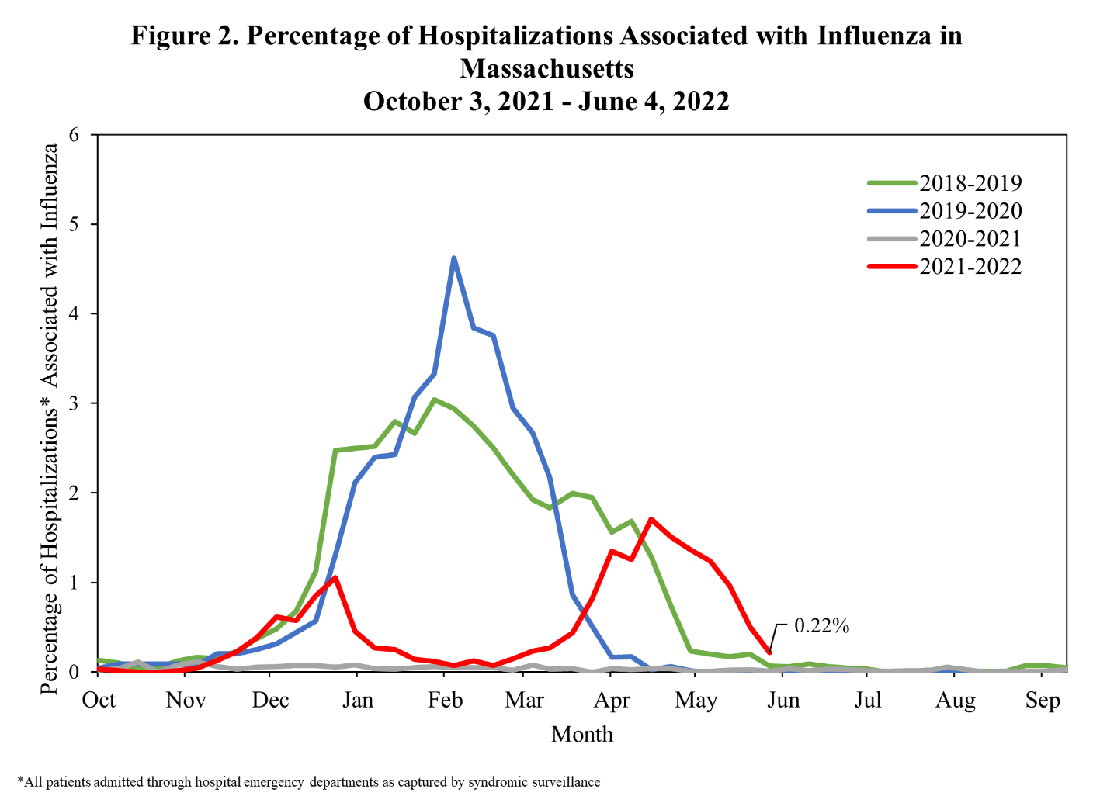

ILI Activity in Massachusetts by Region
Figure 3 shows the relative intensity of reported ILI activity in Massachusetts by region. Although regions may not all experience the same intensity of ILI at similar times, infections due to influenza can be found throughout Massachusetts during flu season. Figure 3 shows that the Outer Metro Boston and Southeast regions are reporting low ILI activity; the Boston, Central, Inner Metro Boston, and Northeast regions are reporting minimal ILI activity.

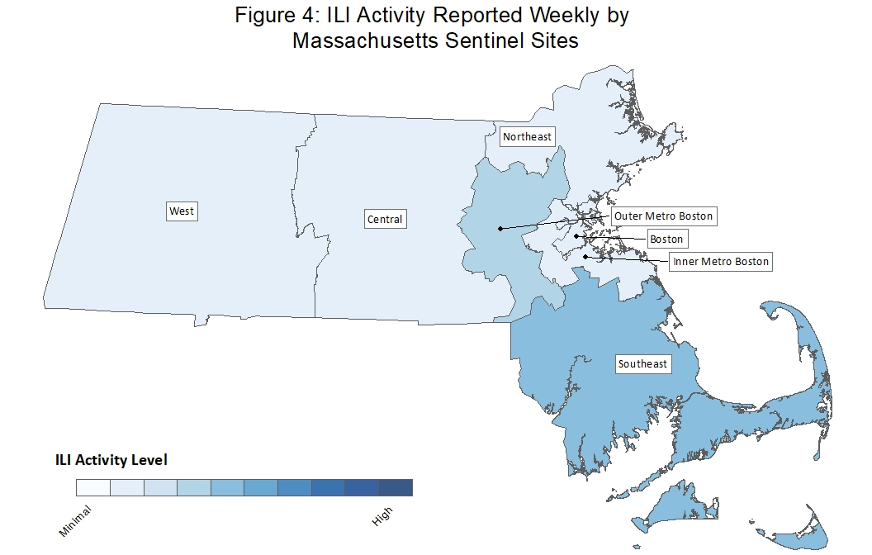
Figure 3: ILI Activity Reported Weekly by Massachusetts Sentinel Sites

Laboratory testing for influenza
Laboratories in Massachusetts report all positive influenza test results to MDPH. The majority of individuals with influenza-like illness are not tested; therefore, the number of positive test results does not reflect the total number of influenza cases in Massachusetts. However, laboratory data do provide information about the types of influenza virus circulating in Massachusetts and help indicate the presence and define the distribution of influenza in the state.

Figure 4 illustrates the number of laboratory confirmed influenza cases in Massachusetts by week. Laboratory-confirmed influenza cases decreased by 48% this week. More influenza A than influenza B positive specimens have been reported by hospitals and outpatient facilities in Massachusetts.

