Highlights from this week’s report:
- There is still time to get a flu shot to ensure you are protected as flu activity continues.
- Influenza-like illness activity in Massachusetts remains elevated, consistent with activity levels normally seen at this time of year.
- Geographic spread is widespread: ILI activity and influenza laboratory confirmations remain elevated in all regions of the state.
- Influenza-associated hospitalizations in Massachusetts are declining but remain elevated this week and are consistent with activity levels normally seen at this time of year.
- The number of influenza positive laboratory tests reported to MDPH decreased this week by 3.4% compared to last week.
- For the 2018-2019 season to date, the predominant influenza strain is A/2009 H1N1; however, influenza strain A/H3N2 has become more common than the A/2009 H1N1 strain in recent weeks.
- All influenza strains that have been characterized in Massachusetts this season to date are covered by the current influenza vaccine.
- No resistance to antiviral medications has been detected this season.
- Nationally, flu activity remains high, consistent with normal levels of activity at this time of year.
- Additional data are available upon request and at www.cdc.gov/flu/weekly.

Influenza-like illness activity
Influenza-like illness (ILI) is defined as fever above 100F in addition to either cough or sore throat. Many more people are infected with influenza than are tested for influenza. ILI is used throughout the regular influenza season as a way to help track influenza activity in individuals who are not tested, as trends in ILI have been shown to mirror influenza trends. Sixty healthcare facilities called ‘sentinel sites’, including provider offices, school health services, community health centers, and emergency departments across Massachusetts report the number of patients they see with ILI each week during regular flu season.

Figure 1 shows that ILI activity has steadied in recent weeks but remains elevated, consistent with activity levels normally seen at this time of year. For more information, see CDC’s influenza surveillance website at www.cdc.gov/flu/weekly/fluactivitysurv.htm.

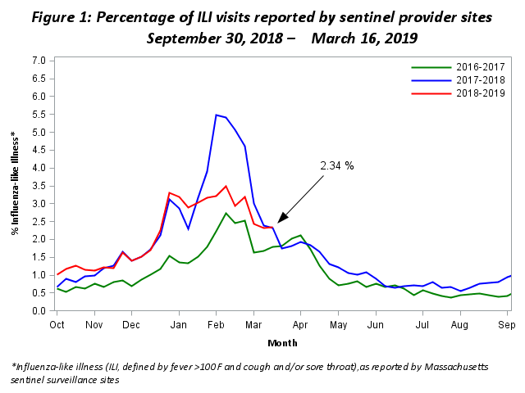
Influenza-associated hospitalizations
As part of the National Syndromic Surveillance Program, MDPH receives data from Emergency Departments (EDs) covering more than 90% of ED visits statewide. These data are used to track patient visits related to influenza by monitoring the reason patients are seeking care (chief complaint) and the diagnoses the patients receive (ICD-10 code). These data are available to MDPH in near real-time.

Figure 2 shows the percent of all ED visits which result in the patient being hospitalized that are associated with influenza infection.

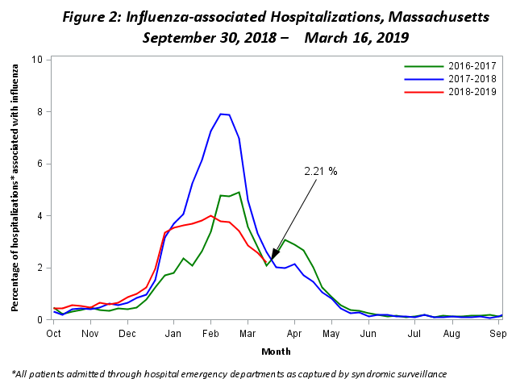

Regional ILI activity
Figure 3 shows the relative intensity of reported ILI activity in Massachusetts by region. Although regions may not all experience the same intensity of ILI at similar times, infections due to influenza can be found throughout Massachusetts during flu season. Figure 3 shows that ILI activity in all seven regions of the state remains elevated, consistent with what is normally seen at this time of year.
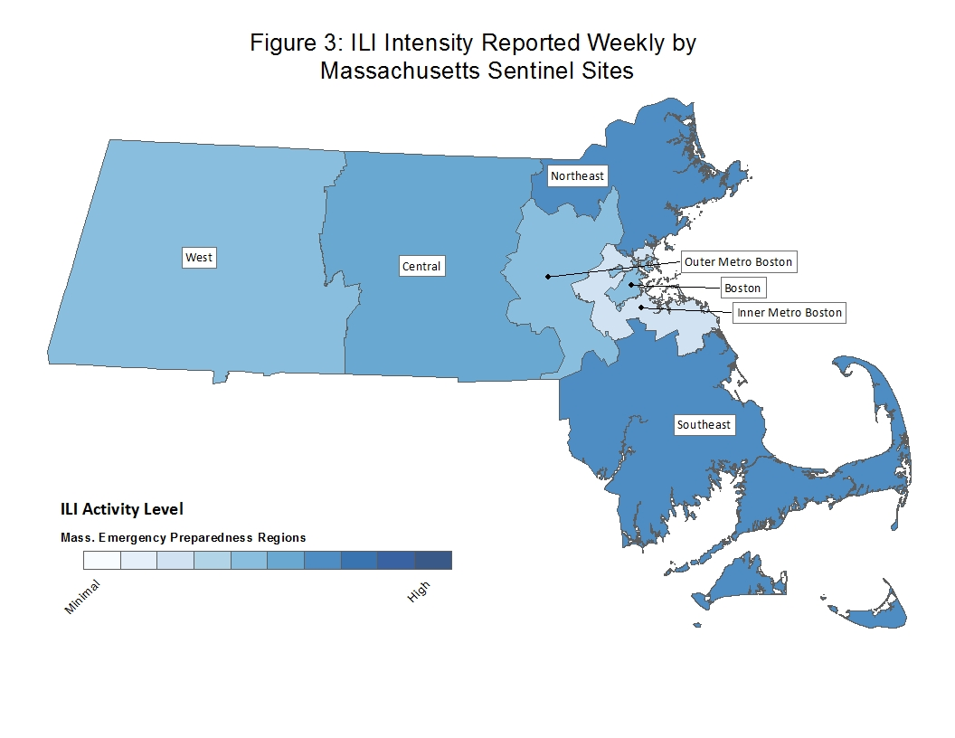

Laboratory testing for influenza
Laboratories in Massachusetts report all positive influenza test results to MDPH. The majority of individuals with influenza-like illness are not tested; therefore the number of positive test results does not reflect the total number of influenza cases in Massachusetts. However, laboratory data do provide information about the types of influenza virus circulating in Massachusetts and help indicate the presence and define the distribution of influenza in the state. Figure 4 illustrates the number of positive laboratory confirmed influenza cases in Massachusetts by week.

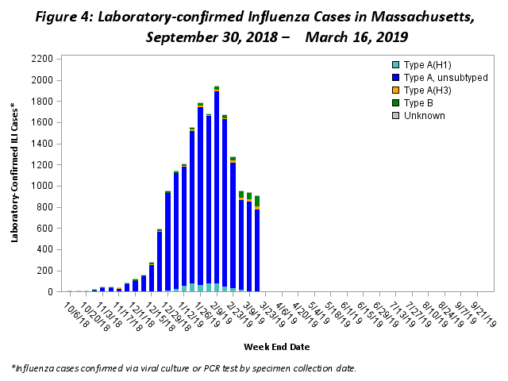

Testing at the State Public Health Laboratory
The Massachusetts State Public Health Laboratory (MA SPHL) performs influenza surveillance testing year round to confirm circulating influenza virus types. Samples are submitted by outpatient healthcare providers (ILINet) and hospital diagnostic laboratories in Massachusetts. For the 2018-2019 season, Table 1 summarizes the influenza surveillance testing conducted by MA SPHL beginning September 30, 2018. For the 2018-2019 season so far, the predominant influenza strain is A/2009 H1N1; however, influenza strain A/H3N2 has become more common than the A/2009 H1N1 strain in the most recent week.

Table 1: Weekly Summary of Massachusetts State Public Health Laboratory Influenza Surveillance Test Results
2018-2019 Season: Influenza Surveillance
Week | 2009 H1N1 | seasonal A/H3N2 | H3N2v | B Yam | B Vic | No. Flu Pos (%) | Unsat | Total Tested | Total  Rec’d
08 (02/17 – 02/23/19) | 25 | 10 | 0 | 1 | 0 | 36(67%) | 1 | 54 | 55
09 (02/24 – 03/02/19) | 17 | 14 | 0 | 3 | 2 | 36(78%) | 0 | 46 | 46
10 (03/03 – 03/09/19) | 11 | 10 | 0 | 1 | 1 | 23(77%) | 0 | 30 | 30
11 (03/10 – 03/16/19) | 6 | 10 | 0 | 4 | 1 | 21(78%) | 0 | 27 | 27
Prior 4 wk Total | 59 | 44 | 0 | 9 | 4 | 116(74%) | 1 | 157 | 158
Cumulative Season total | 394 | 70 | 0 | 13 | 4 | 481(74%) | 14 | 651 | 665
All data are subject to change as test results become finalized. The 2018 -2019 influenza season began the week of 09/30- 10/06/2018.

All specimens which test negative for influenza at MA SPHL are also tested for non-influenza respiratory diseases. Table 2 shows that viruses from rhinovirus (RHV)/enterovirus (ENT) and coronavirus (HCoV) groups have circulated in Massachusetts this season. This contributes to ILI trends in Massachusetts.

Table 2: Weekly Summary of Massachusetts State Public Health Laboratory non-Influenza Respiratory Surveillance Test Results
2018-2019 Season: Influenza Like Illness Surveillance
Week: | RSV | RHV/ENT | PIV | HMPV | HCoV | ADV | # Co-Infection | No. Pos (%) | Unsat | Total Tested | Total  Rec’d
08 (02/17 – 02/23/19) | 1 | 1 | 0 | 0 | 4 | 0 | 0 | 6(33%) | 0 | 18 | 18
09 (02/24 – 03/02/19) | 0 | 0 | 0 | 0 | 2 | 1 | 0 | 3(38%) | 0 | 8 | 8
10 (03/03 – 03/09/19) | 0 | 0 | 0 | 0 | 0 | 0 | 0 | 0(0%) | 0 | 7 | 7
11 (03/10 – 03/16/19) | 0 | 0 | 0 | 0 | 0 | 0 | 0 | 0(0%) | 0 | 4 | 4
Prior 4 wk Total | 1 | 1 | 0 | 0 | 6 | 1 | 0 | 9(24%) | 0 | 37 | 37
Cumulative Season total | 6 | 11 | 4 | 3 | 28 | 4 | 1 | 55(34%) | 0 | 161 | 161
All data are subject to change as test results become finalized. The 2018 -2019 influenza season began the week of 9/30- 10/06/2018.

MA SPHL submits a subset of influenza samples to CDC for further genetic analysis (antigenic characterization). All strains that have been analyzed from Massachusetts this season are covered by the current influenza vaccine.

Every two weeks MASPHL screens influenza specimens to detect mutations within influenza A/H3N2 and A/2009 H1N1 viruses to look for antiviral resistance. No mutations have been identified in the 2018-2019 season.

Additional information on national antiviral resistance testing including recommendations for antiviral treatment and chemoprophylaxis of influenza virus infection can be found at http://www.cdc.gov/flu/weekly/.

