Highlights from this week’s report:
- Influenza severity for Massachusetts is moderate this week.
- The percent of influenza-like illness (ILI) visits in Massachusetts is 3.06%, which is higher than previous seasons and the regional baseline of 2.0%.
- The percent of hospitalizations associated with influenza is 0.92%, which is higher than previous seasons.
- Overall ILI activity is moderate. The Central, Northeast, and Southeast regions are reporting high ILI activity; the Boston, Inner Metro Boston, Outer Metro Boston, and West regions are reporting moderate ILI activity
- Laboratory-confirmed influenza cases increased by 3% this week. More influenza A than influenza B positive specimens have been reported by hospitals and outpatient facilities in Massachusetts. For influenza A, the predominant strain is currently H3N2.
- The number of influenza vaccine doses administered this flu season is comparable to last season in the same week. The vaccination rate for all ages is 48%. See figure 6 and 7 for vaccination data.
- Nationally, seasonal influenza viruses continue to circulate, and activity is increasing in parts of the country.
- Additional statewide and national data including geographic spread, ILI activity, and pneumonia and influenza mortality are available at CDC’s FluView Weekly Report at www.cdc.gov/flu/weekly and FluView Interactive https://www.cdc.gov/flu/weekly/fluviewinteractive.htm.
- Statewide and national COVID data are available at
https://www.mass.gov/info-details/covid-19-response-reporting and
https://www.cdc.gov/coronavirus/2019-ncov/covid-data/covidview/index.html

Flu vaccination is always the best way to prevent flu and its potentially serious complications.

Influenza-like illness activity
Influenza-like illness (ILI) is defined as fever (temperature of 100 deg F or greater) in addition to cough and/or sore throat. Many more people are infected with influenza than are tested for influenza. ILI is used throughout the regular influenza season to help track influenza activity in individuals who are not tested, as trends in ILI have been shown to mirror influenza trends. Eighty-eight healthcare facilities called ‘sentinel sites’ report the number of patients they see with ILI each week during regular flu season to the Massachusetts Department of Public Health (MDPH). Sentinel sites include provider offices, school health services, community health centers, urgent care centers, and emergency departments across Massachusetts. Data reported by emergency departments provide information about ED visits that include diagnostic codes (influenza diagnosis code) as well as terms indicative of ILI. The CDC uses trends from past years to determine a region-specific baseline rate of ILI visits, which for Massachusetts is 2.0%. A rate above this regional baseline indicates higher than normal levels of ILI in the state. For more information on how regional baselines are calculated see CDC’s influenza surveillance website at https://www.cdc.gov/flu/weekly/overview.htm.

Figure 1 shows that 3.06% of reported visits are due to ILI, which is higher than the regional baseline of 2.0%. ILI visits for the current week are higher than previous seasons.
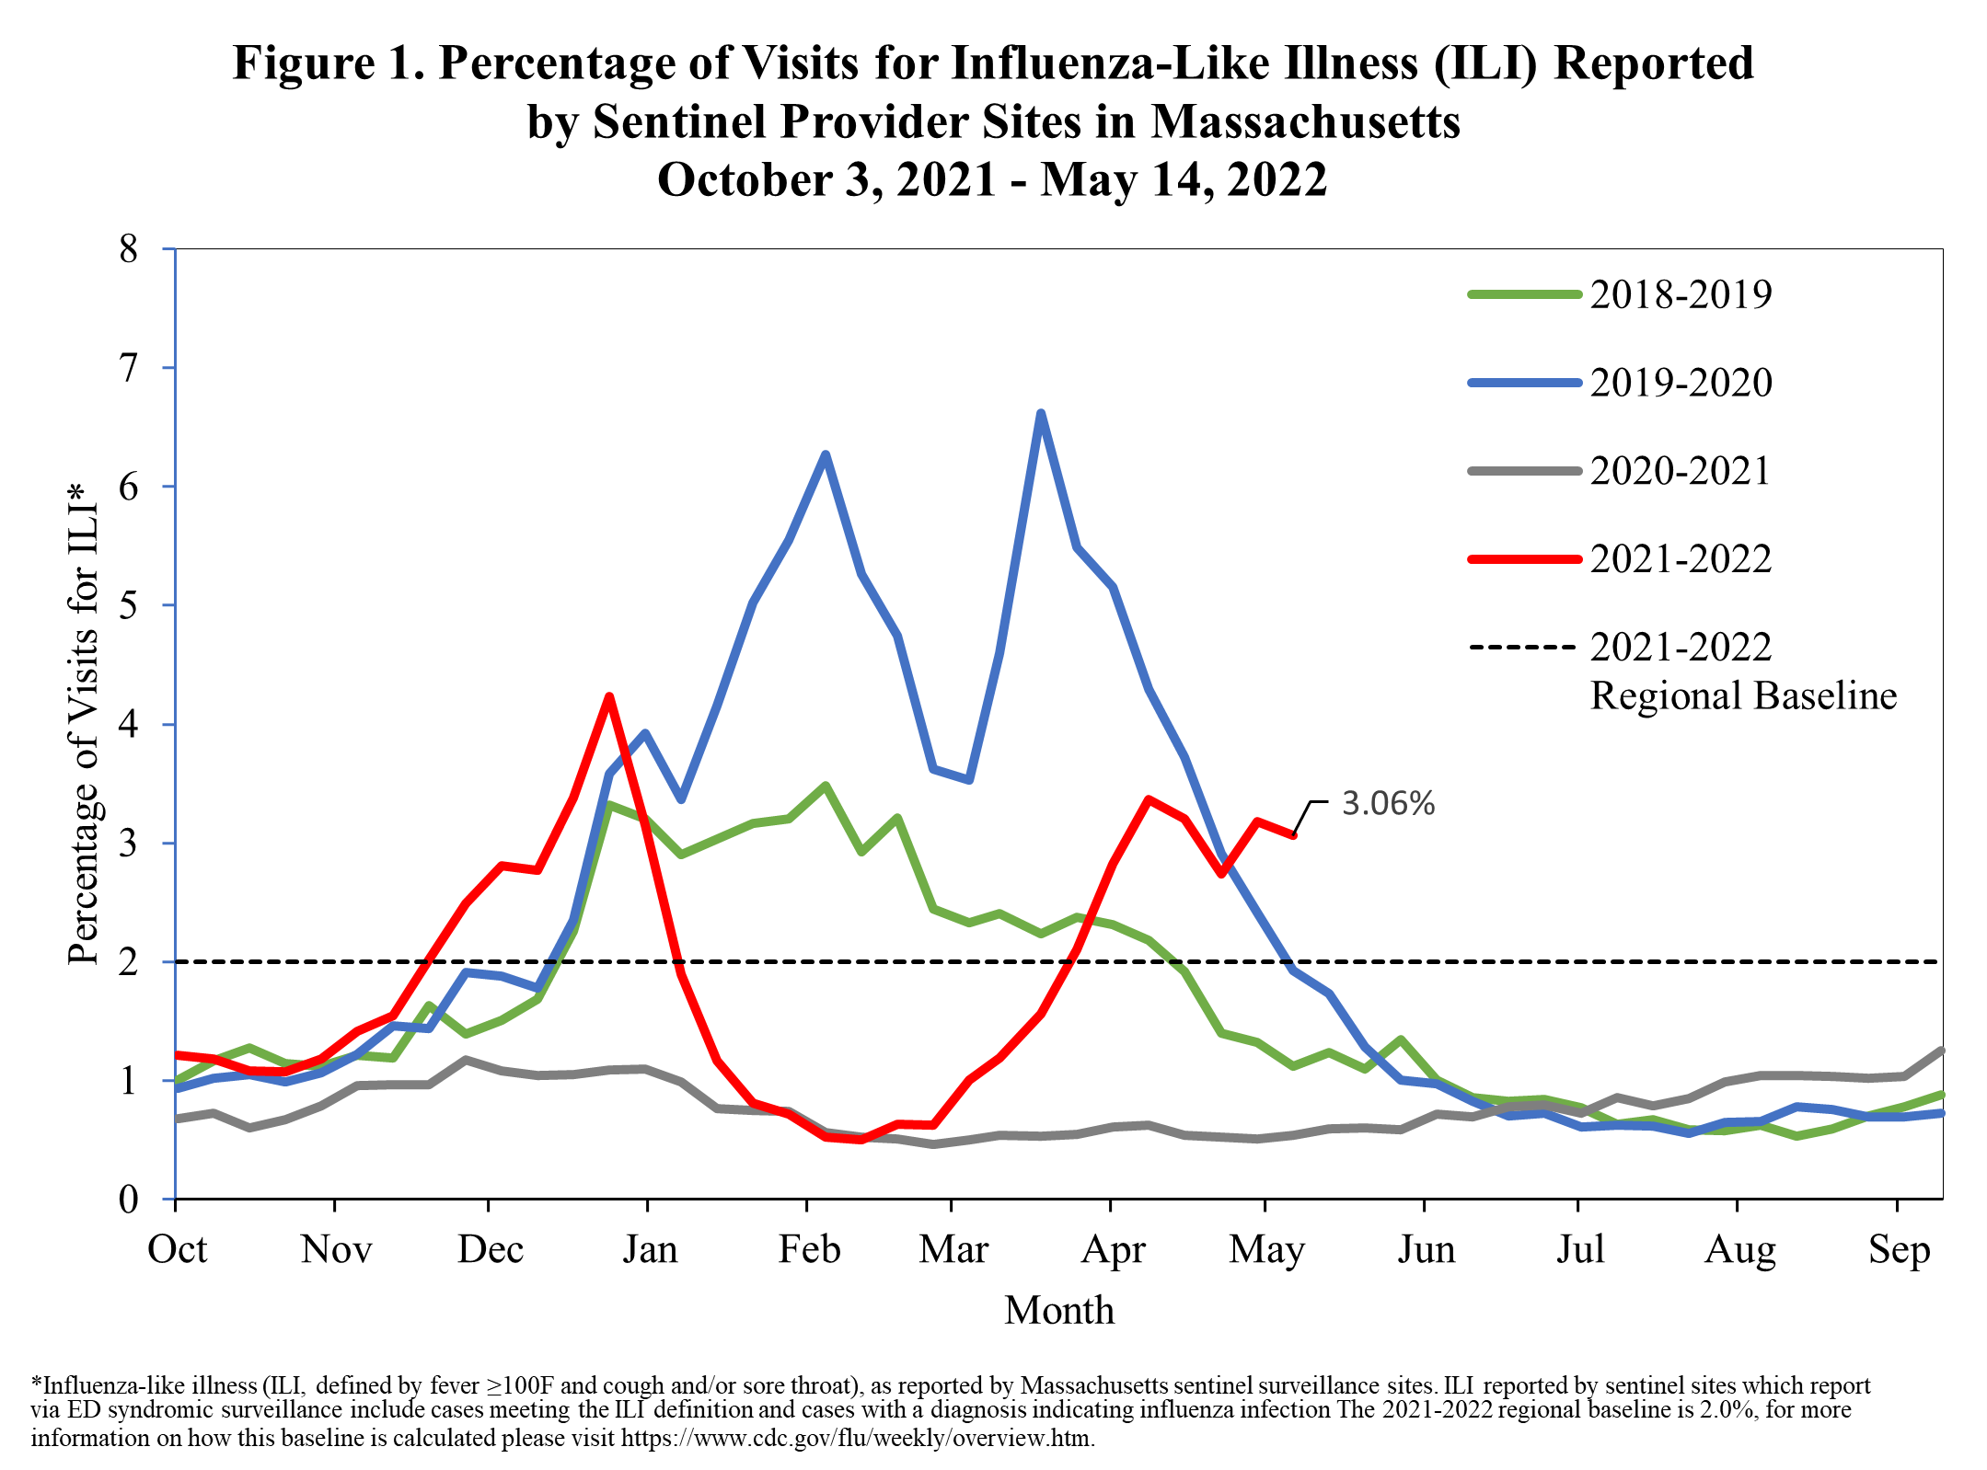

Influenza-associated hospitalizations
As part of the National Syndromic Surveillance Program, MDPH receives data from Emergency Departments (EDs) covering 100% of ED visits statewide. These data are used to track patient visits related to influenza by monitoring the diagnoses the patients receive (ICD-10 code). These data are available to MDPH in near real-time.

Figure 2 shows the percent of all ED visits which result in a patient hospitalized because of illness associated with influenza infection. The percentage of influenza-associated hospitalizations is higher than previous seasons.

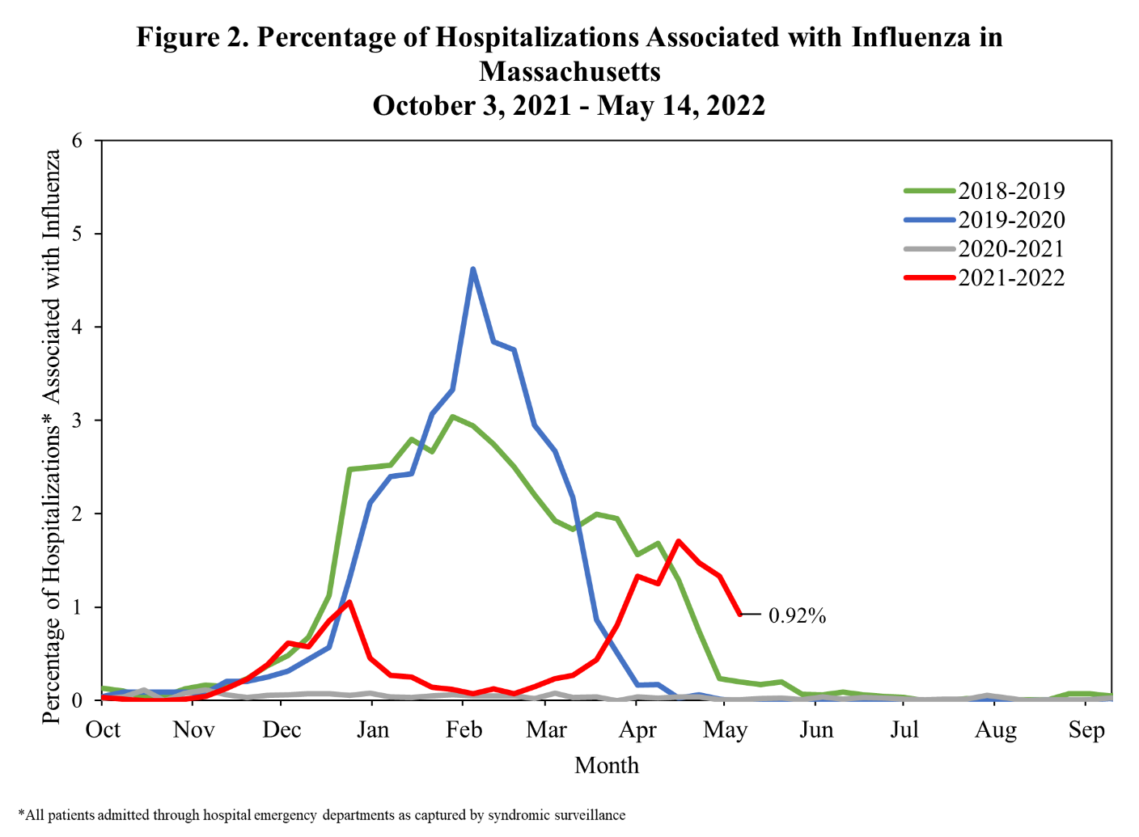

ILI Activity in Massachusetts
Figure 3 shows the current season’s weekly ILI activity compared to the last five flu seasons in Massachusetts. ILI activity for each week is categorized as minimal, low, moderate, or high, with a shade of blue corresponding to the category of ILI activity for that week. Darker shades of blue indicate more intense ILI activity. Figure 3 shows that ILI activity in Massachusetts is moderate this week.

Figure 3. ILI Activity in Massachusetts Reported Weekly by Sentinel Sites
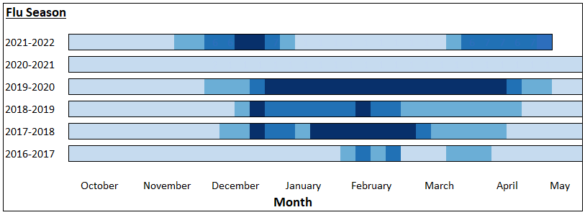
Minimal | Low | Moderate | High

ILI Activity in Massachusetts by Region
Figure 4 shows the relative intensity of reported ILI activity in Massachusetts by region. Although regions may not all experience the same intensity of ILI at similar times, infections due to influenza can be found throughout Massachusetts during flu season. Figure 4 shows that the Central, Northeast, and Southeast regions are reporting high ILI activity; the Boston, Inner Metro Boston, Outer Metro Boston, and West regions are reporting moderate ILI activity.

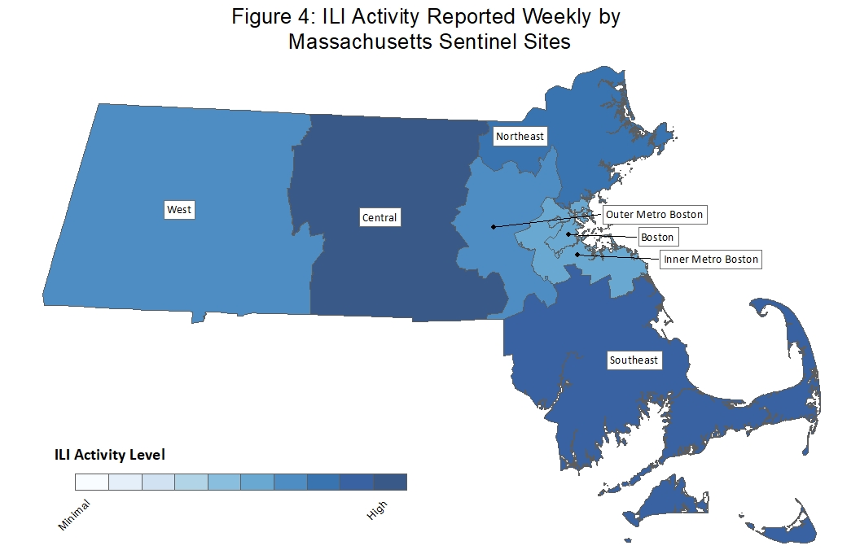
Laboratory testing for influenza
Laboratories in Massachusetts report all positive influenza test results to MDPH. The majority of individuals with influenza-like illness are not tested; therefore, the number of positive test results does not reflect the total number of influenza cases in Massachusetts. However, laboratory data do provide information about the types of influenza virus circulating in Massachusetts and help indicate the presence and define the distribution of influenza in the state.

Figure 5 illustrates the number of laboratory confirmed influenza cases in Massachusetts by week. Laboratory-confirmed influenza cases increased by 3% this week. More influenza A than influenza B positive specimens have been reported by hospitals and outpatient facilities in Massachusetts.
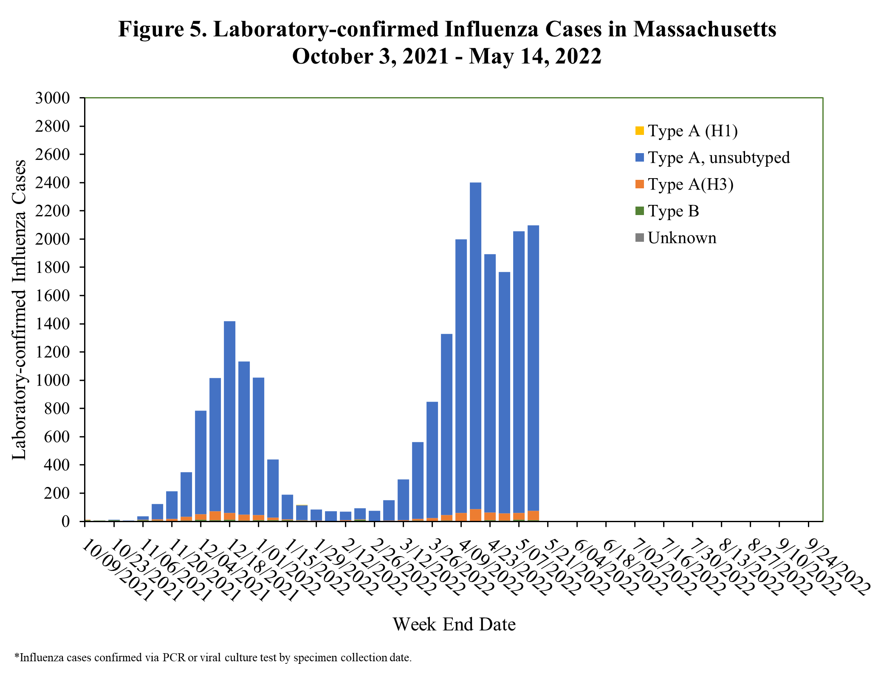

Testing at the State Public Health Laboratory
The Massachusetts State Public Health Laboratory (MA SPHL) performs influenza surveillance testing year-round to confirm circulating influenza virus types. Samples are submitted by outpatient healthcare providers (ILINet) and hospital diagnostic laboratories in Massachusetts. For the 2021-2022 season, Table 1 summarizes the influenza surveillance testing conducted by MA SPHL beginning October 3, 2021. In the 2021-2022 flu season, 131 cases of seasonal A/H3N2 influenza and 1 case of B Victoria has been confirmed among 166 samples tested.

Table 1. Weekly Summary of Massachusetts State Public Health Laboratory Influenza Surveillance Test Results
2021-2022 Season: Influenza Surveillance
MMWR Week:  (Specimen Collected) | 2009 H1N1 | seasonal A/H3N2 | H3N2v | B Yam | B Vic | No. Flu Pos (%) | Unsat | Total Tested | Total  Rec’d
16 (04/17 – 04/23/22) | 0 | 2 | 0 | 0 | 0 | 2(29%) | 0 | 7 | 7
17 (04/24 – 04/30/22) | 0 | 3 | 0 | 0 | 0 | 3(100%) | 0 | 3 | 3
18 (05/01 – 05/07/22) | 0 | 3 | 0 | 0 | 0 | 3(100%) | 1 | 3 | 4
19 (05/08 – 05/14/22) | 0 | 0 | 0 | 0 | 0 | 0(0%) | 0 | 0 | 0
Prior 4 wk Total | 0 | 8 | 0 | 0 | 0 | 8(62%) | 1 | 13 | 14
Cumulative Season total | 0 | 131 | 0 | 0 | 1 | 132(80%) | 14 | 166 | 180
All data are subject to change as test results become finalized. The 2021-2022 influenza season began the week of 10/03- 10/09/2021.

All specimens which test negative for influenza at MA SPHL are also tested for non-influenza respiratory diseases including COVID-19 (SARS-CoV-2), respiratory syncytial virus (RSV), rhinovirus (RHV)/enterovirus (ENT), parainfluenza virus (PIV), human metapneumovirus (HMPV), seasonal human coronavirus (HCV) and adenovirus (ADENO). HCV does not include COVID-19. In the 2021-2022 flu season, 1 case of RHV/ENT, 1 case of PIV, 1 case of HMPV, 4 cases of HCV, 1 case of ADENO and 1 co-infection has been confirmed among 120 samples tested.

Table 2. Weekly Summary of Massachusetts State Public Health Laboratory non-Influenza Respiratory Surveillance Test Results
2021-2022 Season: Influenza-like Illness Surveillance
MMWR Week:  (Specimen Collected) | SARS-CoV-2 | RSV | RHV/ENT | PIV | HMPV | HCV | ADENO | Co-Infection* | No. Pos (%) | Unsat | Total Tested | Total  Rec’d
16 (04/17 – 04/23/22) | 0 | 0 | 0 | 0 | 0 | 4 | 0 | 0 | 4(57%) | 0 | 7 | 7
17 (04/24 – 04/30/22) | 0 | 0 | 0 | 0 | 0 | 0 | 0 | 0 | 0(0%) | 0 | 3 | 3
18 (05/01 – 05/07/22) | 0 | 0 | 0 | 0 | 0 | 0 | 0 | 0 | 0(0%) | 0 | 3 | 3
19 (05/08 – 05/14/22) | 0 | 0 | 0 | 0 | 0 | 0 | 0 | 0 | 0(0%) | 0 | 0 | 0
Prior 4 wk Total | 0 | 0 | 0 | 0 | 0 | 4 | 0 | 0 | 4(31%) | 0 | 13 | 13
Cumulative Season total | 0 | 0 | 1 | 1 | 1 | 4 | 1 | 1 | 7(6%) | 0 | 120 | 120
All data are subject to change as test results become finalized. The 2021 -2022 influenza season began the week of 10/03- 10/09/2021.
*Coinfection is the simultaneous detection of two or more of the non-influenza respiratory diseases included in this table.

MA SPHL submits a subset of influenza samples to CDC for further genetic analysis (antigenic characterization).

Every two weeks MA SPHL screens influenza specimens to detect mutations within influenza A/H3N2 and A/2009 H1N1 viruses to look for antiviral resistance once positive specimens have been identified.

Additional information on national antiviral resistance testing including recommendations for antiviral treatment and chemoprophylaxis of influenza virus infection can be found at http://www.cdc.gov/flu/weekly/.

Influenza Vaccination
The Massachusetts Immunization Information System (MIIS), also called an immunization registry, is a confidential, web-based system that collects and stores vaccination records for Massachusetts residents of all ages. This system allows providers to have access to more complete immunization records for their patients, and assists public health systems in the monitoring and control of vaccine preventable diseases. For more information see the MIIS’ website at https://www.mass.gov/service-details/massachusetts-immunization-information-system-miis-overview.

Figure 6 shows the percent of MA residents vaccinated for influenza by age group. The vaccination rate for all age groups is 48%. The highest vaccination rates are among the youngest age group (six months - four years old), and the oldest age group (65 years old and older). Eighteen to 49 year-olds have the lowest vaccination rate.

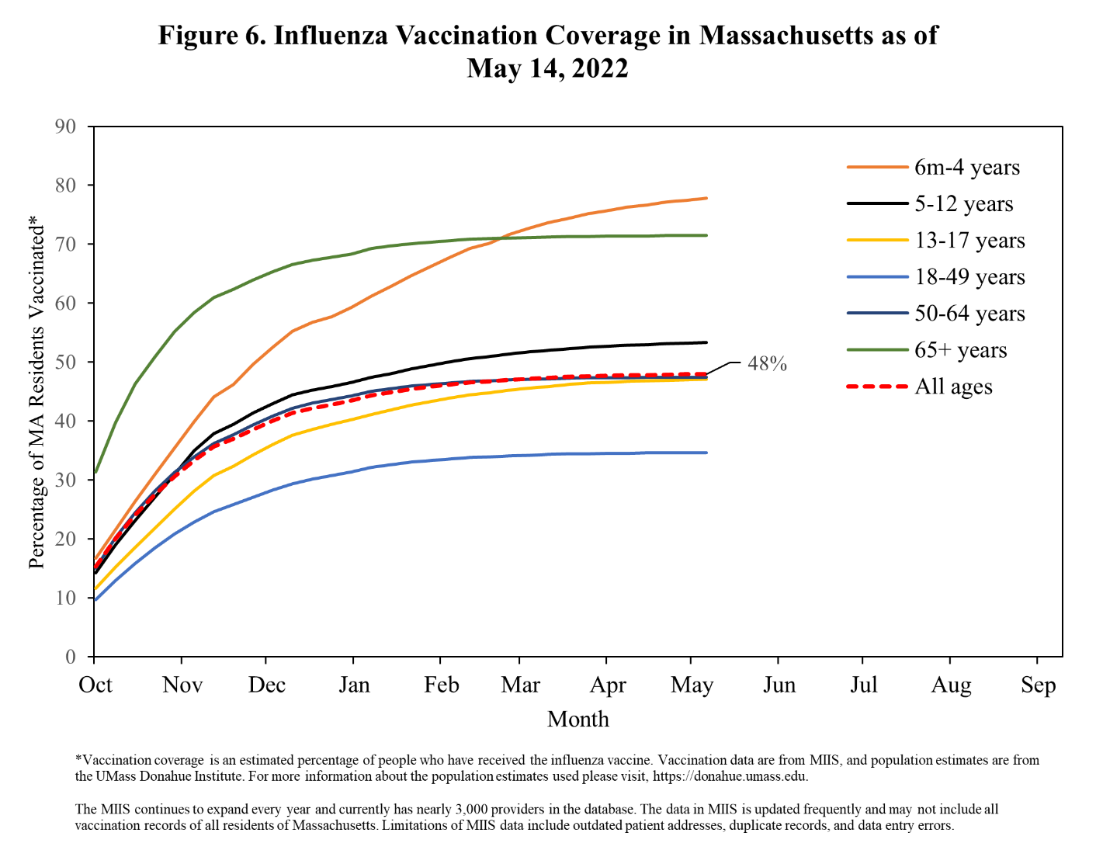

Figure 7 shows the number of influenza vaccine doses administered. The number of influenza doses administered this season is comparable to last season.
