**Highlights from this week’s report:**

* Influenza severity and Influenza-like illness activity for Massachusetts are low this week.
* The percent of influenza-associated hospitalizations in Massachusetts is comparable to the last two flu seasons in the same week.
* At this point in the 2019-2020 flu season, both influenza A and influenza B have been identified in Massachusetts.
* Nationally, influenza-like illness activity is low but increasing, consistent with typical levels of activity at this time of year.
* Additional statewide and national data including geographic spread, ILI activity, and pneumonia and influenza mortality are available at CDC’s FluView Weekly Report at [www.cdc.gov/flu/weekly](http://www.cdc.gov/flu/weekly/fluactivitysurv.htm) and FluView Interactive <https://www.cdc.gov/flu/weekly/fluviewinteractive.htm>.

*Flu season has begun and the best time to get your flu shot is now!*

**Influenza-like illness activity**

Influenza-like illness (ILI) is defined as fever above 100Fin addition to either cough and/or sore throat. Many more people are infected with influenza than are tested for influenza. ILI is used throughout the regular influenza season as a way to help track influenza activity in individuals who are not tested, as trends in ILI have been shown to mirror influenza trends. Seventy-nine healthcare facilities called ‘sentinel sites’ report the number of patients they see with ILI each week during regular flu season. Sentinel sites include provider offices, school health services, community health centers, urgent care centers, and emergency departments across Massachusetts.

Figure 1 shows that the percentage of ILI visits is comparable to the last two seasons. For more information, see CDC’s influenza surveillance website at [www.cdc.gov/flu/weekly/fluactivitysurv.htm](http://www.cdc.gov/flu/weekly/fluactivitysurv.htm).

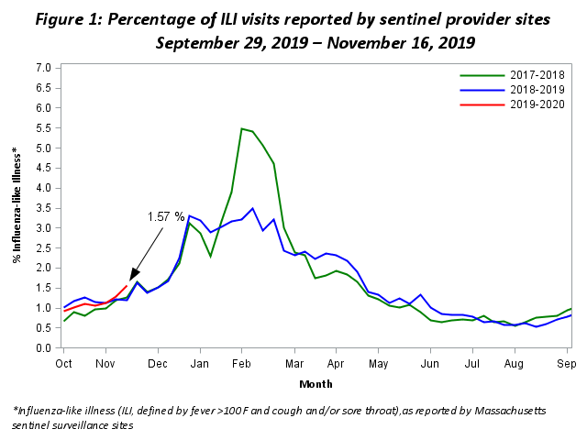**Influenza-associated hospitalizations**

As part of the National Syndromic Surveillance Program, MDPH receives data from Emergency Departments (EDs) covering more than 90% of ED visits statewide. These data are used to track patient visits related to influenza by monitoring the reason patients are seeking care (chief complaint) and the diagnoses the patients receive (ICD-10 code). These data are available to MDPH in near real-time.

Figure 2 shows the percent of all ED visits which result in a patient hospitalized because of illness associated with influenza infection. The percentage of influenza-associated hospitalizations is comparable to the last two seasons.

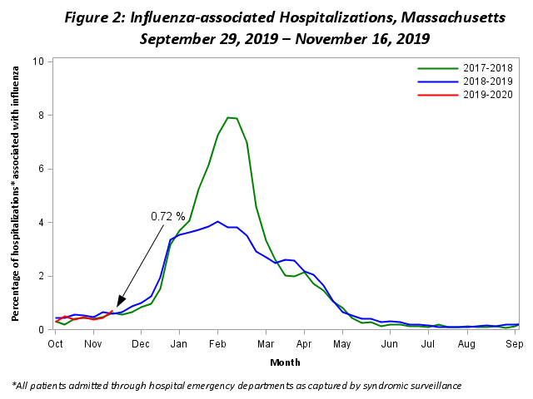

**ILI Activity in Massachusetts**

Figure 3 shows the current season’s weekly ILI activity compared to the last five flu seasons in Massachusetts. ILI activity for each week is categorized as minimal, low, moderate, or high, with a shade of blue corresponding to the category of ILI activity for that week. Darker shades of blue indicate more intense ILI activity. Figure 3 shows that ILI activity in Massachusetts is minimal this week, which is comparable to the last five seasons for the same week.

**Figure 3: ILI Activity in Massachusetts Reported Weekly by Sentinel Sites**

Figure three is a color coded representation of influenza-like illness (ILI) activity by week compared to the last five flu seasons in Massachusetts. ILI activity is categorized as minimal, low, moderate, or high. Darker shades of blue indicate more intense ILI activity. Each week is given a shade of blue corresponding to the category of ili activity for that week. As of November 16, 2019, this week's ILI activity is minimal, which is comparable to the last five seasons for the same week.

|  |  |  |  |
| --- | --- | --- | --- |
| **Minimal** | **Low** | **Moderate** | **High** |

**ILI Activity in Massachusetts by Region**

Figure 4 shows the relative intensity of reported ILI activity in Massachusetts by region. Although regions may not all experience the same intensity of ILI at similar times, infections due to influenza can be found throughout Massachusetts during flu season. Figure 4 shows that all regions of Massachusetts are reporting minimal ILI activity.

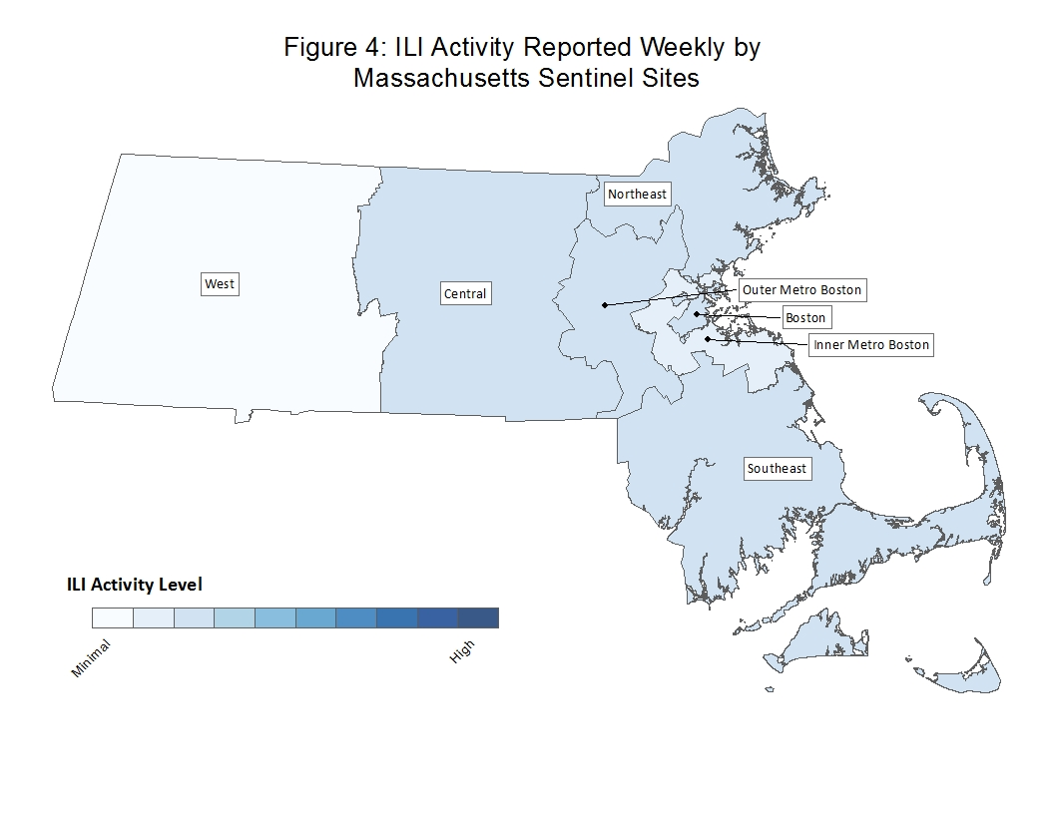

**Laboratory testing for influenza**

Laboratories in Massachusetts report all positive influenza test results to MDPH. The majority of individuals with influenza-like illness are not tested; therefore the number of positive test results does **not** reflect the total number of influenza cases in Massachusetts. However, laboratory data do provide information about the types of influenza virus circulating in Massachusetts and help indicate the presence and define the distribution of influenza in the state. Figure 5 illustrates the number of positive laboratory confirmed influenza cases in Massachusetts by week.

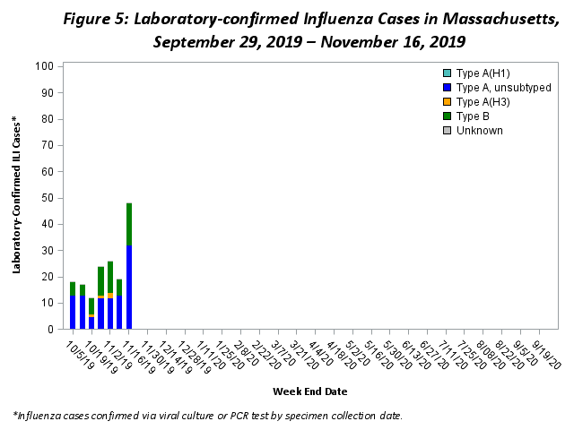

**Testing at the State Public Health Laboratory**

The Massachusetts State Public Health Laboratory (MA SPHL) performs influenza surveillance testing year round to confirm circulating influenza virus types. Samples are submitted by outpatient healthcare providers (ILINet) and hospital diagnostic laboratories in Massachusetts.  For the 2019-2020 season, Table 1 summarizes the influenza surveillance testing conducted by MA SPHL beginning September 29, 2019.  For the 2019-2020 season so far, three cases of A/H3N2 influenza, one case of B/Yamagata influenza, and three cases of B/Victoria have been confirmed in 44 samples tested.

***Table 1: Weekly Summary of Massachusetts State Public Health Laboratory Influenza Surveillance Test Results***

|  |  |  |  |  |  |  |  |  |  |
| --- | --- | --- | --- | --- | --- | --- | --- | --- | --- |
| **2019-2020 Season**: Influenza Surveillance  MA Department of Public Health’s Bureau of Laboratory Sciences (MDPH-BLS) | | | | | | | | | |
| MMWR Week:  (Specimen Collected) | 2009 H1N1 | seasonal A/H3N2 | H3N2v | B Yam | B Vic | No. Flu Pos (%) | Unsat | Total Tested | Total  Rec’d |
| 43 (10/20 – 10/26/19) | 0 | 1 | 0 | 0 | 1 | **2(33%)** | 0 | **6** | **6** |
| 44 (10/27 – 11/02/19) | 0 | 1 | 0 | 0 | 1 | **2(33%)** | 0 | **6** | **6** |
| 45 (11/03 – 11/09/19) | 0 | 0 | 0 | 0 | 0 | **0(0%)** | 0 | **13** | **13** |
| 46 (11/10 – 11/16/19) | 0 | 0 | 0 | 0 | 0 | **0(0%)** | 0 | **4** | **4** |
| **Prior 4 wk Total** | **0** | **2** | **0** | **0** | **2** | **4(14%)** | **0** | **29** | **29** |
| **Cumulative Season total** | **0** | **3** | **0** | **1** | **3** | **7(16%)** | **0** | **44** | **44** |

All data are subject to change as test results become finalized. The 2019 -2020 influenza season began the week of 09/29- 10/05/2019.

All specimens which test negative for influenza at MA SPHL are also tested for non-influenza respiratory diseases. Table 2 shows that two respiratory syncytial virus (RSV) cases, nine rhinovirus (RHV)/enterovirus (ENT) cases, one parainfluenza virus (PIV) case and one adenovirus case have been confirmed this flu season. This contributes to ILI trends in Massachusetts.

***Table 2: Weekly Summary of Massachusetts State Public Health Laboratory non-Influenza Respiratory Surveillance Test Results***

|  |  |  |  |  |  |  |  |  |  |  |  |
| --- | --- | --- | --- | --- | --- | --- | --- | --- | --- | --- | --- |
| **2019-2020 Season**: Influenza Like Illness Surveillance  MA Department of Public Health’s Bureau of Laboratory Sciences (MDPH-BLS) | | | | | | | | | | | |
| MMWR Week:  (Specimen Collected) | RSV | RHV/ENT | PIV | HMPV | HCV | ADENO | Co-Infection | No. Pos (%) | Unsat | Total Tested | Total  Rec’d |
| 43 (10/20 – 10/26/19) | 1 | 2 | 0 | 0 | 0 | 1 | 0 | **4(80%)** | 0 | **5** | **5** |
| 44 (10/27 – 11/02/19) | 1 | 0 | 0 | 0 | 0 | 0 | 0 | **1(25%)** | 0 | **4** | **4** |
| 45 (11/03 – 11/09/19) | 0 | 2 | 1 | 0 | 0 | 0 | 0 | **3(30%)** | 0 | **10** | **10** |
| 46 (11/10 – 11/16/19) | 0 | 0 | 0 | 0 | 0 | 0 | 0 | **0(0%)** | 0 | **4** | **4** |
| **Prior 4 wk Total** | **2** | **4** | **1** | **0** | **0** | **1** | **0** | **8(35%)** | **0** | **23** | **23** |
| **Cumulative Season total** | **2** | **9** | **1** | **0** | **0** | **1** | **0** | **13(36%)** | **0** | **36** | **36** |

All data are subject to change as test results become finalized. The 2019 -2020 influenza season began the week of 9/29- 10/05/2019.

MA SPHL submits a subset of influenza samples to CDC for further genetic analysis (antigenic characterization).  No influenza strains from Massachusetts have been analyzed as of yet this season.

Every two weeks MASPHL screens influenza specimens to detect mutations within influenza A/H3N2 and A/2009 H1N1 viruses to look for antiviral resistance. No specimens have been analyzed for antiviral resistance in the 2019-2020 season.

Additional information on national antiviral resistance testing including recommendations for antiviral treatment and chemoprophylaxis of influenza virus infection can be found at <http://www.cdc.gov/flu/weekly/>.