 | Welcome Family Statewide Expansion Advisory Committee
 | Massachusetts Department of Public Health

Meeting: September Meeting: Workforce Training and Capacity: Onboarding and Training
Date: September 14, 2026 | Start/End Time: 2-3 PM EST

Attendees:
Member |  | Attendance (Yes/No)
Betti | Samantha | Yes
Caffrey | Susan | No
Curry | Suzanne | Yes
Daftary | Genevieve | Yes
Duff | Laura | Yes
Fils | Samantha | No
Frias | Damaris | No
Gago | Cristina | Yes
Grasso | Joe | Yes
Hamblin | Cherise | Yes
Horgan | Cindy | Yes
Jones | Alexandria | Yes
Kim | Kira | Yes
Laflamme | Elise | Yes
Lara-Cahoon | Olivia | Yes
Manning | Meg | Yes
Martin | Jessica | Yes
McCall | Lori | Yes
Melville | Paul | No
Morrissey | Deirdre | Yes
Nalubega | Shanish | Yes
Teixeira | Lisa | Yes
Valdman | Olga | Yes
Whetzel | Leona | No

Agenda
# | Topic | Notes
1 | Introduction | - Gave the committee members an overview to inform several key components of statewide expansion.
2 | Summary of August Input | - Members emphasized the importance of strong community partnerships, high-quality referral networks, and ensuring nurses are knowledgeable about local resources available to families.  - We also heard recommendations related to data collection, ongoing family access to services, and opportunities to strengthen the role of community-based support within the Welcome Family model.
3 | Welcome Family Nurse Competencies - Statewide System of Training and Onboarding: Current State | Current training landscape  - Onboarding and training are currently managed primarily at the program level, resulting in variation across programs.  - While DPH requires several training courses across programs, there is not currently a comprehensive statewide onboarding and training system.  - Many existing competencies build upon foundational nursing knowledge and maternal and child health experience.  - Additional competencies are specific to the Welcome Family model, including its family engagement and service delivery approach.
4 | Mentimeter Word Cloud: What competencies were you glad to see included? | 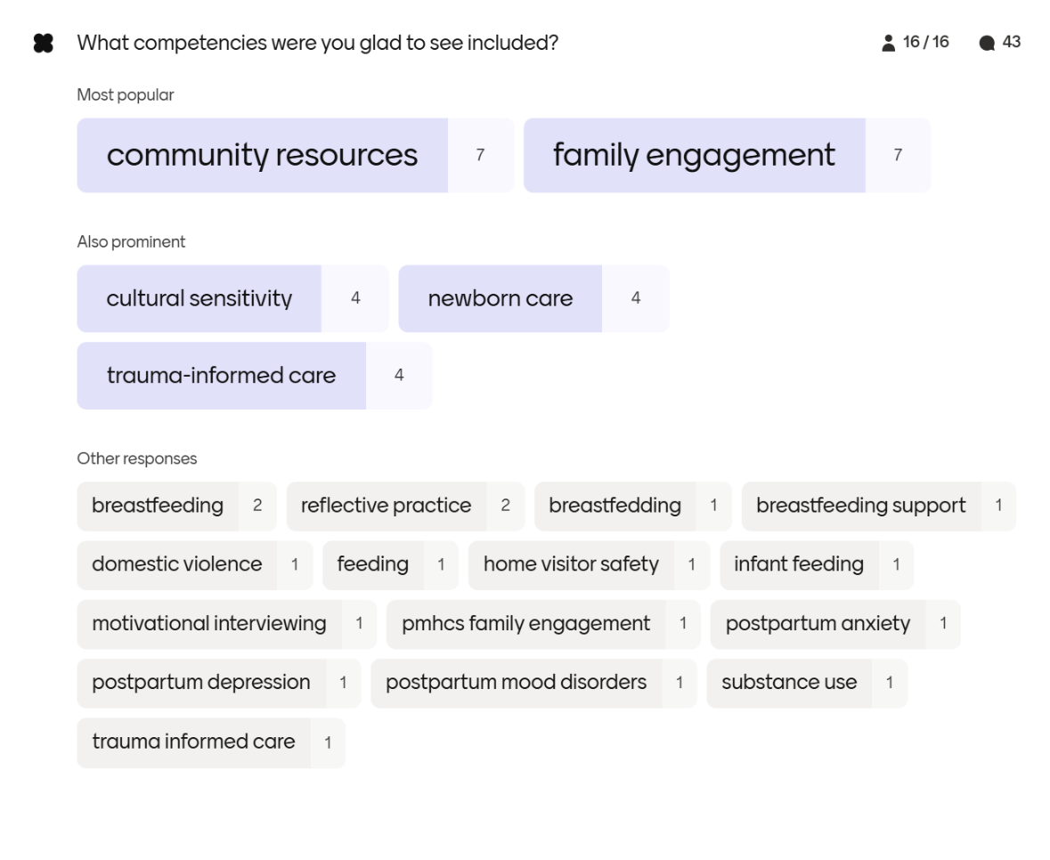
5 | Chat Waterfall 1: Please share if there are competencies missing that should be expected of a Welcome Family nurse, and why | - Develop a comprehensive inventory of resources and referral pathways to support families experiencing perinatal mental health (PMH) concerns.  - Include dedicated training on newborn immunizations and vaccine counseling to address increasing vaccine hesitancy and misinformation among families.  - Ensure nurses are prepared to connect families with appropriate resources and make timely referrals when screening or assessment identifies concerns such as postpartum depression or other behavioral health needs.  - Expand guidance on effective family engagement strategies, including how to facilitate sensitive conversations and build trust with families.  - Incorporate a strengths-based approach throughout training and service delivery.  - Strengthen competencies related to infant growth and development, including anticipatory guidance and practical strategies parents can use to support healthy development.  - Provide foundational knowledge of key support programs such as MassHealth, WIC, and Paid Family and Medical Leave (PFML), recognizing that families often need assistance navigating these complex systems.  - Ensure nurses can recognize signs and symptoms of elevated stress, anxiety, depression, and other perinatal mental health concerns.  - Clarify expectations for communication and care coordination with obstetric providers and other members of the prenatal and postpartum care team.  - Reinforce best practices related to infant sleep, safe sleep recommendations, and assessment of parental sleep deprivation and exhaustion.  - Further define breastfeeding and lactation competencies, recognizing that inpatient experience during the first few days postpartum may not fully prepare nurses for breastfeeding support in a community-based setting.  - Include crisis assessment and management skills, particularly for situations that arise during home visits, including mental health crises and other urgent family needs.  - Address screening, support, and engagement strategies for fathers and other caregivers, with particular attention to challenges related to infant feeding, sleep schedules, and adjustment to parenthood.  - Expand nutrition-related content beyond infant feeding to include maternal, parental, and family nutrition, as well as food access and food security considerations during the postpartum period.
6 | Chat Waterfall 2: What was the best training or onboarding experience you ever had? What made it great? | - Offer opportunities to pursue recognized credentials and professional development pathways, such as the Family Development Credential.  - Utilize adult learning principles and change management strategies, including reflective practice, personalized learning, coaching, and hands-on skill development.  - Incorporate multiple learning modalities, including auditory, written, visual, and experiential approaches, to support different learning styles.  - Provide opportunities to observe experienced staff in the field, allowing new team members to learn from a variety of approaches and real-world interactions.  - Foster a culture of kindness, patience, and support during onboarding and beyond.  - Establish strong mentorship structures that combine guidance, experiential learning, and opportunities to hear directly from client and family perspectives.  - Ensure supervisors are actively connected to onboarding and training activities so they can reinforce learning and integrate it into ongoing supervision.  - Including in-person, full-day training opportunities that allow for deep exploration of key topics, skill building, and interactive learning.  - Build peer support and peer mentoring systems to help new staff navigate documentation requirements, technology platforms, and field-based practice.  - Design training that is clear, organized, engaging, practical, and relationship centered.  - Create opportunities for participants to build connections, develop professional networks, and foster a sense of community among peers.  - Balance didactic content with small-group discussions, reflection, and application activities to strengthen knowledge retention and practical implementation.  - Incorporate real-life case examples, scenarios, simulations, and hands-on learning opportunities grounded in evidence-based practice.  - Establish clear learning objectives, shared language, community agreements, and accessible training environments that promote connection, inclusion, and belonging.  - Maintain centralized, easily accessible training materials and shared resources.  - Provide a structured onboarding roadmap with clear expectations for the first 90 days, including required reading, recommended training, technical assistance opportunities, key contacts, and dedicated time for questions.  - Encourage inquiry-based learning environments that emphasize critical thinking, curiosity, and reflective practice rather than a single "right" way of approaching care.  - Ensure trainers and subject matter experts are approachable, responsive, and open to questions, discussion, and respectful challenge.
7 | Poll: Which competencies reflect the greatest opportunity for the state to develop a system of strategies, tools, or resources that support welcome family programs and their nurses? Choose your top 3 | Competency, Votes  - Infant Feeding, Including Breastfeeding, 8  - Family Engagement, 8  - Knowledge and Skills for Screening and Discussing Postpartum Depression and Anxiety, 7  - Knowledge of Community Resources and Collaboration with Others in the Field, 6  - Knowledge of Newborn Care, 4  - Cultural Sensitivity, 3  - Fundamentals of Home Visiting, Including Home Visitor Safety, 3  - Knowledge of Maternal and Postpartum Care, 3  - Motivational Interviewing, 2  - Knowledge of Trauma-Informed Care, 2  - Knowledge and Skills for Screening and Discussing Substance Abuse, 2  - Knowledge and Skills for Screening and Discussing Domestic Violence, 1  - Reflective Practice, 1  - Child Abuse and Neglect, 0
8 | Breakout Group Discussions: What strategies, tools, resources and other supports should comprise the future statewide system of training for Welcome Family? | Infant Feeding and Lactation  - Infant feeding is a high-priority topic for new families and should be a core component of onboarding and ongoing training.  - Provide easily accessible, on-demand resources and infant feeding reference guides to support nurses in the field.  - Incorporate hands-on learning opportunities, including practical skill development and case-based training.  - Establish a network of regional mentors with lactation expertise to provide guidance and support.  - Consider an on-call consultation resource to assist Welcome Family nurses with complex feeding concerns.  - Ensure nurses understand the normal course of lactation, common challenges, red flags, and when referrals are needed.  - Include education on the impact of infant feeding on maternal and family well-being, including sleep, mental health, and family functioning.  - Explore incorporating Certified Lactation Counselor (CLC) training or other standardized lactation education into the onboarding process.  - Consider developing a statewide lactation education program specifically designed for home visiting nurses.  - While advanced lactation certification may not be necessary for a one-time home visit model, foundational competency in infant feeding and breastfeeding support is essential.  - Early identification of feeding challenges and maternal mental health concerns can help prevent downstream health and psychosocial impacts for both parents and infants.  - Training should balance practical knowledge, referral skills, and recognition of situations that require consultation with specialists or additional clinical support.  Family Engagement  - Emphasize skills for building rapport and establishing trust with families during visits.  - Reinforce the importance of strong interpersonal communication and emotional intelligence.  - Promote cultural humility and family-centered approaches throughout training.  - Consider hiring practices that assess relationship-building skills in addition to clinical expertise.  - Include structured shadowing experiences and observation checklists to support skill development.  - Expand opportunities for in-person buddy training and peer learning.  Knowledge and Skills for Screening and Discussing Postpartum Depression and Anxiety  - Prepare nurses to engage families with diverse communication styles, learning preferences, and cultural backgrounds.  - Ensure screening tools are readily available and easy to administer during visits.  - Provide strategies for creating multiple opportunities for families to disclose concerns, including options outside of formal screening processes.  - Build staff confidence in administering screenings, interpreting results, and facilitating supportive conversations.  - Clearly define escalation pathways, referral processes, and follow-up expectations when concerns are identified.  - Tailor training and resources to reflect the needs of specific communities and populations served.

