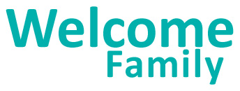

A Year in Review

July 1, 2021 to June 30, 2022

Welcome Family offers a universal, one-time nurse home visit to all caregivers with newborns up to eight weeks postpartum in Boston, Fall River, Lowell, Holyoke, and Springfield. A Year in Review shares annual program updates and accomplishments with our partners.

Highlights from the Year
- 1,439 families with newborns were served this year through virtual visits.

- The most common referrals offered were to home visiting programs (Healthy Families, Parents as Teachers, Early Intervention Parenting Partnerships Program), Early Intervention, and WIC.

- DPH contracted with Tufts Interdisciplinary Evaluation Research (TIER) to evaluate the impacts of Welcome Family and found that:
  - Infants of Welcome Family participants were 25.4% more likely than comparison group infants to be enrolled in Early Intervention by age 3.
  - Infants of Welcome Family participants were 1.21 times more likely to be enrolled in evidence-based home visiting (e.g., Healthy Families, Parents as Teachers) than the comparison group.

Family Testimonials
- “It is so hard and lonely those first few weeks with a new baby and [the nurse] was so supportive, helpful and genuinely cared for how I was doing, not just the baby. This was exactly what I needed; someone to talk to, with experience who would give me immense amounts of advice and tips to cope with a new baby.”

“The nurse took the time to actually listen to my concerns. She went above and beyond to get me to speak to the appropriate doctors to get me the help I need.”

“[Most helpful about the visit was] all the information that I have access to, to better help me become an amazing mother.”

Looking Forward…
- Welcome Family is expanding to New Bedford! Families who live in New Bedford or who give birth at St. Luke’s Hospital can now receive a visit.

- Welcome Family will continue to offer both in-person and virtual home visits for the foreseeable future.

Thank you for your continued support!
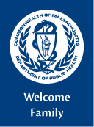
Department of Public Health
https://www.mass.gov/welcome-family
katie.stetler@mass.gov
Funded by HRSA/MCHB

