INDOOR AIR QUALITY ASSESSMENT

Wellesley Middle School
Administration Area
50 Kingsbury Road
Wellesley, MA

Prepared by:
Massachusetts Department of Public Health
Bureau of Environmental Health
Indoor Air Quality Program
February 2018

Background
Building: | Wellesley Middle School (WMS) Administration Area
Address: | 50 Kingsbury Road  Wellesley, MA
Requested by: | Joe Murray, Project Manager, Facilities Management Department, Town of Wellesley
Reason for Request: | Allergy/irritation symptoms and general indoor air quality (IAQ)
Date of Assessment: | January 24, 2018
Massachusetts Department of Public Health/Bureau of Environmental Health (MDPH/BEH) Staff Conducting Assessment: | Ruth Alfasso, Environmental Engineer/Inspector, IAQ Program
Building Description: | WMS is a two-story brick building originally constructed in 1952 as Wellesley Junior High School. Only the administrative area in the center part of the first floor was assessed during this visit.
Windows: | Windows are openable in the areas assessed.

Methods
Please refer to the IAQ Manual for methods, sampling procedures, and interpretation of results (MDPH, 2015).

Results
The following is a summary of indoor air testing results (Table 1).
- Carbon dioxide levels were slightly above 800 parts per million (ppm) in half of the areas assessed.
- Temperature was within the recommended range of 70°F to 78°F in all areas assessed.
- Relative humidity was below the recommended range of 40% to 60% in all areas as is typical during the heating season in the Northeast.
- Carbon monoxide levels were non-detectable (ND) in all indoor areas assessed.
- Fine particulate matter (PM2.5) concentrations measured were below the National Ambient Air Quality Standard (NAAQS) level of 35 micrograms per cubic meter (μg/m³) in all occupied areas.

Discussion

Ventilation
A heating, ventilating, and air conditioning (HVAC) system has several functions. First it provides heating and, if equipped, cooling. Second, it is a source of fresh air. Finally, an HVAC system will dilute and remove normally occurring indoor environmental pollutants by not only introducing fresh air, but by filtering the airstream and ejecting stale air to the outdoors via exhaust ventilation. Even if an HVAC system is operating as designed, point sources of respiratory irritation may exist and cause symptoms in sensitive individuals.
The HVAC system in this space consists of an air handling unit (AHU) located above the ceiling that draws in fresh air from intakes on the exterior wall of the building. Supply air is ducted to ceiling-mounted supply diffusers throughout the space (Picture 1). Air is returned through grates (Picture 2) to the AHU via a plenum system. The testing results in this area indicate that some additional fresh air circulation is warranted.
To maximize air exchange, the MDPH recommends that both supply and exhaust ventilation operate continuously during periods of occupancy. In order to have proper ventilation with a mechanical supply and exhaust system, the systems must be balanced to provide an adequate amount of fresh air to the interior of a room while removing stale air from the room. It is recommended that HVAC systems be re-balanced every five years to ensure adequate air systems function (SMACNA, 1994).
Heating is supplemented by radiators below windows (Picture 3). These should be cleaned periodically and kept free of blockages and items that may give off odors when heated.

Microbial/Moisture Concerns
Water-damaged ceiling tiles were observed in several of the offices examined (Pictures 4 and 5; Table 1). Wellesley school maintenance staff indicated that these resulted from leaks from the HVAC system, including steam traps for unit ventilators in the library located above the area assessed. Water-damaged ceiling tiles can be a source of mold and odors, and should be replaced once the leak is repaired. During replacement, the area above the ceiling tile should be examined for any water damage or microbial growth and repaired/cleaned as needed. What appeared to be water-damaged plaster was observed in the ceiling of the file room (Picture 6). Sprinklers should be monitored and maintained to prevent leakage.
Plants were observed in some areas of the office (Picture 7). Plants should be well maintained, not overwatered and kept away from the airstream of ventilation equipment to prevent odors, water damage, and pests.

Other Conditions
Hand sanitizers and cleaning products were also noted in some areas of the office space. Dry erase boards with pens and cleaning solutions were also observed in several offices. These products can cause irritation of the eyes, nose and respiratory system of some people.
In some areas, items were observed on the floor, windowsills, tabletops, counters, bookcases and desks. Stored items provide a source for dusts to accumulate and make it difficult for custodial staff to clean. Items should be relocated and/or be cleaned periodically to avoid excessive dust build up. Some areas examined were carpeted. The Institute of Inspection, Cleaning and Restoration Certification (IICRC), recommends that carpeting be cleaned annually (or semi-annually in soiled high traffic areas) (IICRC, 2012).

Conclusions/Recommendations
Based on the observations made during the visit, the following is recommended:
- Operate the HVAC system to provide for continuous fresh air ventilation during occupied hours. Ensure any fresh air intake louvres are opened adequately.
- If openable windows are used to supplement fresh air, ensure that they are kept closed when the HVAC system is operating in cooling mode to prevent condensation, and are tightly closed at the end of the day.
- Replace water-damaged ceiling tiles once leaks are repaired. Inspect the area above the stained tiles for water damage or odors and remediate or clean as necessary.
- Ensure plants are well maintained and not overwatered. Keep them away from the airstream of ventilation equipment.
- For buildings in New England, periods of low relative humidity during the winter are often unavoidable. Therefore, scrupulous cleaning practices should be adopted to minimize common indoor air contaminants whose irritant effects can be enhanced when the relative humidity is low. To control for dusts, a high efficiency particulate arrestance (HEPA) filter equipped vacuum cleaner in conjunction with wet wiping of all surfaces is recommended. Avoid the use of feather dusters. Drinking water during the day can help ease some symptoms associated with a dry environment (throat and sinus irritations).
- Reduce or eliminate the use of scented cleaners, hand sanitizers and dry erase materials to reduce irritation.
- Consider reducing the amount of stored materials to allow for more thorough cleaning. Clean items regularly with a wet cloth or sponge to prevent excessive dust build-up.
- Clean radiators once a year to remove dust build up that may lead to odors when heated.
- Clean carpeting at least once per year according to IICRC recommendations (IICRC 2012). Consider replacing any carpeting that is beyond its service life. In below-grade areas, consider using non-porous flooring instead of carpeting when flooring is replaced.
- Consider setting up a balancing schedule to have the HVAC system balanced every five years.
- Ensure filters for AHUs are of a pleated variety, Minimum Efficiency Reporting Value (MERV) dust-spot efficiency 8 or higher, which are adequate in filtering out pollen and mold spores (ASHRAE, 2012). Filters should be changed 2-4 times a year or in accordance with the manufacture’s recommendations.
- Refer to resource manuals and other related IAQ documents for further building-wide evaluations and advice on maintaining public buildings. Copies of these materials are located on the MDPH’s website: http://mass.gov/dph/iaq.

References
ASHRAE. 2012. American Society of Heating, Refrigeration and Air Conditioning Engineers. Standard 52.2-2012 -- Method of Testing General Ventilation Air-Cleaning Devices for Removal Efficiency by Particle Size (ANSI Approved).
IICRC. 2012. Institute of Inspection Cleaning and Restoration Certification. Institute of Inspection, Cleaning and Restoration Certification. Carpet Cleaning: FAQ. Retrieved from http://www.iicrc.org/consumers/care/carpet-cleaning.
MDPH. 2015. Massachusetts Department of Public Health. “Indoor Air Quality Manual: Chapters I-III”. Available at: http://www.mass.gov/eohhs/gov/departments/dph/programs/environmental-health/exposure-topics/iaq/iaq-manual/.
SMACNA. 1994. HVAC Systems Commissioning Manual. 1st ed. Sheet Metal and Air Conditioning Contractors’ National Association, Inc., Chantilly, VA.
Picture 1
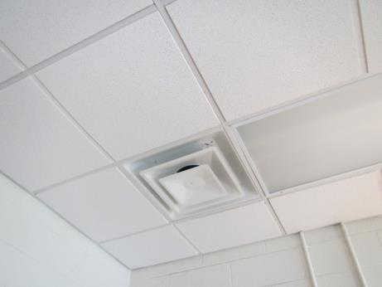
Typical supply vent
Picture 2
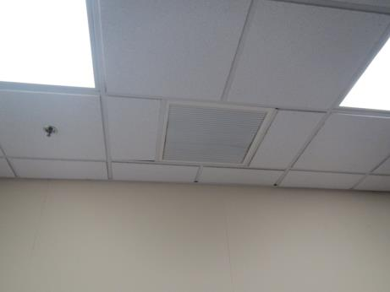
Exhaust/return vent
Picture 3
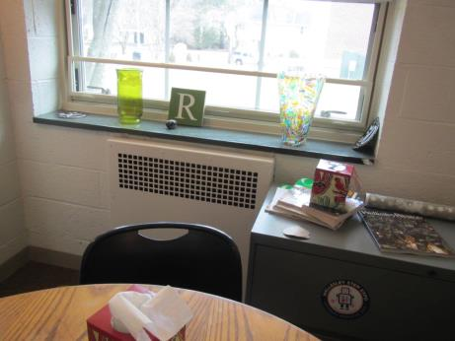
Radiator
Picture 4
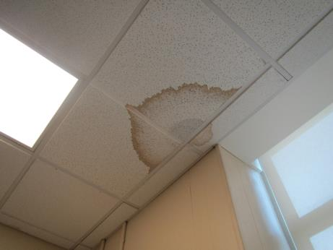
Water-damaged ceiling tiles
Picture 5
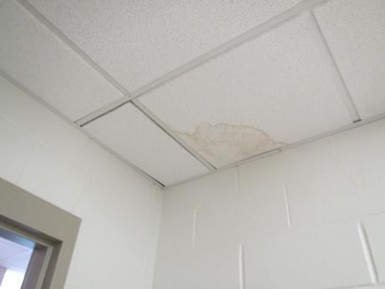
Water-damaged ceiling tiles
Picture 6
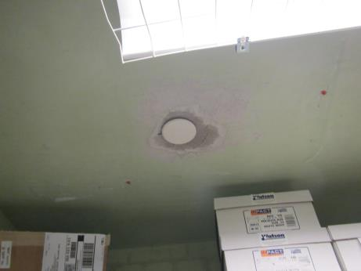
Possibly water-damaged ceiling plaster next to sprinkler head
Picture 7
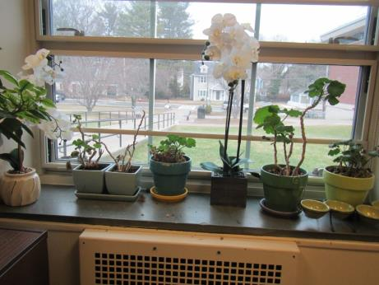
Plants in the copy room

Location | Carbon  Dioxide  (ppm) | Carbon Monoxide  (ppm) | Temp  (°F) | Relative  Humidity  (%) | PM2.5  (µg/m³) | Occupants  in Room | Windows  Openable | Ventilation |  | Remarks
 |  |  |  |  |  |  |  | Supply | Exhaust
Background | 424 | 1.0 | 44 | 31 | 1 |  |  |  |  | Cloudy
285-2 | 840 | ND | 71 | 29 | 1 | 2 just left | Y | Y |  | 2 WD CT, historic from steam trap leaks in library above, carpeted
Hallway in 285 | 920 | ND | 72 | 28 | 1 | 0 | N | N |  | 2 WD CT from historic air handling unit leak
285-3 | 780 | ND | 74 | 25 | 0 | 0 | Y | Y |  | DEM
281 main office waiting area | 886 | ND | 75 | 23 | 1 | 3 | N | Y | Y | NC, HS
Main office file area | 789 | ND | 75 | 23 | 2 | 0 | N | N | N | Concrete floor, WD plaster around sprinkler head, items on floor
Main office | 797 | ND | 75 | 23 | 1 | 5 | Y | Y | Y | Carpeted, DEM
Copy room | 737 | ND | 74 | 23 | 1 | 0 | Y | Y | Y | Carpeted, 2 WD CT, fridge, plants, photocopier
Principal’s office | 821-930 | ND | 74 | 24 | 1 | 2 | Y | Y | Y | Carpeted, DEM, books

