INDOOR AIR QUALITY ASSESSMENT

Wellesley Middle School
50 Kingsbury Street
Wellesley, MA

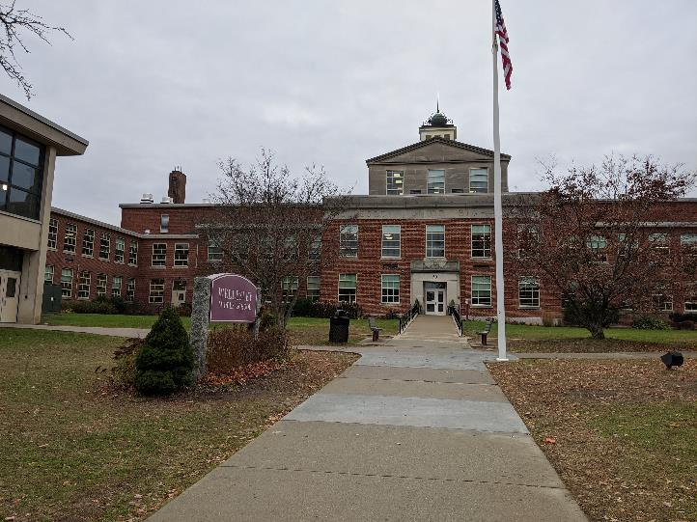

Prepared by:
Massachusetts Department of Public Health
Bureau of Environmental Health
Indoor Air Quality Program
February 2020

Background
Building: | Wellesley Middle School (WMS)
Address: | 50 Kingsbury Street  Wellesley, MA
Requested by: | Joe Murray, Project Manager, Facilities Management Department, Town of Wellesley
Reason for Request: | General IAQ
Date of Assessment: | February 10, 2020
Massachusetts Department of Public Health/Bureau of Environmental Health (MDPH/BEH) Staff Conducting Assessment: | Ruth Alfasso, Environmental Engineer/Inspector, Cory Holmes, Environmental Analyst/Inspector and Jason Dustin, Environmental Analyst/Inspector, IAQ Program
Building Description: | WMS is a two-story brick building originally constructed in 1952 as Wellesley Junior High School. Additions were built in 1958 and 1967 (new N & S CR wing). Major renovations were conducted in 2005-2007. New windows were installed and the roof was replaced recently as well.
Windows: | Windows are openable in most areas of the school.
Note that portions of this building were visited by the IAQ Program previously. In 2018, the administration wing was visited for general IAQ concerns and allergy symptoms. In 2019, room 103 was visited for an odor complaint. Reports from these visits can be found at https://www.mass.gov/info-details/indoor-air-quality-reports-cities-and-towns-w#wellesley-. The administration wing was not visited during this assessment.

Methods
Please refer to the IAQ Manual for methods, sampling procedures, and interpretation of results (MDPH, 2015).

Results
The following is a summary of indoor air testing results (Table 1).
- Carbon dioxide levels were below the MDPH recommended level of 800 parts per million (ppm) in most of the areas surveyed, indicating adequate air exchange in nearly all areas of the building.
- Temperature was within or close to the MDPH recommended range of 70°F to 78°F in occupied areas. Many areas had readings a few degrees below 70°F and a few areas had readings above 78°F. Temperature control issues were frequently reported in the building.
- Relative humidity was below the lower end of the MDPH recommended range of 40 to 60% in nearly all areas tested the day of assessment, which is typical of conditions during the heating season.
- Carbon monoxide levels were non-detectable (ND) in all areas tested.
- Particulate matter (PM2.5) concentrations measured were below the National Ambient Air Quality (NAAQS) level of 35 μg/m³ in all areas tested.
- Total Volatile Organic Compounds (TVOC) were measured in a few areas where VOCs might be expected to be generated; all readings were ND.

Discussion

Ventilation
A heating, ventilating, and air conditioning (HVAC) system has several functions. First it provides heating and, if equipped, cooling. Second, it is a source of fresh air. Finally, an HVAC system will dilute and remove normally occurring indoor environmental pollutants by not only introducing fresh air, but by filtering the airstream and ejecting stale air to the outdoors via exhaust ventilation. Even if an HVAC system is operating as designed, point sources of respiratory irritation may exist and cause symptoms in sensitive individuals.
The WMS has a combination of HVAC equipment. Most classrooms are equipped with unit ventilators (univents, Picture 1). A univent draws fresh air through a vent on the exterior wall (Picture 2). Air is mixed with return air from the room, filtered, heated (if needed) and delivered to the room (Figure 1). Both the top and the vent at the bottom need to be kept clear of obstructions for the units to operate as designed. Some offices and common areas of the school (e.g., gymnasium, auditorium) have fresh air supplied through ceiling-mounted vents from air handling units (AHU) located in utility rooms or above ceilings.
Exhaust ventilation for rooms with univents is supplied by wall-mounted vents (Picture 3) or exhaust “cubbies” (Picture 4). The “cubby” type exhausts are found in the oldest parts of the school, and were probably originally designed to use the stack effect to draw heated stale air up and out of the building. Currently, both types of vents are connected to fans on the roof. Most wall-mounted exhaust vents tested were drawing air; however air flow could not be detected through the older “cubby” style vents. Rooms with air supplied by AHU typically have ceiling-mounted exhaust vents (Picture 5). At the time of the assessment, commissioning work was being performed on the exhaust system to identify and repair non-functioning exhaust vents.
To maximize air exchange, the MDPH recommends that both supply and exhaust ventilation operate continuously during periods of occupancy. In order to have proper ventilation with a mechanical supply and exhaust system, the systems must be balanced to provide an adequate amount of fresh air to the interior of a room while removing stale air from the room. It is recommended that HVAC systems be re-balanced every five years to ensure adequate air systems function (SMACNA, 1994).
A few rooms did not have any source of ventilation. Room 115, for example, has no window and no source of supply or exhaust apart from passive vents to adjacent rooms. This room was originally for storage, and was converted to a classroom. Rooms that are intended for regular occupancy, particularly by groups of students, should have a source of fresh air and exhaust.
Radiators supply additional heating in some areas. In some offices and other areas, ductless air conditioning units were present to supply cooling. Temperature control issues were reported by staff in some areas of the building. As noted above, many areas were a few degrees colder than the recommended range of 70°F to 78°F. The heating system is controlled by a computer system using a thermostat in nearly every occupied room (e.g. Picture 6). Thermostats can be adjusted through a small range to supply less or more heating for that room. Not all occupants were aware that this option is available. Some occupants had placed wet paper towels on top of thermostats to “trick” them into reading a colder temperature than representative of the room and thus supply more heat. Not only does this method prevent facility staff from adjusting the heating system to serve everyone, but moisture on the thermostat can degrade the electronics in the unit and cause premature failure. Other thermostats were behind furniture, preventing an accurate reading of room temperature (Picture 7). Occupants should work with facility staff to properly adjust heat and ventilation to a comfortable range.
Note that many of the exhaust vents and wall-mounted thermostats are located near the doors to the hallway. These are both designed to function most efficiently when the hallway doors are closed. When hallway doors are open, the exhaust vents tend to draw stale air from the hallway instead of the room, and thermostats measure hallway temperatures instead of room temperatures.
The stairwells at the ends of the wings have only minimal heating through a single radiator on the bottom level. Since these are large open areas with exterior walls and windows on most sides, they can be cold during winter months such as during the assessment. Cold air from the stairwells can make temperature control difficult in the rooms nearest the stairs.

Microbial/Moisture Concerns
In order for building materials to support mold growth, a source of water exposure is necessary. Identification and elimination of the source of water moistening building materials is necessary to control mold growth. Water-damaged ceilings/tiles were observed in some classrooms and offices (Table 1; Pictures 8 and 9), which can indicate current/historic roof/plumbing leaks or other water infiltration. Water-damaged ceiling tiles can provide a source of mold and should be replaced after a water leak is discovered and repaired. The United States Environmental Protection Agency (US EPA) and the American Conference of Governmental Industrial Hygienists (ACGIH) recommend that porous materials be dried with fans and heating within 24 to 48 hours of becoming wet (US EPA, 2008; ACGIH, 1989). If porous materials are not dried within this time frame, they should be removed and discarded.
Facility staff report that the roof is repaired whenever leaks are found. No active leaks were observed during the assessment.
The refrigerator in the staff lunchroom had evidence of a spill (Table 1). Refrigerators should be cleaned out regularly to prevent odors and microbial growth. Stained gaskets should be cleaned with a mild antimicrobial solution; if they are too heavily stained/damaged, they should be replaced. Refrigerators should not be placed on carpet/porous materials (Picture 10) to protect carpets from spills.
Plants were present in some classrooms and other areas (Picture 11). Plants should be well maintained, not overwatered, and not placed on porous materials or in the airstream of ventilation equipment. A few aquariums were observed in the building (Picture 12). Aquariums should also be kept in good condition to prevent mold/odors.
Sinks are present in some classrooms. Some of these appear to be disused. Unwanted plumbing should be cut and capped appropriately. Facility staff report that several restrooms were converted to storage space and that plumbing in these areas was cut and capped.
A sewer gas odor was detected in the boys’ locker room (Table 1). Since showers in this area are seldom used, the drain traps can dry out and allow gases and odors from the drainage system into the room (Picture 13). Similar issues are reported to occur in the coaches’ office area which has a shower now being used for equipment storage. Drain traps should be filled with water regularly to ensure a good trap seal. If floor drains are no longer needed, they should be properly sealed.
Ductless and portable air conditioning units (Picture 14), found in some areas of the building, create condensation. The drains from these units should have appropriate drainage, and the drain lines and pumps should be checked periodically for clogs and leaks.
Door sweeps were worn out in some areas of the building. Doors should be made tight-fitting to prevent unconditioned air, moisture and pests from entering the building.
There is a room on the lowest level which is used to access some electrical wiring. Groundwater accumulates in this room which appears to be chronically wet. Chronic moisture in this room may contribute odors, mold and excess humidity to other areas of the lower level. Until drainage issues can be resolved in this room, the door should be kept tightly closed; use of a door sweep or other weather-stripping may also be useful to decrease transfer of air between this room and any occupied areas.

Other Conditions
Exposure to low levels of total volatile organic compounds (TVOCs) may produce eye, nose, throat, and/or respiratory irritation in some sensitive individuals. BEH/IAQ staff measured TVOCs in the photography/darkroom area, and none were detected. BEH/IAQ staff also examined rooms for products containing VOCs and noted hand sanitizers, scented products, plug in air fresheners/diffusers (Picture 15), home cleaning products, and dry erase materials in use within the building. All of these products have the potential to be irritants to the eyes, nose, throat, and respiratory system of sensitive individuals. In addition, spray bottles/cleaning products should be kept out of reach of children.
The health/kitchen room (Room 241) has several stoves, including one which is gas fired. No exhaust fan or hood was present for this stove. Exhaust hoods are used to eject products of combustion (e.g., carbon monoxide, nitrogen dioxide, carbon dioxide, water vapor, particulates, odors, heat) to the outdoors. Exchanging the gas range for an electric range would be an improvement but would not address the particulates, water vapor, heat, and odors associated with cooking/heating of foods.
The production room on the lower level has several photocopiers, other mail machines and a laminator. All of this equipment can be a source of TVOCs and odors. Photocopiers can also be a source of ozone. There is currently no direct vented exhaust in this room. When possible, windows should be opened when the equipment is being heavily used. Installation of a direct exhaust vent or fan to the outdoors should be considered.
In some classrooms, tennis balls were being used as chair glides. Regular tennis balls contain latex. However, the blue coloration of most of the tennis balls noted in the building may indicate that they are latex-free chair glides specially designed for use in classrooms. Regular tennis balls, which were seen in a few rooms (Picture 16), are made of a number of materials that are a source of respiratory irritants. Constant wearing of tennis balls can produce fibers and lead to off-gassing of VOCs. Tennis balls are made with a natural rubber latex bladder, which becomes abraded when used as a chair leg pad. Use of tennis balls in this manner may introduce latex dust into the school environment. Some individuals are highly allergic to latex (e.g., spina bifida patients) (SBAA, 2001). It is recommended that the use of materials containing latex be limited in buildings to reduce the likelihood of symptoms in sensitive individuals (NIOSH, 1998).
The MDPH recommends pleated filters with a Minimum Efficiency Reporting Value (MERV) of 8, which are adequate in filtering out pollen and mold spores (ASHRAE, 2012). Filters should also be changed two to four times a year, or per the manufacturer’s recommendations. Facility staff report that filters are changed at least three times a year and the cabinets vacuumed at those times. Boxes of MERV 8 filters were found in the facility. In a few classrooms, extra external filters were placed on top of the univent supply vent (Picture 17). These filters were installed in order to address concerns regarding dust from the supply vent. It is reportedly planned to thoroughly clean the less accessible parts, which requires removing most of the univent from the wall, during the next maintenance cycle to see if this addresses dust concerns. Insulation on the inside of the unit may be disintegrating, which may account for dust/debris seen from the units. Note that the use of these external filters may be impeding airflow from these units.
A few areas of the school are carpeted and some classrooms have area rugs. Carpeting should be vacuumed regularly with a high efficiency particulate arrestance (HEPA) filter equipped vacuum cleaner to avoid particulates from causing further irritation or serving as a reservoir for microbial colonization. Also, carpeting and rugs should be cleaned at least once per year according to IICRC recommendations (IICRC 2012). Some carpeting, such as in the Information Technology Suite, appeared worn. It should be noted that the usable life of carpeting in schools is approximately 10-11 years (IICRC, 2002). Aging carpet can produce fibers that can be irritating to the respiratory system. Area rugs too worn to be effectively cleaned should be replaced. Area rugs should be rolled up and stored in a clean, dry place when rooms are not occupied during the summer months to prevent moistening due to condensation.
In many classrooms, large numbers of items were on floors, windowsills, tabletops, counters, bookcases and desks, which provide a source for dusts to accumulate (Picture 18). These items (e.g., papers, folders, boxes) make it difficult for custodial staff to clean. Items should be relocated and/or be cleaned periodically to avoid excessive dust build up. In addition, dust and debris can accumulate on flat surfaces (e.g., desktops, shelving and carpets) in occupied areas and subsequently be re-aerosolized causing further irritation. Pencil shavings were seen on surfaces (Picture 19), which can be a source of irritating dusts.
The shop/technology area was equipped with several local exhaust options to collect wood dust from equipment as well as the general exhaust system. In some areas the exhaust ducts all connect via vacuum with a collection system outdoors (Picture 20), which is preferable. Other areas are outfitted with a wood dust collection system that is located indoors (Picture 21) (i.e., filters and returns air to the room). Both areas are supplemented by air filtration units (Picture 22) and local exhaust fans (Picture 23) to assist in capturing fugitive dusts. These local exhaust units need to be turned on whenever the equipment is operating along with the room exhaust. The collection system should be emptied and maintained regularly to prevent a build-up of wood shavings; this would include changing the filters as recommended by the manufacturer.
The photography area also has several different ventilation components. The Darkroom itself has local exhaust vents located directly over chemical developing areas (Picture 24), which were operating at the time of assessment. Photography room B had an air filtration unit installed in the ceiling, which was not in use at the time of assessment. It was not clear what the function/capabilities of this unit were (e.g., able to filter out airborne photography chemicals). This unit did not appear to exhaust to the outdoors (i.e., remove airborne pollutants) but rather draws air into a filter and recirculates back into the room.
Art room 304b contained a kiln that was outfitted with local exhaust that vents directly outdoors. It was also reported that students occasionally perform soldering work. In the past, the majority of soldering compounds contained lead. Art staff should ensure that any soldering compounds used are environmentally friendly/lead-free products. In addition, local exhaust fans located above work stations (Picture 25) should be activated during soldering as well as any other odor or dust producing activities.
Note that the Environmental Protection Agency (EPA) conducted a National School Radon Survey in which it discovered nearly one in five schools had “…at least one frequently occupied ground contact room with short-term radon levels above 4 [picocuries per liter] pCi/L” (US EPA 1993). The BEH/IAQ Program therefore recommends that every school be tested for radon, and that this testing be conducted during the heating season while school is in session in a manner consistent with USEPA radon testing guidelines. Radon measurement specialists and other information can be found at www.nrsb.org and http://aarst-nrpp.com/wp, with additional information at: http://www.mass.gov/eohhs/gov/departments/dph/programs/environmental-health/exposure-topics/iaq/radon.

Conclusions/Recommendations
In view of the findings at the time of the visit, the following recommendations are made:
- Utilize a system to report and track maintenance issues so that concerns can be reported by staff and maintenance staff can indicate when issues have been resolved.
- Operate the HVAC system to provide for continuous fresh air ventilation during occupied hours.
- Remove furniture and items blocking the front and top of univents.
- Remove furniture and items blocking exhaust vents. Consider closing classroom doors for most efficient exhaust vent function and accurate thermostat readings.
- Continue with exhaust vent commissioning. Periodically check exhaust vents for draw of air, particularly in high-pollutant areas such as restrooms.
- For occupied rooms without a source of supply and exhaust ventilation or an openable window, consider methods to add mechanical ventilation.
- Use openable windows to supplement fresh air during temperate weather. Ensure all windows are closed tightly at the end of each day. Do not use windows while AC system is operating to prevent condensation/mold growth.
- Consider adopting a balancing schedule of every 5 years for all mechanical ventilation systems, as recommended by ventilation industrial standards (SMACNA, 1994).
- Ensure staff are aware of the location and function of thermostats. Remind staff not to tamper with thermostats (e.g., with a wet paper towel) and to keep them clear of large furniture and other obstructions.
- Consider adding additional heating to the stairwells at the end of wings to help address temperature concerns in nearby classrooms.
- Replace water-damaged ceiling tiles once a leak is discovered and repaired. Ensure that dust from cutting ceiling tiles is cleaned promptly.
- Replace any missing or ajar ceiling tiles to avoid pathways to unconditioned areas.
- Keep classroom/office plants in good condition, avoid overwatering, and keep them away from the airstream of ventilation equipment.
- Ensure aquariums are clean and odor free.
- Ensure all refrigerators are kept clean to prevent microbial growth and odors. Clean gaskets and other surfaces with a mild antimicrobial solution to remove debris and mold. If gaskets cannot be adequately cleaned, replace them.
- Ensure that unused plumbing, including floor drains, are either regularly maintained to keep the traps seals wet, or are properly cut and capped. Pour water down drains on a weekly basis, or as needed to prevent dry drain traps/sewer gas odors.
- Check the drain tubing and pumps on ductless air conditioners periodically for clogs and leaks.
- Replace worn out door sweeps. Check for light and drafts around doors.
- Repair drainage in electric access room in the basement. Until drainage can be repaired, consider using weather-stripping on this door to prevent infiltration of odors and moisture from this room. Avoid any storage in this room.
- Reduce or eliminate the use of air fresheners, scented cleaners, hand sanitizers and dry erase materials to reduce irritation.
- Ensure local exhaust vents for Darkroom are drawing air prior to developing processes.
- Determine the use/function of air filtration unit in Photography room B.
- Ensure local exhaust vents/fans for kiln and other fume/dust producing activities are operating to reduce/prevent exposure to airborne pollutants.
- Ensure soldering materials in use are lead-free.
- Ensure wood dust collection units, air filters and local exhaust fans are turned on whenever the equipment is operating. The collection system should be emptied and maintained regularly to prevent a build-up of wood shavings and filters should be changed per manufacturer recommendations.
- Consider adding exhaust ventilation to the production room.
- Check if blue tennis ball/glides on chair legs are latex free and replace those that may contain latex with non-latex glides.
- Continue to change filters in HVAC units at least twice a year with MERV 8 or higher filters. Clean HVAC and univent cabinets of debris and dust when filters are changed.
- Clean supply/exhaust vents and personal fans regularly to remove accumulated dust/debris. Replace surrounding ceiling tiles that cannot be adequately cleaned.
- For buildings in New England, periods of low relative humidity during the winter are often unavoidable. Therefore, scrupulous cleaning practices should be adopted to minimize common indoor air contaminants whose irritant effects can be enhanced when the relative humidity is low. To control for dusts, a high efficiency particulate arrestance (HEPA) filter equipped vacuum cleaner in conjunction with wet wiping of all surfaces is recommended. Avoid the use of feather dusters. Drinking water during the day can help ease some symptoms associated with a dry environment (throat and sinus irritations).
- Clean carpeting and area rugs at least once per year according to IICRC recommendations (IICRC 2012). Area carpets too worn to be effectively cleaned should be replaced. Roll up and store are rugs in a clean, dry place during the summer.
- Relocate or consider reducing the amount of materials stored in classrooms to allow for more thorough cleaning of classrooms. Clean items regularly with a wet cloth or sponge to prevent excessive dust build-up.
- Ensure fluorescent light fixtures have covers installed.
- Continue to utilize the US EPA’s (2000), “Tools for Schools”, as an instrument for maintaining a good IAQ environment in the building available at: http://www.epa.gov/iaq/schools/index.html.
- The school should be tested for radon by a certified radon measurement specialist during the heating season when school is in session. Radon measurement specialists and other information can be found at: www.nrsb.org, and http://aarst-nrpp.com/wp.
- Refer to resource manuals and other related IAQ documents for further building-wide evaluations and advice on maintaining public buildings. Copies of these materials are located on the MDPH’s website: http://mass.gov/dph/iaq.

References
ACGIH. 1989. Guidelines for the Assessment of Bioaerosols in the Indoor Environment. American Conference of Governmental Industrial Hygienists, Cincinnati, OH.
MDPH. 2015. Massachusetts Department of Public Health. “Indoor Air Quality Manual: Chapters I-III”. Available at: http://www.mass.gov/eohhs/gov/departments/dph/programs/environmental-health/exposure-topics/iaq/iaq-manual/.
NIOSH. 1998. National Institute for Occupational Safety and Health. Latex Allergy A Prevention. National Institute for Occupational Safety and Health, Atlanta, GA.
SBAA. 2001. Latex In the Home And Community Updated Spring 2001. Spina Bifida Association of America, Washington, DC.
SMACNA. 1994. HVAC Systems Commissioning Manual. 1st ed. Sheet Metal and Air Conditioning Contractors’ National Association, Inc., Chantilly, VA.
US EPA. 1993. Radon Measurement in Schools, Revised Edition. Office of Air and Radiation, Office of Radiation and Indoor Air, Indoor Environments Division (6609J). EPA 402-R-92-014. https://www.epa.gov/sites/production/files/2014-08/documents/radon_measurement_in_schools.pdf.
US EPA. 2000. Tools for Schools. Office of Air and Radiation, Office of Radiation and Indoor Air, Indoor Environments Division (6609J). EPA 402-K-95-001, Second Edition. http://www.epa.gov/iaq/schools/index.html.
US EPA. 2008. “Mold Remediation in Schools and Commercial Buildings”. Office of Air and Radiation, Indoor Environments Division, Washington, DC. EPA 402-K-01-001. September 2008. Available at: http://www.epa.gov/mold/mold-remediation-schools-and-commercial-buildings-guide.
Picture 1
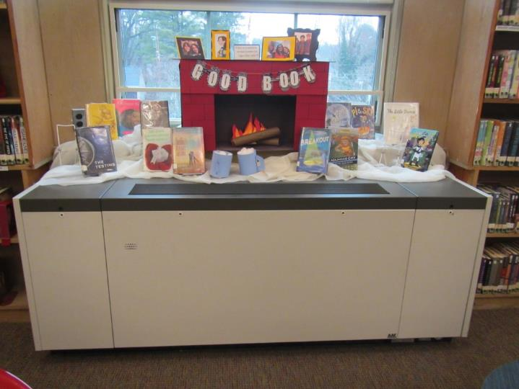
Unit ventilator
Picture 2
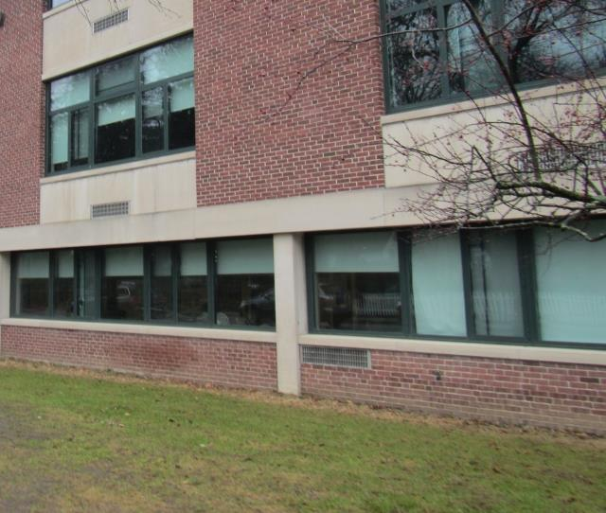
Univent air intakes (arrows)
Picture 3
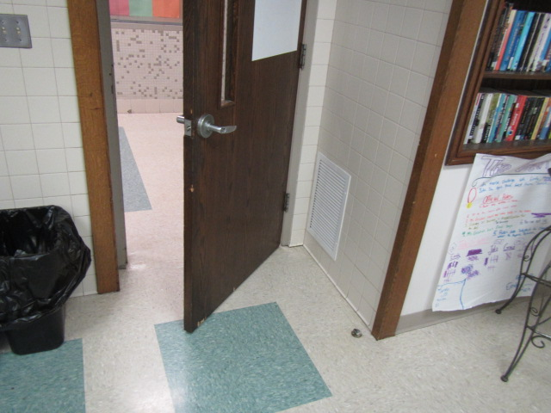
Wall-mounted exhaust vent
Picture 4
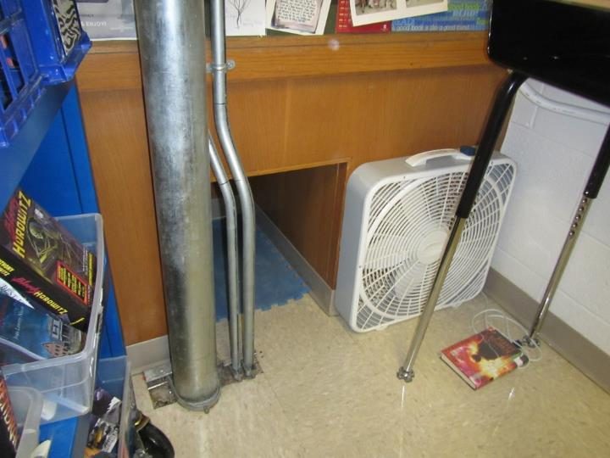
Exhaust “cubby”
Picture 5
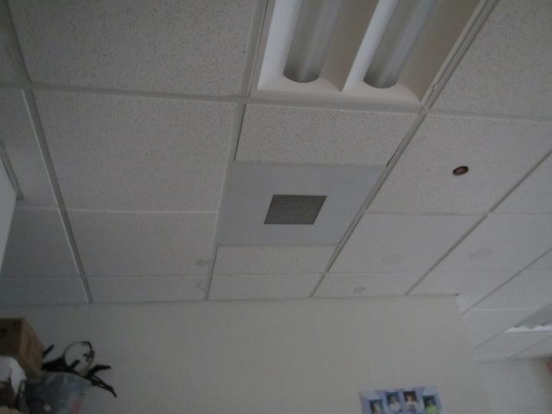
Ceiling-mounted return/exhaust vent
Picture 6
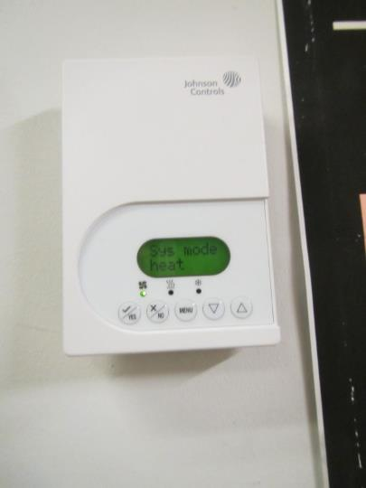
Typical thermostat
Picture 7
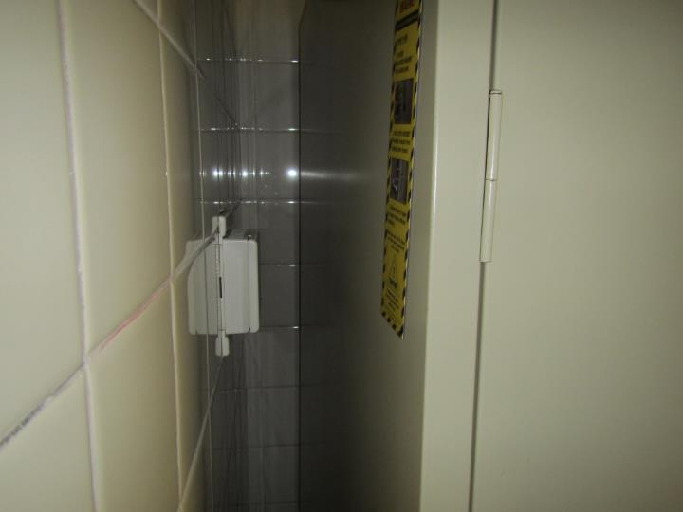
Thermostat behind furniture
Picture 8
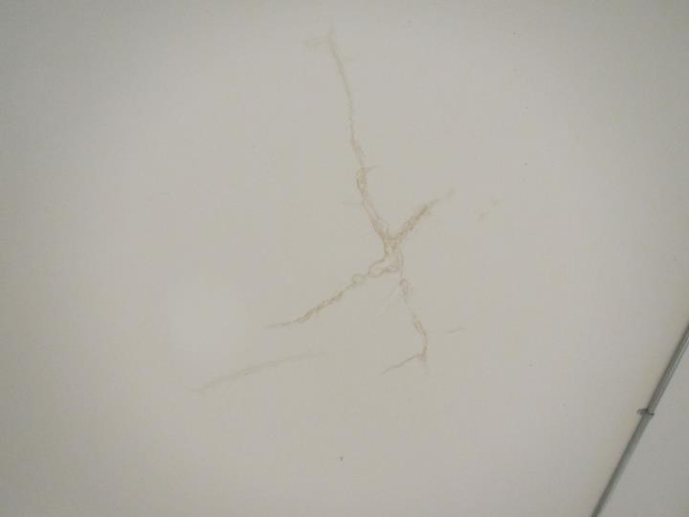
Water-damaged ceiling plaster
Picture 9
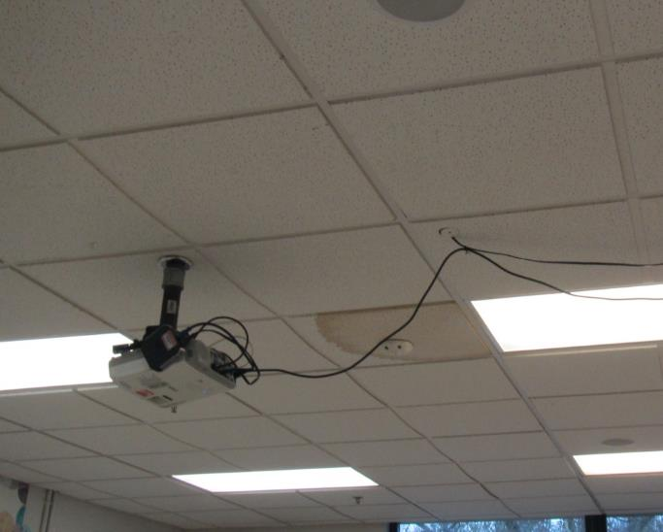
Water-damaged ceiling tile
Picture 10
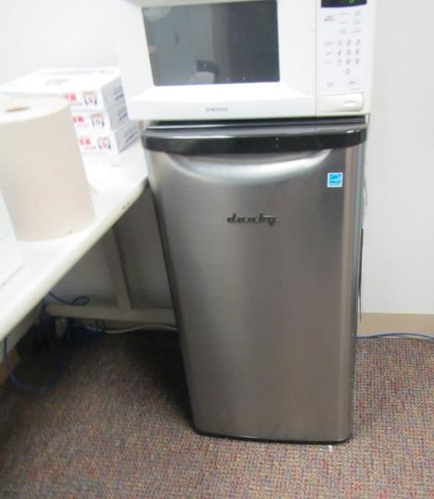
Refrigerator on carpet
Picture 11
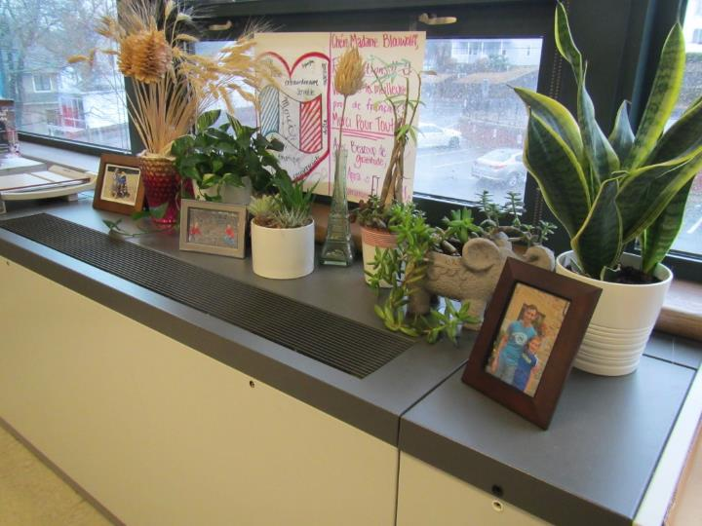
Plants on a univent
Picture 12
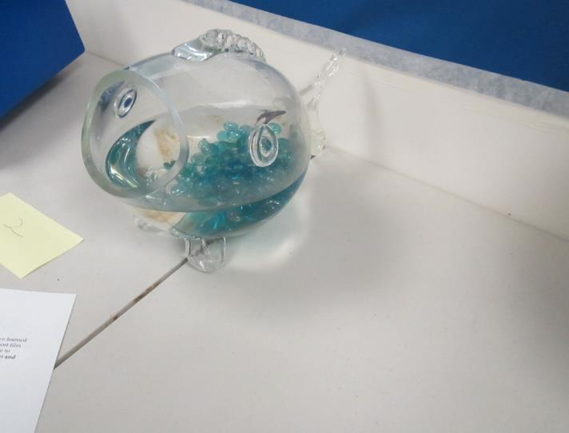
Aquarium
Picture 13
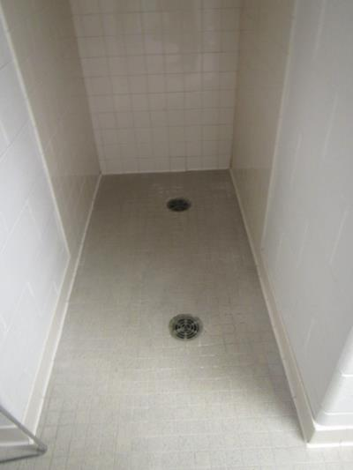
Drains in seldom-used shower area
Picture 14
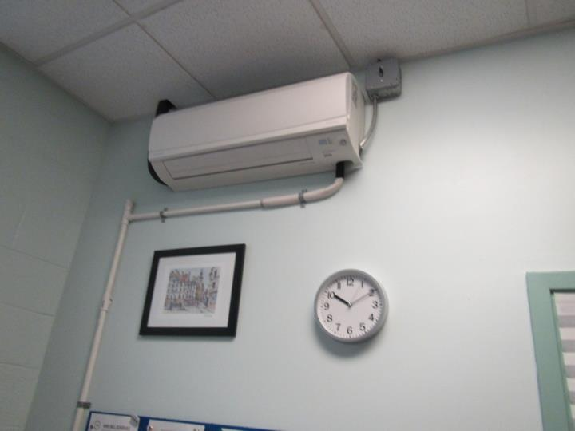
Ductless air conditioner
Picture 15
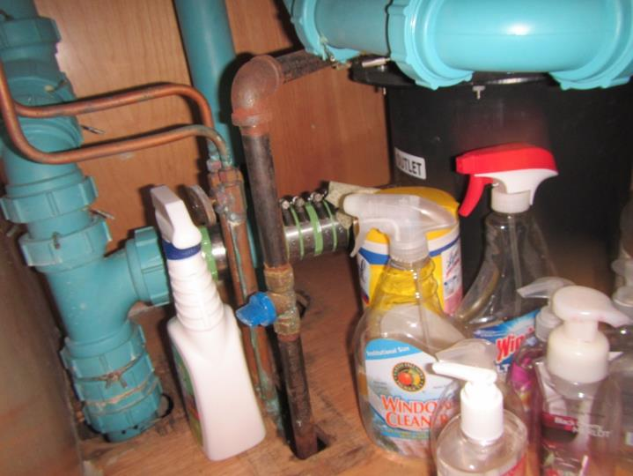
Hand sanitizer and cleaning products
Picture 16
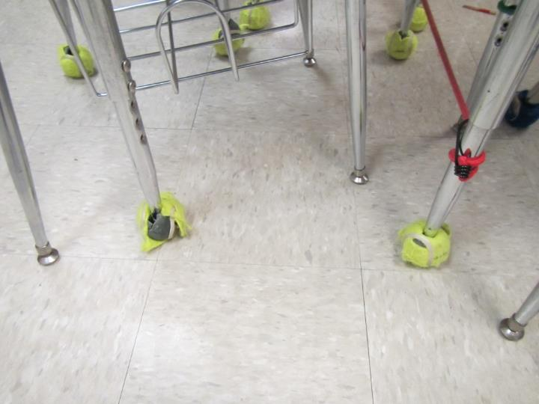
Tennis balls (yellow) on chair legs
Picture 17
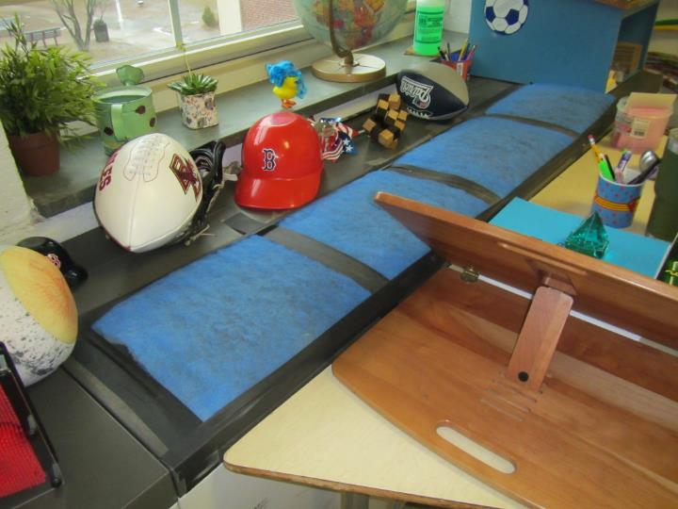
Extra filter on a univent
Picture 18
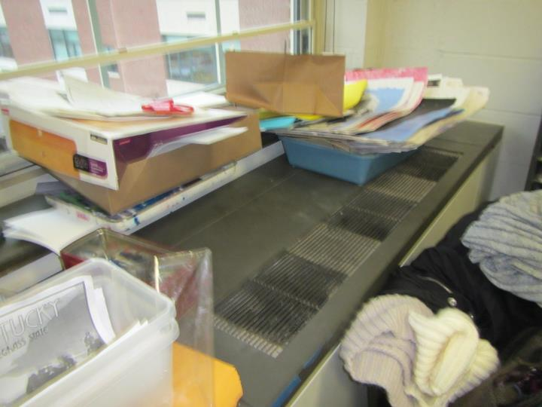
Items on surfaces and dust and debris
Picture 19
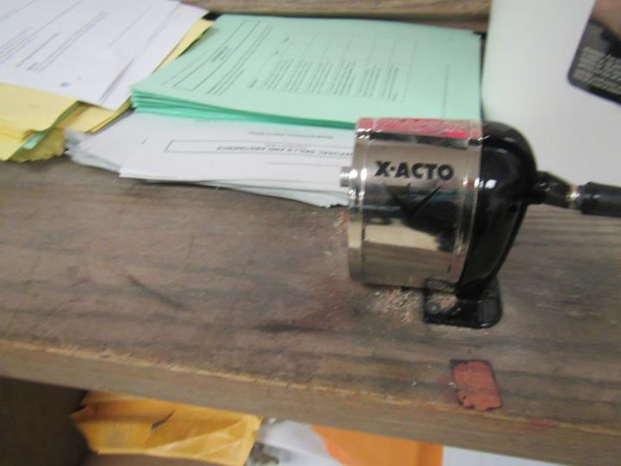
Pencil shavings
Picture 20
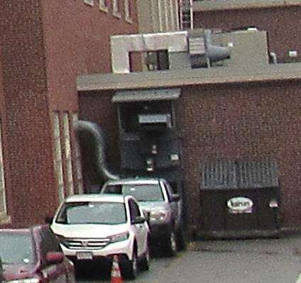
Outside wood dust collection system
Picture 21
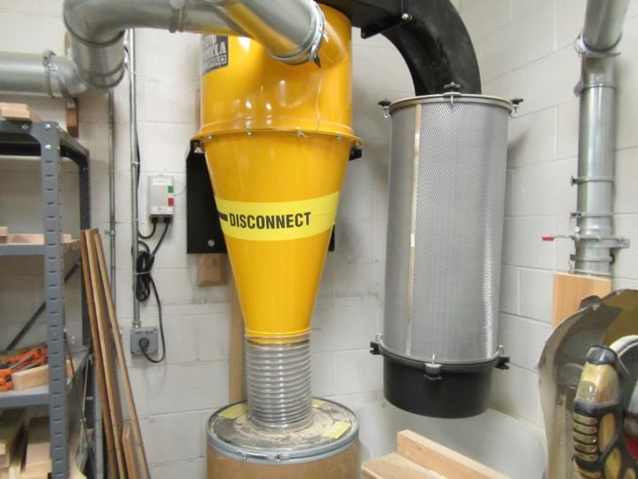
Interior wood dust collection system
Picture 22
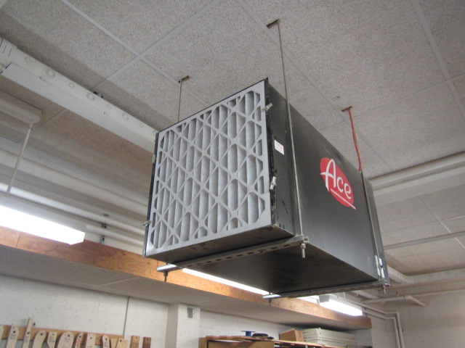
Air filtration unit in woodshop/technology area
Picture 23
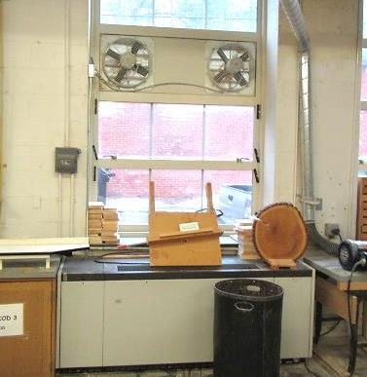
Local exhaust fans in woodshop/technology area
Picture 24
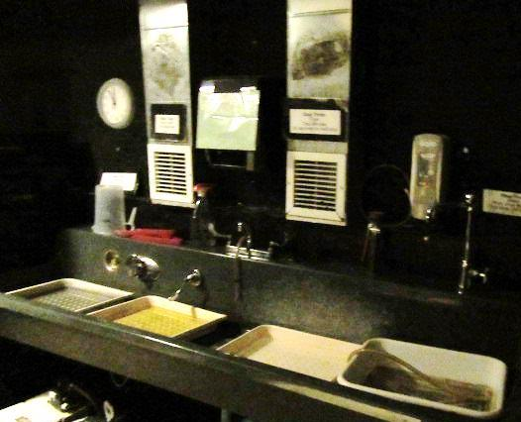
Local exhaust vents located over developing area in Darkroom
Picture 25
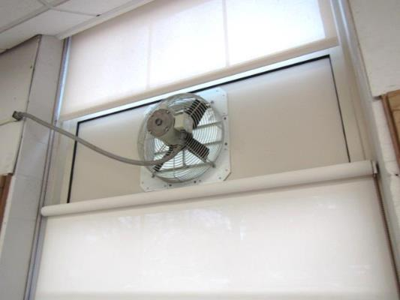
Local exhaust fan in Art room 304b near soldering station
Location | Carbon  Dioxide  (ppm) | Carbon Monoxide  (ppm) | Temp  (°F) | Relative  Humidity  (%) | PM2.5  (µg/m³) | Occupants  in Room | Windows  Openable | Ventilation |  | Remarks
 |  |  |  |  |  |  |  | Supply | Exhaust
Background | 394 | ND | 48 | 33 | 8 |  |  |  |  | Light rain and fog, TVOCs = ND
Upper level
400 (chorus) | 811 | ND | 74 | 32 | 4 | 50 | Y | univent | Y on, blocked | NC, DEM, carpeted risers,
upper auditorium | 793 | ND | 74 | 31 | 3 | 0 | N | Y | Y | some carpeting
former women’s room/storage |  |  |  |  |  |  |  |  |  | drains removed, items storage on floor
Third Floor
library | 626 | ND | 74 | 28 | 3 | 1 | Y | Y |  | Carpeted, UF, books
library classroom area | 708 | ND | 74 | 29 | 4 | 18 | Y | Y | Y | DEM, carpet
stage area | 583 | ND | 71 | 31 | 4 | 0 | N | Y | Y
instrument storage | 566 | ND | 72 | 29 | 4 | 0 | Y | Y | Y
Gym | 587 | ND | 71 | 33 | 2 | ~25 | Y | Y | Y
300 computers | 704 | ND | 73 | 28 | 4 | 0 | Y | Y | Y | carpet, computers, WD CT
304a | 740 | ND | 72 | 33 | 6 | 11 | Y | Y |  | Portable AC unit, plants, PF, DO
304b | 670 | ND | 67 | 36 | 6 | 11 | Y | Y | Y | Local exhaust fan, sauntering, kiln-local exhaust vent
308 | 797 | ND | 73 | 32 | 3 | 14 | Y | Y | Y | Cubby exhaust obstructed
310 Guidance Suite | 697 | ND | 71 | 37 | 2 | 0 | Y | Y | Y | DO, PF, TB
Guidance Office | 752 | ND | 72 | 31 | 2 | 2 | Y | Y | Y
320 | 542 | ND | 71 | 30 | 4 | 4 | Y | Y | Y
322 | 591 | ND | 69 | 32 | 4 | 5 | Y | Y | Y | TB, DO, plants, portable AC
324 | 929 | ND | 69 | 35 | 4 | 23 | Y | Y | Y
326 | 873 | ND | 69 | 35 | 3 | 18 | Y | Y | Y  Off | PF, CP
328 | 794 | ND | 68 | 35 | 4 | 16 | Y | Y | Y | Plants, TB
332 | 1002 | ND | 68 | 37 | 3 | 18 | Y | Y | Y  Off/Weak | PF
336 | 450 | ND | 68 | 33 | 3 | 4 | Y | Y | ? | PF, classroom exhaust vent could not be located/identified
306 Art | 667 | ND | 73 | 30 | 6 | 2 | Y | Y | Y | Electric kiln vented outdoors, UV on/blocked
306 Supply room | - | - | - | - | - | - | Y | N | Y | AI, WD CT
312 | 653 | ND | 74 | 30 | 3 | 2 | Y | Y | Y | WD CT, split AC, UV on
312-Director | 570 | ND | 75 | 29 | 4 | 1 | Y | N | Y | Heat complaints
316 office | 752 | ND | 73 | 28 | 4 | 1 | Y | N | Y | Plants, split AC
316-Malinn | 698 | ND | 74 | 28 | 3 | 1 | Y | N | Y | Cold complaints
342 | 622 | ND | 73 | 29 | 3 | 1 | Y | N | Y | HS, radiators
330 | 1179 | ND | 71 | 37 | 3 | 40 | Y | Y | Y | UV on, Bowed CT’s, WD CT, HS, guest speaker (more occupants than typical in class)
334 | 425 | ND | 66 | 36 | 4 | 0 | Y open | Y | Y | UV on, HS, plants, DEM, blue TBs on chairs (reportedly non-latex)
338 | 739 | ND | 68 | 38 | 2 | 23 | Y | Y | Y | HS, DEM
301 | 745 | ND | 70 | 36 | 6 | 22 | Y | Y | Y | NC, DEM, TBs, HS
303 | 540 | ND | 71 | 33 | 4 | 5 | Y | Y | Y | UF, area rug, DEM
303 inner |  |  |  |  |  |  |  |  |  | bowed CT, AI
305 | 622 | ND | 71 | 33 | 5 | 21 | Y | Y | Y | DEM, NC, HS, PF, chalk
307 | 824 | ND | 71 | 34 | 6 | 17 | Y | Y with filter | Y | DEM, plant, HS
309 | 523 | ND | 71 | 33 | 7 | 1 | Y | Y | Y | DEM, WD CT, PF
311 | 600 | ND | 71 | 31 | 4 | 1 | Y | Y with filter | Y | NC, TBs, DEM, PF
313 | 715 | ND | 69 | 34 | 5 | 10 | Y | Y | Y | DEM, PF, bowed tiles
315 | 585 | ND | 70 | 32 | 16 | 6 | Y | Y with filter | Y | food, HS.CP
315 office | 645 | ND | 70 | 31 | 4 | 1 | N | Y | Y | PF
315 office | 581 | ND | 70 | 32 | 5 | 0 | N | Y | Y | food prep, HS, CP
317 | 553 | ND | 67 | 35 | 5 | 5 | Y | Y | Y | space heater, TB, DEM, HS, PF
319 | 576 | ND | 68 | 35 | 6 | 11 | Y | Y | Y | DEM, 3 WD CT, HS
321 | 536 | ND | 68 | 36 | 6 | 12 | Y | Y | Y | 5 WD CT, Dusty PF, DEM, HS
323 | 574 | ND | 69 | 34 | 5 | 9 | Y | Y | Y | UV on, HS, PF
325-1 | 551 | ND | 68 | 34 | 5 | 2 | N | Y | Y | TBs, DEM, HS
325 | 548 | ND | 69 | 34 | 5 | 20 | Y | Y | Y | TBs, DEM, PF/stand fan
329-3 | 585 | ND | 69 | 32 | 5 | 0 | Y | N | N | Fridge
327-1 | 564 | ND | 68 | 33 | 4 | 0 | N | N | N
329-2 | 564 | ND | 69 | 33 | 5 | 0 | N | N | N | DEM, books on windowsill, HS
327 | 527 | ND | 68 | 32 | 4 | 6 | Y | Y | Y | PF
329-1 | 511 | ND | 69 | 32 | 5 | 2 | N | Y | Y | cloth, food
329 | 429 | ND | 67 | 33 | 5 | 1 | Y | Y | Y
331 | 465 | ND | 67 | 33 | 5 | 1 | Y | Y | Y | HS, TBs, AI, DEM
333 | 485 | ND | 73 | 28 | 4 | 6 | Y | Y | Y | NC, DEM
335 | 464 | ND | 72 | 28 | 4 | 3 | Y | Y | Y | carpeted risers, instruments
341 | 510 | ND | 69 | 35 | 4 | 0 | Y | Y | Y off | TBs, NC
343 | 483 | ND | 71 | 31 | 4 | 1 | Y | Y | Y | NC, TBs, DEM, PF, plants on univent
345 | 488 | ND | 69 | 33 | 4 | 1 | Y | Y | Y | DEM, TBs, NC
347 | 749 | ND | 69 | 35 | 5 | 21 | Y | Y | Y | NC, PF, DEM, WD CT
349 | 509 | ND | 69 | 34 | 4 | 0 | Y | Y | Y | DEM, TBs
351 | 646 | ND | 69 | 35 | 4 | 16 | Y | Y | Y | NC, plants, HS, PF
361 | 700 | ND | 72 | 31 | 4 | 0 | N | Y | Y | MT
363 | 675 | ND | 72 | 33 | 4 | 10 | Y | Y | Y | NC, 2 WD CT, DEM
375 | 472 | ND | 73 | 38 | 4 | 0 | Y | Y | Y | ductless AC
377 | 479 | ND | 73 | 31 | 4 | 2 | Y | Y | Y | UV, food, plant, diffuser
379 |  |  |  |  |  |  |  |  |  | used to be restroom
Second floor
CAF | 651 | ND | 74 | 37 | 6 | ~400 | N | Y | Y | compost program bins
main office | 795 | ND | 73 | 31 | 7 | 4 | Y | Y | Y | Carpet
principal | 815 | ND | 73 | 31 | 6 | 3 | Y | Y | Y | carpet, HS, plant
204 | 571 | ND | 74 | 34 | 1 | 2 | N | Y | Y | MT
204-4 | 671 | ND | 70 | 33 | 5 | 2 | Y | Y | Y | DEM, carpet
206 | 1081 | ND | 70 | 39 | 3 | 21 | Y | Y | Y | Burning odor reported on occasion, DEM, HS, reported particles from UV (external filter over UV supply)
208-A | 553 | ND | 71 | 34 | 4 | 4 | Y | Y | ? | Exhaust vent could not be located/identified, WD CT near windows, PF, TB
208-B | 584 | ND | 72 | 34 | 14 | 1 | Y | Y | Y | WD CT in office
210 | 770 | ND | 74 | 31 | 3 | 23 | Y | Y | Y | DEM, bowed CTs, HS
212 | 627 | ND | 70 | 34 | 6 | 6 | Y | Y | Y | MT, PF, TB
214 | 675 | ND | 74 | 32 | 3 | 11 | Y | Y on | Y | Some green TB’s, PF, HS, CPs, bowed CTs
218 | 591 | ND | 72 | 32 | 3 | 6 | Y | Y on | Y | DEM, container with plant/water residue
220 | 591 | ND | 71 | 30 | 3 | 2 | Y | Y | Y | DEM, HS, passive return vent to back room
222 | 721 | ND | 69 | 33 | 4 | 1 | Y | Y | Y | DO, TB, plant
224 | 1006 | ND | 70 | 34 | 4 | 24 | Y | Y | Y | Exhaust obstructed by furniture
226 | 805 | ND | 70 | 35 | 3 | 1 | Y | Y | Y | ~17 occupants gone ~ 5 mins, DO, PF, TB
228 | 483 | ND | 66 | 35 | 2 | 5 | Y | Y on | Y | DEM, HS, CPs
230 | 1030 | ND | 67 | 39 | 3 | 10 | Y | Y | Y  Off/Weak | DO, PFs
234 | 914 | ND | 68 | 36 | 4 | 12 | Y | Y | Y
240 Wood Shop | 479 | ND | 72 | 33 | 5 | 1 | Y | Y  Off | Y | Wood dust collector, air filters
246 Gym | 527 | ND | 70 | 32 | 5 | 0 | N | Y | Y | Dust/debris on CTs around supply vents
248 Exercise Room | 1213 | ND | 71 | 36 | 6 | 21 | Y | Y | Y  Off | Wall to wall carpeting
250 | 610 | ND | 68 | 34 | 3 | 1 | Y | N | N | DEM, former WD tiles replaced
252 | 625 | ND | 68 | 35 | 6 | 24 | Y | Y | Y | UV return obstructed, plants, lab hood
258 Teacher’s | 639 | ND | 81 | 29 | 25 | 5 | N | Y | Y | UF, PF, heat complaints
232 | 409 | ND | 67 | 34 | 3 | 1 | Y | Y | Y | TB, PF
205 CTO | 689 | ND | 70 | 33 | 5 | 1 | Y | Y | Y | older carpet, fridge on carpet
205-1 | 714 | ND | 72 | 31 | 5 | 1 | Y | Y | Y | PF
205-2 | 690 | ND | 71 | 32 | 5 | 1 | Y | Y | Y | plants, carpet
207 | 1019 | ND | 70 | 36 | 5 | 20 | Y | Y | Y | ajar light cover, TB, DEM
209 | 745 | ND | 70 | 33 | 8 | 4 | Y | Y | Y | plants, AI
211 | 740 | ND | 70 | 36 | 6 | 14 | Y | Y | Y | DEM, PF
213 | 586 | ND | 69 | 32 | 4 | 6 | Y | Y | Y | HS, CP, DEM, sink, internal restroom
213-2 | 667 | ND | 70 | 31 | 6 | 1 | Y | Y | N | DEM
215 | 596 | ND | 70 | 33 | 5 | 10 | Y | Y | Y | HS, TBs, AF
217 | 555 | ND | 69 | 32 | 4 | 11 | Y | Y | Y
217-1 | 540 | ND | 69 | 31 | 3 | 0 | N | Y |  | DEM, defunct sink and real sink
219 | 756 | ND | 71 | 39 | 4 | 14 | Y | Y | Y | DEM, plants on UV, TB
221 | 647 | ND | 70 | 34 | 7 | 11 | Y | Y | Y | 2 WD CT
223 | 982 | ND | 72-75 | 37 | 4 | 20 | Y | Y | Y | TBs, HS
225 | 536 | ND | 70 | 31 | 5 | 1 | Y | Y | Y | HS, PS
227 | 1015 | ND | 70 | 38 | 6 | 22 | Y | Y | Y | DEM, HS
229 | 769 | ND | 69 | 36 | 5 | 22 | Y | Y | Y | portable AC window open with plastic, TBs
231 | 673 | ND | 68 | 35 | 5 | 24 | Y | Y | Y | plants, DEM, HS
241 | 528 | ND | 71 | 31 | 5 | 0 | Y | Y | Y | health/kitchen, sinks, stoves including gas stove no hood, TBs
243 | 663 | ND | 68 | 35 | 6 | 0 | Y | Y | Y | TBs, DEM, PF - dusty
245 | 999 | ND | 70 | 38 | 5 | 0 (26 just left) | Y | Y | Y | DEM
247 | 843 | ND | 70 | 37 | 5 | 6 (class change) | Y | Y | Y | PS, DEM, HS
249 | 738 | ND | 70 | 34 | 5 | 12 (class change) | Y | Y | Y | DEM, HS, CP, plants on UV
251 | 891 | ND | 69 | 36 | 5 | 3 (class change | Y | Y | Y | filter on UV, TBs, DEM, 3 aquariums
271 Faculty lunch | 780 | ND | 68-70 | 40 | 7 | 18 | Y | Y | Y | NC, food, fridge and microwave
285-2 | 867 | ND | 73 | 33 | 10 | 5 | Y | Y | Y | office
285-3 | 642 | ND | 73 | 32 | 8 | 0 | Y | Y | Y | plant
Tech shop | 675 | ND | 70 | 34 | 7 | 25 | N | Y | Y | DEM, local exhaust is ducted outside
Woodshop | 606 | ND | 71 | 33 | 12 | 3 | N | Y | Y on | Local exhaust leads to wood dust filter that returns room to air, general exhaust/return has accumulated wood dust, two additional box filters
Woodshop supply room | 595 | ND | 70 | 31 | 10 | 2 | N | Y | Y | Ajar ceiling tile, UV blocked
First Floor
Greenhouse | 419 | ND | 69 | 41 | 6 | 0 | Y | N | N | Hydronic heater, water, fish
5-1 | 438 | ND | 70 | 35 | 6 | 0 | N | N | Y | door to greenhouse
116 | 431 | ND | 66 | 37 | 4 | 1 | Y | Y | Y | UV-return vent obstructed
118 | 459 | ND | 64 | 34 | 2 | 2 | Y | Y | Y | CPs, HS, UV, former sink leak- porous materials stored under and pathways around plumbing
120 | 427 | ND | 69 | 36 | 5 | 7 | Y | Y | Y | DO, PF
122 Photography | 443 | ND | 69 | 36 | 5 | 7 | N | Y | Y | TVOCs = ND, dehumidifier
124 | 422 | ND | 70 | 31 | 4 | 0 | N | Y | Y | DO, WD CT
126 | 461 | ND | 69 | 32 | 3 | 0 | Y | Y on | Y | UV, DEM, CPs
126 Rear | 499 | ND | 69 | 33 | 3 | 3 | Y | N | Y | DO
Darkroom | 481 | ND | 72 | 32 | 5 | 0 | N | Y | Y | TVOCs = ND, local exhaust vents operating over chemical/developing baths
Photography A | 422 | ND | 70 | 34 | 4 | 0 | Y | Y | Y  Passive | TVOCs = ND
Photography B | 446 | ND | 73 | 31 | 5 | 0 | Y | Y | N | TVOCs = ND, ceiling mounted ventilation unit (unknown function)
101 | 603 | ND | 69 | 35 | 4 | 1 | Y | Y | Y | science, DEM, gas jets, TBs
103 science | 675 | ND | 71 | 32 | 6 | 0 | Y | Y | Y | previous odor investigation, sinks, acid waste system, TBs
105 science | 775 | ND | 70 | 34 | 11 | 0 | Y | Y | Y | DEM, HS, sinks, emergency shower
107 | 777 | ND | 71 | 35 | 5 | 22 | Y | Y | Y | DEM, PF, emergency shower
109 | 878 | ND | 70 | 34 | 7 | 21 | Y | Y | Y | DEM, emergency shower, PF
111 science | 758 | ND | 69 | 36 | 6 | 23 | Y | Y | Y | sinks, DEM
113 science | 612 | ND | 68 | 35 | 5 | 1 | Y | Y | Y | gas jets, DEM, HS
115 | 514 | ND | 69 | 35 | 6 | 0 | N | N | N | DEM, passive vent only
Boys Locker Room | 578 | ND | 78 | 31 | 5 | 0 | N | Y | Y | Sewer gas odors-shower/floor drains
Girls Locker Room | 578 | ND | 81 | 27 | 4 | 0 | N | Y | Y
Storage room | - | - | - | - | - | - | N | N | N | Former sprinkler leak, remediation firm responded quickly, removed WD GW and WD porous items
conference in basement 3 | 512 | ND | 71 | 34 | 4 | o | N | Y | Y | ductless AC
135 curriculum | 572 | ND | 69 | 37 | 6 | 4 | Y | Y | Y | carpet, plants, AI and shelves of items
139 production | 513 | ND | 69 | 37 | 5 | 0 | y | Y | Y | laminator and copy machines, UV, ductless AC

