ODOR INVESTIGATION

Wellesley Middle School
Science Classroom (Room 103)
50 Kingsbury Street
Wellesley, MA

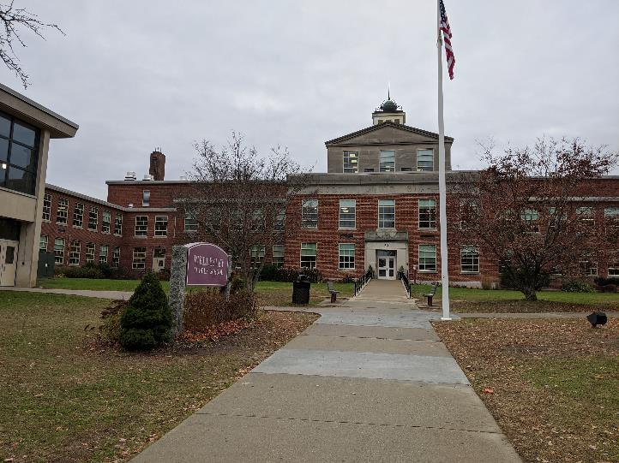

Prepared by:
Massachusetts Department of Public Health
Bureau of Environmental Health
Indoor Air Quality Program
December 2019

Background
Building: | Wellesley Middle School (WMS) Science Classroom
Address: | 50 Kingsbury Street  Wellesley, MA
Requested by: | Joe Murray, Project Manager, Facilities Management Department, Town of Wellesley
Reason for Request: | Odors in room 103, a science classroom
Date of Assessment: | November 22, 2019
Massachusetts Department of Public Health/Bureau of Environmental Health (MDPH/BEH) Staff Conducting Assessment: | Ruth Alfasso, Environmental Engineer/Inspector, IAQ Program
Building Description: | WMS is a two-story brick building originally constructed in 1952 as Wellesley Junior High School. Only Room 103, a science classroom on the first floor, was assessed during this visit.
Windows: | Windows are openable in the areas assessed.

Methods
Please refer to the IAQ Manual for methods, sampling procedures, and interpretation of results (MDPH, 2015).

Results
The following is a summary of indoor air testing results (Table 1).
- Carbon dioxide was measured at 678 parts per million (ppm), which is below the 800 ppm level recommended by the IAQ program.
- Temperature was 65°F, which is below the recommended range of 70°F to 78°F. The room was unoccupied and the heat off at the time of the assessment.
- Relative humidity was 46% which is within the recommended range of 40% to 60%.
- Carbon monoxide levels were non-detectable (ND).
- Fine particulate matter (PM2.5) concentrations measured were 9 micrograms per cubic meter (μg/m³), which is below the National Ambient Air Quality Standard (NAAQS) level of 35 μg/m³.

Discussion

Ventilation
A heating, ventilating, and air conditioning (HVAC) system has several functions. First it provides heating and, if equipped, cooling. Second, it is a source of fresh air. Finally, an HVAC system will dilute and remove normally occurring indoor environmental pollutants by not only introducing fresh air, but by filtering the airstream and ejecting stale air to the outdoors via exhaust ventilation. Even if an HVAC system is operating as designed, point sources of respiratory irritation may exist and cause symptoms in sensitive individuals.
The HVAC system in this space consists of a unit ventilator (univent). The univent draws fresh air through a vent on the exterior wall (Picture 1). Air is mixed with return air from the room, filtered, heated (if needed) and delivered to the room (Figure 1). Both the top and the vent at the bottom need to be kept clear of obstructions for the units to operate as designed. An exhaust vent is located on the wall on the other side of the classroom. The heating pipes for the univent continue behind the cabinets up against the exterior wall, including a portion with radiator fins to provide additional heating (Pictures 2 and 3). Since this is a first floor room on slab, there is no utility space underneath the floor for univent pipes.
To maximize air exchange, the MDPH recommends that both supply and exhaust ventilation operate continuously during periods of occupancy. In order to have proper ventilation with a mechanical supply and exhaust system, the systems must be balanced to provide an adequate amount of fresh air to the interior of a room while removing stale air from the room. It is recommended that HVAC systems be re-balanced every five years to ensure adequate air systems function (SMACNA, 1994).

Odor Concerns
The reason for this visit was reports of odors in this classroom, which is used for middle school science. Occupants reported that the odors started about Friday the 15th of November and at times it made them feel sick. Occupants did not have consensus about the identity and source of the odor. Odors were reported to be strongest near the cabinets next to the windows. Facility staff attempted to alleviate the odor through cleaning the univent and then turning it off to see if that would reduce odors. Facility staff cut holes in several of the cabinets (e.g. Picture 2) to access the area for cleaning and to see if that helped to pinpoint/dissipate the odor, and a few charcoal odor absorbers were added to the rear of the cabinets. The room was closed to occupancy until the odors could be resolved.
At the time the BEH/IAQ visit on November 22, 2019, there was an odor discernable on entering the room, although it was described as less strong as before by facility staff. This odor was not readily identifiable, although it could be described as “chemical”. The IAQ staff investigation found odors strongest from locations directly above the heating pipes behind the cabinets. Other locations were checked for odors, including: the exterior of the building next to the univent air intake and windows (Picture 1), the chemistry storage room (Picture 4), an electrical room next to the classroom, the hallway, the univent interior, and many other locations and items in the room. None of these other areas had any strong odor, and none had an odor similar to the odor detected from behind the cabinets. No signs of water damage or mold were noted in the areas examined.
Note that there is an acid waste system that serves the sink in this room, designed to prevent chemicals from impacting the general sanitary drain system and protect the sewers from chemical releases. A small tank with pH neutralization “chips” in it is connected to the sink drain underneath the sink cabinet. The piping out of this system uses the same pipe chase behind the cabinets as the heating/univent pipes (Pictures 4 and 5). Facility staff reported that the acid waste neutralization unit was checked during the previous week as a potential source of the odor and did not seem related, however, the location of the acid waste piping corresponds to the location of the odor, so it is worth additional investigation. This pipe can be leak-tested by a plumber to see if a small hole or breach at one of the fittings is present. A small amount of waste may have leaked from the system and become adsorbed onto other materials behind the cabinet, such as the wall. When heated by the univent/radiator piping, even a small amount of chemical residue can continue to emit odors for a long time. Alternatively, a chemical material may have been spilled into the opening/grill at the top of the radiator and again be emitting odors as it is heated.

Conclusions/Recommendations
Based on the observations made during the visit, the following is recommended:
- Inspect the acid waste system piping for any leaks in pipe or connections, and repair as needed.
- Clean the area behind the cabinets, including all pipes, thoroughly with a mild detergent to remove any residues that may be emitting odors.
- Refer to resource manuals and other related IAQ documents for further building-wide evaluations and advice on maintaining public buildings. Copies of these materials are located on the MDPH’s website: http://mass.gov/dph/iaq.

References
MDPH. 2015. Massachusetts Department of Public Health. “Indoor Air Quality Manual: Chapters I-III”. Available at: http://www.mass.gov/eohhs/gov/departments/dph/programs/environmental-health/exposure-topics/iaq/iaq-manual/.
Picture 1
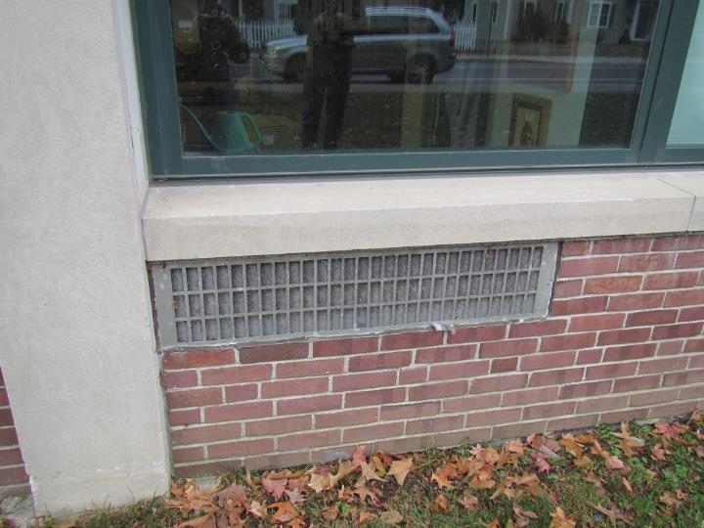
Univent air intake on the outside of the building
Picture 2
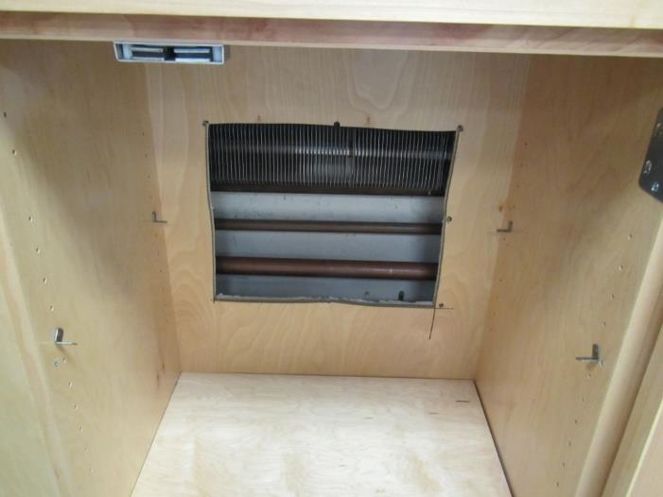
Radiator fins on heating pipe behind cabinet against exterior wall, hole cut to identify/dissipate odor
Picture 3
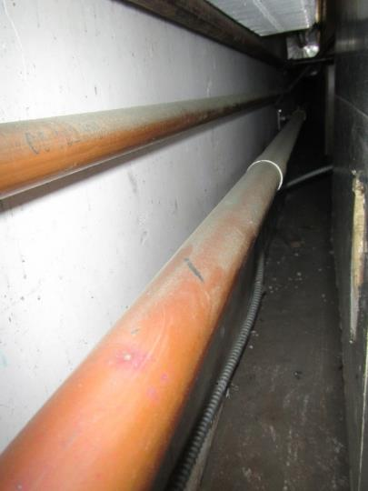
Heating pipes behind the cabinet on exterior wall
Picture 4
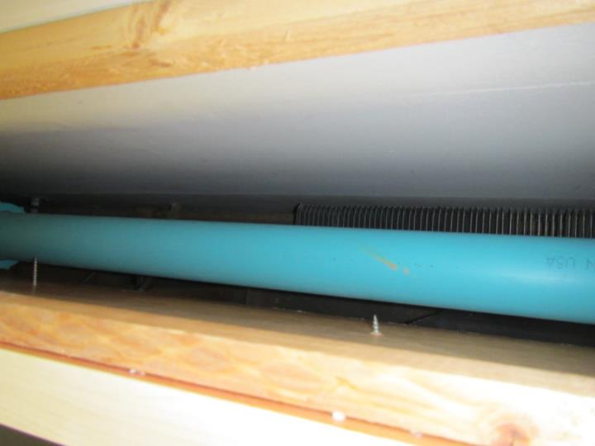
Acid waste piping above radiator fins, seen from above
Picture 5
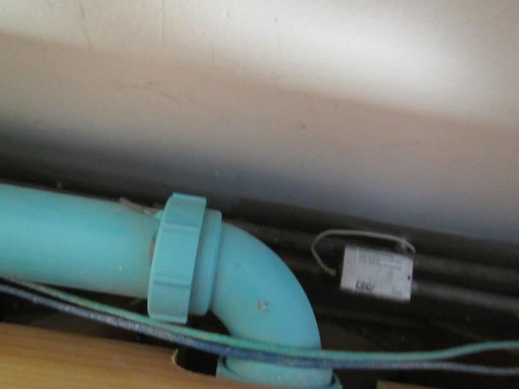
Acid waste system elbow

