January 26, 2022

Ms. Lara Szent-Gyorgyi, Director
Determination of Need Program
Department of Public Health
250 Washington Street, 6th Floor
Boston, MA 02108

Wellforce Response to the Independent Cost Analysis for DoN – Mass General Brigham (MGB)Incorporated – Multisite – 21012113-AS

Dear Director Szent-Gyorgyi,

Thank you for the opportunity to submit written testimony on behalf of the Wellforce Ten Taxpayer Group regarding DoN – Mass General Brigham Incorporated – Multisite - 21012113-AS. We are submitting this testimony in response to the independent cost analysis (ICA) conducted by Charles River Associates (CRA), which misrepresents the consequences and substantial cost-drivers underlying MGB’s proposed ambulatory care center (ACC) expansion into Woburn, Westwood, and Westborough.

The Wellforce health system includes 13,000 employees and 2,000 affiliated physicians across four community hospital campuses, an academic medical center, and a home care organization – reaching from Cape Cod to the New Hampshire border. Wellforce includes Tufts Medical Center, Lowell General Hospital, Home Health Foundation, the Physicians of the Wellforce Clinically Integrated Network (CIN), and Melrose Wakefield Healthcare (MWHC). MWHC operates MelroseWakefield Hospital (MWH) in Melrose and Lawrence Memorial Hospital in Medford, which together serve many communities north of Boston, including Woburn. In fact, 51 percent of the visits at MWHC come from patients who live in the expansive 17-town Woburn service area where MGB is proposing an expansion of its footprint: Andover, Arlington, Bedford, Billerica, Burlington, Hanscom AFB, Lexington, Medford, Melrose, North Reading, Reading, Stoneham, Tewksbury, Wakefield, Wilmington, Winchester, and Woburn.

We have significant concerns regarding MGB’s application to establish an outpatient center in the community we are honored to serve with high-quality and high-value care. We believe that MGB’s proposed project is misaligned with the Commonwealth’s goals to contain health care costs and improve our health care ecosystem, and that the Proposed Project would have catastrophic effects on local community hospitals and our patients.

Our concerns with MGB’s proposal are only reinforced by the blatant bias and narrow scope of the ICA. Rather than evaluate the breadth of the proposal’s implications comprehensively and meaningfully, the ICA fails to adequately examine key cost drivers. In an independent civil investigation, the Massachusetts Attorney General’s Office calls for “a broad analysis of the cost impacts of [MGB’s] proposals, including the likely shifts in hospital commercial volume and migration of primary care physicians and specialists from lower-cost systems to MGB.” Despite calls for greater scrutiny by the Attorney General’s Office, the ICA does not thoroughly analyze the recruitment of commercially insured patients from low-cost providers into the MGB system, how MGB intends to backfill newfound capacity at its hospitals, or the projected increase of secondary and tertiary referrals to the MGB system – the most expensive system in the Commonwealth. Simply, the ICA falls far short of providing sufficient evidence to support MGB’s contention that their proposal will lower the total cost of care for consumers regionally and statewide.

Considering the glaring shortfalls of this ICA, in conjunction with the project application, it is apparent that MGB’s Proposed Project will not meaningfully contribute to the Commonwealth’s goals for cost containment and we urge the Department of Public Health (DPH) to recommend denial of this Proposed Project in its Staff Report.

The ICA does not meet the legal criteria set forth by the DPH’s Determination of Need (DoN) program.

Per the DoN regulation, MGB must clearly and convincingly provide evidence that the proposed project meets all six DoN Factors. The DoN program required this independent cost analysis (ICA) as part of its review as to whether the Proposed Project meets Factor 2. As such, MGB must clearly and convincingly demonstrate that the Proposed Project “will meaningfully contribute to the Commonwealth’s goals for cost containment […].”

While we commend DPH for requiring an ICA, the ICA relies heavily on many of the unsubstantiated price, volume, and market assumptions laid out by MGB in its Application, as opposed to independently questioning and investigating the validity of such claims. For instance, in footnote 94, CRA notes that “to match MGB’s projected volume, we mathematically ‘expand’ or ‘shrink’ the Proposed Clinic until the volumes predicted by our model match MGB’s projections,” admitting that the economic models utilized by CRA to evaluate MGB’s proposal were tailored to confirm, rather than challenge, MGB assertions.

Additional misleading representations of the Massachusetts health care landscape set by MGB serve as guiding parameters for the report. For instance, the ICA accepts without question MGB’s definition of its Patient Panel, which, for example, would include individuals who have a non-MGB PCP and get most of their care at non-MGB providers, but had one MGB claim in 2018. By this definition, and based upon our internal analysis of our patient panel by zip code, nearly one-in-three Wellforce-attributed patients would be considered by MGB and the ICA as part of MGB’s Patient Panel. This definition creates an inflated patient panel that both obscures the number of patients regularly served by local providers and falsely reinforces MGB’s claim to a more robust patient panel than is accurate. Even more noteworthy, MGB’s claims of savings rely on the assumption that patients who would otherwise receive Hospital Outpatient Department (HOPD) services at an MGB hospital will now get care at one of these new Ambulatory Care Center (ACCs). There are always going to be cost savings found if patients transition from a more expensive health care setting within the MGB system to a less expensive health care setting within the MGB system; however, calculating for the migration of more patients than is accurate overestimates potential savings.

The cost analysis also functions under the false assumption that it will be 25 percent and 50 percent less expensive for patients to receive care at one of their ambulatory care centers than at one of the system’s community hospitals or academic medical centers, respectively, when there is no evidence to support that MGB won’t negotiate higher prices. CRA even acknowledges that it “cannot validate these projections using actual negotiated prices for MGB’s hospital outpatient departments and ambulatory care centers because MGB does not currently operate freestanding ambulatory care centers in Massachusetts.”

Taking into account the market realities of the Massachusetts health care landscape, we have grave concerns that MGB will in fact command higher reimbursement rates than the ICA anticipates. MGB is already the most profitable health care system in the Commonwealth by a landslide, with $15.7 billion in revenue and $442 million in operational earnings for the 2021 fiscal year. In addition to being the most profitable, MGB remains the most expensive health care system in the state by far. Per the Health Policy Commission’s 2021 Cost Trends Report, MGB had the highest unadjusted and adjusted total medical spending in 2018; at $6,131 adjusted per member per year (PMPY), the system’s total medical expenditures were 15 percent higher than the average of the provider groups shown in the report.

As it currently stands, MGB’s outpatient rates are much higher than those of local competitors. In December 2021, CHIA released a detailed file outlining the relative pricing of various commercial products offered by Massachusetts acute hospitals. For illustrative purposes, we analyzed Blue Cross Blue Shield’s (BCBS) relative pricing for local hospitals in the below 3 markets and compared the rates to MGB’s outpatient rates as a whole. Not surprisingly, MGB’s relative pricing is much higher than that of local providers for this particular payer. As an example, in the Woburn area, MGB’s outpatient rates are 50% higher than those of local outpatient providers for BCBS cases. Note, we defined local outpatient providers as MWH, B.I. Lahey, and Winchester Hospital (see table footnote to see how we defined competitors in the other 2 markets).

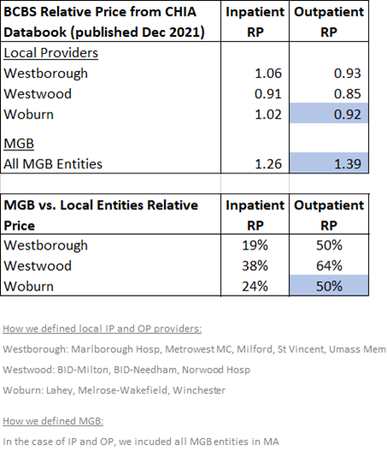

In its DoN Application, MGB claims these proposed new sites will lower costs because surgeries currently performed in its inpatient settings will shift to an ambulatory environment. Ultimately, our findings allow us to conclude that, even if procedures performed in proposed MGB outpatient settings are less costly within its own system, they are significantly more expensive than surgeries performed in existing community provider ambulatory settings. The Health Policy Commission has also cautioned that consumer savings are currently limited in the shift to outpatient care because lower-priced systems are losing volume to higher-priced systems like MGB.

Taking market realities into account alongside CRA’s own admission of flexing its economic models to match MGB’s projections, the informational foundation of the ICA and its findings are inherently misleading, unreliable, and undermine the legitimacy of the report.

What the Independent Cost Analysis doesn’t address is even more notable.

The ICA fails to evaluate significant cost escalations that will result from MGB’s expansion plans, including the influx of referrals to MGB’s system, backfill, and the long-term implications of siphoning patients from lower-cost providers.

As previously referenced, in November 2021, the Massachusetts Attorney General’s Office (AGO) released the findings of an independent examination of the cost impacts of MGB’s ambulatory care expansion proposal as it relates to the overall Massachusetts health care market, consistent with its statutory responsibility to monitor and investigate health care cost trends and drivers. The AGO ultimately concluded that disclosure of the following four points from MGB’s application is warranted and should be subject to consideration by DPH in the review of this proposed project:
- Margins/Backfill: In its 2018 planning process, MGB projected that this expansion plan would contribute direct margins to the MGB system of approximately $385 million per year, including new ambulatory volume as well as net revenue from incremental hospital volume resulting from new ambulatory sites. New hospital margin from patient referrals from the ambulatory sites to MGB hospitals was projected to outweigh losses resulting from the shift of visits from MGB hospitals to the ambulatory sites. ,
- Market Share: In its 2018 planning process, MGB also projected that its multi-year ambulatory expansion plan would ultimately increase MGB’s share of the market for inpatient hospital services and covered lives. MGB projected it would gain an additional 1-2% of all secondary inpatient admissions in Eastern Massachusetts and an additional 3-4% of all tertiary inpatient admissions in Eastern Massachusetts. MGB also projected it would gain an additional 1-2% of all covered lives in Eastern Massachusetts.,
- Volume: The volume of ambulatory surgery procedures performed at a health care facility depends on the utilization plan for its operating rooms (ORs). MGB’s projections from 2018 projected that OR capacity utilization would be 85%. In MGB’s 2021 DoN application for its Westborough, Woburn, and Westwood sites, it relied on significantly lower OR productivity assumptions (i.e. 70% capacity utilization). The cost implications of this differential and analysis of any reasons for the decline in volume projections should be part of the cost containment analysis of these proposals.
- Staffing: The AGO asserted that the evaluation of staffing plans is critical to a complete analysis of the likely cost and market impacts of a new health care facility, highlighting current staffing shortages and the fact that primary care providers often bring their patient panels with them if they move to a new system. According to the AGO report, based on MGB projections dated from 2018, MGB planned to staff the three currently proposed sites at Westborough, Westwood, and Woburn by adding 22 new primary care physicians to the MGB system in total across the three sites. This fact is especially important to consider given the likely shifts in hospital commercial volume and migration of primary care physicians and specialists from lower-cost systems, like Wellforce, to MGB.

After considering the facts presented in the AGO’s independent examination, there is a significant question as to the “independent” nature of CRA’s ICA when you consider the blatant omissions from its analysis.

To start, the ICA does not provide any analysis of projected secondary and tertiary referrals, nor does CRA account for how capacity at MGB hospitals created by shifting inpatient services to these new outpatient sites would be backfilled. By extension, the ICA does not acknowledge or analyze the interrelated impacts of MGB’s other DoN applications currently under review by DPH, which propose to build a new tower at Mass General Hospital and construct a new five-story addition at Brigham and Women’s Faulkner Hospital. Both projects would substantially expand MGB’s inpatient capacity and yet the ICA fails to consider how MGB’s ACC facilities would feed into the system’s greatly expanded hospital capacity through referrals and backfill should the DoN proposals be approved.

The need for new health care services in Woburn is finite, and rather than addressing actual need, these expansion proposals will increase the size of MGB’s patient panel and its ability to drive increased referrals within its own expensive system. MGB primary care and specialty physicians at the proposed project locations are likely to refer patients for follow-up and inpatient treatment at higher-cost Boston area hospitals and to providers within the MGB system, rather than to lower-cost providers in the surrounding communities. Our local providers, employers and community members will end up paying the price. Mass General Hospital, for example, is on average paid 42 percent more for an inpatient stay than MWH for the exact same level of care. An MGB outpatient center will further exacerbate cost increases for patients by pulling them away from appropriate, less expensive local care settings. The net result will be an overall increase in state health care costs.

Further, the ICA includes no significant analysis on how shifting commercial volume away from existing community providers might impact their ability to sustainably continue to serve MassHealth and Medicare patients. In general, acute hospitals lose money on Medicare and Medicaid reimbursement and rely on commercial payers to remain financially viable. For reference, hospitals only receive 65 percent of what it costs them to provide care to patients covered by Medicaid, which insures low-income families, patients with disabilities, and seniors not covered by Medicare. Providing care to patients covered by Medicare and Medicaid is crucial to sustaining the health and wellbeing of our communities and helps to remove barriers to care. However, safety net care can only be offered when there are enough commercially insured patients to sustain it – and those rates are largely set by rate negotiations with payers. As UMass Memorial Health President of Community Hospitals and Chief Administrative Officer Douglas Brown explains in a CommonWealth Magazine op-ed,

How well a hospital does financially, therefore, is largely a function of how much commercial insurance business it has and how high its rates are for that business. And its rates are determined by its negotiating power. How does a hospital increase its negotiating power? By becoming as big as possible and having hospitals and doctors in its network that patients want to see. If an insurance company cannot do without you in their network, you have a huge advantage in negotiating rates with them.

Brown’s description makes clear two important points: if MGB were to pull even a marginal number of commercial cases out of our acute hospitals, our financial balance would destabilize; and that MGB’s ever-growing market size further enhances its negotiating power with payers to command higher reimbursement rates for commercially insured patients. Taken together, MGB’s expansion into Woburn, Westwood, and Westborough would increase its returns by attracting more commercially insured patients and granting the system superior negotiating power to set more profitable rates – passing along greater costs to patients and employers – while financially undermining safety net care for Medicare and Medicaid patients and patients with high barriers to care.

In support of these concerns, the below table obtained from the CHIA website shows that commercial rates at Wellforce and other community hospitals are much lower than the rates at MGB entities. If commercial cases are pulled from Wellforce and other local health care providers to MGB facilities, health care will become more expensive in Massachusetts as a whole due to MGB’s more favorable commercial payer contracts.

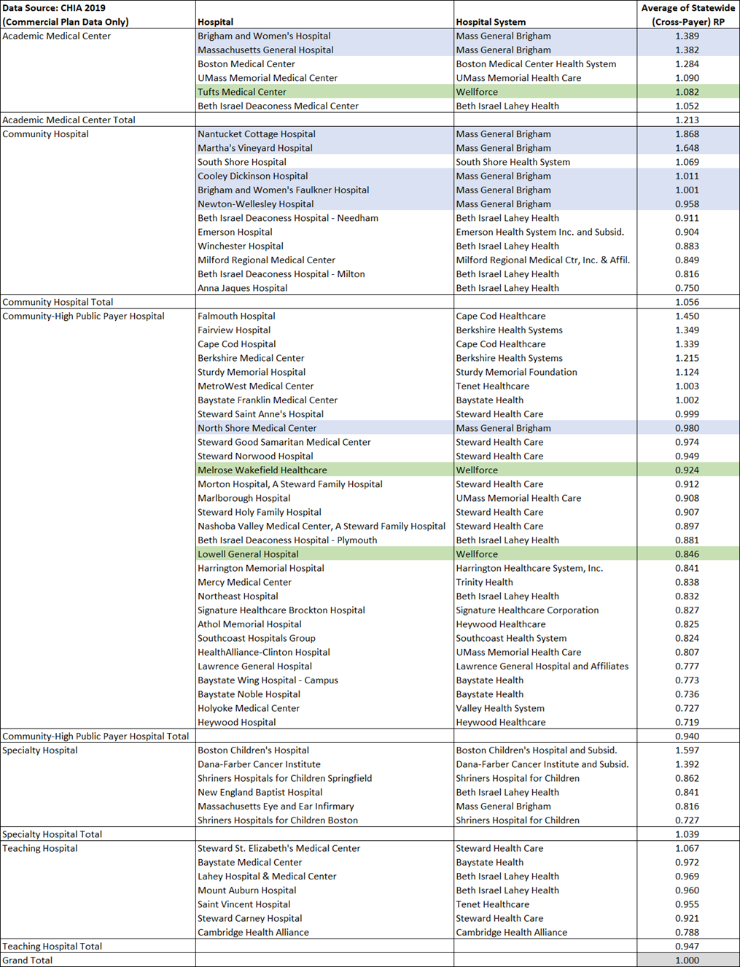

On the matter of staffing, CRA bases its workforce implications on MGB’s 2018 staffing projections, which do not account for the COVID-19 pandemic, and is unresponsive to the AGO’s call for a thorough analysis of this important fact. The ICA’s staffing analysis paints a rosy picture of the COVID-related staffing crisis in the health care landscape by denying it even exists; the report implicitly suggests that COVID-19 has had no impact upon workforce supply by not addressing the impacts of the pandemic. This omission directly contradicts MGB’s public testimony at the Health Policy Commission’s (HPC) 2021 Cost Trends Hearing in which they stated that health systems are “all very fragile right now.”

Finally, CRA neglects to analyze the costs for the full breadth of services MGB plans to offer at the ACCs. There are discrepancies between the services MGB has stated it will offer and what is analyzed by the ICA, which only evaluates the cost impacts of MRI and CT scans, and surgeries.

Therefore, despite the AGO’s findings and MGB’s own admission that referrals are the primary growth strategy behind its community expansion plans, the ICA seemingly ignores these key cost-drivers that would raise health care costs across the Commonwealth, as well as substantially boost MGB’s margins and market share through new patient volume at the ACCs and the funneling of new patients to MGB inpatient settings through referrals.

And yet, even with these significant analytical shortfalls, the ICA still only concludes that the expansion will result in negligible on-average savings of 0.1% - 0.2% for patients who will receive specified services at the ACCs. It is not unreasonable to assume that, if the ICA had examined secondary/tertiary referrals, backfill and rate disparities between MGB and local health care providers, there is a very high likelihood that, in aggregate, the expansions would have been found to significantly increase costs. Therefore, it is exceedingly unlikely that the Application and ICA taken together “clearly and convincingly” demonstrate that the Proposed Project meaningfully contributes to the state’s cost containment goals, as required by DoN regulation.

Although these comments primarily focus on the ICA, we would be remiss if we did not continue to raise the significant concerns we have with MGB’s proposal beyond the ICA.

At the same time that the ICA is touting cost savings, claiming that the expansion is primarily to serve current MGB patients, that hospitals are overrun amidst the omicron surge, and that state policymakers are trying to stay true to the Commonwealth’s cost containment goals, MGB is investing significant funds on primetime television, print and digital ads in an attempt to attract new patients to facilities that it assumes will be approved by DPH and open. Not only is this presumptuous and inappropriate for-profit behavior for a nonprofit system, especially as most providers are struggling to make ends meet and serve more patients with severe illness than ever before, but it is a huge amount to spend on something that has little impact on patient health.

Yet, there is no shortage of areas that MGB could invest in to improve the health and wellbeing of residents throughout the state, including improving equity and access for communities that need it.
While health equity is a leading concern for the Commonwealth, MGB’s proposal will financially threaten local health systems that serve vulnerable patient populations with critical safety net care, potentially reducing access if such services can no longer be subsidized and sustained.
Notably, each of the proposed MGB outpatient sites are slated for well-off, predominantly white communities; every town listed as part of the Woburn service area is above the state median household income, falling between 112% and 229% of the state median. MGB’s decision to expand into well-served communities with quality care options suggests that it is primarily looking to attract commercially insured patients to its system.

Siphoning away commercially insured patients will diminish a critical source of revenue for lower cost, high public payer hospitals and health systems that rely on a balanced payor mix to maintain operations and deliver quality care patients with high barriers to care. Already, there is a significant payer mix difference between MGB and MWHC. Massachusetts’ top three commercial payers account for 42 percent of MGB’s Woburn service area payer mix, whereas they only comprise 22 percent of MWHC’s. Thirty-one percent of MGB’s Woburn payer mix comes from government insurers, contrasted with nearly 63 percent of MWHC’s. MGB’s proposed outpatient center in Woburn could put providers who prioritize caring for patients affected by health inequities – which are disproportionately communities of color – out of business. This could further perpetuate the need for more services for underserved communities, rather than truly increasing access to medical services for all patients.

In response to how its outpatient centers would address economic, social and/or environmental disadvantages in its proposed project communities, MGB simply states that “the Proposed Project will increase access to the Clinical Services for all of the Applicant’s patients.” This response is inadequate, especially when paired with the fact that only 11 percent of MGB’s statewide payer mix is Medicaid as compared to 26 percent at Wellforce. This claim warrants a request for further explanation and examination.

As part of the review process, among many of the health equity questions we’ve posed in previous public comments, we also call for a thorough analysis of how meaningfully MGB considered the demographics of Woburn as a site and how the location of the new facility will address or reduce existing health disparities for Black/African American and Hispanic/Latino residents. This portion of MGB’s application was under-addressed and absent from the ICA.

Much of the threat to community health care providers and the essential care they provide stems from the fact that there is not demonstrated need in the Woburn market for additional health care services. The Woburn area is amply served by local practitioners and health systems. MGB’s proposed Woburn site is only two miles away from Winchester Hospital, 3.5 miles from MWH, and five miles from Lawrence Memorial Hospital, which recently opened a low-cost ambulatory surgery center. Multiple community providers are also available to patients just less than a mile away from the proposed MGB location, including but not limited to Tufts Medical Center’s Cancer Center, Agility Orthopedics, Excel Orthopedics, and the CHEM MRI Center.

MGB will also be offering services that are already available to patients in the area and that local health care providers rely on to subsidize care for patients with government insurance or who are uninsured. Instead of introducing health care services that are needed by the community, such as more safety net care, inpatient beds, and emergency room services, MGB will be duplicating care without demonstrated need. Given that health care demand is finite, MGB’s replication of services will substantially reduce the patient base and fiscal solvency of local practitioners, undercutting pre-existing quality care, pushing up health care costs as providers strive to remain competitive, and threatening job loss among nurses, office administrators, and others within the local medical community. As such, while MGB argues that it is expanding access to care for residents, what it will not do is fill the gap of services that community hospitals provide if they fail as a result of MGB’s expansion.

Furthermore, MGB’s proposal to offer two MRI units at its proposed Woburn location is not adequately justified. The market is already well supplied with a sufficient number of units given limited patient demand, wherein the MWHC site in Stoneham, for example, regularly has capacity. Adding more units would oversaturate the market and further increase total medical expense in the Commonwealth. In light of this, we respectfully ask DPH to evaluate if and where there is market need, given that MGB was recently granted approval for the expansion of its existing clinic to a new satellite at Assembly Square in Somerville, with the addition of three MRI units. It is important to note that there is an overlap in zip codes for the recently approved Somerville MRIs and the Woburn outpatient center. If MGB’s expansion plans are approved, MGB will have a total of 62 magnets within its system. The Applicant should provide utilization rates and costs for all MRIs within its system, compare that to industry-defined benchmarks to determine if all these units are necessary, and elucidate if it intends to transfer any of its higher-priced MRIs to lower-cost settings to exhibit a true commitment to lowering health care costs for patients.

Inasmuch as demand for health care services is limited, so too is the availability of health care professionals. In order to appropriately staff its outpatient facilities, MGB will be pressed to hire medical professionals away from local health care providers, substantially exacerbating devastating staff shortages being experienced across the Commonwealth.

Despite MGB’s statements that it is shifting care from MGH and other locations to Woburn, its application asserts it is hiring a full spectrum of providers to fill required roles at its new ambulatory facilities. Similar to points raised about the duplication of care, clarity around whether there will be a concerted effort to shift care or if new hiring will be the primary focus of MGB’s recruitment approach will be key to understanding the impact of MGB’s expansion.

The realities we are facing in losing staff to MGB, not to mention as a result of the COVID-19 pandemic, contrasts the ICA’s findings that promise there is no shortage of health care professionals. This disregard for the health care industry’s difficult staffing challenges indicates that MGB has not conducted an adequate, robust review of the physician market across service areas to determine the number of physicians needed in the market generally, as well as to identify specific community access needs when it comes to both primary care and subspecialist physicians. We are particularly keen on seeing more information on demand in the context of the Woburn market.

Conclusion
Based on the facts and figures presented in the AGO’s November report along with the information we have laid out here, and HPC’s conclusion that MGB’s projects are not consistent with the Commonwealth’s goals for cost containment, we respectfully ask DPH and the Public Health Council to reject the ICA’s shortsighted and misleading conclusions, consider the project’s impacts in relation to MGB’s two other pending DoN applications, and recommend in its Staff Report to the Public Health Council that the ambulatory care center Proposed Project be denied in its entirety.

Sincerely,

<signature on file>

Jeffrey A. Weinstein
Executive Vice President, Secretary and Chief Legal Officer
Wellforce Inc.

Wellforce internal analysis, based on FY19 risk contract patient panel data.
Office of the Attorney General – Commonwealth of Massachusetts. “Examination of Health Care Cost Trends and Cost Drivers Pursuant to G.L. c. 12C, § 17. Report for Annual Public Hearing Under G.L. c. 6D, § 8,” available at https://www.mass.gov/doc/ago-examination-into-cost-drivers/download.
See 105 CMR 100.210.
Charles River Associates. “Independent Cost Analysis for: Mass General Brigham Incorporated DoN Application #21012113-AS,” available at https://www.mass.gov/doc/independent-cost-analysis-4/download, p. 34, footnote 94 [hereinafter, CRA ICA].
CRA ICA, p. 26-7.
Wellforce internal analysis.
CRA ICA, p. 55.
CRA ICA, p. 56.
Priyanka Dayal McCluskey, “Mass General Brigham reports profitable year, despite COVID challenges,” (December 2021), The Boston Globe, available at https://www.bostonglobe.com/2021/12/10/business/mass-general-brigham-reports-profitable-year-despite-covid-challenges/.
Health Policy Commission, “2021 Annual Health Care Cost Trends Report: Chartpack,” available at https://www.mass.gov/doc/2021-cost-trends-report-chartpack/download, pg. 50.
Center for Health Information and Analysis, “Relative Price and Provider Price Variation in the MA Commercial Market” (December 2021), available at https://www.chiamass.gov/relative-price-and-provider-price-variation. For our analysis, we used the CY2019 Relative Price Data Book published.
See at https://www.mass.gov/news/for-massachusetts-to-remain-a-national-leader-in-health-care-hpc-urges-policy-action-this-year.
Office of the Attorney General – Commonwealth of Massachusetts. “Examination of Health Care Cost Trends and Cost Drivers Pursuant to G.L. c. 12C, § 17. Report for Annual Public Hearing Under G.L. c. 6D, § 8,” available at https://www.mass.gov/doc/ago-examination-into-cost-drivers/download.
MGB produced a 79-page report to the AGO dated November 10, 2021 projecting that the three pending DoN proposals (the three ambulatory sites, the Massachusetts General Hospital project, and the Brigham and Women’s Faulkner Hospital project) would decrease annual total medical expenditures for Massachusetts residents. The AGO has not vetted the models, data, or assumptions underlying this report, but notes that the report does not account for any increase in medical expenditures generated by MGB backfilling its hospitals as MGB hospital patients move to the new ambulatory sites. To the extent patients receiving care in the newly available MGB hospital capacity would have otherwise received care at lower-priced competitors, total health care expenditures would increase.
Office of the Attorney General – Commonwealth of Massachusetts. “Examination of Health Care Cost Trends and Cost Drivers Pursuant to G.L. c. 12C, § 17. Report for Annual Public Hearing Under G.L. c. 6D, § 8,” available at https://www.mass.gov/doc/ago-examination-into-cost-drivers/download.
Office of the Attorney General – Commonwealth of Massachusetts. “Examination of Health Care Cost Trends and Cost Drivers Pursuant to G.L. c. 12C, § 17. Report for Annual Public Hearing Under G.L. c. 6D, § 8,” available at https://www.mass.gov/doc/ago-examination-into-cost-drivers/download.
Office of the Attorney General – Commonwealth of Massachusetts. “Examination of Health Care Cost Trends and Cost Drivers Pursuant to G.L. c. 12C, § 17. Report for Annual Public Hearing Under G.L. c. 6D, § 8,” available at https://www.mass.gov/doc/ago-examination-into-cost-drivers/download.
MGB Determination of Need Application 21012113-AS (2021), p. 9-10 (“Assuming that each OR at a Project Site has a capacity of 1,000 procedures per year, the Applicant projects that each Project Site will need a minimum of four (4) ORs to accommodate this projected volume of Ambulatory Surgery Services.”); n. 20 (“The 1,000 procedures per OR per year amount is based on the assumptions that (i) the ambulatory surgery centers at the Project Sites will operate 9 hours per day, 5 days per week for 48 weeks annually; (ii) each surgical procedure will take an average of 95 minutes to complete (including both surgical case time and OR turnover time); and (iii) the ambulatory surgery centers will operate at 70% efficiency (i.e., an average 70% of the available procedure times will be utilized).”).
Office of the Attorney General – Commonwealth of Massachusetts. “Examination of Health Care Cost Trends and Cost Drivers Pursuant to G.L. c. 12C, § 17. Report for Annual Public Hearing Under G.L. c. 6D, § 8,” available at https://www.mass.gov/doc/ago-examination-into-cost-drivers/download.
See DoN – Mass General Brigham Incorporated MGB-20121612-HE, available at https://www.mass.gov/lists/don-mass-general-brigham-incorporated-mgb-20121612-he.
See DoN – Mass General Brigham Incorporated – BWFH - MGB-20121716-HE, available at https://www.mass.gov/lists/don-mass-general-brigham-incorporated-bwfh-mgb-20121716-he.
Wellforce internal analysis, based on 2019 internal claims data.
Douglas S. Brown, “At Mass General Brigham, when is enough enough?” (November 2021), CommonWealth Magazine, available at https://commonwealthmagazine.org/opinion/at-mass-general-brigham-when-is-enough-enough/ [hereinafter, Brown, CommonWealth Magazine].
Brown, CommonWealth Magazine.
Center for Health Information and Analysis, “Relative Price and Provider Price Variation in the MA Commercial Market” (December 2021), available at https://www.chiamass.gov/relative-price-and-provider-price-variation. For our analysis, we used the CY2019 Relative Price Data Book published.
Bruce Mohl, “Hospital execs say industry in fragile state” (November 2021), CommonWealth Magazine, available at https://commonwealthmagazine.org/health-care/hospital-execs-say-industry-in-fragile-state/.
MGB internal analysis (June 2018), via Office of the Attorney General – Commonwealth of Massachusetts. “Examination of Health Care Cost Trends and Cost Drivers Pursuant to G.L. c. 12C, § 17. Report for Annual Public Hearing Under G.L. c. 6D, § 8.”
United States Census Bureau, 2019 data, available at https://www.census.gov/.
MGB Incorporated DoN Application, #21012113-AS (2021), page 65
Wellforce internal analysis, FY20 payer mix.
Massachusetts Health Data Consortium, 2019 Spotlight Inpatient Data
According to Mass General Brigham, Inc. Multisite 21012113 AS Application DoN Questions Responses, available at https://www.mass.gov/doc/mass-general-brigham-incorporated-multisite-responses-to-don-questions-1/download, the PSA for MGH is made up of Boston, Revere, Chelsea, Lynn, Cambridge, Medford, Everett, Somerville, Malden and Charlestown. The Woburn service area overlap includes two zip codes in the town of Medford, 02153 and 02155. In the DoN application for Partners HealthCare System – Mass General Physician’s Organization DoN # PHS-19093011-HS Applicant Responses, available at https://www.mass.gov/doc/partners-healthcare-system-somerville-mri-responses-to-don-questions/download, there is zip code overlap for the Somerville location with the same Medford zip codes 02153 and 02155.
at https://www.mass.gov/doc/presentation-board-meeting-january-25-2022/download, slide 62

