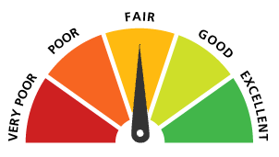
WellMASS Webinar:
Understanding Your Credit Score and Credit Report
Presented by
Metro Credit Union

Tuesday, February 14, 2017
10:00 a.m. – 10:30 a.m. &
1:00 p.m. – 1:30 p.m.
This webinar will provide information to improve your financial wellbeing. We’ll discuss:
- What goes into determining your credit score
- How to check your credit report
- Tips to increase your credit score
- How to stay clear of credit repair scams

There is no need to RSVP for this event. To participate in the webinar, call (866) 740-1260 and log on to http://staywell.readytalk.com, and enter access code 7317756.
For more information contact:
Kayla Mantegazza, Kayla.mantegazza@state.ma.us

