INDOOR AIR QUALITY ASSESSMENT

Wenham Town Hall
138 Main Street
Wenham, Massachusetts

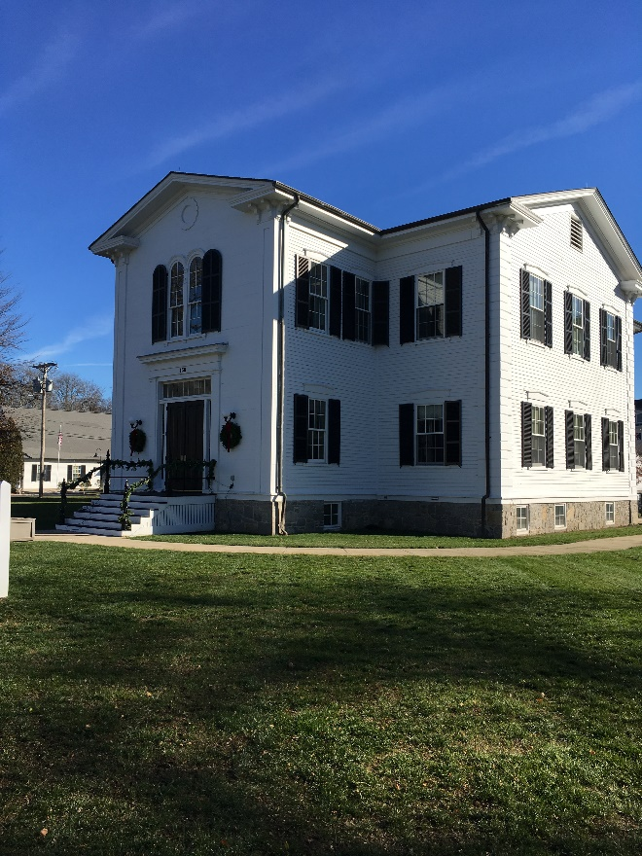

Prepared by:
Massachusetts Department of Public Health
Bureau of Environmental Health
Indoor Air Quality Program
January 2023

BACKGROUND
Building: | Wenham Town Hall (WTH)
Address: | 138 Main Street, Wenham, MA
Assessment Requested by: | Wenham Board of Health (BOH)
Reason for Request: | Water accumulation on lower floors during hot, humid weather causing mold growth concerns
Date of Assessment: | December 2, 2022
Massachusetts Department of Public Health/Bureau of Environmental Health (MDPH/BEH) Staff Conducting Assessment: | Michael Feeney, Director, and  Jennifer Lajoie, Environmental  Analyst, IAQ Program
Building Description: | Wenham Town Hall is a two-story wood building constructed in 1842. The building was renovated in 2006.
Windows: | Windows are openable.

METHODS
Please refer to the IAQ Manual for methods, sampling procedures, and interpretation of results (MDPH, 2015).

RESULTS AND DISCUSSION
The following is a summary of indoor air testing results (Table 1).
- Carbon dioxide levels were below the MDPH guideline of 800 parts per million (ppm) in all areas assessed.
- Temperature was within the MDPH recommended range of 70°F to 78°F in most areas.
- Relative humidity was slightly below the MDPH recommended range of 40% to 60% in most of the areas tested.
- Carbon monoxide levels were non-detectable (ND) in all indoor areas assessed.

Ventilation
It can be seen from the tables that carbon dioxide levels were below 800 parts per million of air (ppm) in all areas sampled, indicating adequate air exchange. Converted office space does not have mechanical ventilation. Each room has a radiator beneath the window which provides heat. The sole source of fresh air is the openable windows.
A heating, ventilating, and air conditioning (HVAC) system has several functions. First it provides heating and, if equipped, cooling. Second, it is a source of fresh air. Finally, an HVAC system will dilute and remove normally occurring indoor environmental pollutants by not only introducing fresh air, but by filtering the airstream and removing stale air to the outdoors via exhaust ventilation. Even if an HVAC system is operating as designed, point sources of respiratory irritants may be present and produce symptoms in sensitive individuals. The following analysis examines and identifies components of the HVAC system and likely sources of respiratory irritant/allergen exposure due to water damage, aerosolized dust, and/or chemicals found in the indoor environment.

Original Design of WTH Ventilation System
It is important to note that originally the WTH was not intended to be occupied year-round and was likely unoccupied during the warmest, most humid, months of the year. The original building likely used openable windows for fresh air, with heating provided by fireplaces/stoves typical of a c. 1840 building.
The building was renovated in 2006 including the installation of a mechanical heating, ventilation, and air-conditioning (HVAC) system. Fan coil units (FCU) are currently installed along the exterior walls of the building (Picture 1). The FCUs are designed to provide both heat and cooling. Depending on the setting, heated or chilled water is pumped through a finned tube (i.e., a coil) that is connected to the furnace/chiller by copper pipes that are installed in the pipe chase. Water runs through the copper pipe into the coils, which heat/cool the air forced over the coils by the FCU fans. It is important to note that FCUs are designed to provide either heating or cooling, but do not have a fresh air supply. FCU units can only recirculate air.

Current condition of the WTH Ventilation System
Most FCUs have water damage inside, including corroded drip pans (Picture 2), scale/rust (Picture 3) and signs of drip pan water overflow and condensation on surfaces outside the drainage surfaces of drip pans (Picture 4). Since these units were likely installed in 2006, they are over 17 years old. Function of equipment of this age is difficult to maintain since compatible replacement parts are often unavailable. According to the American Society of Heating, Refrigeration, and Air-Conditioning Engineers (ASHRAE), the service life for a unit heater (hot water or steam) is 20 years, assuming routine maintenance of the equipment (ASHRAE, 1991). From the extent of rust/scale, the FCUs have likely not had routine cleaning/maintenance. It is recommended that FCUs be cleaned a minimum of twice a year to remove accumulated debris.
As noted above, the WTH was not originally constructed to be occupied during hot, humid weather. Heating, ventilating, and air conditioning (HVAC) systems are designed to heat and cool a predetermined maximum volume of air by air-handing units (AHUs). If the volume of air is exceeded by the introduction of unconditioned air, the ability of the HVAC system equipment to maintain heating and cooling consistently will be impaired, resulting in increased indoor relative humidity as well as temperature complaints. Such conditions exist at the WTH.
Of note are areas where unconditioned air exists that can both increase the volume of air beyond the design capacity of equipment and/or be a source of unconditioned moist air. As an example, frequent opening of exterior doors can allow significant amounts of unconditioned hot, moist air to enter the building during extended periods hot, humid weather.
Of note was that relative humidity measurements indoors were higher than outdoors on the day of the assessment. Outdoor relative humidity was measure at 28% with a temperature of 45°F. Indoor relative humidity was in a range of 30-37% at 66°F to 74°F in various locations. When air is heated, relative humidity percentage should decrease rather than increase. These results can indicate:
- a lack of exhaust ventilation to eject moisture from the building.
- a source of moisture inside the building, or
- both conditions.
Without adequate exchange of conditioned air and/or lack of adequate exhaust ventilation, water vapor entering the WTH can build up, which may cause occupant discomfort and/or moisten building components stored materials.

Microbial/Moisture Concerns
It is important to note that Massachusetts has experienced extended periods of relative humidity during the summer of 2021. July 2021 was the wettest ever recorded in Massachusetts, and the three-month period from June through August, known as the meteorological summer, was the fourth wettest on record, according to the National Oceanic and Atmospheric Administration’s Centers for Environmental Information. The three-month period also was the third warmest ever in the state and was tied for the warmest on record across the United States. (HG, 2021; NOAA, 2021). If a building material/component or stored material has a temperature below the dew point, condensation will accumulate on that material. Over time, condensation can collect and form water droplets. If such materials stay moist for greater than 24 hours, mold growth may occur. If unconditioned hot, moist air enters the building, it can have the following effects:
- Increased humidity indoors can cause condensation on cold surfaces, particularly in below-grade space. Such conditions may moisten porous materials that can then become mold colonized Such materials may include paper, cardboard, latex carpet, books, and other porous materials.
- The FCU drip pans have a fixed rate of condensation drainage. If excess condensation is formed, condensation can overflow the drip pan to wet carpeting and the internal FCU cabinet surfaces to cause mold growth.
- If the chilled water pipes serving the HVAC system are not sufficiently insulated (adequate R value of insulation), the outside surface can become moistened and, if made of a porous material like paper, become mold colonized.
- Condensation dripping from chilled water pipes can also result in wetting of ceiling tiles, walls and/or floors.
- Condensation can occur on other uninsulated water pipes, such as those serving fire sprinklers
- High humidity weakens the material in ceiling tiles, which then sags or bows. This condition was observed in a number of areas (Table 1).
Of note is that interior hallway fire doors appear to be propped open during business hours. When this occurs, a significant amount of unconditioned air is likely entering the WTH hallways and is then captured by the HVAC system and then redistributed throughout the building, resulting in poor air chilling control during hot, humid weather. If the same use pattern of the exterior doors exists during cold weather months, heat control would also become difficult due to the introduction of large volume of cold, unconditioned air.
BEH staff examined the building to identify possible water sources; breaches in the building envelope and/or other conditions that could provide a source of moisture that can adversely affect indoor air quality. The following conditions related to moisture were identified:
- The furnace room has a sump pump. The presence of a sump pump indicates that the basement likely becomes repeatedly flooded. In addition, the sump is a source of water vapor. A sump pump opening may also be a source of mold and odors as well as provide a means for other below grade pollutants (such as radon gas) to enter the building’s interior.
- The building roof gutters/downspouts do not have sufficient capacity to drain rainwater at the roof edge or are blocked. Signs of water exposure exist around the foundation walls (Pictures 5 and 6). These conditions can undermine the integrity of the building envelope and provide a means for water entry by capillary action into the building through exterior walls, foundation concrete and masonry. In addition, these breaches in exterior areas can provide a means for drafts and pest entry into the building.
- Water-damaged ceiling tiles were noted around windows (Picture 7), indicating infiltration through the window system during wind-driven rains.
As noted previously, the building is configured in a manner where significant hot, moist air can readily pass into interior of the building. Other sources of hot, humid air impacting the main offices include spaces around the exterior wall basement doors, spaces in the exterior walls, and other parts of the building envelop around windows/doors as well as outdoor exterior doors.
Note that both liquid water and water vapor can create conditions conducive to mold growth on porous materials. While leaks or plumbing issues are obvious water sources, high relative humidity alone (>70% for an extended period of time) can also lead to mold growth on susceptible materials even in the absence of liquid water (ASHRAE, 2019).
It is recommended that porous material be dried with fans and heated within 24 to 48 hours of becoming wet (US EPA, 2008). If porous materials are not dried within this time frame, mold growth may occur. Water-damaged porous materials cannot be adequately cleaned to remove mold growth.

Other Conditions
Carpets should be cleaned annually (or semi-annually in soiled/high traffic areas) in accordance with Institute of Inspection, Cleaning and Restoration Certification (IICRC) recommendations, (IICRC, 2012). The service life of carpeting is approximately 10-11 years (IICRC, 2002). Old and worn carpeting becomes increasingly difficult to clean and maintain and may be a source of particulate matter to the indoor environment. Regular cleaning with a high efficiency particulate air (HEPA) filtered vacuum in combination with an annual cleaning will help to reduce accumulation and potential aerosolization of materials from carpeting.

CONCLUSIONS/RECOMMENDATIONS
The WTH has a number of issues related to moisture in the building. The following documents can provide guidance that can be used to reduce the impact of hot, humid weather in building, even those equipped with an HVAC system with chilling capacity.
- Mold growth Prevention during Hot, Humid Weather https://www.mass.gov/service-details/preventing-mold-growth-in-massachusetts-schools-during-hot-humid-weather
- Remediation and Prevention of Mold Growth and Water Damage in Public Schools https://www.mass.gov/service-details/remediation-and-prevention-of-mold-growth-and-water-damage-in-public-schools-and
- Methods for Increasing Comfort in Non-air-conditioned Schools https://www.mass.gov/doc/methods-for-increasing-comfort-in-non-air-conditioned-schools/download

To remedy building problems, two sets of recommendations are made: short-term measures that may be implemented as soon as practicable and long-term measures that will require planning and resources to address overall IAQ concerns:

Short Term Recommendations
- Keep all exterior doors closed during hot, humid weather.
- Keep all doors closed in each air conditioning zone to maintain air temperature and prevent condensation in adjoining areas.
- Render sump pump cover airtight to prevent moisture entry into basement.
- Do not store any porous materials on the basement floor.
- Clean carpets in a manner consistent with IICRC recommendations.
- Any water-damaged material should be removed in a manner consistent with recommendations listed in the US EPA’s “Mold Remediation in Schools and Commercial Buildings” (US EPA, 2008).
  - This work should be performed when the building is unoccupied.
  - In addition, due to the age of the building and the presence of asbestos-containing floor tiles, all work should be done in accordance with state and federal regulations.
  - Monitoring weather for predicted high outdoor relative humidity is recommended to implement the guidelines is highly recommended. This is mostly likely to occur during summer heatwave conditions in New England.
- Refer to the resource manual and other related indoor air quality documents located on the MDPH’s website for further building-wide evaluations and advice on maintaining public buildings. These documents are available at http://mass.gov/dph/iaq.

Long-term recommendations:
- Consult a ventilation engineer regarding the function of the FCUs. Due to the configuration, age, and condition of the FCU system, consideration should be given to replacing damaged FCUs.
- Consult with a building and HVAC engineer to determine the effective of supply and exhaust ventilation in the.
- Consult a building engineer to examine the feasibility of repairing or replacing the window system.
- Consider increasing capacity of gutters/downspouts to prevent water pooling on foundation ground.
- Improve water drainage of ground around foundation wall.
- Consider replacing carpets with a flooring resistant to water damage/mold growth.

REFERENCES

ASHRAE. 1991. ASHRAE Applications Handbook, Chapter 33 “Owning and Operating Costs”. American Society of Heating, Refrigeration and Air Conditioning Engineers, Atlanta, GA.
ASHRAE, 2019. American Society of Heating, Refrigeration and Air Conditioning Engineers (ASHRAE) Ventilation for Acceptable Indoor Air Quality. ANSI/ASHRAE Standard 62.1-2019. Atlanta, GA.
HG. 2021. Mold keeps South Hadley High School shuttered. Hampshire Gazette. https://www.gazettenet.com/South-Hadley-High-School-still-closed-amid-mold-remediation-42413519.
IICRC. 2002. Institute of Inspection, Cleaning and Restoration Certification. A Life-Cycle Cost Analysis for Floor Coverings in School Facilities.
IICRC. 2012. Institute of Inspection, Cleaning and Restoration Certification. Carpet Cleaning: FAQ.
NOAA. 2021. Summer 2021 neck and neck with Dust Bowl summer for hottest on record. National Oceanic and Atmospheric Administration, 1401 Constitution Avenue NW, Room 5128, Washington, DC 20230 https://www.noaa.gov/news/summer-2021-neck-and-neck-with-dust-bowl-summer-for-hottest-on-record
US EPA. 2008. Mold Remediation in Schools and Commercial Buildings. US Environmental Protection Agency, Office of Air and Radiation, Indoor Environments Division, Washington, D.C. EPA 402-K-01-001. http://www.epa.gov/mold/mold-remediation-schools-and-commercial-buildings-guide.

Picture 1

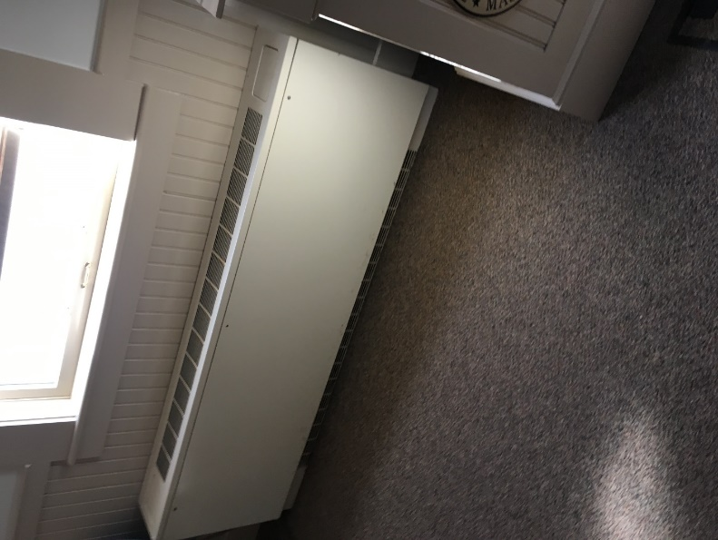
Fan Coil Unit (FCU)
Picture 2
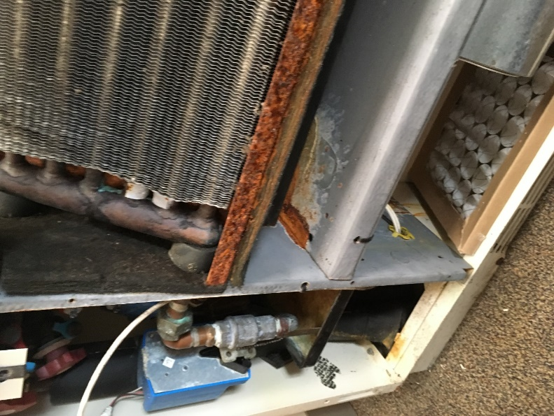
Corroded drip pan

Picture 3
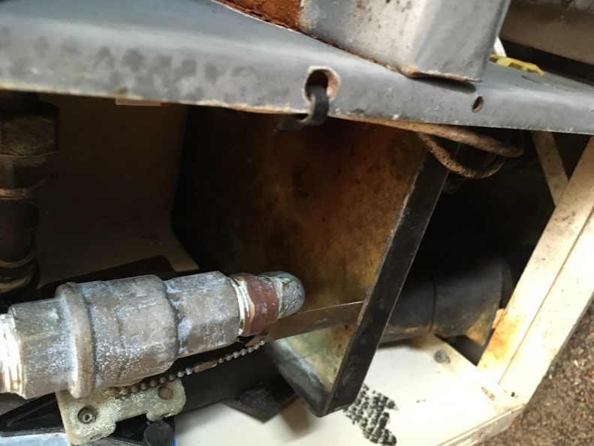
Rust/scale in condensation drain collector
Picture 4
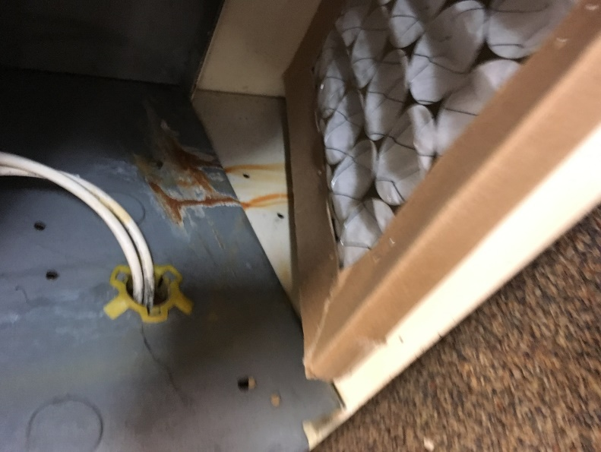
Water staining inside FCU

Picture 5
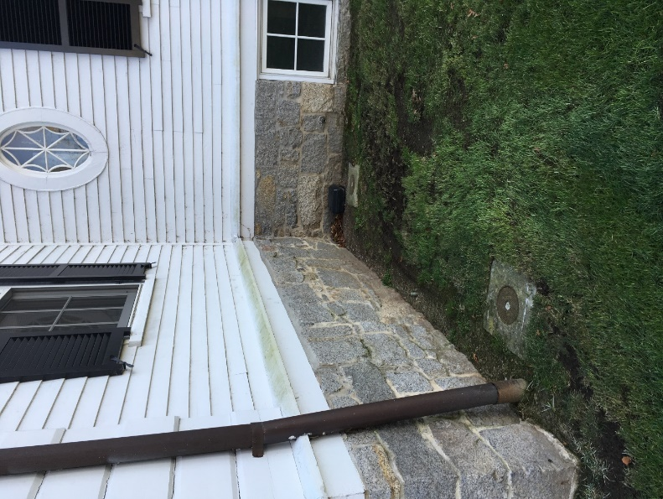
Waterlogged ground at foundation
Picture 6
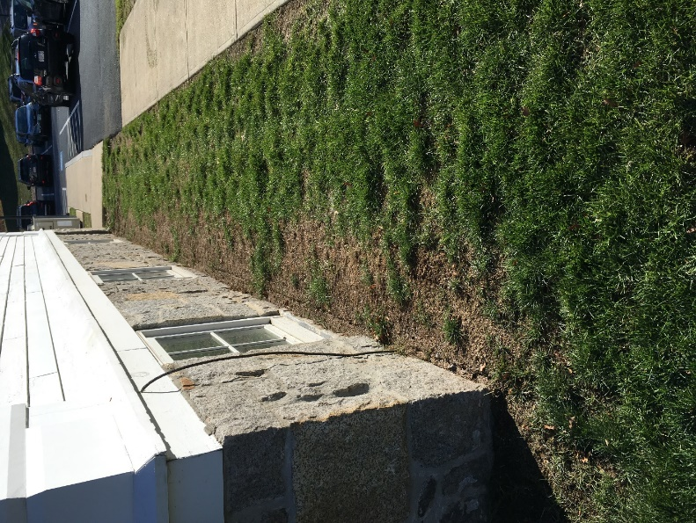
Drip line on ground and lack of grass indicating regular rainwater puddle from gutter overflow

Picture 7
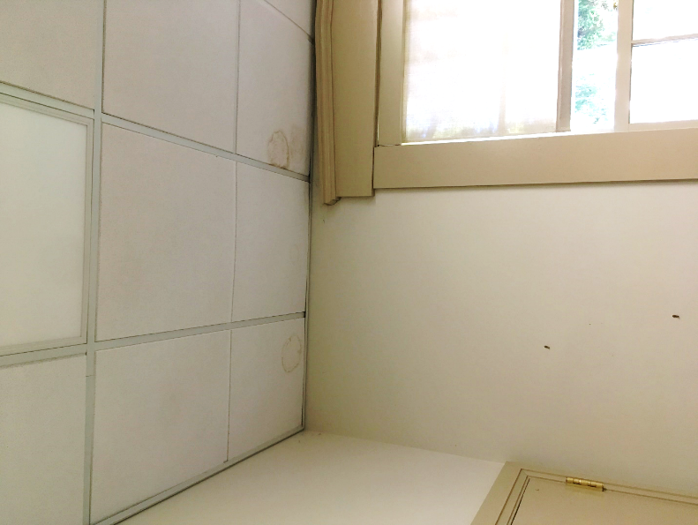
Water-damaged ceiling tile
Location | Carbon Dioxide  (ppm) | Carbon Monoxide (ppm) | Temp  (°F) | Relative  Humidity  (%) | PM2.5  (µg/m³) | Occupants | Window  Openable | Ventilation |  | Remarks
 |  |  |  |  |  |  |  | Supply | Exhaust
Background | 398 | ND | 45 | 28 | ND |  |  |  |  | Sunny
115 | 555 | ND | 71 | 36 | ND | 2 | Y | Y | Y | Plants
115 private office | 579 | ND | 73 | 37 | ND | 1 | Y | Y | Y
115 office 1 | 599 | ND | 74 | 37 | ND | 1 | Y | Y | Y | Bowed CTs
115 office 2 | 481 | ND | 72 | 35 | ND | 1 | Y | Y | Y | Bowed CTs
211 | 618 | ND | 72 | 32 | ND | 3 | Y | Y | Y | Air purifier, WD boxes, dry erase board and markers, carpet, WD CTs
214 | 491 | ND | 71 | 30 | ND | 1 | Y | Y | Y | Carpet
214 left office | 502 | ND | 71 | 30 | ND | 0 | Y | Y | Y | Vent blocked by box, carpet
217 | 465 | ND | 71 | 31 | ND | 0 | N/A | Y | Y | WD CTs around sprinkler
Office across from #209 | 464 | ND | 71 | 31 | ND | 0 | N/A | Y | N | Space heater
209 mailroom | 468 | ND | 70 | 31 | ND | 0 | N/A | Y | Y | Photocopier, mail machine, chemicals for mail machine
201 breakroom | 455 | ND | 70 | 31 | ND | 0 | Y | Y | Y | Toaster, microwave, coffeemaker, fridge
213 | 483 | ND | 70 | 31 | ND | 1 | Y | Y | Y | Carpet
213 inner office | 504 | ND | 72 | 30 | ND | 1 | Y | Y | Y | Carpet
Selectmen’s Office | 441 | ND | 66 | 37 | ND | 0 | Y | Y | Y | Bowed CTs, air purifiers

