INDOOR AIR QUALITY ASSESSMENT

**Barnstable-West Barnstable Elementary School**

2463 Main Street

Barnstable, MA

**January 2025**

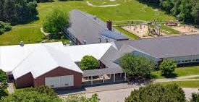

Prepared by:

Massachusetts Department of Public Health

Bureau of Climate and Environmental Health

Division of Environmental Health Regulations and Standards

Contents

EXECUTIVE SUMMARY 3

BACKGROUND 5

RESULTS AND DISCUSSION 5

Ventilation 6

HVAC System Maintenance 7

HVAC Types and Specific Conditions 8

Water Damage and Moisture Concerns 8

Sources of Respiratory Irritants/Possible Asthma Triggers 10

Other IAQ Issues 12

CONCLUSIONS AND RECOMMENDATIONS 12

Short-term Recommendations 12

Long-term Recommendations 17

REFERENCES 18

FIGURES 19

PICTURES 20

Ventilation Pictures 20

Water Damage pictures 27

Exterior Damage pictures 29

Respiratory Irritants pictures 37

Table 1 41

Table 2A 44

Table 2B 45

Table 2C 46

Table 3 47

Table 4 49

# EXECUTIVE SUMMARY

The Massachusetts Department of Public Health’s (MDPH) Division of Environmental Health, Regulations and Standards (EHRS) conducted an Indoor Air Quality (IAQ) assessment of Barnstable-West Barnstable (BWB) Elementary School located at 2463 Main Street, on December 19, 2024. This assessment was requested by the Barnstable School District.

Any building can have IAQ issues. These issues can worsen through conditions common to marginalized communities (Environmental Justice communities or EJ) such as inequitable exposure to outdoor air pollution and a greater likelihood of poor building conditions leading to deterioration of IAQ, resulting in higher asthma rates. BWB is not within an EJ community, however the town of Barnstable contains a number of EJ communities (<https://matracking.ehs.state.ma.us/Environmental-Data/ej-vulnerable-health/environmental-justice.html>). Note that the pediatric asthma rate for this school as of 2024 is 8.3%. While this rate does not have a statistically significantdifference from the statewide pediatric asthma prevalence rate, it is, however, lower than the statewide rate of 9.6% (MAEPHT, 2024).

The assessment was conducted by evaluating several key elements within the school: a visual inspection of the heating, cooling, and ventilation (HVAC) systems, water/microbial damage, cleanliness, point sources of respiratory irritants such as chemicals, and electronic measurement of carbon dioxide (CO2), carbon monoxide (CO), temperature, relative humidity (RH), and small particulate matter (PM2.5), all taken with a Qtrak XP monitor. Data collected in this manner identifies potential asthma triggers, allergens, and other environmental factors that can cause IAQ symptoms. Please refer to the [Indoor Air Quality Manual](https://www.mass.gov/lists/indoor-air-quality-manual-and-appendices#indoor-air-quality-manual-) on the MDPH website for methods, sampling procedures, and interpretation of results.

Additionally, since this school was last visited in 2013 (<https://www.mass.gov/info-details/indoor-air-quality-reports-cities-and-towns-b#barnstable->), the Barnstable School District has made a considerable change to improve IAQ by replacing all classroom unit ventilators. Room 13 was reported to have had mold on the wall over the summer, however at the time of assessment it was cleaned and no obvious signs of mold on building materials inside the building were present, although few areas had water-damaged ceiling tiles from current or historic roof or plumbing leaks. Many of the materials used in construction of schools of this age, such as concrete, hard wood, floor tile, and brick, are resistant to mold growth. (Results and Discussion)

As a result of this assessment, a number of primary recommendations are made to optimize existing systems and improve air exchange. (Conclusions and Recommendations)

* Have the supply and exhaust system on and operational during the building occupied hours. In addition, have the exhaust system evaluated and repaired if needed by a professional HVAC engineering firm to increase air exchange, remove airborne pollutants, lower humidity, and increase effectiveness of HVAC systems in all rooms.
* Facility staff should work with occupants to place air purifiers where they will be most effective, including placing them so the filtered airstream is in the breathing zone of occupants and away from open doors. Maintain units in accordance with manufacturer’s instructions.
* Move classroom materials away from univents and exhaust vents in all rooms to ensure proper air circulation and temperature control.
* Make repairs to windows (handles, screens, etc.). If repairs cannot be made to allow normal function, replace.
* Make repairs to the building envelope to restore watertight integrity.
* Install/replace gutters and downspouts to direct water away from the building and clean the area to remove any presence of sludge, grime, or mold.

As climate change and global warming intensifies, the urgent need for modern, energy-efficient solutions becomes clear, without significant repair of the building envelope and repair/upgrade of interior HVAC components, building conditions and indoor air quality will continue to degrade.

(Conclusions and Recommendations)

Please note: this report contains a series of recommendations that should serve as Best Practices that apply to most public-school buildings across the Commonwealth and should be shared amongst other buildings in the school district.

# BACKGROUND

|  |  |
| --- | --- |
| Building: | Barnstable-West Barnstable Elementary School (BWB) |
| Address: | 2463 Main Street, West Barnstable, Massachusetts |
| Coordinated Via: | Barnstable School District |
| Reason for Request: | General indoor air quality (IAQ) issues |
| Date of Assessment: | December 19, 2024 |
| Massachusetts Department of Public Health/Bureau of Climate and Environmental Health, **Division of Environmental Health Regulations and Standards** (MDPH/BCEH/EHRS) Staff Conducting Assessment: | Cory Holmes, Senior Advisor for Indoor Air Quality Inspections, Audits, Outreach and Training, EHRS  and Bharathi Patimalla-Dipali, Environmental Analyst, EHRS |
| Building Description: | The BWB is a one-story brick building that was built in the 1950s. The building contains general classrooms, library, kitchen, cafeteria/auditorium (cafetorium), gymnasium, faculty workrooms/lounge and office space. |
| Windows: | Windows in the building are openable. |

# RESULTS AND DISCUSSION

The following is a summary of indoor air testing results (Table 1)

|  |  |  |
| --- | --- | --- |
| * ***Carbon dioxide (CO2)*** | *a measure of the adequacy of ventilation* | Levels were above the MDPH guideline of 800 parts per million (ppm) in 18 of 23 areas surveyed, indicating a lack of air exchange in many areas. This is likely due to the lack of operational exhaust ventilation in most areas of the school. |
| * ***Temperature*** | *a measure of comfort* | Was mostly within/close to the MDPH recommended range of 70°F to 78°F in occupied areas, except for the **Reading and Math Intervention room (83°F),** that is located next to the boiler room. This is discussed further in the report. |
| * ***Relative humidity*** | *a measure of comfort and, when in excess for an extended period, a way to reflect the potential for mold and fungal growth* | Was within/close to the lower level of the MDPH recommended range of 40 to 60% in most areas tested. This is reflective of outdoor conditions. Relative humidity would be expected to be higher during hot, humid weather. |
| * ***Carbon monoxide***   ***(CO)*** | *a product of combustion that can result in acute and long term cardiovascular, respiratory, and neurological symptoms* | Levels were non-detect (ND) in all areas tested. |
| * ***Particulate matter (PM2.5)*** | *a way to measure inhalable particle distribution in the air* | Concentrations were below the National Ambient Air Quality Standard (NAAQS) of 35 micrograms per cubic meter (μg/m3) in all areas tested. |

## Ventilation

Ventilation refers to both the supply of fresh air and the removal of stale air from a room. The introduction of fresh air into an occupied space will dilute normally occurring pollutants that are generated by occupancy and other activities. In addition, an HVAC system will remove pollutants from a building if operating appropriately. All ventilation systems throughout the building should operate continuously during periods of occupancy.

Most classrooms are equipped with unit ventilators (univent, Picture 1). Univents bring in fresh air from a vent on the outside of the building (Picture 2), filter, heat it, and supply the air through a vent on the top. Some room air is recirculated along with the fresh air through a vent at the bottom (Figure 1). The univents are reported to be controlled by a computerized management system (Picture 3). If able, this computerized system should be utilized to monitor real-time measurements for temperature and relative humidity to track trends and take actions to prevent excess moisture conditions that can lead to mold growth over summer months.

Mechanical ventilation to the cafetorium is provided by an air handling unit (AHU) located near the kitchen (Picture 4). The AHU draws in air from the outside, heats it and distributes it via a wall-mounted vent near the ceiling. A corresponding return vent draws air back into the unit at the floor level. With both supply and return air being introduced and removed from the same wall of the cafetorium, it leads to an issue called short-circuiting (Picture 4).

At the time of assessment, exhaust ventilation in most rooms was deactivated. Exhaust vents in classrooms are in coat closets (Pictures 5a and 5b) or are wall-mounted (Picture 6). In several areas wall mounted exhaust vents were found obstructed by classroom furniture and other items (Pictures 7, 8, and 9). Without proper supply and exhaust ventilation, normally occurring environmental pollutants can build up and lead to IAQ/comfort complaints. In addition, without proper exhaust ventilation, excess moisture cannot be removed from the building, which can lead to mold growth conditions over the summer.

Ventilation for the Annex building is provided rooftop AHUs (Picture 10). Fresh air is drawn in through air intakes on the exterior of the unit, heated/cooled and filtered and distributed to occupied areas via ceiling-mounted supply diffusers and remove stale air from classrooms via ceiling-mounted return vents (Picture 11). The HVAC system is controlled by digital thermostats. The MDPH recommends that the fan be set to the “on” setting to provide continuous circulation/filtration during occupied hours. Airflow is controlled using a fan switch that has two settings, *on* and *auto*. When the fan is set to *on,* the system provides a continuous source of air circulation and filtration. The *automatic* setting on the thermostat activates the HVAC system at a preset temperature. Once the preset temperature is reached, the HVAC system is deactivated. Therefore, no mechanical ventilation is provided until the thermostat re-activates the system. **It should be noted that one of the thermostats (Room 16) had a dead battery at the time of assessment, therefore no air exchange was occurring.**

**Although windows have been replaced within the last 10 years, many of them are reported to be difficult to open due to broken handles, in addition, many have missing or damaged screens.**

The various types of ventilation components as well as devices that can move/redirect airflow that were identified in the building are listed in Table 2A, Table 2B and Table 2C.

### HVAC System Maintenance

* **A univent was opened and the filter examined, which appeared to provide minimal filtration (Picture 12).** MDPH recommends that filters of at least a Minimum Efficiency Rating Value (MERV) 8 be used as these are adequate to filter out pollen, mold, and similar particulates (ASHRAE, 2012). MDPH recommends that filters be changed two to four times a year or as per the manufacturers’ recommendations. It was reported that filters are replaced four times a year.
* **Some of the univents were obstructed by items in front of return vents (Pictures 13 and 14) or along the top.** To provide mechanical ventilation as designed and to prevent damage to machinery, both the supply and return vents (along the front/bottom of the unit) should be free and clear of obstructions.

**Balancing**

To have proper ventilation with a mechanical supply and exhaust system, a system must be balanced to provide an adequate amount of fresh air to the interior of a room while also removing stale air from the room. It is recommended that HVAC systems be re-balanced every five years to ensure adequate air systems function (SMACNA, 1994).

### HVAC Types and Specific Conditions

(see Ventilation pictures)

**Additional HVAC Conditions:**

* **The Reading and Math Intervention room, located adjacent to the Boiler Room, is not equipped with mechanical (supply/exhaust) or natural ventilation (windows).** It is recommended to provide mechanical ventilation into this occupied space. As an interim measure, it is recommended to install passive vents, openings, or louvers within the hallway door to enable fresh air to enter the room while letting stale air escape. The ambient temperatures recorded in the room are beyond the MDPH recommendations of occupied space.
* **Air purifiers were also found in classrooms (Pictures 15a and 15b).** High-efficiency particulate arrestance (HEPA) air purifiers remove up to 99% of airborne contaminants as small as 0.1 microns including airborne mold spores. These are good choices for use in occupied areas. Air purifiers that may produce ozone should not be used (EPA, 2003). All air purifiers should be cleaned and maintained in accordance with manufacturers’ instructions. Air purifiers should be also placed away from walls and open doors to ensure proper air intake.

## Water Damage and Moisture Concerns

Please note that the MDPH does not recommend conducting mold testing in a typical water damage remediation. For details, please consult [Guidance Regarding Testing for Mold in Water-Damaged Public Buildings](https://www.mass.gov/info-details/guidance-regarding-testing-for-mold-in-water-damaged-public-buildings) | Mass.gov

The application of a mildewcide to moldy porous materials is not recommended.

Molds are found naturally in our environment both indoors and outdoors. Inside, mold growth may occur when items, particularly porous products such as paper or gypsum wallboard, are exposed to moisture. Typical water sources include leaks, floods, and condensation. To avoid mold growth, dry all water-damaged items and affected areas within 24-48 hours and reduce indoor humidity. Some people with chronic respiratory conditions, such as asthma, are more likely to experience health symptoms associated with molds, including allergic reactions and respiratory irritation. Controlling moisture is the key to preventing mold growth and potential health symptoms.

Hot humid summers are becoming more frequent due to climate change. Massachusetts has experienced hot, humid, and rainy summers in 2018, 2021, and 2023. July of 2021 was the wettest ever recorded in Massachusetts, and the three-month period from June through August, known as the meteorological summer, was the fourth wettest on record, according to the National Oceanic and Atmospheric Administration’s (NOAA) Centers for Environmental Information (NOAA, 2021). The summer of 2023 was also hot, and wet, being measured as the second rainiest on record (WBUR, 2023). The summer of 2024 has also had significant stretches of hot, humid weather. These conditions are challenging for buildings, particularly those without central air conditioning.

During these hot and wet summers, extended periods of outdoor relative humidity above 70% occurred. Under this weather, public buildings experienced extended periods of water vapor exposure from high relative humidity. When exposed to these conditions, porous materials such as gypsum wallboard, cardboard, and other materials may become prone to developing mold colonization, particularly if located in areas that are prone to developing condensation on floors and walls (e.g., below grade space).

The digital thermostats are part of a computerized management system. If able, this computerized system should be utilized to monitor *real-time measurements* for temperature and relative humidity to track trends and take actions to prevent excess moisture conditions that can lead to mold growth over summer months.

All rooms were assessed for the presence of either mold or visible water damage and an exterior evaluation was conducted to identify potential pathways for water penetraion. The following issues were noted.

* **Water-damaged ceiling tiles were found in several locations (Table 1),** which can indicate current/historic roof/plumbing leaks or other water infiltration. **Several active roof leaks were reported including one that was discovered in the Annex Building prior to the assessment.** Water-damaged ceiling tiles can provide a source of mold and should be replaced after a water leak is discovered and repaired. Suspended ceiling tiles (Picture 16) should be discarded and replaced. Leaks discovered above suspended ceiling tiles (Picture 17), could be an indication of a larger issue.
* **The wooden gymnasium floor showed signs of water damage,** most likely caused by chronic water exposure over the years, or a flooding event, causing it to swell and buckle. Although not an air quality issue, this could provide a tripping hazard and should be repaired. It was reported that this was on a capital repair list.
* **Visible mold was observed on the gaskets of refrigerators and freezers in the Teacher’s Lunchroom (Pictures 18 and 19).**
* **Light was seen penetrating around the exterior door Room 14.** These spaces can allow for uncontrolled drafts, moisture, and pest entry (Picture 20). These conditions can also make it difficult to control temperature, leading to comfort complaints and condensation issues that can lead to mold growth.
* **Damaged wood and delaminating paint were found along the roof eaves, trim, and exterior walls**, which can accelerate water damage and rot (Pictures 21 through 24) allowing a pathway for drafts, moisture, and pest entry into the building.
* **Gutters and downspouts were removed from some parts of the building exterior**, it is recommended to clean the surfaces to remove sludge, grime, or mold buildup (Pictures 25 and 26).
* **Damaged concrete masonry (Picture 27) and damaged/missing sealant around intake vents (Pictures 27 and 28) were noted.**
* **Overgrown vegetation and shrubbery on the exterior of the building can negatively impact indoor air quality** by trapping moisture, creating a breeding ground for mold and mildew spores which can then enter the building through open windows or air vents, potentially causing respiratory issues for occupants (Pictures 29 through 31).
* **Damaged crawlspace vent (Picture 32).** Breaches in the exterior wall allow access to the outside elements, pests, and moisture.
* **The exterior walls of the main and Annex buildings should be cleaned** (pressured washed) to remove dirt, grime, and the presence of lichen growth (Pictures 33 through 35).

A list of water damage issues identified inside and outside the building is included as Table 3.

(see Water Damage Pictures)

**Mold Growth**

Porous materials (e.g., gypsum wallboard, ceiling tiles and carpeting) can be dried with fans and heating within 24 to 48 hours of becoming wet (US EPA, 2008).

If porous materials are not dried within this time frame, mold growth may occur.

## Sources of Respiratory Irritants/Possible Asthma Triggers

Asthma is a lung disease that can make breathing difficult. Without careful management of asthma, some people can have symptoms, like a tight feeling in the chest, shortness of breath, coughing, or wheezing. Although there is no cure for asthma, people with asthma can live healthy, active lives. A safe and healthy environment helps to reduce asthma symptoms.

**Comparison of Local and State-wide Asthma Rates (2023-2024)**

8.3% of children

have asthma.

**Barnstable-West Barnstable ES**

9.6% of children

have asthma.

**Massachusetts**

7.8% of children

have asthma.

**Barnstable**

* **Sometimes, learning tools and personal items in a classroom can be a source of irritants.** For example, a bird or insect nest is a great learning tool for students but may harbor microbes and allergens, **as does an aquarium which could be a source of odors (Picture 36)**. Similarly, food-based projects can attract pests that carry disease or trigger allergies.
* **Dust, a common respiratory and eye irritant, can collect on surfaces and items.** Although janitorial and maintenance staff perform routine cleaning in classrooms, they may not be able to clean as effectively if classroom items are not picked up or surfaces are cluttered.
* Even with a properly functioning ventilation system, it is necessary to **reduce the use of materials that can be a source of respiratory irritants** to prevent symptoms in individuals who have sensitivity to such pollutants. **Without operational mechanical exhaust in most areas, irritants can linger.**

For guidance on maintaining an asthma-friendly healthy school environment, please consult the MDPH Asthma Prevention and Control Program’s [Clearing the Air: An Asthma Toolkit for Healthy Schools](https://www.maasthma.org/schooltoolkit).

Possible asthma triggers and/or airborne pollutants exist in the building. These are listed below as well as in (Table 4).

(see Sources of Respiratory Irritant Pictures)

* **Many classrooms had area rugs, pillows and cushions (Table 1, Picture 37).** Area rugs need to be cleaned regularly to remove dust, debris, and odors. Area rugs should also be stored off the floor in a climate-controlled area during the summer to prevent moistening by condensation. Used area rugs should not be brought into the school as they may harbor allergens such as pet dander.
* **An emergency generator was stationed outside the building (Picture 38).** It is important to note the area of installation and its proximity to openable windows and fresh air intakes. The generator should be set using automatic startup timers for after hours or weekends to prevent exposure to exhaust emissions and noise.
* **Exposure to low levels of total volatile organic compounds (TVOCs)** may produce eye, nose, throat, and/or respiratory irritation in some sensitive individuals. Testing for TVOCs was not conducted, however MDPH staff examined rooms for products containing VOCs. MDPH staff noted diffusing oils, hand sanitizers, cleaners, and dry erase materials (Table 1) in use within the building. These products have the potential to be irritants to the eyes, nose, throat, and respiratory system of sensitive individuals. Consult “[Clean Air Is Odor Free](https://www.mass.gov/doc/clean-air-is-odor-free-removing-fragrances-to-improve-indoor-air-quality-in-schools-and-offices-0/download)” for more information on fragrances in schools and other building.
* **Tennis balls were used as chair glides in a few areas (Picture 39; Table 1).** Tennis balls are made of materials that may be a source of respiratory irritants. Constant wearing of tennis balls can produce fibers and off-gas VOCs. Tennis balls are made with a natural rubber latex bladder, which becomes abraded when used as a chair leg pad. Use of tennis balls in this manner may introduce latex dust into the school environment. Some individuals are highly allergic to latex (e.g., spina bifida patients) (SBAA, 2001). It is recommended that the use of materials containing latex be limited to reduce the potential for symptoms in sensitive individuals (NIOSH, 1997). Latex-free glides should be used for this purpose.
* **In some areas supply/exhaust vents and personal fans were dusty (Table 1; Pictures 40 and 41).** This dust can be aerosolized under certain conditions and can also be a medium for mold growth.
* **Filters for portable air purifiers were checked and found to be clogged with dust/debris (Picture 15b).** Air purifiers should be cleaned and maintained in accordance with manufacturer’s instructions.

## Other IAQ Issues

*Radon*

Radon is a naturally occurring radioactive gas that seeps into buildings from the surrounding soil and at elevated levels can increase the risk of lung cancer.

The Environmental Protection Agency (EPA) conducted a National School Radon Survey “in which it discovered nearly one in five schools has at least one schoolroom with a short-term radon level above the action level of 4pCi/L (picocuries per liter) – the level at which the EPA recommends that schools take action to reduce the level” (US EPA, 1993).

**The MDPH therefore recommends that every school be tested for radon, and that this testing be conducted during the heating season while school is in session in a manner consistent with US EPA radon testing guidelines**. Radon measurement specialists and other information can be found at [www.nrsb.org](http://www.nrsb.org) and <http://aarst-nrpp.com/wp>, with additional information at: <https://www.mass.gov/radon>.

# 

# CONCLUSIONS AND RECOMMENDATIONS

Please note: this report contains a series of recommendations that should serve as *Best Practices* that apply to most public-school buildings across the Commonwealth and should be shared amongst other buildings in the Barnstable School District.

**Short-term recommendations** can be implemented as soon as practicable, however **long-term measures** are more complex and will require planning and resources to adequately address overall indoor air quality issues within the building.

|  |  |  |  |
| --- | --- | --- | --- |
| Short-term Recommendations | | | |
|  | **HVAC System** | | **Helpful Links** |
|  | Reactivate exhaust vents throughout the building. |  | |
|  | Remove blockages from univents and exhaust vents. |  | |
|  | Install exhaust fans in restrooms that do not have them or windows. |  | |
| 1. If | Ensure all univents are on and operating continuously during occupied periods. If univent operation is linked to *carbon dioxide sensors*, work with HVAC vendor to determine a set point to introduce outside air (e.g., 800 ppm carbon dioxide). |  | |
|  | If equipped, ensure carbon dioxide sensors are calibrated or replaced periodically per the manufacturers’ recommendations to ensure accuracy. |  | |
|  | Program thermostats in the Annex to the fan *on* setting toprovide a continuous source of air circulation and filtration.  Ensure battery is replaced for thermostat in Room 16. |  | |
|  | If possible, utilize computerized management system to monitor real-time measurements for temperature and relative humidity to track trends and take actions to prevent excess moisture conditions that can lead to mold growth over summer months. |  | |
|  | Utilize stand-up fans in cafetorium to help air circulation. Consider installing ceiling fans to help airflow. |  | |
|  | Operate windows in occupied classrooms unless contraindicated by outdoor conditions or occupant concerns. Such conditions may include heavy precipitation, extreme cold, poor outdoor air quality, high pollen counts, idling vehicles, or excessive noise. | <https://www.airnow.gov/> | |
|  | Ensure windows are closed tightly at the end of the day as well as during periods of elevated relative humidity (70%) and during freezing weather to prevent pipe bursts. |  | |
|  | Make repairs to windows (handles, screens, etc.). If repairs cannot be made to allow normal function, replace. |  | |
|  | Change HVAC filters 2-4 times a year using MERV 8 or the best MERV-rating that can work with current equipment. | [ANSI/ASHRAE Standard 52.2-2017](https://www.ashrae.org/File%20Library/Technical%20Resources/COVID-19/52_2_2017_COVID-19_20200401.pdf) | |
|  | During filter changes, clean dust and debris from the inside of HVAC cabinets. |  | |
|  | Clean dust and debris from vents and personal fans periodically. |  | |
|  | Ensure local exhaust ventilation in Staff Rooms to remove access heat and odors from photocopiers and lamination machines. |  | |
|  | Consider providing mechanical supply and exhaust ventilation in theReading and Math Intervention room. In the interim, it is recommended to allow for natural air circulation by incorporating passive vents, or louvers within the door to provide limited air exchange/heat relief. |  | |
|  | Close classroom doors for more effective operation of exhaust vents/air exchange. |  | |
|  | Once mechanical exhaust systems are repaired/activated, have the HVAC system balanced if it has been more than 5 years since the last balancing. |  | |

|  |  |  |
| --- | --- | --- |
|  | **Water damage** | |
|  | Replace water-damaged suspended ceiling tiles. Repeated water damage to ceiling tiles indicates leaks from the roof or plumbing/HVAC system which should be repaired. | <http://www.epa.gov/mold/mold-remediation-schools-and-commercial-buildings-guide> |
|  | Continue with plans to replace or make repairs to the gymnasium floor. |  |
|  | Clean mold from refrigerator and freezer gaskets. |  |
|  | Use the computerized HVAC management system to monitor real-time measurements for temperature and relative humidity to track trends and take actions to prevent excess moisture conditions that can lead to mold growth. |  |
|  | Do not store books, cardboard, or other porous items directly on ground-level floors or up against walls to prevent mold growth due to condensation on cool surfaces, Elevate items with pallets or store on shelving. |  |
|  | Seal spaces in and around exterior doors with weatherstripping (e.g., Room 14), to prevent drafts, moisture, and pest entry. |  |
|  | Use these guidelines to control for moisture and increase comfort in a non-air-conditioned school especially during heatwaves. | * Mold Growth Prevention During Hot, Humid Weather <https://www.mass.gov/service-details/preventing-mold-growth-in-massachusetts-schools-during-hot-humid-weather> * Remediation and Prevention of Mold Growth and Water Damage in Public Schools <https://www.mass.gov/service-details/remediation-and-prevention-of-mold-growth-and-water-damage-in-public-schools-and> * Methods for Increasing Comfort in Non-air-conditioned Schools <https://www.mass.gov/doc/methods-for-increasing-comfort-in-non-air-conditioned-schools/download> |
|  | During summer months, pull furniture away (1 to 2 inches) from walls to prevent mold growth due to lack of airflow and remove impermeable wall coverings that can trap moisture such as laminated posters. |  |
|  | Trim trees, branches, and shrubbery at least 5 feet away from the building. |  |
|  | Conduct a thorough building envelope evaluation to make repairs/repointing efforts to eliminate leaks. Building occupants should ensure they report active leaks to building management for investigation and repairs. |  |
|  | Replace missing/damaged caulking around univent air intakes. |  |
|  | Replace damaged vents on exterior of building to prevent pest entry. |  |
|  | Pressure wash exterior walls of the main and Annex buildings to remove dirt, grime, and the presence of lichen growth. |  |
|  | **Respiratory Irritants/Possible Asthma Triggers** | |
|  | Clean dust from surfaces, including dry erase dust, frequently using methods that do not aerosolize the dust, including HEPA-equipped vacuuming or wet wiping. Avoid using feather dusters or sweeping dust into the air. |  |
|  | Reduce clutter. Periodically remove unwanted items. Store remaining items neatly and off the floor. Where rooms have a history of moisture issues, consider storing items in waterproof totes. |  |
|  | Reduce use of products and equipment that create irritating volatile organic compounds (VOCs) and only use in well-ventilated areas. Minimize the use of air fresheners (e.g., plug-ins), deodorizers, and scented products. | <https://www.mass.gov/cleaner-greener-healthier-schools>  [Clean Air Is Odor Free](https://www.mass.gov/doc/clean-air-is-odor-free-removing-fragrances-to-improve-indoor-air-quality-in-schools-and-offices-0/download) |
|  | Use only District-approved cleaning products. Keep spray bottles properly labeled and out of the reach of children. |  |
|  | Clean area rugs frequently using a HEPA-equipped vacuum cleaner. Avoid bringing used area rugs or pillows/cushions into the school. |  |
|  | Clean classroom learning tools like aquariums or terrariums regularly to prevent odors. |  |
|  | Set timer for emergency generator to test during unoccupied periods to prevent entrainment of exhaust emissions during occupied periods. |  |
|  | Avoid using latex-containing tennis balls as chair or table glides. Replace with latex-free glides or other materials. | <https://www.cdc.gov/niosh/docs/97-135/default.html>  <https://www.spinabifidaassociation.org/wp-content/uploads/latex-in-the-home-and-community-eng.pdf> |
|  | Clean personal fans, supply, and exhaust/return vents periodically to remove dust and debris. |  |
|  | Air purifiers that use HEPA filters, with or without carbon filters, are good choices for occupied areas. Units that may produce ozone should not be used. Maintain all in accordance with manufacturer’s instructions.  Place them so the filtered airstream is in the breathing zone of occupants and away from open doors. | <https://www.epa.gov/indoor-air-quality-iaq/ozone-generators-are-sold-air-cleaners> |
|  | **Other Recommendations to Improve Air Quality Conditions** | |
|  | Test the school for radon by a certified radon measurement specialist during the heating season when school is in session. | Radon measurement specialists and other information can be found at: [www.nrsb.org](http://www.nrsb.org), and <http://aarst-nrpp.com/wp> |
|  | To learn more about radon, review the MDPH’s Radon in Schools and Childcare Programs factsheet. | <https://www.mass.gov/radon>. |
|  | Utilize the US EPA’s (2000), “Tools for Schools” as an instrument for maintaining a good IAQ environment in the building. | <https://www.epa.gov/iaq-schools>. |
|  | For guidance on maintaining an asthma-friendly healthy school environment, please consult the MDPH Asthma Prevention and Control Program’s Clearing the Air: An Asthma Toolkit for Healthy Schools. | <https://www.maasthma.org/schooltoolkit> |
|  | Include an IAQ component in the school’s Wellness Advisory Committee program. An IAQ plan should have an IAQ liaison/teacher representative, a member of maintenance/facilities and administration that conduct regular walk-throughs to identify on-going and/or potential environmental issues. |  |
|  | Long-term Recommendations | |
|  | Replace gutters and downspouts to provide proper drainage away from the building. |  |
|  | Work with HVAC engineer to provide mechanical supply and exhaust ventilation in the Reading and Math Intervention room. |  |
|  | If repairs cannot be made to allow normal function of windows, replace. |  |

# REFERENCES

ASHRAE. 2012. American Society of Heating, Refrigeration and Air Conditioning Engineers (ASHRAE) Standard 52.2-2012 – Method of Testing General Ventilation Air-Cleaning Devices for Removal Efficiency by Particle Size (ANSI Approved).

MAEPHT. 2024. Massachusetts Environmental Public Health Tracking. Massachusetts Department of Public Health – Bureau of Climate and Environmental Health. <https://matracking.ehs.state.ma.us/>

NIOSH. 1997. NIOSH Alert Preventing Allergic Reactions to Natural Rubber latex in the Workplace. National Institute for Occupational Safety and Health, Atlanta, GA.

NOAA. 2021. Summer 2021 neck and neck with Dust Bowl summer for hottest on record. National Oceanic and Atmospheric Administration, 1401 Constitution Avenue NW, Room 5128, Washington, DC 20230 <https://www.noaa.gov/news/summer-2021-neck-and-neck-with-dust-bowl-summer-for-hottest-on-record>

SBAA. 2001. Latex In the Home And Community Updated Spring 2001. Spina Bifida Association of America, Washington, DC.

SMACNA. 1994. HVAC Systems Commissioning Manual. 1st ed. Sheet Metal and Air Conditioning Contractors’ National Association, Inc., Chantilly, VA.

US EPA. 1993. Radon Measurement in Schools, Revised Edition. Office of Air and Radiation, Office of Radiation and Indoor Air, Indoor Environments Division (6609J). EPA 402-R-92-014.

US EPA. 2000. Tools for Schools. Office of Air and Radiation, Office of Radiation and Indoor Air, Indoor Environments Division (6609J). EPA 402-K-95-001, Second Edition. <https://www.epa.gov/iaq-schools>.

US EPA. 2003. “Ozone Generators that are Sold as Air Cleaners: An Assessment of Effectiveness and Health Consequences”. United States Environmental Protection Agency, Office of Air and Radiation, Indoor Environments Division, Washington, DC. Last updated September, 2018. <https://www.epa.gov/indoor-air-quality-iaq/ozone-generators-are-sold-air-cleaners>

US EPA. 2008. Mold Remediation in Schools and Commercial Buildings. US Environmental Protection Agency, Office of Air and Radiation, Indoor Environments Division, Washington, D.C. EPA 402-K-01-001. <http://www.epa.gov/mold/mold-remediation-schools-and-commercial-buildings-guide>.

WBUR. 2023. “It’s been a summer of rain and flooding misery in Mass.” WBUR local news. September 12, 2023. <https://www.wbur.org/news/2023/09/12/summer-flooding-rain-massachusetts>

(Click to link back to report)

# FIGURES

**Figure 1**

**Unit Ventilator (Univent)**

Mixed Air

Air Diffuser

**Outdoors Indoors**

Fan

Heating/Cooling Coil

Air Mixing Plenum

Filter

Outdoor Return

Air Air

Air

Flow

Control

Louvers

**Air Flow**

= Fresh Air/Return Air

= Mixed Air

# PICTURES

## Ventilation Pictures

**Picture 1**

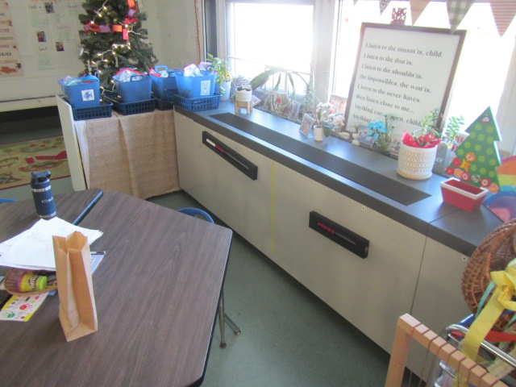

**Univent in classroom**

**Picture 2**

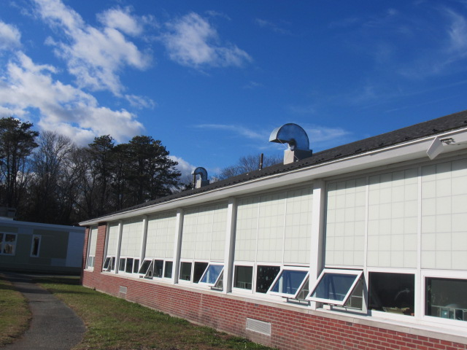

**Univent fresh air intakes (arrows)**

**Picture 3**

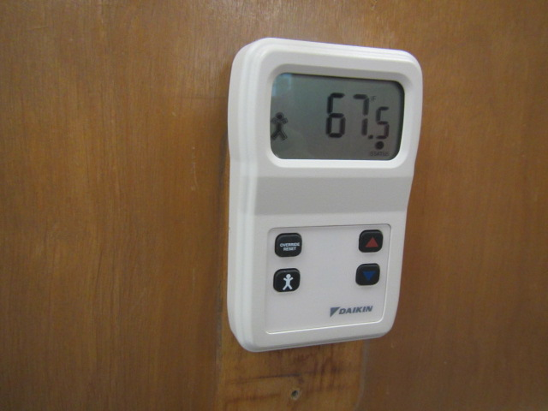

**Digital thermostat for computerized management system displaying temperature measurement in Fahrenheit**

**Picture 4**

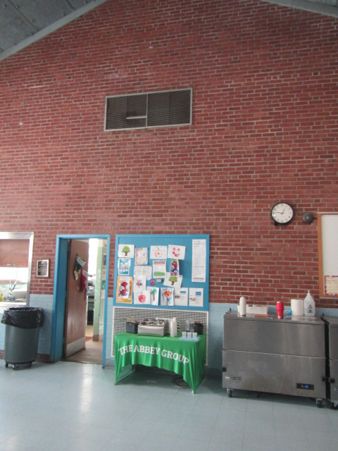

**Short-circuiting of AHU in cafetorium, arrow shows airflow**

**Pictures 5a & 5b**

****A picture of a bifold closet with exhaust vent on the ceiling inside. 

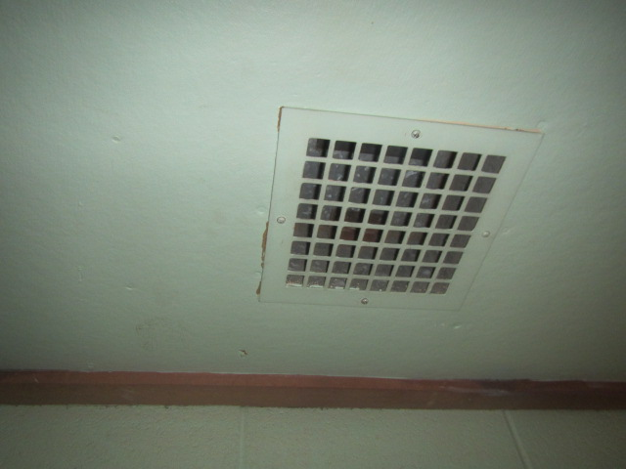

**Exhaust vent inside the closet at the top (arrow)**

**Picture 6**

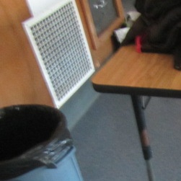

**Wall-mounted exhaust vents in classroom**

**Picture 7**

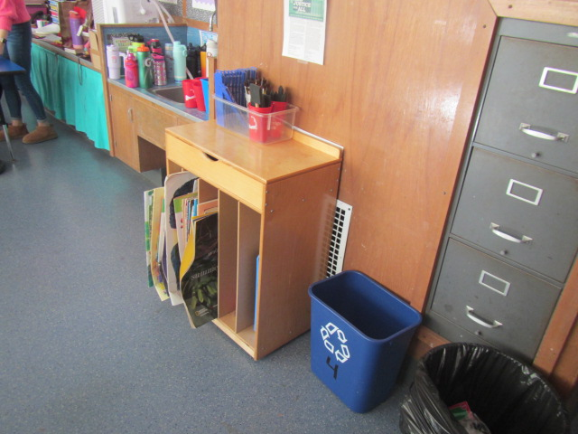

**Wall-mounted exhaust vent (arrow) behind bookcase in classroom**

**Picture 8**

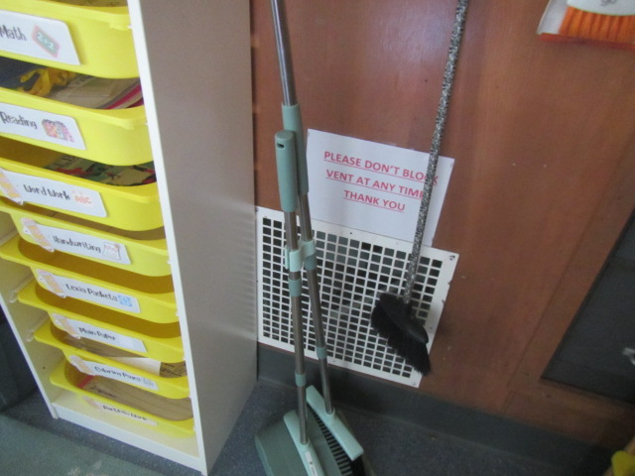

**Wall-mounted exhaust vent (arrow) behind cleaning supplies in classroom**

**Picture 9**

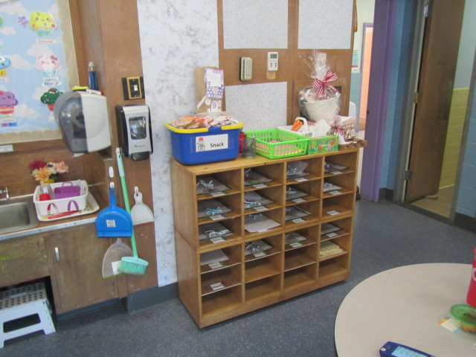

**Exhaust vent behind shelf in classroom (arrow)**

**Picture 10**

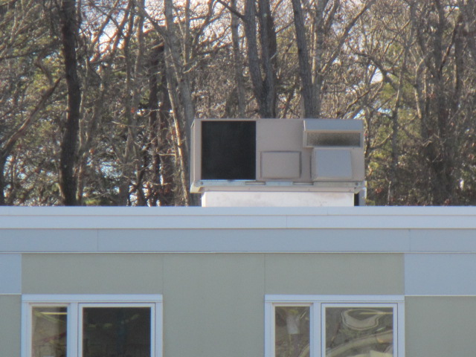

**Rooftop AHU on Annex Building**

**Picture 11**

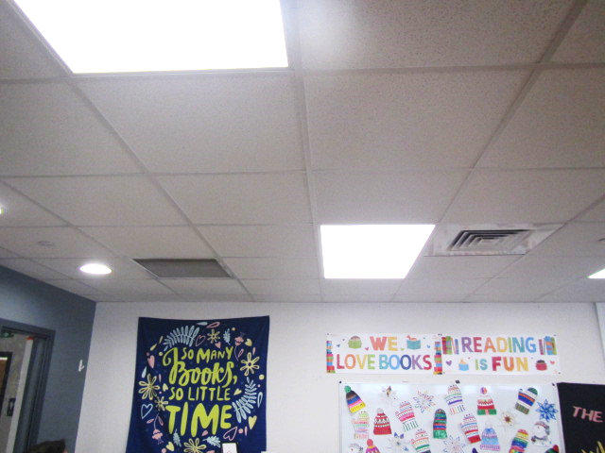

**Arrows indicated supply (right) and return (right) vents in Annex building**

**Picture 12**

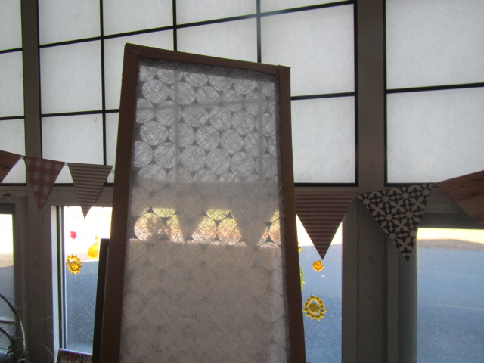

**Filter in classroom univent**

**Picture 13**

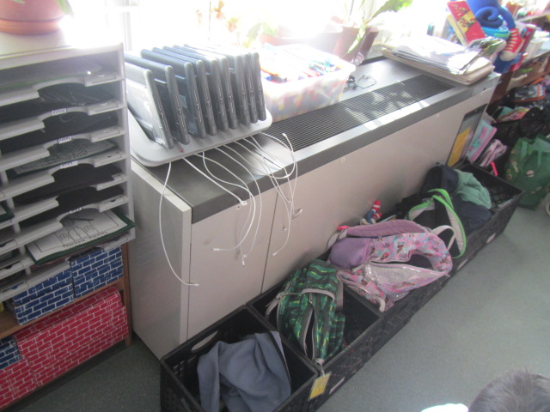

**Univent return vent (bottom front) obstructed by storage crates preventing airflow into unit**

**Picture 14**

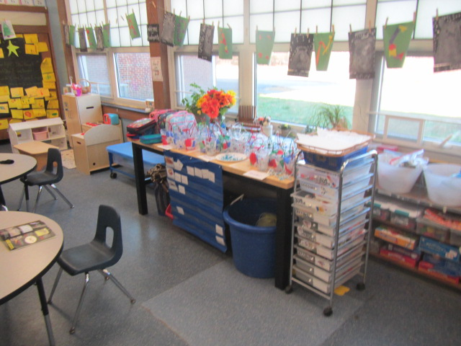

**Univent return vent (bottom front) obstructed by paper and materials, preventing airflow into the unit**

**Pictures 15a & 15b**

****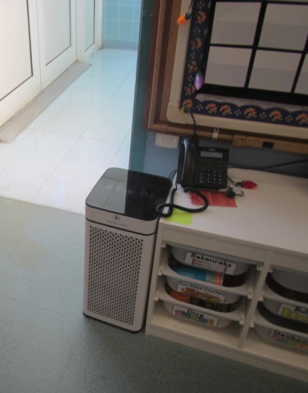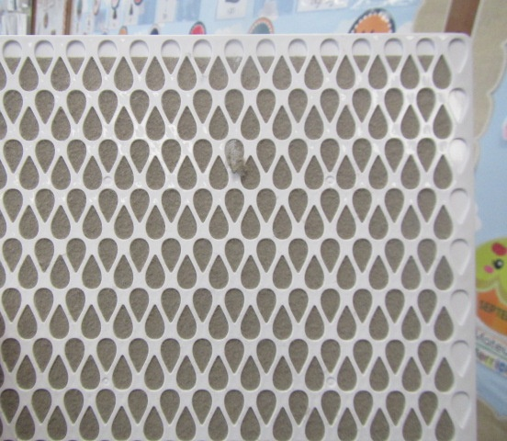

**Air purifier in classroom by an open door. The filter in the purifier (arrow)**

## Water Damage pictures

Picture 16

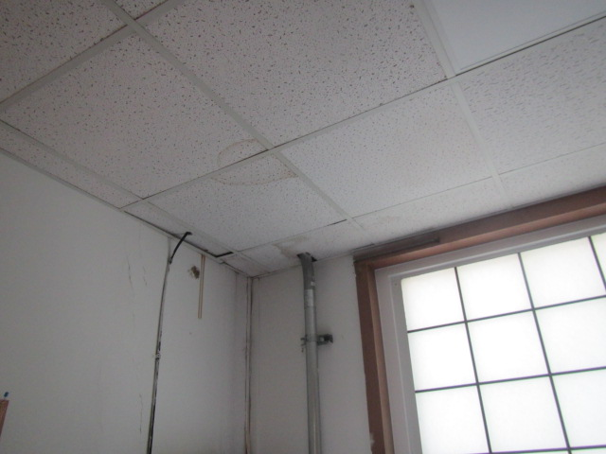

Water-damaged suspended ceiling tiles

Picture 17

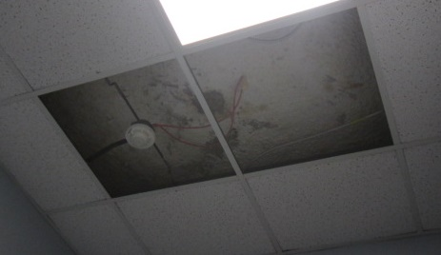

Water damage above the ceiling tiles in the Teacher’s break room

Picture 18

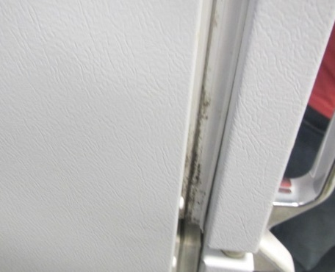

Mold growth on refrigerator/freezer gasket

Picture 19

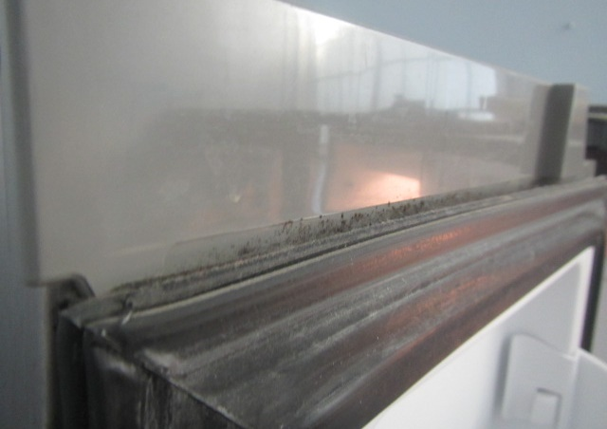

Mold growth on refrigerator/freezer gasket

## Exterior Damage pictures

Picture 20

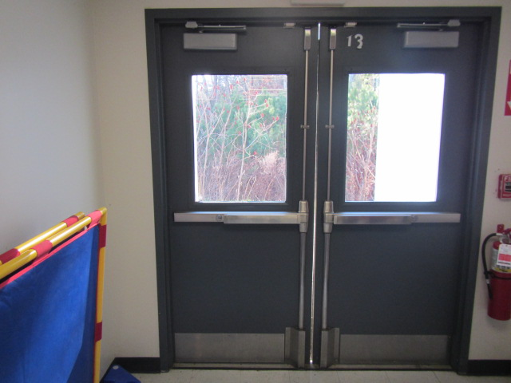

Exterior doors of the Annex, gap (arrow) leading to drafts and poor weatherproofing

Picture 21

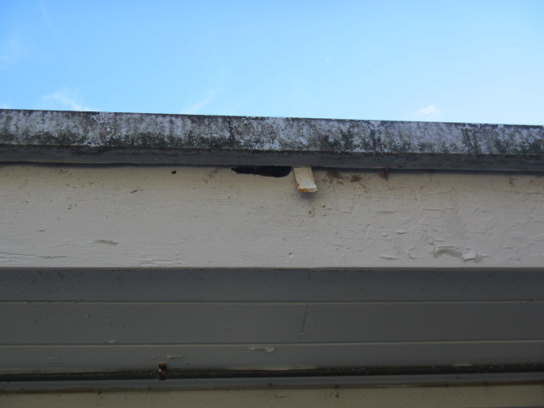

Open holes/peeling paint/damage to the exterior of the building

Picture 22

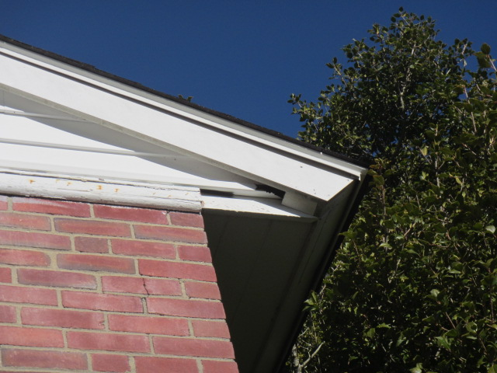

Open holes/damage to the exterior of the building, also note proximity of trees/overhanging branches

Picture 23

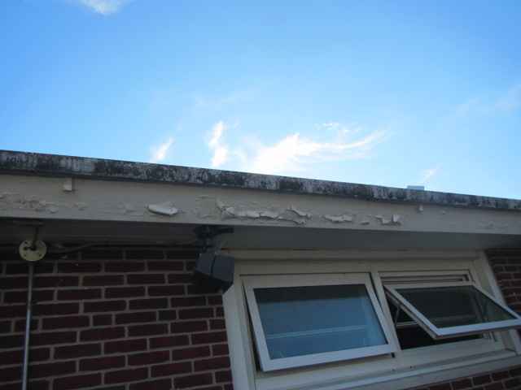

Delaminating wood along roof/exterior walls

Picture 24

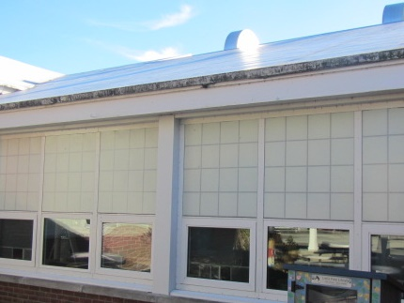

Dark staining on exterior wall panels indicates sludge, grime or mold buildup

Picture 25

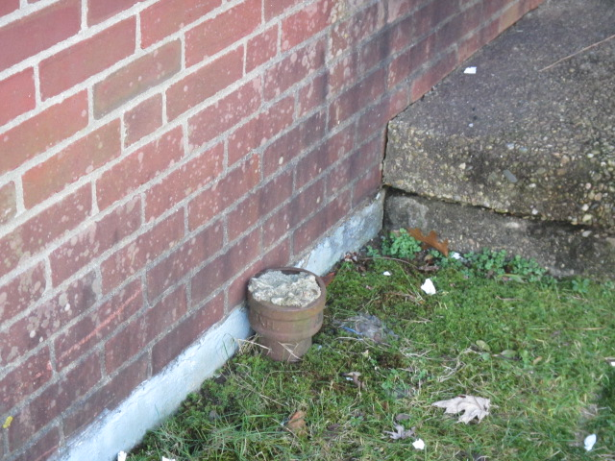

Missing downspout, underground drainage system abandoned/filled in

Picture 26

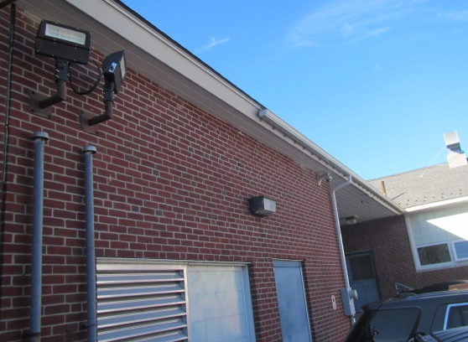

Partial gutter system (arrow)

Picture 27

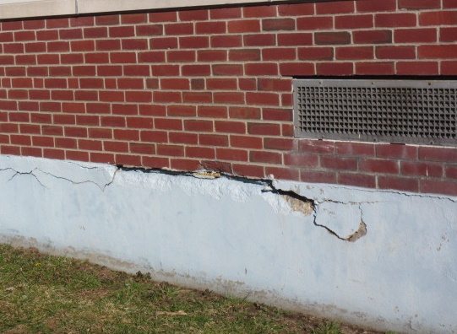

Damaged concrete foundation, Note missing/damaged sealant around univent air intake

Picture 28

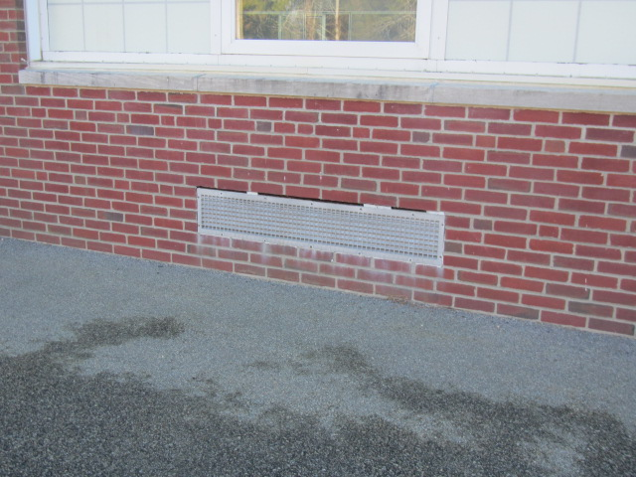

Missing/damaged sealant around univent air intake

Picture 29

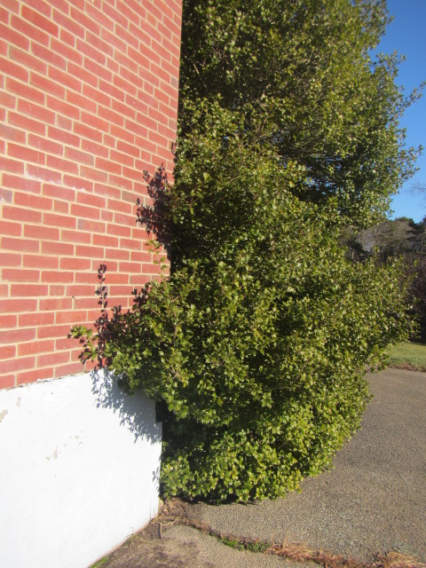

Overgrown shrubbery on the exterior of the building

Picture 30

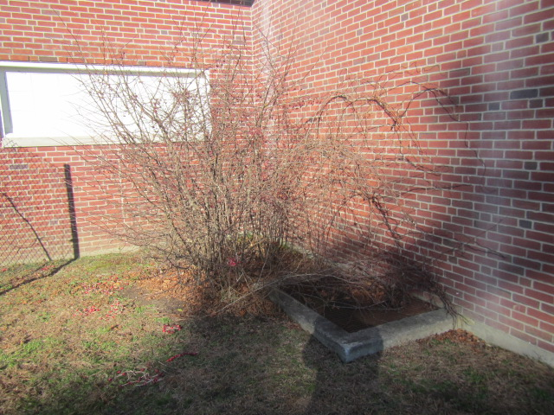

Overgrown shrubbery on the exterior of the building

Picture 31

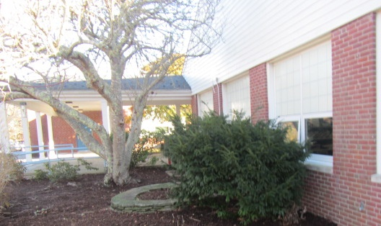

Overgrown shrubbery on the exterior of the building

Picture 32

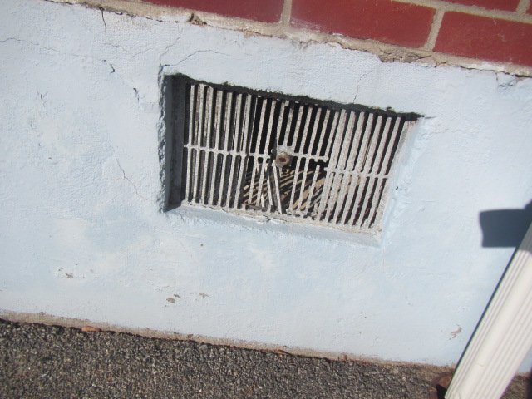

Damaged crawlspace vent, allowing access to outside elements, pests, and moisture

Picture 33

Debris and buildup on the exterior of the Annex building 

 

Debris and buildup on the exterior of the Annex building

Picture 34

Lichen (algae and fungi) growth on the exterior walls of the main building



Lichen (algae and fungi) growth on the exterior walls of the main building

Picture 35

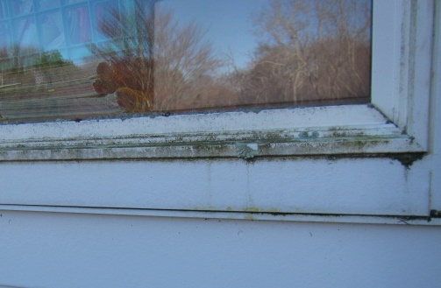

Lichen (algae and fungi) growth on the exterior windowsills of the main building

## Respiratory Irritants pictures

Picture 36

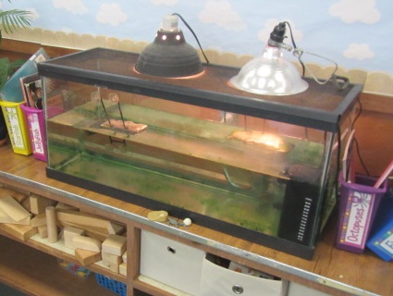

An aquarium containing a turtle, green with algal growth

Picture 37

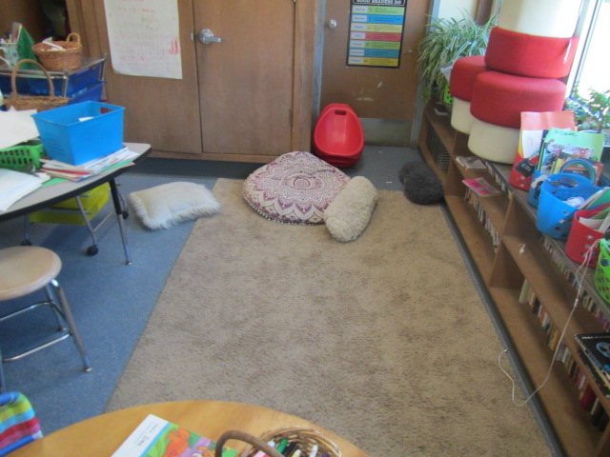

Area rugs and pillow cushions in classroom

Picture 38

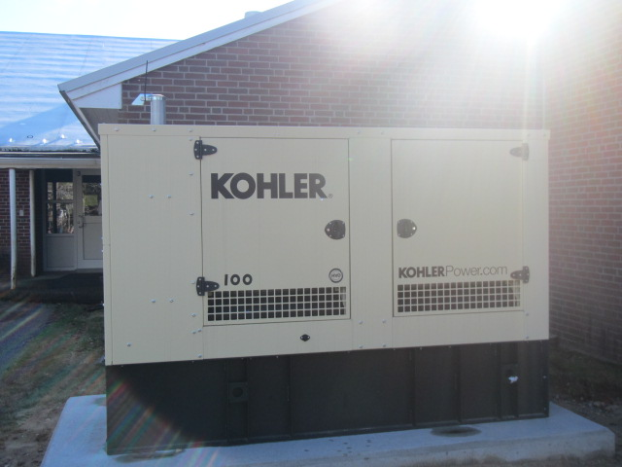

Emergency generator stationed outside the building

Picture 39

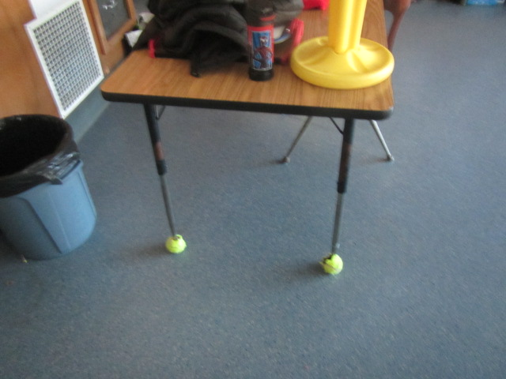

Tennis balls on table legs in classroom

Picture 40

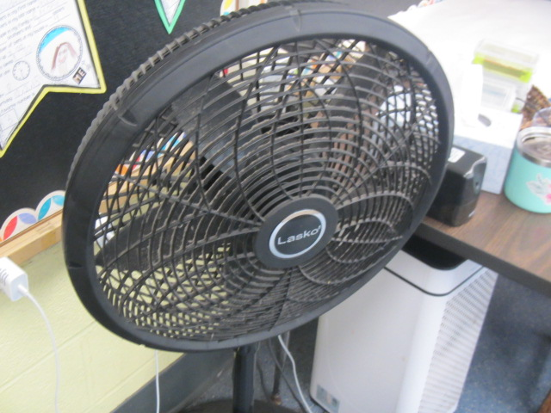

Personal fan with accumulated dust/debris

Picture 41

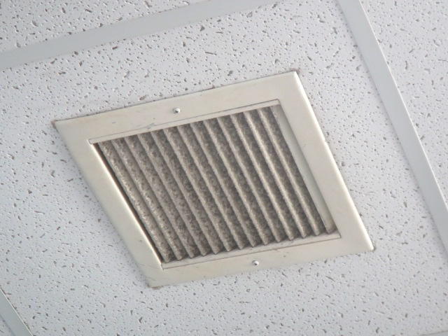

Accumulated dust/debris on exhaust vent

Click to link back to report

# Table 1

| **Location** | **Carbon**  **Dioxide**  **(ppm)** | **Carbon Monoxide**  **(ppm)** | **Temp**  **(°F)** | **Relative**  **Humidity**  **(%)** | **PM2.5**  **(µg/m3)** | **Occupants**  **in Room** | **Windows**  **Openable** | **Ventilation** | | **Remarks** |
| --- | --- | --- | --- | --- | --- | --- | --- | --- | --- | --- |
| **Supply** | **Exhaust** |
| Background (outside) | 460 | ND | 49 | 59 | ND |  |  |  |  | Cool, clear and sunny |
| Teachers Workroom | 695 | ND | 76 | 33 | ND | 1 | Y  Open | Y | Y | Active leak ceiling (damaged), 1 WD CT, visible mold on/in refrigerator, TB |
| 1 | 979 | ND | 74 | 38 | ND | 0 | Y | Y  Off | Y  Off | Dehumidifier-draining in sink, area rug, AP, DO, WD CT changed in bathroom over the summer-no exhaust to remove moisture (recommend), no current mold/moisture issues |
| 2 | 777 | ND | 70 | 39 | ND | 19 | Y  Open | Y | Y | AP, plants, CP-spray, 4 WD CTs |
| 3 | 768 | ND | 71 | 39 | ND | 0 | Y | Y  Blocked | Y  Blocked | CP, aquarium-turtles (algal growth in tank), DO, CP-spray, bathroom exhaust not functioning, 5 WD CT |
| 4 | 859 | ND | 74 | 36 | 2 | 20 | Y  Open | Y | Y | AP, DO, area rug |
| 5 | 695 | ND | 71 | 40 | ND | 0 | Y | Y | Y  Off | AP, 3 WD CTs, area rug, CP-spray |
| 6 | 924 | ND | 76 | 34 | ND | 20 | Y  Open | Y | Y | AP, DO, area rug, PF |
| 7 | 990 | ND | 73 | 39 | ND | 20 | Y | Y | Y  Off | Area rug, AP, TB, DO |
| 8 | 906 | ND | 74 | 35 | ND | 20 | Y  Open | Y | Y | PF, plants, AP, plants, AF, PF, 1 WD CT, area rug |
| 9 | 981 | ND | 72 | 37 | ND | 22 | Y | Y | Y | 2 WD CT, TB, AF, CP-spray |
| 10 | 981 | ND | 75 | 36 | ND | 21 | Y | Y | Y | Area rug, PF, AP, plants, CP-spray, pillows/cushions, DO |
| 11 | 960 | ND | 71 | 37 | ND | 12 | Y | Y | Y | TB, area rug, DO |
| 12 | 933 | ND | 69 | 40 | ND | 14 | Y | Y | Y  Off | Plants, area rug, AP, 3 WD CT, microwave, CP |
| 13 | 884 | ND | 68 | 41 | ND | 17 | Y  Open | Y | Y  Off | Mold reported on surface of wall over summer – cleaned (no current mold issues/growth), AP, area rug, WD light cover, DO |
| Supply Room (Reading & Math Intervention) | 943 | ND | 83 | 33 | ND | 1 | N | N | N | Chronic heat complaints, no windows or HVAC system, can have up to 12 occupants in room |
| Nurse’s Suite | 841 | ND | 76 | 33 | ND | 1 | Y | N | Y | Exhaust vent in bathroom, WD CT corner |
| Nurse’s Restroom |  |  |  |  |  |  |  |  | Y | Exhaust off/weak |
| Gym | 718 | ND | 70 | 42 | ND | 0 | Y | Y | Y  Off | AP, bowed floor-on capital repair list |
| Cafeteria | 1169 | ND | 73 | 39 | 1 | 61 | Y  Open | Y | Y | TB |
| **Annex Building** |  |  |  |  |  |  |  |  |  |  |
| Library | 1181 | ND | 72 | 37 | ND | 0 | Y | Y | Y | Carpet squares, TB, dust/debris on vents, TB |
| Staff Room | 1406 | ND | 72 | 38 | ND | 9 | Y | Y | Y | Carpet squares, AP |
| Staff Room Restroom |  |  |  |  |  |  | N | Y | Y | Dust/debris on restroom exhaust vent |
| 14 | 933 | ND | 71 | 35 | ND | 4 | Y | Y | Y | Dust/debris on vents, area rug, AP, |
| 15 | 1109 | ND | 70 | 37 | ND | 5 | Y | Y | Y | Area rug, AP |
| 16 | 1300 | ND | 70 | 40 | ND | 3 | Y  Open | Y  Off | Y  Off | Digital thermostat off/battery dead, DO, TB, AP, PF, dust/debris on vents |
| Music Storeroom |  |  |  |  |  |  |  |  | Y | Dust/debris on vents |
| Annex Hallway |  |  |  |  |  |  |  |  |  | WD CTs-active leak reported outside room 14, space underneath/around exterior door near room 14 |

(Click to link back to report)

# Table 2A

|  |  |  |  |  |  |
| --- | --- | --- | --- | --- | --- |
| **Equipment Present in Building**  **(X = Yes)** | **Type of Heating/Cooling Ventilation**  **Equipment** | **Fresh**  **Air**  **Supply**  **(X = Yes)** | **Type of Location(s)** | **Air Filters Installed**  **MERV Rating**  **(1-15, U*)**  **(X = Yes)** | **Comments** |
| X | Univents | X | Classrooms | X |  |
|  | Rooftop Air Handling Units |  |  |  |  |
|  | Outdoor, Ground-Installed Air Handling Units |  |  |  |  |
|  | Attic/Crawlspace Air Handling Units |  |  |  |  |
|  | Ceiling-Mounted Air Handling Units (including inside plenum) |  |  |  |  |
|  | Basement/Crawlspace-Installed Air Handling Units |  |  |  |  |
|  | Mechanical Room-installed Air Handling Units |  |  |  |  |
|  | Fan Coil Units |  |  |  |  |
|  | Window-Mounted Air Conditioners |  |  |  |  |
|  | Portable air conditioners |  |  |  |  |
|  | Wall Louver-Controlled Gravity Air Supply |  |  |  |  |
| X | Windows | X | Most rooms |  | Openable |
|  | Fan in window (blowing in) |  |  |  |  |
|  | Built in wall fan (switched) |  |  |  |  |
|  | Heat recovery ventilator unit |  |  |  |  |
|  | Energy recovery ventilator unit |  |  |  |  |
|  | Chilled Beam |  |  |  |  |
|  | Passive combustion supply vent in basement/boiler room |  |  |  |  |

*U = Filter Rating underdetermined due to inaccessibility during building visit

# Table 2B

|  |  |  |  |  |
| --- | --- | --- | --- | --- |
| **Equipment Present in Building**  **(X = Yes)** | **Type of Exhaust Ventilation**  **Equipment** | **Ducted**  **To Outdoors**  **(X = Yes)** | **Type of Location(s)** | **Comments** |
| X | Rooftop Motors/Fans | X | Classrooms and common areas | Not functioning |
|  | Unit Exhaust |  |  |  |
|  | Ceiling Return Vent |  |  |  |
|  | Ceiling Return Vent, Plenum |  |  |  |
|  | Wall Return Vent |  |  |  |
|  | Kitchen Stove Hood |  |  |  |
| X | Restroom Exhaust Vent | X |  | Not functioning |
|  | Photocopier Exhaust Vent |  |  |  |
|  | Garage |  |  |  |
|  | Chemical Hood(s) |  |  |  |
|  | Locker Rooms |  |  |  |
|  | Showers |  |  |  |
|  | Clothes Dryers |  |  |  |
|  | Gas Water Heaters |  |  |  |
|  | Furnace-Flue to Chimney |  |  |  |
|  | Furnace/Boiler direct vent or power vent (no combustion air supply) |  |  |  |
|  | Kiln, Pottery |  |  |  |
|  | Dark Room |  |  |  |
|  | Generator Room |  |  |  |
|  | Wood Shop Dust Collector |  |  |  |
|  | Spray Paint Booths |  |  |  |
|  | Fan in window (blowing out) |  |  |  |

# Table 2C

|  |  |  |  |
| --- | --- | --- | --- |
| **Equipment Present in Building**  **(X = Yes)** | **Type of Equipment** | **Type of Location(s)** | **Comments** |
|  | Floor Fans, pedestal |  |  |
| X | Floor Fans, portable | Classrooms, offices |  |
| X | Air Purifier (HEPA, other) | Classrooms, offices |  |
|  | Floor heaters, portable |  |  |
| X | Refrigerators, Cold Beverage Vending Machines | Staff Room |  |
|  | Radiator, wall-mounted |  |  |
|  | Radiator, floor-mounted |  |  |
|  | Passive Vents (Wall/Door) |  |  |

(Click to link back to report)

# Table 3

| **Found in Building**  **X = Yes** | **Water-Damaged Materials, Building Components or Stored Materials** | **Location** | **Visible Microbial Growth?**  **X = Yes** | **Musty odor detected?**  **X = Yes** | **Comments** |
| --- | --- | --- | --- | --- | --- |
|  | Books-other bound materials |  |  |  |  |
| X | Brick walls – broken, missing mortar | exterior |  |  | Damage in several areas |
|  | Brick walls – blocked weep holes |  |  |  |  |
|  | Cardboard boxes |  |  |  |  |
|  | Carpet tiles |  |  |  |  |
| X | Carpet - Area rugs |  |  |  |  |
|  | Carpet wall-to-wall |  |  |  |  |
|  | Ceiling tiles - affixed directly to ceiling surface |  |  |  |  |
|  | Ceiling tiles - bowing-in suspended ceiling |  |  |  |  |
|  | Ceiling tiles - water-stained in splined ceiling |  |  |  |  |
| X | Ceiling tiles - water-stained in suspended ceiling | classrooms/common areas | No | No |  |
|  | Chairs - laminated |  |  |  |  |
| X | Cloth | classrooms | No | No |  |
| X | Countertops (around sinks) |  |  |  |  |
|  | Curtains |  |  |  |  |
|  | Dust/debris within AHU, uninvent, HVAC, chilled beam units, etc. (WD through condensation, humidity, or leaks) |  |  |  |  |
| X | Efflorescence (i.e., mineral deposits) | Staff Room ceiling | No | No | There was no mold presence detected. It is recommended to replace the area with mineral deposits. |
|  | Engineered woods - particleboard, plywood, Masonite |  |  |  |  |
|  | Flooring – loosened tiles |  |  |  |  |
| X | Flooring - wooden | Gym | No | No | Signs of “buckling", most likely caused by moisture damage |
|  | Furniture - laminated |  |  |  |  |
| X | Furniture - upholstered | Classrooms | No | No |  |
|  | Gypsum wallboard - ceiling |  |  |  |  |
|  | Gypsum wallboard - restroom wall |  |  |  |  |
|  | Gypsum wallboard - interior wall |  |  |  |  |
|  | Gypsum wallboard – located on exterior wall |  |  |  |  |
|  | HVAC drain pan – lack of draining |  |  |  |  |
|  | HVAC filters |  |  |  |  |
|  | Insulation- attic (paper-backed) |  |  |  |  |
|  | Insulation - inside air handling unit |  |  |  |  |
|  | Insulation - on pipe(s) fiberglass |  |  |  |  |
|  | Insulation - on pipe(s) other/plaster-like material |  |  |  |  |
|  | Insulation - wall cavity |  |  |  |  |
|  | Insulation – ceiling plenum |  |  |  |  |
|  | Modular furniture – walls/cloth partitions |  |  |  |  |
|  | Musical instrument cases |  |  |  |  |
|  | Plaster ceilings |  |  |  |  |
|  | Records/files |  |  |  |  |
| X | Refrigerator - door gasket | Teacher’s Breakroom | Yes | Yes | Visible mold on gaskets of refrigerator and freezer |
|  | Refrigerator - drip pan |  |  |  |  |
|  | Refrigerator - Interior surfaces |  |  |  |  |
|  | Room divider - ceiling-mounted, sliding |  |  |  |  |
|  | Sink backsplash |  |  |  |  |
|  | Tables – laminated |  |  |  |  |
|  | Wallpaper |  |  |  |  |
|  | Wood - attic/roof materials |  |  |  |  |
|  | Wood - floor joists in basement ceiling |  |  |  |  |
|  | Wood - wall framing |  |  |  |  |
|  | Wood - window sills |  |  |  |  |
|  | Wood - window-mounted air conditioner framing |  |  |  |  |
| X | OTHER | Exterior trim |  |  | Damage in many areas |

WHAT ARE ENVIRONMENTAL ASTHMA TRIGGERS?

Asthma triggers are any chemical, pollutant, or allergen that can make your asthma worse. Asthma triggers can also be strong chemical smells, dust, or pets. Your asthma triggers may be different from those of other people. Not all asthma triggers affect people the same way. Environmental asthma triggers are found both indoors and outdoors. DPH link: [Asthma and Your Environment (mass.gov)](https://www.mass.gov/doc/asthma-and-your-environment-english/download)

(click to link back to report)

# Table 4

| **Condition Present**  **X = Yes** | **Possible asthma symptom-inducing environmental pollutant** | **Recommendation to reduce or eliminate the pollutant** |
| --- | --- | --- |
| X | Water Damage and/or Mold  (allergen) | Identify water source and repair to eliminate.  Clean non-porous materials.  Remove and replace porous materials susceptible to mold growth.  Perform regular water damage assessments as a tool to ensure timely mitigation as needed.  Use NIOSH water damage assessment protocol as a guide: [NIOSH water damage assessment guideline](https://www.cdc.gov/niosh/docs/2019-115/pdfs/2019-115.pdf?id=10.26616/NIOSHPUB2019115&inf_contact_key=241b5c2ed98c27d94b530dedc36f1623f651f238aa2edbb9c8b7cff03e0b16a0). |
|  | Moistening of building components during hot, humid weather (>2 days in length) (mold, allergen) | Remove materials not dried in <2 days in a manner consistent with [US EPA Mold Removal in Commercial Buildings guideline](https://www.epa.gov/mold/pdf-version-checklist-mold-remediation-mold-remediation-schools-and-commercial-buildings).  Use dehumidification in occupied basement areas and other areas with chronic dampness. |
| X | Vegetation against exterior of building (water damage-mold) | Remove all vegetation preventing building exterior drying.  Remove all vegetation capable of falling onto a building or depositing debris onto the roof. |
| X | Personal humidifiers (lack of proper maintenance)  (pollutant and allergen) | Clean and maintain properly.  Use distilled water to eliminate metal and water treatment odors.  Maintain hydration by increasing water consumption. |
|  | Drains: Floor drains, Sink drains (abandoned use)  Water bubblers (abandoned use) | If in use, pour water into drain at least twice a week.  If not in use, seal the drain with an appropriate material in accordance with Massachusetts Plumbing Code (248 CMR 10.00). |
| X | Live Animals (turtles, gerbils, birds, rabbits, etc.) | Ensure cleanliness or remove animals from the location. |
| X | Improperly maintained aquariums and terrariums (allergen) | Maintain such equipment properly to eliminate odor.  Discontinue use. |
|  | Plants and flowers  (allergen and mold) | Keep indoor plants well maintained and not overwatered. Monitor for signs of mold and pests.  Ensure water for cut flowers does not become stagnant.  Ensure dried plant material is free of odors, mold, and pests and handled carefully  If asthma risks are high, eliminate plants and flowers. |
|  | HVAC system moisture issues  (mold, allergen) | Consult ASHRAE’s minimum standards for HVAC maintenance and inspection of commercial HVAC systems (<https://www.ashrae.org/technical-resources/bookstore/standards-180-and-211>). |
|  | HVAC system contaminant issues (allergen) | Consult ASHRAE’s minimum standards for HVAC maintenance and inspection of commercial HVAC systems (<https://www.ashrae.org/technical-resources/bookstore/standards-180-and-211>). |
|  | Indoor swimming pool odors outside of swimming pool (mold, chemical) | Maintain and operate pool HVAC systems to vent odors from building.  Ensure locker room exhaust vents are operating during building hours.  All doors leading to pool should be rendered airtight and be closed. |
|  | Pollen (allergen) | Recommend installation of MERV 8 or better filters if HVAC engineer confirms HVAC system can be so equipped without adversely affecting function.  Cut grass after hours.  Cut grass in a pattern to direct clippings away from exterior wall.  Remove trees and shrubs from in front of windows and air intakes. |
| X | Dry air | Maintain hydration.  Avoid overheating of air. |
| X | Dust mites  (allergen) | Recommendation to remove non-official upholstered furniture, area rugs, pillows, cushions, etc.  Cleaning with use of HEPA-filtered vacuum cleaner.  Eliminating clutter, storing items in dust and moisture-proof containers, and regularly removing dust through wet wiping. |
|  | Pests, including rodents and cockroaches  (allergen) | Use of integrated pest management guidelines, including:   * Proper disposal of food containers * Proper storage of food products in airtight containers * Elimination of use of food as art projects * Remove pest harborages/clutter * Regular monitoring for pests   [EPA IPM guideline link](https://www.epa.gov/ipm/introduction-integrated-pest-management) |
| X | Latex-containing materials | Remove tennis balls from furniture legs. |
| X | Fragrances  (chemical) | Eliminate point sources, such as:   * Plug-in air fresheners * Aroma/oil reed diffusers * Scented sprays * Discontinue use of other scented materials * Consult DPH fragrance guideline: [*Clean air is odor-free*](https://www.mass.gov/doc/clean-air-is-odor-free-removing-fragrances-to-improve-indoor-air-quality-in-schools-and-0/download) |
|  | Strong smells from /use of Chemicals (such as cleaning products)  (chemical) | Use building-issued cleaning products.  Use products in accordance with manufacturer’s instructions including dilution, application, and ventilation.  Avoid using products that are stronger than needed for the situation. |
|  | Strong odors from new building materials (carpeting/furniture)  (chemical) | Use low VOC-emitting materials.  Air out materials (outside or in unoccupied area) prior to installation. |
|  | Tobacco smoke  Secondhand Smoke  (pollutant) | Eliminate tobacco smoking.  Seal all shared wall penetrations. |
|  | Products with a strong odor such as paint, perfume, hairspray, air fresheners, bug-spray, laminators, candles, wax melters, dry erase markers and other VOC-containing products  (chemical) | If essential:   * Provide proper exhaust ventilation to eject aerosolized product directly outdoors. * Avoid/reduce use during occupied hours.   If not necessary, remove and eliminate. |
|  | Vehicle exhaust  (pollutant) | Enforce anti-idling regulations and post signs to give notice.  Relocate vehicles away from fresh air intakes.  Require cars to park face-in at building walls.  [MA anti-idling law FAQs](https://www.mass.gov/files/documents/2018/02/20/idling-faq.pdf#:~:text=The%20Massachusetts%20Anti-Idling%20Law%20The%20goal%20of%20the,sometime%20wonder%20when%20idling%20might%20be%20considered%20necessary.) |
|  | Vapors and or fumes from gas, oil, or kerosene stoves  (pollutant) | Operate stove hood when stove in use.  Install stove hood if not present.  Ensure equipment is in good working order. |
|  | Ozone (pollutant) | Eliminate use of ozone generating equipment. |
|  | Window Air Conditioners (if not properly maintained) (allergen) | Equip with proper filter and clean periodically.  Clean drip pans.  Install in window with weathertight, non-mold-growth sustaining material. |
|  | Pottery (pollutant) | Do not operate kiln during occupied hours.  Operate kiln with exhaust system activated.  Seal all seams and holes in kiln vent.  Ensure kiln exhaust discharge terminates outdoors. |
| X | Carpeting (allergen) | Clean carpeting in a manner consistent with IICRC standards, including regular vacuuming with a high efficiency particulate air (HEPA) filtered vacuum in combination with annual cleaning or semi-annual cleaning in soiled high traffic areas. |
| X | Sweeping/dusting vs HEPA vacuuming/wet wiping  (allergen or pollutant) | Refrain from using feather dusters or brooms.  Utilize HEPA vacuums and wet wiping to minimize aerosolizing particulate matter. |
| X | Lack of adequate air exchange/mechanical ventilation | Make repairs as necessary and ensure all HVAC system components are operating continuously when building is occupied. |
|  | Lack of local exhaust at source of pollution (vocational shop activities, kitchen exhaust hood) (all) | Recommend installation of exhaust ventilation to direct pollutants directly outdoors. |
|  | Renovating buildings while occupied  (chemical) | Use all SMACNA guidelines for Renovation While Buildings Are Occupied. For information, visit <https://www.mass.gov/service-details/construction-and-renovation-generated-pollutants-in-occupied-buildings>. |
|  | Chemistry program chemical storage  (chemical) | Repair (if needed) and operate chemical storeroom vents appropriately.  Reduce or eliminate unneeded or overstocked chemicals.  Store all chemicals in a manner to separate incompatible chemicals.  Keep chemical storerooms clean. |
| X | Photocopiers/duplicating machines | All machines should have dedicated exhaust vents. |