INDOOR AIR QUALITY ASSESSMENT
West Boylston Middle/High School
125 Crescent Street
West Boylston, Massachusetts

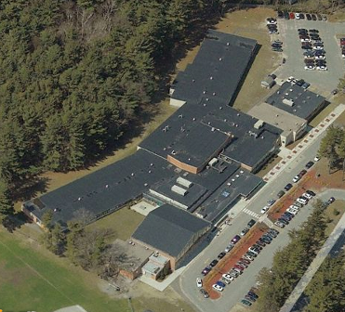

Prepared by:
Massachusetts Department of Public Health
Bureau of Environmental Health
Indoor Air Quality Program
January 2010

Background/Introduction
At the request of a parent, the Massachusetts Department of Public Health (MDPH), Bureau of Environmental Health (BEH) provided assistance and consultation regarding indoor air quality at the West Boylston Middle/High School (WBMHS) located at 125 Crescent Street, West Boylston, Massachusetts, in coordination with the West Boylston Board of Health and West Boylston Public Schools (WBPS). Concerns about indoor air quality, water damage, potential mold growth and exacerbation of asthma symptoms prompted the request. On October 21, 2009, Cory Holmes and James Tobin, Environmental Analysts/Inspectors from BEH’s Indoor Air Quality (IAQ) Program, made a visit to the WBMHS to conduct an assessment. During the assessment, BEH staff were accompanied by Rick Watson, Maintenance Coordinator, WBPS.
The WBMHS is a one-story, brick building built in 1958 on a slab foundation. The school houses general classrooms, science classrooms, small rooms for specialized instruction, an auditorium, library, art room, computer room, music room, woodshop, gymnasium, locker rooms, cafeteria/kitchen and office space. The majority of building components are original including floors, ceiling, and ventilation components. An addition was built in 1996 that included the Superintendent’s offices, classrooms and shop areas. Windows are openable throughout the building.

Methods
Air tests for carbon dioxide, temperature, relative humidity and carbon monoxide were conducted with the TSI, Q-Trak, IAQ Monitor, Model 7565. BEH staff also performed visual inspection of building materials for water damage and/or microbial growth. Moisture content of porous building materials was measured with a Delmhorst, BD-2100 Model, Moisture Detector equipped with a Delmhorst Standard Probe.

Results
The school houses approximately 630 students in grades 6 to 12 with approximately 90 staff members. Tests were taken during normal school operations and results appear in Table 1.

Discussion

Ventilation
It can be seen from Table 1 that carbon dioxide levels were above 800 parts per million (ppm) in 45 of 56 areas surveyed with 10 of those areas exceeding 2,000 ppm, three of which were in excess of 3,000 ppm. These carbon dioxide levels indicate poor air exchange in the building at the time of the assessment and can result in comfort complaints at minimum. The majority of elevated carbon dioxide levels were directly related to deactivated/non-functioning ventilation equipment, particularly in rooms with full occupancy. Further, several areas had open windows or were empty/sparsely populated, both of which can greatly reduce carbon dioxide levels. Carbon dioxide levels would be expected to increase with windows closed and higher occupancy.
Fresh air is supplied to classrooms by unit ventilator (univent) systems (Picture 1). A univent draws outdoor air through an air intake located on the exterior wall of the building (Picture 2) and return air from the room through an air intake located at the base of the unit (Figure 1). Fresh and return air are mixed, filtered, heated, and then delivered to the room through an air diffuser located in the top of the unit.
Univents have control settings of ‘off, low, medium and high’ (Picture 3). At the time of the assessment, BEH staff found univents switched ‘off’ in the majority of rooms, preventing fresh air from being introduced into these rooms (Table 1). Univent air diffusers and return intakes were also blocked by books, furniture and other stored items in front and on top of the unit, thereby limiting airflow in the rooms (Picture 4). In science room 201, BEH staff found the front panels of a univent removed and placed on top of the unit (Picture 5). In order for univents to provide fresh air as designed, air diffusers and intakes must remain free of obstructions. Importantly, these units must remain “on” and be allowed to operate while rooms are occupied.
Exhaust ventilation in classrooms is provided by ceiling or wall-mounted vents ducted to rooftop motors (Pictures 6 through 8). The exhaust ventilation system is designed to continuously remove moisture, odors, and pollutants from the indoor environment. Exhaust vents were not functioning in the majority of areas surveyed at the time of the assessment. BEH staff also found several exhaust vents blocked by furniture and other stored items (Pictures 9 and 10). In order to function properly, exhaust vents must be activated and allowed to operate without obstruction while rooms are occupied. Without adequate exhaust ventilation, excess heat and environmental pollutants can build up leading to indoor air/comfort complaints.
The heating, ventilating and air conditioning (HVAC) systems for areas such as the auditorium, computer rooms, gymnasium, main office and library consist of rooftop or ceiling-mounted air handling units (Picture 11). Air handling units (AHUs) draw in outdoor air through intakes, filter, heat and/or cool the air, and distribute it to occupied areas via ceiling or wall-mounted air diffusers (Picture 12). Exhaust air is returned to the AHUs via return vents (Picture 13).
BEH staff examined the AHUs on the roof. A number of AHUs appeared to be original equipment, and nearing the end of their useful life cycle. AHU casings and ductwork were severely corroded, weathered and physically damaged (Picture 14). In one instance, ductwork was not attached to the roof (Picture 15). This ductwork was reportedly taken apart during the installation of the new roof, and never re-attached.
Science classrooms are equipped with chemical fume hoods ducted to the roof. Like the AHUs, this ductwork appeared to be original equipment. Ductwork for the fume hoods was damaged and glued together with caulking (Picture 16). The chemical hoods were not operating at the time of the assessment. No record of the last date of calibration/inspection of the hoods was readily apparent. A chemical hood should be recalibrated on an annual basis or as recommended by the manufacturer to ensure proper function.
To maximize air exchange, the MDPH recommends that both supply and exhaust ventilation operate continuously during periods of school occupancy. In order to have proper ventilation with a mechanical supply and exhaust system, the systems must be balanced to provide an adequate amount of fresh air to the interior of a room while removing stale air from the room. It is recommended that HVAC systems be re-balanced every five years to ensure adequate air systems function (SMACNA, 1994). The date of the last balancing of these systems was not available at the time of the assessment.
The Massachusetts Building Code requires a minimum ventilation rate of 15 cubic feet per minute (cfm) per occupant of fresh outside air or have openable windows in each room (SBBRS, 1997; BOCA, 1993). The ventilation must be on at all times that the room is occupied. Providing adequate fresh air ventilation with open windows and maintaining the temperature in the comfort range during the cold weather season is impractical. Mechanical ventilation is usually required to provide adequate fresh air ventilation.
Carbon dioxide is not a problem in and of itself. It is used as an indicator of the adequacy of the fresh air ventilation. As carbon dioxide levels rise, it indicates that the ventilating system is malfunctioning or the design occupancy of the room is being exceeded. When this happens, a buildup of common indoor air pollutants can occur, leading to discomfort or health complaints. The Occupational Safety and Health Administration (OSHA) standard for carbon dioxide is 5,000 parts per million parts of air (ppm). Workers may be exposed to this level for 40 hours/week, based on a time-weighted average (OSHA, 1997).
The MDPH uses a guideline of 800 ppm for publicly occupied buildings. A guideline of 600 ppm or less is preferred in schools due to the fact that the majority of occupants are young and considered to be a more sensitive population in the evaluation of environmental health status. Inadequate ventilation and/or elevated temperatures are major causes of complaints such as respiratory, eye, nose and throat irritation, lethargy and headaches. For more information concerning carbon dioxide, consult Appendix A.

Temperature and Relative Humidity
Temperature measurements in the school ranged from 70° F to 78° F, which were within the MDPH recommended range (Table 1). The MDPH recommends that indoor air temperatures be maintained in a range of 70º F to 78º F in order to provide for the comfort of building occupants. In many cases concerning indoor air quality, fluctuations of temperature in occupied spaces are typically experienced, even in a building with an adequate fresh air supply.
The relative humidity measured in the building ranged from 32 to 59 percent; most areas, however, were within the MDPH recommended comfort range (Table 1). The MDPH recommends a comfort range of 40 to 60 percent for indoor air relative humidity. Relative humidity levels in the building would be expected to drop during the winter months due to heating. The sensation of dryness and irritation is common in a low relative humidity environment. Low relative humidity is a very common problem during the heating season in the northeast part of the United States.

Microbial/Moisture Concerns
In order for building materials to support mold growth, a source of water exposure is necessary. Identification and elimination of the source of water moistened building materials is necessary to control mold growth.
BEH staff examined the building to identify breaches in the building envelope that could provide a source of water penetration. BEH identified the following conditions:
- Cracked and damaged caulking around fresh air intakes on exterior wall (Picture 17).
- Blocked weep holes (Pictures 18 and 19); weep holes serve a drainage function allowing moisture inside the building to move outside.
- Shrubs growing against the building and in front of fresh air intakes (Picture 20), which can hold moisture against exterior brick and allow moisture-laden air to be drawn in by the fresh air intakes.
- Damaged and/or missing exterior brick and mortar (Picture 21).
- Damaged downspouts, which allow water to pool at the base of the building (Picture 22).
- Gutters clogged with debris including leaves and pine needles, preventing proper drainage (Picture 23).
- Pooling water was observed in a number of areas on the roof due to lack of drainage (Picture 23). The freezing and thawing of water during winter months can lead to roof leaks and subsequent water penetration into the interior of the building. Pooling water can also become stagnant, which can lead to mold and bacterial growth, and serve as a breeding ground for mosquitoes.
- The slope of the roof adjacent to the library windows directs water toward the library windows, allowing water to pool (Picture 24).
- Roof drains clogged with debris and/or missing.
- Cracks and holes in exterior walls (Picture 25).
- Damaged/missing sealant between expansion joints (Picture 26).
- Breaches in the building foundation (Picture 27).
- Several exterior doors had damaged weather stripping, and light could be seen penetrating through the spaces underneath the door from the outdoors (Picture 28).
Many of these conditions can allow water and moist air to infiltrate through breaches and condense on building materials. A heavy and/or continuous water exposure to the building exterior can undermine the integrity of the building envelope and provide a means of water entry into the building via capillary action through exterior walls, foundation concrete (i.e., cement slab) and masonry (Lstiburek & Brennan, 2001). Further, these breaches can serve as pathways for insects, rodents and other pests to enter the building.
BEH staff examined building materials inside the building for water damage and/or microbial growth. BEH staff found water damage in a number of areas, which can indicate leaks from the roof, plumbing system or water penetration through the building envelope (Pictures 29 through 35/Table 1). Water damage was visible on ceilings and walls, and above windows. BEH also noted water-damaged ceiling tiles in hallways and rooms. Ceiling tiles should be replaced after a water leak is discovered and repaired.
BEH conducted moisture testing in order to determine if porous building materials were wet at the time of the assessment. Materials with increased moisture content over normal concentrations may indicate the possible presence of mold growth. All materials tested during the assessment were found to have low (i.e., normal) moisture content (Table 1). It is important to note that moisture content of materials measured is a real-time measurement of the conditions in the building at the time of the assessment. Repeated water damage to porous building materials (e.g., wallboard, ceiling tiles) can result in microbial growth
The US Environmental Protection Agency (US EPA) and the American Conference of Governmental Industrial Hygienists (ACGIH) recommend that porous materials be dried with fans and heating within 24 to 48 hours of becoming wet (US EPA, 2001; ACGIH, 1989). If not dried within this time frame, mold growth may occur. Once mold has colonized porous materials, they are difficult to clean and should be removed/discarded.
Open seams between sink countertops and walls were observed in several rooms. If not watertight, improperly drained water and sink overflow can penetrate through the seam into the countertop, cabinet interior and areas behind cabinets, causing water damage. Water penetration and chronic water exposure to porous and wood-based materials can cause these materials to swell and show signs of water damage. Repeated moistening of porous materials can result in mold growth.
A number of classrooms had plants (Picture 36). Plants can be a source of pollen and mold, which can serve as respiratory irritants for some sensitive individuals. Plants should be properly maintained and equipped with drip pans to prevent water damage to porous building materials. Plants should also be located away from ventilation sources (e.g., univent air diffusers) to prevent the aerosolization of dirt, pollen or mold.
Aquariums were also located in some classrooms (Picture 37). Aquariums should be properly maintained to prevent microbial/algae growth, which can emit unpleasant odors.

Carbon Monoxide and Particulate Matter
Indoor air quality can be negatively influenced by the presence of respiratory irritants, such as products of combustion. The process of combustion produces a number of pollutants. Common combustion emissions include carbon monoxide, carbon dioxide, water vapor and smoke (fine airborne particle material). Of these materials, exposure to carbon monoxide and particulate matter with a diameter of 2.5 micrometers (μm) or less (PM2.5) can produce immediate, acute health effects upon exposure. To determine whether combustion products were present in the school environment, BEH staff obtained measurements for carbon monoxide and PM2.5.
Carbon monoxide is a by-product of incomplete combustion of organic matter (e.g., gasoline, wood and tobacco). Exposure to carbon monoxide can produce immediate and acute health affects. Several air quality standards have been established to address carbon monoxide and prevent symptoms from exposure to these substances. The MDPH established a corrective action level concerning carbon monoxide in ice skating rinks that use fossil-fueled ice resurfacing equipment. If an operator of an indoor ice rink measures a carbon monoxide level over 30 ppm, taken 20 minutes after resurfacing within a rink, that operator must take actions to reduce carbon monoxide levels (MDPH, 1997).
The American Society of Heating Refrigeration and Air-Conditioning Engineers (ASHRAE) has adopted the National Ambient Air Quality Standards (NAAQS) as one set of criteria for assessing indoor air quality and monitoring of fresh air introduced by HVAC systems (ASHRAE, 1989). The NAAQS are standards established by the US EPA to protect the public health from six criteria pollutants, including carbon monoxide and particulate matter (US EPA, 2006). As recommended by ASHRAE, pollutant levels of fresh air introduced to a building should not exceed the NAAQS levels (ASHRAE, 1989). The NAAQS were adopted by reference in the Building Officials & Code Administrators (BOCA) National Mechanical Code of 1993 (BOCA, 1993), which is now an HVAC standard included in the Massachusetts State Building Code (SBBRS, 1997). According to the NAAQS, carbon monoxide levels in outdoor air should not exceed 9 ppm in an eight-hour average (US EPA, 2006).
Carbon monoxide should not be present in a typical, indoor environment. If it is present, indoor carbon monoxide levels should be less than or equal to outdoor levels. Outdoor carbon monoxide concentrations were non-detect (ND) at the time of the assessment (Table 1). Carbon monoxide levels inside the building were also ND (Table 1).
The US EPA has established NAAQS limits for exposure to particulate matter. Particulate matter (PM) is airborne solids that can be irritating to the eyes, nose and throat. The NAAQS originally established exposure limits to PM with a diameter of 10 μm or less (PM10). According to the NAAQS, PM10 levels should not exceed 150 microgram per cubic meter (μg/m³) in a 24-hour average (US EPA, 2006). These standards were adopted by both ASHRAE and BOCA. Since the issuance of the ASHRAE standard and BOCA Code, US EPA established a more protective standard for fine airborne particles. This more stringent PM2.5 standard requires outdoor air particle levels be maintained below 35 μg/m³ over a 24-hour average (US EPA, 2006). Although both the ASHRAE standard and BOCA Code adopted the PM10 standard for evaluating air quality, MDPH uses the more protective PM2.5 standard for evaluating airborne PM concentrations in the indoor environment.
Outdoor PM2.5 concentrations the day of the assessment were measured at 27 μg/m³. PM2.5 levels measured inside the school ranged from 7 to 37 μg/m³ (Table 1). Indoor PM 2.5 levels were below the NAAQS PM2.5 level of 35 μg/m³ in all but one area, the cafeteria, during the assessment. Frequently, indoor air levels of particulates (including PM2.5) can be at higher levels than those measured outdoors. A number of mechanical devices and/or activities that occur in schools can generate particulate during normal operations. Sources of indoor airborne particulates may include but are not limited to: particles generated during the operation of fan belts in the HVAC system; cooking in the cafeteria stoves and microwave ovens; use of photocopiers, fax machines and computer printing devices; operation of an ordinary vacuum cleaner; and, heavy foot traffic indoors.

Volatile Organic Compounds
Indoor air concentrations can be greatly impacted by the use of products containing volatile organic compounds (VOCs). VOCs are carbon-containing substances that have the ability to evaporate at room temperature. Frequently, exposure to low levels of total VOCs (TVOCs) may produce eye, nose, throat and/or respiratory irritation in some sensitive individuals. For example, chemicals evaporating from a paint can stored at room temperature would most likely contain VOCs. In an effort to identify materials that can potentially increase indoor VOC concentrations, BEH staff examined rooms for products containing these respiratory irritants.
Cleaning products were found in rooms throughout the building. Cleaning products contain chemicals that can be irritating to the eyes, nose and throat of sensitive individuals. These products should be properly labeled and stored in an area inaccessible to children. Additionally, a Material Safety Data Sheet (MSDS) should be available at a central location for each product in the event of an emergency. Consideration should be given to providing teaching staff with school issued cleaning products and supplies to prevent any potential for adverse chemical interactions between residues left from cleaners used by the schools facilities staff and those left by cleaners brought in by others.
Several classrooms contained dry erase boards and related materials (Picture 38). Materials such as dry erase markers and dry erase board cleaners may contain VOCs, such as methyl isobutyl ketone, n-butyl acetate and butyl-cellusolve (Sanford, 1999), which can be irritating to the eyes, nose and throat.
Plug-in air fresheners were observed in several areas (Picture 39). Air fresheners contain chemicals that can be irritating to the eyes, nose and throat of sensitive individuals. Many air fresheners contain 1,4-dichlorobenzene, a VOC which may cause reductions in lung function (NIH, 2006). Further, air fresheners do not remove materials causing odors, but rather, mask odors which may be present in the area.

Other Conditions
Other conditions that can affect indoor air quality were observed during the assessment. BEH staff examined the science rooms and chemical prep areas. Science chemicals are stored in the prep room:
- Both the chemistry classroom and chemical prep room were accessible to students when the room was not occupied (Picture 40).
- Shelves were observed to be overstored with chemical containers (Picture 41), so much so that labels could not be seen without moving bottles.
- Shelves did not have a lip or guardrail on the front to prevent bottle roll-off and accidental breaks.
- Bottles of chemicals were stored on shelving above eye level.
- A number of containers were not properly labeled.
- Stored materials appeared to be of extreme age (Picture 42).
- Chemical(s) containers were not properly sealed. Some bottle stoppers were made of cork material (Picture 43). Cork is not an appropriate material for sealing chemical(s) bottles and/or containers.
- Corrosion of ‘Corrosives’ cabinet may indicate the presence of improperly stored chlorine solvents, incompatible chemicals and/or off-gassing materials, which can undermine the structural integrity of the handles and shelves.
- A spill was noted on the floor surrounding the ‘Acids’ cabinet (Picture 44).
- Chemicals were stored in fume hoods that were not operating (Picture 45).
A passive duct at the top of the chemical cabinets connects to a non-motorized exhaust vent on the roof (Picture 46). Without a motorized roof vent, this duct can backdraft, resulting in off-gassing chemicals from stored containers being forced through the cabinet doors into the chemical prep room. Exposure to vapors of off-gassing chemicals can be irritating to the eyes, nose and respiratory system.
Filters for ventilation equipment (AHUs and univents) strain particulates from the air (Pictures 47 and 48). Filters are reportedly changed once per year; however, the experience of BEH staff reveals that most schools change filters 2 to 4 times per year, usually during school vacations. Filters should be changed as per the manufacturer’s instructions or more frequently to avoid the build up and re-aerosolization of dirt, dust and particulate matter.
BEH staff observed wood dust and debris accumulated on wood cutting machines and flat surfaces throughout the woodshop (Picture 49). The woodshop has general exhaust ventilation. The shop also has a local exhaust system dedicated to collecting dust from equipment; however, the hoses are not connected to the equipment. Other machines completely lacked exhaust systems, allowing dust and debris to spread freely throughout the shop. Wood dust is a fine particulate, which can be easily aerosolized, irritating the eyes, nose, throat and respiratory system. In addition, under certain conditions, wood dust can be a fire hazard.
In several classrooms, items were observed on windowsills, tabletops, counters, bookcases and desks. The large number of items stored in classrooms provides a source for dusts to accumulate. These items (e.g., papers, folders, boxes) make it difficult for custodial staff to clean. Items should be relocated and/or be cleaned periodically to avoid excessive dust build up. In addition, these materials can accumulate on flat surfaces (e.g., desktops, shelving and carpets) in occupied areas and subsequently be re-aerosolized causing further irritation.
An accumulation of chalk dust and dry erase particulates was observed in some classrooms (Picture 50). When windows are opened or univents are operating, these materials can become airborne. Once aerosolized, they can act as irritants to the eyes and respiratory system.
Lastly, a number of personal fans, exhaust vents, air diffusers and surrounding ceiling tiles were observed to have accumulated dust/debris (Pictures 13 and 51). Re-activated diffusers, vents or fans can aerosolize accumulated dust. If exhaust vents are not functioning, backdrafting can occur, which can re-aerosolize dust particles.

Conclusions/Recommendations
The conditions related to indoor air quality problems at the WBMHS raise a number of issues. The general building conditions, maintenance, work hygiene practices and the condition of HVAC equipment, if considered individually, present conditions that could degrade indoor air quality. When combined, these conditions can serve to further degrade indoor air quality. Some of these conditions can be remedied by actions of building occupants. Other remediation efforts will require alteration to the building structure and equipment. For these reasons, a two-phase approach is required for remediation. The first consists of short-term measures to improve air quality and the second consists of long-term measures that will require planning and resources to adequately address the overall indoor air quality concerns.

Short Term Recommendations
The following short-term measures should be considered for implementation:
- Operate all ventilation systems (e.g., AHUs, univents and exhaust vents) throughout the building continuously during periods of school occupancy. To increase airflow in classrooms, set univent controls to “high”. School staff should be encouraged not to deactivate classroom univents; rather, report any complaints to the facilities department.
- Consider contacting a ventilation engineer to inspect HVAC equipment and control system for proper function. Repair or replace components as necessary to ensure adequate air supply and exhaust capability throughout the school’s classrooms, offices and common areas.
- Restore exhaust ventilation throughout the building. Inspect motors and belts for proper function, and perform repairs and adjustments as necessary.
- Remove all blockages from univents and exhaust vents to ensure adequate airflow.
- Use openable windows in conjunction with mechanical ventilation to facilitate air exchange. Care should be taken to ensure windows are properly closed at night and weekends to avoid the freezing of pipes and potential flooding.
- Consider adopting a balancing schedule of every 5 years for all mechanical ventilation systems, as recommended by ventilation industrial standards (SMACNA, 1994).
- Change filters for air-handling equipment (e.g., AHUs, and univents) as per the manufacturers’ instructions or more frequently if needed. Vacuum interior of units prior to activation to prevent the aerosolization of dirt, dust and particulate matter. Ensure filters fit flush in their racks with no spaces in between allowing bypass of unfiltered air into the unit.
- For buildings in New England, periods of low relative humidity during the winter are often unavoidable. Therefore, scrupulous cleaning practices should be adopted to minimize common indoor air contaminants whose irritant effects can be enhanced when the relative humidity is low. To control for dusts, a high efficiency particulate arrestance (HEPA) filter equipped vacuum cleaner in conjunction with wet wiping of all surfaces is recommended. Avoid the use of feather dusters. Drinking water during the day can help ease some symptoms associated with a dry environment (throat and sinus irritations).
- Store cleaning products properly and out of reach of students. Ensure spray bottles are properly labeled. All cleaning products used at the facility should be approved by the school department with MSDS’ available at a central location.
- Conduct a thorough inventory of chemicals in the science department. Inventory should consist of the name of the chemical, how much, the date the container is opened, and where it is stored. Assess the chemical storage areas and dispose of materials in an appropriate manner consistent with Massachusetts hazardous waste laws.
- Secure chemical storage area from unauthorized access.
- Arrange all chemical products on shelves in chemically-compatible groups.
- Store acids in dedicated acid cabinet.
- Store flammables in a dedicated flammables cabinet. Ensure flammable cabinet has a back-flow preventer.
- Store chemicals below eye level in such a manner to allow visual access to chemical containers without having to move other bottles out of the way. Do not store chemicals on the top shelf.
- Provide anti-roll-off lips or guardrails along the edge of shelving to prevent accidental spillage.
- Properly label all chemicals. Labels should include: Chemical name, concentration, target organ, effect, and date prepared; Hazards, both physical and health; and, Name and address of manufacturer.
- Discard hazardous materials or empty containers of hazardous materials in a manner consistent with environmental statutes and regulations. Follow proper procedures for storing and securing hazardous materials.
- Acquire, update and maintain MSDS’ for all chemicals from manufacturers or suppliers. Train individuals in the proper use, storage and protective measures for each material in a manner consistent with the Massachusetts Right-To-Know Law, M.G.L. c. 111F (MGL, 1983).
- Remove and properly store chemicals in chemical fume hoods upon completion of experiments. Chemical hoods should not be used to store chemicals.
- Restore operation of the local wood dust collection system in the wood shop, make repairs as needed. Ensure that excess wood dust is cleaned after completion of projects.
- Relocate or consider reducing the amount of materials stored in classrooms to allow for more thorough cleaning of classrooms. Clean items regularly with a wet cloth or sponge to prevent excessive dust build-up.
- Clean chalkboards and dry erase board trays regularly to avoid the build-up of dust and particulates.
- Clean air diffusers, exhaust vents and personal fans periodically of accumulated dust. If stained ceiling tiles cannot be cleaned, replace.
- Consider adopting the US EPA (2000) document, “Tools for Schools”, as an instrument for maintaining a good indoor air quality environment in the building. This document is available at: http://www.epa.gov/iaq/schools/index.html.
- Refer to resource manual and other related indoor air quality documents located on the MDPH’s website for further building-wide evaluations and advice on maintaining public buildings. These documents are available at: http://mass.gov/dph/iaq.

Long Term Recommendations
The following long-term measures should be considered:
- Contact an HVAC engineering firm for an assessment of the ventilation system’s control system (e.g., controls, air intake louvers, thermostats). Based on the age, physical deterioration and availability of parts for ventilation components, such an evaluation is necessary to determine the operability and feasibility of repairing/replacing the equipment.
- Consider having exterior walls re-pointed and waterproofed to prevent water intrusion. This measure should include a full building envelope evaluation.
- Re-grade roof to slope toward drains in the library area to prevent water pooling/infiltration.

References
ACGIH. 1989. Guidelines for the Assessment of Bioaerosols in the Indoor Environment. American Conference of Governmental Industrial Hygienists, Cincinnati, OH.
ASHRAE. 1989. Ventilation for Acceptable Indoor Air Quality. American Society of Heating, Refrigeration and Air Conditioning Engineers. ANSI/ASHRAE 62-1989
BOCA. 1993. The BOCA National Mechanical Code/1993. 8th ed. Building Officials and Code Administrators International, Inc., Country Club Hill, IL.
Lstiburek, J. & Brennan, T. 2001. Read This Before You Design, Build or Renovate. Building Science Corporation, Westford, MA. U.S. Department of Housing and Urban Development, Region I, Boston, MA
MDPH. 1997. Requirements to Maintain Air Quality in Indoor Skating Rinks (State Sanitary Code, Chapter XI). 105 CMR 675.000. Massachusetts Department of Public Health, Boston, MA.
MGL. 1983. Hazardous Substances Disclosure by Employers. Massachusetts General Laws. M.G.L. c. 111F.
NIH. 2006. Chemical in Many Air Fresheners May Reduce Lung Function. NIH News. National Institute of Health. July 27, 2006. http://www.nih.gov/news/pr/jul2006/niehs-27.htm
OSHA. 1997. Limits for Air Contaminants. Occupational Safety and Health Administration. Code of Federal Regulations. 29 C.F.R 1910.1000 Table Z-1-A.
Sanford. 1999. Material Safety Data Sheet (MSDS No: 198-17). Expo® Dry Erase Markers Bullet, Chisel, and Ultra Fine Tip. Sanford Corporation. Bellwood, IL.
SBBRS. 1997. Mechanical Ventilation. State Board of Building Regulations and Standards. Code of Massachusetts Regulations. 780 CMR 1209.0
SMACNA. 1994. HVAC Systems Commissioning Manual. 1st ed. Sheet Metal and Air Conditioning Contractors’ National Association, Inc., Chantilly, VA.
US EPA. 2000. Tools for Schools. Office of Air and Radiation, Office of Radiation and Indoor Air, Indoor Environments Division (6609J). EPA 402-K-95-001, Second Edition. http://www.epa.gov/iaq/schools/tools4s2.html
US EPA. 2001. Mold Remediation in Schools and Commercial Buildings. US Environmental Protection Agency, Office of Air and Radiation, Indoor Environments Division, Washington, D.C. EPA 402-K-01-001. March 2001.
US EPA. 2006. National Ambient Air Quality Standards (NAAQS). US Environmental Protection Agency, Office of Air Quality Planning and Standards, Washington, DC. http://www.epa.gov/air/criteria.html.
Picture 1

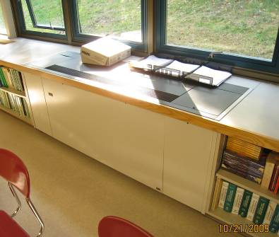

Classroom Univent

Picture 2

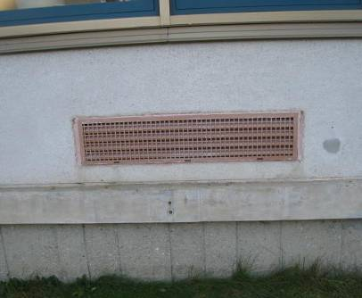

Univent Fresh Air Intake on Exterior Wall

Picture 3

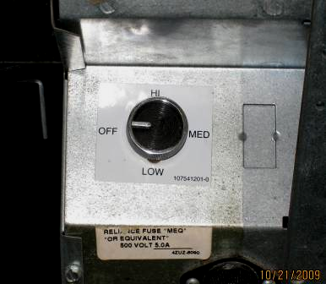

Univent Control Settings

Picture 4

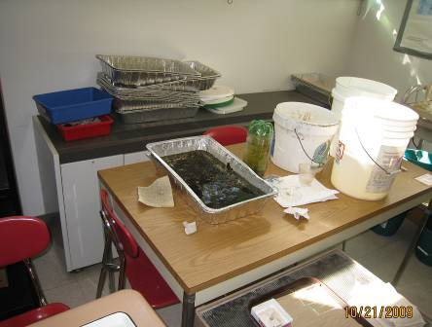

Items Stored in Front and on Top of Univent

Picture 5

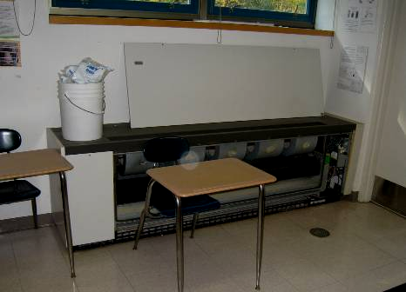

Univent Front Panels Removed

Picture 6

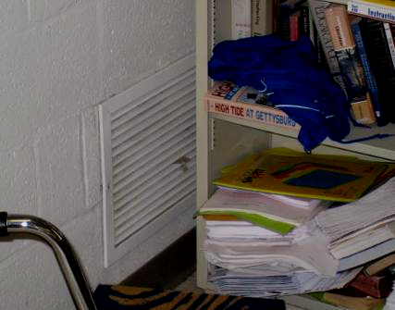

Exhaust Vents on Wall; Note Furniture in Front of Vent

Picture 7

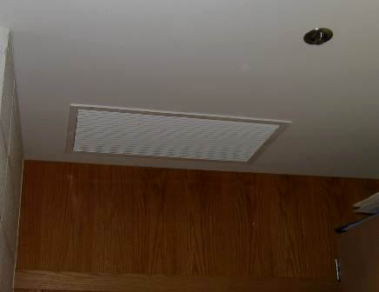

Exhaust Vent on Ceiling

Picture 8

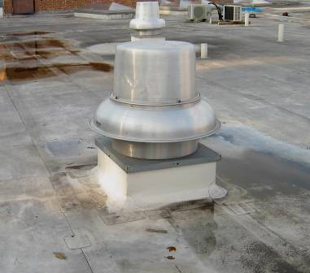

Rooftop Exhaust Vent Motor

Picture 9

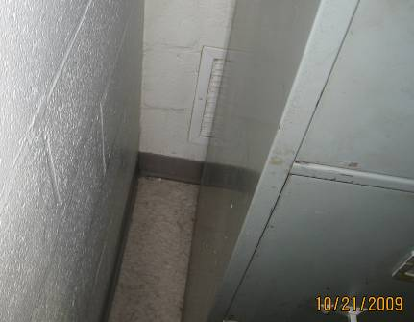

Exhaust Vent Blocked by Furniture
Picture 10

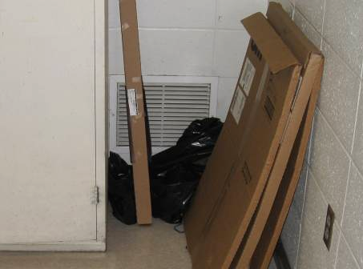

Exhaust Vent Blocked by Stored Items

Picture 11

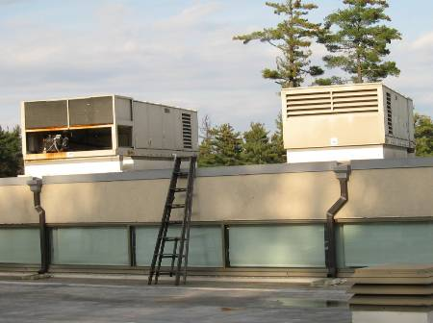

Air Handling Units on Roof

Picture 12

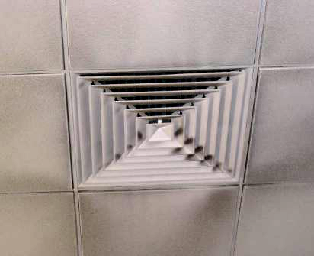

Air Diffuser in Ceiling; Note Accumulated Dust/Debris on Ceiling Tiles

Picture 13

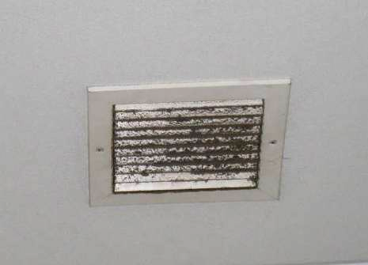

Exhaust Vent in Ceiling; Note Accumulated Dust/Debris on Vent

Picture 14

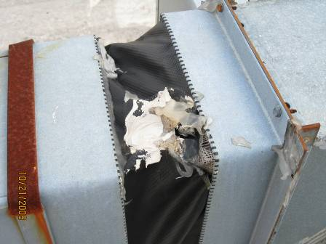

Damaged Ductwork on Roof

Picture 15

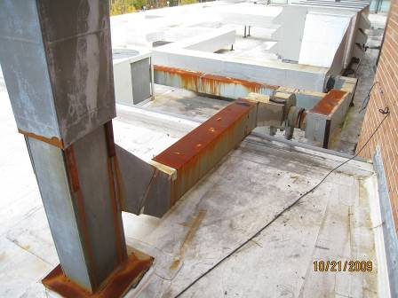

Damaged and Corroded Ductwork; Arrow Indicates where Ductwork Detached

Picture 16

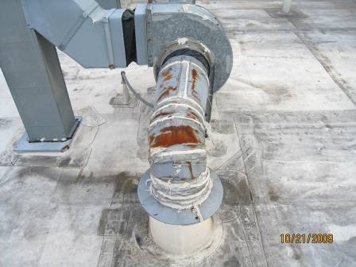

Damaged Chemical Fume Hood Ductwork

Picture 17

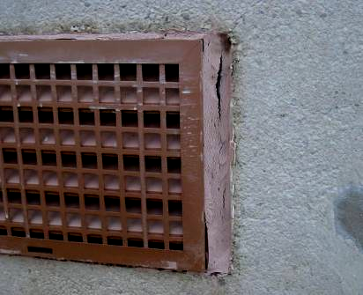

Damaged Caulking Around Air Intake

Picture 18

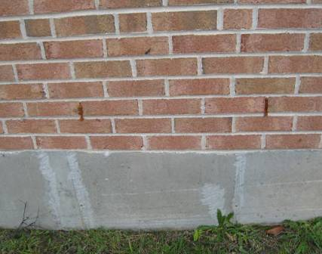

Blocked Weep Holes on Exterior Wall

Picture 19

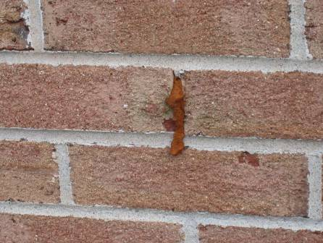

Blocked Weep Hole

Picture 20

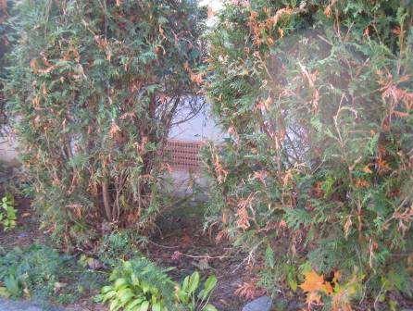

Shrubs Growing against Building and in Front of Air Intake

Picture 21

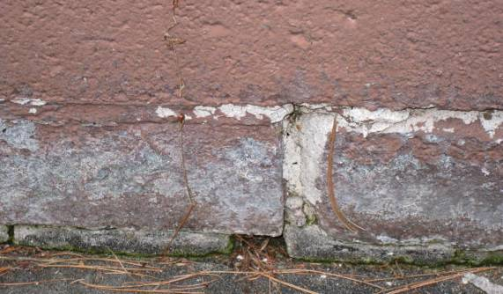

Damaged and/or Missing Exterior Brick and Mortar

Picture 22

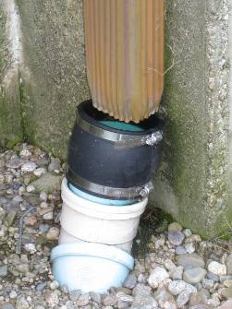

Disconnected Downspout

Picture 23

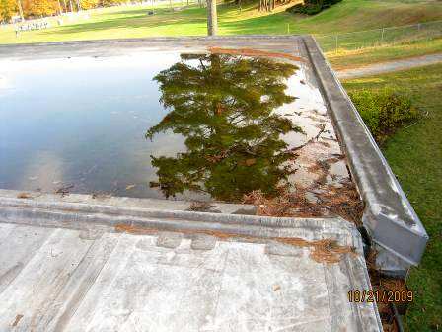

Gutters Clogged with Debris Causing Pooling Water on Roof

Picture 24

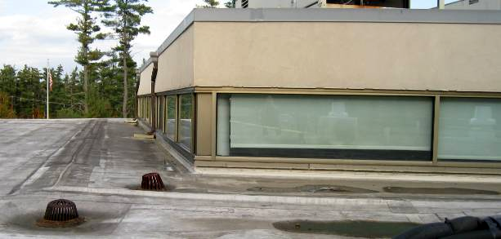

Slope of Roof Directs Water Toward the Library Windows, Where the Water Pools
Arrows Point to Areas Where Water has Pooled

Picture 25

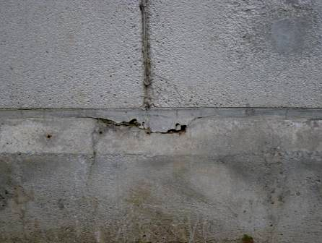

Cracks and Holes in Exterior Wall

Picture 26

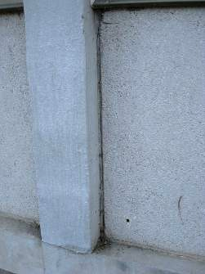

Damaged/Missing Sealant Between Expansion Joints

Picture 27

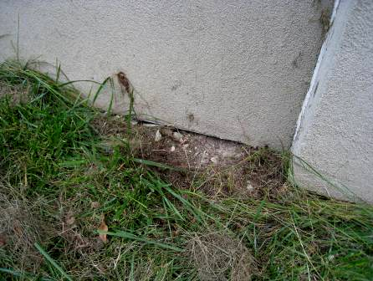

Breach in Building Foundation

Picture 28

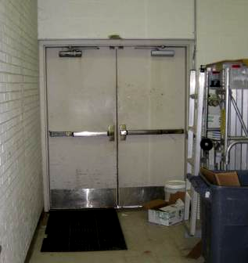

Light Penetrating Beneath Exterior Door

Picture 29

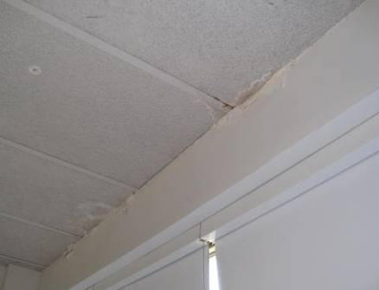

Water Damage on Ceiling and Wall Along Windows

Picture 30

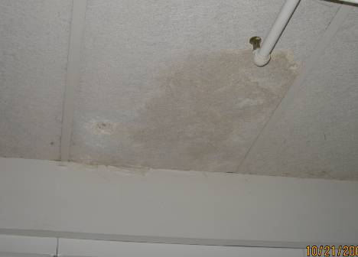

Water Damage on Ceiling and Wall Above Windows

Picture 31

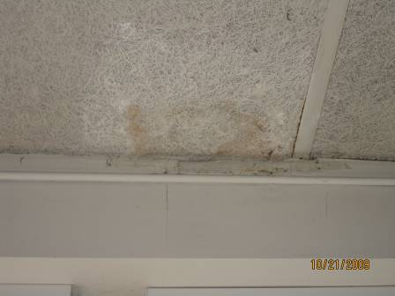

Water Damage on Ceiling

Picture 32

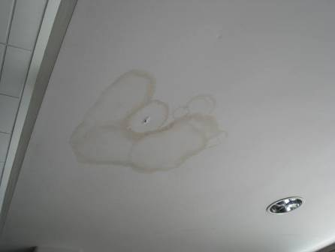

Water Damaged Ceiling

Picture 33

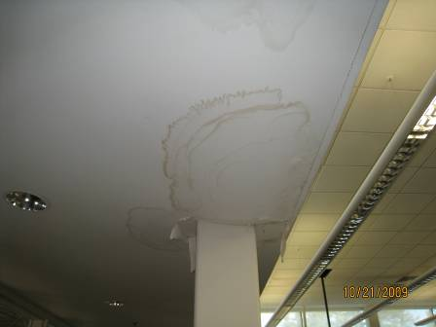

Water Damaged Ceiling

Picture 34

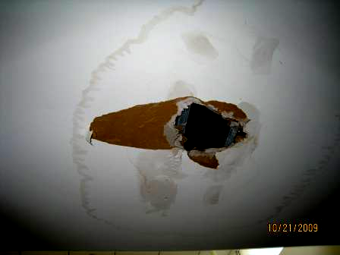

Water Damaged Ceiling

Picture 35

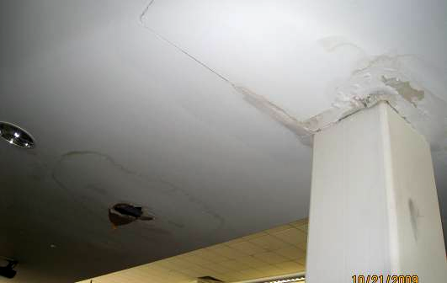

Water Damaged Ceiling

Picture 36

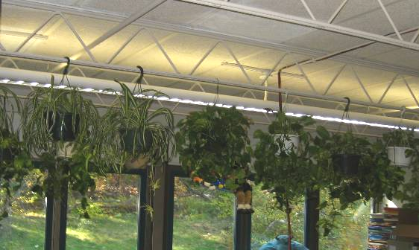

Hanging Plants in Classroom

Picture 37

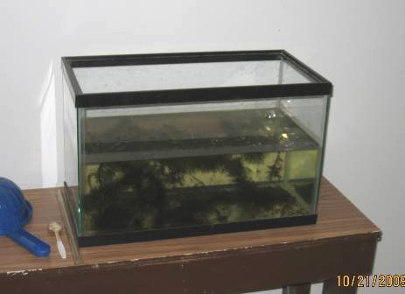

Aquarium in Room

Picture 38

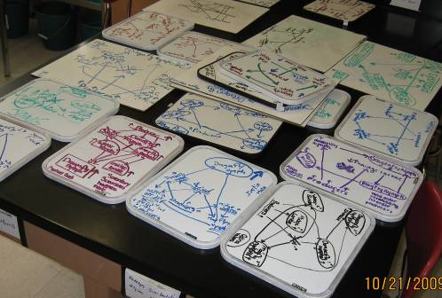

Dry Erase Materials

Picture 39

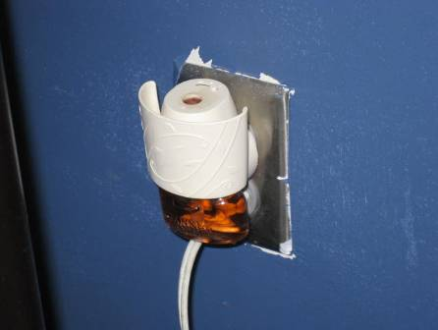
Plug-in Air Freshener

Picture 40

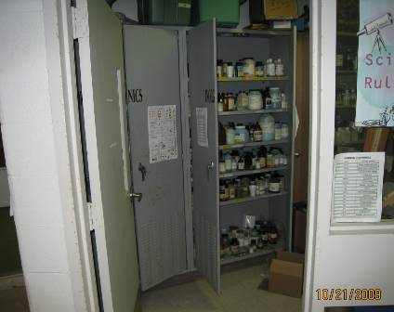

Chemical Prep Room and Chemical Storage Cabinet Open

Picture 41

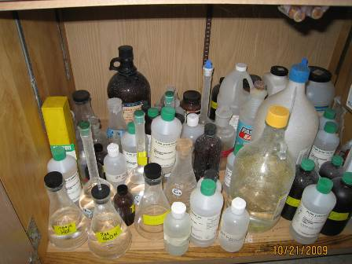

Shelves Overloaded With Chemicals

Picture 42

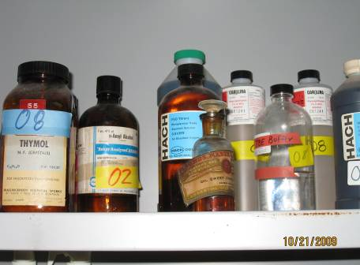

Chemicals of Extreme Age, Note Label Falling Off

Picture 43

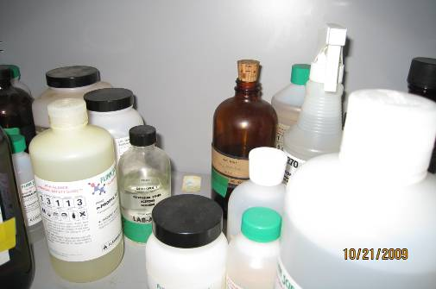

Cork Bottle Stopper

Picture 44

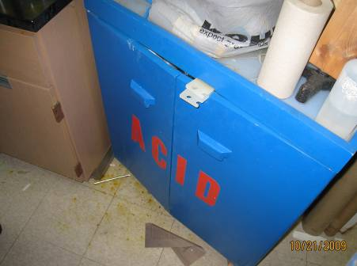

Spill on Floor Around Acid Cabinet

Picture 45

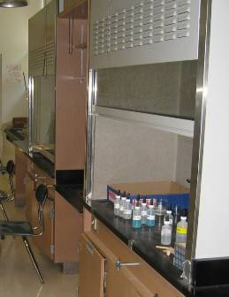

Chemicals Stored in Deactivated Fume Hood

Picture 46

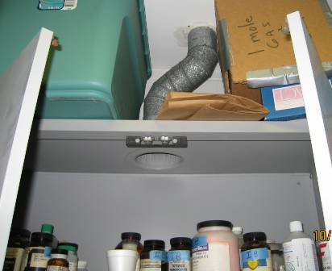

Passive Duct at the Top of Chemical Cabinet

Picture 47

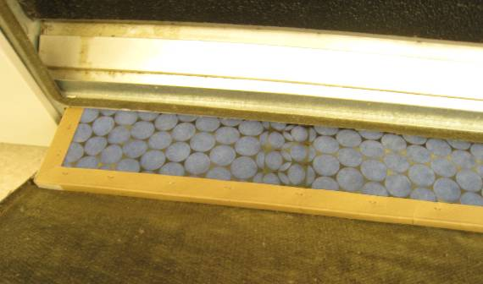

Mesh Filter in Univent

Picture 48

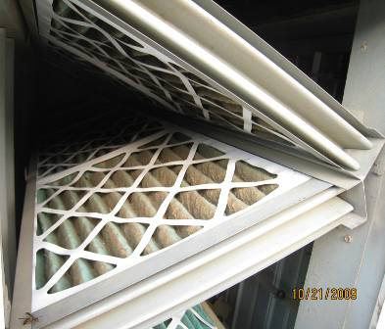

Pleated Filters in Rooftop Air Handling Unit

Picture 49

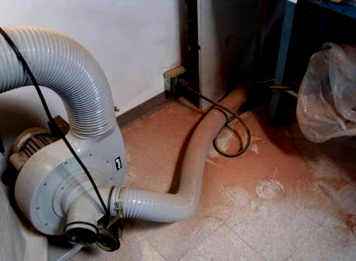

Wood Dust on Floor near Dust Collecting System

Picture 50

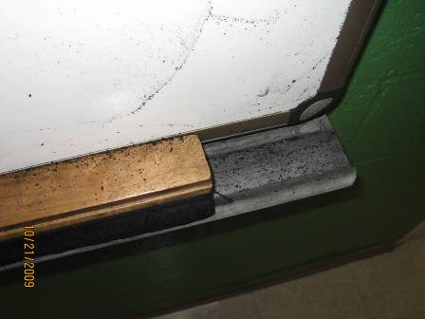

Accumulated Dry Erase Particulate in Board Tray

Picture 51

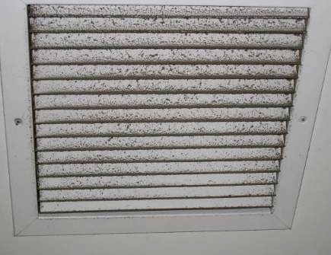

Accumulated Dust on Vent
Location/ Room | Occupants  in Room | Temp  (°F) | Relative  Humidity  (%) | Carbon  Dioxide  (ppm) | Carbon Monoxide  (ppm) | PM2.5  (µg/m³) | Windows  Openable | Ventilation |  | Remarks
 |  |  |  |  |  |  |  | Supply | Exhaust | Remarks
Outdoor |  | 61 | 60 | 430 | ND | 27 |  |  |  | Cool, partly cloudy, school surrounded by tall pine trees
101 | 1 | 73 | 41 | 1250 | ND | 12 | Y  1 open | 1 of 2 UVs off |  | UV panels removed; PF; WD along windows; DEM; space between sink and backsplash; exterior door
102 | 0 | 73 | 43 | 730 | ND |  |  |  |  | Strong odors – plug-in AF
102 B | 2 | 74 | 44 | 868 | ND | 26 | Y | Y  off | Y  off | WD CT/wall
103 | 2 | 72 | 43 | 1221 | ND | 22 | Y | UV off | could not locate | Plants; DEM
104 | 20 | 74 | 47 | 1270 | ND | 14 | Y | UV on | Y
105 | 0 | 73 | 43 | 1063 | ND | 22 | Y | UV off | Y | Items on UV; DO to hallway and 107
106 | 20 | 74 | 46 | 1348 | ND | 17 | Y | UV on | Y | Plants on paper plates
107 | 21 | 74 | 44 | 1325 | ND | 20 | Y | UV on | Y | Stored items in room and on UV; dust on exhaust vent; DO to hallway and 105
108 | 25 | 74 | 49 | 1806 | ND | 28 | Y  open | UV off | Y  off | Exhaust blocked by file cabinet
109 | 19 | 74 | 56 | 3481 | ND | 25 | Y | UV off | Y | CPs
110 | 27 | 74 | 59 | 3208 | ND | 34 | Y | UV off | Y  off
111 | 21 | 73 | 49 | 2085 | ND | 21 | Y  2 open | UV off | Y | PF
112 | 1 | 72 | 46 | 1584 | ND | 25 | Y | UV off | Y  off
113 | 28 | 74 | 50 | 2398 | ND | 24 | Y  1 open | UV off | Could not locate | Items on top of UV
114 | 36 | 74 | 56 | 3993 | ND | 29 | Y | UV off | Y | Items on UV; plants
115 | 17 | 73 | 49 | 2242 | ND | 24 | Y  1 open | UV off | Could not locate | File cabinets on wall where exhaust suppose to be; CPs; DEM
200 | 12 | 72 | 38 | 732 | ND | 13 | Y | 2 UVs  1 on low  1 off | Y  off | Filter on top of ‘off’ UV; DEM; DO
200 Prep |  |  |  |  |  |  |  | Y | Y | 2 DO
201 | 10 | 72 | 42 | 1411 | ND | 24 | Y | 2 UVs off | Y  off | Chemical odor upon entering; UV panels removed, items on UV; 2 chemical hoods, 1 with chemical inside off; WD around exhaust; shower and floor drain near hoods
201 Prep |  |  |  |  |  |  |  | Y | Y  off | Chemical lockers open: unlabeled chemicals, vintage chemicals, cork stopper; Acid Cabinet: spill in front, doors do not close properly, overstocked; Corrosives stored under bench, corroding cabinet; stored items; soda can collection; WD CTs; CPs; rust on sprinkler
202 | 20 | 71 | 43 | 998 | ND | 14 | Y | 2 UV off | Y  off | vent hood, algal growth experiments in standing water, aquarium
202 Prep |  |  |  |  |  |  |  | Y  off | Y  off
203 | 6 | 73 | 39 | 849 | ND | 9 | Y | UV off | Y | Plants on UV; MTs; damaged pipe insulation; DEM; 2 DO to 203 B
203 B | 0 | 74 | 38 | 811 | ND | 10 | Y | ceiling UV | Y | WD CTs; MTs; DEM; Exterior door; dryer; stove; pillows
204 Music Office | 0 | 75 | 42 | 956 | ND | 32 | N | N | N
204 Music Room | 24 | 75 | 43 | 974 | ND | 31 | N | Y  UV off | Y  off | DO
300 | 11 | 73 | 46 | 2729 | ND | 18 | Y | UV off | Y  blocked | Plug in AF with strong odor in room; DEM; CPs
300 wing Boys’ Room |  |  |  |  |  |  |  |  | Y  off | Bathroom odors
300 wing hallway |  |  |  |  |  |  |  |  | Y  near 309 | Space around exterior door at end of hallway; WD CTs throughout
301 | 23 | 73 | 51 | 2278 | ND | 11 | Y | UV on | Y  off, blocked | plants
302 | 11 | 73 | 44 | 2366 | ND | 7 | Y | UV on | Y  blocked | CD; plants
303 | 24 | 72 | 50 | 1651 | ND | 16 | Y | UV on | Y  off/weak | WD wall near ceiling/windows
304 | 14 | 71 | 43 | 1791 | ND | 15 | Y | UV off | Y  blocked | DEM; CPs
305 | 16 | 72 | 53 | 2333 | ND | 20 | Y | UV off | Y  off | WD CT
306 | 19 | 71 | 45 | 1467 | ND | 15 | Y | UV on | Y  blocked | WD above windows
307 | 13 | 71 | 49 | 1304 | ND | 16 | Y | UV on | Y  off, partially blocked | Accumulated items; WD CTs and wall near windows, low (i.e. normal) moisture
308 | 18 | 71 | 44 | 1264 | ND | 19 | Y | UV on | Y | DEM; PF
309 | 0 | 70 | 43 | 891 | ND | 16 | Y | UV off | Y | DEM – accumulated marker particulates in tray; Exhaust in hallway outside room working
310 | 0 | 71 | 43 | 1301 | ND | 23 | Y | UV off | Y  off, blocked | Exhaust blocked by furniture; DO; DEM
311 | 1 | 70 | 48 | 1207 | ND | 17 | Y | UV off | Y  off | 12 occupants gone 45 minutes
312 | 21 | 71 | 44 | 1821 | ND | 8 | Y | UV on | off
313 | 1 | 70 | 44 | 645 | ND | 17 | Y  1 open | UV on | Y  off
401 | 2 | 75 | 39 | 615 | ND | 10 | Y | ceiling UV off | Y | supplemental mech vent system, supply blocked with wood-drafts
402 | 0 | 77 | 32 | 546 | ND | 14 | N | Y | Y | Debris/dust on vents; PF; CPs; DO; WD CTs
403 | 15 | 77 | 43 | 1802 | ND | 10 | Y | UV off | Y  off
404 | 20 | 77 | 40 | 944 | ND | 20 | Y  open | ceiling UV off | Y  off | Dust on UV return grill and Exhaust vent
Art Room | 9 | 73 | 45 | 1184 | ND | 22 | Y | ceiling UV off | Y | kiln vented with local exhaust
Auditorium | 0 | 72 | 39 | 520 | ND | 15 | N | Y  off | Y  off | dust/debris accumulated on stage exhaust grills; musty odors
Cafeteria | 5 | 74 | 49 | 710 | ND | 37 | Y | 3 of 4 UVs off | Y | 100 occupants gone 12 minutes
Foreign Lang Room | 0 | 72 | 49 | 1203 | ND | 23 | Y | Y  off | Y  off | MT
Guidance Office | 2 | 76 | 44 | 1001 | ND | 25 | Y | Y  off | Y  off | Dust on vents
Guidance Reception | 2 | 75 | 43 | 833 | ND | 26 | N | Y  off | Y  off | Dusty CTs around supply vent
Gym | 30 | 72 | 40 | 807 | ND | 18 | Y | Y | Y
Health Office | 1 | 74 | 45 | 869 | ND | 32 | N | Y |  | Exhaust in connected bathroom; DO; PF
Library | 19 | 78 | 36 | 864 | ND | 8 | N | Y |  | PC odors upon entering; WD CTs; MTs; laminator; CPs; DEM
Main Office | 2 | 72 | 40 | 517 | ND | 24 | N | Y | Y | WD around light and vent
Main Office Copy Room | 0 | 76 | 39 | 709 | ND | 27 | N | Y  off | Y  off | Dust on vents; WD wall/leak
Receiving Room |  |  |  |  |  |  |  |  |  | Space around exterior door; paper storage; refrigerator
Science Work Room | 1 | 73 | 46 | 1032 | ND | 22 | Y | Y  off | Y  off | UF; PC
Superintendent | 4 | 73 | 36 | 504 | ND | 14 | Y | Y | Y
Teachers Work Room | 2 | 75 | 45 | 1104 | ND | 18 | Y | UV off | Y  off | MT
Wood Shop | 0 | 71 | 37 | 719 | ND | 10 | Y |  |  | Sawdust on equipment, floor and surfaces

Building envelope means the roof, exterior walls, exterior windows, exterior doors and foundation of a building.

