WATER DAMAGE/MOLD INVESTIGATION

West Bridgewater Middle-High School
155 West Center St
West Bridgewater, MA

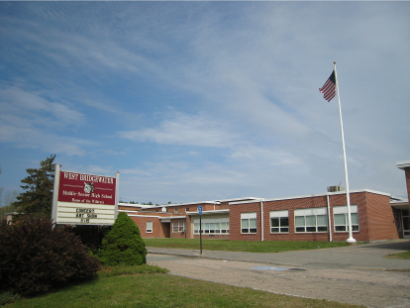

Prepared by:
Massachusetts Department of Public Health
Bureau of Environmental Health
Indoor Air Quality Program
July 2014

Background/Introduction
At the request of Julie Hamblin, Director of Buildings and Grounds for West Bridgewater Public Schools, the Massachusetts Department of Public Health (MDPH), Bureau of Environmental Health (BEH) conducted an assessment in response to concerns related to water damage following a flooding incident at the West Bridgewater Middle-High School (WBMHS) located at 155 West Center St, West Bridgewater, Massachusetts. As reported by Ms. Hamblin, approximately 4 to 5 feet of water had accumulated in the basement boiler room following failure of a pipe supplying water to the hot water heater. Ms. Hamblin and her staff discovered the building was flooded early in the morning on Monday, May 5, 2014. The school remained closed until Thursday May 8, 2014 to allow for water removal, cleaning, drying, and replacement of damaged components, including the broken pipe, boilers, electrical components, and an energy management system. On May 14, 2014, a site visit was made to the WBMHS by Sharon Lee, Environmental Analyst/ Inspector within BEH’s Indoor Air Quality (IAQ) Program. The assessment was prompted by staff concerns of potential mold in first floor classrooms in close proximity to the basement area where water accumulated.
The WBMHS was constructed in 1950. The school consists of a brick exterior and concrete foundation. Windows are openable throughout the building.

Methods
BEH/IAQ staff performed a visual inspection of building materials for water damage and/or microbial growth. Temperature and relative humidity measurements were taken with a TSI, Q-Trak, IAQ Monitor 7565.

Results and Discussion
At the time of the BEH/IAQ assessment, a plastic containment door was noted at the entry to the basement boiler area (Picture 1). Water that had discharged from the broken supply pipe had been removed, the affected areas had been cleaned, and the electricity was operating (Picture 2). Dehumidifiers and fans were in place to remove moisture and dry the basement. The concrete basement was relatively dry, and no musty odors were observed. BEH/IAQ staff did detect some boiler-related odors. BEH/IAQ staff noted the presence of some water near the stairwell to the basement (Picture 3); Ms. Hamblin indicated that the water infiltration observed is not from the flood but from groundwater penetration that occurs annually.
The US Environmental Protection Agency (US EPA) and the American Conference of Governmental Industrial Hygienists (ACGIH) recommends that porous materials (e.g., wallboard and carpeting) be dried with fans and heating within 24 to 48 hours of becoming wet (US EPA, 2001; ACGIH, 1989). If porous materials are not dried within this time frame, mold growth may occur.
As mentioned, WBMHS staff were concerned about the impacts of the flooding to classrooms in close proximity to the boiler room. No basement/musty odors were observed in occupant areas at the time of assessment. BEH/IAQ staff examined classrooms above the basement for pathways that would allow movement of moisture/materials from the basement boiler areas to occupant areas. Breaches around pipes penetrating through the floor were observed in univent cabinets (Picture 4). Openings were also observed in the cabinet wall that separates the univent cabinet from the fan compartment (Picture 5). When a univent is operating, the fan can draw basement air up through breaches around pipes through openings in the univent cabinet wall, where the basement air is subsequently mixed and distributed to the classroom. Since the openings in the univent wall are above the filtration compartment, dust/debris/odors that may be suspended in the basement air may also be circulated. Similar breaches were observed around heat/water pipes in the gym area.
Please note that at the time of assessment, univents were not operating. This would likely minimize any potential of movement of materials/odors from the basement to occupant areas. BEH/IAQ staff recommended that spaces around all pipes be sealed with a fire-rated foam insulation prior to re-activation of univents.
The indoor temperature ranged from 70°F to 72°F in the basement. Temperature in occupied areas ranged from 70°F to 74°F (Table 1), which were within the MDPH recommended comfort range the day of assessment. The MDPH recommends that indoor air temperatures be maintained in a range of 70°F to 78°F in order to provide for the comfort of building occupants. In many cases concerning indoor air quality, fluctuations of temperature in occupied spaces are typically experienced, even in a building with an adequate fresh air supply.
Indoor relative humidity measurements ranged from 62 to 62 percent in the basement to 56 percent at the top of the basement stairs. Relative humidity in occupied areas ranged from 41 to 49 percent. The difference in indoor relative humidity levels between the basement and the occupant areas would suggest that moisture in the basement is not migrating to occupant areas. Relative humidity levels were within the MDPH recommended comfort range in classroom areas surveyed at the time of the assessment (Table 1). The MDPH recommends a comfort range of 40 to 60 percent for indoor relative humidity. Relative humidity levels in the building would be expected to drop during the winter months due to heating. The sensation of dryness and irritation is common in a low relative humidity environment. Low relative humidity is a very common problem during the heating season in the northeast part of the United States.

Conclusions/Recommendations
Based on conditions observed at the time of the assessment, it does not appear that flooding in the basement impacted classrooms on upper levels. In view of these findings, the following recommendations are made:
- Continue to dry the basement area by operating fans and dehumidifiers.
- Examine remaining porous materials in the basement for signs of water damage. Remove any water-damaged materials in a manner consistent with recommendations found in “Mold Remediation in Schools and Commercial Buildings” published by the US Environmental Protection Agency (US EPA, 2001).
- Thoroughly clean the school to prevent any remaining dust/debris from persisting within the indoor environment.
- Seal breaches and pipes and spaces in the univent cabinet walls in a manner that prevents the movement of materials from the basement to occupant areas.

References
ACGIH. 1989. Guidelines for the Assessment of Bioaerosols in the Indoor Environment. American Conference of Governmental Industrial Hygienists, Cincinnati, OH.
US EPA. 2001. Mold Remediation in Schools and Commercial Buildings. US Environmental Protection Agency, Office of Air and Radiation, Indoor Environments Division, Washington, D.C. EPA 402-K-01-00. http://www.epa.gov/mold/mold_remediation.html

Picture

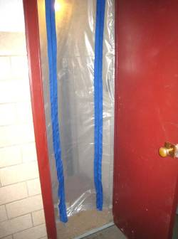

Plastic containment door to basement boiler area

Picture

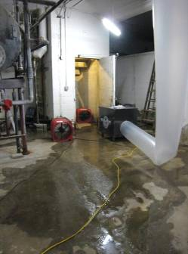

Water on floor near basement stairs

Picture

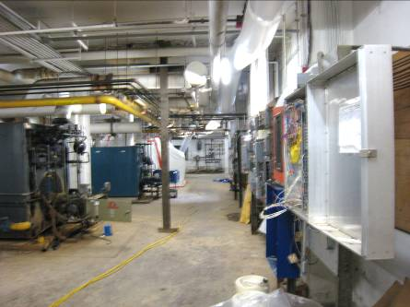

Dry basement area

Picture

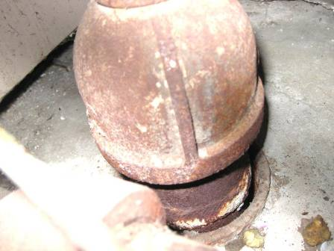

Breach around univent pipe

Picture

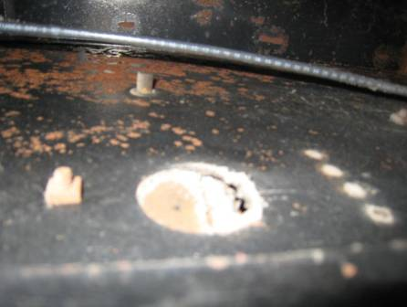

Space in univent cabinet wall

Location/ Room | Temp (°F) | Relative Humidity (%) | Occupants  in Room | Windows Openable | Ventilation |  | Remarks
 |  |  |  |  | Supply | Exhaust
Background | 61 | 49 |  |  |  |  | sunny
Basement – near electric panel | 70 | 62 |  |  |  |  | Boiler odors
Basement – water heater | 70 | 61 |  |  |  |  | Boiler odors
Basement – top of stairs | 72 | 56 |  |  |  |  | Containment door
122 | 70 | 44 | 3 | Y | Y  Off | Y | Door open, Spaces around pipe in univent
113 | 74 | 49 | 1 | Y | Y  Off | Y | Spaces around pipe in univent
Weight room | 72 | 41 | 47 |  |  |  | Breach around pipe
Exercise/cardio room | 72 | 42 | 1 | Y | Y  Off | Y
Hallway near gym | 72 | 42 | 5 |  | N | N
Hallway near 118 | 73 | 41 |  |  | N | N
Main hallway | 73 | 42 |  |  | N | N

