INDOOR AIR QUALITY ASSESSMENT

West Elementary School
2463 Main Street
West Barnstable, Massachusetts

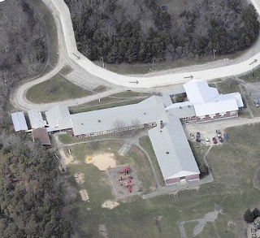

Prepared by:
Massachusetts Department of Public Health
Bureau of Environmental Health
Indoor Air Quality Program
August 2013

Background/Introduction
At the request of the Barnstable Public Schools (BPS), the Massachusetts Department of Public Health (MDPH), Bureau of Environmental Health (BEH) provided assistance and consultation regarding indoor air quality (IAQ) at the West Barnstable Elementary School (WBES) located at 2463 Main Street, West Barnstable, Massachusetts. On May 2, 2013, Cory Holmes, Environmental Analyst/Regional Inspector in BEH’s IAQ Program visited the school to perform an assessment. The assessment was part of an on-going effort to monitor and improve IAQ conditions in each of the Barnstable Public Schools.
The WBES is a one-story brick building that was built in the mid 1950s. The building contains general classrooms, library, kitchen, cafeteria, gymnasium, faculty workrooms/lounge and office space. A portable classroom was added in the late 1970s-early 1980s and is used for art and music. A second portable classroom was added in the mid 1980s and is used for special education classes and a computer room. Windows were replaced in the original building within the last year and are openable throughout the building. Building materials in the portable classrooms (e.g., carpeting, mechanical ventilation equipment, windows) are original equipment.

Methods
Air tests for carbon monoxide, carbon dioxide, temperature and relative humidity were conducted with the TSI, Q-Trak, IAQ Monitor, Model 7565. Air tests for airborne particle matter with a diameter less than 2.5 micrometers were taken with the TSI, DUSTTRAK™ Aerosol Monitor Model 8520. BEH/IAQ staff also performed visual inspection of building materials for water damage and/or microbial growth.

Results
The school houses approximately 270 students in grades K through 3 with a staff of approximately 35. Tests were taken during normal operations at the school. Results appear in Table 1.

Discussion

Ventilation
It can be seen from Table 1 that carbon dioxide levels were above 800 parts per million (ppm) in 13 out of 24 areas, indicating less than optimal air exchange in about half of the areas surveyed. Fresh air in classrooms is supplied by unit ventilators (univents) (Picture 1). A univent is designed to draw air from outdoors through a fresh air intake located on the exterior wall of the building (Picture 2). Return air is drawn through an air intake located at the base of each unit where fresh and return air are mixed, filtered, heated or cooled and provided to classrooms through an air diffuser located in the top of the unit (Figure 1).
Univents have fan settings of “low”, “med” and “high”. Univents were found deactivated or obstructed with classroom items in several areas (Pictures 3 and 4; Table 1). In order for univents to provide fresh air as designed, intakes/returns must remain free of obstructions. Importantly, these units must remain on and be allowed to operate while rooms are occupied. A “buzzing” noise was detected from the univent in classroom 11 during the assessment, which may indicate a mechanical problem.
Mechanical ventilation in the gym is provided by an air handling unit (AHU) that is reportedly activated by a main switch located in the stage area. At the time of assessment, the gym was being used and the system was deactivated, therefore no means of air exchange was being provided for occupants.
Ventilation for modular classrooms is provided by wall-mounted AHUs (Picture 5). Fresh air is drawn in through air intakes on the exterior of the building and distributed to classrooms via ceiling or wall-mounted air diffusers and drawn back to the AHUs through return grills. Thermostats for both portable classrooms were set to the fan “auto” setting, which deactivates the HVAC system when it reaches a preset temperature. Therefore, no mechanical ventilation is provided until the thermostat reactivates the system.
Note that the univents and AHUs are original equipment, over 50 years old (30 years for modular classroom AHUs). Function of equipment of this age is difficult to maintain, since compatible replacement parts are often unavailable. According to the American Society of Heating, Refrigeration and Air-Conditioning Engineers (ASHRAE), the service life for a unit heater, hot water or steam is 20 years, assuming routine maintenance of the equipment (ASHRAE, 1991). Despite attempts to maintain the univents, the operational lifespan of the equipment has been exceeded. Maintaining the balance of fresh air to exhaust air will become more difficult as the equipment ages and as replacement parts become increasingly difficult to obtain.
Exhaust ventilation in classrooms is provided by wall-mounted vents ducted to rooftop motors. It is important to note that exhaust vents are located near hallway doors, which are generally left open (Picture 6). With the hallway doors open, the exhaust vent will tend to draw air from the hallway into the classroom, instead of drawing stale air from the classroom. Therefore it is recommended that classroom doors remain shut while exhaust vents are operating to function as designed. Exhaust vents were also found off and/or obstructed in some areas (Picture 7; Table 1).
The WBES was designed for wall-mounted exhaust vents in classrooms to be supplemented by exhaust vents located in the ceilings of coat closets (Picture 8). Air is drawn into the coat closet from the classroom via undercut closet doors. However, the design of the closet vents allows them to be easily blocked by stored materials. The majority of the exhaust vents were not drawing air at the time of assessment. As with univents, in order to function properly, exhaust vents must be activated and remain free of obstructions.
To maximize air exchange, the MDPH recommends that both supply and exhaust ventilation operate continuously during periods of occupancy. In order to have proper ventilation with a mechanical supply and exhaust system, the systems must be balanced to provide an adequate amount of fresh air to the interior of a room while removing stale air from the room. It is recommended that heating, ventilating and air conditioning (HVAC) systems be re-balanced every five years to ensure adequate air systems function (SMACNA, 1994). The date of the last balancing of these systems was not available at the time of assessment.
Minimum design ventilation rates are mandated by the Massachusetts State Building Code (MSBC). Until 2011, the minimum ventilation rate in Massachusetts was higher for both occupied office spaces and general classrooms, with similar requirements for other occupied spaces (BOCA, 1993). The current version of the MSBC, promulgated in 2011 by the State Board of Building Regulations and Standards (SBBRS), adopted the 2009 International Mechanical Code (IMC) to set minimum ventilation rates. Please note that the MSBC is a minimum standard that is not health-based. At lower rates of cubic feet per minute (cfm) per occupant of fresh air, carbon dioxide levels would be expected to rise significantly. A ventilation rate of 20 cfm per occupant of fresh air provides optimal air exchange resulting in carbon dioxide levels at or below 800 ppm in the indoor environment in each area measured. MDPH recommends that carbon dioxide levels be maintained at 800 ppm or below. This is because most environmental and occupational health scientists involved with research on IAQ and health effects have documented significant increases in indoor air quality complaints and/or health effects when carbon dioxide levels rise above the MDPH guidelines of 800 ppm for schools, office buildings and other occupied spaces (Sundell et al., 2011). The ventilation must be on at all times that the room is occupied. Providing adequate fresh air ventilation with open windows and maintaining the temperature in the comfort range during the cold weather season is impractical. Mechanical ventilation is usually required to provide adequate fresh air ventilation.
Carbon dioxide is not a problem in and of itself. It is used as an indicator of the adequacy of the fresh air ventilation. As carbon dioxide levels rise, it indicates that the ventilating system is malfunctioning or the design occupancy of the room is being exceeded. When this happens, a buildup of common indoor air pollutants can occur, leading to discomfort or health complaints. The Occupational Safety and Health Administration (OSHA) standard for carbon dioxide is 5,000 parts per million parts of air (ppm). Workers may be exposed to this level for 40 hours/week, based on a time-weighted average (OSHA, 1997).
The MDPH uses a guideline of 800 ppm for publicly occupied buildings. A guideline of 600 ppm or less is preferred in schools due to the fact that the majority of occupants are young and considered to be a more sensitive population in the evaluation of environmental health status. Inadequate ventilation and/or elevated temperatures are major causes of complaints such as respiratory, eye, nose and throat irritation, lethargy and headaches. For more information concerning carbon dioxide, consult Appendix A.
Indoor temperature measurements ranged from 70 F to 76 F (Table 1), which were within the MDPH recommended comfort range on the day of assessment. The MDPH recommends that indoor air temperatures be maintained in a range of 70 F to 78 F in order to provide for the comfort of building occupants. In many cases concerning indoor air quality, fluctuations of temperature in occupied spaces are typically experienced, even in a building with an adequate fresh air supply. In addition, it is difficult to control temperature and maintain comfort without operating the ventilation equipment as designed (e.g., univents/exhaust vents deactivated/obstructed).
The relative humidity measured in the building ranged from 32 to 43 percent, which was within or slightly below the MDPH recommended comfort range in areas surveyed (Table 1). The MDPH recommends a comfort range of 40 to 60 percent for indoor air relative humidity. Relative humidity levels in the building would be expected to drop during the winter months due to heating. The sensation of dryness and irritation is common in a low relative humidity environment. Low relative humidity is a very common problem during the heating season in the northeast part of the United States.

Microbial/Moisture Concerns
Water-damaged ceiling tiles were observed in a few areas (Table 1), which appear to be from current/historic roof and/or building envelope leaks (Pictures 9 through 11). Water-damaged ceiling tiles can provide a source of mold and should be replaced after a water leak is discovered and repaired. During the assessment, active leaks through windows were reported in portable classroom B (Picture 12); and water-damaged ceilings and walls were observed in the front right corner of classroom 13 (Picture 13). BEH/IAQ staff inspected conditions on the exterior of this area and found a breach/damage to the fascia near the roof, which likely serves as the source of water penetration causing the damage (Picture 14).
The US Environmental Protection Agency (US EPA) and the American Conference of Governmental Industrial Hygienists (ACGIH) recommend that porous materials (e.g., carpeting, gypsum wallboard) be dried with fans and heating within 24 to 48 hours of becoming wet (US EPA, 2001; ACGIH, 1989). If not dried within this time frame, mold growth may occur. Once mold has colonized porous materials, they are difficult to clean and should be removed/discarded.
Plants were noted in a few classrooms (Table 1). Plants can be a source of pollen and mold which can be respiratory irritants to some individuals. Plants should be properly maintained and equipped with drip pans and should be located away from univents to prevent the aerosolization of dirt, pollen and mold.
BEH/IAQ staff observed plants and shrubs in close proximity to the building’s exterior in some areas with some near univent air intakes. Plants, shrubs and trees in close proximity to the building hold moisture against the building exterior. The growth of roots against exterior walls can bring moisture in contact with the foundation. Plant roots can eventually penetrate the wall, leading to cracks and/or fissures in the foundation. Over time, these conditions can undermine the integrity of the building envelope and provide a means of water entry into the building via capillary action through exterior walls, foundation concrete, and masonry (Lstiburek & Brennan, 2001). The freezing and thawing action of water during the winter months can create cracks and fissures in the foundation that can result in additional penetration points for both water and pests. Trees, shrubs and plants can also be a source of pollen, debris and mold into univents and windows. Consideration should be given to removing landscaping in close proximity to the building so as to maintain a space of 5 feet between shrubbery and the building.
BEH/IAQ staff examined the exterior of the portable classrooms to identify breaches in the building envelope and/or other issues that could provide a source of water penetration. Portable classrooms showed numerous signs of damage and deterioration. As previously mentioned, portable classrooms were added in the late 1970s and mid 1980s and as reported by BPS officials, and at least one of them was reportedly previously used condition at the time it was installed. These reports, as well as the observed present condition, would indicate that they are being used far beyond their intended service life. Along the exterior, numerous breaches were noted to the underside, exterior doors, walls and along the roof edge of portable classrooms (Pictures 15 through 19), which could allow pest entry or increased water damage that could lead to mold growth. Portable classrooms had leaking windows (Picture 12) and clogged/missing/damaged gutters and downspouts which can enhance water penetration issues and create water pooling around the buildings (Picture 20).
Bird nesting materials were observed inside an abandoned exhaust vent along the exterior of portable classroom B (Pictures 21 and 22). Birds can be a source of disease, and bird wastes and feathers can contain mold and mildew, which can be irritating to the respiratory system. No obvious signs of bird roosting inside the building was noted by BEH/IAQ staff or reported by occupants; however, the vent should be properly sealed.

Other IAQ Evaluations
Indoor air quality can be negatively influenced by the presence of respiratory irritants, such as products of combustion. The process of combustion produces a number of pollutants. Common combustion emissions include carbon monoxide, carbon dioxide, water vapor and smoke (fine airborne particle material). Of these materials, exposure to carbon monoxide and particulate matter with a diameter of 2.5 micrometers (μm) or less (PM2.5) can produce immediate, acute health effects upon exposure. To determine whether combustion products were present in the indoor environment, BEH/IAQ staff obtained measurements for carbon monoxide and PM2.5.

Carbon Monoxide
Carbon monoxide is a by-product of incomplete combustion of organic matter (e.g., gasoline, wood and tobacco). Exposure to carbon monoxide can produce immediate and acute health effects. Several air quality standards have been established to address carbon monoxide and prevent symptoms from exposure to these substances. The MDPH established a corrective action level concerning carbon monoxide in ice skating rinks that use fossil-fueled ice resurfacing equipment. If an operator of an indoor ice rink measures a carbon monoxide level over 30 ppm, taken 20 minutes after resurfacing within a rink, that operator must take actions to reduce carbon monoxide levels (MDPH, 1997).
The American Society of Heating Refrigeration and Air-Conditioning Engineers (ASHRAE) has adopted the National Ambient Air Quality Standards (NAAQS) as one set of criteria for assessing indoor air quality and monitoring of fresh air introduced by HVAC systems (ASHRAE, 1989). The NAAQS are standards established by the US EPA to protect the public health from six criteria pollutants, including carbon monoxide and particulate matter (US EPA, 2006). As recommended by ASHRAE, pollutant levels of fresh air introduced to a building should not exceed the NAAQS levels (ASHRAE, 1989). The NAAQS were adopted by reference in the Building Officials & Code Administrators (BOCA) National Mechanical Code of 1993 (BOCA, 1993), which is now an HVAC standard included in the Massachusetts State Building Code (SBBRS, 2011). According to the NAAQS, carbon monoxide levels in outdoor air should not exceed 9 ppm in an eight-hour average (US EPA, 2006).
Carbon monoxide should not be present in a typical, indoor environment. If it is present, indoor carbon monoxide levels should be less than or equal to outdoor levels. On the day of assessment, outdoor carbon monoxide concentrations were non-detect (ND) (Table 1). No measurable levels of carbon monoxide were detected inside the building (Table 1).

Particulate Matter
The US EPA has established NAAQS limits for exposure to particulate matter. Particulate matter includes airborne solids that can be irritating to the eyes, nose and throat. The NAAQS originally established exposure limits to PM with a diameter of 10 μm or less (PM10). In 1997, US EPA established a more protective standard for fine airborne particulate matter with a diameter of 2.5 μm or less (PM2.5). This more stringent PM2.5 standard requires outdoor air particle levels be maintained below 35 μg/m³ over a 24-hour average (US EPA, 2006). Although both the ASHRAE standard and BOCA Code adopted the PM10 standard for evaluating air quality, MDPH uses the more protective PM2.5 standard for evaluating airborne PM concentrations in the indoor environment.
Outdoor PM2.5 concentrations were measured at 3 μg/m³ (Table 1). PM2.5 levels measured in the school were between 4 to 15 μg/m³ (Table 1), which were below the NAAQS PM2.5 level of 35 μg/m³. Frequently, indoor air levels of particulates (including PM2.5) can be at higher levels than those measured outdoors. A number of activities that occur indoors and/or mechanical devices can generate particulate during normal operations. Sources of indoor airborne particulates may include but are not limited to particles generated during the operation of fan belts in the HVAC system, use of stoves and/or microwave ovens in kitchen areas; use of photocopiers, fax machines and computer printing devices; operation of an ordinary vacuum cleaner and heavy foot traffic indoors.

Volatile Organic Compounds
Indoor air concentrations can be greatly impacted by the use of products containing volatile organic compounds (VOCs). VOCs are carbon-containing substances that have the ability to evaporate at room temperature. Frequently, exposure to low levels of total VOCs (TVOCs) may produce eye, nose, throat and/or respiratory irritation in some sensitive individuals. For example, chemicals evaporating from a paint can stored at room temperature would most likely contain VOCs. In an effort to identify materials that can potentially increase indoor VOC concentrations, BEH/IAQ staff examined rooms for products containing these respiratory irritants.
Classrooms contained dry erase boards and related materials. Materials such as dry erase markers and dry erase board cleaners may contain VOCs, such as methyl isobutyl ketone, n-butyl acetate and butyl-cellusolve (Sanford, 1999), which can be irritating to the eyes, nose and throat.
Cleaning and sanitizing products were observed on sinks in some rooms (Table 1). These products contain chemicals that can be irritating to the eyes, nose and throat of sensitive individuals. Cleaning products should be properly labeled and stored in an area inaccessible to children. In addition, a Material Safety Data Sheets (MSDS) should be available at a central location for each product in the event of an emergency. Consideration should be given to providing teaching staff with school issued cleaning products and supplies to prevent any potential for adverse chemical interactions between residues left from cleaners used by the facilities staff and those left by cleaners brought in by others.

Other Conditions
Other conditions that can affect IAQ were observed during the assessment. In many classrooms, a large number of items were on floors, windowsills, tabletops, counters, bookcases and desks, which provide a source for dusts to accumulate. These items (e.g., papers, folders, boxes) make it difficult for custodial staff to clean. Items should be relocated and/or be cleaned periodically to avoid excessive dust build up. In addition, dust and debris can accumulate on flat surfaces (e.g., desktops, shelving and carpets) in occupied areas and subsequently be re-aerosolized causing further irritation.
Inside modular classrooms carpets that appear to be original to their construction (over 30 years old) were soiled and deteriorated, in some cases to a threadbare state. The Institute of Inspection, Cleaning and Restoration Certification (IICRC), recommends that carpeting be cleaned annually (or semi-annually in soiled high traffic areas) (IICRC, 2005). Since the average service time of carpeting in a school environment is approximately eleven years (Bishop, 2002), consideration should be given to planning for the replacement of carpeting with new flooring. If these portable units are to continue to be in service, extensive renovations to both the interior and exterior are warranted. If the space is needed by the school, new units may be more feasible than much-needed repairs.
A number of air diffusers, exhaust/return vents and personal fans were found to have accumulated dust/debris (Picture 8; Table 1). If exhaust vents are not functioning, backdrafting can occur, which can re-aerosolize accumulated dust particles. Re-activated supply, exhaust/return vents and fans can also aerosolize dust accumulated on vents/fan blades.
Finally, fluorescent light fixtures were missing covers in a number of areas. Fixtures should be equipped with access covers installed with bulbs fully secured in their sockets. Breakage of glass can cause injuries and may release mercury and/or other hazardous compounds.

Conclusions/Recommendations
Some of the conditions listed in this report can be remedied by the actions of building occupants. Other remediation efforts will require alteration to the building structure and equipment. It is also important to stress that if portable units are to continue to be in service, extensive renovations to both the interior and exterior are warranted. If the space is needed by the school, new units may be more feasible than much-needed repairs on the existing structures.
For these reasons, a two-phase approach is recommended. The first consists of short-term measures to improve air quality and the second consists of long-term measures that will require planning and resources to adequately address overall IAQ conditions. In view of the findings at the time of the visit, the following recommendations are made:

Short-Term Recommendations
- Operate all ventilation systems throughout the building (e.g., gym, cafeteria, classrooms) continuously during periods of occupancy to maximize air exchange. If increased airflow is desired, operate univents in fan “high” mode.
- Consider setting thermostat fan controls in modular classrooms to the “on” position to provide constant supply and exhaust ventilation during periods of occupancy.
- Contact HVAC engineering firm to restore proper operation of cafeteria AHU, make repairs as needed.
- Investigate “buzzing” noise for univent in classroom 11, make repairs as needed.
- Remove all blockages/items from the surface of univent air diffusers and return vents (along front/bottom) and coat closet exhausts to ensure adequate airflow.
- Ensure classroom doors are closed for proper operation of mechanical ventilation system/air exchange.
- Continue to change filters for air handling equipment (univents and AHUs) 2-4 times a year. Ensure filters for modular classrooms are included. Vacuum interior of units prior to activation to prevent the aerosolization of dirt, dust and particulates. Ensure filters fit flush in their racks with no spaces in between allowing bypass of unfiltered air into the unit.
- Consider adopting a balancing schedule of every 5 years for all mechanical ventilation systems, as recommended by ventilation industrial standards (SMACNA, 1994).
- For buildings in New England, periods of low relative humidity during the winter are often unavoidable. Therefore, scrupulous cleaning practices should be adopted to minimize common indoor air contaminants whose irritant effects can be enhanced when the relative humidity is low. To control dusts, a high efficiency particulate arrestance (HEPA) filter equipped vacuum cleaner in conjunction with wet wiping of all surfaces is recommended. Avoid the use of feather dusters. Drinking water during the day can help ease some symptoms associated with a dry environment (throat and sinus irritations).
- Ensure roof/plumbing leaks are repaired and replace any remaining water-damaged ceiling tiles. Examine the area above these tiles for mold growth. Disinfect areas of water leaks with an appropriate antimicrobial, as needed.
- Repair breach/damaged section of wooden fascia along roof edge outside of classroom 13 to prevent water/pest infiltration/damage. Once completed, repair/refinish water-damaged ceiling and walls inside classroom.
- Ensure leaks around windows are fixed and make replace/repair water-damaged building materials around windows.
- Ensure plants, trees and shrubs are located at least five feet away from exterior walls/foundation of the building, particularly those in close proximity to univent fresh air intakes.
- Make repairs to existing gutter and downspout systems; replace missing elbow extensions to drain water away from the building. Clean out gutters on regular basis to prevent blockage.
- Replace missing/damaged weather-stripping on exterior doors (e.g., portables) to prevent drafts, moisture infiltration and pest entry. Ensure tightness of doors by monitoring for light penetration and drafts around doorframes.
- Remove bird nesting materials from abandoned exhaust vent on exterior of portable classroom B. If not functional, seal to prevent reoccupation; if vent is restored it must be cleaned and disinfected with an antimicrobial agent prior to reactivation.
- Seal spaces/breaches and/or open utility holes around exterior of the building.
- Ensure indoor plants are equipped with drip pans. Examine drip pans periodically for mold growth and disinfect with an appropriate antimicrobial, as needed. Move plants away from the air stream of mechanical ventilation equipment.
- Relocate or consider reducing the amount of materials stored in classrooms to allow for more thorough cleaning of classrooms. Clean items regularly with a wet cloth or sponge to prevent excessive dust build-up.
- Clean carpeting annually or semi-annually in soiled high traffic areas as per the recommendations of the Institute of Inspection, Cleaning and Restoration Certification (IICRC). Copies of the IICRC fact sheet can be downloaded at: http://1.cleancareseminars.net/?page_id=185 (IICRC, 2005).
- Consider replacing carpeting in areas susceptible to moisture (e.g., first floor on slab) with a non-porous flooring material.
- Consider adopting the US EPA (2000) document, “Tools for Schools”, as an instrument for maintaining a good indoor air quality environment in the building. This document is available at: http://www.epa.gov/iaq/schools/index.html
- Refer to resource manual and other related indoor air quality documents located on the MDPH’s website for further building-wide evaluations and advice on maintaining public buildings. These documents are available at: http://mass.gov/dph/iaq.

References
ACGIH. 1989. Guidelines for the Assessment of Bioaerosols in the Indoor Environment. American Conference of Governmental Industrial Hygienists, Cincinnati, OH.
ASHRAE. 1989. Ventilation for Acceptable Indoor Air Quality. American Society of Heating, Refrigeration and Air Conditioning Engineers. ANSI/ASHRAE 62-1989.
ASHRAE. 1991. ASHRAE Applications Handbook, Chapter 33 “Owning and Operating Costs”. American Society of Heating, Refrigeration and Air Conditioning Engineers, Atlanta, GA.
Bishop. 2002. Bishop, J. & Institute of Inspection, Cleaning and Restoration Certification. A Life Cycle Cost Analysis for Floor Coverings in School Facilities.
BOCA. 1993. The BOCA National Mechanical Code/1993. 8th ed. Building Officials and Code Administrators International, Inc., Country Club Hill, IL.
IICRC. 2005. Carpet Cleaning FAQ 4 Institute of Inspection, Cleaning and Restoration Certification. Institute of Inspection Cleaning and Restoration, Vancouver, WA.
Lstiburek, J. & Brennan, T. 2001. Read This Before You Design, Build or Renovate. Building Science Corporation, Westford, MA. U.S. Department of Housing and Urban Development, Region I, Boston, MA.
MDPH. 1997. Requirements to Maintain Air Quality in Indoor Skating Rinks (State Sanitary Code, Chapter XI). 105 CMR 675.000. Massachusetts Department of Public Health, Boston, MA.
OSHA. 1997. Limits for Air Contaminants. Occupational Safety and Health Administration. Code of Federal Regulations. 29 C.F.R 1910.1000 Table Z-1-A.
Sanford. 1999. Material Safety Data Sheet (MSDS No: 198-17). Expo Dry Erase Markers Bullet, Chisel, and Ultra Fine Tip. Sanford Corporation. Bellwood, IL.
SBBRS. 2011. Mechanical Ventilation. State Board of Building Regulations and Standards. Code of Massachusetts Regulations, 8th edition. 780 CMR 1209.0
SMACNA. 1994. HVAC Systems Commissioning Manual. 1st ed. Sheet Metal and Air Conditioning Contractors’ National Association, Inc., Chantilly, VA.
Sundell, J., H. Levin, W. W. Nazaroff, W. S. Cain, W. J. Fisk, D. T. Grimsrud, F. Gyntelberg, Y. Li, A. K. Persily, A. C. Pickering, J. M. Samet, J. D. Spengler, S. T. Taylor, and C. J. Weschler. 2011. Ventilation rates and health: multidisciplinary review of the scientific literature. Indoor Air, Volume 21: pp 191–204.
US EPA. 2000. Tools for Schools. Office of Air and Radiation, Office of Radiation and Indoor Air, Indoor Environments Division (6609J). EPA 402-K-95-001, Second Edition. http://www.epa.gov/iaq/schools/actionkit.html.
US EPA. 2001. Mold Remediation in Schools and Commercial Buildings. US Environmental Protection Agency, Office of Air and Radiation, Indoor Environments Division, Washington, D.C. EPA 402-K-01-001. March 2001.
US EPA. 2006. National Ambient Air Quality Standards (NAAQS). US Environmental Protection Agency, Office of Air Quality Planning and Standards, Washington, DC. http://www.epa.gov/air/criteria.html.
Picture 1

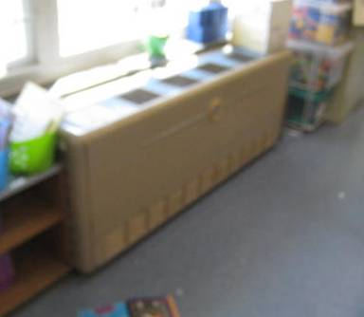

1950s vintage univent

Picture 2

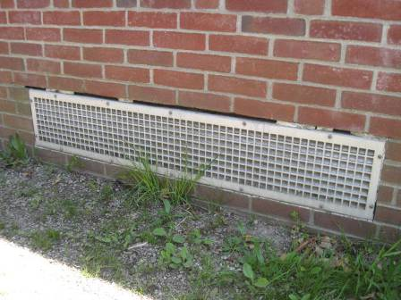

Univent fresh air intake

Picture 3

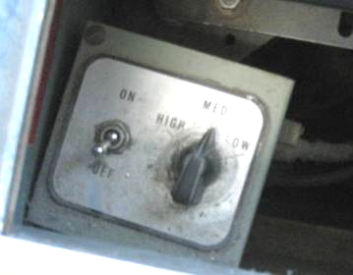

Univent controls, note unit is deactivated/switched “off”

Picture 4

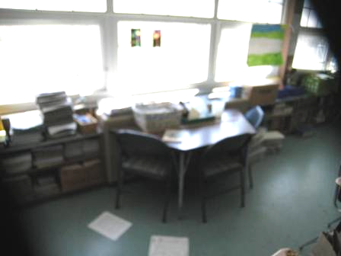

Items on and in front of classroom univent

Picture 5

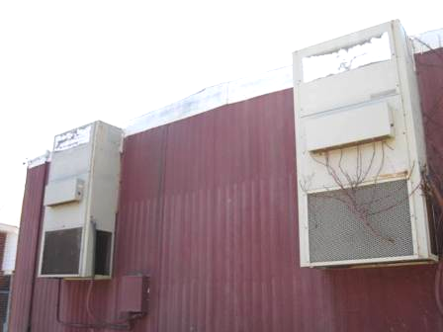

AHUs for modular classroom, note plant growth on right unit

Picture 6

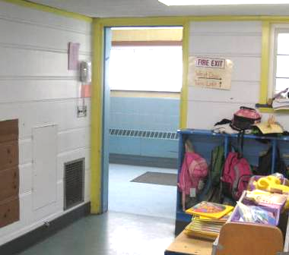

Proximity of wall-mounted exhaust vent to open classroom door (arrows)

Picture 7

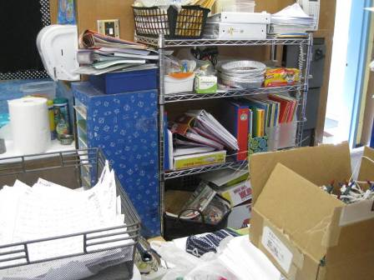

Classroom items obstructing wall-mounted exhaust vent (arrow)

Picture 8

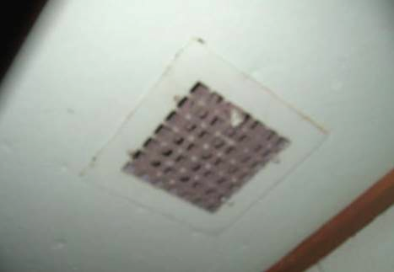

Coat closet exhaust vent, note accumulated dust and debris on grill

Picture 9

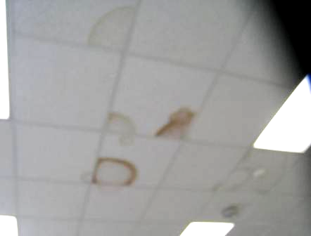

Water-damaged ceiling tiles in main building

Picture 10

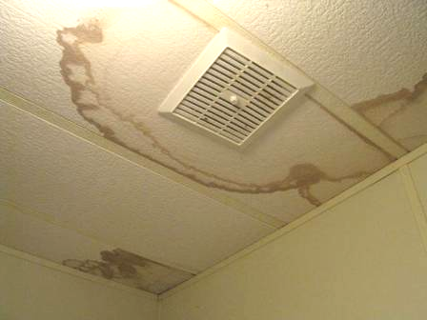

Water-damaged ceiling tiles in portable classroom B

Picture 11

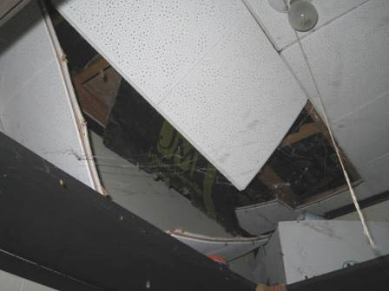

Failing/water-damaged closet ceiling in portable classroom A

Picture 12

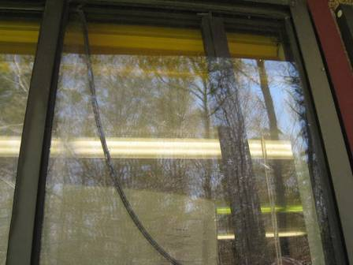

Failing window strip caulking in portable classroom B

Picture 13



Water-damaged building material in classroom 13

Picture 14

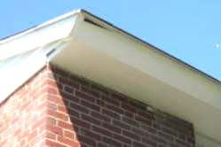

Breach in exterior fascia (arrow) outside of classroom 13

Picture 15

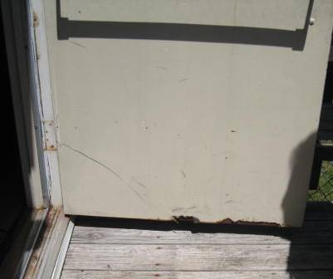

Corroded/damaged metal exterior door

Picture 16

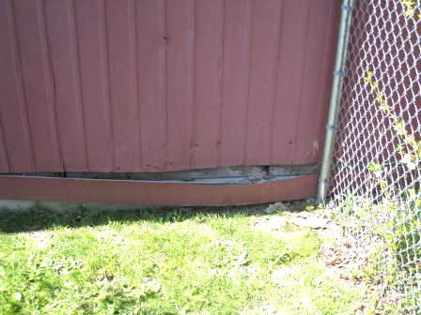

Damaged siding exposing insulation of portable classroom

Picture 17

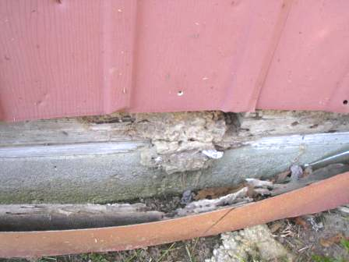

Damaged siding exposing insulation of portable classroom

Picture 18

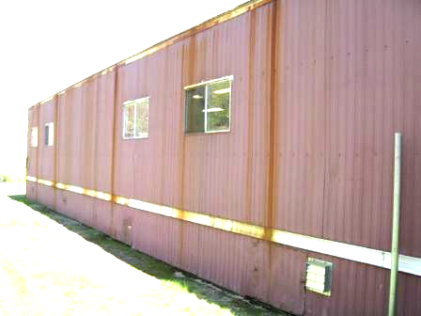

Rusted/corroded siding (as indicated by dark vertical staining)

Picture 19

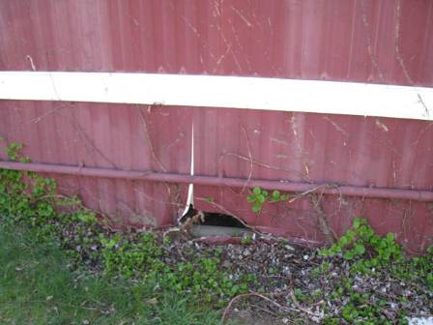

Missing/damaged siding to portable classroom

Picture 20

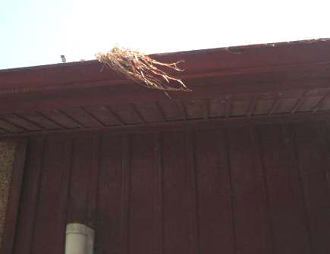

Gutter to portable classroom clogged with debris

Picture 21

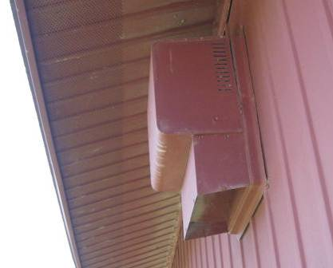

Abandoned exhaust vent on exterior of portable classroom B

Picture 22

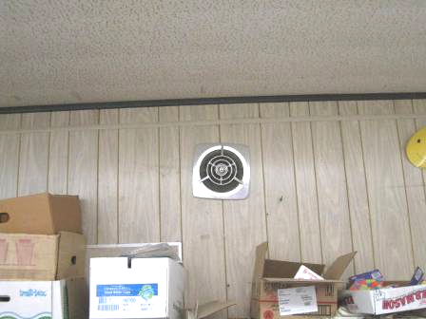

Interior view of abandoned exhaust vent in preceding picture
Location | Carbon  Dioxide  (*ppm) | Carbon Monoxide  (ppm) | Temp  (°F) | Relative  Humidity  (%) | PM2.5  (ug/m³) |  | Occupants  in Room | Windows  Openable | Ventilation |  |  | Remarks
 |  |  |  |  |  |  |  |  | Intake | Exhaust |  | Remarks
Background | 425 | ND | 75 | 26 | 3 |  |  |  |  |  |  | Sunny, warm, clear skies
1 | 1312 | ND | 70 | 42 | 8 |  | 0 | Y | Y |  | Y | UV off, exhaust off, DO, occupants gone~40 mins, exhaust near door
2 | 1133 | ND | 72 | 43 | 7 |  | 23 | Y | Y |  | Y | Exhaust obstructed, restroom exhaust off, aquarium, 1 WD CT
3 | 1549 | ND | 71 | 43 | 10 |  | 21 | Y | Y |  | Y | UV off/obstructed, exhaust off/obstructed, DO, restroom exhaust off
4 | 1369 | ND | 72 | 42 | 15 |  | 18 | Y | Y |  | Y | UV off, DO
5 | 1003 | ND | 71 | 39 | 8 |  | 21 | Y | Y |  | Y | Exhaust obstructed, DO
6 | 645 | ND | 73 | 34 | 5 |  | 20 | Y | Y |  | Y | Window open, exhaust partially obstructed, DO
7 | 720 | ND | 72 | 33 | 6 |  | 19 | Y | Y |  | Y | DO, CP sink, exhaust off
8 | 900 | ND | 73 | 39 | 6 |  | 18 | Y | Y |  | Y | UV off, exhaust partially obstructed, PF-dusty, CP sink
9 | 909 | ND | 74 | 37 | 8 |  | 21 | Y | Y |  | Y | UV-obstructed (front), 3 WD CT, missing fluorescent light covers
10 | 743 | ND | 74 | 33 | 7 |  | 20 | Y | Y |  | Y | Plants, 18 occupants gone several minutes, missing florescent light covers
11 | 802 | ND | 73 | 36 | 8 |  | 20 | Y | Y |  | Y | Buzzing noise from UV, DO
12 | 978 | ND | 76 | 32 | 7 |  | 18 | Y | Y |  | Y | Exhaust obstructed, CP sink, DO
13 | 767 | ND | 73 | 37 | 6 |  | 21 | Y | Y |  | Y | WD walls corner/front-breach on outside of roof fascia, 8 WD CT, DO, missing florescent light covers
Gym | 589 | ND | 75 | 39 | 10 |  | 0 | Y | Y |  | Y | 2 UV off
Mrs. Lee | 532 | ND | 74 | 38 | 6 |  | 0 | Y | N |  | N | DO, wall-to-wall carpeting
School Psychologist’s Office/Conference Room | 560 | ND | 74 | 39 | 8 |  | 0 | Y | N |  | N | Wall-to-wall carpeting
Library (stage/cafe) | 639 | ND | 74 | 40 | 13 |  | 10 | Y | Y  off |  | Y  off
Girls’ Restroom |  |  |  |  |  |  |  | Y | N |  | Y | 1 WD CT, exhaust off
Boy’s Restroom |  |  |  |  |  |  |  | Y | N |  | Y | Exhaust off
Faculty Lunchroom | 590 | ND | 73 | 33 | 5 | 1 |  | Y | N |  | Y | 2 WD CT
Teacher’s Workroom | 592 | ND | 73 | 33 | 6 | 1 |  | Y | N |  | Y | Window open, laminator, PC, 1 WD CT
Teacher’s Women’s Restroom |  |  |  |  |  |  |  | N | N |  | Y | Periodic leaks reported, 1 WD CT
Girl’s Restroom |  |  |  |  |  |  |  | Y | N |  | Y | Exhaust off
Boy’s Restroom |  |  |  |  |  |  |  | Y | N |  | Y | Exhaust off
Portable A | 1076 | ND | 72 | 36 | 8 |  | 19 | Y | Y |  | Y | Exposed insulation/failing siding, missing downspouts gutter clogged with plant debris, bird nesting material in local exhaust vent, thermostat fan on “auto”, ceiling in closet failing-water damage, 9 WD CT
Portable B | 734 | ND | 75 | 32 | 4 |  | 3 | Y | Y |  | Y | Aluminum sided, thermostat fan on “auto”, exterior door damage, carpet old/worn/soiled, moisture penetration issues reported through windows, store room 5 WD CT
Health Office | 856 | ND | 73 | 38 | 13 |  | 2 | Y | N |  | N | WD CT
Reading | 1050 | ND | 73 | 39 | 10 |  | 6 | Y | N |  | N
Cafeteria | 924 | ND | 74 | 38 | 12 |  | ~150 | Y | Y |  | Y | Mechanical ventilation off

The service life is the median time during which a particular system or component of …[an HVAC]… system remains in its original service application and then is replaced. Replacement may occur for any reason, including, but not limited to, failure, general obsolescence, reduced reliability, excessive maintenance cost, and changed system requirements due to such influences as building characteristics or energy prices (ASHRAE, 1991).

