INDOOR AIR QUALITY ASSESSMENT

West Memorial Elementary School
15 Bow Street
Peabody, Massachusetts

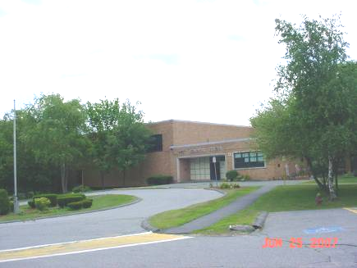

Prepared by:
Massachusetts Department of Public Health
Bureau of Environmental Health
Indoor Air Quality Program
September 2007

Background/Introduction
At the request of Sharon Cameron, Director of Health and Human Services for the City of Peabody, and Susan Cassidy, Principal, the Massachusetts Department of Public Health (MDPH), Bureau of Environmental Health (BEH) provided assistance and consultation regarding indoor air quality concerns at the West Elementary School (WES), 15 Bow Street, Peabody, Massachusetts. Specific concerns regarding musty odors and potential mold growth in the Principal’s office and administrative area prompted the assessment.
On June 25, 2007, a visit to conduct an indoor air quality assessment was made to this building by Cory Holmes, an Environmental Analyst in BEH’s Indoor Air Quality (IAQ) Program. Mr. Holmes was accompanied by Nick Catone, Director of Maintenance, Peabody Public Schools (PPS), Ms. Cassidy and Ms. Cameron during the assessment. Although the assessment focused on the Principal’s office and administrative area, BEH staff also examined the kitchen, cafeteria, gym, classroom 4 and resource room 22-B, at the request of PPS staff.

Methods
BEH staff performed a visual inspection of building materials for water damage and/or microbial growth. Air tests for carbon dioxide, temperature and relative humidity were conducted with the TSI, Q-TRAK™ IAQ Monitor, Model 8551.

Results
This WES houses approximately 250 pre-kindergarten through 5th grade students with a staff of approximately 50 staff. The school was on summer break therefore classrooms were not occupied at the time of the assessment. Test results are listed in Table 1.

Discussion
Ventilation
It can be seen from Table 1 that the carbon dioxide levels were below 800 parts per million (ppm) in all areas surveyed during the assessment, which typically indicates adequate air exchange. As mentioned previously however, the school was observing summer break; therefore, the building was sparsely populated at the time of the assessment. Low occupancy can greatly reduce carbon dioxide levels.
Neither the Principal’s office nor administrative area is equipped with mechanical ventilation. Instead, these areas rely on openable windows for the introduction of fresh air. Portable air-conditioning (AC) units provide cooling during summer months.
Fresh air to classrooms is supplied by unit ventilators (univents) (Figure 1). A univent is designed to draw air from outdoors through a fresh air intake located on the exterior wall of the building (Picture 1). Return air is drawn through an air intake located at the base of each unit. Fresh and return air are mixed, filtered, heated and provided to classrooms through an air diffuser located in the top of the unit. The mechanical exhaust ventilation system in classrooms consists of wall-mounted vents ducted to rooftop motors.
Ventilation in the gymnasium and cafeteria is provided by ceiling-mounted air handling units (AHUs). The AHU in the cafeteria (Picture 2) was not operable at the time of the assessment. Mr. Catone reported that parts were on order to repair this unit. The cafeteria also has openable windows (Picture 3). A local exhaust fan is located opposite the windows (Picture 4). BEH staff suggested that, if the AHU is not repaired prior to the start of the school year, local exhaust fan should be used in combination with openable windows to provide cross ventilation/air exchange.
To maximize air exchange, the MDPH recommends that both supply and exhaust ventilation operate continuously during periods of school occupancy. In order to have proper ventilation with a univent and exhaust system, the systems must be balanced to provide an adequate amount of fresh air to the interior of a room while removing stale air from the room. It is recommended that HVAC systems be re-balanced every five years to ensure adequate air systems function (SMACNA, 1994). The date of the last balancing of these systems was not available at the time of the assessment.
The Massachusetts Building Code requires that each room have a minimum ventilation rate of 15 cubic feet per minute (cfm) per occupant of fresh outside air or openable windows (BOCA, 1993; SBBRS, 1997). The ventilation must be on at all times that the room is occupied. Providing adequate fresh air ventilation with open windows and maintaining the temperature in the comfort range during the cold weather season is impractical. Mechanical ventilation is usually required to provide adequate fresh air ventilation.
Carbon dioxide is not a problem in and of itself. It is used as an indicator of the adequacy of the fresh air ventilation. As carbon dioxide levels rise, it indicates that the ventilating system is malfunctioning or the design occupancy of the room is being exceeded. When this happens a buildup of common indoor air pollutants can occur, leading to discomfort or health complaints. The Occupational Safety and Health Administration (OSHA) standard for carbon dioxide is 5,000 parts per million parts of air (ppm). Workers may be exposed to this level for 40 hours/week based on a time-weighted average (OSHA, 1997).
The MDPH uses a guideline of 800 ppm for publicly occupied buildings. A guideline of 600 ppm or less is preferred in schools due to the fact that the majority of occupants are young and considered to be a more sensitive population in the evaluation of environmental health status. Inadequate ventilation and/or elevated temperatures are major causes of complaints such as respiratory, eye, nose and throat irritation, lethargy and headaches. For more information concerning carbon dioxide, please see Appendix A.
Temperature readings during the assessment ranged from 74º F to 78 º F, which were within the MDPH comfort guidelines. The MDPH recommends that indoor air temperatures be maintained in a range between 70 º F to 78 º F in order to provide for the comfort of building occupants. In many cases concerning indoor air quality, fluctuations of temperature in occupied spaces are typically experienced, even in a building with an adequate fresh air supply.
Relative humidity measurements in the areas surveyed during the assessment ranged from 51 to 56 percent, which were within the MDPH recommended comfort range. The MDPH recommends that indoor air relative humidity is comfortable in a range of 40 to 60 percent. While temperature is mainly a comfort issue, relative humidity in excess of 70 percent for extended periods of time can provide an environment for mold and fungal growth (ASHRAE, 1989). During periods of high relative humidity (late spring/summer months), windows and exterior doors should be closed to keep moisture out. Relative humidity levels in the building would be expected to drop during the winter months due to heating. The sensation of dryness and irritation is common in a low relative humidity environment. Low relative humidity is a very common problem during the heating season in the northeast part of the United States.

Odors/Microbial/Moisture Concerns
As discussed, the assessment was prompted by musty odors and concerns of potential mold growth in the Principal’s office and administrative area. Ms. Cassidy reported that prior to the MDPH assessment, the PPS maintenance team initiated several measures to identify and eliminate potential sources of moisture and odors, including:
- Removal of an old area carpet;
- Repointing of exterior brick directly outside the Principal’s office; and
- Removal and replacement of water-damaged ceiling tiles.
At the time of the assessment, Ms. Cassidy reported that no further odors had been detected since these measures were taken. BEH staff examined the room and its building components; no visible mold growth or associated odors were observed/detected.
Occupants in the administrative area attributed musty odors to a previous leak that occurred in the storage closet. BEH staff examined the closet and materials contained therein and removed ceiling tiles to observe the ceiling plenum. No current water damage or visible mold growth was observed.
Odors were also reported in the corner of the administrative office near the communications console. BEH observed accumulated dust and cobwebs in this area, as well as an open utility hole in the ceiling above this area (Pictures 5 and 6). Open utility holes can serve as pathways for odors, drafts and particulates to migrate into occupied areas.
The WES reportedly experiences chronic leaking in the main hallway, possibly around the chimney, that the PPS is actively investigating. Water-damaged ceiling tiles resulting from this leak were observed in resource room 22-B (Picture 7). Water-damaged ceiling tiles can provide a source of mold and should be replaced after a leak is discovered and repaired. BEH staff removed damaged ceiling tiles to observe conditions in the ceiling plenum and noticed a dark staining on the surface of ceiling plaster that may be mold growth (Picture 8).
Although some areas of exterior brickwork outside of the Principal’s office were reportedly re-pointed, mortar around brick in other areas was observed to be missing/damaged (Pictures 9 to 13). These conditions can undermine the integrity of the building envelope and provide a means of water entry by capillary action into the building through exterior walls, foundation concrete and masonry (Lstiburek & Brennan, 2001).
The US Environmental Protection Agency (US EPA) and the American Conference of Governmental Industrial Hygienists (ACGIH) recommends that porous materials be dried with fans and heating within 24 to 48 hours of becoming wet (US EPA, 2001; ACGIH, 1989). If porous materials are not dried within this time frame, mold growth may occur. Water-damaged porous materials cannot be adequately cleaned to remove mold growth. The application of a mildewcide to moldy porous materials is not recommended.
Another source of moisture impinging on the building are trees/branches in close proximity or hanging over the roof of the building (Pictures 14 and 15). Leaves and debris from branches can clog roof drains and accumulate on the roof. Clogged drains, accumulated leaves and debris can hold water on the roof where repeated freezing and thawing during winter months can damage the roof membrane and lead to water penetration.

Other IAQ Evaluations
Window-mounted air conditioners are normally equipped with filters, which should be cleaned or changed as per manufacturer’s instructions to prevent accumulation and re-aerosolization of dirt, dust and particulate matter. BEH staff examined air conditioning units and observed the filter in the administrative office to be occluded with dust and debris (Picture 16).

Conclusions/Recommendations

At the time of the assessment, it appeared that remedial actions taken by the PPS prior to the BEH visit were successful in eliminating musty odors in the Principal’s office. No evidence of visible mold growth was observed in the Principal’s office or administrative area. However, active and suspected roof leaks (i.e., around the chimney area) can provide sources of moisture that may lead to mold growth on porous building materials.
In view of the findings at the time of the visit, the following recommendations are made:
- Continue to investigate and repair roof leaks. Once leaks are repaired, replace any remaining water-damaged ceiling tiles. Examine the areas above and behind these areas for mold growth. Disinfect areas of water leaks with an appropriate antimicrobial.
- Remove dark-stained section of ceiling plaster in resource room 22-B.
- Continue with plans to repair AHU in cafeteria. If not repaired prior to the school year, use openable windows in conjunction with local exhaust fan to provide cross ventilation/air exchange.
- Consider balancing mechanical ventilation systems every 5 years, as recommended by ventilation industrial standards (SMACNA, 1994).
- Remove and inspect all items in administrative area storage closet, discard if water-damaged or odorous. Clean, disinfect and dry all surfaces prior to re-storage.
- Seal utility hole in ceiling of administrative area.
- Clean and disinfect corner of administrative area around communications console.
- Trim tree branches to prevent any from overhanging above the roof. Inspect and clear debris from roof drains regularly.
- Repair breaches in the building envelope including, cracks in walls, missing/damaged mortar around exterior brick and open utility holes.
- For buildings in New England, periods of low relative humidity during the winter are often unavoidable. Therefore, scrupulous cleaning practices should be adopted to minimize common indoor air contaminants whose irritant effects can be enhanced when the relative humidity is low. To control for dusts, a high efficiency particulate arrestance (HEPA) filter equipped vacuum cleaner in conjunction with wet wiping of all surfaces is recommended. Avoid the use of feather dusters. Drinking water during the day can help ease some symptoms associated with a dry environment (throat and sinus irritations).
- Clean/change filters for portable air conditioners as per the manufacturer’s instructions or more frequently if needed.
- Refer to “Mold Remediation in Schools and Commercial Buildings” published by the US EPA (US EPA, 2001) for further information on mold and/or mold remediation. This document is available at: http://www.epa.gov/iaq/molds/mold_remediation.html.
- Consider adopting the US EPA (2000) document, “Tools for Schools”, to maintain a good indoor air quality environment on the building. This document can be downloaded from the Internet at: http://www.epa.gov/iaq/schools/index.html.
- Refer to resource manuals and other related indoor air quality documents for further building-wide evaluations and advice on maintaining public buildings. These materials are located on the MDPH’s website: http://mass.gov/dph/indoor_air.
References
ACGIH. 1989. Guidelines for the Assessment of Bioaerosols in the Indoor Environment. American Conference of Governmental Industrial Hygienists, Cincinnati, OH.
ASHRAE. 1989. Ventilation for Acceptable Indoor Air Quality. American Society of Heating, Refrigeration and Air Conditioning Engineers. ANSI/ASHRAE 62-1989
BOCA. 1993. The BOCA National Mechanical Code/1993. 8th ed. Building Officials & Code Administrators International, Inc., Country Club Hills, IL.
Lstiburek, J. & Brennan, T. 2001. Read This Before You Design, Build or Renovate. Building Science Corporation, Westford, MA. U.S. Department of Housing and Urban Development, Region I, Boston, MA
OSHA. 1997. Limits for Air Contaminants. Occupational Safety and Health Administration. Code of Federal Regulations. 29 C.F.R 1910.1000 Table Z-1-A.
SBBRS. 1997. Mechanical Ventilation. State Board of Building Regulations and Standards. Code of Massachusetts Regulations. 780 CMR 1209.0
SMACNA. 1994. HVAC Systems Commissioning Manual. 1st ed. Sheet Metal and Air Conditioning Contractors’ National Association, Inc., Chantilly, VA.
US EPA. 2000. Tools for Schools. Office of Air and Radiation, Office of Radiation and Indoor Air, Indoor Environments Division (6609J). EPA 402-K-95-001, Second Edition. http://www.epa.gov/iaq/schools/tools4s2.html
US EPA. 2001. “Mold Remediation in Schools and Commercial Buildings”. Office of Air and Radiation, Indoor Environments Division, Washington, DC. EPA 402-K-01-001. March 2001. Available at: http://www.epa.gov/iaq/molds/mold_remediation.html

Picture 1

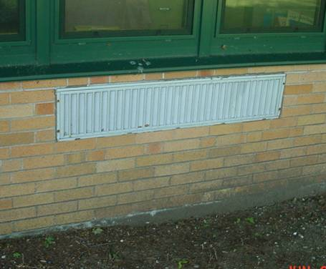

Univent Fresh Air Intake

Picture 2

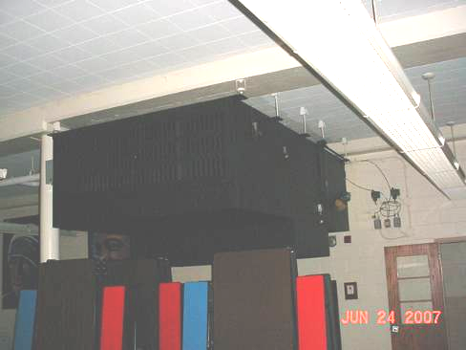

Ceiling-Mounted AHU in Cafeteria
Picture 3

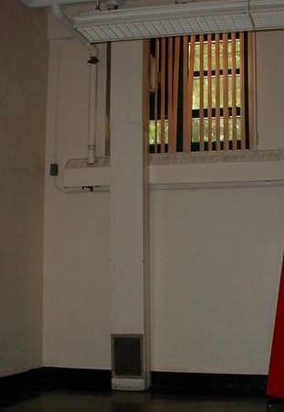

Local Exhaust Fan and Ducted Vent

Picture 4

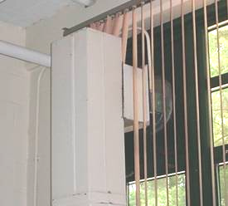

Close-Up of Local Exhaust Fan
Picture 5

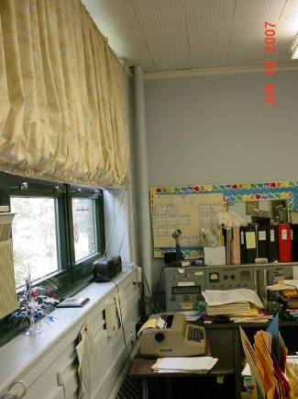

Corner of Administrative Office Where Communications Console is Located,
Arrow Indicates Open Utility Hole

Picture 6

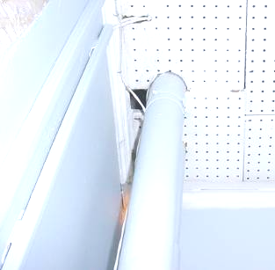

Close-Up of Open Utility Hole above Communications Console in Administrative Office
Picture 7

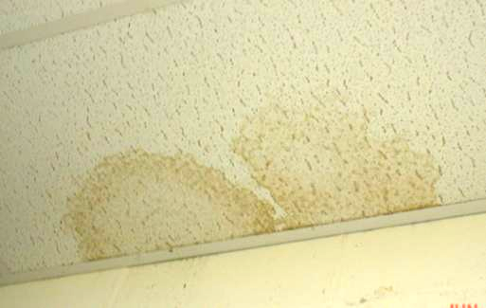

Water Damaged Ceiling Tiles in Resource Room 22-B

Picture 8

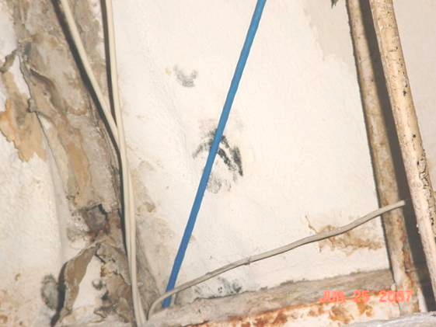

Water Damaged Ceiling Plaster above Ceiling Tile System in Resource Room 22-B, Dark Staining in Center (Arrow) Indicates Possible Mold Growth
Picture 9

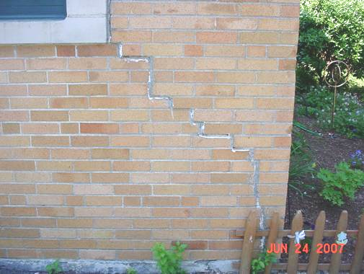

Crack/Damage to Exterior Brick

Picture 10

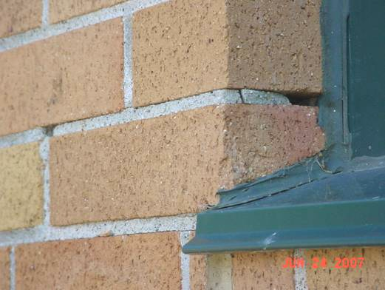

Missing/Damaged Mortar around Brick
Picture 11

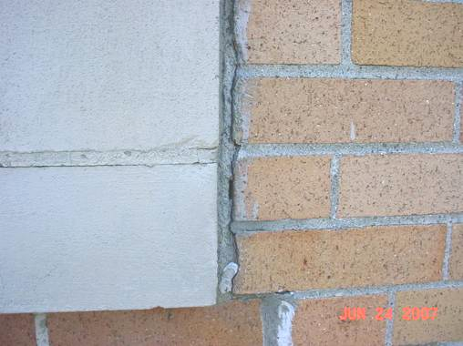

Spaces between Building Materials on Exterior of Building

Picture 12

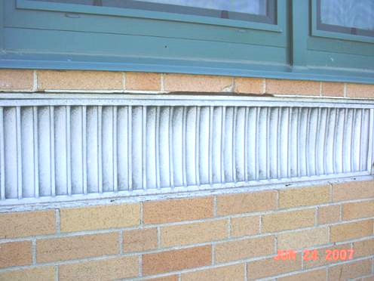

Spaces, Missing/Damaged Sealant around Univent Air Intake
Picture 13

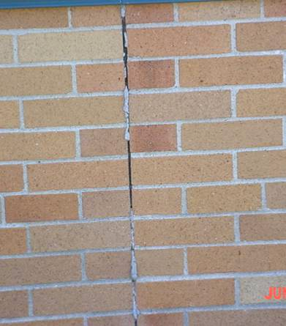

Missing/Damaged Mortar around Brick

Picture 14



Branches Overhanging Roof
Picture 15

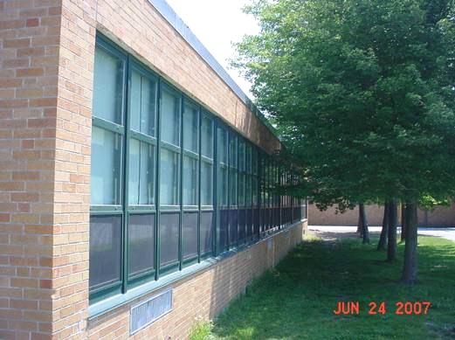

Branches in Close Proximity and over Roof

Picture 16

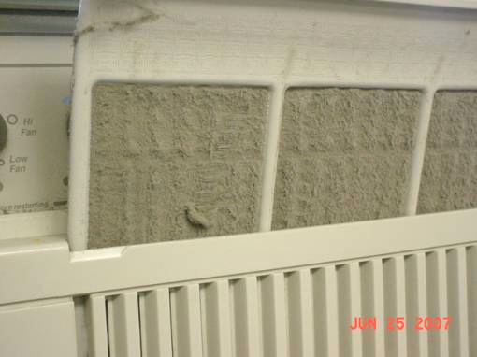

AC Air Filter Clogged With Dust and Debris
Location | Carbon  Dioxide  (ppm) | Temp  (°F) | Relative  Humidity  (%) | Occupants  in Room | Windows  Openable | Ventilation |  | Remarks
 |  |  |  |  |  | Supply | Exhaust | Remarks
Outside  (Background) | 312 | 86 | 52 |  |  |  |  | Clear, sunny, hot
Principal’s Office | 729 | 76 | 55 | 4 | Y | N | N | Ceiling tiles replaced, area rug replaced, brick re-pointed, portable AC unit, no active leaks, visible mold growth or associated odors
Gym | 354 | 77 | 54 | 0 | N | Y | Y | No active leaks, ceiling sealed/painted, no active leaks, visible mold growth or associated odors
Cafeteria | 355 | 74 | 56 | 0 | Y | Y | Y | AHU-not operable, parts reportedly on order, local exhaust fan-operable
Kitchen | 440 | 76 | 52 | 0 | Y | N | Y | Local exhaust hood
Room 4 | 383 | 78 | 52 | 0 | N | Y | Y
Administrative Office | 416 | 77 | 51 | 1 | Y | N | N | Clogged AC filter, open utility hole-corner, dirt/dust accumulation corner near communications console, odors reported from storage closet
Resource Room 22-B |  |  |  |  |  |  |  | Active leak, water damaged ceiling tiles, dark staining on ceiling plaster-possible mold growth

