**WATER DAMAGE ASSESSMENT**

**West Newbury Town Hall**

**Treasurer’s Office**

**381 Main Street**

**West Newbury, MA**

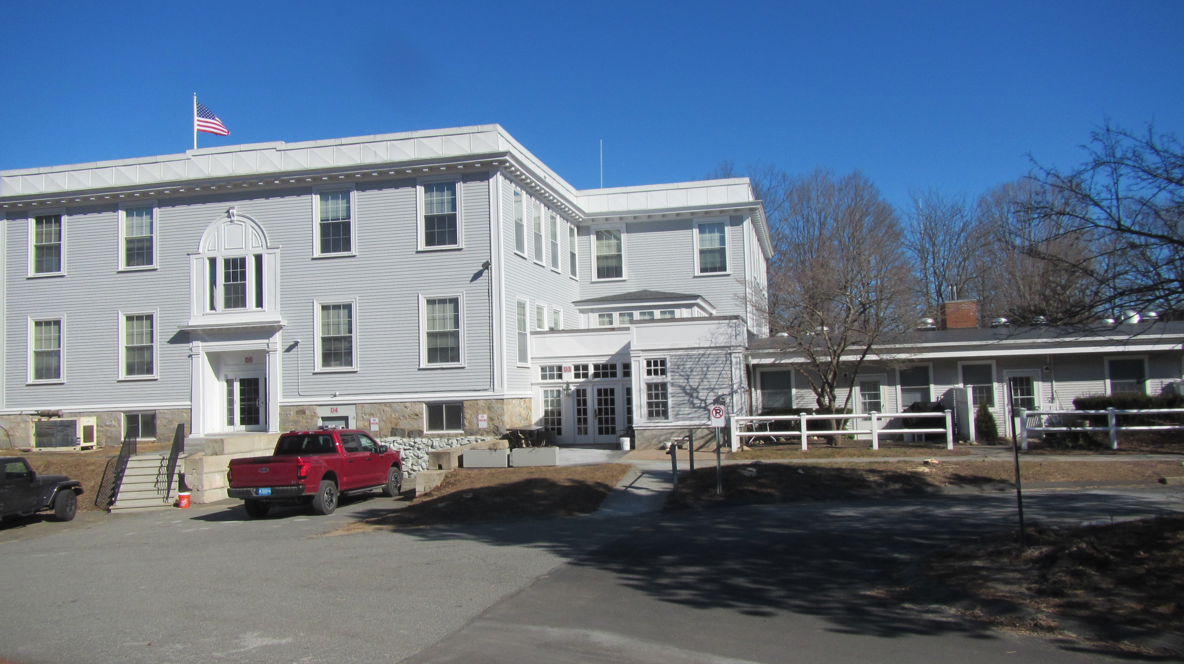

Prepared by:

Massachusetts Department of Public Health

Bureau of Climate and Environmental Health

Indoor Air Quality Program

April 2024

# BACKGROUND

|  |  |
| --- | --- |
| Building: | West Newbury Town Hall (WNTH) |
| Address: | 381 Main Street, West Newbury, MA |
| Requestor: | Brian Richard, Building and Grounds, Town of West Newbury |
| Reason for Request: | Water damage concerns to Treasurer’s Office |
| Date of Assessment: | February 15, 2024 |
| Massachusetts Hall of Public Health/Bureau of Climate and Environmental Health (MDPH/BCEH) Staff Conducting Assessment: | Michael Feeney, Director, IAQ  Program |
| Building Description: | The WNTH was constructed as a two-story school in 1857. A wing was added to the rear of the building in the late 1960s. The Treasurer’s Office is located on the first floor below the flat roof where the addition is attached to the original building |
| Building Population: | Approximately 10 employees |
| Year of Construction: | 1800s |
| Windows: | Openable |

# EXECUTIVE SUMMARY

The Treasurer’s Office exterior wall has experienced odors that may be attributed to one or more factors: Water damage from water penetration along a wall roof seams where the 1960s addition was attached to the original building (Picture 1) or water damage from high relative humidity accumulation during summer months when the WNTH HVAC system is operating in chilling mode. It is also possible both are contributing to the reported odor. The Treasurer’s Office has an exterior wall that is adjacent to where an addition was joined to the original building. Beneath the junction are school-style bulletin boards which appear to be covered with a burlap material, which may be the source of the reported odors when moistened. Removal of these bulletin boards to expose the underlying plaster walls and conducting a thorough cleaning will likely remove the odors.

While removing the bulletin board material may remove the reported odor, the water sources causing water damage should be addressed. Remediation actions may include:

1. Repairing all flashing and sealants where the addition joins the original building.
2. Reducing the amount of water lingering on the flat roof by installing gutters and downspouts along the roof edge of the original building and the skylight structure in the original building, and/or
3. Installing a means to exhaust air from the Treasurer’s Office by the existing HVAC system.

# METHODS

Please refer to the IAQ Manual for methods, sampling procedures, and interpretation of results (MDPH, 2015).

# RESULTS AND DISCUSSION

## Odor Assessment

## As reported by WNTH staff, an odor has been periodically present in the Treasurer’s Office. The Treasurer’s Office is a large room that was originally constructed as a school classroom. It still has slate chalkboards and bulletin boards covered in a burlap-like material (Pictures 2 and 3).

## In the experience of IAQ staff, placement of chalk and bulletin boards on exterior walls is unusual. Typically chalk and bulletin boards would be installed on interior walls separating classrooms or interior hallway walls. A practical reason for placement on interior walls would be to maximize window space to increase natural light in a classroom. In addition, water infiltration through exterior walls would not be hidden behind permanently affixed chalk and bulletin boards. If a water leak were to occur behind chalk and bulletin boards, such water penetration can accumulate and damage walls, floors and supported beams before it is discovered.

The location of the bulletin boards in the Treasurer’s Office may be significant due to the report of chronic water penetration that has occurred where the 1960s addition joins the original building. Due to the recent increase of rainstorm volume and frequency in New England, water leaks in this location are likely more frequent. Massachusetts has experienced extended periods of high relative humidity as well as increased frequency of high volume/wind driven rainstorms over the past decade. As an example, July of 2021 was the wettest ever recorded in Massachusetts, and the three-month period from June through August 2021 (meteorological summer), was the fourth wettest on record, according to the National Oceanic and Atmospheric Administration’s Centers for Environmental Information. The three-month period also was the third warmest ever in the state and was tied for the warmest on record across the United States. (ML, 2021, NOAA, 2021). Conditions in the summer of 2023 were also warm and wet. These conditions are challenging for buildings, particularly those without air conditioning or partial components of an HVAC system.

The following are several possible conditions resulting in rainwater accumulating on the skylight or flat roof that may moisten walls and bulletin board material:

1. The configuration of the original building creates a concave corner facing south/southwest (Picture 4). As originally constructed, rain would fall to the ground and drain away from the building. In its current configuration, all south/southwest wind driven rain drains into and is possibly forced into the concave corner on the skylight flat roof.
2. The new wing skylight is constructed in a doghouse-shape, with a peaked roof and windows in its side walls (Picture 5). The peaked roof of the skylight does not contain gutters/downspouts to drain water from the flat roof.
3. If rain falls on the peaked skylight with significant volume and velocity, it is likely the clapboards and window frames of the original building are directly soaked and may result in water penetration into the interior.
4. Of note is the short distance between the skylight and exterior wall of the original building, (estimated to be ~3 feet) (Picture 5). Rain during a south/southwest storm with high winds may not readily drain, resulting in contact with the window of the Treasurer’s Office above the bulletin board. Such regular water exposure may result in water leaks through the window system in a manner seen in other windows in the WNTH (Picture 6).

The WNTH is equipped with a ducted air-conditioning system that provides chilled air during hot, humid weather. A typical air-conditioning system will have an air handling unit that is connected to a vent in each room (supply vent). Each room usually has a second vent that is connected by a duct back to the air handler (return vent). IAQ noted that the Treasurer’s Office has a supply vent but does not have a return vent. Without a return vent, pollutants (such as humid air) can build up to increase humidity and moisten materials capable of absorbing water, such as bulletin board materials, cardboard, paper, and other materials. According to the American Society of Heating, Refrigerating and Air-conditioning Engineers (ASHRAE), if relative humidity exceeds 70% for long enough, building materials may absorb moisture growth may occur even in the absence of liquid water (ASHRAE, 2019). Wet building materials, such as the bulletin board material, may be the source of the odor.

# CONCLUSIONS/RECOMMENDATIONS

The Treasurer’s Office of the WNTH has a number of issues that are likely related to water drainage, including those related to moisture in the building. While the configuration of the skylight on the flat roof may have been appropriate when New England experienced less frequent rainstorms with lower water volumes, the design of this location likely leads to extended water exposure to the original building’s exterior wall, windows, building seams, the flat roof and associated components. Extended water exposure may lead to leaks and moistening of building materials. In addition to these conditions, the management of the hot, humid weather with a mechanical HVAC system retrofitted into a building like WNTH can be challenging.

The following recommendations are separated into odor **short-term** recommendations, and **long-term** recommendations that may require planning and capital funds to achieve:

## Short-Term Recommendations

### Odor Issues

1. Remove the bulletin board from the exterior wall of the Treasurer’s Office in a manner consistent with using practices outlined in the US EPA Mold Remediation in Schools and Commercial Buildings <http://www.epa.gov/mold/mold-remediation-schools-and-commercial-buildings-guide>.
2. Examine building materials around windows above the exterior wall bulletin board for water damage and mold growth. If found, remove in a manner consistent with US EPA mold remediation guidelines. Clean or repair the plaster wall as needed.
3. It is not recommended to use gypsum wallboard to repair any wall damage behind the bulletin board. Use cement board that is not prone to mold growth.
4. Examine the wall materials above the bulletin board for water damage, particularly around the windows and replace any that are water-damaged; consider replacing them with cement board that is not prone to supporting mold growth.
5. Examine the junction between the original building’s exterior wall and addition’s flat roof. Repair in a manner to eliminate/reduce water damage.
6. Examine all flashing and other sealants in the flat roof/original wall junction for damage and repair as needed to make the seam waterproof.
7. The following documents can provide guidance that can be used to reduce the impact of hot, humid weather in any building:
   1. Preventing mold growth in Massachusetts schools during hot, humid weather: [Preventing mold growth in Massachusetts schools during hot, humid weather | Mass.gov](https://www.mass.gov/info-details/preventing-mold-growth-in-massachusetts-schools-during-hot-humid-weather)
   2. Remediation and prevention of mold growth and water damage in public schools and buildings to maintain air quality: [Remediation and prevention of mold growth and water damage in public schools and buildings to maintain air quality | Mass.gov](https://www.mass.gov/info-details/remediation-and-prevention-of-mold-growth-and-water-damage-in-public-schools-and-buildings-to-maintain-air-quality)
   3. Methods for increasing comfort in non-air-conditioned schools: <https://www.mass.gov/doc/methods-for-increasing-comfort-in-non-airconditioned-schools/download>
8. The IAQ Program offers to conduct a full IAQ Assessment of WNTH during the summer months when the weather is hot and humid to provide additional guidance.

### Other Short-term Recommendations

1. Refer to resource manual and other related IAQ documents located on the MDPH’s website for further building-wide evaluations and advice on maintaining public buildings. These documents are available at: <http://mass.gov/dph/iaq>.

## Long-Term Recommendations

1. Consider installing a gutter/downspout system of sufficient capacity on the skylight roof edge to drain from the flat roof.
2. Consider installing a roof drain of sufficient capacity to rapidly drain the flat roof to prevent water exposure to the original building’s exterior wall.
3. Consider installing a return vent for the Treasurer’s Office that is connected to the existing WNTH air handling unit, if feasible.

# REFERENCES

ASHRAE. 1991. ASHRAE Applications Handbook, Chapter 33 “Owning and Operating Costs”. American Society of Heating, Refrigeration and Air Conditioning Engineers, Atlanta, GA.

ASHRAE, 2019. American Society of Heating, Refrigeration and Air Conditioning Engineers (ASHRAE) Ventilation for Acceptable Indoor Air Quality. ANSI/ASHRAE Standard 62.1-2019. Atlanta, GA.

MDPH. 2015. Massachusetts Department of Public Health. “Indoor Air Quality Manual: Chapters I-III”. Available at: <https://www.mass.gov/lists/indoor-air-quality-manual-and-appendices>.

ML. Extensive mold forces South Hadley High School to remain closed. 2021. Masslive. September 5, 2021. <https://www.masslive.com/news/2021/09/extensive-mold-forces-south-hadley-high-school-to-remain-closed.html>

NOAA. 2021. Summer 2021 neck and neck with Dust Bowl summer for hottest on record. National Oceanic and Atmospheric Administration, 1401 Constitution Avenue NW, Room 5128, Washington, DC 20230 <https://www.noaa.gov/news/summer-2021-neck-and-neck-with-dust-bowl-summer-for-hottest-on-record>

US EPA. 2008. “Mold Remediation in Schools and Commercial Buildings”. Office of Air and Radiation, Indoor Environments Division, Washington, DC. EPA 402-K-01-001. September 2008. Available at: [Mold Remediation in Schools and Commercial Buildings Guide: Chapter 1 | US EPA](https://www.epa.gov/mold/mold-remediation-schools-and-commercial-buildings-guide-chapter-1)

**Picture 1**

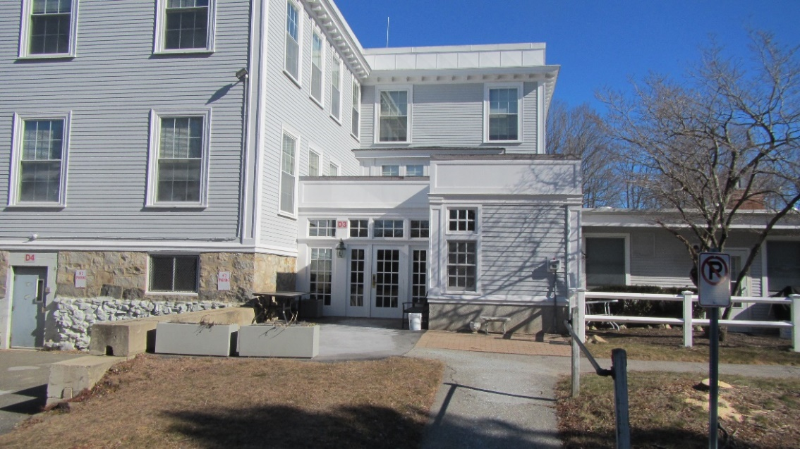

**Junction where addition joins the rear to the original building**

**Note windows above roof (arrow)**

**Picture 2**

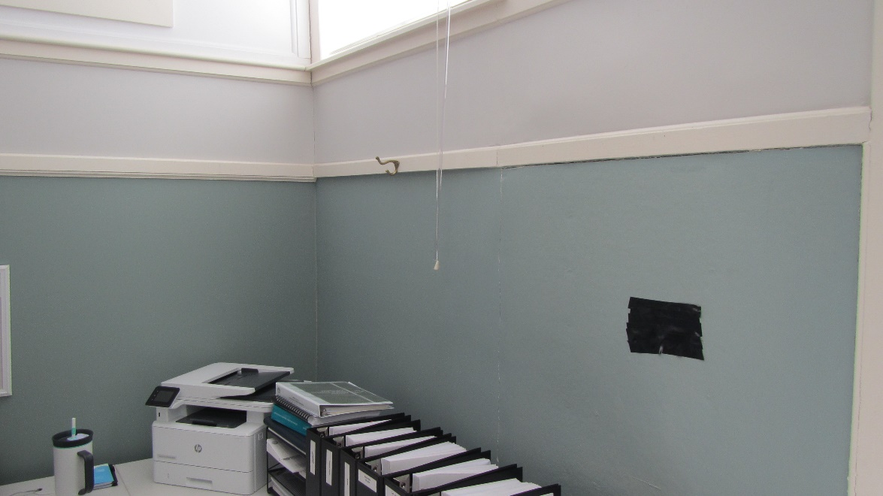

**Bulletin board on exterior wall, note location below window (arrow)**

**Picture 3**

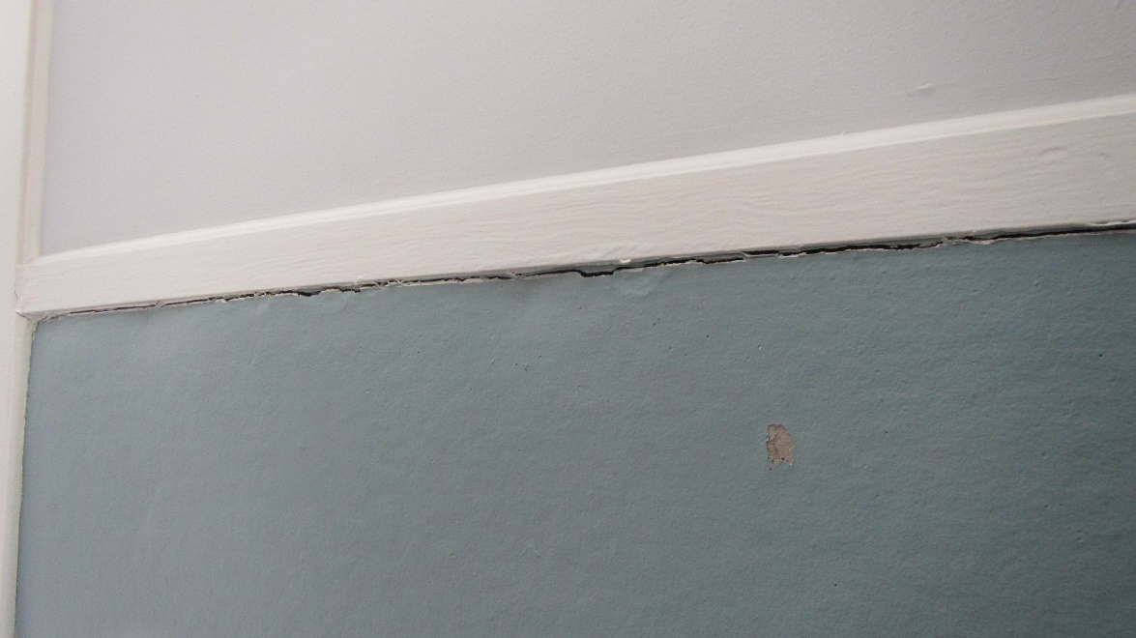

**Crack between bulletin board frame and materials, possible odor pathway**

**Picture 4**

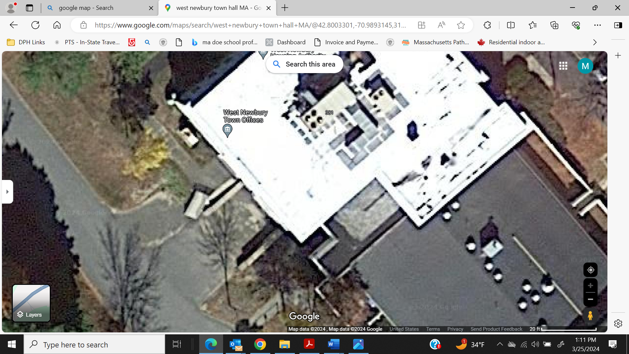

**Peaked roof skylight, note roof edge to original building exterior wall (arrow)**

**Picture 5**

**Peaked roof skylight, note roof edge to original building exterior wall
Note Treasurer’s Office windows that are above bulletin board (arrows)
**

**Peaked roof skylight, note roof edge to original building exterior wall**

**Note Treasurer’s Office windows that are above bulletin board (arrows)**

**Picture 6**

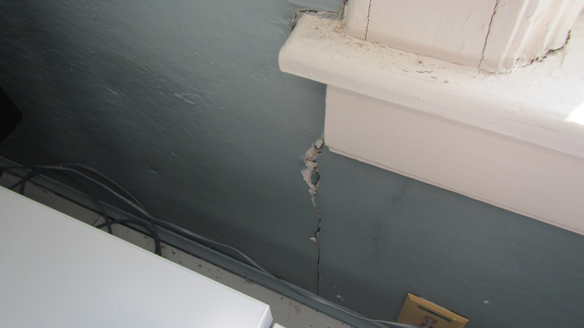

**Likely water damaged plaster beneath window, likely from rain penetrating through/around window frame**