INDOOR AIR QUALITY ASSESSMENT

West Parish Elementary School
10 Concord Street
Gloucester, Massachusetts

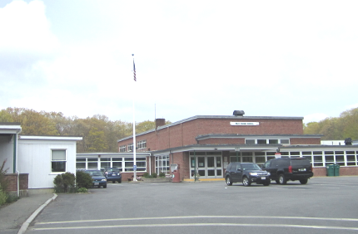

Prepared by:
Massachusetts Department of Public Health
Bureau of Environmental Health
Indoor Air Quality Program
August 2012

Background/Introduction
At the request of the Gloucester Public Schools (GPS), the Massachusetts Department of Public Health’s (MDPH) Bureau of Environmental Health (BEH) conducted an indoor air quality (IAQ) assessment at the West Parish Elementary School (WPES), 10 Concord Street, Gloucester, Massachusetts. On May 3, 2012, a visit was made to the WPES by Sharon Lee, an Environmental Analyst/Inspector for BEH’s IAQ Program. The request was in response to general concerns regarding IAQ.
The WPES is a single-story building constructed in 1949. A number of additions were made to the building including a three-classroom addition in approximately 2002 and one modular classroom in 2006. A new roof was installed over the original portion of the building in 2011. Most of the school buildings are constructed on slab; however, a crawlspace runs below a portion of the building. The school consists of classrooms, a gymnasium, auditorium, library and offices. Windows throughout the school are openable.

Methods
Air tests for carbon dioxide, carbon monoxide, temperature and relative humidity were conducted with the TSI, Q-Trak, IAQ Monitor, Model 7565. Air tests for airborne particle matter with a diameter less than 2.5 micrometers were taken with the TSI, DUSTTRAK™ Aerosol Monitor Model 8520. BEH staff also performed visual inspection of building materials for water damage and/or microbial growth.

Results
The school houses approximately 350 students in kindergarten through 5th grade with approximately 50 staff members. Tests were taken during normal operations, and results appear in Table 1.

Discussion

Ventilation
It can be seen from Table 1 that carbon dioxide levels were above 800 parts per million (ppm) in 29 of 30 areas, indicating poor air exchange in all but one of the areas surveyed at the time of assessment. In some areas, ventilation equipment was found deactivated, therefore no means of mechanical ventilation was being provided to these areas at the time of testing. It is also important to note that several areas had open windows or were empty/sparsely populated, which can greatly reduce carbon dioxide levels. Carbon dioxide levels would be expected to increase with higher occupancy and windows closed.
Fresh air to classrooms in the original building, as well as 2002 addition, is supplied by unit ventilator (univent) systems (Picture 1). A univent draws air from the outdoors through a fresh air intake located on the exterior wall of the building (Picture 2). Return air from the classroom is drawn through an air intake located at the base of the unit (Figure 1). Fresh and return air are mixed, filtered, heated and provided to classrooms through an air diffuser located in the top of the unit. As mentioned, univents were found deactivated in the majority of rooms/areas in the school at the time of assessment (Table 1). In addition, several univents were found obstructed by furniture and other items on top of air diffusers and/or in front of return vents along the bottom of the units (Pictures 1 and 3). In order for univents to provide fresh air as designed, they must remain “on” and operating while rooms are occupied. Furthermore, units must remain free of obstructions.
Exhaust ventilation for classrooms in the 1949 and 2002 portions of the building is provided by either unit exhaust ventilators or wall-mounted exhaust vents ducted to rooftop motors. While similar to appearance to a univent, unit exhaust ventilators lack a fresh air supply on the top of the unit and are designed to draw air directly to the outside of a building (Picture 4). The majority of unit exhaust ventilators have reportedly not been functional for some time. In addition, a number of wall-mounted exhaust vents were blocked at the time of assessment (Picture 5). As with supply ventilation, exhaust ventilation must be free of blockages and allowed to operate while the building is occupied.
Please note, univents and unit exhaust ventilators in the 1949 portion of the building are original equipment, roughly 63 years old. Function of equipment of this age is difficult to maintain, since compatible replacement parts are often unavailable. According to the American Society of Heating, Refrigeration and Air-Conditioning Engineers (ASHRAE), the service life for a unit heater, hot water or steam is 20 years, assuming routine maintenance of the equipment (ASHRAE, 1991). Despite attempts to maintain the univents, the operational lifespan of the equipment has been exceeded. Maintaining the balance of fresh air to exhaust air will become more difficult as the equipment ages and as replacement parts become increasingly difficult to obtain.
Mechanical ventilation for the modular classroom and common areas (e.g., auditorium, cafeteria) is provided by rooftop or side-mounted air-handling units (AHUs) (Picture 6). Fresh air is distributed via ceiling-mounted air diffusers and ducted back to AHUs via ceiling or wall-mounted return vents. The AHU for the modular classroom is controlled by a thermostat, which has fan settings of “on” and “auto”. The automatic setting on the thermostat activates the heating, ventilation and air-conditioning (HVAC) system at a preset temperature. Once a preset temperature is measured by the thermostat, the HVAC system is deactivated. Therefore, no mechanical ventilation is provided until the thermostat re-activates the system. The thermostat was set to the “auto” setting in the modular classroom surveyed during the assessment. Consideration should be given to setting thermostat controls for modular classrooms to the fan “on” setting.
The AHUs for the auditorium and cafeteria were also found deactivated at the time of the assessment; therefore, there was no means of mechanical air exchange. As with univents, AHUs should be activated and allowed to operate continuously during occupied periods.
To maximize air exchange, the MDPH recommends that both supply and exhaust ventilation operate continuously during periods of occupancy. In order to have proper ventilation with a mechanical supply and exhaust system, the systems must be balanced to provide an adequate amount of fresh air to the interior of a room while removing stale air from the room. It is recommended HVAC systems be re-balanced every five years to ensure adequate air systems function (SMACNA, 1994). The date of the last balancing of these systems was not available at the time of the assessment.
The Massachusetts Building Code requires that each room have a minimum ventilation rate of 15 cubic feet per minute (cfm) per occupant of fresh outside air or openable windows (SBBRS, 1997; BOCA, 1993). The ventilation must be on at all times that the room is occupied. Providing adequate fresh air ventilation with open windows and maintaining the temperature in the comfort range during the cold weather season is impractical. Mechanical ventilation is usually required to provide adequate fresh air ventilation.
Carbon dioxide is not a problem in and of itself. It is used as an indicator of the adequacy of the fresh air ventilation. As carbon dioxide levels rise, it indicates that the ventilating system is malfunctioning or the design occupancy of the room is being exceeded. When this happens, a buildup of common indoor air pollutants can occur, leading to discomfort or health complaints. The Occupational Safety and Health Administration (OSHA) standard for carbon dioxide is 5,000 parts per million parts of air (ppm). Workers may be exposed to this level for 40 hours/week, based on a time-weighted average (OSHA, 1997).
The MDPH uses a guideline of 800 ppm for publicly occupied buildings. A guideline of 600 ppm or less is preferred in schools due to the fact that the majority of occupants are young and considered to be a more sensitive population in the evaluation of environmental health status. Inadequate ventilation and/or elevated temperatures are major causes of complaints such as respiratory, eye, nose and throat irritation, lethargy and headaches. For more information concerning carbon dioxide, consult Appendix A.
Temperatures ranged from 68 °F to 74 °F, which were within or very close to the MDPH recommended range in all areas surveyed (Table 1). The MDPH recommends that indoor air temperatures be maintained in a range of 70 °F to 78 °F in order to provide for the comfort of building occupants. In many cases concerning indoor air quality, fluctuations of temperature in occupied spaces are typically experienced, even in a building with an adequate fresh air supply. In addition, it is difficult to control temperature and maintain comfort without operating the ventilation equipment as designed (e.g., univents/exhaust vents deactivated/obstructed).
Relative humidity measurements in the building ranged from 44 to 61 percent at the time of assessment, which again were within or very close to the MDPH recommended comfort range in all areas surveyed (Table 1). The MDPH recommends a comfort range of 40 to 60 percent for indoor air relative humidity. Relative humidity levels in the building would be expected to drop during the winter months due to heating. The sensation of dryness and irritation is common in a low relative humidity environment. Low relative humidity is a very common problem during the heating season in the northeast part of the United States.

Microbial/Moisture Concerns
Evidence of a water leak was observed in a storage closet for classroom 1 (Picture 7). The ceiling had crumbled, and efflorescence was observed on both the ceiling and the walls. Efflorescence is not mold but a characteristic sign of water intrusion. As moisture works its way through mortar around brick, it leaves behind characteristic mineral deposits. A variety of items were stored in the closet, including paper goods and stuffed animals (Picture 8), which can be sources of mold growth if moistened for a prolonged period of time. Items showing water staining or damage should be discarded and salvageable items should be stored in resealable plastic containers away from the area of leakage. Measures to identity and remediate the area of water penetration should be taken. Such measures may include examining the roof, drainage, and flashing along the exterior of the building.
A crawlspace access door was not flush with the floor (Picture 9), which can allow materials/odors from the crawlspace to migrate into occupant areas. Measures, such as the installation of a gasket or membrane, should be taken to render the access door airtight to prevent penetration of odors.
Similarly, spaces were observed around pipes under sinks and in the univent cabinets. Breaches around pipes can allow odors and materials from the crawlspace to penetrate occupant areas. It appears that some of these breaches were sealed with spray foam insulation in the past (Picture 10); however, the foam was not completely adhered to the pipe at the time of assessment. As with the crawlspace access, measures should be taken to reduce movement of air from the crawlspace into occupant space.
Water-stained ceiling tiles were observed in some classrooms (Picture 11). Water damage was noted on some interlocking ceiling tiles as well. This type of ceiling tile can be difficult to replace. These interlocking mineral tiles may also contain asbestos mastic (Picture 12). It was reported to BEH staff that this water damage occurred some time ago and the leaks have been repaired. A determination should be made concerning whether these tiles contain asbestos. If they do, the tiles should be left in place until they can be removed by a licensed asbestos remediation contractor.
Plants were observed in several areas, including on univents (Table 1). One area also had a terrarium (Picture 1). Plants should be properly maintained and equipped with drip pans. Plants should also be located away from ventilation sources to prevent aerosolization of dirt, pollen or mold. Plants should not be placed on porous materials, since water damage to porous materials may lead to microbial growth.
During an examination of the exterior, BEH staff observed trees, shrubs and other plants in close proximity to the building (Pictures 13 and 14). In addition, bark mulch is used as part of the landscaping to protect and add nutrients to the soil below. Shrubs/trees and mulch in close proximity to the building holds moisture against the building exterior and prevents drying. The growth of roots against exterior walls can bring moisture in contact with the foundation. Plant roots can eventually penetrate the wall, leading to cracks and/or fissures in the sublevel foundation. Over time, these conditions can undermine the integrity of the building envelope and provide a means of water entry into the building via capillary action through exterior walls, foundation concrete and masonry (Lstiburek & Brennan, 2001). The freezing and thawing action of water during the winter months can create cracks and fissures in the foundation that can create additional penetration points for both water and pests. Consideration should be given to removing landscaping in close proximity to the building so as to maintain a space of 5 feet between shrubbery and the building. Consideration should also be given to paving around the apron of the building to ensure proper drainage. If possible, improve the grading of the ground away from the foundation at a rate of 6 inches per every 10 feet (Lstiburek & Brennan, 2001).
BEH staff also observed cracks in the building’s exterior wall and foundation (Picture 13), which can undermine the integrity of the building envelope and provide a means of water entry by capillary action into the building (Lstiburek & Brennan, 2001). The freezing and thawing action of water during the winter months can create cracks and fissures in the foundation. In addition, they can serve as pathways for insects, rodents and other pests into the building.
Some downspouts for the gutter system appeared damaged (Picture 15). Downspouts are designed to allow water to drain away from the building. Damage to downspouts can result in water impacting the ground repeatedly. Over time, depressions can form, which can cause water to pool against the building.

Other IAQ Evaluations
Indoor air quality can be negatively influenced by the presence of respiratory irritants, such as products of combustion. The process of combustion produces a number of pollutants. Common combustion emissions include carbon monoxide, carbon dioxide, water vapor and smoke (fine airborne particle material). Of these materials, exposure to carbon monoxide and particulate matter with a diameter of 2.5 micrometers (μm) or less (PM2.5) can produce immediate, acute health effects upon exposure. To determine whether combustion products were present in the indoor environment, BEH staff obtained measurements for carbon monoxide and PM2.5.

Carbon Monoxide
Carbon monoxide is a by-product of incomplete combustion of organic matter (e.g., gasoline, wood and tobacco). Exposure to carbon monoxide can produce immediate and acute health affects. Several air quality standards have been established to address carbon monoxide and prevent symptoms from exposure to these substances. The MDPH established a corrective action level concerning carbon monoxide in ice skating rinks that use fossil-fueled ice resurfacing equipment. If an operator of an indoor ice rink measures a carbon monoxide level over 30 ppm, taken 20 minutes after resurfacing within a rink, that operator must take actions to reduce carbon monoxide levels (MDPH, 1997).
The American Society of Heating Refrigeration and Air-Conditioning Engineers (ASHRAE) has adopted the National Ambient Air Quality Standards (NAAQS) as one set of criteria for assessing indoor air quality and monitoring of fresh air introduced by HVAC systems (ASHRAE, 1989). The NAAQS are standards established by the US EPA to protect the public health from six criteria pollutants, including carbon monoxide and particulate matter (US EPA, 2006). As recommended by ASHRAE, pollutant levels of fresh air introduced to a building should not exceed the NAAQS levels (ASHRAE, 1989). The NAAQS were adopted by reference in the Building Officials & Code Administrators (BOCA) National Mechanical Code of 1993 (BOCA, 1993), which is now an HVAC standard included in the Massachusetts State Building Code (SBBRS, 1997). According to the NAAQS, carbon monoxide levels in outdoor air should not exceed 9 ppm in an eight-hour average (US EPA, 2006).
Carbon monoxide should not be present in a typical, indoor environment. If it is present, indoor carbon monoxide levels should be less than or equal to outdoor levels. Outdoor carbon monoxide concentrations were non-detect (ND) at the time of the assessment (Table 1). No measureable levels of carbon monoxide were detected inside the building during the assessment (Table 1).

Particulate Matter
The US EPA has established NAAQS limits for exposure to particulate matter. Particulate matter is airborne solids that can be irritating to the eyes, nose and throat. The NAAQS originally established exposure limits to particulate matter with a diameter of 10 μm or less (PM10). According to the NAAQS, PM10 levels should not exceed 150 micrograms per cubic meter (μg/m³) in a 24-hour average (US EPA, 2006). These standards were adopted by both ASHRAE and BOCA. Since the issuance of the ASHRAE standard and BOCA Code, US EPA established a more protective standard for fine airborne particles. This more stringent PM2.5 standard requires outdoor air particle levels be maintained below 35 μg/m³ over a 24-hour average (US EPA, 2006). Although both the ASHRAE standard and BOCA Code adopted the PM10 standard for evaluating air quality, MDPH uses the more protective PM2.5 standard for evaluating airborne particulate matter concentrations in the indoor environment.
Outdoor PM2.5 concentrations the day of the assessment were measured at 17 μg/m³. PM2.5 levels measured inside the building ranged from 3 to 15 μg/m³ (Table 1). Both indoor and outdoor PM 2.5 levels were below the NAAQS PM2.5 level of 35 μg/m³. Frequently, indoor air levels of particulates (including PM2.5) can be at higher levels than those measured outdoors. A number of activities that occur indoors and/or mechanical devices can generate particulate during normal operations. Sources of indoor airborne particulates may include but are not limited to particles generated during the operation of fan belts in the HVAC system, use of stoves and/or microwave ovens in kitchen areas; use of photocopiers, fax machines and computer printing devices; operation of an ordinary vacuum cleaner and heavy foot traffic indoors.

Volatile Organic Compounds
Indoor air concentrations can be greatly impacted by the use of products containing volatile organic compounds (VOCs). VOCs are carbon-containing substances that have the ability to evaporate at room temperature. Frequently, exposure to low levels of total VOCs (TVOCs) may produce eye, nose, throat and/or respiratory irritation in some sensitive individuals. For example, chemicals evaporating from a paint can stored at room temperature would most likely contain VOCs. In an effort to identify materials that can potentially increase indoor VOC concentrations, BEH staff examined rooms for products containing these respiratory irritants.
Cleaning products were found in a number of rooms throughout the building (Picture 16; Table 1). Cleaning products contain chemicals that can be irritating to the eyes, nose and throat of sensitive individuals. These products should be properly labeled and stored in an area inaccessible to children. In addition, a Material Safety Data Sheets (MSDS) should be available at a central location for each product in the event of an emergency. Consideration should be given to providing teaching staff with school issued cleaning products and supplies to prevent any potential for adverse chemical interactions between residues left from cleaners used by the facilities staff and those left by cleaners brought in by others.
In an effort to reduce noise, tennis balls had been sliced open and placed on the base of desk/chair legs in some classrooms (Picture 17). Tennis balls are made of a number of materials that are a source of respiratory irritants. Constant wearing of tennis balls can produce fibers and cause VOCs to off-gas. Tennis balls are made with a natural rubber latex bladder, which becomes abraded when used as a chair leg pad. Use of tennis balls in this manner may introduce latex dust into the school environment. Some individuals are highly allergic to latex (e.g., spina bifida patients) (SBAA, 2001). It is recommended that the use of materials containing latex be limited in buildings to reduce the likelihood of symptoms in sensitive individuals (NIOSH, 1997).
Some air fresheners and deodorizing materials were observed in a couple of areas (Table 1). Air deodorizers contain chemicals that can be irritating to the eyes, nose and throat of sensitive individuals. Many air fresheners contain 1,4-dichlorobenzene, a VOC which may cause reductions in lung function (NIH, 2006). Furthermore, deodorizing agents do not remove materials causing odors, but rather mask odors that may be present in the area.

Other Conditions
Other conditions that can affect indoor air quality were observed during the assessment. In several classrooms, items were observed on windowsills, tabletops, counters, bookcases and desks. The large number of items stored in classrooms provides a source for dusts to accumulate. These items (e.g., papers, folders, boxes) make it difficult for custodial staff to clean. Items should be relocated and/or be cleaned periodically to avoid excessive dust build up. In addition, these materials can accumulate on flat surfaces (e.g., desktops, shelving and carpets) in occupied areas and subsequently be re-aerosolized causing further irritation.
Dust was also observed accumulated on the blades of personal fans as well as on univent diffusers. Univents and fans should be cleaned periodically in order to prevent them from serving as a source of aerosolized particulates.

Conclusions/Recommendations
In view of the findings at the time of the visit, the following additional recommendations are made:
- Operate all ventilation systems throughout the building (e.g., gym, cafeteria, classrooms) continuously during periods of occupancy to maximize air exchange. Set digital thermostat for AHU in modular classroom in fan “on” setting.
- Consult with an HVAC engineering firm regarding the feasibility of repair vs. replacement of ventilation system components given their age. In the interim, work with an HVAC engineering firm to adjust/repair univents and exhaust vents to improve air exchange in classrooms.
- Remove all blockages/items from the surface of univent air diffusers and return vents (along front/bottom) to ensure adequate airflow. Remove all blockages from unit exhaust equipment and wall-mounted exhaust vents.
- Consider adopting a balancing schedule of every 5 years for all mechanical ventilation systems, as recommended by ventilation industrial standards (SMACNA, 1994).
- Use openable windows to supplement fresh air in the classrooms classroom occupancy. If thermal comfort is a concern, consider opening windows during class intermission. Care should be taken to ensure windows are closed at the day’s end.
- For buildings in New England, periods of low relative humidity during the winter are often unavoidable. Therefore, scrupulous cleaning practices should be adopted to minimize common indoor air contaminants whose irritant effects can be enhanced when the relative humidity is low. To control dusts, a high efficiency particulate arrestance (HEPA) filter equipped vacuum cleaner in conjunction with wet wiping of all surfaces is recommended. Avoid the use of feather dusters. Drinking water during the day can help ease some symptoms associated with a dry environment (throat and sinus irritations).
- Repair damaged plaster in the closet of classroom 1. Discard materials that appear to be water-damaged. Store items in re-sealable plastic bins to guard against future damage and to prevent settling of dust/debris that can accumulate during storage.
- Ensure roof/plumbing leaks are repaired and replace any remaining water-damaged ceiling tiles. Examine the area above these tiles for mold growth. Disinfect areas of water leaks with an appropriate antimicrobial, as needed.
- Determine whether interlocking ceiling tiles contain asbestos. If so, remediate damaged floor tiles in conformance with Massachusetts asbestos remediation and hazardous waste disposal laws.
- Seal crawlspace access door shown in Picture 9 with gasketing. Seal other holes/breaches where pipes from univents and sinks penetrate into the crawlspace or wall cavity with appropriate fire-rated sealant to prevent movement of odors/particles from the crawlspace.
- Ensure plants, trees and shrubs are located at least five feet away from exterior walls/foundation of the building. Remove any growth observed between the foundation wall and tarmac.
- Consider paving around the apron of the building to ensure proper drainage. If possible, improve the grading of the ground away from the foundation at a rate of 6 inches per every 10 feet (Lstiburek & Brennan, 2001).
- Examine and seal cracks around the building’s foundation.
- Check integrity of gutter and downspout systems and repair as needed.
- Ensure indoor plants are equipped with drip pans. Examine drip pans periodically for mold growth and disinfect with an appropriate antimicrobial, as needed. Move plants away from the air stream of mechanical ventilation equipment.
- Store cleaning products properly and out of reach of students. All cleaning products used at the facility should be approved by the school department with MSDS’ available at a central location.
- Refrain from using air fresheners and deodorizers to prevent exposure to VOCs.
- Relocate or consider reducing the amount of materials stored in classrooms to allow for more thorough cleaning of classrooms. Clean items regularly with a wet cloth or sponge to prevent excessive dust build-up.
- Clean air diffusers, exhaust/return vents and personal fans periodically of accumulated dust.
- Clean plush toys, upholstered furniture and area rugs frequently to remove dust and dust mites.
- Consider replacing tennis balls with latex-free tennis balls or glides.
- Consider adopting the US EPA (2000) document, “Tools for Schools”, as an instrument for maintaining a good indoor air quality environment in the building. This document is available at: http://www.epa.gov/iaq/schools/index.html
- Refer to resource manual and other related indoor air quality documents located on the MDPH’s website for further building-wide evaluations and advice on maintaining public buildings. These documents are available at: http://mass.gov/dph/iaq.

References
ASHRAE. 1989. Ventilation for Acceptable Indoor Air Quality. American Society of Heating, Refrigeration and Air Conditioning Engineers. ANSI/ASHRAE 62-1989.
ASHRAE. 1991. ASHRAE Applications Handbook, Chapter 33 “Owning and Operating Costs”. American Society of Heating, Refrigeration and Air Conditioning Engineers, Atlanta, GA.
BOCA. 1993. The BOCA National Mechanical Code/1993. 8th ed. Building Officials & Code Administrators International, Inc., Country Club Hills, IL.
Lstiburek, J. & Brennan, T. 2001. Read This Before You Design, Build or Renovate. Building Science Corporation, Westford, MA. U.S. Department of Housing and Urban Development, Region I, Boston, MA.
MDPH. 1997. Requirements to Maintain Air Quality in Indoor Skating Rinks (State Sanitary Code, Chapter XI). 105 CMR 675.000. Massachusetts Department of Public Health, Boston, MA.
NIH. 2006. Chemical in Many Air Fresheners May Reduce Lung Function. NIH News. National Institute of Health. July 27, 2006. http://www.nih.gov/news/pr/jul2006/niehs-27.htm
NIOSH. 1997. NIOSH Alert Preventing Allergic Reactions to Natural Rubber latex in the Workplace. National Institute for Occupational Safety and Health, Atlanta, GA.
OSHA. 1997. Limits for Air Contaminants. Occupational Safety and Health Administration. Code of Federal Regulations. 29 C.F.R 1910.1000 Table Z-1-A.
SBAA. 2001. Latex In the Home And Community Updated Spring 2001. Spina Bifida Association of America, Washington, DC.
SBBRS. 1997. Mechanical Ventilation. State Board of Building Regulations and Standards. Code of Massachusetts Regulations. 780 CMR 1209.0.
SMACNA. 1994. HVAC Systems Commissioning Manual. 1st ed. Sheet Metal and Air Conditioning Contractors’ National Association, Inc., Chantilly, VA.
US EPA. 2000. Tools for Schools. Office of Air and Radiation, Office of Radiation and Indoor Air, Indoor Environments Division (6609J). EPA 402-K-95-001, Second Edition. http://www.epa.gov/iaq/schools/tools4s2.html
US EPA. 2006. National Ambient Air Quality Standards (NAAQS). US Environmental Protection Agency, Office of Air Quality Planning and Standards, Washington, DC. http://www.epa.gov/air/criteria.html
Picture 1

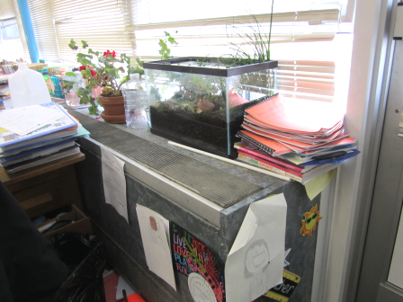

Classroom univent, note plants, terrarium and other items

Picture 2

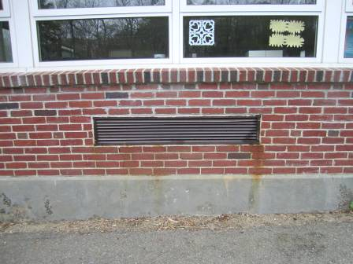

Univent fresh air intake

Picture 3

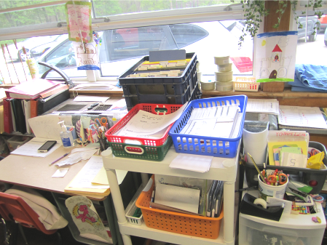

Univent behind furniture and other items

Picture 4

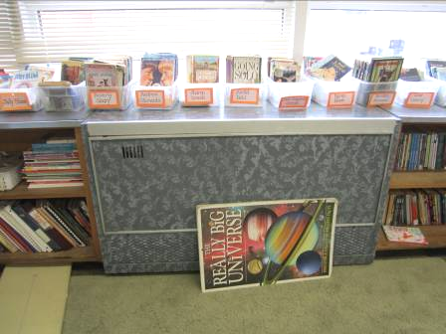

Unit exhaust ventilator

Picture 5

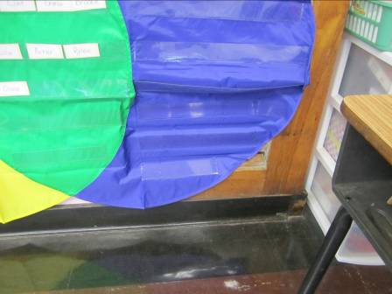

Wall exhaust vent blocked by vinyl wall hanging

Picture 6

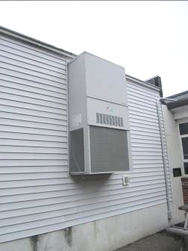

AHU for modular classroom

Picture 7

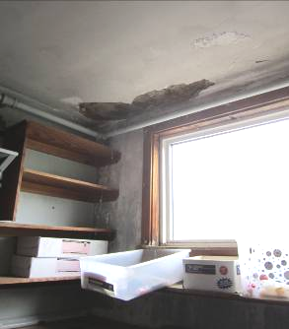

Damaged plaster reportedly from water leaks

Picture 8

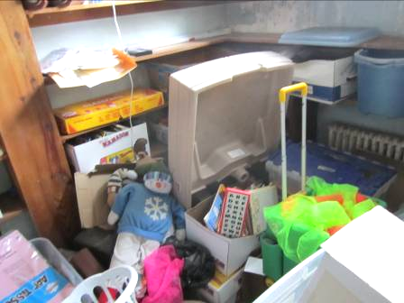

Items stored in closet with water leak

Picture 9

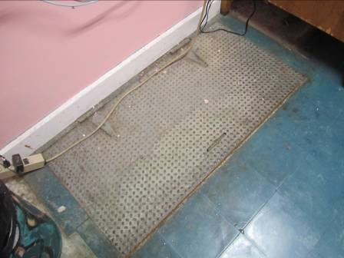

Crawlspace access door

Picture 10

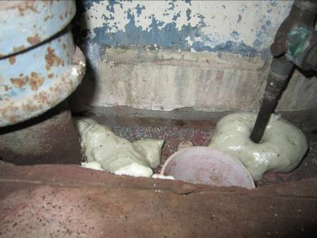

Spray foam insulation around pipes leading to crawlspace

Picture 11

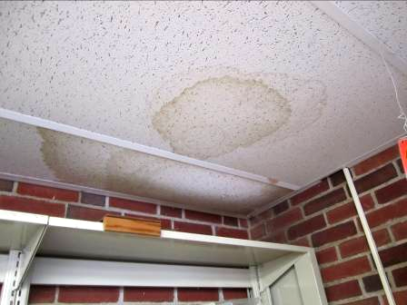

Water-stained ceiling tiles

Picture 12

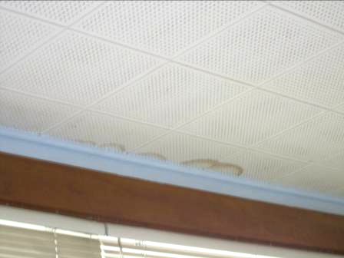

Water-stained interlocking ceiling tiles

Picture 13

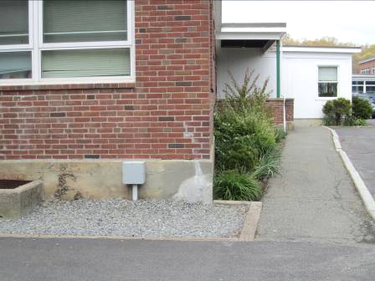

Plants in close proximity to building, note cracks in foundation

Picture 14

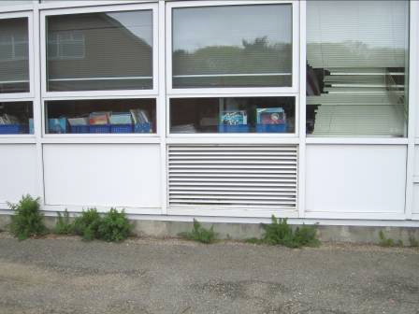

Plant growth against foundation and tarmac

Picture 15

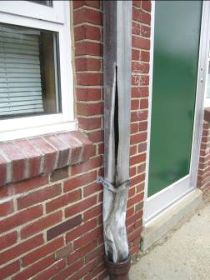

Damaged downspout

Picture 16

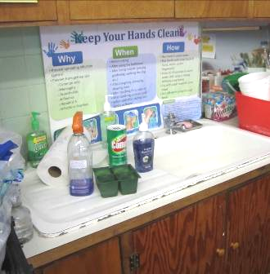

Cleaning products in classroom

Picture 17

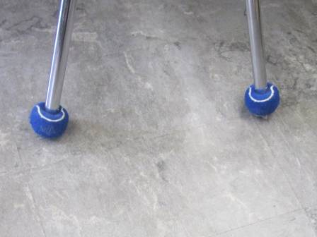

Tennis balls on chair legs

Location | Carbon  Dioxide  (ppm) | Carbon Monoxide  (ppm) | Temp  (°F) | Relative  Humidity  (%) | PM2.5  (µg/m³) | Occupants  in Room | Windows  Openable | Ventilation |  | Remarks
 |  |  |  |  |  |  |  | Supply | Exhaust | Remarks
Background | 438 | ND | 56 | 57 | 17
1 | 1374 | ND | 68 | 61 | 9 | 23 | Y | Y  Off, blocked | Y | Sink dripping, WD-CT, plants, items, water leak in closet
2 | 1569 | ND | 70 | 55 | 8 | 25 | Y | Y  Off, blocked | Y | DO, Plants, TB
R | 1080 | ND | 70 | 49 | 6 | 6 | Y | N | N | DO, DEM, WD-CT, plants, AT, CPs, window condensation
Morris’ Office | 1215 | ND | 70 | 52 | 4 | 1 | Y | N | N | WD-CT, AD, plants
A | 1507 | ND | 70 | 51 | 8 | 23 | Y |  |  | WD-CT, DEM, window condensation, light penetrating from door frame
3 | 1507 | ND | 72 | 50 | 9 | 19 | Y | Y  Off, blocked | Y  Blocked | CPs, carpet fresh
4 | 1288 | ND | 72 | 50 | 10 | 19 | Y | Y | Y  Blocked | CPs, DEM, PF
5 | 1628 | ND | 73 | 51 | 11 | 19 | Y | Y | Y  Blocked | DEM, CPs, plants, PF
Library | 843 | ND | 70 | 47 | 5 | 3 | Y | N | N | DO, window condensation, CPs, microwave, toaster, plants
6 | 1232 | ND | 71 | 51 | 9 | 23 | Y | Y  Off, blocked | Y  Blocked | Plants, DEM, CPs
7 | 1252 | ND | 73 | 45 | 3 | 17 | Y | Y | Y  Blocked | DEM
8 | 1358 | ND | 71 | 50 | 5 | 16 | Y | Y  Off | Y  Off, blocked | CPs, Plants, DEM
9 | 1246 | ND | 73 | 49 | 5 | 16 | Y | Y  Off | Y  Off | TB, plant on rug
10 | 1066 | ND | 72 | 48 | 3 | 19 | Y | Y  Items | Y  Off, blocked | CPs
11 | 911 | ND | 72 | 45 | 5 | 0 | Y | Y  Off | Y  Blocked | WD-CTs, WD-books, DO
12 | 1241 | ND | 74 | 49 | 4 | 18 | Y | Y  Plants, AQ | Y  Off | WD-CT, plants, items
13 | 1160 | ND | 71 | 50 | 9 | 23 | Y | Y | Y  Off | PF, CPs, DEM
14 | 626 | ND | 70 | 44 | 3 | 21 | Y | Y  Off | Y  Off | Exterior DO, DEM, plants, CD
15 | 1067 | ND | 70 | 52 | 3 | 0 | Y | Y | Y  Off | DO, PF, DEM
16 | 1149 | ND | 70 | 51 | 8 | 6 | Y | Y  Off | Y  Off | CPs, PF, DEM
19 | 1529 | ND | 70 | 52 | 7 | 21 | Y | N | N | Plants, MT, WD-CTs
17 | 2081 | ND | 70 | 58 | 9 | 21 | Y | Y  Off, items | Y  Off
18 | 1190 | ND | 71 | 54 | 5 | 20 | Y | Y  Off | Y  Off | CPs, TB
Teacher’s room | 1243 | ND | 72 | 48 | 5 | 6 | Y | N | N | WD-CT, DO, kitchen appliances
Auditorium | 1239 | ND | 70 | 50 | 3 | 0 | Y | Y | Y
Cafeteria | 1302 | ND | 70 | 50 | 15 | 0 | Y | Y | Y | DO, broken floor tile
Conference room | 1214 | ND | 70 | 48 | 8 | 0 | N | N | N | DO
Modular art room | 969 | ND | 73 | 45 | 10 | 3 | Y | Y | Y | DO, WD-CTs
Behavior room | 1939 | ND | 73 | 56 | 6 | 2 | N | N | N | Crawlspace access
Counselor’s office | 1246 | ND | 73 | 51 | 7 | 0 | Y | N | N | DO

The service life is the median time during which a particular system or component of …[an HVAC]… system remains in its original service application and then is replaced. Replacement may occur for any reason, including, but not limited to, failure, general obsolescence, reduced reliability, excessive maintenance cost, and changed system requirements due to such influences as building characteristics or energy prices (ASHRAE, 1991).

