# BACKGROUND

**INDOOR AIR QUALITY ASSESSMENT**

**West Roxbury District Court**

**445 Arborway**

**Jamaica Plain, Massachusetts**

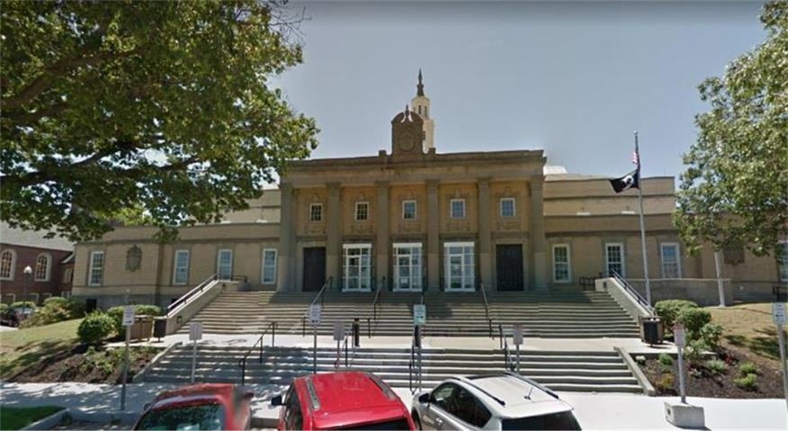

Prepared by:

Massachusetts Department of Public Health

Bureau of Environmental Health

Indoor Air Quality Program

January 2019

|  |  |
| --- | --- |
| **Building:** | West Roxbury Division of the Boston Municipal Court (WRC) |
| **Address:** | 445 Arborway, Jamaica Plain, MA |
| **Reason for Request:** | Mold growth concerns due to indoor humidity |
| **Date of Assessment:** | September 21, 2018 |
| **Massachusetts Department of Public Health/Bureau of Environmental Health (MDPH/BEH) Staff Conducting Assessment:** | Sharon Lee, Environmental Analyst, Indoor Air Quality Program |
| **Date of Building Construction:** | 1925 |
| **Building/Site Description:** | The WRC is a two-story building with an occupied basement. |
| **Windows:** | Openable |
| **Occupancy:** | The building has 75 staff and is visited by at least 200 people on a daily basis. |

Humid weather coupled with a faulty chiller system resulted in mold growth in the Probate Office, located in the basement level of building. The purpose of this visit included an assessment of areas impacted by mold growth, as well as a general assessment of court and administrative spaces at the WRC.

# Methods

Please refer to the IAQ Manual for methods, sampling procedures, and interpretation of results (MDPH, 2015).

# Results

The following is a summary of indoor air testing results (Table 1).

* **Carbon dioxide levels** were below the MDPH guideline of 800 parts per million (ppm) in all areas.
* **Temperature** was within the MDPH recommended range of 70°F to 78°F in all occupied areas tested.
* **Relative humidity** was within to slightly above the MDPH recommended range of 40% to 60% in all occupied areas tested.
* **Carbon monoxide levels** were non-detect (ND) throughout the occupied areas surveyed.
* **Fine particulate matter (PM2.5)** concentrations measured were below the National Ambient Air Quality Standard (NAAQS) level of 35 μg/m3 in all areas assessed.

# Discussion

## Ventilation

A heating, ventilating, and air conditioning (HVAC) system has several functions. First it provides heating and, if equipped, cooling. Second, it is a source of fresh air. Finally, an HVAC system will dilute and remove normally occurring indoor environmental pollutants by not only introducing fresh air, but by filtering the airstream and ejecting stale air to the outdoors via exhaust ventilation. Even if an HVAC system is operating as designed, point sources of respiratory irritation may exist and cause symptoms in sensitive individuals.

Air-handling units (AHUs) located in a mechanical room (Picture 1) provide fresh air to court rooms and office spaces in the WRC. AHUs are fitted with pleated filters that are changed four times a year (Picture 2). Fresh, tempered air is supplied by ceiling-mounted supply vents (Picture 3). Air is returned to AHUs via ceiling-mounted exhaust vents (Picture 4). To maximize air exchange, the MDPH recommends that both supply and exhaust ventilation operate continuously during periods of occupancy.

In order to have proper ventilation with a mechanical supply and exhaust system, the systems must be balanced to provide an adequate amount of fresh air to the interior of a room while removing stale air from the room. It is recommended that HVAC systems be re-balanced every five years to ensure adequate air systems function (SMACNA, 1994). The date of the last balancing of these systems was not available.

A number of concerns regarding excessive heat were reported in the DA’s office, particularly where staff cubicles, break room, and intern spaces are shared. HVAC equipment servicing these areas should be examined to ensure adequate fresh air supply and exhaust ventilation are provided to the space.

Dust was observed on a number of air supply and return diffusers (Picture 3; Table 1). Dust can be attracted to air supply vents because of the charge transferred to the metal diffuser when air is propelled out of the vent at high velocity. Dust can accumulate on return vents as air is being removed from a room. Accumulated dust can dislodged and recirculate in the air, becoming a source for respiratory irritation. Furthermore, dust can be a source for mold growth if it becomes wet over time. Vents should be cleaned of dust periodically to prevent accumulation and potential for mold growth.

## Microbial/Moisture Concerns

At the time of the assessment, it was reported that the chiller that services Probate Court offices in the basement had failed in early August 2018, during a stretch of hot, humid weather, resulting in moist air being circulated in the Probate Court Offices. This increase in humid air in the below-grade space likely resulted in condensation formation on a number of surfaces in the building, which resulted in mold growth. As reported by Administrative Office of the Trial Court (AOTC) and WRC staff, mold growth was observed on hard surfaces (e.g., desktops, typewriters, keyboards) as well as water impermeable materials (e.g., chairs, some clothing items). Mold growth was also reportedly observed on gypsum wallboard (GW) ceilings near fresh air supply vents. AOTC reported removing water-damaged chairs and cleaning desks and ceiling surfaces. The AOTC repaired the chiller and provided a small dehumidifier to remove excess humidity in the air.

As a result of increased humidity experienced during early September 2018, mold growth reportedly re-occurred on similar surfaces as previously described. Additionally, ceiling GW was noted to have mold growth. In response to this September 2018 event, AOTC rented industrial dehumidifier units as well as air cleaning equipment to remove excess humidity and air particles in the WRC. At the time of the September 21, 2018 site visit, AOTC staff reported that they planned to replace damaged ceiling board during off-work hours to prevent potential mold exposure to building occupants.

### Relative Humidity and Condensation

The Boston area experienced an unprecedented period of extended hot, humid weather. According to the Washington Post, “[d]ata…show[s]…cities in the Northeast have witnessed such humidity levels for record-challenging duration...[i]ncluding Albany, Boston, Burlington Portland and Providence” during the summer of 2018 (WP, 2018). “Boston and nearby locations… [saw]…historic numbers of those warm nights with low temperatures at or above 70 degrees…Providence and Blue Hill Observatory have already broken their annual records” (WP, 2018). If a building does not have either adequate exhaust ventilation and/or air chilling capacity to remove/reduce relative humidity from outside air, then hot, moist air can be introduced into a building and linger to increase occupant discomfort as well as possibly moisten materials that may lead to mold growth.

Moisture from humid air will condense and accumulate on the surface of building materials that have temperatures **at or below the dew point.** The dew point is the temperature that air must reach for saturation to occur. For example, during humid weather when the temperature is 85°F and relative humidity is 90%, the dew point is approximately 82°F. Surfaces with a temperature at or below 82°F are prone to condensation formation.

In order for mold growth to occur, materials must be exposed to chronic moisture. Below-grade spaces are more likely to experience elevated relative humidity levels. Relative humidity in excess of 70 percent for extended periods of time, even in the absence of other sources of water, can provide an environment for mold and fungal growth (ASHRAE, 1989). Porous material should be dried with fans and heating within **24 to 48 hours of becoming wet** (US EPA, 2008, ACGIH, 1989). If porous materials are not dried within this time frame, mold growth may occur.

Evidence of condensation-related issues on building materials consistent with mold growth was observed by IAQ staff on supply vents and ceiling GW (Pictures 5 and 6). The type of observed damage suggests that water was condensing on metal air diffuser surfaces and the ceiling in proximity to the diffusers. Moisture can condense when the air conditioning system chills the metal supply diffusers in excessive humid weather. Dust and debris adhered to ceiling tiles or build up on air vents may become a source of material on which mold can grow.

Condensation-related damage and mold growth was observed on GW around ceiling-mounted supply vents. At the time of the assessment, BEH/IAQ staff suggested that GW be replaced with a mold resistant material (e.g., cement board or similar material) in impacted areas. Correspondence from Michael Lane, AOTC Environmental, Health & Safety Manager, reported that moldy GW was removed on October 3, 2018 after close of business.

IAQ staff observed mold growth on a wall in the locker room outside of the Control Room (Picture 7). Growth in this area was also associated with the aforementioned humidity events. Considering the location of mold growth, the process of mopping with moisture wicking up the wall material can also contribute to increased mold growth in the area. As with other impacted areas, these walls should be removed and replaced with cement board.

BEH/IAQ staff observed industrial dehumidifiers (Picture 8) in the basement space, which were not operating at the time of the assessment due to reported noise. Dehumidifiers must be maintained in accordance with manufacturer’s instructions including drainage and cleaning.

Probate Court staff had reported upholstered materials, chairs, desks, and keyboards to have mold growth. AOTC staff removed and discarded Probate Court property. At the time of the assessment, BEH/IAQ staff suggested that Probate Court staff clean personal items that experienced mold growth in a manner consistent with US EPA guidelines (US EPA, 2008).

### Other sources of water damage

The WRC had water-damaged, missing and ajar ceiling tiles in a number of areas (Picture 4; Table 1), which may be from plumbing or building envelope leaks. Leaks should be repaired and pipes should be fitted with appropriate R-rated insulation to prevent condensation from occurring. Water-damaged ceiling tiles should be replaced once the water source has been fixed. During the replacement, the area above the ceiling tile system should be checked for any additional water damage or odors and cleaned or repaired as needed.

Damaged and bubbling paint was observed around windows in a few areas (Pictures 9 and 10), which suggests water intrusion around the window frame. Measures should be taken to identify the cause of the leak. These areas should be examined and remediated following repair of the leak.

Indoor plants were observed in a few areas (Table 1), including on carpet. Plants can be a source of pollen and mold, which can be respiratory irritants to some individuals. Plants should be properly maintained and equipped with drip pans and should be located away from air diffusers to prevent the aerosolization of dirt, pollen, and mold.

A gap was observed between a sink backsplash and countertop (Table 1). This space can allow water into the porous material underneath. Over time, this can lead to water damage and mold growth.

Mold growth was observed in refrigerator gaskets (Picture 11). Condensation on debris collected in gaskets is a common source of mold growth. Gaskets are also prone to bacterial growth. Cleaning gaskets periodically can prevent debris buildup and subsequent mold growth, as well as bacteria proliferation. If gaskets are too damaged to clean, they can be replaced.

Stains from leaks and spills were observed on carpet in the basement level (Picture 12). In some instances, stains were the result of leaks from heating elements (Picture 13). Carpeting moistened periodically will be subject to microbial growth. In many instances, particularly in the DA’s office, carpet appeared visibly stained, wrinkled, or threadbare, indicating it is past its service life. The service life of carpeting is approximately 10-11 years (IICRC, 2002). Aging carpet can produce fibers that can be irritating to the respiratory system. In addition, tears or lifting carpet can create tripping hazards. Carpeting should be cleaned annually or semi-annually in soiled high traffic areas (IICRC, 2012).

## Other IAQ Evaluations

Indoor air can be greatly impacted by the use of products containing volatile organic compounds (VOCs), which can cause eye, nose, throat, and/or respiratory irritation. BEH staff examined areas for products containing these respiratory irritants and noted some offices contained dry erase materials and cleaning products (Table 1).

Additionally, air deodorizers and scented candles were observed in office spaces (Picture 14). Air fresheners and deodorizers contain chemicals that can be irritating to the eyes, nose, and throat of sensitive individuals. Deodorizing agents do not remove materials causing odors, but rather mask odors that may be present in the area. Furthermore, candles present a fire hazard.

In several areas, items were observed on windowsills, tabletops, counters, bookcases and desks as well as in storage rooms. The large number of items in offices and storage areas provides a source for dusts to accumulate. These items (e.g., papers, folders, boxes) make it difficult for custodial staff to clean. Items should be relocated and/or be cleaned periodically to avoid excessive dust build up. Dust can accumulate on flat surfaces (e.g., desktops, shelving and carpets) in occupied areas and subsequently be re-aerosolized causing further irritation. Dust can also serve as a source for mold growth.

Note that papers and other items were found stored on the floor. Because of humidity and the potential for condensation, porous items such as papers, boxes, or clothing should not be stored on the floor in below-grade areas. These items should be placed in cabinets or on shelving.

Staff in the DA’s office indicated concerns about rodents in the ceiling plenum. Wall cavities, dropped ceilings, and utility conduits can often serve as a pathway for rodents. Note that a small kitchen and staff eating area is also located in this space. Food and crumbs, especially in difficult to clean areas such as upholstered furniture, can attract pests into the space. The first step to preventing pests in the building is reducing or eliminating pathways and food sources that are attracting rodents. Under current Massachusetts law (effective November 1, 2001), the principles of integrated pest management (IPM) must be used to remove pests in state buildings (Mass Act, 2000). Pesticide should not be used indoors, since these products can introduce chemicals that are sources of eye, nose, and throat irritation.

Rodent infestation can result in indoor air quality related symptoms due to materials in their wastes. Mouse urine contains a protein that is a known sensitizer (US EPA, 1992). A sensitizer is a material that can produce symptoms in exposed individuals can cause running nose or skin rashes in sensitive individuals (e.g., running nose or skin rashes). A three-step approach is necessary to eliminate rodent infestation:

1. Removal of the rodents;

2. Cleaning of waste products from the interior of the building; and

3. Reduction/elimination of pathways/food sources that are attracting rodents.

Please note that pest removal, even after cleaning, may not provide immediate relief since allergens can exist in the interior for several months after rodents are eliminated (Burge, 1995). A combination of cleaning, along with an increase in ventilation and filtration should serve to reduce rodent-associated allergens once the infestation is eliminated.

# Recommendations

In view of the findings at the time of the visit, the following recommendations are made:

1. Work with an HVAC engineer/contractor to service and maximize the capacity of existing AHUs to dehumidify and provide cool air during summer months.
2. Consider adopting a balancing schedule of every 5 years for all mechanical ventilation systems, as recommended by ventilation industrial standards (SMACNA, 1994).
3. Use dehumidifiers regularly to remove moisture from the space. Consider purchasing additional units for use during periods of sustained high humidity. Ensure all units are maintained in accordance with manufacturer’s instructions including drainage and cleaning.
4. Examine the AHUs that service the DA’s office areas to ensure adequate supply and exhaust ventilation and improve comfort.
5. Clean air diffusers regularly of dust and debris to prevent mold growth.
6. Ensure water-damaged or mold-colonized materials are remediated consistently with the recommendations in the US Environmental Protection Agency’s Mold Remediation in Schools and Commercial Buildings (US EPA, 2008).
7. Ensure building envelope/plumbing leaks are repaired and remove/replace ceiling tiles that show signs of water staining or mold growth.
8. Examine water damage around windows. Repoint and repair to prevent continued damage.
9. Ensure indoor plants are properly maintained and not overwatered, and ensure each has a waterproof drip pan to prevent damage to porous materials.
10. Repair sink backsplashes with appropriate caulking material, or replace with a single-piece unit.
11. Clean refrigerator interior and gaskets periodically to prevent mold growth and any potential for food contamination.
12. Have carpet in basement spaces professionally cleaned. If they are beyond their service life, replace carpet with vinyl composition floor tiles. Floor tiles are resistant to moisture.
13. Reduce use of products and equipment that contain VOCs.
14. Remove candles from office to prevent fire hazard.
15. Ensure flat surfaces are cleaned periodically to prevent buildup of dust, which can serve as a source for mold growth. Reduce the number of items stored on flat services.
16. Remove paper and other porous items products from the floor to prevent moistening through condensation.
17. Implement integrated pest management practices to reduce and prevent rodents in the building. Examine and seal all breaches above the ceiling and in wall areas, remove pest attractants, and clean all impacted areas thoroughly.
18. Refer to resource manual and other related indoor air quality documents located on the MDPH’s website for further advice on maintaining public buildings. These documents are available at: <http://mass.gov/dph/iaq>.

# References

ACGIH. 1989. Guidelines for the Assessment of Bioaerosols in the Indoor Environment. American Conference of Governmental Industrial Hygienists, Cincinnati, OH.

ASHRAE. 1989. Ventilation for Acceptable Indoor Air Quality. American Society of Heating, Refrigeration and Air Conditioning Engineers. ANSI/ASHRAE 62-1989.

Burge, H.A. 1995. *Bioaerosols*. Lewis Publishing Company, Boca Raton, FL.

IICRC. 2002. Institute of Inspection, Cleaning and Restoration Certification. A Life-Cycle Cost Analysis for Floor Coverings in School Facilities.

IICRC. 2012. Institute of Inspection, Cleaning and Restoration Certification*. Carpet Cleaning: FAQ*.

Mass. Act. 2000. An Act Protecting Children and families from Harmful Pesticides. 2000 Mass Acts c. 85 sec. 6E.

MDPH. 2015. Massachusetts Department of Public Health, Indoor Air Quality Manual: Chapters I-III. Available at: <http://www.mass.gov/eohhs/gov/departments/dph/programs/environmental-health/exposure-topics/iaq/iaq-manual/>.

SMACNA. 1994. HVAC Systems Commissioning Manual. 1st ed. Sheet Metal and Air Conditioning Contractors’ National Association, Inc., Chantilly, VA.

US EPA. 1992. Indoor Biological Pollutants. US Environmental Protection Agency, Environmental Criteria and Assessment Office, Office of Health and Environmental Assessment, research Triangle Park, NC. EPA 600/8-91/202. January 1992.

US EPA. 2008. Mold Remediation in Schools and Commercial Buildings. US Environmental Protection Agency, Office of Air and Radiation, Indoor Environments Division, Washington, D.C. EPA 402-K-01-001. <http://www.epa.gov/mold/mold-remediation-schools-and-commercial-buildings-guide>.

WP. 2018. ‘It’s been relentless’: Smothering summer humidity in the Northeast has crushed records. Washington Post, Washington, DC. <https://www.washingtonpost.com/news/capital-weather-gang/wp/2018/08/30/its-been-relentless-smothering-summer-humidity-in-the-northeast-has-crushed-records/>

**Picture 1**

Air-handling unit in mechanical room


**Air-handling unit in mechanical room**

**Picture 2**

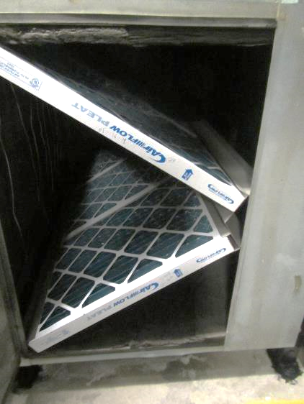

**Pleated filters installed into air-handling unit**

**Picture 3**

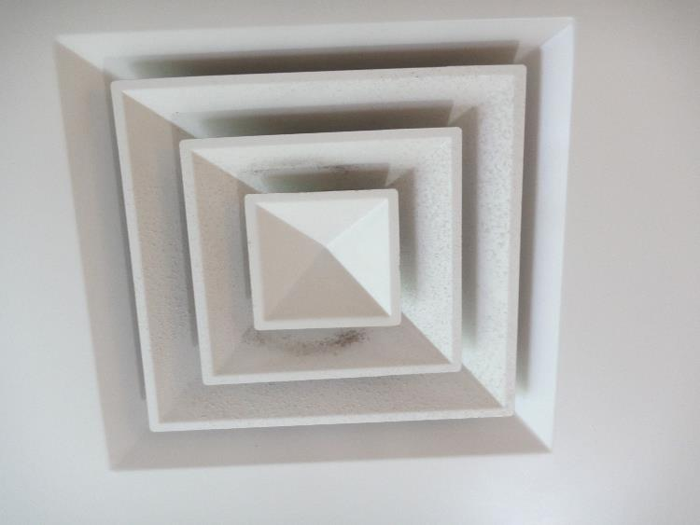

**Fresh air supply diffuser, note dust accumulation on vent**

**Picture 4**

Exhaust vent occluded with dust. Note water-damaged and missing ceiling tiles


**Exhaust vent occluded with dust. Note water-damaged and missing ceiling tiles**

**Picture 5**

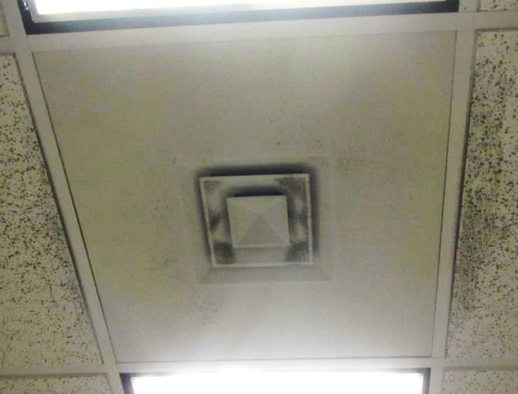

**Dust and potential mold growth on supply diffuser and ceiling tiles**

**Picture 6**

Mold growth on ceiling on either sides of supply diffuser


**Mold growth on ceiling on either sides of supply diffuser**

**Picture 7**

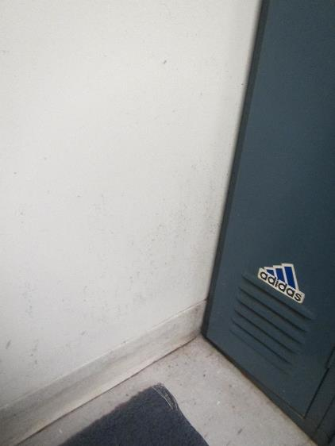

**Mold growth on wall of locker room**

**Picture 8**

Industrial dehumidifier (not operating at time of assessment)


**Industrial dehumidifier (not operating at time of assessment)**

**Picture 9**

Water-damaged paint around window


**Water-damaged paint around window**

**Picture 10**

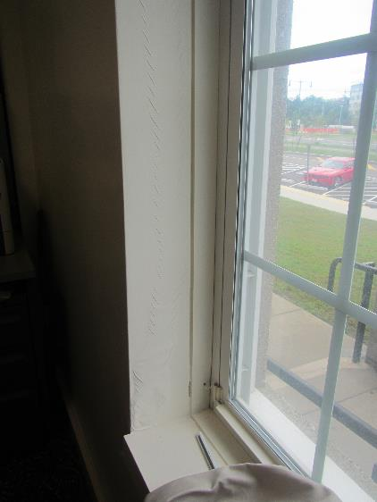

**Water-damaged paint around window**

**Picture 11**

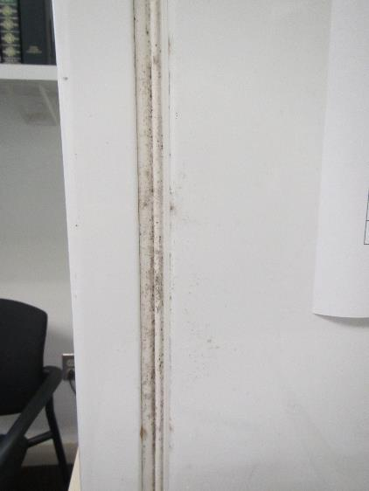

**Mold growth around refrigerator gasket**

**Picture 12**

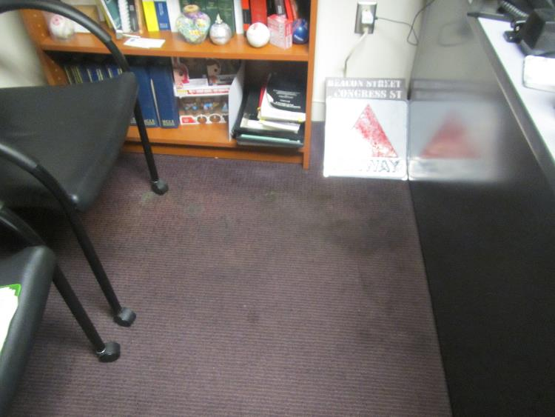

**Stained and damaged carpet**

**Picture 13**

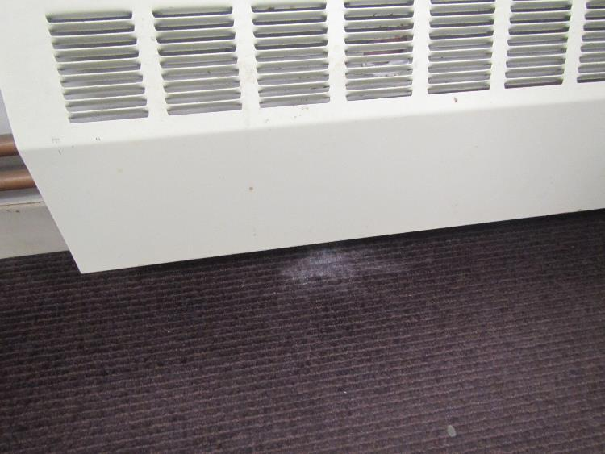

**Water-damaged carpet**

**Picture 14**

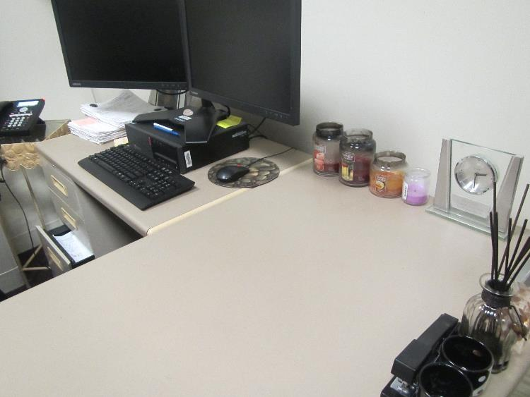

**Scented candles in office**

| **Location** | **Carbon**  **Dioxide**  **(ppm)** | **Carbon Monoxide**  **(ppm)** | **Temp**  **(°F)** | **Relative**  **Humidity**  **(%)** | **PM2.5**  **(µg/m3)** | **Dew Point**  **(°F)** | **Occupants**  **in Room** | **Windows**  **Openable** | **Ventilation** | | **Remarks** |
| --- | --- | --- | --- | --- | --- | --- | --- | --- | --- | --- | --- |
| **Supply** | **Exhaust** |
| Background | 385 | ND | 74 | 47 | 23 | 57 |  |  |  |  | Cars, cigarette smoke |
| Fourth session court room | 702 | ND | 76 | 50 | 9 | 60 | 35 | N | Y  Dusty | Y | WD ceiling plaster, cracks in wall, carpet |
| Police room (district court) | 543 | ND | 74 | 55 | 4 | 61 | 56 | N | Y | Y  Dusty | WD-CT, AT |
| Fifth session court room | 451 | ND | 75 | 54 | 4 | 61 | 0 | N | Y | Y |  |
| Facilities supervisor room | 545 | ND | 75 | 54 | 4 | 61 | 0 | N | Y | Y | CPs, paint |
| Jury deliberation room | 494 | ND | 75 | 52 | 4 | 60 | 0 | Y | Y | Y | WD-CTs, DEM |
| Hearing room C | 448 | ND | 75 | 51 | 4 | 60 | 0 | Y | Y | Y | WD-CTs, cooler on carpet |
| 107 | 421 | ND | 74 | 54 | 4 | 60 | 0 | Y | Y | Y | DO, PF, CPs, plants, food storage |
| 106 | 439 | ND | 76 | 56 | 4 | 63 | 0 | Y | Y | Y | DO |
| 105 | 453 | ND | 73 | 56 | 4 | 60 | 0 | Y | Y | Y | Plants, CPs, refrigerator |
| 109 | 454 | ND | 73 | 54 | 5 | 59 | 0 | N | Y | N | WD-CTs, DO |
| 104 | 443 | ND | 73 | 56 | 4 | 60 | 1 | Y | Y  Dusty | N | DO |
| 100 (file room) | 471 | ND | 73 | 57 | 5 | 60 | 0 | N | Y | Y |  |
| 143 | 485 | ND | 73 | 57 | 4 | 60 | 2 |  | Y  Dusty | Y | DO, fridge on carpet |
| Clerk’s counter | 483 | ND | 73 | 56 | 4 | 60 | 3 | Y | Y | Y | Plants, CPs |
| 126 | 454 | ND | 74 | 53 | 4 | 60 | 0 | Y | Y | Y | DO, plants |
| 147 | 505 | ND | 75 | 54 | 4 | 61 | 0 | N | Y | N | MT, CT, DO |
| 146 | 531 | ND | 75 | 53 | 5 | 61 | 1 | N | Y | Y | WD-CTs, DO, PF, refrigerator |
| 110 | 461 | ND | 75 | 53 | 5 | 61 | 0 | N | Y | Y |  |
| 148 | 472 | ND | 75 | 53 | 5 | 61 | 0 | Y | Y | Y | WD-CT |
| 152 | 483 | ND | 75 | 54 | 5 | 61 | 0 | N | Y Dusty | Y Dusty |  |
| First Session Court Room | 484 | ND | 77 | 54 | 5 | 63 | 0 | Y | Y | Y | WD-CTs |
| 155 | 479 | ND | 76 | 51 | 4 | 61 | 0 | N | Y | Y | Stored items |
| 156 | 500 | ND | 76 | 51 | 4 | 61 | 0 | Y | Y | Y | WD-CTs, WD |
| 157 | 488 | ND | 75 | 58 | 5 | 63 | 1 | Y | Y | Y Dusty |  |
| 158 | 454 | ND | 75 | 52 | 5 | 60 | 0 | y | Y | Y Dusty |  |
| 208 (judge’s lobby admin) | 460 | ND | 73 | 55 | 5 | 60 | 0 | Y | Y | Y | Plant on carpet |
| 201 | 436 | ND | 72 | 54 | 5 | 58 | 1 | Y | Y | Y | DO |
| 200 | 428 | ND | 72 | 55 | 5 | 59 | 0 | N | Y | N |  |
| 202 | 426 | ND | 71 | 56 | 5 | 58 | 0 | Y | Y | Y | WD-CTs, DO |
| 203 | 413 | ND | 70 | 52 | 4 | 56 | 1 | Y | Y | Y | Plants |
| 204 | 448 | ND | 71 | 57 | 4 | 59 | 0 | Y | Y | Y | DO |
| 207 | 476 | ND | 71 | 56 | 4 | 58 | 0 | Y | Y | Y | Refrigerator, breach between sink and backsplash, DO |
| 26 | 430 | ND | 71 | 58 | 5 | 59 | 1 | Y  Open | Y  Dusty/ mold | Y | Plants, DO |
| 25 | 473 | ND | 72 | 55 | 5 | 58 | 0 | Y | Y | Y | Plants, DO, pillows |
| 24 | 421 | ND | 71 | 58 | 5 | 59 | 0 | Y | Y Dusty | Y | Plants, stained carpet |
| 23 | 458 | ND | 71 | 58 | 5 | 59 | 1 | Y | Y Dusty | Y | Fridge on carpet, CPs, paper on floor |
| 22 | 467 | ND | 71 | 61 | 7 | 59 | 1 | Y | Y Dusty | Y | Plants, items |
| 20 | 459 | ND | 71 | 61 | 6 | 60 | 1 | Y | Y Dusty | Y | DO |
| 21 | 441 | ND | 71 | 60 | 7 | 60 | 0 | Y | Y | Y | CPs, paper on floor, reported mold growth leather chair |
| 19 | 423 | ND | 71 | 61 | 6 | 60 | 1 | N | Y Dusty | Y | Candles |
| 17 | 515 | ND | 71 | 60 | 6 | 60 | 1 | N | Y Dusty | Y | DO |
| 16 | 431 | ND | 71 | 60 | 7 | 60 | 7 | Y | Y Dusty | Y | DO |
| 15 | 429 | ND | 71 | 60 | 5 | 60 | 0 | Y | Y | Y | AT, DEM |
| Probate admin area | 444 | ND | 72 | 60 | 5 | 60 | 0 | N | Y | Y |  |
| 14 | 431 | ND | 71 | 60 | 8 | 61 | 0 | N | Y | Y | Carpet stained |
| 12 | 431 | ND | 71 | 60 | 5 | 60 | 0 | N | Y | Y |  |
| 13 | 444 | ND | 72 | 60 | 5 | 60 | 0 | N | Y | Y |  |
| 11 | 455 | ND | 73 | 60 | 6 | 61 | 0 | N | Y | Y | Air deodorizer odor |
| Break room | 472 | ND | 73 | 60 | 6 | 62 | 0 | N | Y | N | Refrigerator |
| 30 | 495 | ND | 74 | 57 | 7 | 62 | 0 | N | Y Dusty | Y | DO |
| Control room | 528 | ND | 74 | 57 | 4 | 61 | 2 | N | Y | Y | AT, dusty CTs, DO |
| DA break area | 567 | ND | 76 | 55 | 8 | 61 | 0 | N | Y | Y | Couch |
| DA cubicle area | 766 | ND | 77 | 51 | 6 | 62 | 0 | N | Y Dusty | Y | Concerns of mouse dropping in CT system |
| DA Intern office | 564 | ND | 77 | 51 | 6 | 62 | 0 | N | Y Dusty | Y |  |
| 41 | 513 | ND | 75 | 51 | 6 | 62 | 2 | N | Y | Y | CPs, PF, carpet concerns |
| 39 | 456 | ND | 76 | 51 | 7 | 60 | 0 | N | Y | Y | DO |
| Probation counter | 439 | ND | 75 | 50 | 8 | 61 | 3 | N | Y | Y | Mold growth on ceiling – GW dry; plants, candles |