INDOOR AIR QUALITY ASSESSMENT

West Street School
14 West Street
Granby, Massachusetts

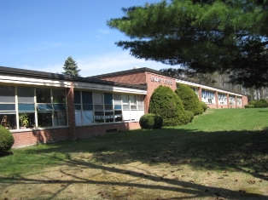

Prepared by:
Massachusetts Department of Public Health
Bureau of Environmental Health
Indoor Air Quality Program
October 2010

Background/Introduction
At the request of Ms. Patricia A. Stevens, Superintendent of Granby Public Schools, the Massachusetts Department of Public Health (MDPH), Bureau of Environmental Health (BEH) conducted an indoor air quality (IAQ) assessment at the West Street School (WSS) located at 14 West Street, Granby Massachusetts. On April 15, 2010, Lisa Hébert, Environmental Analyst/Regional Inspector for BEH’s IAQ Program conducted the assessment. Concerns of general air quality within the building as well as complaints regarding soot generated by the boiler prompted the request.
The WSS is a one-story red brick complex composed of a main building and two wings. The original building was constructed in 1941 and contains a partially occupied lower level. In 1951, a renovation was conducted which added classrooms and administrative offices to the complex (north wing). In 1956, a second addition was constructed which added classrooms, a gymnasium, cafeteria and kitchen to the complex (south wing). Windows are openable throughout the building.

Methods
Air tests for carbon monoxide, carbon dioxide, temperature and relative humidity were conducted with the TSI, Q-Trak, IAQ Monitor, Model 7565. Air tests for airborne particle matter with a diameter less than 2.5 micrometers were taken with the TSI, DUSTTRAK™ Aerosol Monitor Model 8520. BEH staff also performed visual inspection of building materials for water damage and/or microbial growth.

Results
The school houses approximately 300 Pre-K to third grade students and a staff of approximately 45. The building is visited by approximately 10 individuals daily. Tests were taken during normal operations and results appear in Table 1.

Discussion

Ventilation
It can be seen from Table 1 that carbon dioxide levels were below 800 parts per million (ppm) in 25 of 36 areas surveyed indicating adequate air exchange in the majority of areas in the building.
Fresh air in classrooms is supplied by unit ventilator (univent) systems (Picture 1). A univent draws air from the outdoors through a fresh air intake located on the exterior wall of the building and returns air through an air intake located at the base of the unit. Fresh and return air are mixed, filtered, heated and provided to classrooms through an air diffuser located in the top of the unit (Figure 1). Univents appear to be original equipment. The ventilation equipment in this building was likely installed when the building was constructed (i.e., over 60 years ago). According to the American Society of Heating, Refrigeration and Air-Conditioning Engineering (ASHRAE), the service life for a unit heater, hot water or steam is 20 years, assuming routine maintenance of the equipment (ASHRAE, 1991). Despite reported attempts to maintain the univents (cleaning univents and changing filters regularly), the operational lifespan of this equipment has been exceeded. Maintaining the balance of fresh air to exhaust air will be difficult with univents and exhaust vent motors/equipment of this vintage.
Air handling units (AHUs) provide fresh air to the cafeteria, library and lower level classrooms and exhaust air via rooftop exhaust fans. The lower level classrooms have passive vents located near each doorway that lead to an exhaust vent in the hallway (Pictures 2 through 4). It was reported that the AHU in the library had a failed heating coil.
Exhaust for classrooms is provided by gravity exhaust vents located near the floor in the original building and ducted rooftop vents in the subsequent additions (Pictures 5 and 6). Some of the dampers for the original building’s exhaust vents were not open and/or were obstructed on the day of the assessment (Pictures 7 and 8). It is difficult to control temperature and maintain comfort without operating the ventilation equipment as designed.
To maximize air exchange, the MDPH recommends that both supply and exhaust ventilation operate continuously during periods of occupancy. In order to have proper ventilation with a mechanical supply and exhaust system, the systems must be balanced to provide an adequate amount of fresh air to the interior of a room while removing stale air from the room. It is recommended that HVAC systems be re-balanced every five years to ensure adequate air systems function (SMACNA, 1994). The system was reportedly last balanced in 2003.
The Massachusetts Building Code requires that each room have a minimum ventilation rate of 15 cubic feet per minute (cfm) per occupant of fresh outside air or openable windows (SBBRS, 1997; BOCA, 1993). The ventilation must be on at all times that the room is occupied. Providing adequate fresh air ventilation with open windows and maintaining the temperature in the comfort range during the cold weather season is impractical. Mechanical ventilation is usually required to provide adequate fresh air ventilation.
Carbon dioxide is not a problem in and of itself. It is used as an indicator of the adequacy of the fresh air ventilation. As carbon dioxide levels rise, it indicates that the ventilating system is malfunctioning or the design occupancy of the room is being exceeded. When this happens, a buildup of common indoor air pollutants can occur, leading to discomfort or health complaints. The Occupational Safety and Health Administration (OSHA) standard for carbon dioxide is 5,000 parts per million parts of air (ppm). Workers may be exposed to this level for 40 hours/week, based on a time-weighted average (OSHA, 1997).
The MDPH uses a guideline of 800 ppm for publicly occupied buildings. A guideline of 600 ppm or less is preferred in schools due to the fact that the majority of occupants are young and considered to be a more sensitive population in the evaluation of environmental health status. Inadequate ventilation and/or elevated temperatures are major causes of complaints such as respiratory, eye, nose and throat irritation, lethargy and headaches. For more information concerning carbon dioxide, consult Appendix A.
Indoor temperature measurements ranged from 71º F to 81º F, which were within the MDPH recommended comfort range in 32 of 36 areas surveyed on the day of the assessment (Table 1). The MDPH recommends that indoor air temperatures be maintained in a range of 70º F to 78º F in order to provide for the comfort of building occupants. In many cases concerning indoor air quality, fluctuations of temperature in occupied spaces are typically experienced, even in a building with an adequate fresh air supply.
The relative humidity measured in the building ranged from 18 to 29 percent, which was below the MDPH recommended comfort range in all areas surveyed during the assessment (Table 1). The MDPH recommends a comfort range of 40 to 60 percent for indoor air relative humidity. Relative humidity levels in the building would be expected to drop during the winter months due to heating. The sensation of dryness and irritation is common in a low relative humidity environment. Low relative humidity is a very common problem during the heating season in the northeast part of the United States.

Microbial/Moisture Concerns
BEH staff examined the exterior of the building to identify breaches in the building envelope and other issues that could provide a source of water penetration. Several potential sources were identified:
- Numerous wooden window sashes had severely deteriorated rails and sills which were repaired using expandable foam (Picture 9). The application of expandable foam likely resulted in many windows no longer being openable;
- Windows exhibited substantial peeling paint. If this paint contains lead, any work done must be in compliance with EPA’s new Lead Renovation, Repair and Painting Rule (40 CFR 745.80 through 745.92).
- Caulking around windows and below exterior window sills was in extreme disrepair (Picture 10). Window sealant may be composed of regulated materials [e.g., asbestos, polychlorinated biphenyls (PCBs)]. For further information regarding PCBs in schools, please consult MDPH guidance in Appendix B.
- Window glazing was cracked and/or missing (Picture 11);
- Deteriorated wood was observed on exterior window sills;
- Extensive peeling paint was observed on many exterior surfaces allowing wood fibers to become exposed to moisture, which will accelerate deterioration;
- A large gap was observed between the windows and soffits;
- Evidence of chronic moisture damage was observed on the underside of an exterior overhang (Picture 12);
- Cracks/holes were observed in the foundation;
- Numerous exterior doors exhibit gaps, are water-damaged and are delaminating (Pictures 13 and 14);
- Mortar was cracked, crumbling and in disrepair (Picture 15);
- Mulch was observed adjacent to the building in some areas. Mulch has the capacity to hold moisture against the building which can lead to moisture penetration of the building envelope;
- The driveway slopes toward the building in one area, resulting in surface water being directed at the building during rainstorms (Picture 16);
- Moss was observed at the base of the building and is indicative of chronic water exposure, and
- Shrubs are located in close proximity to the building. Shrubbery can serve as a possible source of water impingement on the exterior curtain wall. Plants retain water and in some cases can work their way into mortar and brickwork causing cracks and fissures, which may subsequently lead to water penetration and possible mold growth.
The aforementioned conditions represent potential water penetration sources. Over time, these conditions can undermine the integrity of the building envelope and provide a means of water entry into the building via capillary action through foundation concrete and masonry (Lstiburek & Brennan, 2001). In addition, these breaches may provide a means for pests/rodents to enter the building.
It was reported that the rubber membrane roof was replaced in 2008. Several classrooms had water-damaged ceiling tiles which can indicate sources of water penetration from either the building envelope or plumbing system (Picture 17; Table 1). Water-damaged ceiling tiles can provide a source of mold and should be replaced after a water leak is discovered and repaired. Evidence of water infiltration was also observed on the floor of the boiler room. Efflorescence was observed on brick walls in the lower level (Picture 18). Efflorescence is a characteristic sign of water intrusion. As penetrating moisture works its way through mortar around brick, it leaves behind characteristic white, powdery mineral deposits. It is important to note that efflorescence is not mold growth.
A water cooler was located over a carpeted area. Overflow of the water basin or spills that often occur can moisten carpeting, which can lead to mold growth. It is important that the catch basin of a water cooler be cleaned regularly as stagnant water can be a source of odors, and materials (i.e., dust) collected in the water can provide a medium for mold growth.
The US Environmental Protection Agency (US EPA) and the American Conference of Governmental Industrial Hygienists (ACGIH) recommend that porous materials be dried with fans and heating within 24 to 48 hours of becoming wet (US EPA, 2001; ACGIH, 1989). If not dried within this time frame, mold growth may occur. Once mold has colonized porous materials, they are difficult to clean and should be removed and discarded.
Plants were noted in classrooms. Plant soil and drip pans can serve as a source of mold growth. They should be properly maintained and be equipped with drip pans. In addition, flowering plants can be a source of pollen. Therefore, plants should be located away from the air stream of ventilation sources to prevent aerosolization of mold, pollen and particulate matter. Further, plants should not be placed on porous materials, since water damage to porous materials may lead to microbial growth.

Other IAQ Evaluations
Indoor air quality can be negatively influenced by the presence of respiratory irritants, such as products of combustion. The process of combustion produces a number of pollutants. Common combustion emissions include carbon monoxide, carbon dioxide, water vapor, and smoke (fine airborne particle material). Of these materials, exposure to carbon monoxide and particulate matter with a diameter of 2.5 micrometers (μm) or less (PM2.5) can produce immediate, acute health effects upon exposure. To determine whether combustion products were present in the indoor environment, BEH staff obtained measurements for carbon monoxide and PM2.5.

Carbon Monoxide
Carbon monoxide is a by-product of incomplete combustion of organic matter (e.g., gasoline, wood and tobacco). Exposure to carbon monoxide can produce immediate and acute health effects. Several air quality standards have been established to address carbon monoxide and prevent symptoms from exposure to these substances. The MDPH established a corrective action level concerning carbon monoxide in ice skating rinks that use fossil-fueled ice resurfacing equipment. If an operator of an indoor ice rink measures a carbon monoxide level over 30 ppm, taken 20 minutes after resurfacing within a rink, that operator must take actions to reduce carbon monoxide levels (MDPH, 1997).
The American Society of Heating Refrigeration and Air-Conditioning Engineers (ASHRAE) has adopted the National Ambient Air Quality Standards (NAAQS) as one set of criteria for assessing indoor air quality and monitoring of fresh air introduced by HVAC systems (ASHRAE, 1989). The NAAQS are standards established by the US EPA to protect the public health from six criteria pollutants, including carbon monoxide and particulate matter (US EPA, 2006). As recommended by ASHRAE, pollutant levels of fresh air introduced to a building should not exceed the NAAQS levels (ASHRAE, 1989). The NAAQS were adopted by reference in the Building Officials & Code Administrators (BOCA) National Mechanical Code of 1993 (BOCA, 1993), which is now an HVAC standard included in the Massachusetts State Building Code (SBBRS, 1997). According to the NAAQS, carbon monoxide levels in outdoor air should not exceed 9 ppm in an eight-hour average (US EPA, 2006).
Carbon monoxide should not be present in a typical, indoor environment. If it is present, indoor carbon monoxide levels should be less than or equal to outdoor levels. Outdoor carbon monoxide concentrations were non-detect (ND) the day of the assessment (Tables 1). No measureable levels of carbon monoxide were detected in the building during the assessment (Table 1).

Particulate Matter
The US EPA has established NAAQS limits for exposure to particulate matter. Particulate matter is airborne solids that can be irritating to the eyes, nose and throat. The NAAQS originally established exposure limits to particulate matter with a diameter of 10 μm or less (PM10). According to the NAAQS, PM10 levels should not exceed 150 micrograms per cubic meter (μg/m3) in a 24-hour average (US EPA, 2006). These standards were adopted by both ASHRAE and BOCA. Since the issuance of the ASHRAE standard and BOCA Code, US EPA established a more protective standard for fine airborne particles. This more stringent PM2.5 standard requires outdoor air particle levels be maintained below 35 μg/m3 over a 24-hour average (US EPA, 2006). Although both the ASHRAE standard and BOCA Code adopted the PM10 standard for evaluating air quality, MDPH uses the more protective PM2.5 standard for evaluating airborne particulate matter concentrations in the indoor environment.
Outdoor PM2.5 concentrations were measured at 10 μg/m3 (Table 1). PM2.5 levels measured indoors ranged from 6 to 28 μg/m3 (Table 1), which were below the NAAQS PM2.5 level of 35 μg/m3. Frequently, indoor air levels of particulates (including PM2.5) can be at higher levels than those measured outdoors. A number of mechanical devices and/or activities that occur in buildings can generate particulate during normal operations. Sources of indoor airborne particulates may include but are not limited to particles generated during the operation of fan belts in the HVAC system, use of stoves and/or microwave ovens in kitchen areas; use of photocopiers, fax machines and computer printing devices; operation of an ordinary vacuum cleaner and heavy foot traffic indoors.

Volatile Organic Compounds
Indoor air concentrations can be greatly impacted by the use of products containing volatile organic compounds (VOCs). VOCs are carbon-containing substances that have the ability to evaporate at room temperature. Frequently, exposure to low levels of total VOCs (TVOCs) may produce eye, nose, throat and/or respiratory irritation in some sensitive individuals. For example, chemicals evaporating from a paint can stored at room temperature would most likely contain VOCs.
In an effort to identify materials that can potentially increase VOC concentrations, BEH staff examined classrooms for products that may contain these respiratory irritants. Several classrooms contained dry erase boards and dry erase board markers. Materials such as permanent markers, dry erase markers and dry erase board cleaners may contain VOCs, such as methyl isobutyl ketone, n-butyl acetate and butyl-cellusolve (Sanford, 1999), which can be irritating to the eyes, nose and throat.
Air fresheners and deodorizing materials were observed in bathroom areas. Air deodorizers contain chemicals that can be irritating to the eyes, nose and throat of sensitive individuals. Many air fresheners contain 1,4-dichlorobenzene, a VOC which may cause reductions in lung function (NIH, 2006). Furthermore, deodorizing agents do not remove materials causing odors, but rather mask odors that may be present in the area.
Cleaning products were also found in some classrooms. Like dry erase materials, cleaning products contain VOCs and other chemicals that can be irritating to the eyes, nose and throat of sensitive individuals. These products should be properly labeled and stored in an area inaccessible to children. Additionally, a Material Safety Data Sheet (MSDS) for each product should be available at a central location in the event of an emergency.
In an effort to reduce noise from sliding desks, tennis balls were observed sliced open and placed on the base of the legs (Picture 19). Tennis balls are made of a number of materials that are a source of respiratory irritants. Constant wearing of tennis balls can produce fibers and cause VOCs to off-gas. Tennis balls are made with a natural rubber latex bladder, which becomes abraded when used as a chair leg pad. Use of tennis balls in this manner may introduce latex dust into the school environment. Some individuals are highly allergic to latex (e.g., spina bifida patients) (SBAA, 2001). It is recommended that the use of materials containing latex be limited in buildings to reduce the likelihood of symptoms in sensitive individuals (NIOSH, 1997).
It was reported by the school nurse that odors are sometimes detected in the Nurse Leader Room. Upon investigation, it appeared that the Nurse Leader Room and the adjacent custodial closet had wall mounted vents located in the same wall cavity (Pictures 20 and 21). These vents appeared to be either passive or nonfunctioning on the day of the assessment. Chemical odors and potential VOCs from supplies in the custodial closet as well as sewer gas from a dry drain trap may be migrating through the vents to the Nurse Leader Room.
Gasoline powered equipment (e.g., snow blower and weed trimmer) were stored within the building. Odors and off-gassing of VOCs from gasoline can have an adverse effect on indoor air quality. In addition, storing gas-powered equipment in occupied areas may be a fire hazard.

Other Conditions
Other conditions that can affect indoor air quality were observed during the assessment. It was reported that the school had previously been evacuated due to misfiring of the boiler which resulted in odors permeating the school. The boiler room itself contains several areas such as utility holes that are not adequately sealed (e.g., around pipes, electrical conduit). In addition, cracks were observed between areas of block wall. These conditions will allow odors and particulate matter to migrate out of the boiler room and into the school proper (Picture 22). Daylight could be seen beneath boiler room door and soot deposition was evident on the exterior of the door, indicating that the seal on the boiler room door is not adequate (Picture 23). A kiln, located in a storage closet and not in use at this time, lacked a proper seal around the exhaust as it penetrated the exterior wall of the building. Daylight could be seen through the improperly sealed area, which could allow exhaust fumes from the kiln to re-enter the building (Picture 24). Prior to use in the future, this seal should be repaired.
One classroom contained a number of animals such as amphibians and reptiles (Picture 25). Keeping animals in the classroom, while providing educational opportunities, can also result in the spread of communicable disease if appropriate precautions are not in place. Some animals should not be kept in facilities in which children under five years of age are attending (MMWR, 2009). A plastic swimming pool appeared to be in use as a place for some of the animals to wander outside of their enclosures (Picture 26). Additionally, no hand washing facility was visible in the room for individuals to utilize after handling the animals. For further information, consult MMWR Guidelines for Animals in School and Child-Care Settings in Appendix C. The same room contained aquariums and terrariums. Aquariums should be properly maintained to prevent microbial/algae growth, which can emit unpleasant odors. Similarly, terrariums should be properly maintained to ensure soil does not become a source for mold growth.
The kitchen exhaust fan was not operating during the assessment. Additionally, several bathrooms lacked operational exhausts (Table 1). These conditions can result in an accumulation of moisture and odors within the building.
A live animal trap was observed on the floor in front of the crawlspace door. To penetrate the exterior of a building, rodents require a minimal breach of ¼ inch (MDFA, 1996). As previously noted, spaces beneath doors were noted around the exterior of the building, which would be sufficient to allow rodents to enter the building. The door to the crawlspace was not tightly sealed, which also could allow rodent access (Picture 27).
Rodent infestation can result from easy access to food and water in a building, and in turn in indoor air quality related symptoms due to materials in their wastes. Mouse urine contains a protein that is a known sensitizer (US EPA, 1992). A three-step approach is necessary to eliminate rodent infestation:
- removal of the rodents;
- cleaning of waste products from the interior of the building; and
- reduction/elimination of pathways/food sources that are attracting rodents.
To eliminate exposure to allergens, rodents must be removed from the building. Please note that removal, even after cleaning, may not provide immediate relief since allergens can exist in the interior for several months after rodents are eliminated (Burge, 1995). A combination of cleaning, increase in ventilation and filtration should serve to reduce rodent associated allergens. Under current Massachusetts law that went into effect November 1, 2001, the principles of integrated pest management (IPM) must be used to remove pests in schools (Mass Act, 2000).
A dry drain was noted in the custodial sink as well as in other areas. In the hallway, a sink was observed to be disconnected. The purpose of a drain trap is to prevent sewer gases and odors from entering the occupied space. When water is poured into a trap, an airtight seal is created by the water in the U-bend section of the pipe. These drains must have water poured into the traps at least twice a week to maintain the integrity of the seal. Without water, the drain opens the room to the drainage system. If a mechanical device (e.g., a fan) depressurizes the room, air, gas and odors can be drawn from the drainage system into the room. The effect of this phenomenon can be increased if heavy rains cause an air backup in the system. Any disconnected plumbing should be properly sealed to prevent sewer gases from entering the building.
The “time out” room contained pillows, blankets and what appeared to be an old futon mattress (Picture 28). As can be seen in Picture 28, the cotton covering of the mattress was soiled/stained. Blankets used by the children should be washed after each use or at least on a weekly basis. Furthermore, stuffed pillows can be a point for dust collection. Close contact with such items can leave oils, perspiration, hair and skin cells. Dust mites feed upon human skin cells and excrete waste products that contain allergens. Dust can be irritating to the eyes, nose and respiratory system.
A number of exhaust vents, window blinds and personal fans were observed to have accumulated dust/debris. These vents and fans should be cleaned on a regular basis in order to prevent dust/debris from being aerosolized and redistributed throughout the room. Peeling paint was observed on some of the fresh air intakes. Some classrooms also contained cloth curtains which may not be cleaned on a regular basis. Textiles can be a source of dust and allergens, which can be irritating to the eyes, nose and throat.
Fluorescent light bulbs were stored in such a manner as to be considered subject to damage (Picture 29). Since these bulbs contain mercury, they must be stored and disposed of in accordance with the Massachusetts Department of Environmental Protection’s Guidelines. These guidelines can be found at: http://www.mass.gov/dep/toxics/stypes/hglamps.htm.
Pipes with damaged insulation that consists of a white, powdered material was found in the boiler room and crawlspace (Picture 30). The material may have asbestos containing material (ACM) and should be remediated in conformance with all applicable Massachusetts asbestos abatement and hazardous materials disposal laws. Damaged or missing floor tiles were also observed in some areas (Picture 31). These floor tiles may also contain asbestos. Intact asbestos-containing materials do not pose a health hazard. If damaged, asbestos-containing materials can be rendered friable and become aerosolized. Friable asbestos is a chronic (long-term) health hazard, but will not produce acute (short-term) health effects (e.g., headaches) typically associated with buildings believed to have indoor air quality problems. Where asbestos-containing materials are found damaged, these materials should be removed or remediated in a manner consistent with Massachusetts asbestos remediation laws (MDLI, 1993).
It is also important to note that schools should be in compliance with the Asbestos Hazard Emergency Response Act (AHERA), which requires inspection of asbestos containing materials every three years. In addition, a semi-annual walkthrough is required to determine current conditions of ACM. AHERA requires public and private non-profit primary and secondary schools to inspect their buildings for asbestos-containing building materials and to develop, maintain and update an asbestos management plan to be kept at the school (US EPA, 1986).

Conclusions/Recommendations
The conditions noted at the WSS raise a number of indoor air quality issues. The general building conditions, maintenance, work hygiene practices and the age/condition of HVAC equipment, if considered individually, present conditions that could degrade indoor air quality. When combined, these conditions can serve to further degrade indoor air quality. Some of these conditions can be remedied by actions of building occupants. Other remediation efforts will require alteration to the building structure and equipment. For these reasons, a two-phase approach is recommended for remediation. The first consists of short-term measures to improve air quality and the second consists of long-term measures that will require planning and resources to adequately address overall indoor air quality concerns.

Short-Term Recommendations
- Operate all ventilation systems throughout the building (e.g., gym, cafeteria, classrooms) continuously during periods of occupancy independent of thermostat control to maximize air exchange.
- Use openable windows in conjunction with mechanical ventilation to facilitate air exchange. In the winter, care should be taken to ensure windows are properly closed at night and weekends to avoid the freezing of pipes and potential flooding.
- Consult with an HVAC engineering firm in order to repair/replace AHU in library and to evaluate the feasibility of maintaining/repairing univents of this vintage. Repair/replace equipment as advised.
- Open dampers to exhaust vents and remove obstructions from in front of ventilation components.
- Consider adopting a balancing schedule of every 5 years for all mechanical ventilation systems, as recommended by ventilation industrial standards (SMACNA, 1994).
- For buildings in New England, periods of low relative humidity during the winter are often unavoidable. Therefore, scrupulous cleaning practices should be adopted to minimize common indoor air contaminants whose irritant effects can be enhanced when the relative humidity is low. To control dusts, a high efficiency particulate arrestance (HEPA) filter equipped vacuum cleaner in conjunction with wet wiping of all surfaces is recommended. Avoid the use of feather dusters. Drinking water during the day can help ease some symptoms associated with a dry environment (throat and sinus irritations).
- Repair gaps between windows and soffit.
- Repair leak on exterior overhang that has resulted in the water-damaged underside.
- Repair cracks and holes in foundation.
- Repair or replace damaged or ill-fitting exterior doors.
- Repair or replace cracked or missing mortar.
- Consider eliminating mulch from garden adjacent to the building.
- Repair deteriorated areas of tarmac.
- Investigate drainage options to reduce/eliminate surface water from collecting in sloped driveway and impacting the building.
- Consider extending the outlets of downspouts at least five feet away from the building/foundation.
- Ensure plants and shrubs are located at least five feet away from the foundation of the building.
- Routinely clean particulate matter from dry erase boards and trays.
- Provide a mat that is impervious to water below the water cooler and ensure that overflow receptacle is routinely emptied and cleaned.
- Repair any existing water leaks and replace any remaining water-damaged ceiling tiles. Examine the area above these tiles for mold growth. Disinfect areas of water leaks with an appropriate antimicrobial, as needed.
- Ensure plants are equipped with drip pans. Examine drip pans periodically for mold growth and disinfect with an appropriate antimicrobial, as needed. Move plants away from fresh air supply sources.
- Refrain from using air deodorizers.
- Store cleaning products in a safe area that is not accessible to children. Ensure MSDS’ are available for all products used in the school. Consideration should be given to providing school issued cleaning products to ensure MSDS’ are available for each product.
- Consider replacing tennis balls with latex-free tennis balls or glides.
- Investigate the vents located in the Nurse Leader Room and custodial closet. Consider installing a dedicated exhaust in the custodial closet.
- Store gas-powered equipment outside the building in accordance with local fire codes.
- Seal the numerous openings, utility holes and cracked mortar which allows soot to migrate from the boiler room to other areas in the building. Ensure a tight seal is installed around boiler room door.
- Consider installing carbon monoxide detectors in hallway and/or areas adjacent to the boiler room.
- Clean accumulated soot from boiler room door and surrounding areas.
- Consult with a professional to repair or replace boiler as necessary to eliminate boiler misfiring and subsequent soot deposition.
- Prior to placing kiln back in use, ensure seal is repaired and exhaust is properly operating.
- Review MMWR document, Guidelines for Animals in School and Child-Care Settings and implement the General Guidelines for School Settings as well as the Animal-Specific Guidelines. If these guidelines cannot be met, consider eliminating animals from the school program.
- Clean and maintain aquariums and terrariums to prevent mold growth and associated odors.
- Install exhaust fans in the bathrooms and ensure exhaust vent in kitchen is on when kitchen operations are taking place.
- Eliminate access points for rodents to enter the building. Seal around crawlspace door. Ensure food, water and harborage are not available to any rodents that may find their way into the building.
- Periodically pour water down drains of all infrequently used sinks (twice weekly or as needed). Ensure open plumbing fixtures are properly repaired or sealed to eliminate sewer gas from entering the building.
- Consider removing pillows, cushions, blankets and mattresses from timeout room. If not feasible, clean on a regular basis. Consider using a zippered, fully enclosing mattress cover that is impervious to moisture.
- Repair damaged drywall in “time out” room.
- Clean accumulated dust and debris periodically from the surface of window blinds, exhaust vents and blades of personal fans.
- Discontinue practice of painting fresh air intakes. Consider removing and replacing with unpainted fresh air intake.
- Periodically clean cloth curtains.
- Store and dispose of fluorescent light bulbs in a manner consistent with DEP guidelines.
- Determine composition of damaged insulation on pipes and of damaged floor tiles. If they contain ACM, remediate damaged floor tiles in conformance with Massachusetts asbestos remediation and hazardous waste disposal laws (MDLI, 1993).
- Maintain compliance with the Asbestos Hazard Emergency Response Act.
- Consider adopting the US EPA (2000) document, “Tools for Schools”, as an instrument for maintaining a good indoor air quality environment in the building. This document is available at: http://www.epa.gov/iaq/schools/index.html.
- Refer to resource manual and other related indoor air quality documents located on the MDPH’s website for further building-wide evaluations and advice on maintaining public buildings. These documents are available at: http://mass.gov/dph/iaq.

Long-Term Recommendations
- Consider the installation of replacement windows throughout the school, beginning with the wooden windows in severe disrepair. Consult MDPH Guidance on PCBs in Schools in Appendix B. Ensure the school is in compliance with EPA regulations regarding PCBs in schools prior to conducting testing and/or replacement.
- Consider repainting all surfaces with peeling paint. Please be advised the building must be in compliance with EPA’s new Lead Renovation, Repair and Painting Rule (40 CFR 745.80 through 745.92) that went into effect on April 22, 2010.

References
ACGIH. 1989. Guidelines for the Assessment of Bioaerosols in the Indoor Environment. American Conference of Governmental Industrial Hygienists, Cincinnati, OH.
ASHRAE. 1989. Ventilation for Acceptable Indoor Air Quality. American Society of Heating, Refrigeration and Air Conditioning Engineers. ANSI/ASHRAE 62-1989.
ASHRAE. 1991. ASHRAE Applications Handbook, Chapter 33 “Owning and Operating Costs”. American Society of Heating, Refrigeration and Air Conditioning Engineers, Atlanta, GA.
BOCA. 1993. The BOCA National Mechanical Code/1993. 8th ed. 115. Building Officials and Code Administrators International, Inc., Country Club Hill, IL.
Burge, H.A. 1995. Bioaerosols. Lewis Publishing Company, Boca Raton, FL.
Lstiburek, J. & Brennan, T. 2001. Read This Before You Design, Build or Renovate. Building Science Corporation, Westford, MA. U.S. Department of Housing and Urban Development, Region I, Boston, MA.
Mass. Act. 2000. An Act Protecting Children and families from Harmful Pesticides. 2000 Mass Acts c. 85 sec. 6E.
MDFA. 1996. Integrated Pest Management Kit for Building Managers. Massachusetts Department of Food and Agriculture, Pesticide Bureau, Boston, MA.
MDLI. 1993. Regulation of the Removal, Containment or Encapsulation of Asbestos, Appendix 2. 453 CMR 6,92(I)(i).
MDPH. 1997. Requirements to Maintain Air Quality in Indoor Skating Rinks (State Sanitary Code, Chapter XI). 105 CMR 675.000. Massachusetts Department of Public Health, Boston, MA.
MMWR. 2009. Morbidity Mortality Weekly Report. Appendix D. Guidelines For Animals in School and Child-Care Settings. Vol. 58/ RR-5. May 1, 2009.
NIH. 2006. Chemical in Many Air Fresheners May Reduce Lung Function (#06-11). National Institutes of Health, Research Triangle Park, NC.
NIOSH. 1997. NIOSH Alert: Preventing Allergic Reactions to Natural Rubber Latex in the Workplace. National Institute for Occupational Safety and Health, Atlanta, GA.
OSHA. 1997. Limits for Air Contaminants. Occupational Safety and Health Administration. Code of Federal Regulations. 29 C.F.R 1910.1000 Table Z-1-A.
Sanford. 1999. Material Safety Data Sheet (MSDS No: 198-17). Expo® Dry Erase Markers Bullet, Chisel, and Ultra Fine Tip. Sanford Corporation. Bellwood, IL.
SBAA. 2001. Latex In the Home And Community Updated Spring 2001. Spina Bifida Association of America, Washington, DC.
SBBRS. 1997. Mechanical Ventilation. State Board of Building Regulations and Standards. Code of Massachusetts Regulations. 780 CMR 1209.0
SMACNA. 1994. HVAC Systems Commissioning Manual. 1st ed. Sheet Metal and Air Conditioning Contractors’ National Association, Inc., Chantilly, VA.
US EPA. 1986. Asbestos Hazard Emergency Response Act of 1986 (AHERA) Public Law 99-519, Oct 22, 1986. 15 USC Section 2651.
US EPA. 1992. Indoor Biological Pollutants. US Environmental Protection Agency, Environmental Criteria and Assessment Office, Office of Health and Environmental Assessment, research Triangle Park, NC. EPA 600/8-91/202. January 1992.
US EPA. 2000. Tools for Schools. Office of Air and Radiation, Office of Radiation and Indoor Air, Indoor Environments Division (6609J). EPA 402-K-95-001, Second Edition. http://www.epa.gov/iaq/schools/tools4s2.html.
US EPA. 2001. “Mold Remediation in Schools and Commercial Buildings”. Office of Air and Radiation, Indoor Environments Division, Washington, DC. EPA 402-K-01-001. March 2001. Available at: http://www.epa.gov/iaq/molds/mold_remediation.html
US EPA. 2006. National Ambient Air Quality Standards (NAAQS). US Environmental Protection Agency, Office of Air Quality Planning and Standards, Washington, DC. http://www.epa.gov/air/criteria.html.
Picture 1

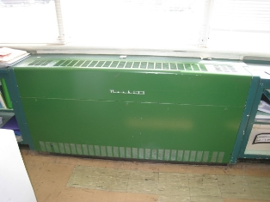

Unit Ventilator (Univent)
Picture 2

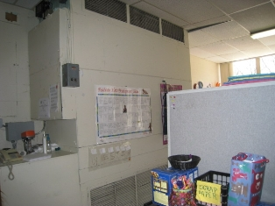

AHU in Cafeteria

Picture 3

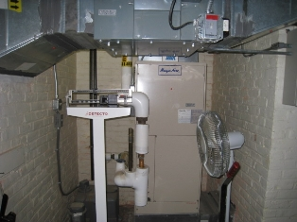

AHU for Lower Level Classrooms

Picture 4

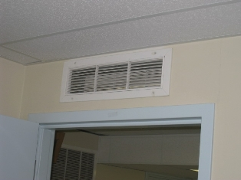

Passive Vent Above Door Casing
Note Exhaust Vent in Hall Outside Door
Picture 5

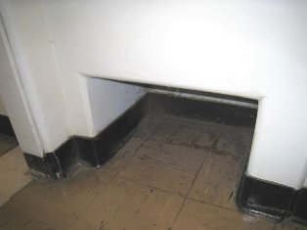

Exhaust Vent

Picture 6

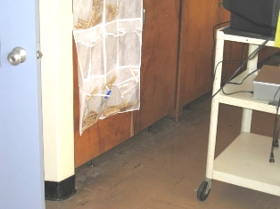

Undercut Door which Leads to Exhaust in Closet
Picture 7

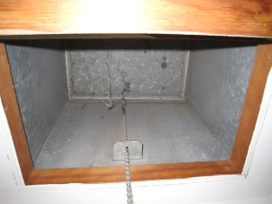

Damper to Exhaust Vent in Closed Position

Picture 8

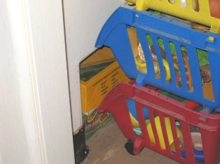

Obstructed Exhaust Vent, Note Items Stored Inside Vent

Picture 9

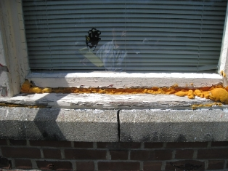

Window in Severe Disrepair
Note Attempt to Seal with Expandable Foam

Picture 10

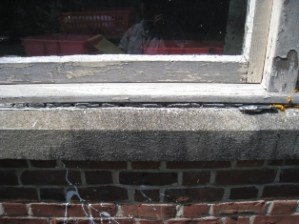

Deteriorated Caulking Beneath Window
Picture 11

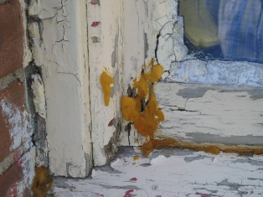

Deteriorated Caulking and Window Glazing
Note Peeling Paint and Foam Used to Stabilize Rotted Rail/Stile Joint

Picture 12

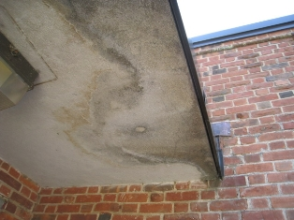

Evidence of Chronic Water Damage on Overhang
Picture 13

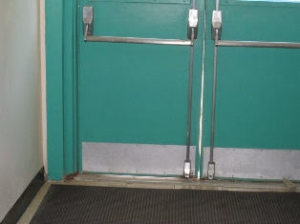

Large Gap Between Doors
Note Daylight Visible Below Door

Picture 14

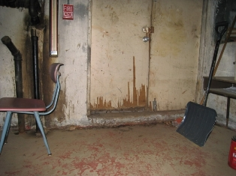

Water-Damaged, Delaminating Door
Picture 15

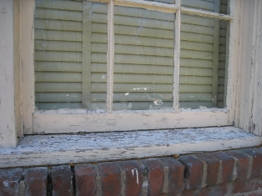

Missing Mortar (Arrow);
Also Note Peeling Paint and Broken, Missing Glazing

Picture 16

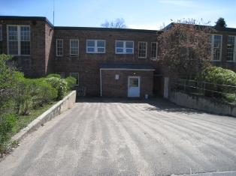

Driveway Slopes Toward Building
Picture 17

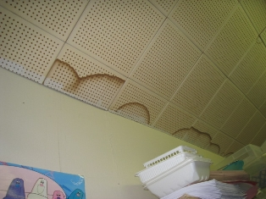

Water-Damaged Ceiling Tiles

Picture 18

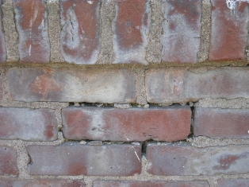

Efflorescence on Masonry
Note Missing, Broken Mortar
Picture 19

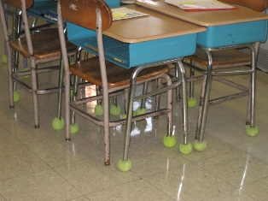

Tennis Balls Utilized as Glides on Legs of Desks

Picture 20

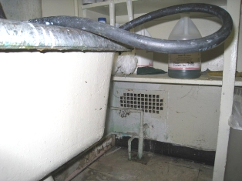

Vent Observed in Custodial Closet

Picture 21

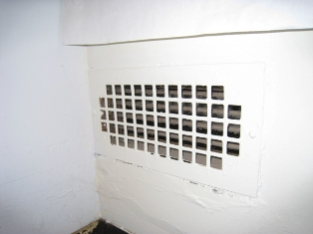

Vent Observed in Nurse Leader Room

Picture 22

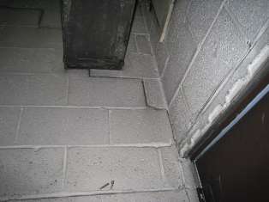

Cracks in Boiler Room Wall

Picture 23

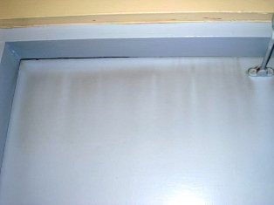

Soot Deposition on the Outside of Boiler Room Door

Picture 24

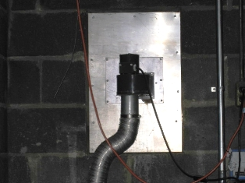

Improperly Sealed Exhaust to Kiln (Arrow)

Picture 25

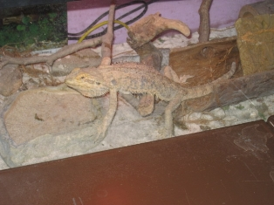

Iguana

Picture 26

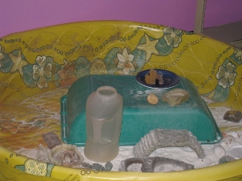

Plastic Sandbox in Room, Presumably Used by
Iguana and Other Animals
Picture 27

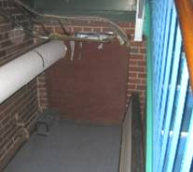

Duct Tape Used to Seal Top of Crawlspace Access Door
Note Animal Trap on Floor
Picture 28

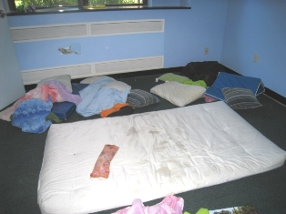

Pillows, Blankets and Mattress in Time-Out Room
Note Broken Gypsum Wallboard
Picture 29

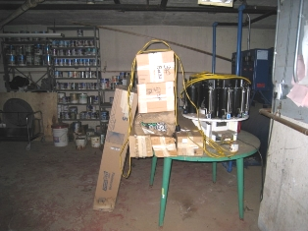

Fluorescent Light Bulb Storage

Picture 30

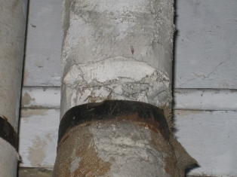

White, Deteriorated Pipe Insulation

Picture 31

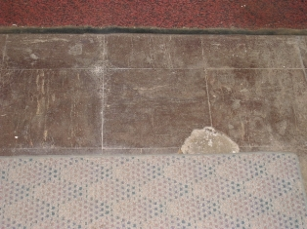

Deteriorated Floor Tiles

Location/ Room | Occupants  in Room | Temp  (°F) | Relative  Humidity  (%) | Carbon  Dioxide  (ppm) | Carbon Monoxide  (ppm) | PM2.5  (µg/m3) | Windows  Openable | Ventilation |  | Remarks
 |  |  |  |  |  |  |  | Supply | Exhaust | Remarks
background |  | 62 | 27 | 447 | ND | 10 |  |  |  | Sunny, few clouds, 0.00 in. precipitation, wind speed 4 mph (NNE), visibility 10 miles
Boiler Room | 0 | 81 | 27 | 627 | ND | 7 | N | Y | N | Numerous penetrations
Cafeteria | 27 | 75 | 23 | 829 | ND | 11 | Y | Y | Y | DO
Clinic | 1 | 77 | 18 | 580 | ND | 8 | Y  1/4 open | N | N | DO, WD CTs, CT ajar
Gymnasium | 24 | 77 | 24 | 922 | ND | 28 | N | Y | Y | Exhaust blocked by gym mat, 3 univents
Kitchen | 2 | 75 | 24 | 640 | ND | 9 | Y | N | Y | DO, exhaust off – turned on through custodian’s office
Learning Center | 1 | 73 | 28 | 710 | ND | 8 | N | Y | Y | DO
Nurse Leader | 0 | 75 | 21 | 553 | ND | 7 | N | N | Y | DO
Office | 0 | 75 | 24 | 866 | ND | 10 | N | N | N | DO, WD CT
Preschool Office | 0 | 73 | 21 | 558 | ND | 7 | Y  1/1 open | N | N | DO, PF
Principal’s Office | 0 | 74 | 26 | 860 | ND | 12 | Y | N | N | DO, Plants, WD CT
Room 1 | 17 | 74 | 18 | 563 | ND | 8 | Y  2/8 open | Y | Y | DO, WD CT, exhaust blocked
Room 2 | 19 | 76 | 20 | 684 | ND | 8 | Y  3/9 open | Y | Y | DO, DEM, PF, no exhaust in bathroom
Room 3 | 15 | 77 | 24 | 968 | ND | 13 | Y  3/9 open | Y | Y | DO, dusty blinds
Room 4 | 19 | 78 | 27 | 919 | ND | 11 | Y | Y | Y | DO, PF, DEM, CD, dusty blinds
Room 5 | 17 | 76 | 24 | 840 | ND | 11 | Y  1/1 open | Y | Y | DO, DEM, WD CTs
Room 6 | 5 | 76 | 23 | 617 | ND | 7 | Y  1/9 open | Y | Y | DO, TB, CD, plants, exhaust in closet obstructed
Room 7 (music) | 22 | 79 | 25 | 1145 | ND | 12 | Y  2/4 open | Y | Y
Room 8 (Art) | 1 | 77 | 21 | 585 | ND | 8 | Y | Y | Y | DO, dusty floor
Room 9 | 24 | 80 | 28 | 737 | ND | 9 | Y | Y | Y | DO, DEM, PF, cleaning products, blinds, curtains
Room 10 | 18 | 77 | 26 | 654 | ND | 10 | Y | Y | Y | DO, PF, plants
Room 11 | 23 | 77 | 24 | 660 | ND | 11 | Y  ¾ | Y | Y | DO, PF, plants, dusty blinds, cloth curtains
Room 12 | 17 | 77 | 25 | 673 | ND | 8 | Y | Y | Y | DO, TB, DEM
Room 13 | 4 | 76 | 25 | 682 | ND | 8 | Y | Y | Y | DO, DEM, CD, plants
Room 14 | 21 | 74 | 29 | 719 | ND | 6 | N | Y | Y | DO, dry drain, plant on univent
Room 15 | 24 | 79 | 28 | 1192 | ND | 11 | Y | Y | Y | DO, CD, UF, DEM, WD CT, plants, exhaust blocked
Room 16 | 0 | 76 | 21 | 596 | ND | 7 | Y  4/6 open | Y | Y | Exhaust blocked
Room 17 | 0 | 74 | 25 | 738 | ND | 8 | Y | Y | Y | PF, CD, WD CTs, exhaust blocked
Room 18 | 0 | 74 | 25 | 850 | ND | 7 | Y | Y | Y | DO, DEM, CD, TB
Room 19 | 6 | 76 | 20 | 611 | ND | 9 | Y | Y | Y | DEM, blinds, exhaust blocked
Room 20 | 4 | 74 | 21 | 596 | ND | 8 | Y  1/6 open | Y | Y | DO, WD CT, DEM, broken floor tiles
Room B-1 | 2 | 74 | 27 | 617 | ND | 6 | Y | Y | Y | DO, DEM, passive vent to exhaust in hall
Room B-2 | 3 | 71 | 22 | 506 | ND | 8 | Y | Y | Y | TB, DEM, passive vent to exhaust in hall
Room B-3  (time out room) | 0 | 71 | 28 | 581 | ND | 8 | Y | Y | Y | DO, pillows, mattress, blankets, passive vent to exhaust in hall
Room B-4 | 0 | 75 | 27 | 594 | ND | 7 | Y | Y | Y | DO, animals (frogs, lizard)
School Psychologist | 6 | 75 | 27 | 904 | ND | 7 | Y | N | N
Storage area |  |  |  |  |  |  |  |  |  | Custodial sink has a dry drain
Teachers Room | 5 | 74 | 24 | 616 | ND | 8 | Y | N | N | DO, WD CT, cooler on carpet, no exhaust in bathroom

An Information Booklet Addressing PCB-Containing Materials in the Indoor Environment of Schools
and Other Public Buildings



Prepared by

Bureau of Environmental Health
Massachusetts Department of Public Health
December 2009
INTRODUCTION
The purpose of this information booklet is to provide assistance to school and public building officials and the general public in assessing potential health concerns associated with polychlorinated biphenyl (PCB) compounds in building materials used in Massachusetts and elsewhere. Recently, the U.S. Environmental Protection Agency (EPA) provided broad guidance relative to the presence of PCBs in building materials, notably PCBs in caulking materials. The most common building materials that may contain PCBs in facilities constructed or significantly renovated during the 1950s through the 1970s are fluorescent light ballasts, caulking, and mastic used in tile/carpet as well as other adhesives and paints.
This information booklet, developed by the Massachusetts Department of Public Health’s Bureau of Environmental Health (MDPH/BEH), is designed to supplement guidance offered by EPA relative to potential health impacts and environmental testing. It also addresses managing building materials, such as light ballasts and caulking, containing PCBs that are likely to be present in many schools and public buildings across the Commonwealth. This is because the Northeastern part of the country, and notably Massachusetts, has a higher proportion of schools and public buildings built during the 1950s through 1970s than many other parts of the U.S. according to a 2002 U.S. General Accounting Office report. The Massachusetts School Building Authority noted in a 2006 report that 53 percent of over 1,800 Massachusetts school buildings surveyed were built during the 1950s through 1970s. This information booklet contains important questions and answers relative to PCBs in the indoor environment and is based on the available scientific literature and MDPH/BEH’s experience evaluating the indoor environment of schools and public buildings for a range of variables, including for PCBs as well as environmental data reviewed from a variety of sources.
1. What are PCBs?
Polychlorinated biphenyl (PCB) compounds are stable organic chemicals used in products from the 1930s through the late 1970s. Their popularity and wide-spread use were related to several factors, including desirable features such as non-flammability and electrical insulating properties. Although the original use of PCBs was exclusive to closed system electrical applications for transformers and capacitors (e.g., fluorescent light ballasts), their use in other applications, such as using PCB oils to control road dust or caulking in buildings, began in the 1950s.
2. When were PCBs banned from production?
Pursuant to the Toxic Substance Control Act (TSCA) of 1976 (effective in 1979), manufacturing, processing, and distribution of PCBs was banned. While the ban prevented production of PCB-containing products, it did not prohibit the use of products already manufactured that contained PCBs, such as building materials or electrical transformers.
3. Are PCBs still found in building materials today?
Yes. Products made with PCBs prior to the ban may still be present today in older buildings. In buildings constructed during the 1950s through 1970s, PCBs may be present in caulking, floor mastic, and in fluorescent light ballasts. Available data reviewed by MDPH suggests that caulking manufactured in the 1950s through 1970s will likely contain some levels of PCBs. Without testing it is unclear whether caulking in a given building may exceed EPA’s definition of PCB bulk product waste of 50 parts per million (ppm) or greater. If it does, removal and disposal of the caulk is required in accordance with EPA’s TSCA regulations (40 CFR § 761).
4. Are health concerns associated with PCB exposure opportunities?
Although the epidemiological evidence is sometimes conflicting, most health agencies have concluded that PCBs may reasonably be anticipated to be a carcinogen, i.e., to cause cancer.
PCBs can have a number of non-cancer effects, including those on the immune, reproductive, neurological and endocrine systems. Exposure to high levels of PCB can have effects on the liver, which may result in damage to the liver. Acne and rashes are symptoms typical in those that are exposed to high PCB levels for a short period of time (e.g., in industry / occupational settings).
5. If PCBs are present in caulking material, does that mean exposure and health impacts are likely?
No. MDPH/BEH’s review of available data suggests that if caulking is intact, no appreciable exposures to PCBs are likely and hence health effects would not be expected. MDPH has conducted indoor tests and reviewed available data generated through the efforts of many others in forming this opinion.
6. How can I tell if caulking or light ballasts in my building may contain PCBs?
If the building was built sometime during the 1950s through 1970s, then it is likely that the caulking in the building and/or light ballasts may contain some level of PCBs. Light ballasts manufactured after 1980 have the words “No PCBs” printed on them. If the light ballast does not have this wording or was manufactured before 1980, it should be assumed that it contains PCBs.
7. What are light ballasts?
A light ballast is a piece of equipment that controls the starting and operating voltages of fluorescent lights. A small capacitor within older ballasts contains about one ounce of PCB oil. If light bulbs are not changed soon after they go out, the ballast will continue to heat up and eventually result in the release of low levels of PCBs into the indoor air.
8. Does the presence of properly functioning fluorescent light ballasts in a building present an environmental exposure concern?
No appreciable exposure to PCBs is expected if fluorescent light ballasts that contain PCBs are intact and not leaking or damaged (i.e., no visible staining of the light lenses), and do not have burned-out bulbs in them.

9. Should I be concerned about health effects associated with exposure to PCBs as a result of PCB-containing light ballasts?
While MDPH has found higher PCB levels in indoor air where light bulbs have burned-out, the levels are still relatively low and don’t present imminent health threats. A risk assessment conducted recently at one school did not suggest unusual cancer risks when considering a worst case exposure period of 35 years for teachers in that school. Having said this, MDPH believes that facility operators and building occupants should take prompt action to replace bulbs and/or ballasts as indicated to reduce/eliminate any opportunities for exposure to PCBs associated with PCB-containing light ballasts.
10. When should PCB-containing light ballasts be replaced?
If ballasts appear to be in disrepair, they should be replaced immediately and disposed of in accordance with environmental regulatory guidelines and requirements. However, if light bulbs burn out, the best remedy is to change them as soon as possible. If light bulbs are not changed soon after they go out, the ballast will continue to heat up and eventually result in the release of low levels of PCBs into the indoor air. Thus, burned-out bulbs should be replaced promptly to reduce overheating and stress on the ballast. As mentioned, ballasts that are leaking or in any state of disrepair should be replaced as soon as possible.
It should be noted that although older light ballasts may still be in use today, the manufacturers’ intended lifespan of these ballasts was 12 years. Thus, to the extent feasible or in connection with repair/renovation projects, the older light ballasts should be replaced consistent with the intended lifespan specified by the manufacturers.
11. Does MDPH recommend testing of caulking in buildings built during the 1950s -1980?
Caulking that is intact should not be disturbed. If caulking is deteriorating or damaged, conducting air and surface wipe testing in close proximity to the deteriorating caulking will help to determine if indoor air levels of PCBs are a concern as well as determining the need for more aggressive cleaning. Results should be compared with similar testing done in an area without deteriorating caulking. In this way, a determination can be made regarding the relative contribution of caulking materials to PCBs in the general indoor environment.
12. What if we determine that caulking in our building is intact and not deteriorating?
Based on a review of available data collected by MDPH and others, the MDPH does not believe that intact caulking presents appreciable exposure opportunities and hence should not be disturbed for testing. As with any building, regular operations and maintenance should include a routine evaluation of the integrity of caulking material. If its condition deteriorates then the steps noted above should be followed. Consistent with EPA advice, if buildings may have materials that contain PCBs, facility operators should ensure thorough cleaning is routinely conducted.
13. Should building facilities managers include information about PCB-containing building materials in their Operations and Maintenance (O&M) plans?
Yes. All buildings should have an O&M plan that includes regular inspection and maintenance of PCB building materials, as well as thorough cleaning of surfaces not routinely used. Other measures to prevent potential exposure to PCBs include increasing ventilation, use of HEPA filter vacuums, and wet wiping. These O&M plans should be available to interested parties.
14. Are there other sources of PCBs in the environment?
Yes. The most common exposure source of PCBs is through consumption of foods, particularly contaminated fish. Because PCBs are persistent in the environment, most residents of the U.S. have some level of PCBs in their bodies.
15. Where can I obtain more information?
For guidance on replacing and disposing of PCB building materials, visit the US EPA website: http://www.epa.gov/pcbsincaulk/. For information on health concerns related to PCBs in building materials, please contact MDPH/BEH at 617-624-5757.

The service life is the median time during which a particular system or component of …[an HVAC]… system remains in its original service application and then is replaced. Replacement may occur for any reason, including, but not limited to, failure, general obsolescence, reduced reliability, excessive maintenance cost, and changed system requirements due to such influences as building characteristics or energy prices (ASHRAE, 1991).

