INDOOR AIR QUALITY ASSESSMENT

West Villages Elementary School
760 Osterville West Barnstable Road
Marstons Mills, Massachusetts

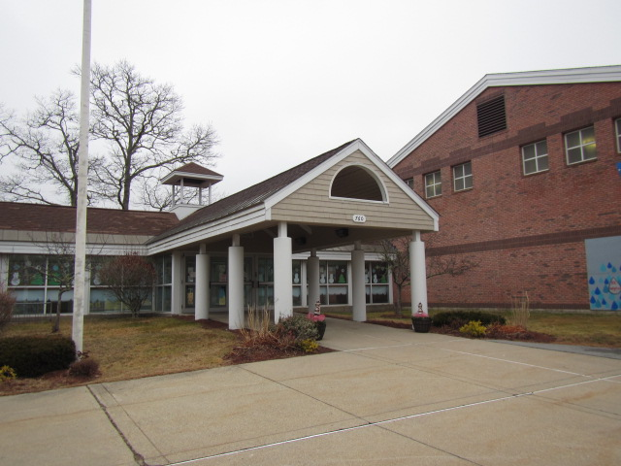

Prepared by:
Massachusetts Department of Public Health
Bureau of Environmental Health
Indoor Air Quality Program
February 2020

BACKGROUND
Building: | West Villages Elementary School (WVES)
Address: | 760 Osterville West Barnstable Road,  Marstons Mills, Massachusetts
Assessment Requested by: | Barnstable Public Schools (BPS)
Reason for Request: | Collaborative effort to perform general indoor air quality (IAQ) assessments throughout the Barnstable School District
Date of Assessment: | January 14, 2020
Massachusetts Department of Public Health/Bureau of Environmental Health (MDPH/BEH) Staff Conducting Assessment: | Cory Holmes, Environmental Inspector, IAQ Program accompanied by Michael Lambros, Deputy Director of Facilities, BPS
Date of Building Construction: | Originally constructed in 1988
Building Description: | This is a single-story brick/concrete block building. The building contains general classrooms, kitchen, cafeteria, gymnasium, faculty workrooms and office space. A portion of the roof (that contains solar panels) was replaced over the summer of 2019. Most rooms are partially carpeted and partially tiled with suspended ceiling tile systems.
Windows: | Openable

METHODS
Please refer to the IAQ Manual and appendices for methods, sampling procedures, and interpretation of results (MDPH, 2015).

RESULTS and DISCUSSION
The following is a summary of indoor air testing results (Table 1).
- Carbon dioxide levels were above the MDPH recommended level of 800 parts per million (ppm) in over half of the areas surveyed, which indicates a lack of air exchange in many classrooms at the time of assessment. This is most likely due to deactivated and/or malfunctioning mechanical ventilation components and is explained further in the Ventilation section of this report.
- Temperature was within or close to the MDPH recommended range of 70°F to 78°F in occupied areas. Temperature control issues were reported in several areas.
- Relative humidity was below or close to the lower end of the MDPH recommended range of 40 to 60% in all areas tested the day of assessment, which is typical of conditions during the heating season.
- Carbon monoxide levels were non-detectable (ND) in all areas tested.
- Particulate matter (PM2.5) concentrations measured were below the National Ambient Air Quality (NAAQS) level of 35 μg/m³ in all areas tested.

Ventilation
A heating, ventilating and air conditioning (HVAC) system has several functions. First it provides heating and, if equipped, cooling. Second, it is a source of fresh air. Finally, an HVAC system will dilute and remove normally-occurring indoor environmental pollutants by not only introducing fresh air, but by filtering the airstream and ejecting stale air to the outdoors via exhaust ventilation. Even if an HVAC system is operating as designed, point sources of respiratory irritation may exist and cause symptoms in sensitive individuals.
Fresh air in classrooms is supplied by unit ventilators (univents, Picture 1). Univents draw air from the outdoors through a fresh air intake located on the exterior wall of the building (Picture 2) and return air through an air intake located at the base of the unit. Fresh and return air are mixed, filtered, heated or cooled and provided to rooms through an air diffuser located in the top of the unit (Figure 1). In several rooms univents were deactivated due to overheating/control issues; therefore no fresh air was being introduced at the time of testing. In addition, in some rooms the top and/or front of some univents were blocked by classroom items (Pictures 3 and 4). In order for univents to provide fresh air as designed, intakes/returns must remain free of obstructions. Importantly, these units must remain on and be allowed to operate while rooms are occupied. It is also important to note that outside air is typically limited (by pneumatically adjusting intake louvers) during cold/winter months to provide comfort and prevent the freezing of pipes.
The HVAC/univent control system includes carbon dioxide sensors (Picture 5) to adjust the amount of fresh air into classrooms. It was not clear how long the system has been in use and what the controls were set at (MDPH recommends 800 ppm). However, it is important to note that these systems need to be regularly maintained/calibrated in accordance with manufacturer’s instructions to ensure proper function. It was not known at the time of assessment, how often the carbon dioxide sensors need to be calibrated or replaced. In addition, the sensors were mounted directly inside the classroom near hallway doors (Picture 6), which if pegged open (which was seen throughout the building) can lead to false readings of hallway air instead of classroom air.
Classroom exhaust vents are located in the ceilings (Picture 7) or in restrooms located within the classrooms. These are connected with ducts to exhaust fans on the roof. A number of these exhaust vents were not drawing air during the assessment; some bathroom vents were also found non-functional. Note that in many classrooms, exhaust vents were located near classroom doors (Picture 8). This design works best with the doors to the hallway closed, otherwise the exhaust vents tend to draw air from the hallway rather than the room, which reduces the effectiveness of air exchange. Without adequate supply and exhaust ventilation, excess heat and environmental pollutants can build up and lead to indoor air/comfort complaints.
To maximize air exchange, the IAQ program recommends that both supply and exhaust ventilation operate continuously during periods of occupancy. In order to have proper ventilation with a mechanical ventilation system, the systems must be balanced after installation to provide an adequate amount of fresh air to the interior of a room while removing stale air from the room. It is recommended that HVAC systems be re-balanced every five years to ensure adequate air systems function (SMACNA, 1994).
It is also important to note that the HVAC equipment appears to be original equipment (1980s) over 30 years old. Efficient function of equipment of this age is difficult to maintain, since compatible replacement parts are often unavailable. According to the American Society of Heating, Refrigeration, and Air-Conditioning Engineering (ASHRAE), the service life of this type of unit is 15-20 years, assuming routine maintenance of the equipment (ASHRAE, 1991). It appears the optimal operational lifespan of this equipment has been exceeded.

Microbial/Moisture Concerns
In order for building materials to support mold growth, a source of water exposure is necessary. Identification and elimination of the source of water moistening building materials is necessary to control mold growth. Water-damaged ceilings/tiles were observed in a number of areas (Table 1. Picture 9), which can indicate current/historic roof/plumbing leaks or other water infiltration. Water-damaged ceiling tiles can provide a source of mold and should be replaced after a water leak is discovered and repaired. In some cases dark/black stains were observed on ceiling tiles indicating mold growth (Table 1), mostly where supply vents are installed (Pictures 10 and 11). Since the school utilizes AC, condensation is likely to form on the cool surface of metal diffusers/vents leading to moistening of ceiling tiles and subsequent mold growth over time. An active leak was observed in the gym from a water valve on the ceiling-mounted HVAC unit. Water was being collected in a bucket stationed on the floor directly below, which can be a tripping/safety hazard.
The United States Environmental Protection Agency (US EPA) and the American Conference of Governmental Industrial Hygienists (ACGIH) recommend that porous materials be dried with fans and heating within 24 to 48 hours of becoming wet (US EPA, 2008; ACGIH, 1989). If porous materials are not dried within this time frame, they should be removed and discarded.
Visible mold growth was observed in the Faculty Lounge. Refrigerators had mold on the doors/gaskets (Pictures 12 and 13). Refrigerators should be cleaned out regularly to prevent odors and microbial growth. Gaskets should be cleaned with a mild antimicrobial solution; if they are too heavily stained to be cleaned/damaged, they should be replaced.
Plants were present in some classrooms and other areas. Plants should be well maintained, not overwatered, and not placed on porous materials or in the airstream of ventilation equipment. A few aquariums were observed in the building. Aquariums should also be kept in good condition to prevent mold/odors.
The sink faucet in classroom 6 was leaking. The backsplashes for sinks in a number of classrooms had a gap (Table 1, Picture 14), which can allow the materials of the sink countertop to become water-damaged and lead to microbial growth.

Other Conditions
Other conditions that can affect IAQ were observed during the assessment. The MDPH recommends pleated filters with a Minimum Efficiency Reporting Value (MERV) of 8, which are adequate in filtering out pollen and mold spores (ASHRAE, 2012). Filters should also be changed two to four times a year, or per the manufacturer’s recommendations. To change univent filters, WVES maintenance staff must remove a panel on the front of the unit, open a filter access panel and remove a metal frame to access the filter medium. The type of filter medium used by the school comes in a bulk roll and must be cut to size. This method is extremely time intensive and the results are variable; if the filter medium is not properly fitted, gaps can allow unfiltered air into the room as well as cause damage to mechanical components. It should be determined if disposable filters with an appropriate dust spot efficiency can be installed in these univents.
In some areas, exhaust vents, supply diffusers and the interior of univents had accumulated dust/debris (Table 1, Picture 10). This dust can be reaerosolized under certain conditions, and can also be a medium for mold growth. Univent cabinets can also accumulate dust and debris, which should be cleaned when filters are changed (2-4 times/year).
The majority of classrooms in the school contain carpeting and despite its age, is in relatively good condition. Carpeting should be vacuumed regularly with a high efficiency particulate arrestance (HEPA) filter equipped vacuum cleaner to avoid particulates from causing further irritation or serving as a reservoir for microbial colonization. Also, carpeting and rugs should be cleaned at least once per year according to IICRC recommendations (IICRC 2012). However, it should be noted that the usable life of carpeting in schools is approximately 10-11 years (IICRC, 2002). Aging carpet can produce fibers that can be irritating to the respiratory system. Area carpets too worn to be effectively cleaned should be replaced. Area rugs should be rolled up and stored in a clean, dry place when rooms are not occupied during the summer months to prevent moistening due to condensation.
In many classrooms, large numbers of items were on floors, windowsills, tabletops, counters, bookcases and desks, which provide a source for dusts to accumulate. These items (e.g., papers, folders, boxes) make it difficult for custodial staff to clean. Items should be relocated and/or be cleaned periodically to avoid excessive dust build up. In addition, dust and debris can accumulate on flat surfaces (e.g., desktops, shelving and carpets) in occupied areas and subsequently be re-aerosolized causing further irritation.
Exposure to low levels of total volatile organic compounds (TVOCs) may produce eye, nose, throat, and/or respiratory irritation in some sensitive individuals. BEH/IAQ staff examined rooms for products containing VOCs. BEH/IAQ staff noted hand sanitizers, scented products, plug in air fresheners/diffusers (Picture 15), home cleaning products, and dry erase materials in use within the building. All of these products have the potential to be irritants to the eyes, nose, throat, and respiratory system of sensitive individuals. In addition, spray bottles/cleaning products should be kept out of reach of children.
Missing light covers were seen in a few areas (Table 1, Picture 16). Fixtures should be equipped with access covers installed with bulbs fully secured in their sockets. Breakage of glass can cause injuries and may release mercury and/or other hazardous compounds.
Note that the Environmental Protection Agency (EPA) conducted a National School Radon Survey in which it discovered nearly one in five schools had “…at least one frequently occupied ground contact room with short-term radon levels above 4 [picocuries per liter] pCi/L” (US EPA 1993). The BEH/IAQ Program therefore recommends that every school be tested for radon, and that this testing be conducted during the heating season while school is in session in a manner consistent with USEPA radon testing guidelines. Radon measurement specialists and other information can be found at www.nrsb.org and http://aarst-nrpp.com/wp, with additional information at: http://www.mass.gov/eohhs/gov/departments/dph/programs/environmental-health/exposure-topics/iaq/radon.

RECOMMENDATIONS
In view of the findings at the time of the visit, the following recommendations are made:
- Operate the HVAC system to provide for continuous fresh air ventilation during occupied hours.
- Remove furniture and items blocking the front and top of univents.
- Contact the HVAC manufacturer to ensure a regular program/preventative maintenance system is instituted to ensure carbon dioxide sensor calibration/integrity and proper HVAC operation.
- Use openable windows to supplement fresh air during temperate weather. Ensure all windows are closed tightly at the end of each day. Do not use windows while AC system is operating to prevent condensation/mold growth.
- Periodically assess whether exhaust vents (classrooms and restrooms) are drawing air and repair as needed.
- Close classroom doors during occupancy to allow for more effective function of exhaust vents (once operating as designed).
- Undercut restroom doors (in classrooms) or install passive door vents to facilitate classroom exhaust/air exchange.
- Work with staff to troubleshoot temperature control problems.
- Continue to employ district-wide/building specific IAQ committees/liaisons with regular walk-troughs of the building to identify on-going and/or potential issues.
- Utilize a system to report and track maintenance issues (e.g., school dude) so that concerns can be reported by staff and maintenance staff can report when issues have been resolved.
- Consider adopting a balancing schedule of every 5 years for all mechanical ventilation systems, as recommended by ventilation industrial standards (SMACNA, 1994).
- Work with a roofing contractor/building engineer to investigate/repair building envelope leaks. Until this has been completed, avoid storing porous materials in areas of known leaks.
- Once repairs are made, refinish water-damaged materials and replace ceiling tiles. Inspect the area above the stained tiles for water damage or odors and remediate or clean as necessary.
- Replace any missing or ajar ceiling tiles to avoid pathways to unconditioned areas.
- Fix HVAC/valve leak in gymnasium.
- Keep classroom/office plants in good condition, avoid overwatering, and keep them away from the airstream of ventilation equipment.
- Ensure aquariums are clean and odor free.
- Reduce or eliminate the use of air fresheners, scented cleaners, hand sanitizers and dry erase materials to reduce irritation.
- Continue to change filters in HVAC units at least twice a year with MERV 8 or higher filters. Clean HVAC and univent cabinets of debris and dust when filters are changed.
- Consider using disposable, pleated cardboard filters instead of filter media that needs to be hand cut and installed in metal racks.
- Clean supply/exhaust vents and personal fans regularly to remove accumulated dust/debris. Replace surrounding ceiling tiles that cannot be adequately cleaned.
- Ensure all refrigerators are kept clean to prevent microbial growth and odors. Clean gaskets and other surfaces with a mild antimicrobial solution to remove debris and mold. If cannot be adequately cleaned-replace.
- Ensure that condensation from AC equipment is draining properly. Check collector pans, piping and any associated pumps for clogs and leaks and clean periodically to prevent stagnant water build-up and remove debris that may provide a medium for microbial growth.
- Trim back trees from overhanging the roof and ensure all plants/shrubs are located at least five feet away from exterior walls. Remove clinging plants.
- Fix sink/dripping faucet in classroom 6.
- For buildings in New England, periods of low relative humidity during the winter are often unavoidable. Therefore, scrupulous cleaning practices should be adopted to minimize common indoor air contaminants whose irritant effects can be enhanced when the relative humidity is low. To control for dusts, a high efficiency particulate arrestance (HEPA) filter equipped vacuum cleaner in conjunction with wet wiping of all surfaces is recommended. Avoid the use of feather dusters. Drinking water during the day can help ease some symptoms associated with a dry environment (throat and sinus irritations).
- Clean carpeting and area rugs at least once per year according to IICRC recommendations (IICRC 2012). Area carpets too worn to be effectively cleaned should be replaced. Roll up and store are rugs in a clean, dry place during the summer.
- Consider a long-term plan to replace all carpeting in the building as funds become available. Consider replacing carpeting with a non-porous surface such as vinyl tile particularly in below-grade areas.
- Relocate or consider reducing the amount of materials stored in classrooms to allow for more thorough cleaning of classrooms. Clean items regularly with a wet cloth or sponge to prevent excessive dust build-up.
- Ensure fluorescent light fixtures have covers installed.
- Continue to utilize the US EPA’s (2000), “Tools for Schools”, as an instrument for maintaining a good IAQ environment in the building available at: http://www.epa.gov/iaq/schools/index.html.
- The school should be tested for radon by a certified radon measurement specialist during the heating season when school is in session. Radon measurement specialists and other information can be found at: www.nrsb.org, and http://aarst-nrpp.com/wp.
- Refer to resource manuals and other related IAQ documents for further building-wide evaluations and advice on maintaining public buildings. Copies of these materials are located on the MDPH’s website: http://mass.gov/dph/iaq.

Long-term Recommendations:
- Consider contacting an HVAC engineering firm for an assessment of the ventilation system’s components and control systems (e.g., controls, air intake louvers, thermostats). Based on the age, physical deterioration, and availability of parts for ventilation components, such an evaluation is necessary to determine the operability and feasibility of repairing/replacing the equipment.

REFERENCES
ACGIH. 1989. Guidelines for the Assessment of Bioaerosols in the Indoor Environment. American.
ASHRAE. 1991. ASHRAE Applications Handbook, Chapter 33 “Owning and Operating Costs”. American Society of Heating, Refrigeration and Air Conditioning Engineers, Atlanta, GA.
ASHRAE. 2012. American Society of Heating, Refrigeration and Air Conditioning Engineers (ASHRAE) Standard 52.2-2012 -- Method of Testing General Ventilation Air-Cleaning Devices for Removal Efficiency by Particle Size (ANSI Approved).
IICRC. 2002. Institute of Inspection, Cleaning and Restoration Certification. A Life-Cycle Cost Analysis for Floor Coverings in School Facilities.
IICRC. 2012. Institute of Inspection Cleaning and Restoration Certification. Institute of Inspection, Cleaning and Restoration Certification. Carpet Cleaning: FAQ.
MDPH. 2015. Massachusetts Department of Public Health. Indoor Air Quality Manual: Chapters I-III. Available at: http://www.mass.gov/eohhs/gov/departments/dph/programs/environmental-health/exposure-topics/iaq/iaq-manual/.
SMACNA. 1994. HVAC Systems Commissioning Manual. 1st ed. Sheet Metal and Air Conditioning Contractors’ National Association, Inc., Chantilly, VA.
US EPA. 1993. Radon Measurement in Schools, Revised Edition. Office of Air and Radiation, Office of Radiation and Indoor Air, Indoor Environments Division (6609J). EPA 402-R-92-014.
US EPA. 2000. Tools for Schools. Office of Air and Radiation, Office of Radiation and Indoor Air, Indoor Environments Division (6609J). EPA 402-K-95-001, Second Edition. http://www.epa.gov/iaq/schools/index.html.
US EPA. 2008. Mold Remediation in Schools and Commercial Buildings. US Environmental Protection Agency, Office of Air and Radiation, Indoor Environments Division, Washington, D.C. EPA 402-K-01-001. http://www.epa.gov/mold/mold-remediation-schools-and-commercial-buildings-guide.
Picture 1
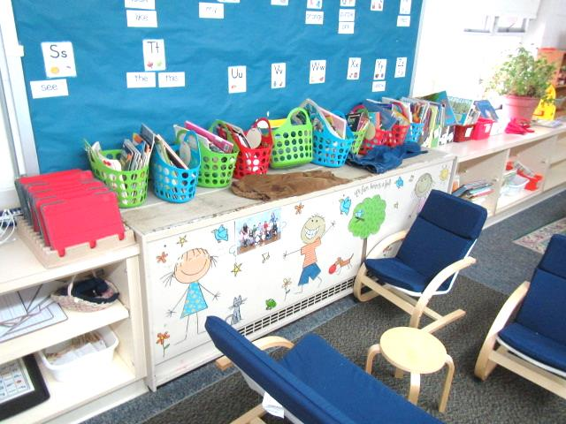
Classroom univent 1980’s vintage
Picture 2
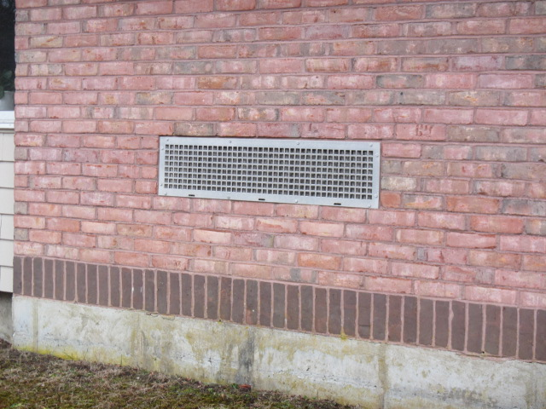
Univent fresh air intake
Picture 3
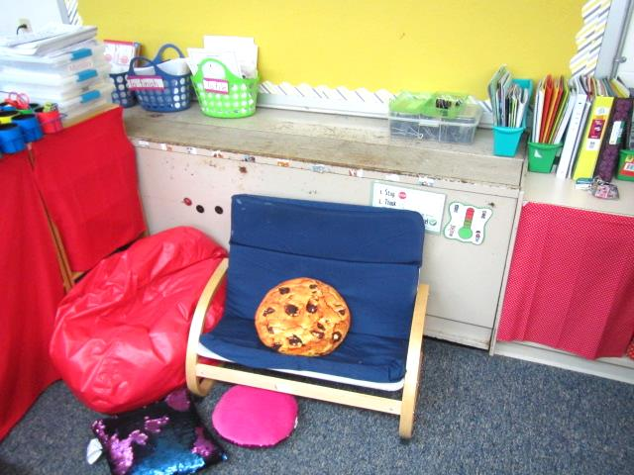
Furniture/classroom items obstructing airflow (bottom front) into univent
Picture 4
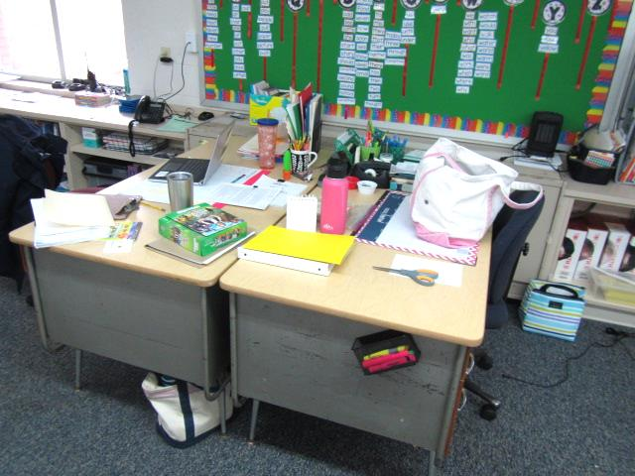
Airflow to univent (arrow) obstructed by placement of classroom furniture
Picture 5
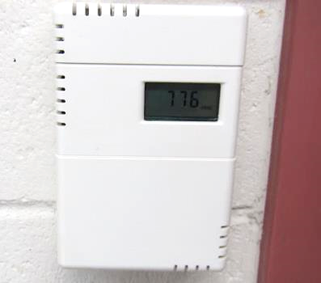
Wall-mounted carbon dioxide sensor for HVAC system/univent control
Picture 6
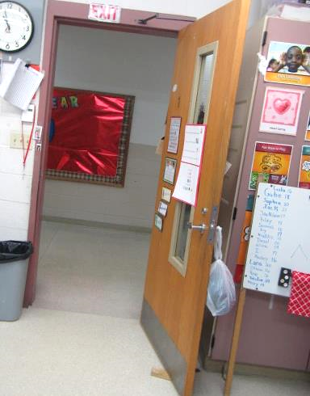
Classroom door pegged open, note location of carbon dioxide sensor (arrow)
Picture 7
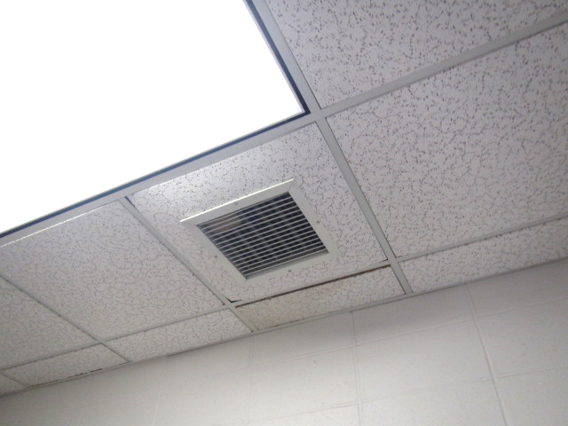
Classroom exhaust vent
Picture 8
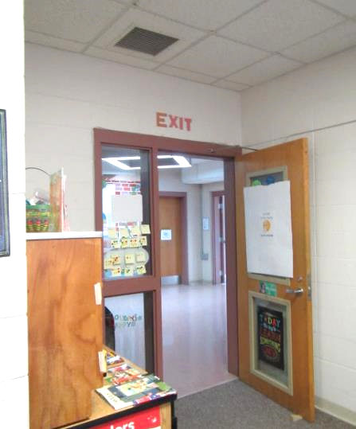
Classroom exhaust, note proximity to hallway door pegged open (arrows)
Picture 9
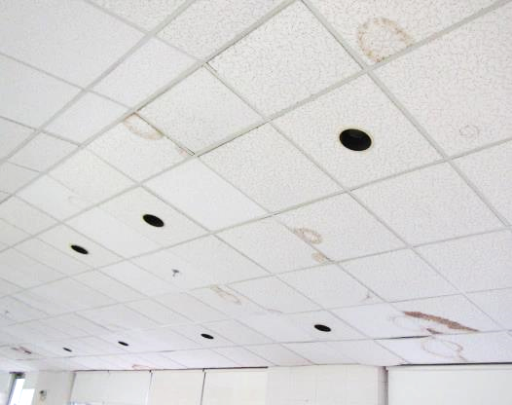
Water-damaged ceiling tiles in cafeteria
Picture 10
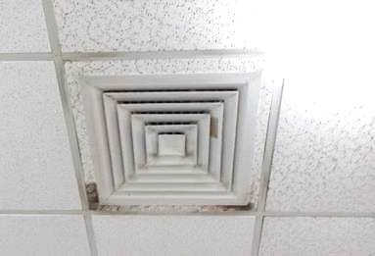
Dark staining around metal diffuser likely indicating mold growth from condensation
Picture 11
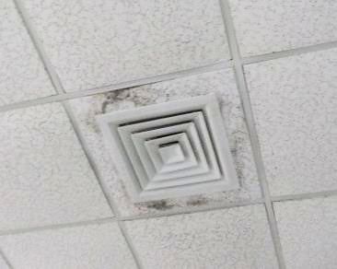
Dark staining around metal diffuser likely indicating mold growth from condensation
Picture 12
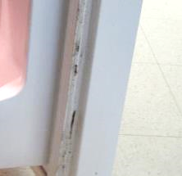
Visible mold growth (dark staining) on refrigerator gasket in Faculty Lounge
Picture 13
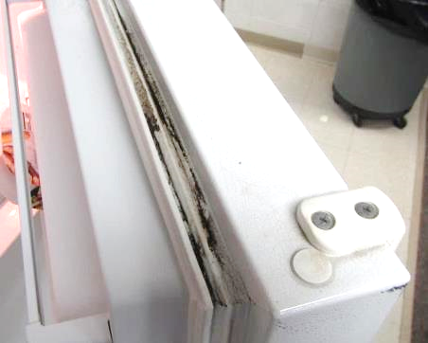
Visible mold growth (dark staining) on refrigerator gasket in Faculty Lounge
Picture 14
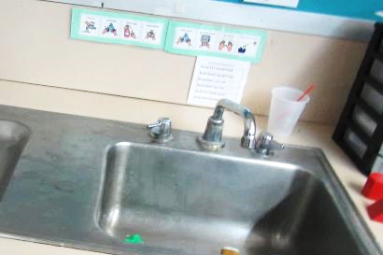
Space between sink countertop and backsplash
Picture 15
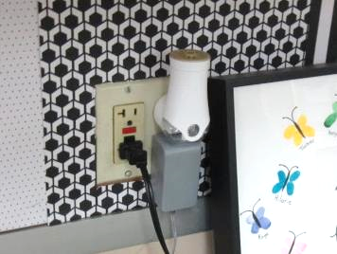
Plug-in air freshener
Picture 16
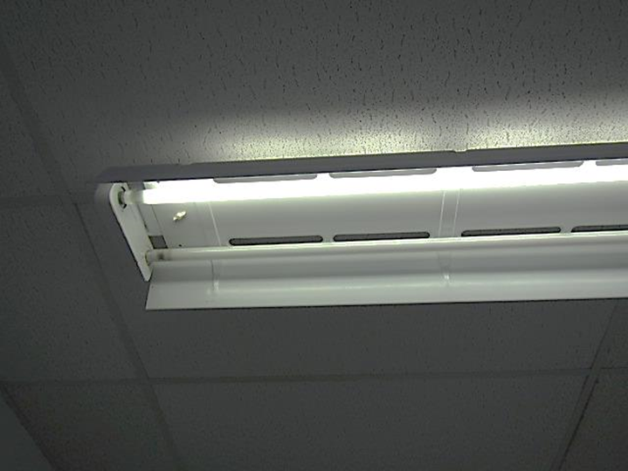
Missing florescent light covers
Location | Carbon  Dioxide  (ppm) | Carbon Monoxide  (ppm) | Temp  (°F) | Relative  Humidity  (%) | PM2.5  (µg/m³) | Occupants  in Room | Windows  Openable | Ventilation |  | Remarks
 |  |  |  |  |  |  |  | Supply | Exhaust
Background (outside) | 392 | ND | 50 | 72 | 17 |  |  |  |  | Grey skies/overcast, rain expected
Mrs. Garrity | 525 | ND | 68 | 36 | 6 | 0 | Y | Y | Y
ESL | 522 | ND | 69 | 34 | 7 | 0 | Y | Y | Y
Teacher’s Lounge | 491 | ND | 70 | 31 | 6 | 0 | Y | Y | Y | Space between sink countertop/backsplash, mold-fridge gaskets
Gym | 467 | ND | 70 | 31 | 4 | 0 | Y | Y | Y | HVAC valve leak-bucket
Cafeteria | 463 | ND | 70 | 31 | 5 | 1 | Y | Y | Y | WD CTs-dark stains around vents (possible mold), dust/debris on vents
Ms. Ellis | 611 | ND | 71 | 34 | 5 | 0 | N | N | N | WD CT, missing light covers
1 | 1160 | ND | 72 | 36 | 9 | 21 | Y | Y | Y | Items in front of UV
2 | 896 | ND | 72 | 35 | 5 | 21 | Y | Y | Y | Exhaust vent in restroom
3 | 900 | ND | 71 | 37 | 5 | 10 | Y | Y | Y
4 | 1018 | ND | 72 | 38 | 6 | 6 | Y | Y | Y  Off | Space between sink countertop/backsplash
5 | 740 | ND | 75 | 32 | 6 | 19 | Y | Y | Y | Space between sink countertop/backsplash, WD CT
K-1 | 1600 | ND | 72 | 41 | 5 | 22 | Y | Y | Y | Furniture around UV, 12 WD CTs-some painted
K-2 | 1089 | ND | 71 | 37 | 7 | 5 | N | N | Y | Space between sink countertop/backsplash, HS, DO, WD CT
6 | 1765 | ND | 72 | 42 | 6 | 19 | Y | Y | Y | 2 WD CT, faucet-drip
OT/PT | 990 | ND | 71 | 37 | 7 | 5 | N | N | Y | Dust/debris on vents, missing light covers, kiln-separate area-vented
7 | 1265 | ND | 72 | 39 | 6 | 20 | N | Y  Off | Y | Space between sink countertop/backsplash, DO, AF
8 | 1259 | ND | 71 | 38 | 6 | 21 | Y | Y | Y | DO, 3 WD CTs
9 | 1128 | ND | 72 | 37 | 6 | 16 | Y | Y | Y | Space between sink countertop/backsplash, plants, DO, 2 WD CTs
10 | 940 | ND | 70 | 36 | 7 | 22 | Y | Y | Y | Space between sink countertop/backsplash, plug-in AF
11 | 830 | ND | 70 | 36 | 4 | 0 | Y | Y | Y | 8 WD CT, DO
12 | 1212 | ND | 72 | 39 | 6 | 26 | Y | Y | Y | Space between sink countertop/backsplash, 3 WD CT
Library | 793 | ND | 71 | 33 | 5 | 24 | Y | Y | Y | WD CT-around vents (dark stains/possible mold)
13 | 769 | ND | 76 | 35 | 5 | 0 | Y | Y | Y | Space between sink countertop/backsplash
14 | 840 | ND | 71 | 35 | 5 | 1 | Y | Y | Y | 3 WD CT, plants
Auditorium Foyer | 976 | ND | 70 | 35 | 10 | 20 | N | N | N | Area used for classroom/activities
Stage/Music Area | 452 | ND | 70 | 30 | 5 | 23 | N | Y | Y
Auditorium | 430 | ND | 70 | 30 | 6 | 0 | N | Y | Y
Music Office | 472 | ND | 71 | 30 | 12 | 0 | N | Y | Y | MTs, WD CTs-around vents (dark stains/possible mold)
15 | 908 | ND | 72 | 35 | 7 | 1 | Y | Y | Y  Off | Space between sink countertop/backsplash, occupants gone ~30 mins, plants, DO, 2 WD CTs
16 | 1142 | ND | 75 | 35 | 8 | 20 | Y | Y | Y  Off
17 | 1159 | ND | 71 | 38 | 6 | 1 | Y | Y  Off | Y  Off | Space between sink countertop/backsplash, occupants at lunch, heat issues with UV
18 | 984 | ND | 77 | 32 | 7 | 23 | Y | Y | Y  Off | Space between sink countertop/backsplash, heat complaints/issues with UV, windows open prior to testing, DO
19 | 788 | ND | 71 | 34 | 7 | 0 | Y | Y | Y  Off | Occupants at lunch
20 | 1096 | ND | 73 | 36 | 5 | 22 | Y | Y | Y  Off
21 | 775 | ND | 71 | 34 | 5 | 0 | Y | Y | Y  Off | Occupants at lunch, DO
22 | 739 | ND | 71 | 35 | 5 | 0 | Y | Y | Y  Off | Wax melter-AF, occupants at lunch
School Psychologist | 588 | ND | 72 | 32 | 5 | 3 | Y | Y | Y  Off | Plants
23 | 1040 | ND | 72 | 39 | 5 | 24 | Y | Y | Y  Off
Nurse | 849 | ND | 73 | 34 | 6 | 1 | Y | Y | Y
Main Office | 825 | ND | 73 | 33 | 7 | 2 | Y | Y | Y
Principal’s Office | 867 | ND | 73 | 33 | 7 | 3 | Y | Y | Y

The service life is the median time during which a particular system or component of …[an HVAC]… system remains in its original service application and then is replaced. Replacement may occur for any reason, including, but not limited to, failure, general obsolescence, reduced reliability, excessive maintenance cost, and changed system requirements due to such influences as building characteristics or energy prices (ASHRAE, 1991).

