INDOOR AIR QUALITY ASSESSMENT

West Villages Elementary School
760 Osterville West Barnstable Road
Marston Mills, Massachusetts



Prepared by:
Massachusetts Department of Public Health
Bureau of Environmental Health
Indoor Air Quality Program
July 2012

Background/Introduction
At the request of the Barnstable Public Schools (BPS), the Massachusetts Department of Public Health (MDPH), Bureau of Environmental Health (BEH) provided assistance and consultation regarding indoor air quality (IAQ) at the West Villages Elementary School (WVES) located at 760 Osterville West Barnstable Road, Marston Mills, Massachusetts. On May 18, 2012, Cory Holmes, Environmental Analyst/Regional Inspector in BEH’s IAQ Program and Ruth Alfasso Environmental Engineer/Inspector in BEH’s IAQ program visited the school to perform an assessment. The assessment was part of an on-going effort to monitor and improve IAQ conditions in each of the Barnstable Public schools.
The WVES is a one-story brick building completed in 1988. School officials reported that a new roof was put on the building approximately 5 years ago. The building contains general classrooms, kitchen, cafeteria, gymnasium, faculty workrooms and office space. Windows are openable throughout the building. Most rooms are partially carpeted and partially tiled.

Methods
Air tests for carbon monoxide, carbon dioxide, temperature and relative humidity were conducted with the TSI, Q-Trak, IAQ Monitor, Model 7565. Air tests for airborne particle matter with a diameter less than 2.5 micrometers were taken with the TSI, DUSTTRAK™ Aerosol Monitor Model 8520. BEH staff also performed visual inspection of building materials for water damage and/or microbial growth.

Results
The school houses approximately 475 children in grades pre-K through 3 with a staff of approximately 40. Reportedly, the auditorium at the school is also used for public functions outside of the school day. Tests were taken during normal operations at the school. Results appear in Table 1.

Discussion

Ventilation
It can be seen from Table 1 that carbon dioxide levels were below 800 parts per million (ppm) in 32 out of 43 areas, indicating adequate air exchange about 75 percent of areas surveyed during the assessment. A number of classrooms were empty/sparsely populated or had open windows at the time of the testing, which can reduce carbon dioxide levels. Carbon dioxide levels would be expected to be higher with full occupancy and/or with windows closed.
Fresh air in classrooms is supplied by unit ventilators (univents) (Picture 1). A univent is designed to draw air from outdoors through a fresh air intake located on the exterior wall of the building (Picture 2). Return air is drawn through an air intake located at the base of each unit where fresh and return air are mixed, filtered, heated or cooled and provided to classrooms through an air diffuser located in the top of the unit (Figure 1).
Univents were found deactivated or obstructed with classroom items in a number of areas (Picture 1; Table 1). In order for univents to provide fresh air as designed, intakes/returns must remain free of obstructions. Importantly, these units must remain “on” and be allowed to operate while rooms are occupied. It was reported by school officials that the mechanical ventilation control systems had been upgraded to computer-controlled units about a month prior to the assessment.
Exhaust ventilation in classrooms is provided by wall or ceiling vents ducted to rooftop motors (Picture 3). Exhaust ventilation was found deactivated in a number of areas during the assessment (Table 1), which may indicate that they were shut off or in need of repair. As with univents, in order to function properly, exhaust vents must be activated and allowed to operate while rooms are occupied. Without adequate supply and exhaust ventilation, excess heat and environmental pollutants can build up and lead to indoor air/comfort complaints.
Rooftop air-handling units (AHUs) provide mechanical ventilation to common areas such as the cafeteria and gymnasium. AHUs draw in fresh, outside air through a set of intake louvers and then through a bank of filters. Air is then distributed to interior areas via air diffusers. Exhaust ventilation is provided by ceiling or wall-mounted return vents ducted back to rooftop AHUs.
To maximize air exchange, the MDPH recommends that both supply and exhaust ventilation operate continuously during periods of occupancy. In order to have proper ventilation with a mechanical supply and exhaust system, the systems must be balanced to provide an adequate amount of fresh air to the interior of a room while removing stale air from the room. It is recommended that heating, ventilating and air conditioning (HVAC) systems be re-balanced every five years to ensure adequate air systems function (SMACNA, 1994). The systems were reportedly balanced after control systems were recently replaced.
The Massachusetts Building Code requires that each room have a minimum ventilation rate of 15 cubic feet per minute (cfm) per occupant of fresh outside air or openable windows (SBBRS, 1997; BOCA, 1993). The ventilation must be on at all times the room is occupied. Providing adequate fresh air ventilation with open windows and maintaining the temperature in the comfort range during the cold weather season is impractical. Mechanical ventilation is usually required to provide adequate fresh air ventilation.
Carbon dioxide is not a problem in and of itself. It is used as an indicator of the adequacy of the fresh air ventilation. As carbon dioxide levels rise, it indicates that the ventilating system is malfunctioning or the design occupancy of the room is being exceeded. When this happens, a buildup of common indoor air pollutants can occur, leading to discomfort or health complaints. The Occupational Safety and Health Administration (OSHA) standard for carbon dioxide is 5,000 parts per million parts of air (ppm). Workers may be exposed to this level for 40 hours/week, based on a time-weighted average (OSHA, 1997).
The MDPH uses a guideline of 800 ppm for publicly occupied buildings. A guideline of 600 ppm or less is preferred in schools due to the fact that the majority of occupants are young and considered to be a more sensitive population in the evaluation of environmental health status. Inadequate ventilation and/or elevated temperatures are major causes of complaints such as respiratory, eye, nose and throat irritation, lethargy and headaches. For more information concerning carbon dioxide, consult Appendix A.
Indoor temperature measurements ranged from 68 °F to 73 °F (Table 1), which were within or close to the MDPH recommended comfort range on the day of the assessment. The MDPH recommends that indoor air temperatures be maintained in a range of 70 °F to 78 °F in order to provide for the comfort of building occupants. In many cases concerning indoor air quality, fluctuations of temperature in occupied spaces are typically experienced, even in a building with an adequate fresh air supply.
The relative humidity measured in the building ranged from 40 to 52 percent, which was within the MDPH recommended comfort range in all areas surveyed during the assessment (Table 1). The MDPH recommends a comfort range of 40 to 60 percent for indoor air relative humidity. Relative humidity levels in the building would be expected to drop during the winter months due to heating. The sensation of dryness and irritation is common in a low relative humidity environment. Low relative humidity is a very common problem during the heating season in the northeast part of the United States.

Microbial/Moisture Concerns
Water-damaged ceiling tiles were observed in a number of areas (Table 1). These indicate current/historic roof leaks, plumbing leaks or other water infiltration (Pictures 4 and 5). Water-damaged ceiling tiles can provide a source of mold and should be replaced after a water leak is discovered and repaired. Water damage around ventilation components in the library (Picture 5) may indicate that the tiles are being moistened by condensation due to use of the air conditioning. When the HVAC system parts are cold (in cooling mode) and in contact with humid air, water may condense on the metal components and then moisten adjacent porous materials (i.e., ceiling tiles). This occurrence can be minimized through control of the infiltration of warm, humid outside air into the building during cooling season by keeping doors and windows closed and sealing any breaches in the building envelope. The temperature of the cooling system may also need to be adjusted.
The US Environmental Protection Agency (US EPA) and the American Conference of Governmental Industrial Hygienists (ACGIH) recommend that porous materials (e.g., carpeting, gypsum wallboard) be dried with fans and heating within 24 to 48 hours of becoming wet (US EPA, 2001; ACGIH, 1989). If not dried within this time frame, mold growth may occur. Once mold has colonized porous materials, they are difficult to clean and should be removed/discarded.
Plants were noted in a few classrooms (Table 1). Plants can be a source of pollen and mold which can be respiratory irritants to some individuals. Plants should be properly maintained and equipped with drip pans and should be located away from univents to prevent the aerosolization of dirt, pollen and mold.
Breaches exist between countertops and sink backsplashes in a number of classrooms (Picture 6; Table 1). Water can penetrate through backsplash seams if they are not watertight. Water penetration and chronic exposure of porous and wood-based materials can cause these materials to swell and show signs of water damage. Porous materials were found stored under many sinks (Picture 7; Table 1). Materials stored under sinks may make leaks harder to detect and repeated moistening of porous materials can result in mold growth. Many of the sinks were also found to be dripping and could not be turned completely off, providing additional moisture. As discussed, moistened materials that are not dried within 24 to 48 hours can become potential sources for mold growth.
BEH staff conducted a perimeter inspection of the building’s exterior to identify potential sources of water penetration. A gutter downspout was found detached from the building (Picture 8). Missing/damaged gutters/downspouts can allow water to moisten the side of the building or pool at the base of the foundation where it may penetrate into the building. A pine tree was noted growing close to the building exterior directly in front of a univent fresh air intake (Picture 2). This and other tree/plant roots may penetrate the building foundation, creating and widening cracks there. In addition, pollen and dirt/debris from the tree are likely to be drawn into the univent system, and from there prematurely occlude the filter or enter the indoor air.
Over time, these conditions can undermine the integrity of the building envelope and provide a means of water entry into the building via capillary action through foundation concrete and masonry (Lstiburek & Brennan, 2001). The freezing and thawing action of water during the winter months can create cracks and fissures in the foundation. In addition, these breaches may provide a means for pests/rodents to enter the building.
Some of the screening on air intake vents were found to be broken, and one had baseballs lodged in it (Picture 9). These screens are needed to keep birds and other pests out of the ventilation systems and should be repaired.

Other IAQ Evaluations
Indoor air quality can be negatively influenced by the presence of respiratory irritants, such as products of combustion. The process of combustion produces a number of pollutants. Common combustion emissions include carbon monoxide, carbon dioxide, water vapor and smoke (fine airborne particle material). Of these materials, exposure to carbon monoxide and particulate matter with a diameter of 2.5 micrometers (μm) or less (PM2.5) can produce immediate, acute health effects upon exposure. To determine whether combustion products were present in the indoor environment, BEH staff obtained measurements for carbon monoxide and PM2.5.

Carbon Monoxide
Carbon monoxide is a by-product of incomplete combustion of organic matter (e.g., gasoline, wood and tobacco). Exposure to carbon monoxide can produce immediate and acute health effects. Several air quality standards have been established to address carbon monoxide and prevent symptoms from exposure to these substances. The MDPH established a corrective action level concerning carbon monoxide in ice skating rinks that use fossil-fueled ice resurfacing equipment. If an operator of an indoor ice rink measures a carbon monoxide level over 30 ppm, taken 20 minutes after resurfacing within a rink, that operator must take actions to reduce carbon monoxide levels (MDPH, 1997).
The American Society of Heating Refrigeration and Air-Conditioning Engineers (ASHRAE) has adopted the National Ambient Air Quality Standards (NAAQS) as one set of criteria for assessing indoor air quality and monitoring of fresh air introduced by HVAC systems (ASHRAE, 1989). The NAAQS are standards established by the US EPA to protect the public health from six criteria pollutants, including carbon monoxide and particulate matter (US EPA, 2006). As recommended by ASHRAE, pollutant levels of fresh air introduced to a building should not exceed the NAAQS levels (ASHRAE, 1989). The NAAQS were adopted by reference in the Building Officials & Code Administrators (BOCA) National Mechanical Code of 1993 (BOCA, 1993), which is now an HVAC standard included in the Massachusetts State Building Code (SBBRS, 1997). According to the NAAQS, carbon monoxide levels in outdoor air should not exceed 9 ppm in an eight-hour average (US EPA, 2006).
Carbon monoxide should not be present in a typical, indoor environment. If it is present, indoor carbon monoxide levels should be less than or equal to outdoor levels. On the day of the assessment, outdoor carbon monoxide concentrations were non-detect (ND) (Table 1). No measurable levels of carbon monoxide were detected inside the building (Table 1).

Particulate Matter
The US EPA has established NAAQS limits for exposure to particulate matter. Particulate matter is airborne solids that can be irritating to the eyes, nose and throat. The NAAQS originally established exposure limits to particulate matter with a diameter of 10 μm or less (PM10). According to the NAAQS, PM10 levels should not exceed 150 micrograms per cubic meter (μg/m³) in a 24-hour average (US EPA, 2006). These standards were adopted by both ASHRAE and BOCA. Since the issuance of the ASHRAE standard and BOCA Code, US EPA established a more protective standard for fine airborne particles. This more stringent PM2.5 standard requires outdoor air particle levels be maintained below 35 μg/m³ over a 24-hour average (US EPA, 2006). Although both the ASHRAE standard and BOCA Code adopted the PM10 standard for evaluating air quality, MDPH uses the more protective PM2.5 standard for evaluating airborne particulate matter concentrations in the indoor environment.
Outdoor PM2.5 concentrations were measured at 7 μg/m³ (Table 1). PM2.5 levels measured in the school were between 4 to 18 μg/m³ (Table 1), which were below the NAAQS PM2.5 level of 35 μg/m³. Frequently, indoor air levels of particulates (including PM2.5) can be at higher levels than those measured outdoors. A number of activities that occur indoors and/or mechanical devices can generate particulates during normal operations. Sources of indoor airborne particulates may include but are not limited to particles generated during the operation of fan belts in the HVAC system, use of stoves and/or microwave ovens in kitchen areas; use of photocopiers, fax machines and computer printing devices; operation of an ordinary vacuum cleaner and heavy foot traffic indoors.

Volatile Organic Compounds
Indoor air concentrations can be greatly impacted by the use of products containing volatile organic compounds (VOCs). VOCs are carbon-containing substances that have the ability to evaporate at room temperature. Frequently, exposure to low levels of total VOCs (TVOCs) may produce eye, nose, throat and/or respiratory irritation in some sensitive individuals. For example, chemicals evaporating from a paint can stored at room temperature would most likely contain VOCs. In an effort to identify materials that can potentially increase indoor VOC concentrations, BEH staff examined rooms for products containing these respiratory irritants.
Cleaning and sanitizing products were observed in some rooms (Picture 7; Table 1). These products contain chemicals that can be irritating to the eyes, nose and throat of sensitive individuals. Cleaning products should be properly labeled and stored in an area inaccessible to children. In addition, a Material Safety Data Sheets (MSDS) should be available at a central location for each product in the event of an emergency. Consideration should be given to providing teaching staff with school issued cleaning products and supplies to prevent any potential for adverse chemical interactions between residues left from cleaners used by the facilities staff and those left by cleaners brought in by others.
Some classrooms contained dry erase boards and related materials. Materials such as dry erase markers and dry erase board cleaners may contain VOCs, such as methyl isobutyl ketone, n-butyl acetate and butyl-cellusolve (Sanford, 1999), which can be irritating to the eyes, nose and throat.
An odor of air freshener or cleaner was noted in one room. Air fresheners contain chemicals that can be irritating to the eyes, nose and throat of sensitive individuals. Further, air fresheners do not remove materials causing odors, but rather, mask odors which may be present in the area.

Other Conditions
An air purifier was found in the nurse’s office (Picture 10). Based on product literature found for this product, it contains a high-efficiency particulate arrestance (HEPA) filter and uses ultraviolet (UV) light for its germicidal properties and a carbon filter to remove odors. It is important that if such devices are used, they are maintained properly, including cleaning or changing the HEPA filter as recommended. Note that air purifiers are not a substitute for appropriate ventilation.
In many classrooms, large numbers of items were on floors, windowsills, tabletops, counters, bookcases and desks, which provide a source for dusts to accumulate (Picture 11). These items (e.g., papers, folders, boxes) make it difficult for custodial staff to clean. Items should be relocated and/or be cleaned periodically to avoid excessive dust build up. In addition, dust and debris can accumulate on flat surfaces (e.g., desktops, shelving and carpets) in occupied areas and subsequently be re-aerosolized causing further irritation.
Plush toys were observed in several classrooms and the library (Picture 12; Table 1). Upholstery and plush toys are covered with fabrics that may be exposed to human skin. This type of contact can leave oils, perspiration, hair and skin cells. Dust mites feed upon human skin cells and excrete waste products that contain allergens. In addition, if relative humidity levels increase above 60 percent, dust mites tend to proliferate (US EPA, 1992). In order to remove dust mites and other pollutants, frequent vacuuming of upholstered furniture is recommended (Berry, 1994). It is also recommended that upholstered furniture (if present in schools), be professionally cleaned on an annual basis. If an excessively dusty environment exists due to outdoor conditions or indoor activities (e.g., renovations), cleaning frequency should be increased (every six months) (IICRC, 2000).
Several aquariums containing turtles were located in hallways (Picture 13). Aquariums should be properly maintained to prevent bacterial/mold/algal growth and associated nuisance odors.
A box filled with used milk cartons was found in a classroom (Picture 14). Food containers, even when emptied, can contain food residues that can cause odors or be attractive to pests.
A number of air diffusers, exhaust/return vents and personal fans were found to have accumulated dust/debris (Picture 15). If exhaust vents are not functioning, backdrafting can occur, which can re-aerosolize accumulated dust particles. Re-activated supply, exhaust/return vents and fans can also aerosolize dust accumulated on vents/fan blades.
Accumulations of pencil shavings were observed in several classrooms (Table 1, Picture 16). These materials can be aerosolized by air movement from the ventilation system, doors opening and closing, or foot traffic and may present an eye or respiratory irritant.
Finally, candles were observed on the univent cabinet in one room. When candles are burned they can produce particulates (e.g., soot), and odors.

Conclusions/Recommendations
In view of the findings at the time of the visit, the following recommendations are made:
- Ensure school/school department personnel are properly trained in use of the new computer-controlled HVAC system to provide and maintain good airflow/thermal comfort of building occupants.
- Operate all ventilation systems throughout the building (e.g., gym, cafeteria, classrooms) continuously during periods of occupancy to maximize air exchange.
- Adjust the percentage of fresh air supplied to and/or exhausted by the HVAC system to improve air exchange.
- Remove all blockages/items from the surface of univent air diffusers and return vents (along front/bottom) to ensure adequate airflow.
- Ensure classroom exhaust vents are operating during occupancy; make repairs as needed.
- Ensure classroom doors are closed for proper operation of HVAC system and to maintain comfort.
- Consider adopting a balancing schedule of every 5 years for all mechanical ventilation systems, as recommended by ventilation industrial standards (SMACNA, 1994).
- For buildings in New England, periods of low relative humidity during the winter are often unavoidable. Therefore, scrupulous cleaning practices should be adopted to minimize common indoor air contaminants whose irritant effects can be enhanced when the relative humidity is low. To control dusts, a high efficiency particulate arrestance (HEPA) filter equipped vacuum cleaner in conjunction with wet wiping of all surfaces is recommended. Avoid the use of feather dusters. Drinking water during the day can help ease some symptoms associated with a dry environment (throat and sinus irritations).
- Do not open windows if HVAC system is in its air-conditioning setting to avoid condensation.
- Ensure roof/plumbing leaks are repaired and replace any remaining water-damaged ceiling tiles. Examine the area above these tiles for mold growth. Disinfect areas of water leaks with an appropriate antimicrobial, as needed.
- Ensure plants, trees and shrubs are located at least five feet away from exterior walls/foundation of the building.
- Repair bird screens.
- Check integrity of gutter and downspout systems and repair as needed.
- Ensure indoor plants are equipped with drip pans. Examine drip pans periodically for mold growth and disinfect with an appropriate antimicrobial, as needed. Move plants away from the air stream of mechanical ventilation equipment.
- Seal breaches, seams and spaces between sink countertops and backsplashes to prevent water damage and repair/adjust leaking sinks.
- Store cleaning products properly and out of reach of students. All cleaning products used at the facility should be approved by the school department with MSDS’ available at a central location.
- Refrain from using air fresheners and deodorizers to prevent exposure to VOCs.
- Monitor aquariums throughout school to maintain cleanliness and reduce associated odors.
- Maintain the air purifier in the nurse’s office in accordance with manufacturer’s instructions.
- Store used food containers only as long as necessary, and keep in tightly-sealed containers when possible, to prevent pests and odors.
- Relocate or consider reducing the amount of materials stored in classrooms to allow for more thorough cleaning of classrooms. Clean items regularly with a wet cloth or sponge to prevent excessive dust build-up.
- Clean air diffusers, exhaust/return vents and personal fans periodically of accumulated dust.
- Clean plush toys, upholstered furniture and area rugs frequently to remove dust and dust mites.
- Clean chalk and dry erase marker trays and pencil sharpening areas regularly with a wet cloth or sponge to prevent excessive build-up of dusts.
- Clean carpeting annually or semi-annually in soiled high traffic areas as per the recommendations of the Institute of Inspection, Cleaning and Restoration Certification (IICRC). Copies of the IICRC fact sheet can be downloaded at: http://www.cleancareseminars.com/carpet_cleaning_faq4.htm (IICRC, 2005).
- Consider adopting the US EPA (2000) document, “Tools for Schools”, as an instrument for maintaining a good indoor air quality environment in the building. This document is available at: http://www.epa.gov/iaq/schools/index.html
- Refer to resource manual and other related indoor air quality documents located on the MDPH’s website for further building-wide evaluations and advice on maintaining public buildings. These documents are available at: http://mass.gov/dph/iaq

References
ACGIH. 1989. Guidelines for the Assessment of Bioaerosols in the Indoor Environment. American Conference of Governmental Industrial Hygienists, Cincinnati, OH.
ASHRAE. 1989. Ventilation for Acceptable Indoor Air Quality. American Society of Heating, Refrigeration and Air Conditioning Engineers. ANSI/ASHRAE 62-1989.
Berry, M.A. 1994. Protecting the Built Environment: Cleaning for Health. Michael A. Berry, Chapel Hill, NC.
BOCA. 1993. The BOCA National Mechanical Code/1993. 8th ed. Building Officials & Code Administrators International, Inc., Country Club Hills, IL.
IICRC. 2000. IICRC S001 Reference Guideline for Professional On-Location Cleaning of Textile Floor Covering Materials Institute of Inspection, Cleaning and Restoration Certification. Institute of Inspection Cleaning and Restoration, Vancouver, WA.
IICRC. 2005. Carpet Cleaning FAQ 4 Institute of Inspection, Cleaning and Restoration Certification. Institute of Inspection Cleaning and Restoration, Vancouver, WA.
Lstiburek, J. & Brennan, T. 2001. Read This Before You Design, Build or Renovate. Building Science Corporation, Westford, MA. U.S. Department of Housing and Urban Development, Region I, Boston, MA.
MDPH. 1997. Requirements to Maintain Air Quality in Indoor Skating Rinks (State Sanitary Code, Chapter XI). 105 CMR 675.000. Massachusetts Department of Public Health, Boston, MA.
OSHA. 1997. Limits for Air Contaminants. Occupational Safety and Health Administration. Code of Federal Regulations. 29 C.F.R 1910.1000 Table Z-1-A.
Sanford. 1999. Material Safety Data Sheet (MSDS No: 198-17). Expo® Dry Erase Markers Bullet, Chisel, and Ultra Fine Tip. Sanford Corporation, Bellwood, IL.
SBBRS. 1997. Mechanical Ventilation. State Board of Building Regulations and Standards. Code of Massachusetts Regulations. 780 CMR 1209.0.
SMACNA. 1994. HVAC Systems Commissioning Manual. 1st ed. Sheet Metal and Air Conditioning Contractors’ National Association, Inc., Chantilly, VA.
US EPA. 1992. Indoor Biological Pollutants. US Environmental Protection Agency, Environmental Criteria and Assessment Office, Office of Health and Environmental Assessment, research Triangle Park, NC. EPA 600/8-91/202. January 1992.
US EPA. 2000. Tools for Schools. Office of Air and Radiation, Office of Radiation and Indoor Air, Indoor Environments Division (6609J). EPA 402-K-95-001, Second Edition. http://www.epa.gov/iaq/schools/tools4s2.html
US EPA. 2001. “Mold Remediation in Schools and Commercial Buildings”. Office of Air and Radiation, Indoor Environments Division, Washington, DC. EPA 402-K-01-001. March 2001. Available at: http://www.epa.gov/iaq/molds/mold_remediation.html
US EPA. 2006. National Ambient Air Quality Standards (NAAQS). US Environmental Protection Agency, Office of Air Quality Planning and Standards, Washington, DC. http://www.epa.gov/air/criteria.html
Picture 1

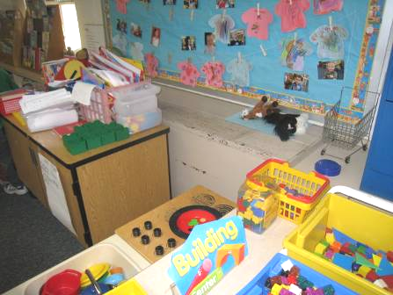

Classroom univent, note blockage of unit by furniture

Picture 2

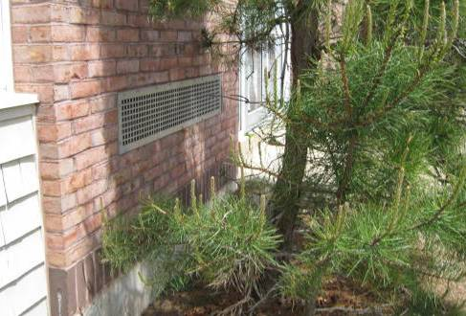

Univent air intake on outside of building; note that this one has a tree directly in front of it

Picture 3

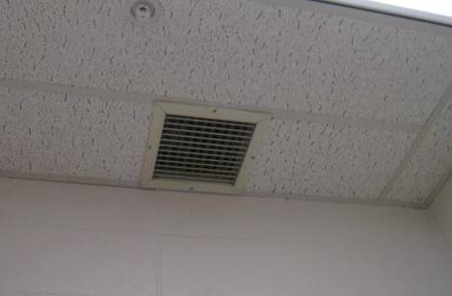

Typical classroom exhaust vent

Picture 4

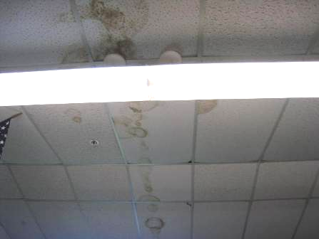

Water-damaged ceiling tiles

Picture 5

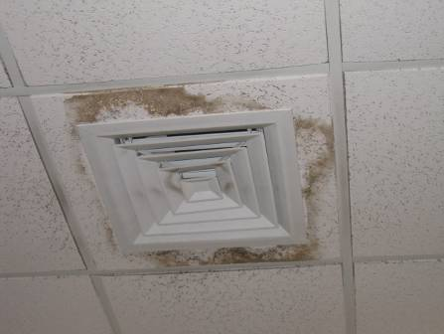

Water-damaged ceiling tile around air diffuser component

Picture 6

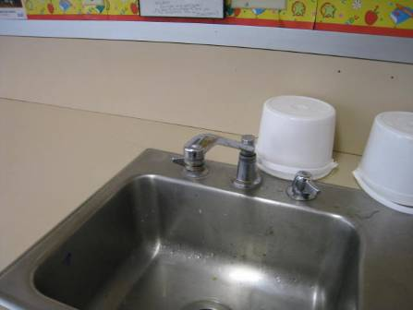

Classroom sink with weakly-sealed backsplash and faucet leak

Picture 7

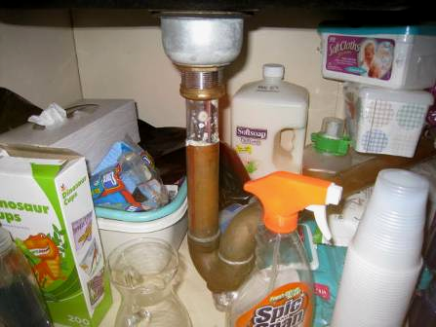

Items, including cleaning products and porous paper and cardboard stored under sink

Picture 8

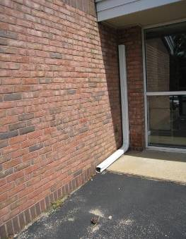

Disconnected gutter downspout

Picture 9

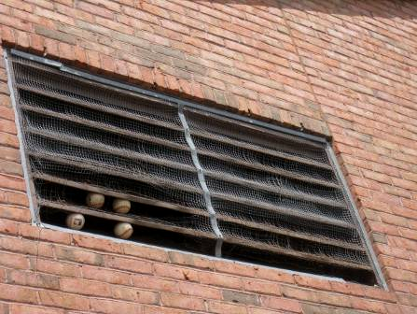

Damaged bird screen on ventilation air intake

Picture 10

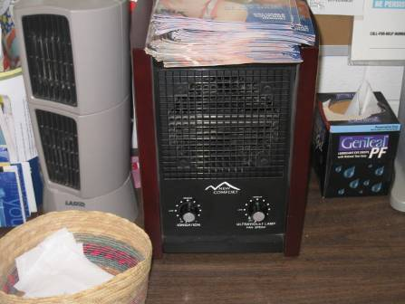

“New Comfort” air purifier with ionization and UV

Picture 11

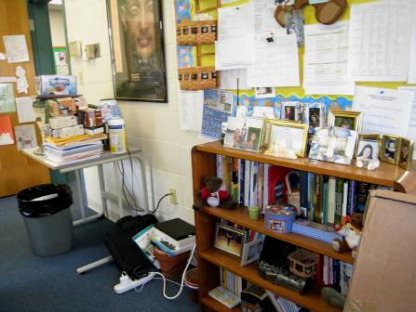

Items in classroom

Picture 12

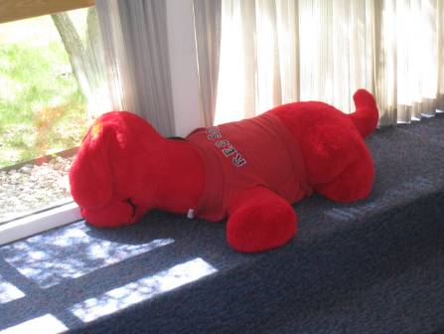

Plush toy in the library

Picture 13

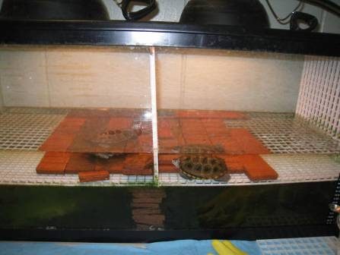

Turtles in an aquarium in the hallway

Picture 14

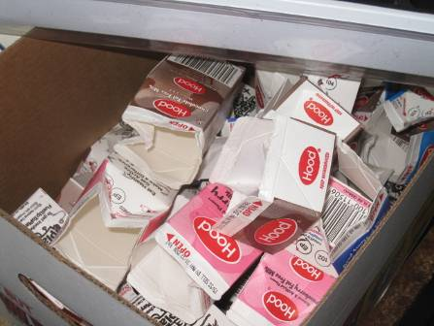

Milk cartons

Picture 15

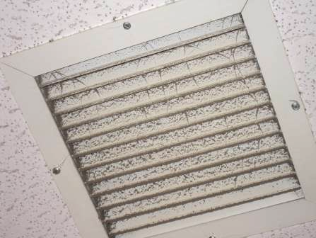

Dusty exhaust vent

Picture 16

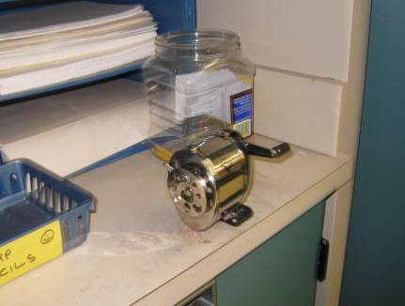

Pencil sharpener with accumulation of shavings next to it
Location/ Room | Carbon  Dioxide  (ppm) | Carbon Monoxide  (ppm) | Temp  (°F) | Relative  Humidity  (%) | PM2.5  (µg/m³) | Occupants  in Room | Windows  Openable | Ventilation |  | Remarks
Background | 320 | ND | 71 | 44 | 7 |  |  |  |  | sunny with light breeze
1 | 1018 | ND | 71 | 47 | 9 | 22 | Y | Y on | Y | Porous items under sink, items, backsplash ok
2 | 878 | ND | 72 | 50 | 13 | 22 | Y | Y | Y | DO, UV blocked
3 | 777 | ND | 70 | 46 | 8 | 5 | Y | Y | Y in bathroom | DEM, DO, items close to sink
4 | 533 | ND | 70 | 42 | 8 | 12 | Y open | Y | Y | DO
5 | 836 | ND | 70 | 43 | 15 | 13 | Y open | Y | Y | UV off, DO
6 | 1262 | ND | 72 | 45 | 8 | 21 | Y open | Y | Y | UV somewhat blocked, sink drips, DEM, items under sink
7 | 775 | ND | 71 | 44 | 8 | 20 | Y | Y | Y | sink backsplash open
8 | 925 | ND | 71 | 44 | 6 | 15 | Y open | Y | Y dusty | candles on UV, items, leaking sink
9 | 887 | ND | 71 | 43 | 6 | 19 | Y | Y |  | plants, DEM, chalk, computers, backsplash not sealed
10 | 880 | ND | 72 | 45 | 11 | 17 | Y | Y | Y | sink backsplash open
11 | 624 | ND | 71 | 43 | 6 | 6 | Y | Y on |  | plants, DEM, CP under sink, 4 WD CT
12 | 627 | ND | 70 | 44 | 5 | 5 | Y | Y on |  | 2 printers, CP under sink, backsplash open, sink drips, toaster oven
13 | 967 | ND | 71 | 46 | 10 | 18 | Y | Y | Y dusty | sink backsplash open
14 | 950 | ND | 71 | 47 | 6 | 19 | Y | Y UV part blocked | Y | Plants, microwave, items under sink, PS
15 | 850 | ND | 71 | 45 | 6 | 19 | Y | Y on | Y | room abuts driveway outside, 6 WD CT, dripping sink
16 | 616 | ND | 72 | 44 | 11 | 21 | Y open | Y | Y off | plants, milk cartons
17 | 605 | ND | 71 | 42 | 6 | gone 40 minutes | Y | Y on | Y | DEM, CP, dripping sink
18 | 629 | ND | 72 | 41 | 13 | 20 | Y | Y | Y off | UV blocked -top and front, DO
19 | 609 | ND | 70 | 43 | 9 | 0 | Y | Y part blocked | Y | Lemon odor (cleaner?), backsplash open, items, DEM, sanitizer and CP under sink
20 | 745 | ND | 73 | 41 | 10 | 17 | Y | Y | Y off | UV blocked, DO, Aqua, PITS, loose AT
21 | 582 | ND | 70 | 44 | 8 | 0 | Y open | Y part blocked | Y off | DO, plants, DEM, items
22 | 635 | ND | 69 | 44 | 7 | 0 | Y | Y on | Y off | stuffed toys, DEM, chalk, items on UV, AT
23 | 840 | ND | 72 | 43 | 12 | 21 | Y | Y | Y | 2 WD CT, DO
Kindergarten A | 772 | ND | 72 | 47 | 9 | 22 | Y | Y on |  | CP under sink, DEM, sink drips, 10 WD CT, UV dirty
Kindergarten B | 749 | ND | 72 | 44 | 9 | 20 | Y open | Y dusty, on | Y | Door to outside open, AT, DEM, sink backsplash unsealed, sink dripping
Rear lobby (art supply) | 342 | ND | 69 | 44 | 6 | 0 | Y and door | N | Y
Stage | 410 | ND | 69 | 48 | 5 | 15 | N | Y
Music storage/office | 417 | ND | 68 | 51 | 5 | 0 | N | Y | Y | 1 AT 2 MT, 3 WD CT, fridge, instruments, sink
Art Storage/Office | 411 | ND | 68 | 52 | 5 | 0 | N | Y | Y | Items, door to outside, rusty PF, microwave
Reading | 550 | ND | 69 | 44 | 8 | 5 | Y | Y on | Y off | books, all carpeted
Principal’s office | 446 | ND | 70 | 43 | 6 | 0 | Y open | Y | Y off | many items, plants, food
Main Office area | 478 | ND | 70 | 44 | 7 | 3 | Y open | Y | Y off | PC w/local exhaust on, plants
Gym | 300 | ND | 70 | 40 | 5 | 0 | N | Y | Y | strong air flow
Staff room | 350 | ND | 70 | 43 | 4 | 0 | Y | Y | Y dusty | Fridge, microwave, sinks, coffeemaker,
Cafeteria | 460 | ND | 70 | 43 | 8 | >100 | Y and door to outside | Y | Y
Supply room | 750 | ND | 71 | 45 | 15 | 0 | N | N | Y | laminator, DO
Pilot | 751 | ND | 71 | 45 | 14 | 1 | N | N | Y | DO
Library computer area | 431 | ND | 70 | 40 | 8 | 6 | Y | Y | Y | WD stained/soiled CT around vents, large stuffed toy
Library | 444 | ND | 70 | 41 | 7 | 0 | Y | Y | N | WD CT around vent
Main lobby/reception | 551 | ND | 72 | 41 | 11 | 2 | Y | Y | Y | 11 WD CT
Nurse | 551 | ND | 71 | 42 | 10 | 5 | Y | Y | Y | plants, ozone machine, 2 WD CT, DO
School counselor | 417 | ND | 70 | 41 | 15 | 0 | Y | Y | Y | DO, 1 WD CT
Miss Schultz | 713 | ND | 71 | 45 | 18 | 0 | N | N | N | 1 WD CT, recommend undercut door

